# Divine Service 1 p.151

2nd Sunday in Lent

March 16,2025

# Confession and Absolution

Hymn of Invocation: 577 Almighty God, Your Word Is Cast

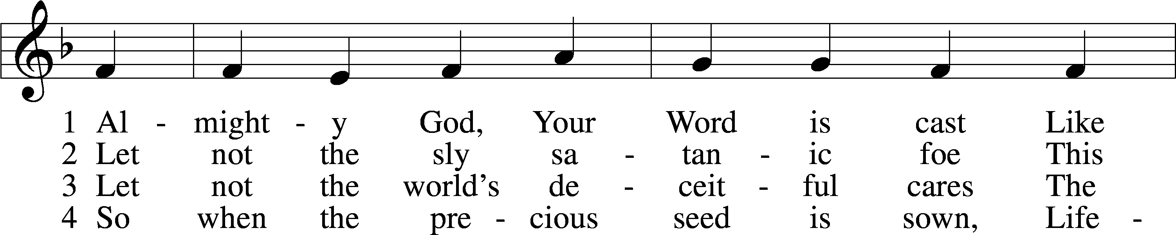

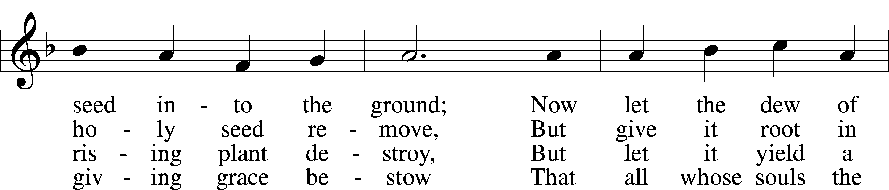

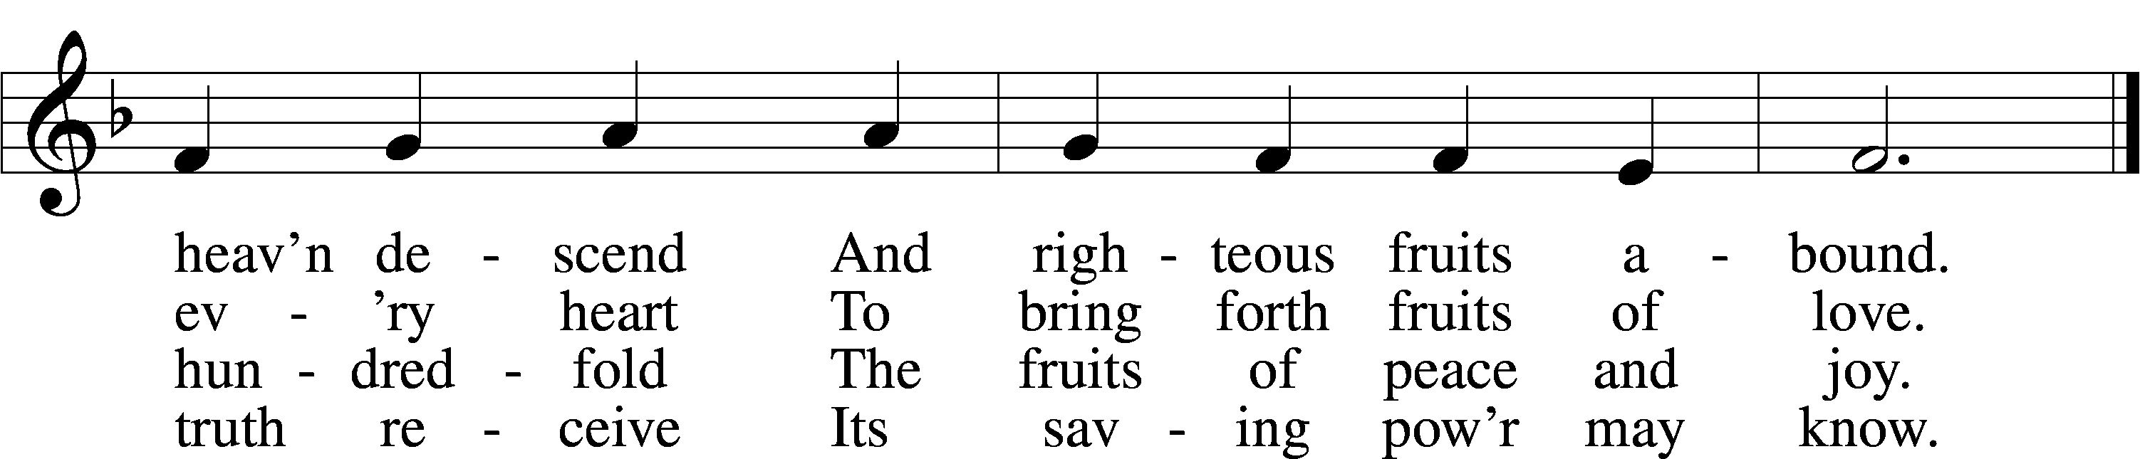

Text: John Cawood, 1775–1852, alt.  
Tune: The Whole Booke of Psalmes, 1562, London  
Text and tune: Public domain

Stand

The sign of the cross may be made by all in remembrance of their Baptism.

P In the name of the Father and of the T Son and of the Holy Spirit.

C **Amen.**

P If we say we have no sin, we deceive ourselves, and the truth is not in us.

C **But if we confess our sins, God, who is faithful and just, will forgive our sins and cleanse us from all unrighteousness.**

Kneel/Stand

Silence for reflection on God’s Word and for self-examination.

P Let us then confess our sins to God our Father.

C **Most merciful God, we confess that we are by nature sinful and unclean. We have sinned against You in thought, word, and deed, by what we have done and by what we have left undone. We have not loved You with our whole heart; we have not loved our neighbors as ourselves. We justly deserve Your present and eternal punishment. For the sake of Your Son, Jesus Christ, have mercy on us. Forgive us, renew us, and lead us, so that we may delight in Your will and walk in Your ways to the glory of Your holy name. Amen.**

P Almighty God in His mercy has given His Son to die for you and for His sake forgives you all your sins. As a called and ordained servant of Christ, and by His authority, I therefore forgive you all your sins in the name of the Father and of the T Son and of the Holy Spirit.

C **Amen.**

Stand

# Service of the Word

Introit Psalm 74:1–3; antiphon: Psalm 69:9

For zeal for your house has consumed me,  
 and the reproaches of those who reproach you have fallen on me.  
O God, why do you cast us off forever?  
 Why does your anger smoke against the sheep of your pasture?  
Remember your congregation, which you have purchased of old, which you have redeemed to be the tribe of your heritage!  
 Remember Mount Zion, where you have dwelt.  
Direct your steps to the perpetual ruins;  
 the enemy has destroyed everything in the sanctuary!  
**Glory be to the Father and to the Son**  
 **and to the Holy Spirit;**  
**as it was in the beginning,**  
 **is now, and will be forever. Amen.**  
For zeal for your house has consumed me,  
 and the reproaches of those who reproach you have fallen on me.

Kyrie LSB 152

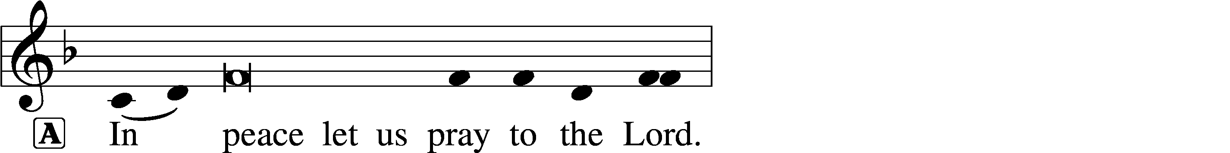

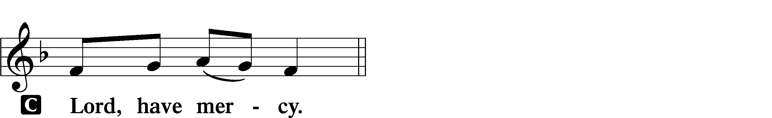

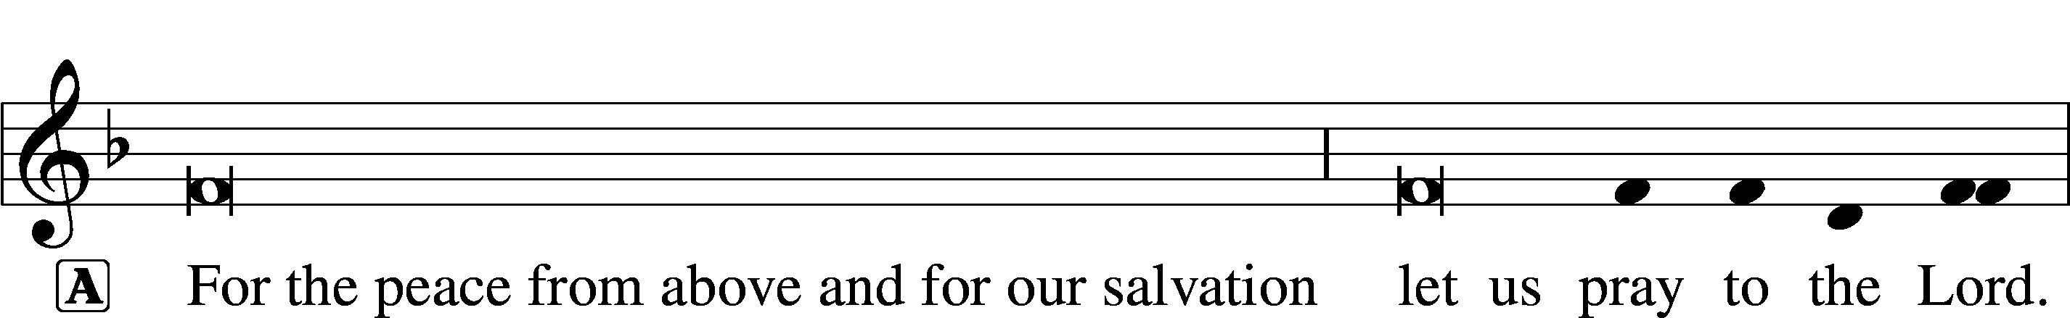

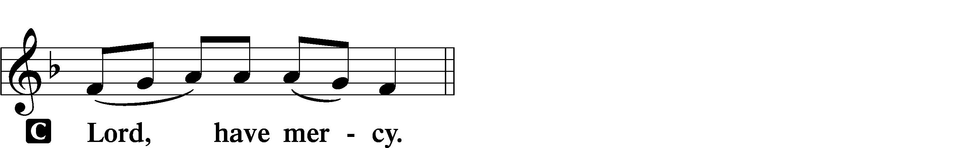

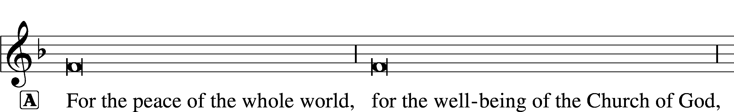

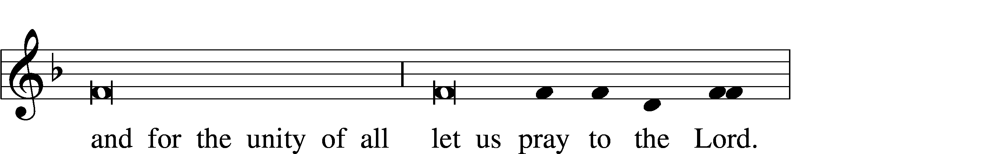

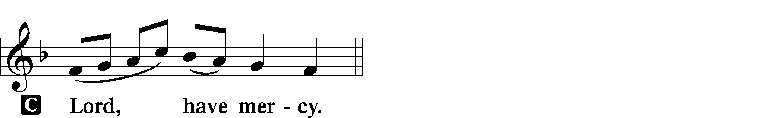

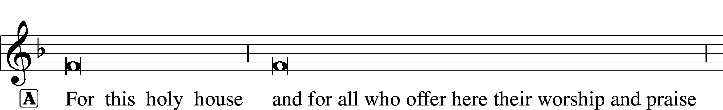



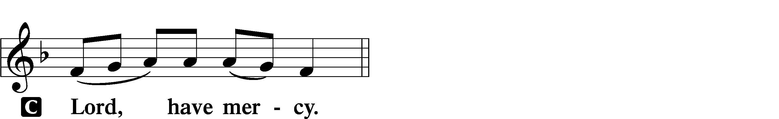

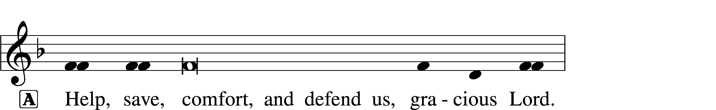



Salutation and Collect of the Day

P The Lord be with you.

C **And also with you.**

P Let us pray.

O God, You see that of ourselves we have no strength. By Your mighty power defend us from all adversities that may happen to the body and from all evil thoughts that may assault and hurt the soul; through Jesus Christ, Your Son, our Lord, who lives and reigns with You and the Holy Spirit, one God, now and forever.

C **Amen.**

Sit

Old Testament Reading Jeremiah 26:8–15

8When Jeremiah had finished speaking all that the Lord had commanded him to speak to all the people, then the priests and the prophets and all the people laid hold of him, saying, “You shall die! 9Why have you prophesied in the name of the Lord, saying, ‘This house shall be like Shiloh, and this city shall be desolate, without inhabitant’?” And all the people gathered around Jeremiah in the house of the Lord.

10When the officials of Judah heard these things, they came up from the king’s house to the house of the Lord and took their seat in the entry of the New Gate of the house of the Lord. 11Then the priests and the prophets said to the officials and to all the people, “This man deserves the sentence of death, because he has prophesied against this city, as you have heard with your own ears.”

12Then Jeremiah spoke to all the officials and all the people, saying, “The Lord sent me to prophesy against this house and this city all the words you have heard. 13Now therefore mend your ways and your deeds, and obey the voice of the Lord your God, and the Lord will relent of the disaster that he has pronounced against you. 14But as for me, behold, I am in your hands. Do with me as seems good and right to you. 15Only know for certain that if you put me to death, you will bring innocent blood upon yourselves and upon this city and its inhabitants, for in truth the Lord sent me to you to speak all these words in your ears.”

A This is the Word of the Lord.

C **Thanks be to God.**

Epistle Philippians 3:17—4:1

17Brothers, join in imitating me, and keep your eyes on those who walk according to the example you have in us. 18For many, of whom I have often told you and now tell you even with tears, walk as enemies of the cross of Christ. 19Their end is destruction, their god is their belly, and they glory in their shame, with minds set on earthly things. 20But our citizenship is in heaven, and from it we await a Savior, the Lord Jesus Christ, 21who will transform our lowly body to be like his glorious body, by the power that enables him even to subject all things to himself.

1Therefore, my brothers, whom I love and long for, my joy and crown, stand firm thus in the Lord, my beloved.

A This is the Word of the Lord.

C **Thanks be to God.**

Stand

Alleluia and Verse (Lent) LSB 157

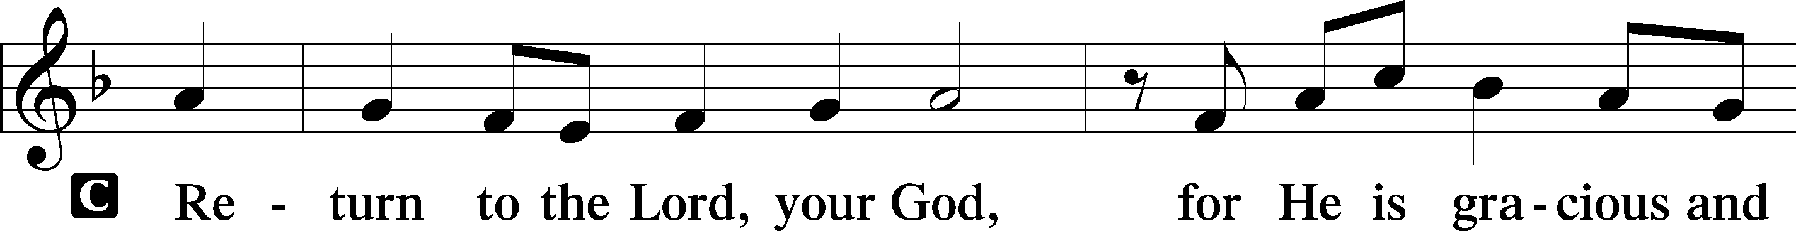

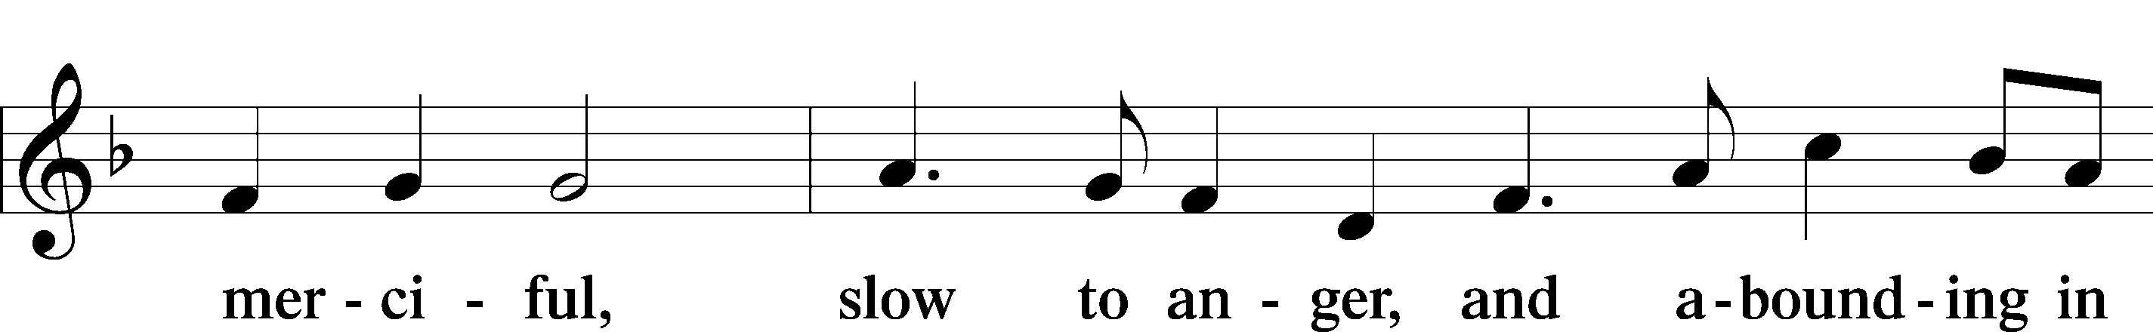

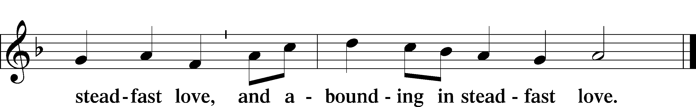

Holy Gospel Luke 13:31–35

P The Holy Gospel according to St. Luke, the thirteenth chapter.

C **Glory to You, O Lord.**

Lament over Jerusalem

31At that very hour some Pharisees came and said to [Jesus], “Get away from here, for Herod wants to kill you.” 32And he said to them, “Go and tell that fox, ‘Behold, I cast out demons and perform cures today and tomorrow, and the third day I finish my course. 33Nevertheless, I must go on my way today and tomorrow and the day following, for it cannot be that a prophet should perish away from Jerusalem.’ 34O Jerusalem, Jerusalem, the city that kills the prophets and stones those who are sent to it! How often would I have gathered your children together as a hen gathers her brood under her wings, and you would not! 35Behold, your house is forsaken. And I tell you, you will not see me until you say, ‘Blessed is he who comes in the name of the Lord!’”

P This is the Gospel of the Lord.

C **Praise to You, O Christ.**

Sit

Hymn of the Day: 708 Lord, Thee I Love with All My Heart

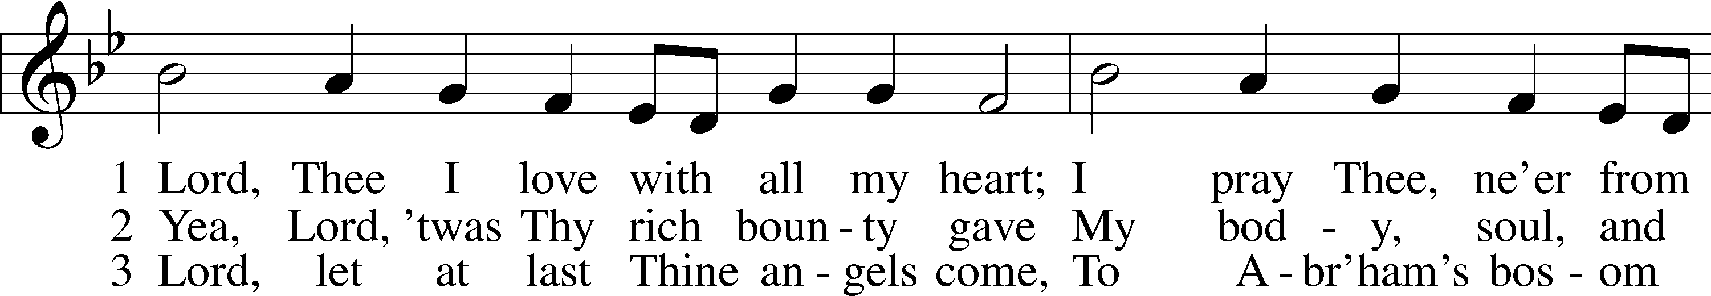

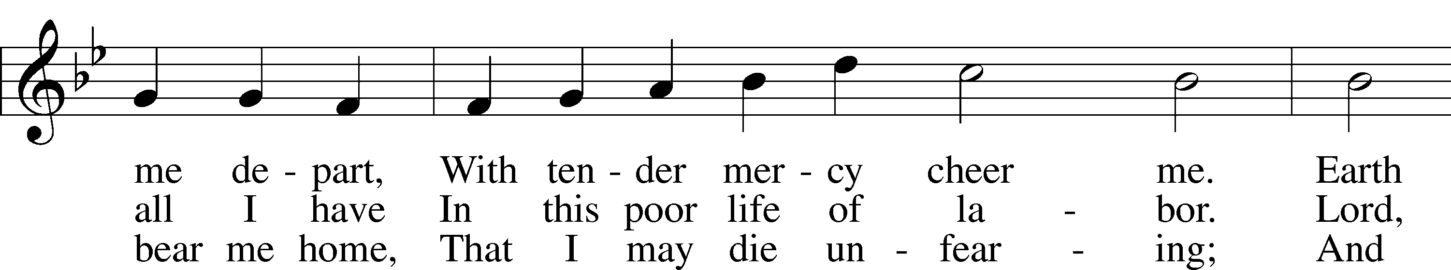

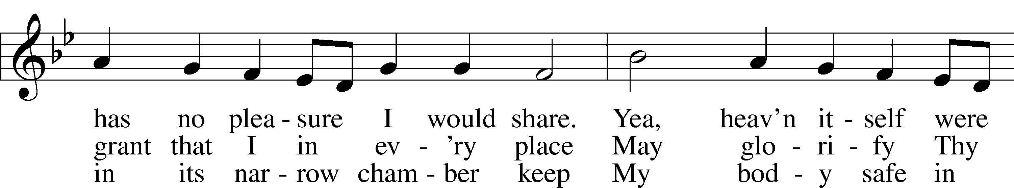

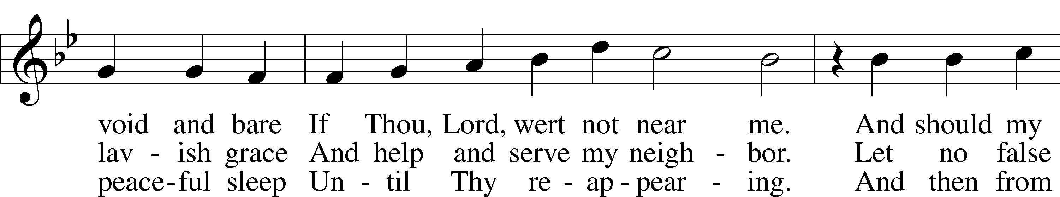

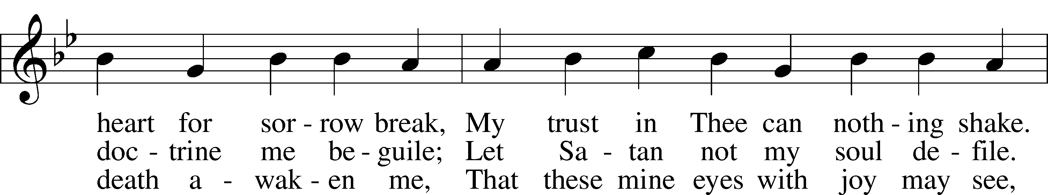

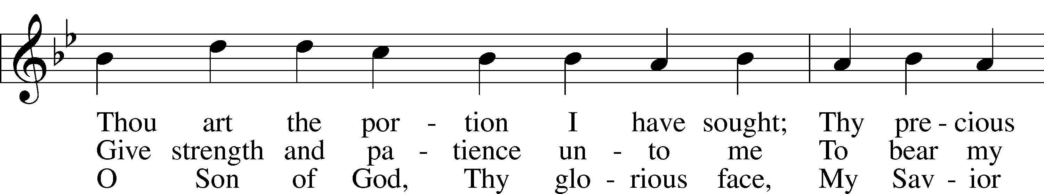

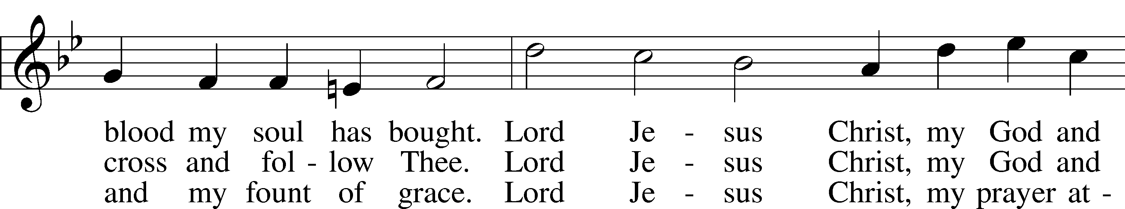

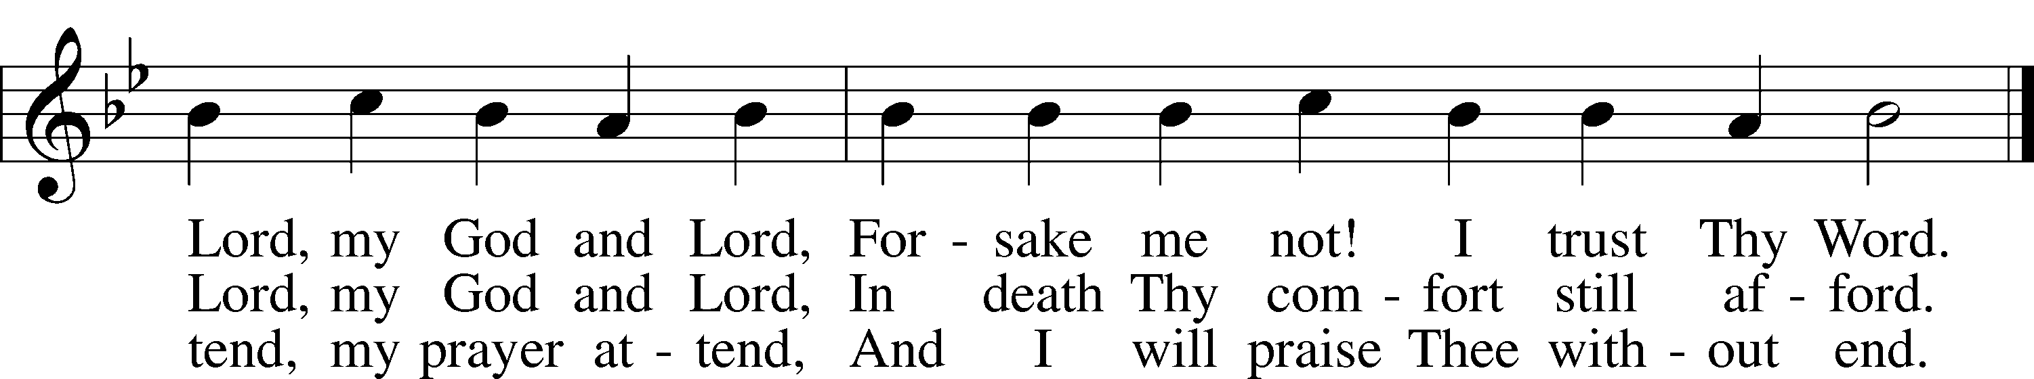

Text: Martin Schalling, 1532–1608; tr. Catherine Winkworth, 1827–78, alt.  
Tune: Zwey Bücher . . . Tabulatur, 1577, Strassburg  
Text and tune: Public domain

Sermon

Stand

Nicene Creed

C **I believe in one God,**

**the Father Almighty,**

**maker of heaven and earth**

**and of all things visible and invisible.**

**And in one Lord Jesus Christ,**

**the only-begotten Son of God,**

**begotten of His Father before all worlds,**

**God of God, Light of Light,**

**very God of very God,**

**begotten, not made,**

**being of one substance with the Father,**

**by whom all things were made;**

**who for us men and for our salvation came down from heaven**

**and was incarnate by the Holy Spirit of the virgin Mary**

**and was made man;**

**and was crucified also for us under Pontius Pilate.**

**He suffered and was buried.**

**And the third day He rose again according to the Scriptures**

**and ascended into heaven**

**and sits at the right hand of the Father.**

**And He will come again with glory to judge both the living and the dead,**

**whose kingdom will have no end.**

**And I believe in the Holy Spirit,**

**the Lord and giver of life,**

**who proceeds from the Father and the Son,**

**who with the Father and the Son together is worshiped and glorified,**

**who spoke by the prophets.**

**And I believe in one holy Christian and apostolic Church,**

**I acknowledge one Baptism for the remission of sins,**

**and I look for the resurrection of the dead**

**and the life** T **of the world to come. Amen.**

Prayer of the Church

Following the prayers, the people may greet one another in the name of the Lord, saying, “Peace be with you,” as a sign of reconciliation and of the unity of the Spirit in the bond of peace (Matt. 5:22–24; Eph. 4:1–3).

Sit

Offering

Stand

Offertory LSB 159

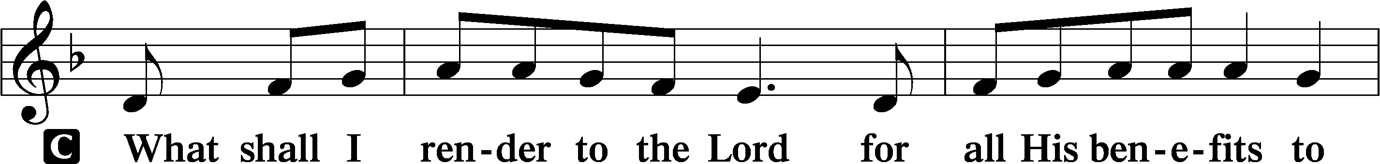

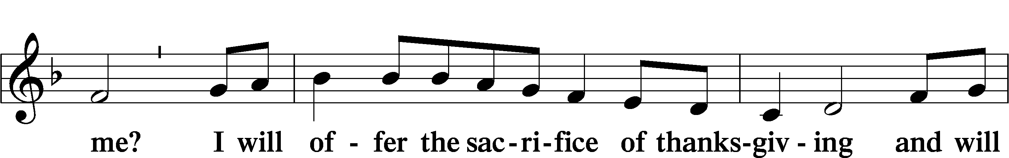

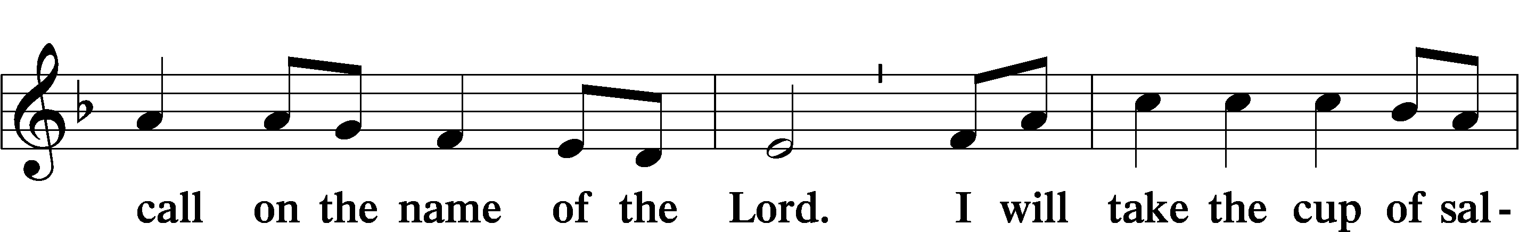

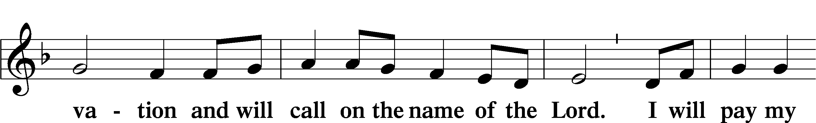

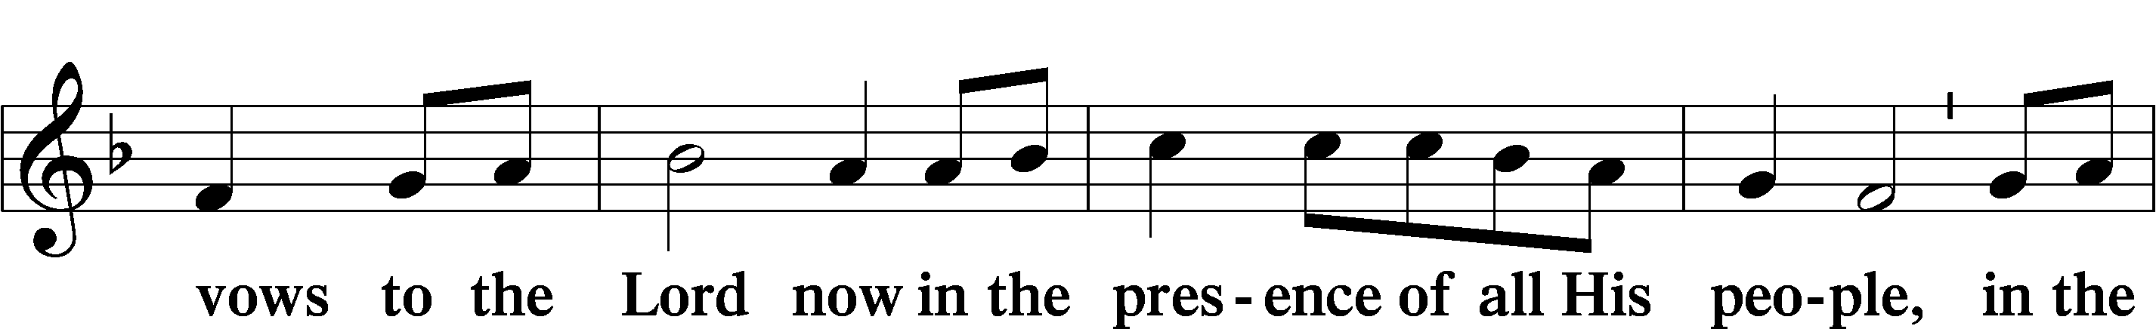

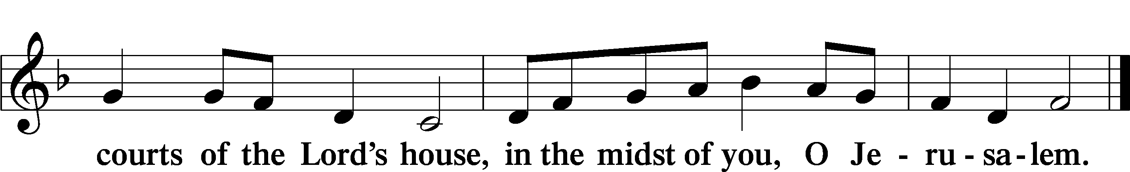

# Service of the Sacrament

Preface LSB 160

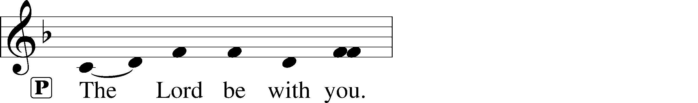

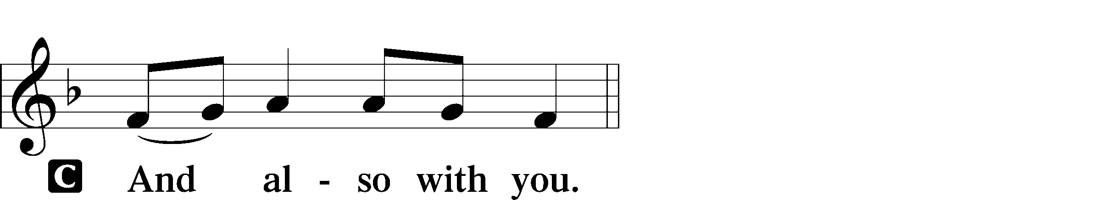

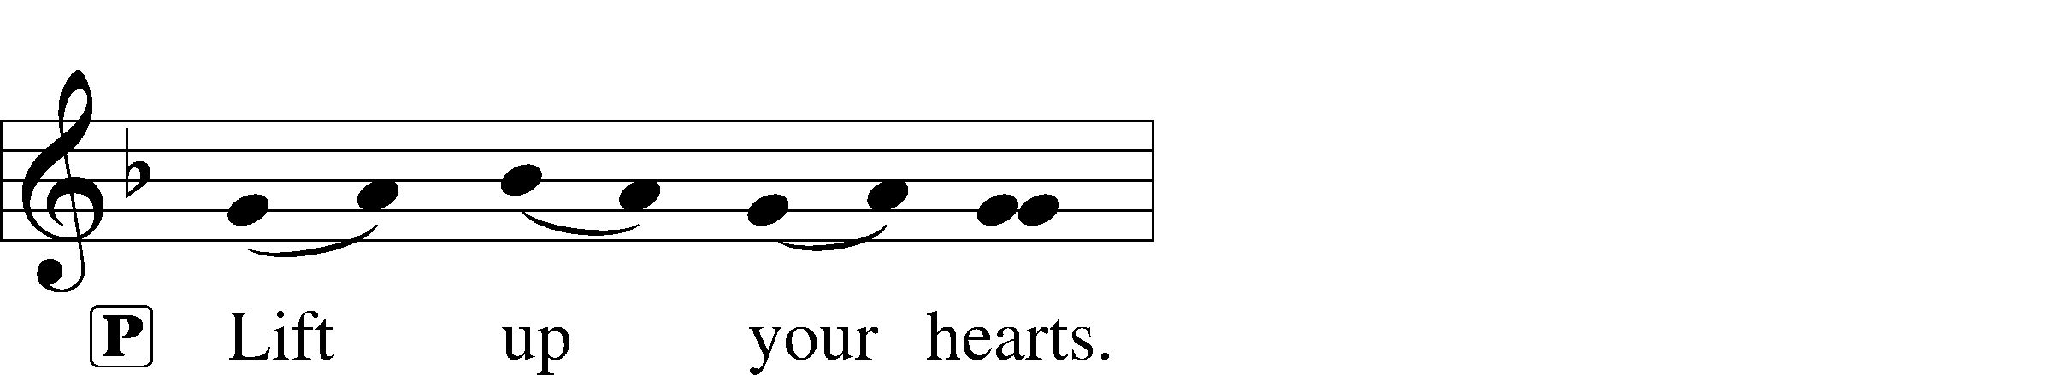



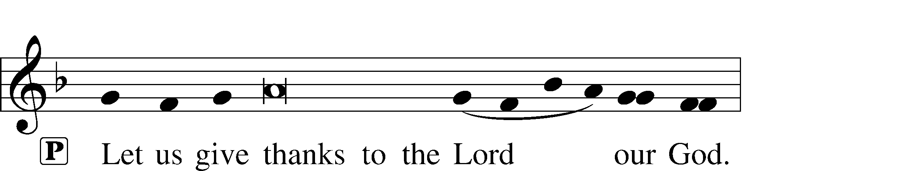

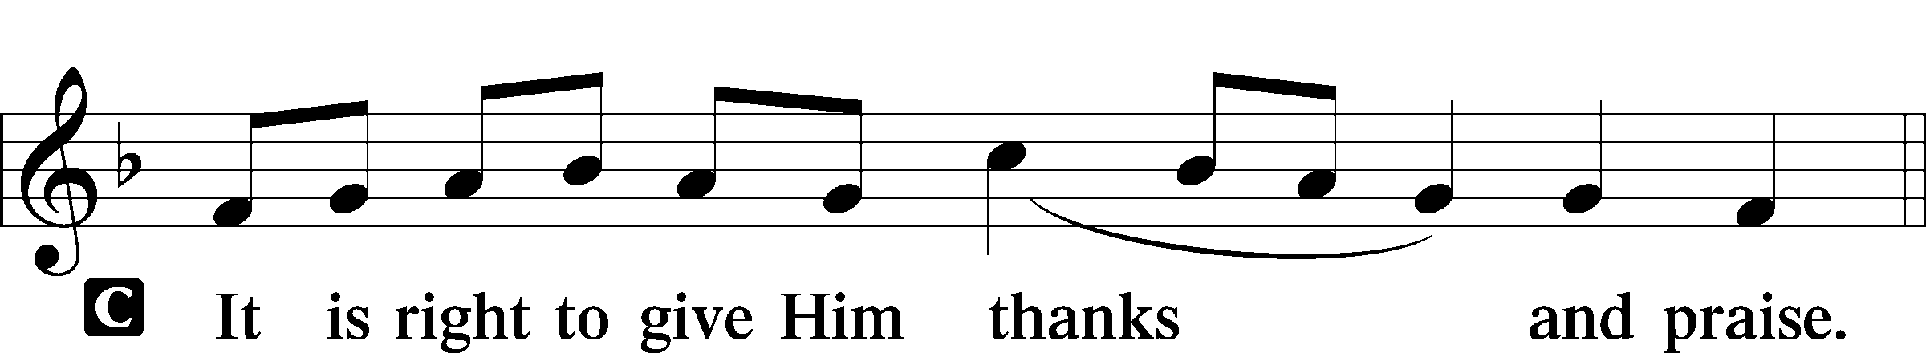

P It is truly good, right, and salutary that we should at all times and in all places give thanks to You, holy Lord, almighty Father, everlasting God, through Jesus Christ, our Lord, who overcame the assaults of the devil and gave His life as a ransom for many that with cleansed hearts we might be prepared joyfully to celebrate the paschal feast in sincerity and truth. Therefore with angels and archangels and with all the company of heaven we laud and magnify Your glorious name, evermore praising You and saying:

Sanctus LSB 161

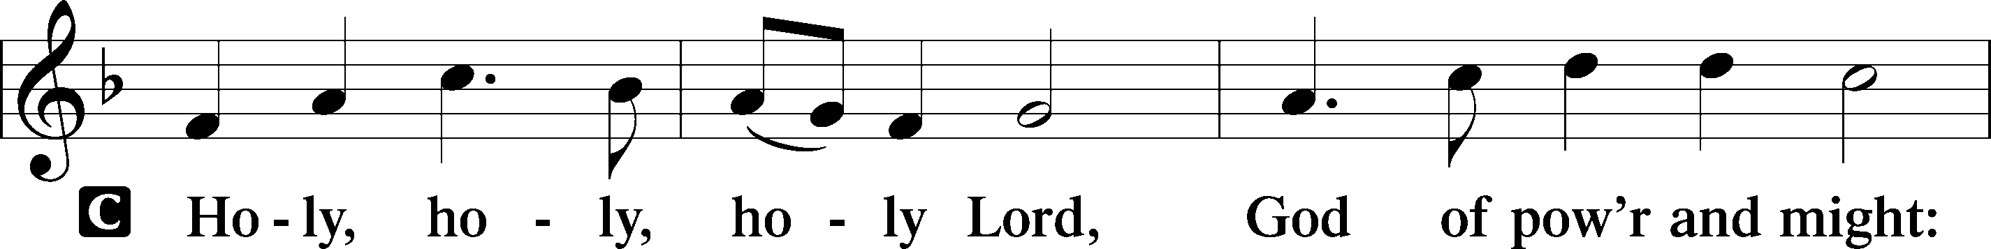

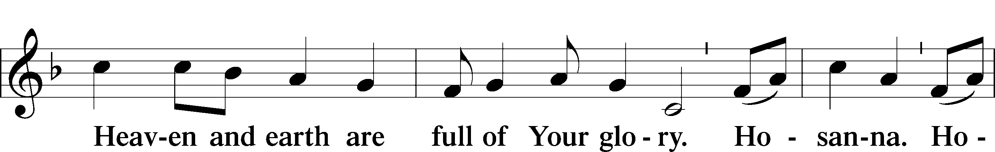

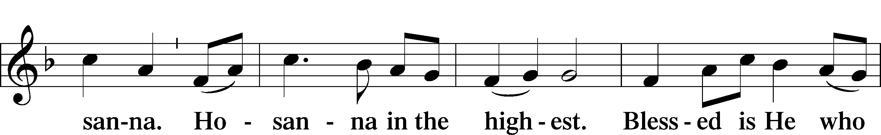

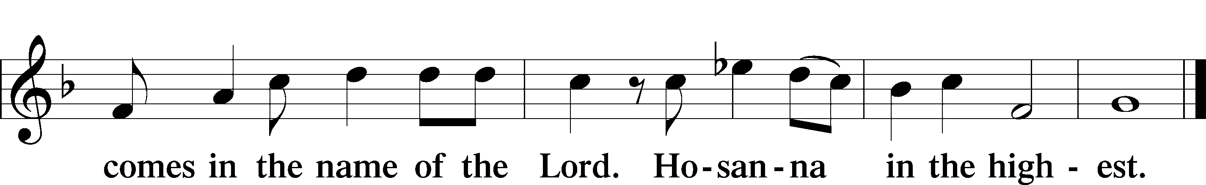

Prayer of Thanksgiving LSB 161

P Blessed are You, Lord of heaven and earth, for You have had mercy on those whom You created and sent Your only-begotten Son into our flesh to bear our sin and be our Savior. With repentant joy we receive the salvation accomplished for us by the all-availing sacrifice of His body and His blood on the cross.

Gathered in the name and the remembrance of Jesus, we beg You, O Lord, to forgive, renew, and strengthen us with Your Word and Spirit. Grant us faithfully to eat His body and drink His blood as He bids us do in His own testament. Gather us together, we pray, from the ends of the earth to celebrate with all the faithful the marriage feast of the Lamb in His kingdom, which has no end. Graciously receive our prayers; deliver and preserve us. To You alone, O Father, be all glory, honor, and worship, with the Son and the Holy Spirit, one God, now and forever.

C **Amen.**

The Words of Our Lord

P Our Lord Jesus Christ, on the night when He was betrayed, took bread, and when He had given thanks, He broke it and gave it to the disciples and said: “Take, eat; this is My T body, which is given for you. This do in remembrance of Me.”

In the same way also He took the cup after supper, and when He had given thanks, He gave it to them, saying: “Drink of it, all of you; this cup is the new testament in My T blood, which is shed for you for the forgiveness of sins. This do, as often as you drink it, in remembrance of Me.”

P As often as we eat this bread and drink this cup, we proclaim the Lord’s death until He comes.

C **Amen. Come, Lord Jesus.**

P O Lord Jesus Christ, only Son of the Father, in giving us Your body and blood to eat and to drink, You lead us to remember and confess Your holy cross and passion, Your blessed death, Your rest in the tomb, Your resurrection from the dead, Your ascension into heaven, and Your coming for the final judgment. So remember us in Your kingdom and teach us to pray:

Lord’s Prayer

C **Our Father who art in heaven,**

**hallowed be Thy name,**

**Thy kingdom come,**

**Thy will be done on earth**

**as it is in heaven;**

**give us this day our daily bread;**

**and forgive us our trespasses**

**as we forgive those**

**who trespass against us;**

**and lead us not into temptation,**

**but deliver us from evil.**

**For Thine is the kingdom**

**and the power and the glory**

**forever and ever. Amen.**

Pax Domini LSB 163

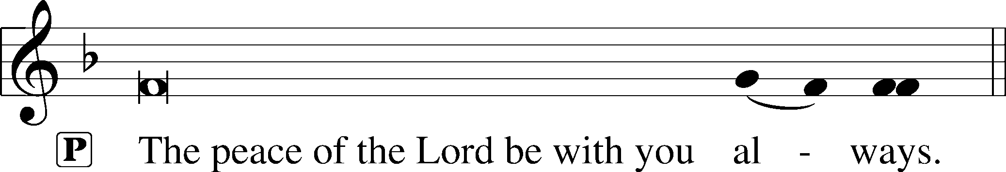



Agnus Dei LSB 163

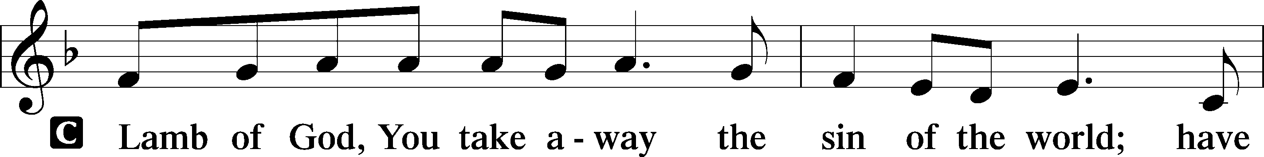

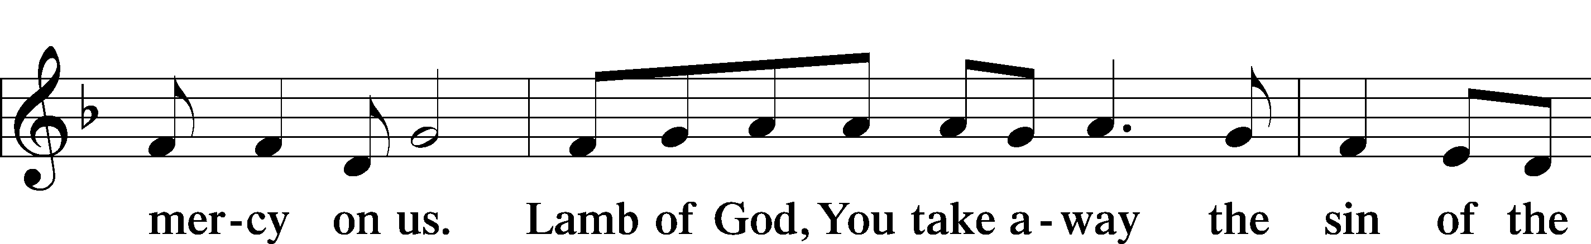

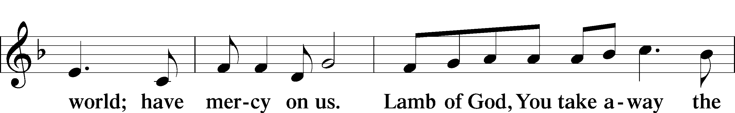

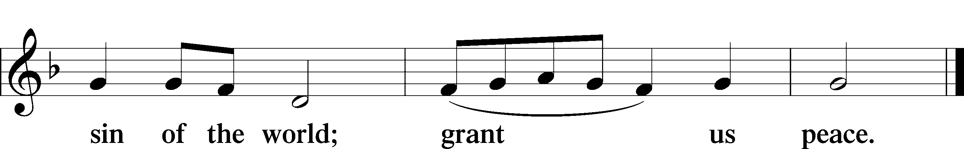

Sit

Distribution

The pastor and those who assist him receive the body and blood of Christ first and then distribute them to those who come to receive, saying:

Take, eat; this is the true body of our Lord and Savior Jesus Christ, given into death for your sins.

**Amen.**

Take, drink; this is the true blood of our Lord and Savior Jesus Christ, shed for the forgiveness of your sins.

**Amen.**

In dismissing the communicants, the following is said:

P The body and blood of our Lord Jesus Christ strengthen and preserve you in body and soul to life everlasting. Depart T in peace.

C **Amen.**

Distribution Hymn: 635 O Gracious Lord, I Firmly Am Believing sts. 1–5

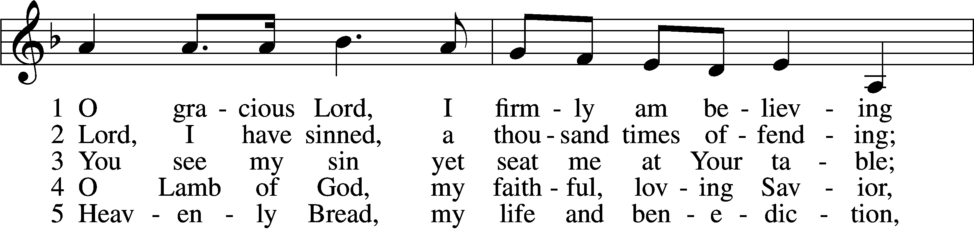

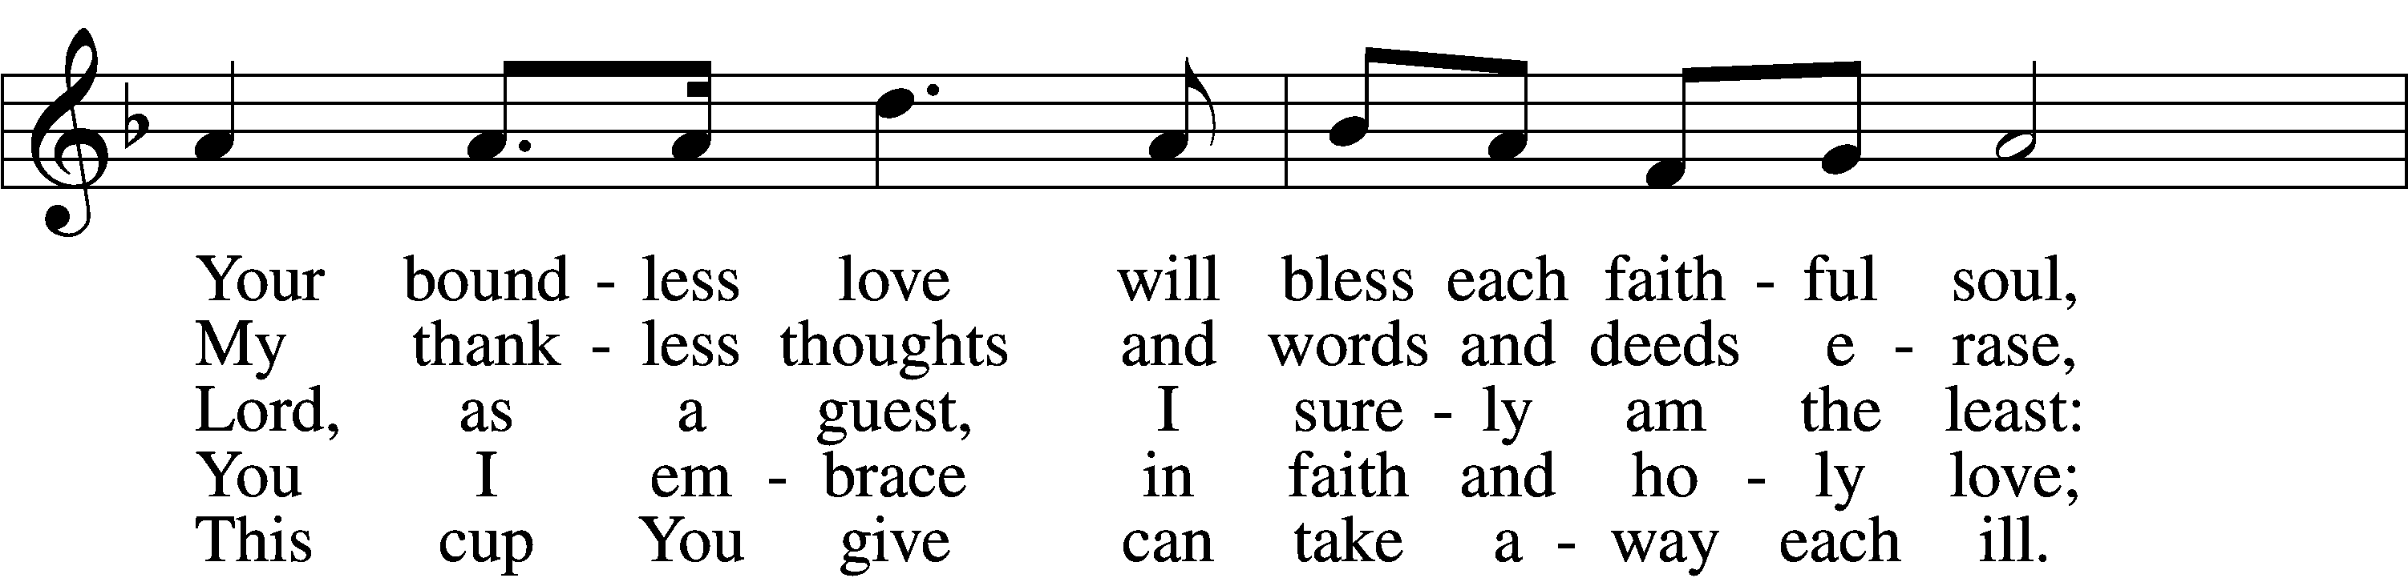

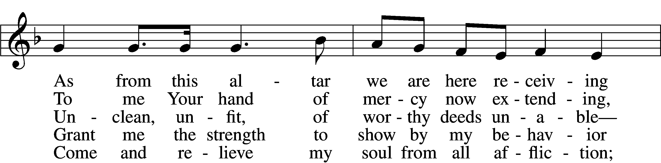

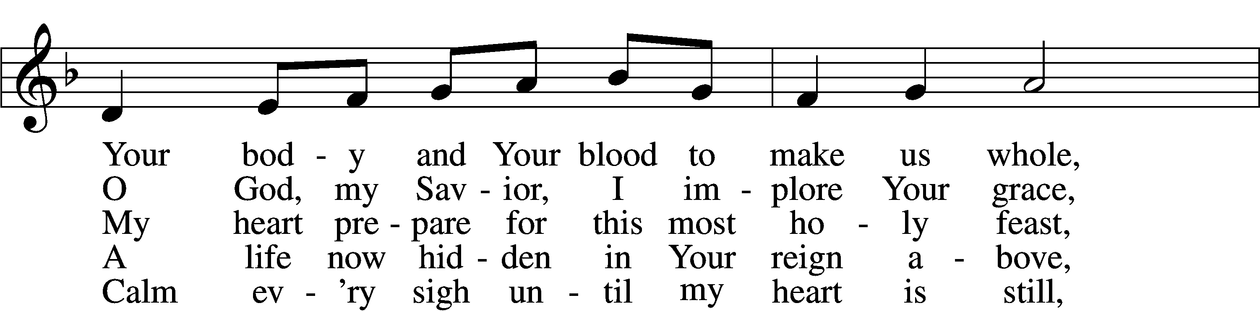

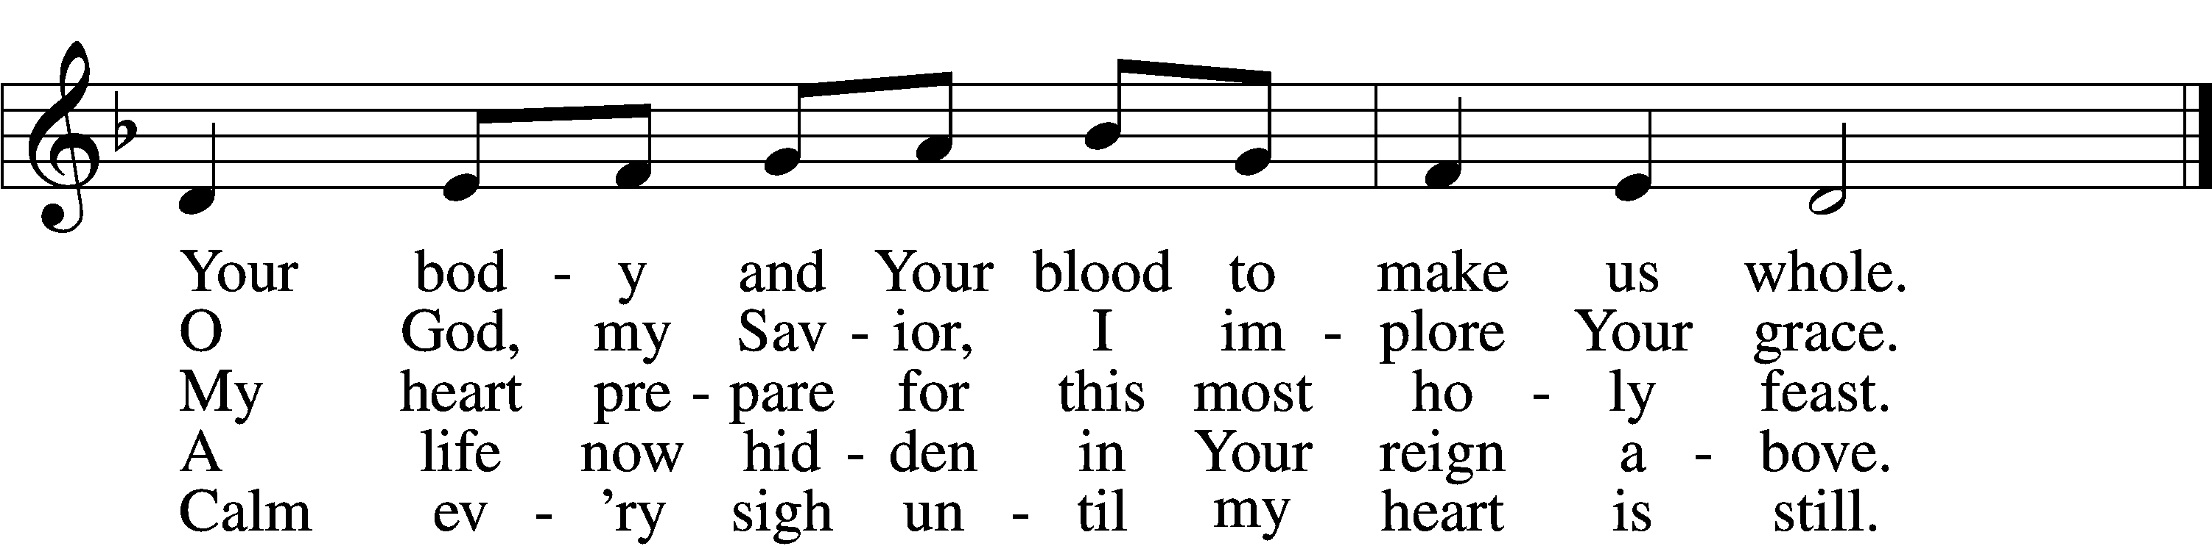

Text: Spanish or Latin American, 20th cent.; tr. Stephen P. Starke, 1955  
Tune: H. León  
Text: © 2004 Stephen P. Starke, admin. Concordia Publishing House. Used by permission: LSB Hymn License no. 110005504  
Tune: Public domain

Distribution Hymn: 725 Children of the Heavenly Father

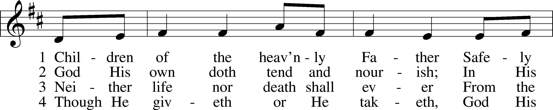

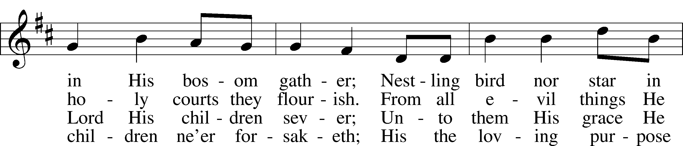

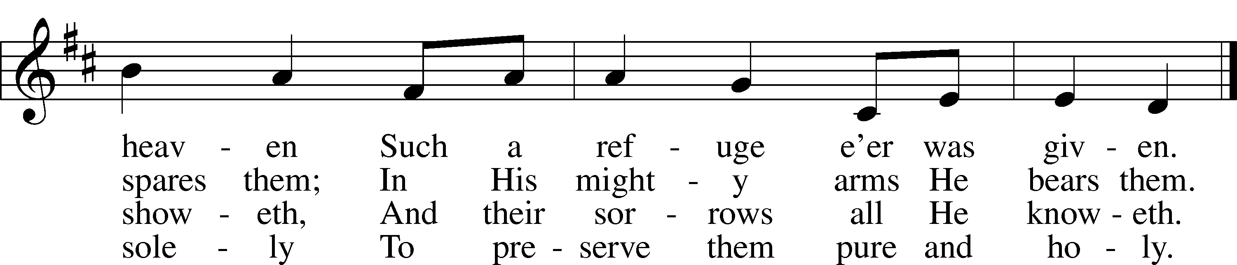

Text: Carolina Sandell Berg, 1832–1903; tr. Ernst W. Olson, 1870–1958  
Tune: Lofsånger och andeliga wisor, 1873, Sweden  
Text: Public domain  
Tune: Public domain

Stand

Nunc Dimittis LSB 165

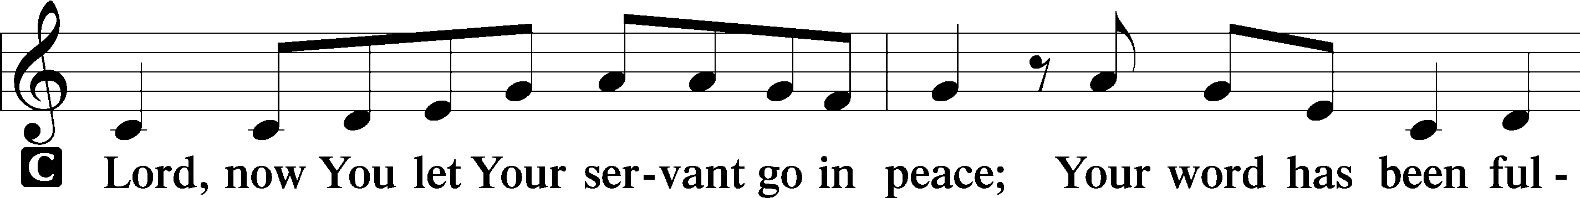

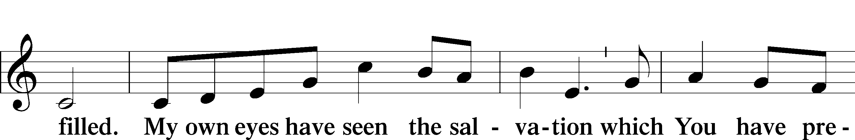

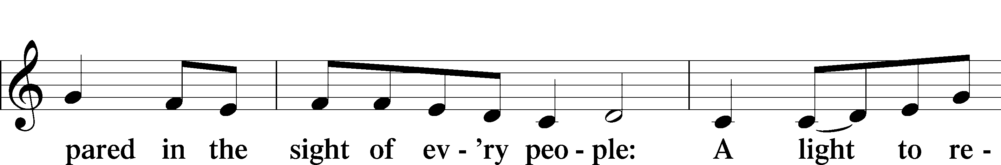

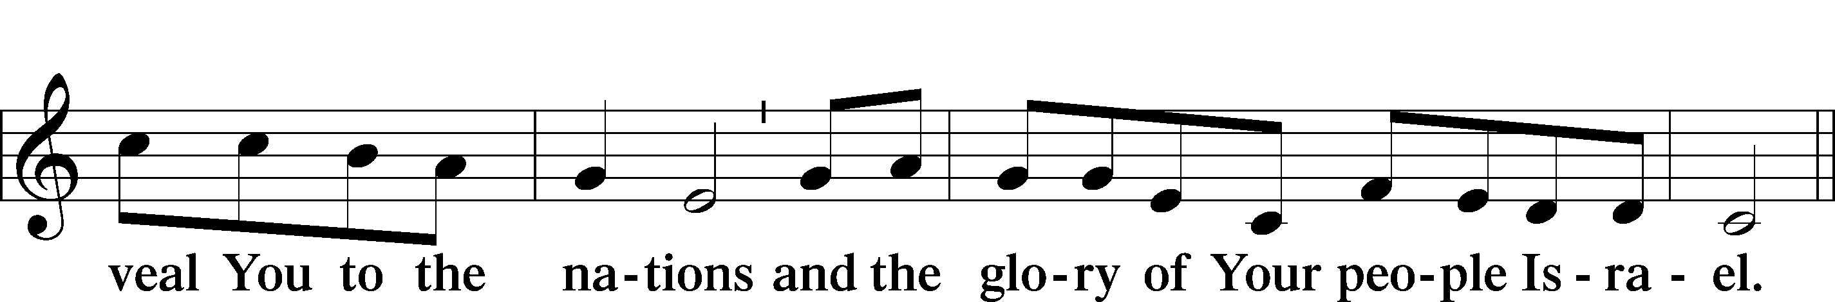

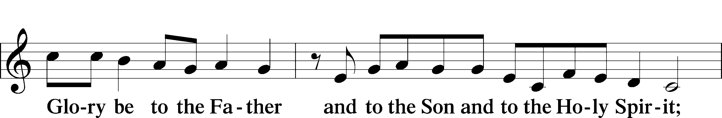

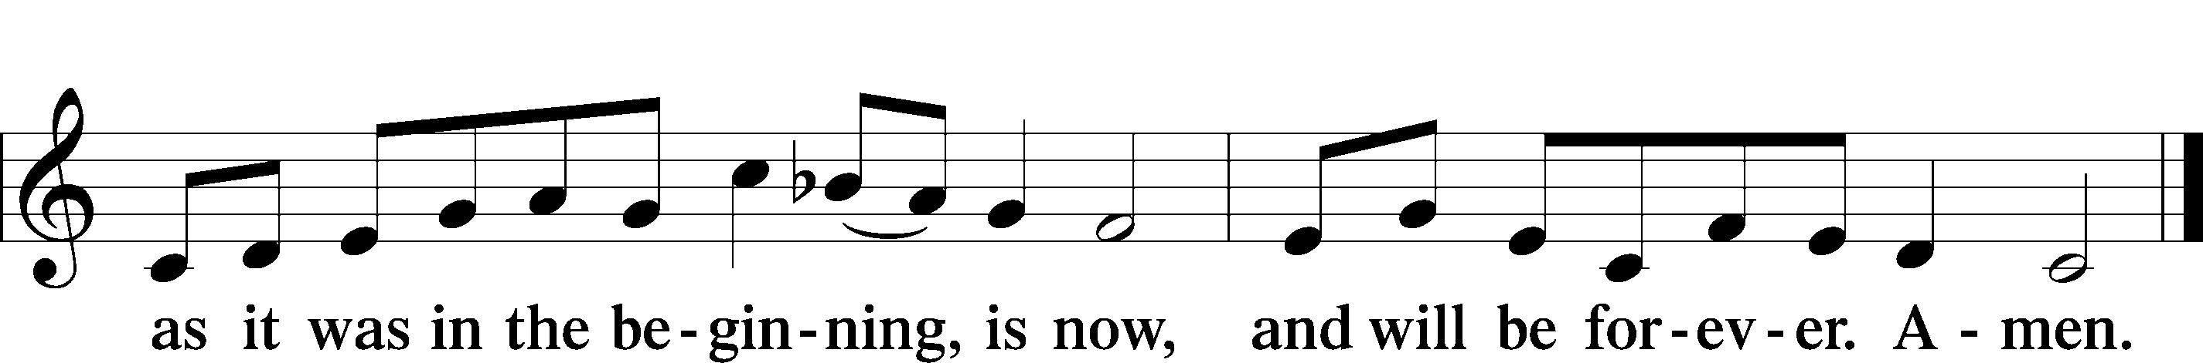

Post-Communion Collect

A Let us pray.

We give thanks to You, almighty God, that You have refreshed us through this salutary gift, and we implore You that of Your mercy You would strengthen us through the same in faith toward You and in fervent love toward one another; through Jesus Christ, Your Son, our Lord, who lives and reigns with You and the Holy Spirit, one God, now and forever.

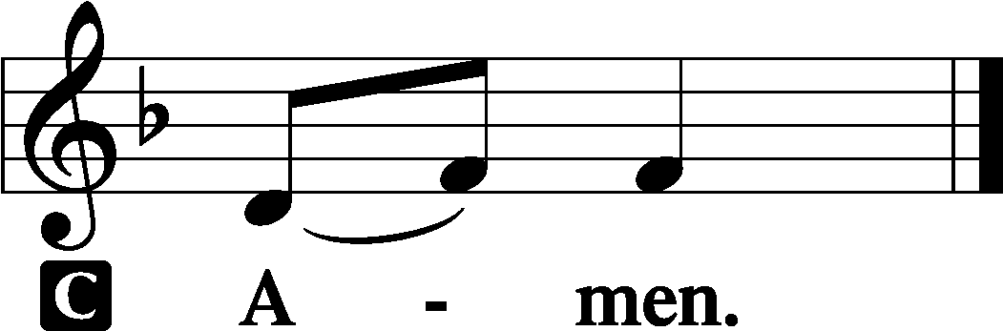

Benediction LSB 166

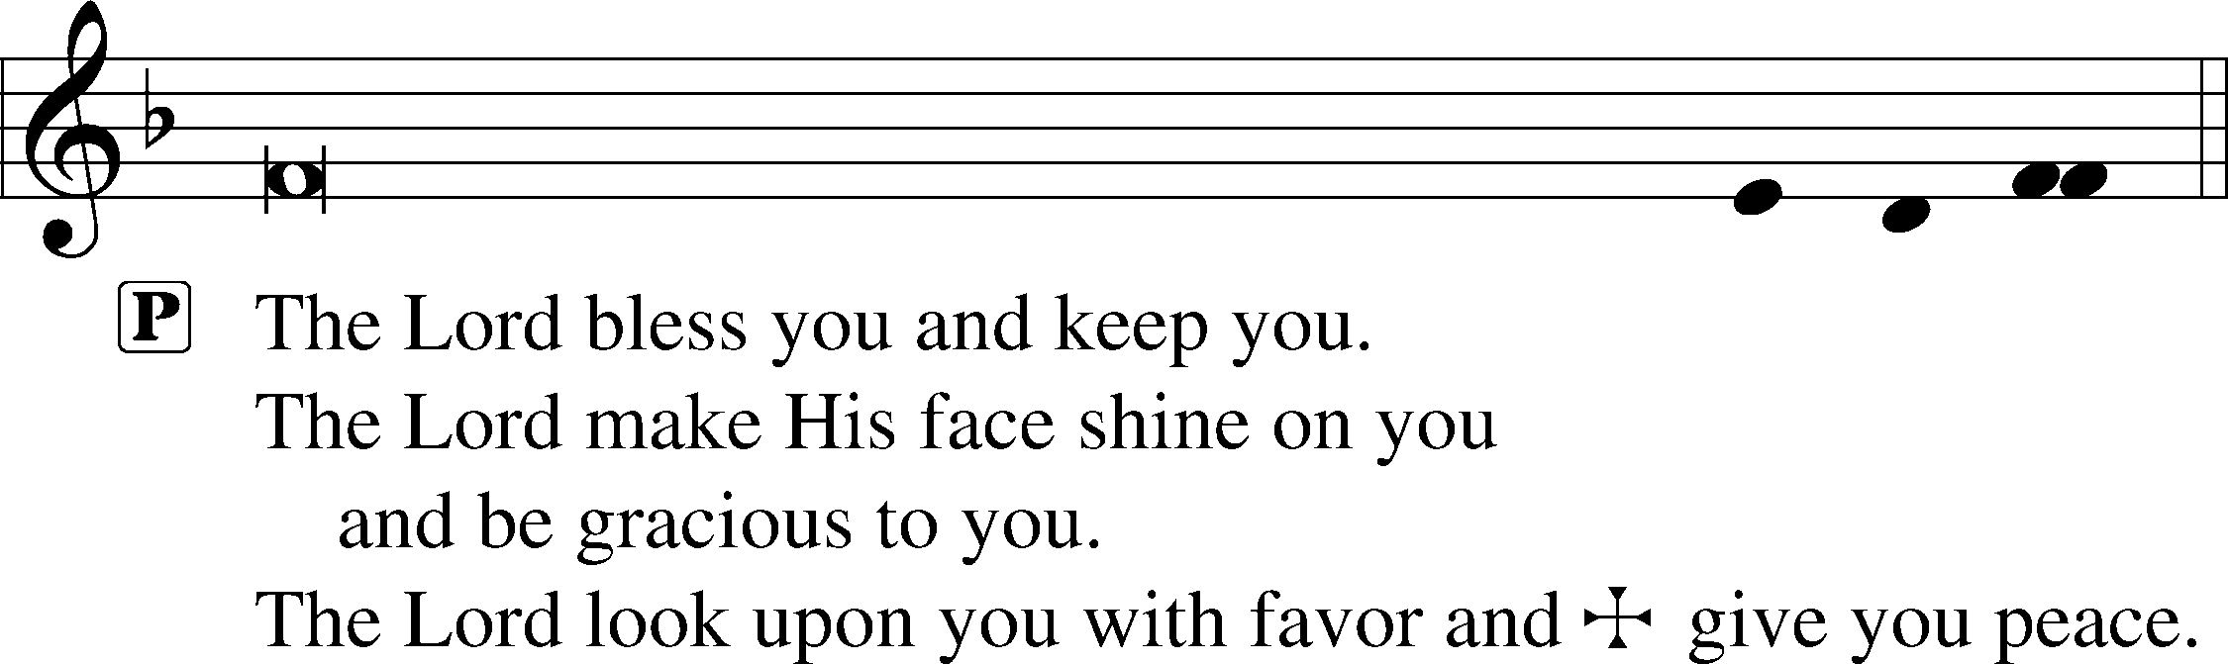



Hymn to Depart: 728 How Firm a Foundation vs.1

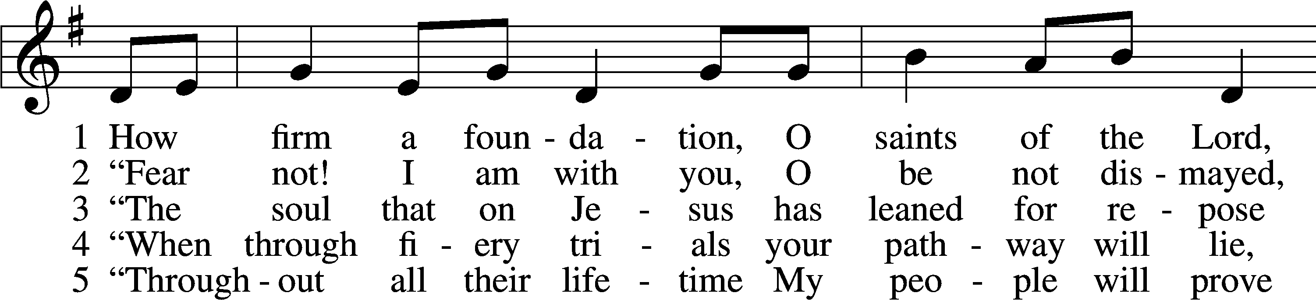

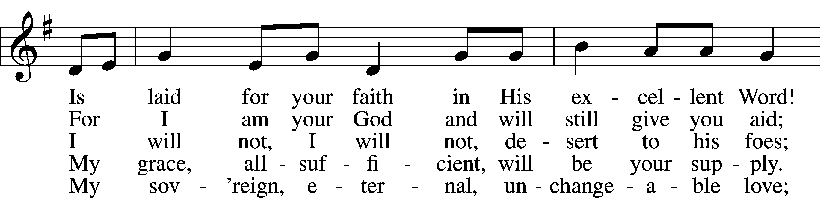

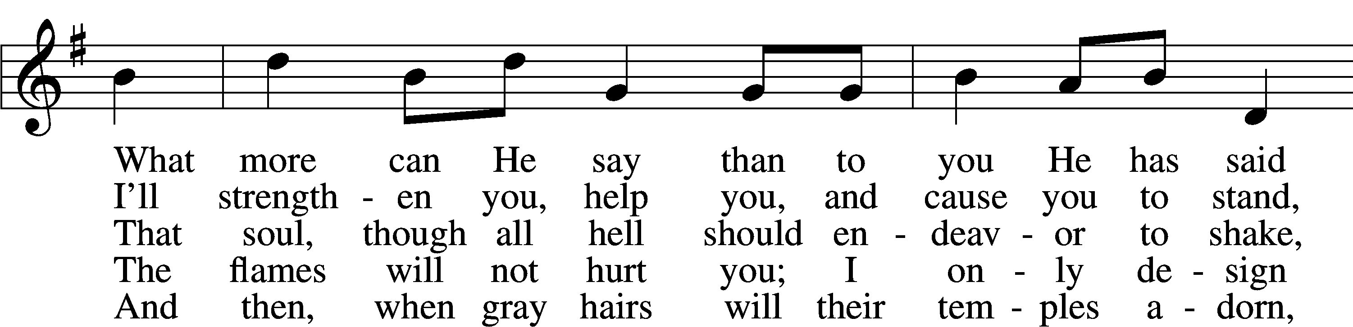

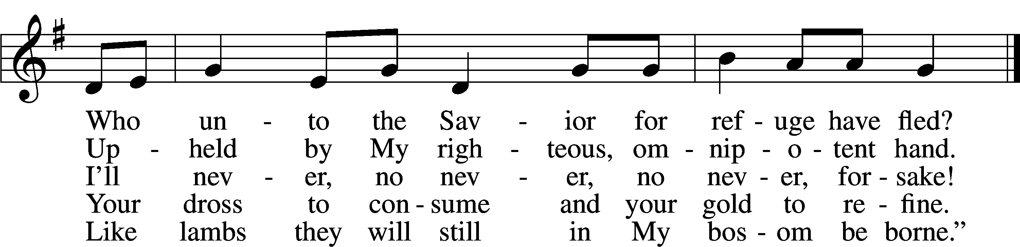

Text: A Selection of Hymns, 1787, London, alt.  
Tune: Genuine Church Music, 1832, Winchester  
Text and tune: Public domain

Acknowledgments

Divine Service, Setting One from Lutheran Service Book

Unless otherwise indicated, Scripture quotations are from the ESV® Bible (The Holy Bible, English Standard Version®), copyright © 2001 by Crossway, a publishing ministry of Good News Publishers. Used by permission. All rights reserved.

Created by Lutheran Service Builder © 2025 Concordia Publishing House.

**Prayers Request:** **Those in the nursing home:** Joann Jaeger, Joan Church **Those Shut-in at home:** Char Herman, Joyce Myers **Those with ongoing health issues:** Owen Metz, Daria (Cindy Wright’s friend), Butch L. (Cindy Wright’s Brother-in-law), Melissa Miller. Brenda Sellent (Denise Stabenow’s sister), Sandy Hahn (Cindy Wright’s cousin’s wife) **,** Brenda Gustum (Missy Wiese’s mom), Lexi Anderson, Marlene Snyder, Shirley Hehl, Ben Cole and his family **Recovering from surgery:** Tim Dennis **Those who lead our nation:** Donald Trump, JD Vance, Tony Evers,Rod Nordby  **Those who serve in our military and law enforcement:** Ryan Graf, Chaplain Pon Chanthaphon (Our Adopt-a-Chaplain), Rusty Weise **Our Childcare Staff:** Melissa Frieburg, Denise Stabenow, Holly Wilhelmi, Janica Skjerly, Jacie Amundson, Cathy Anderson, Alora Provencial, Kailyn Duncan, Micahlee Skjerly, Jessica Bisonette

**Announcements:**

**Church Service Phone: 715-438-4200(Chippewa Falls)**

**715-537-4240(local)**

**(Stay on the line for recorded service to start)**

**Live Stream audio services:** [**http://salem.listentochurch.com**](http://salem.listentochurch.com)

**Salem’s Web Page:** <https://www.salembarron.com/>

**Pastor Fred Buth: Cell phone:715-642-3050 (H)715-353-2540**

**Email: salembarronpastor@gmail.com**

**Office Hours: Monday-Wednesday 9-12**

**Attendance:** 3/9-75

**Coffee and Snacks:** Dwayne & Denise Stabenow

**Elder Today:** Stan Koenig

**Altar Guild:** Mary Ann & Kari

**Today: Voter’s meeting, Chili/Cookie Contest**

**Save the Date:**

**March 30th:** Youth Group 6th-12th St. Paul Cumberland, 4-6pm

**April 12th:** Easter Egg Hunt

Thank you for your prayers, my brother Art has had cancer free scans! Praise the Lord, Sue

**Week 2 in Lent** All four gospels record the event in Gethsemane when the high priest’s servant’s ear is cut off. Only John gives us names—Peter and Malchus. Our attention now is drawn to Gethsemane that night Judas betrays Jesus as Peter cuts off the ear of Malchus. The chief priests, scribes, Judas, and Peter all seek power and control of the situation. Jesus—the only one with true power and authority—lays it down, as He also does with His life itself. In His resurrection, Jesus will take up His life again, reclaiming His power, control, and authority that extends throughout the earth and heavens.