Confession and Absolution

Hymn of Invocation: 655 Lord, Keep Us Steadfast in Your Word
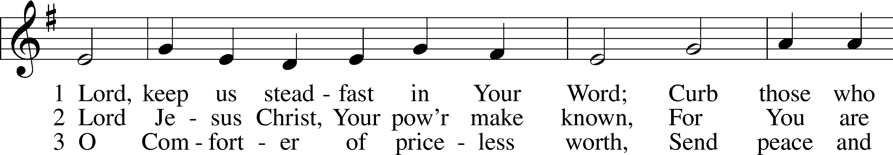
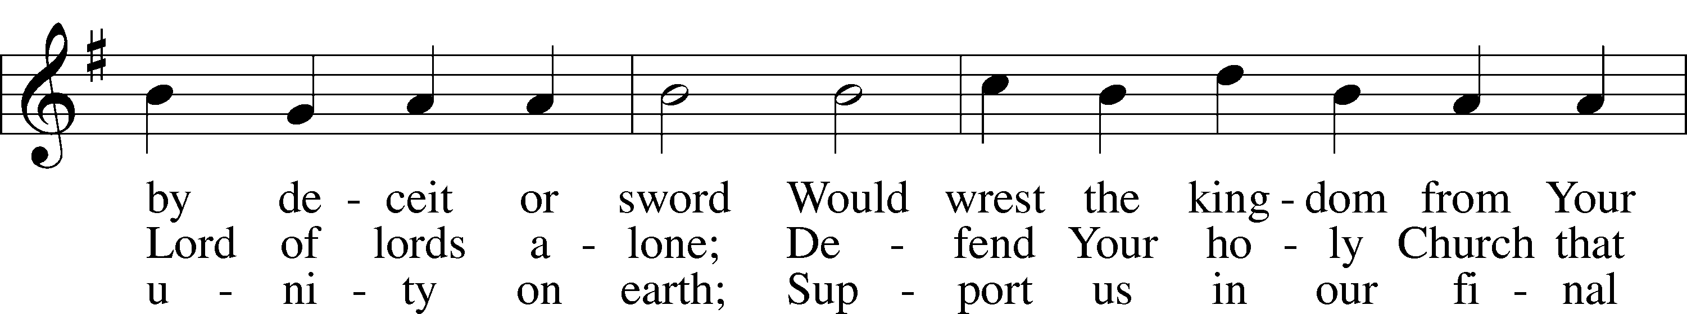
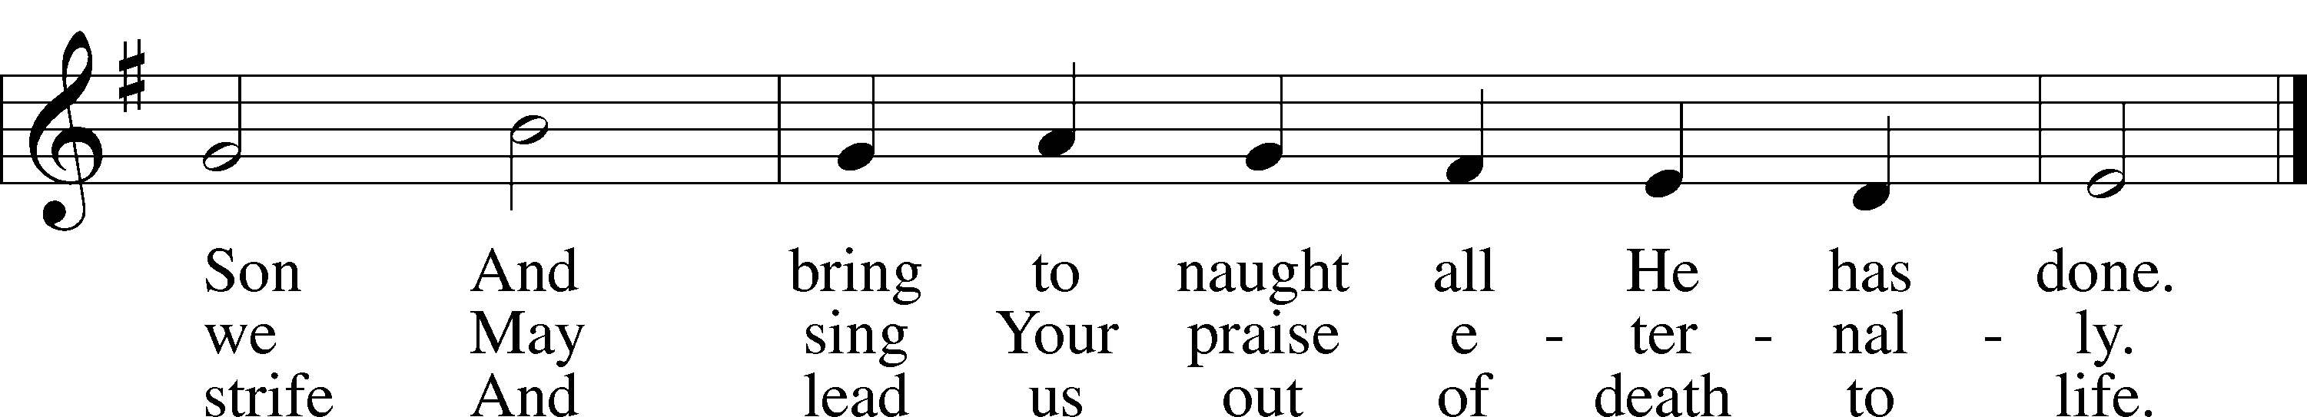
Text: Martin Luther, 1483–1546; tr. Catherine Winkworth, 1827–78, alt.
Tune: Geistliche Lieder auffs new gebessert, 1543, Wittenberg, ed. Joseph Klug
Text and tune: Public domain

Stand

The sign of the cross may be made by all in remembrance of their Baptism.

P In the name of the Father and of the T Son and of the Holy Spirit.
C Amen.

P Our help is in the name of the Lord,
C who made heaven and earth.

P If You, O Lord, kept a record of sins, O Lord, who could stand?
C But with You there is forgiveness; therefore You are feared.

P Since we are gathered to hear God’s Word, call upon Him in prayer and praise, and receive the body and blood of our Lord Jesus Christ in the fellowship of this altar, let us first consider our unworthiness and confess before God and one another that we have sinned in thought, word, and deed, and that we cannot free ourselves from our sinful condition. Together as His people let us take refuge in the infinite mercy of God, our heavenly Father, seeking His grace for the sake of Christ, and saying: God, be merciful to me, a sinner.

Kneel/Stand

C Almighty God, have mercy upon us, forgive us our sins, and lead us to everlasting life. Amen.

P Almighty God in His mercy has given His Son to die for you and for His sake forgives you all your sins. As a called and ordained servant of Christ, and by His authority, I therefore forgive you all your sins in the name of the Father and of the T Son and of the Holy Spirit.
C Amen.

Stand

Service of the Word

Introit Psalm 66:1–2, 8–9, 20; antiphon: v. 16
Come and hear, all you who fear God,
and I will tell what he has done for my soul.
Shout for joy to God, all the earth;
sing the glory of his name; give to him glorious praise!
Bless our God, O peoples;
let the sound of his praise be heard,
who has kept our soul among the living
and has not let our feet slip.
Blessèd be God,
because he has not rejected my prayer or removed his steadfast love from me!
Glory be to the Father and to the Son
and to the Holy Spirit;
as it was in the beginning,
is now, and will be forever. Amen.
Come and hear, all you who fear God,
and I will tell what he has done for my soul.

Kyrie LSB 204
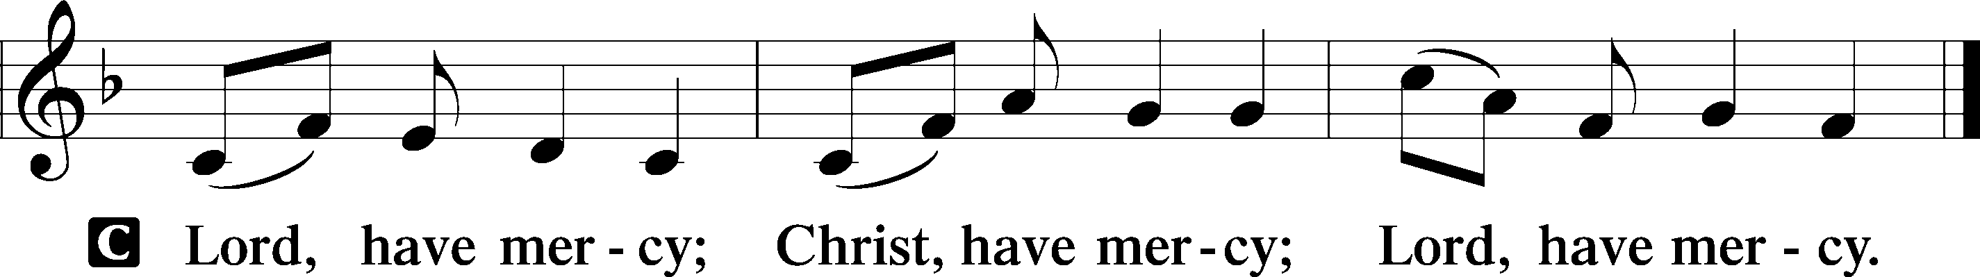

Gloria in Excelsis LSB 204
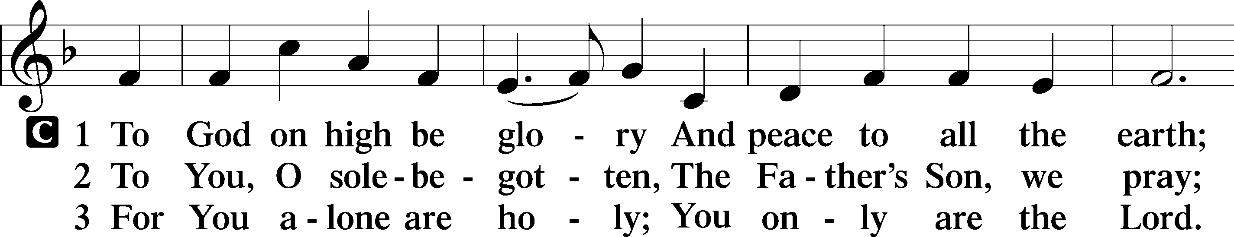
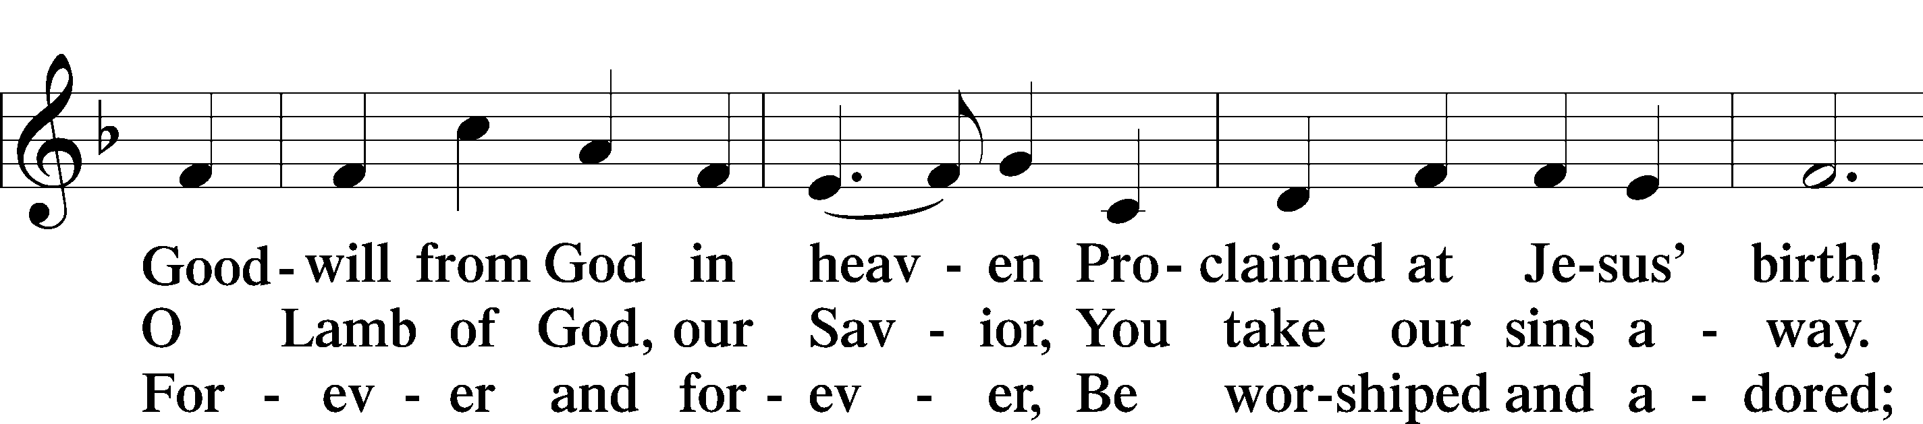
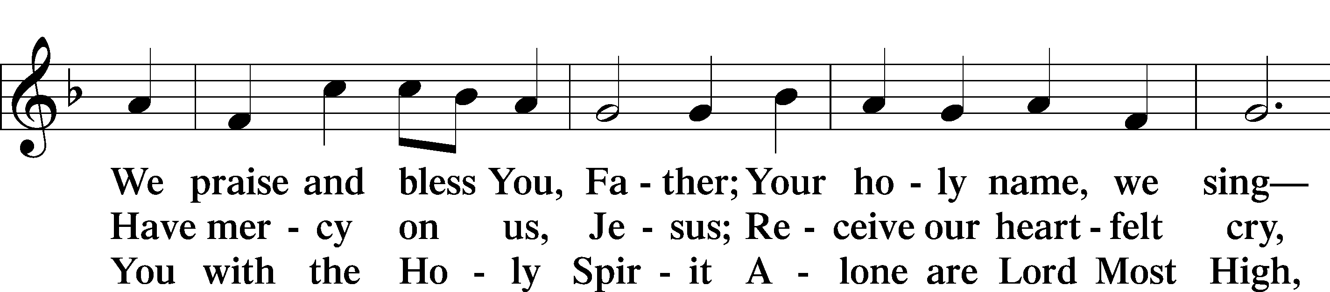
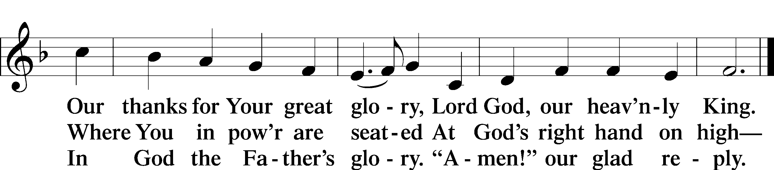
Text: Stephen P. Starke

Salutation and Collect of the Day
P The Lord be with you.
C And also with you.

P Let us pray.
O God, the giver of all that is good, by Your holy inspiration grant that we may think those things that are right and by Your merciful guiding accomplish them; through Jesus Christ, Your Son, our Lord, who lives and reigns with You and the Holy Spirit, one God, now and forever.

C Amen.

Sit

First Reading Acts 10:34–48
Gentiles Hear the Good News
³⁴Peter opened his mouth and said: “Truly I understand that God shows no partiality, ³⁵but in every nation anyone who fears him and does what is right is acceptable to him. ³⁶As for the word that he sent to Israel, preaching good news of peace through Jesus Christ (he is Lord of all), ³⁷you yourselves know what happened throughout all Judea, beginning from Galilee after the baptism that John proclaimed: ³⁸how God anointed Jesus of Nazareth with the Holy Spirit and with power. He went about doing good and healing all who were oppressed by the devil, for God was with him. ³⁹And we are witnesses of all that he did both in the country of the Jews and in Jerusalem. They put him to death by hanging him on a tree, ⁴⁰but God raised him on the third day and made him to appear, ⁴¹not to all the people but to us who had been chosen by God as witnesses, who ate and drank with him after he rose from the dead. ⁴²And he commanded us to preach to the people and to testify that he is the one appointed by God to be judge of the living and the dead. ⁴³To him all the prophets bear witness that everyone who believes in him receives forgiveness of sins through his name.”
The Holy Spirit Falls on the Gentiles
⁴⁴While Peter was still saying these things, the Holy Spirit fell on all who heard the word. ⁴⁵And the believers from among the circumcised who had come with Peter were amazed, because the gift of the Holy Spirit was poured out even on the Gentiles. ⁴⁶For they were hearing them speaking in tongues and extolling God. Then Peter declared, ⁴⁷“Can anyone withhold water for baptizing these people, who have received the Holy Spirit just as we have?” ⁴⁸And he commanded them to be baptized in the name of Jesus Christ. Then they asked him to remain for some days.

A This is the Word of the Lord.
C Thanks be to God.

Psalm Psalm 98; antiphon: v. 2
Make a Joyful Noise to the Lord
¹Oh sing to the Lord a new song,
for he has done marvelous things!
His right hand and his holy arm
have worked salvation for him.
²The Lord has made known his salvation;
he has revealed his righteousness in the sight of the nations.
³He has remembered his steadfast love and faithfulness
to the house of Israel.
All the ends of the earth have seen
the salvation of our God.
⁴Make a joyful noise to the Lord, all the earth;
break forth into joyous song and sing praises!
⁵Sing praises to the Lord with the lyre,
with the lyre and the sound of melody!
⁶With trumpets and the sound of the horn
make a joyful noise before the King, the Lord!
⁷Let the sea roar, and all that fills it;
the world and those who dwell in it!
⁸Let the rivers clap their hands;
let the hills sing for joy together
⁹before the Lord, for he comes
to judge the earth.
He will judge the world with righteousness,
and the peoples with equity.

Epistle 1 John 5:1–8
Overcoming the World
¹Everyone who believes that Jesus is the Christ has been born of God, and everyone who loves the Father loves whoever has been born of him. ²By this we know that we love the children of God, when we love God and obey his commandments. ³For this is the love of God, that we keep his commandments. And his commandments are not burdensome. ⁴For everyone who has been born of God overcomes the world. And this is the victory that has overcome the world—our faith. ⁵Who is it that overcomes the world except the one who believes that Jesus is the Son of God?
Testimony Concerning the Son of God
⁶This is he who came by water and blood—Jesus Christ; not by the water only but by the water and the blood. And the Spirit is the one who testifies, because the Spirit is the truth. ⁷For there are three that testify: ⁸the Spirit and the water and the blood; and these three agree.

A This is the Word of the Lord.
C Thanks be to God.

Stand

Alleluia and Verse

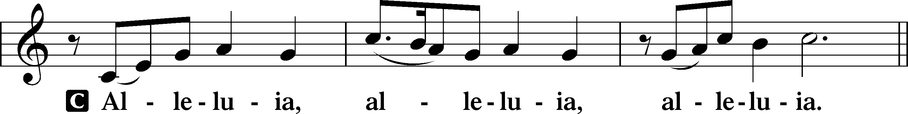

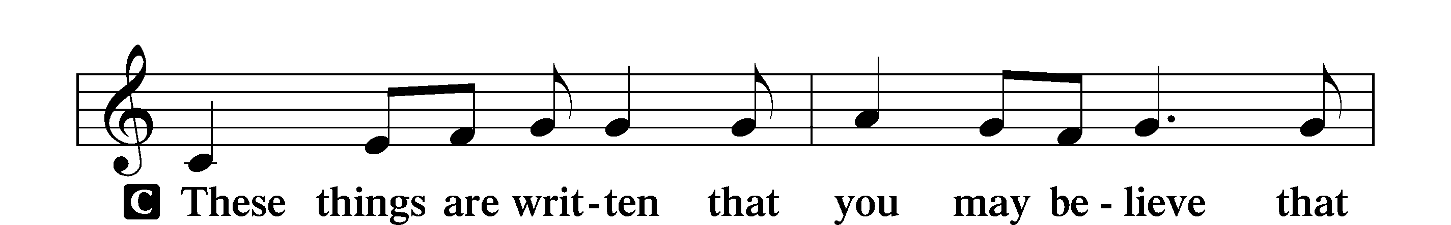
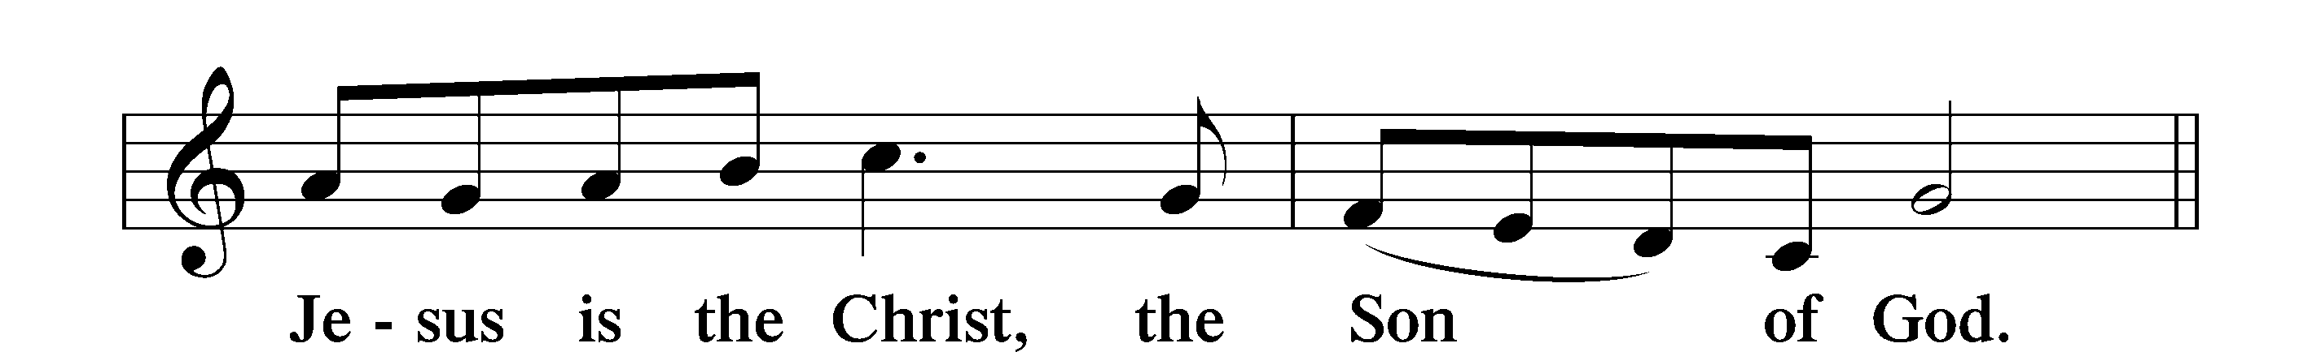

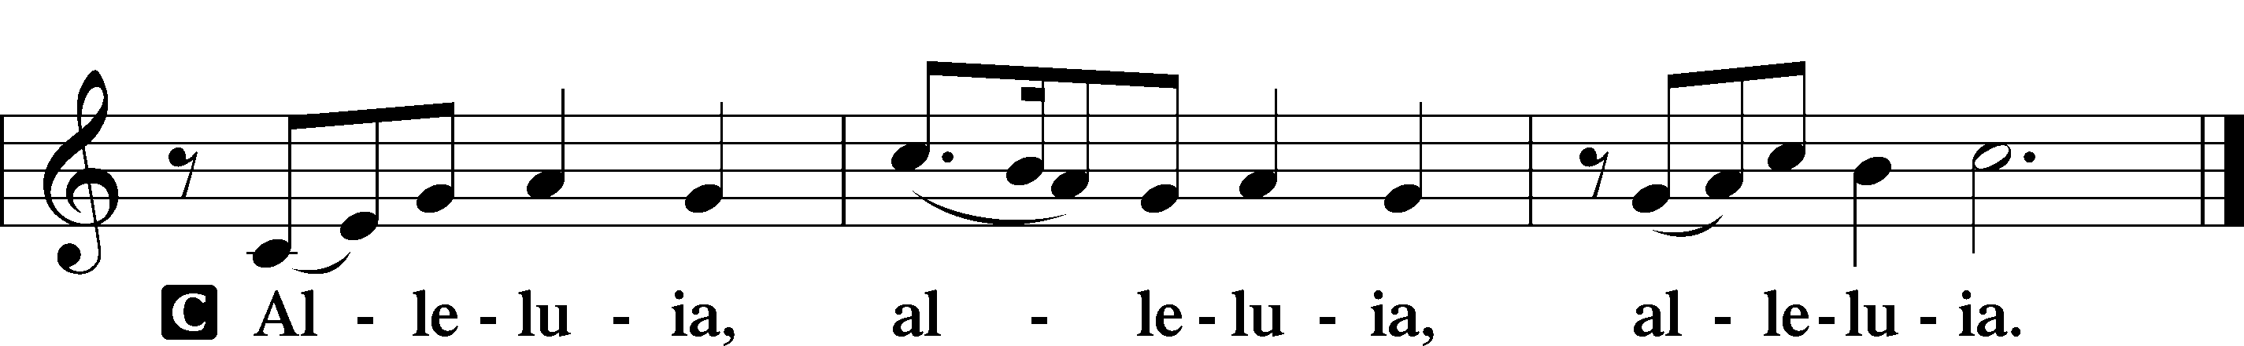

Holy Gospel John 15:9–17
P The Holy Gospel according to St. John, the fifteenth chapter.
C Glory to You, O Lord.

⁹[Jesus said:] “As the Father has loved me, so have I loved you. Abide in my love. ¹⁰If you keep my commandments, you will abide in my love, just as I have kept my Father’s commandments and abide in his love. ¹¹These things I have spoken to you, that my joy may be in you, and that your joy may be full.
¹²“This is my commandment, that you love one another as I have loved you. ¹³Greater love has no one than this, that someone lays down his life for his friends. ¹⁴You are my friends if you do what I command you. ¹⁵No longer do I call you servants, for the servant does not know what his master is doing; but I have called you friends, for all that I have heard from my Father I have made known to you. ¹⁶You did not choose me, but I chose you and appointed you that you should go and bear fruit and that your fruit should abide, so that whatever you ask the Father in my name, he may give it to you. ¹⁷These things I command you, so that you will love one another.”

P This is the Gospel of the Lord.
C Praise to You, O Christ.

Nicene Creed
C I believe in one God,
the Father Almighty,
maker of heaven and earth
and of all things visible and invisible.

And in one Lord Jesus Christ,
the only-begotten Son of God,
begotten of His Father before all worlds,
God of God, Light of Light,
very God of very God,
begotten, not made,
being of one substance with the Father,
by whom all things were made;
who for us men and for our salvation came down from heaven
and was incarnate by the Holy Spirit of the virgin Mary
and was made man;
and was crucified also for us under Pontius Pilate.
He suffered and was buried.
And the third day He rose again according to the Scriptures
and ascended into heaven
and sits at the right hand of the Father.
And He will come again with glory to judge both the living and the dead,
whose kingdom will have no end.

And I believe in the Holy Spirit,
the Lord and giver of life,
who proceeds from the Father and the Son,
who with the Father and the Son together is worshiped and glorified,
who spoke by the prophets.
And I believe in one holy Christian and apostolic Church,
I acknowledge one Baptism for the remission of sins,
and I look for the resurrection of the dead
and the life T of the world to come. Amen.

Sit

Hymn of the Day: 700 Love Divine, All Loves Excelling
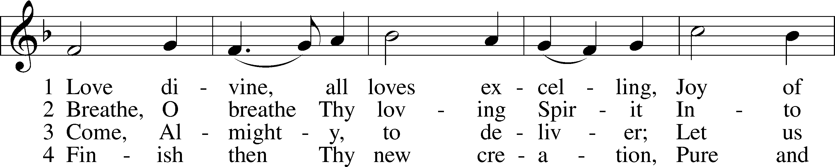
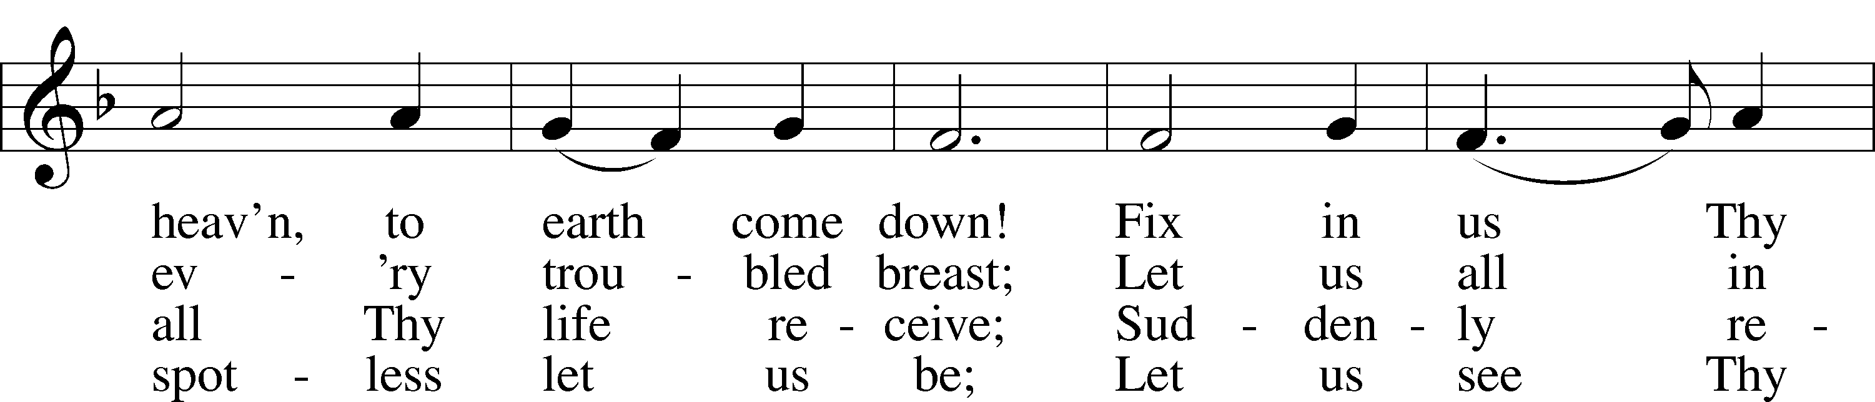
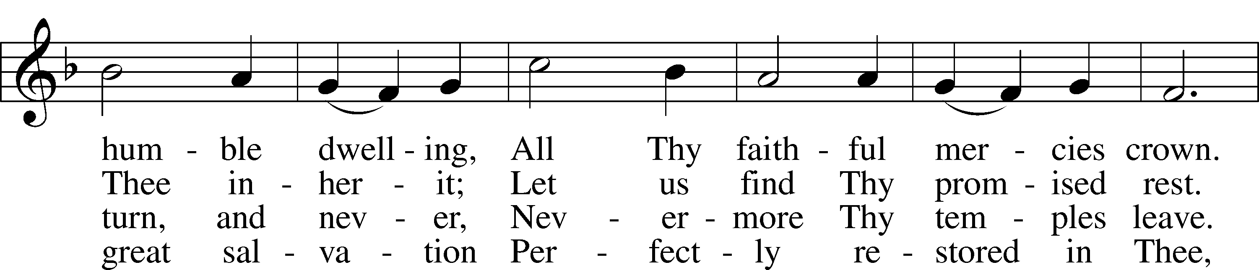
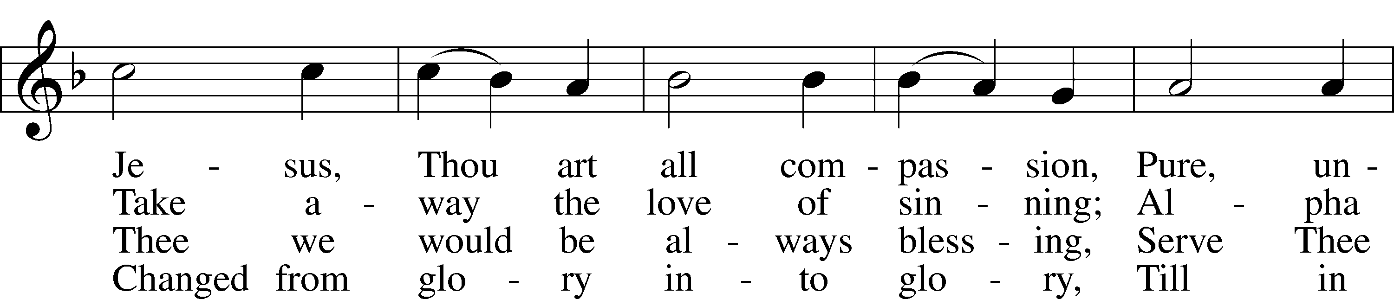
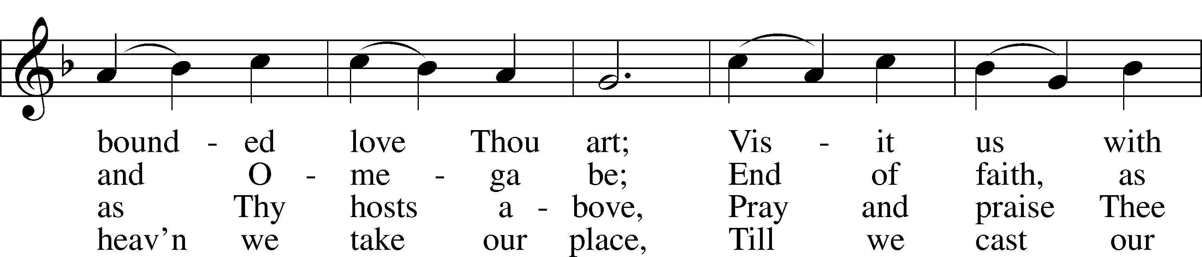
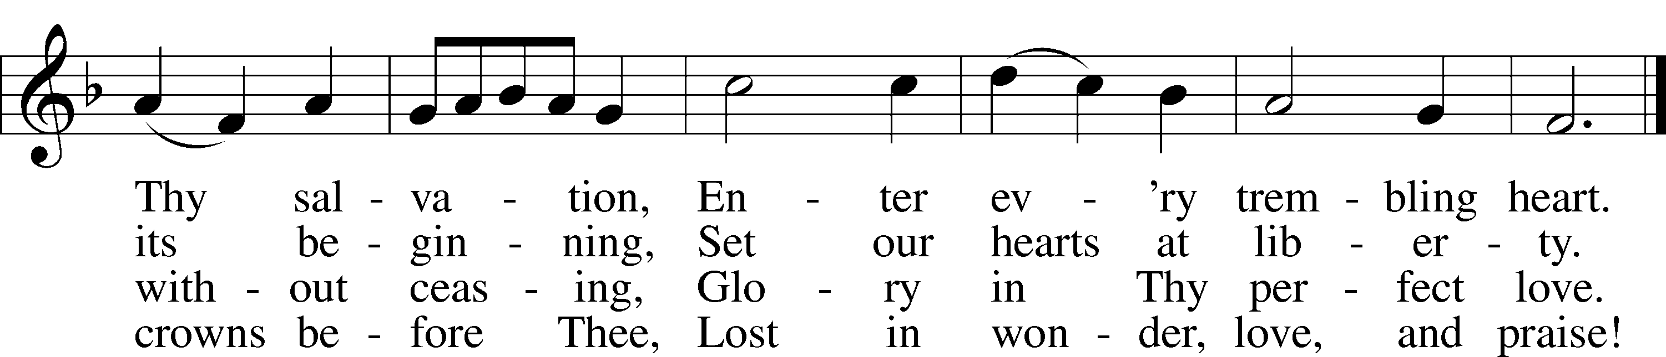
Text: Charles Wesley, 1707–88
Tune: Rowland H. Prichard, 1811–87
Text and tune: Public domain

Sermon

Stand

Prayer of the Church

Following the prayers, the people may greet one another in the name of the Lord, saying, “Peace be with you,” as a sign of reconciliation and of the unity of the Spirit in the bond of peace (Matt. 5:22–24; Eph. 4:1–3).

Sit

Offering

Service of the Sacrament

Stand

Preface LSB 208
P The Lord be with you.
C And also with you.

P Lift up your hearts.
C We lift them to the Lord.

P Let us give thanks to the Lord our God.
C It is right to give Him thanks and praise.

P It is truly good, right, and salutary that we should at all times and in all places give thanks to You, O Lord, holy Father, almighty and everlasting God, for the countless blessings You so freely bestow on us and all creation. Above all, we give thanks for Your boundless love shown to us when You sent Your only-begotten Son, Jesus Christ, into our flesh and laid on Him our sin, giving Him into death that we might not die eternally. Because He is now risen from the dead and lives and reigns to all eternity, all who believe in Him will overcome sin and death and will rise again to new life. Therefore with angels and archangels and with all the company of heaven we laud and magnify Your glorious name, evermore praising You and saying:

Sanctus LSB 208
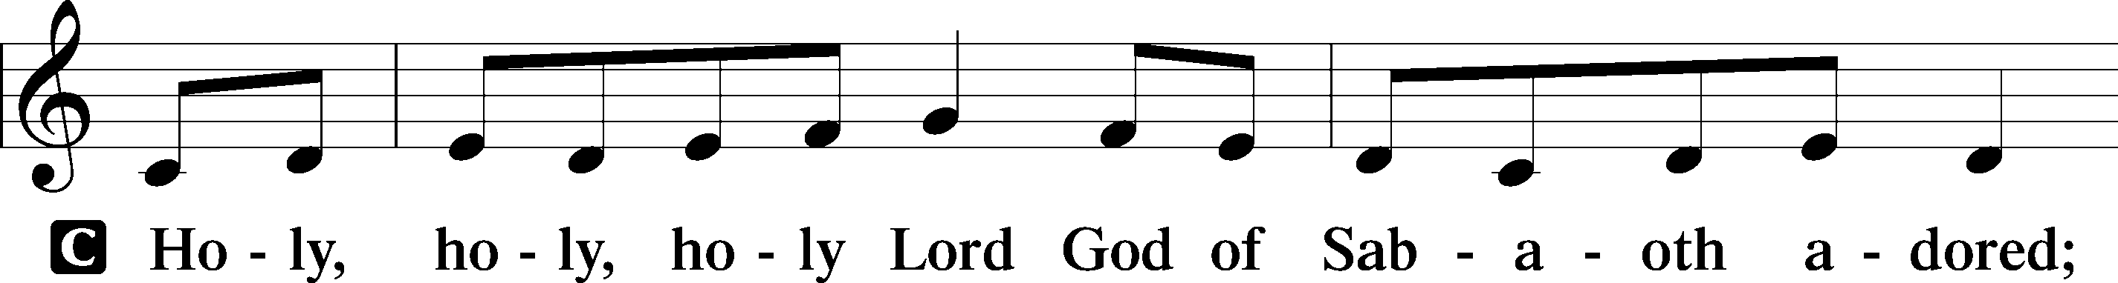
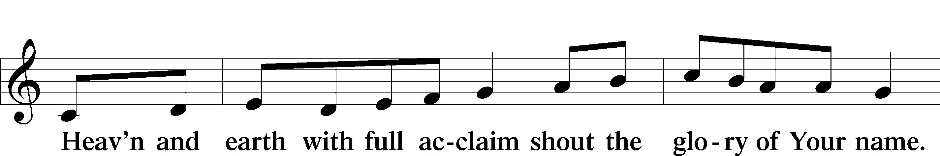
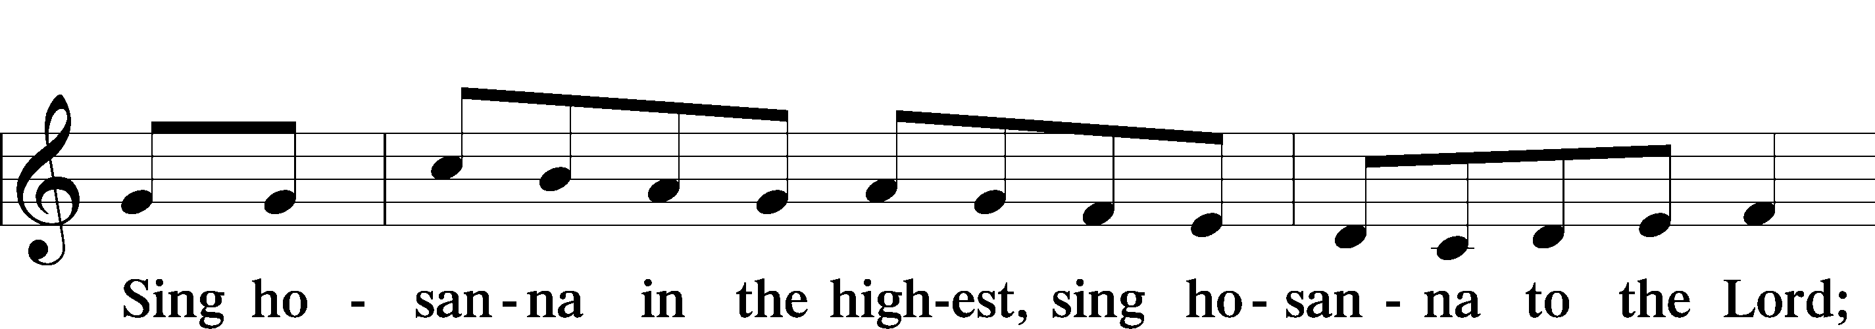
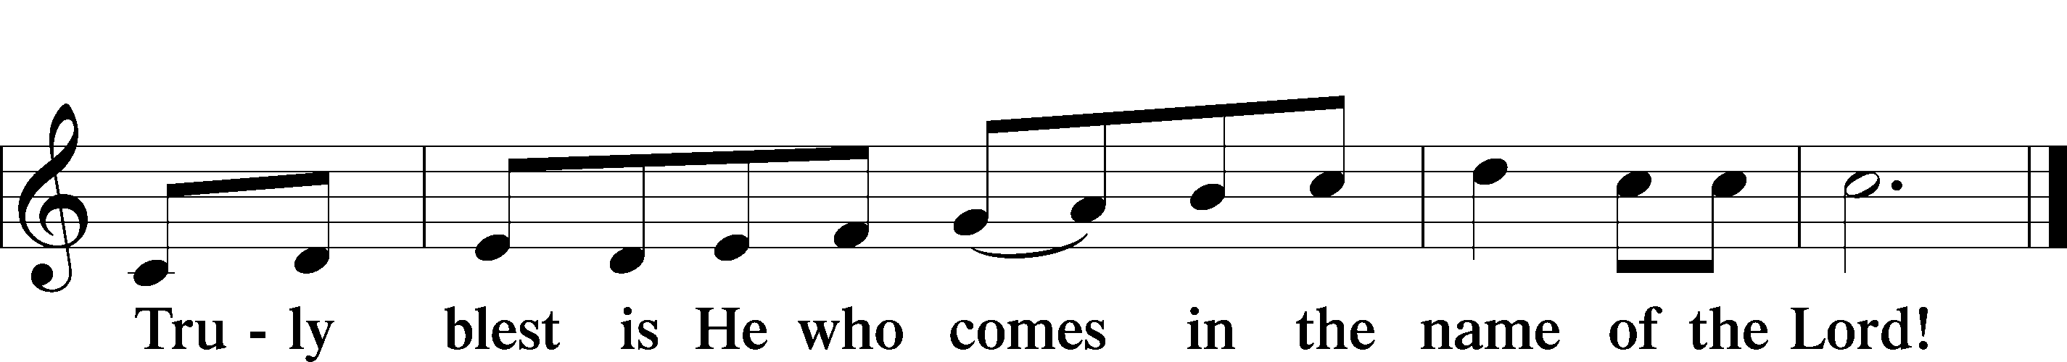
Text: Stephen P. Starke

Prayer of Thanksgiving
P Blessed are You, O Lord our God, king of all creation, for You have had mercy on us and given Your only-begotten Son that whoever believes in Him should not perish but have eternal life.

For Christ, our Passover Lamb, has been sacrificed. By His death, He has redeemed us from bondage to sin and death, and by His resurrection, He has delivered us into new life in Him.

Grant us to keep the Feast in sincerity and truth, faithfully eating His body given into death and drinking His life’s blood poured out for our salvation until we pass through death to the promised land of life eternal.

Hear us as we pray in His name and as He has taught us:

Lord’s Prayer
C Our Father who art in heaven,
hallowed be Thy name,
Thy kingdom come,
Thy will be done on earth
as it is in heaven;
give us this day our daily bread;
and forgive us our trespasses
as we forgive those
who trespass against us;
and lead us not into temptation,
but deliver us from evil.
For Thine is the kingdom
and the power and the glory
forever and ever. Amen.

The Words of Our Lord
P Our Lord Jesus Christ, on the night when He was betrayed, took bread, and when He had given thanks, He broke it and gave it to the disciples and said: “Take, eat; this is My T body, which is given for you. This do in remembrance of Me.”

In the same way also He took the cup after supper, and when He had given thanks, He gave it to them, saying: “Drink of it, all of you; this cup is the new testament in My T blood, which is shed for you for the forgiveness of sins. This do, as often as you drink it, in remembrance of Me.”

Pax Domini
P The peace of the Lord be with you always.
C Amen.

Agnus Dei LSB 210
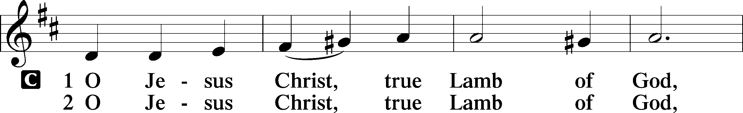
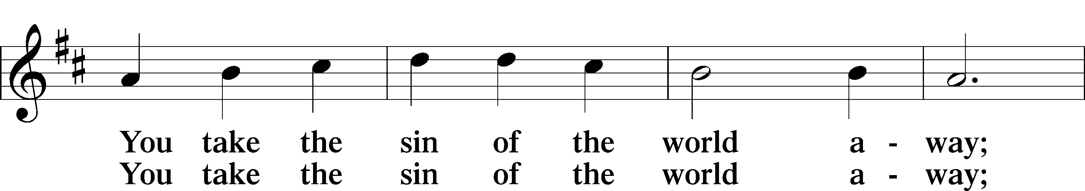
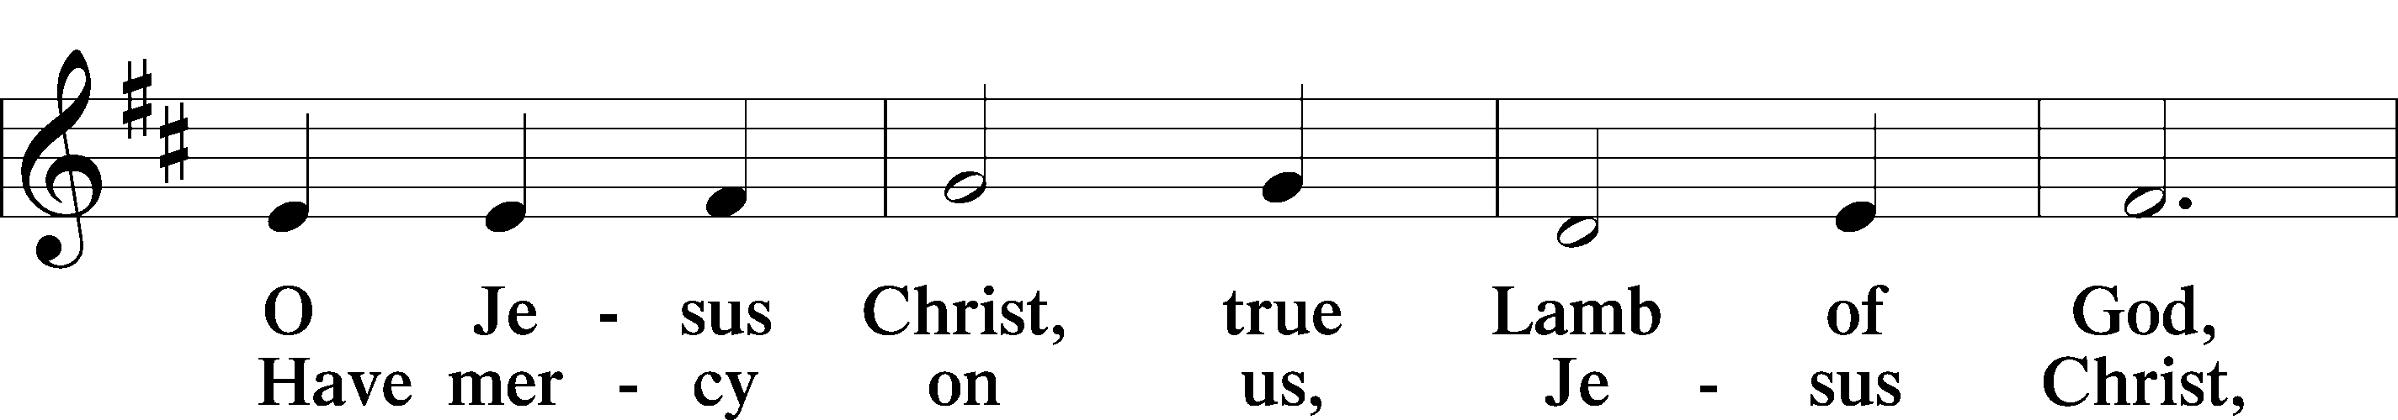
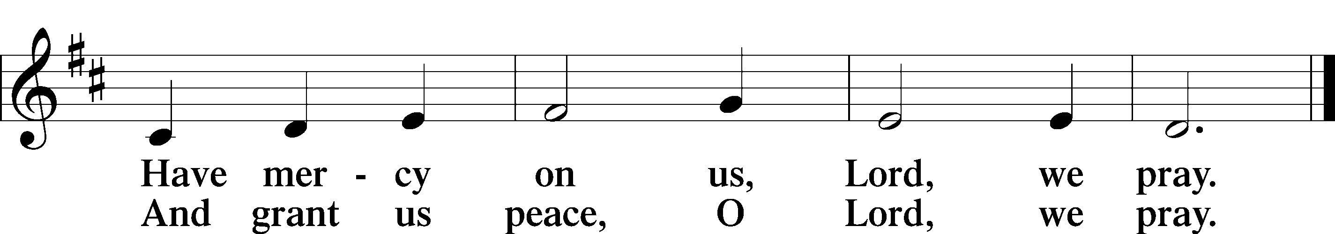
Text: Stephen P. Starke

Sit

Distribution

The pastor and those who assist him receive the body and blood of Christ first and then distribute them to those who come to receive, saying:

Take, eat; this is the true body of our Lord and Savior Jesus Christ, given into death for your sins.
Amen.

Take, drink; this is the true blood of our Lord and Savior Jesus Christ, shed for the forgiveness of your sins.
Amen.

In dismissing the communicants, the following is said:

P The body and blood of our Lord Jesus Christ strengthen and preserve you in body and soul to life everlasting. Depart T in peace.
C Amen.

Distribution Hymn
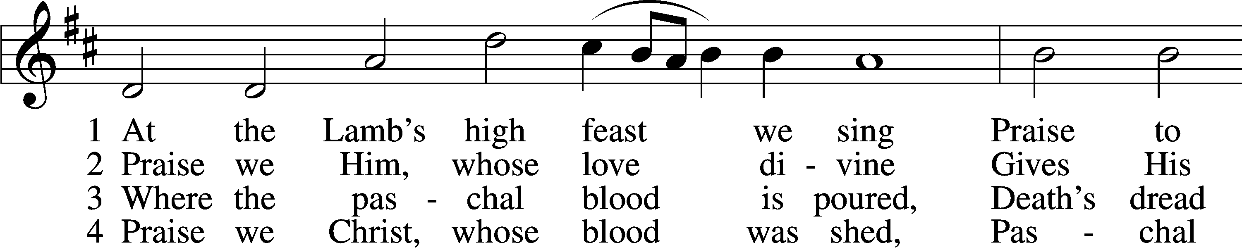
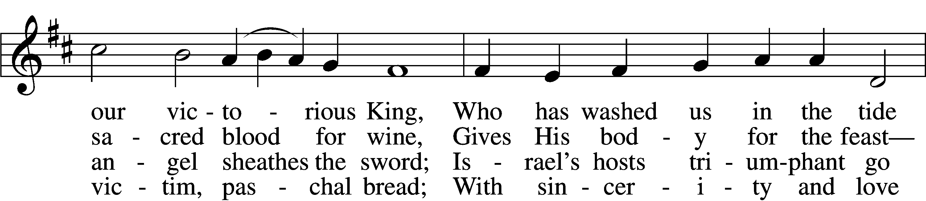
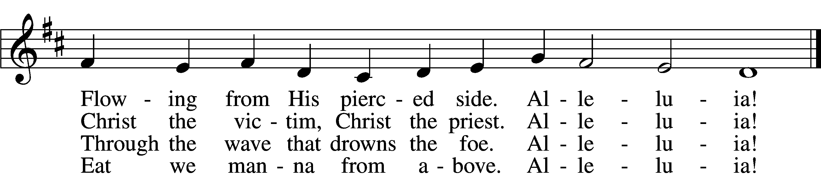

5 Mighty Victim from the sky,
Hell’s fierce pow’rs beneath You lie;
You have conquered in the fight,
You have brought us life and light.
Alleluia!

6 Now no more can death appall,
Now no more the grave enthrall;
You have opened paradise,
And Your saints in You shall rise.
Alleluia!

7 Easter triumph, Easter joy!
This alone can sin destroy;
From sin’s pow’r, Lord, set us free,
Newborn souls in You to be.
Alleluia!

D 8 Father, who the crown shall give,
Savior, by whose death we live,
Spirit, guide through all our days:
Three in One, Your name we praise.
Alleluia!
Text: Latin, c. 5th–10th cent.; tr. Robert Campbell, 1814–68, alt.
Tune: Kirchengeseng, 1566, Ivancice
Text and tune: Public domain

Distribution Hymn: 895 Now Thank We All Our God
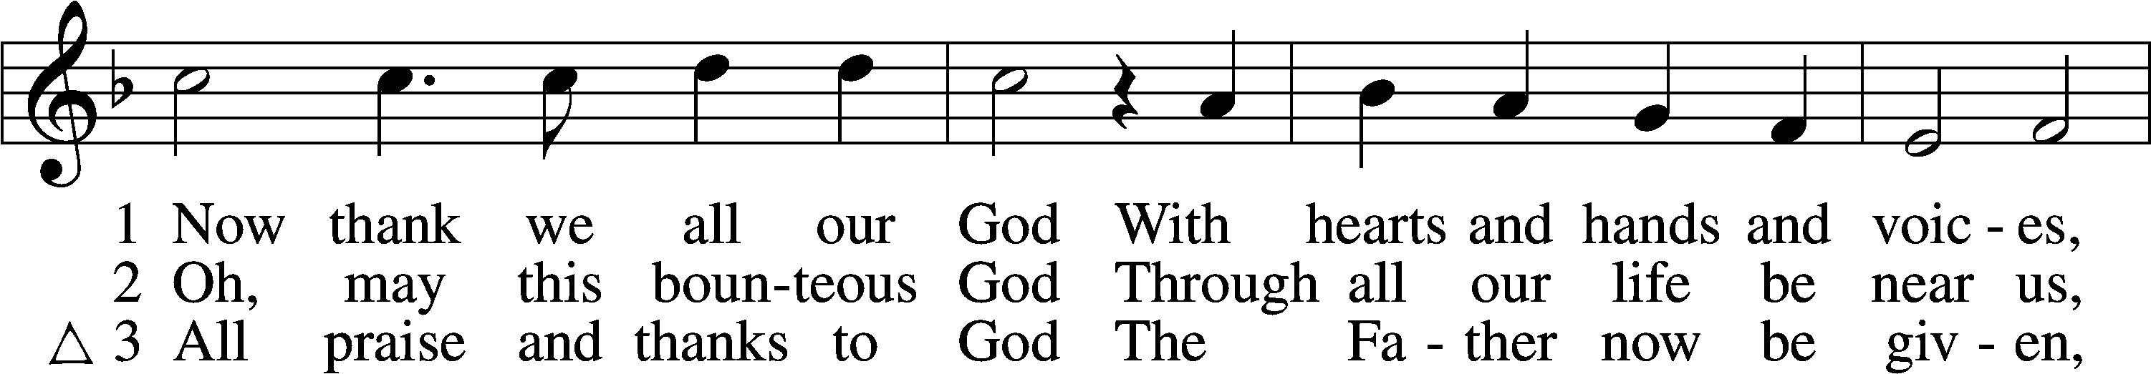
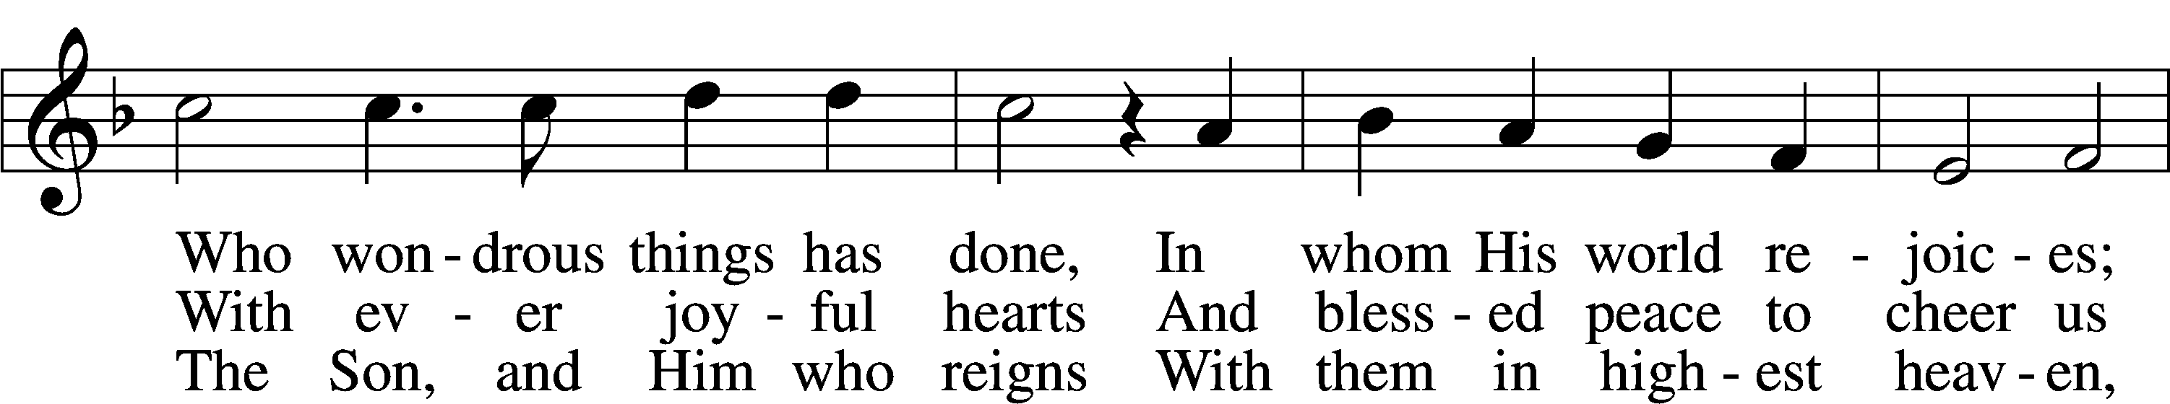
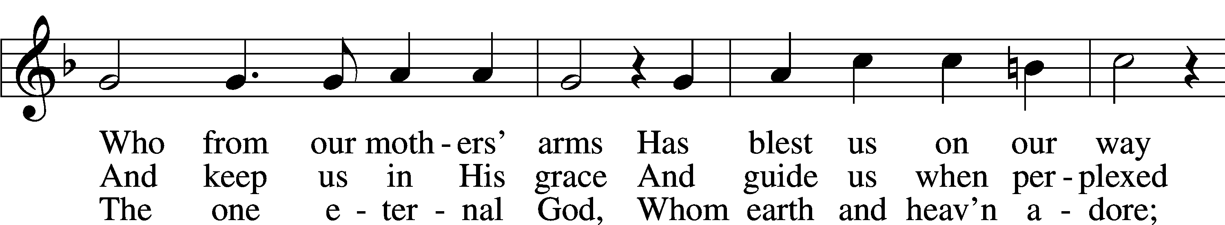
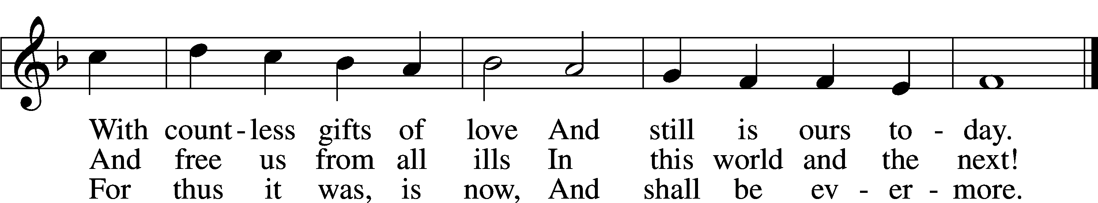
Text: Martin Rinckart, 1586–1649; tr. Catherine Winkworth, 1827–78, alt.
Tune: Johann Crüger, 1598–1662
Text and tune: Public domain

Stand

Nunc Dimittis LSB 211
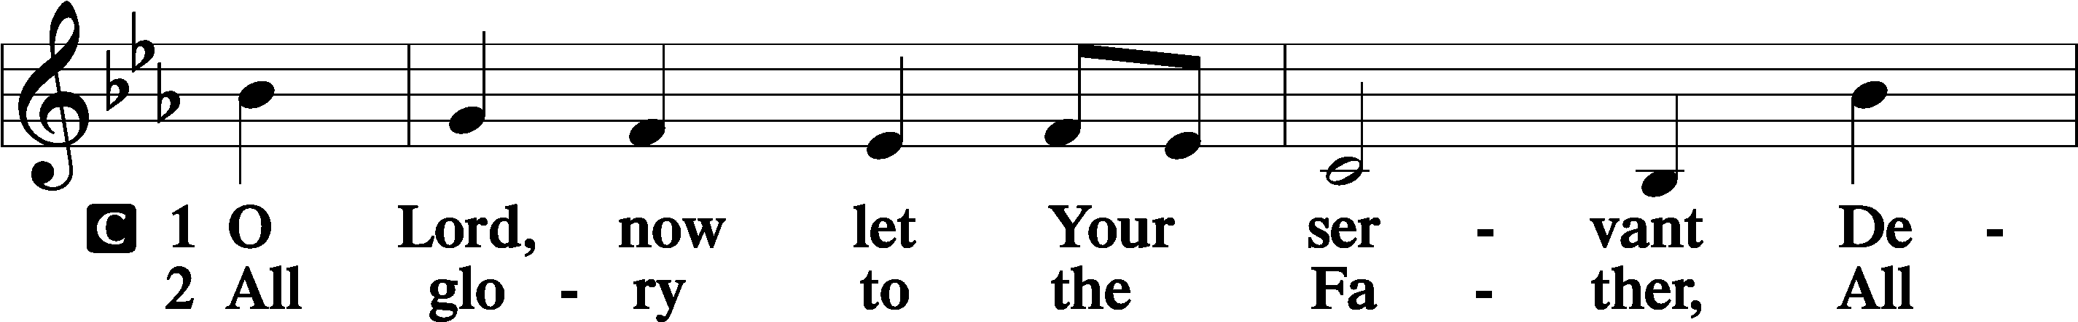
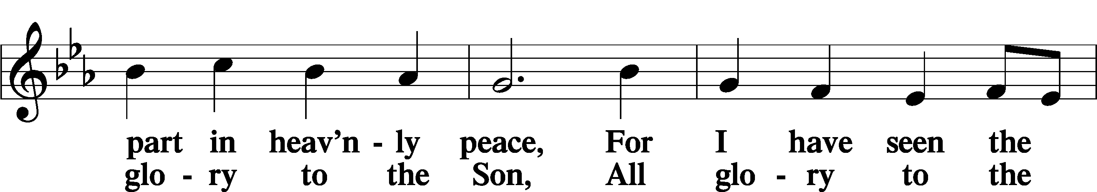
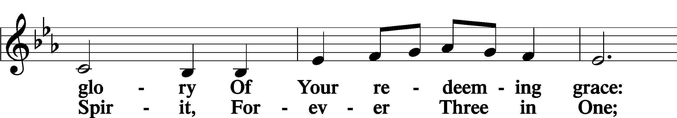
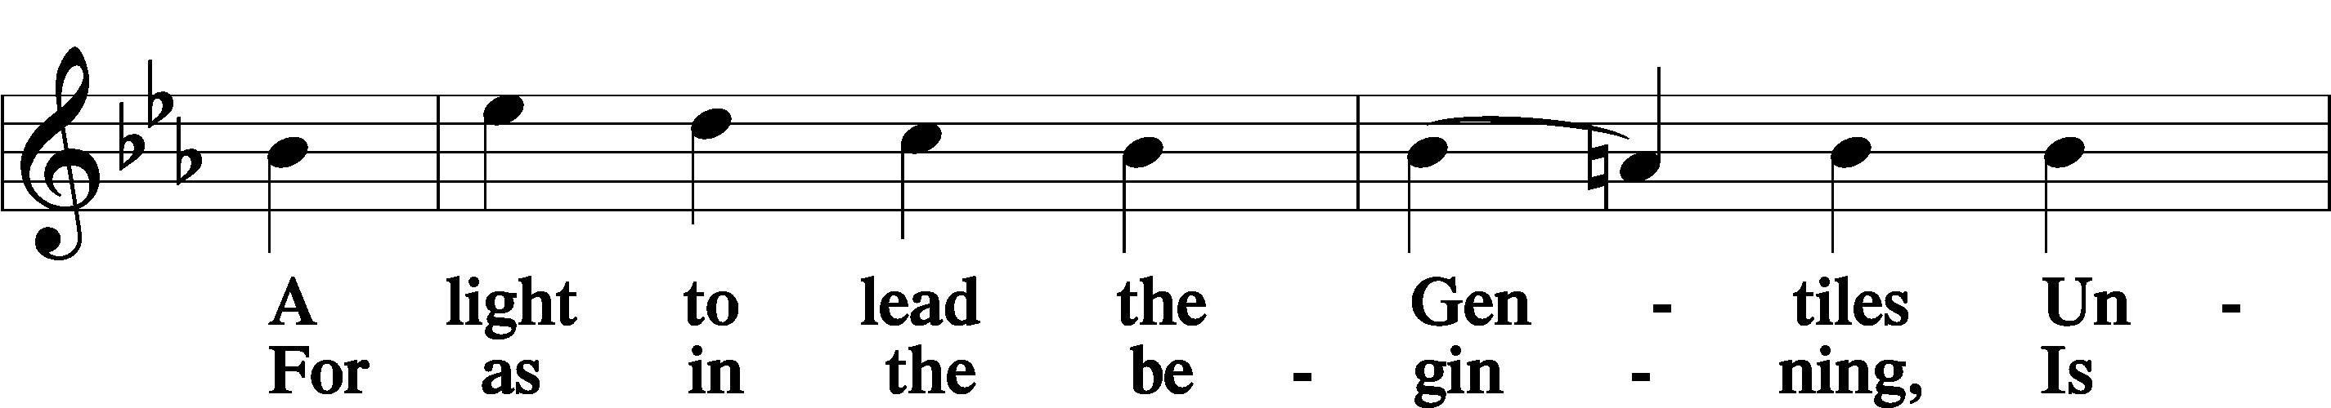
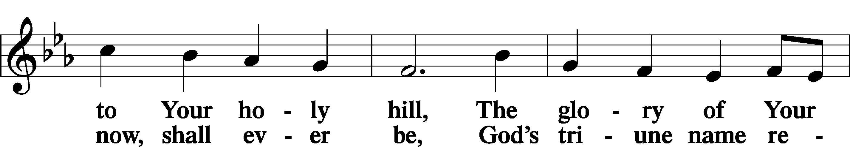
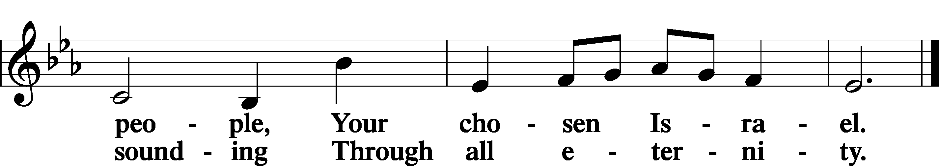

Post-Communion Collect
A Let us pray.
We give thanks to You, almighty God, that You have refreshed us through this salutary gift, and we implore You that of Your mercy You would strengthen us through the same in faith toward You and in fervent love toward one another; through Jesus Christ, Your Son, our Lord, who lives and reigns with You and the Holy Spirit, one God, now and forever.
C Amen.

Benedicamus LSB 212
A Let us bless the Lord.
C Thanks be to God.

Benediction
P The Lord bless you and keep you.
The Lord make His face shine on you and be gracious to you.
The Lord look upon you with favor and T give you peace.
C Amen.

Hymn to Depart: 632 O Jesus, Blessed Lord, to Thee
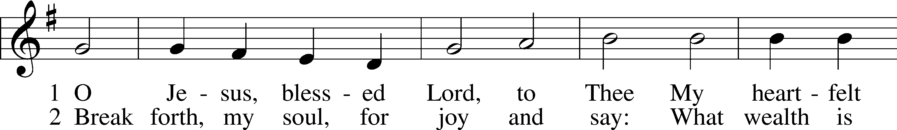
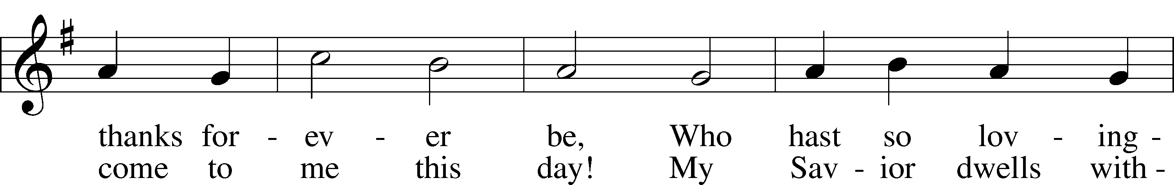
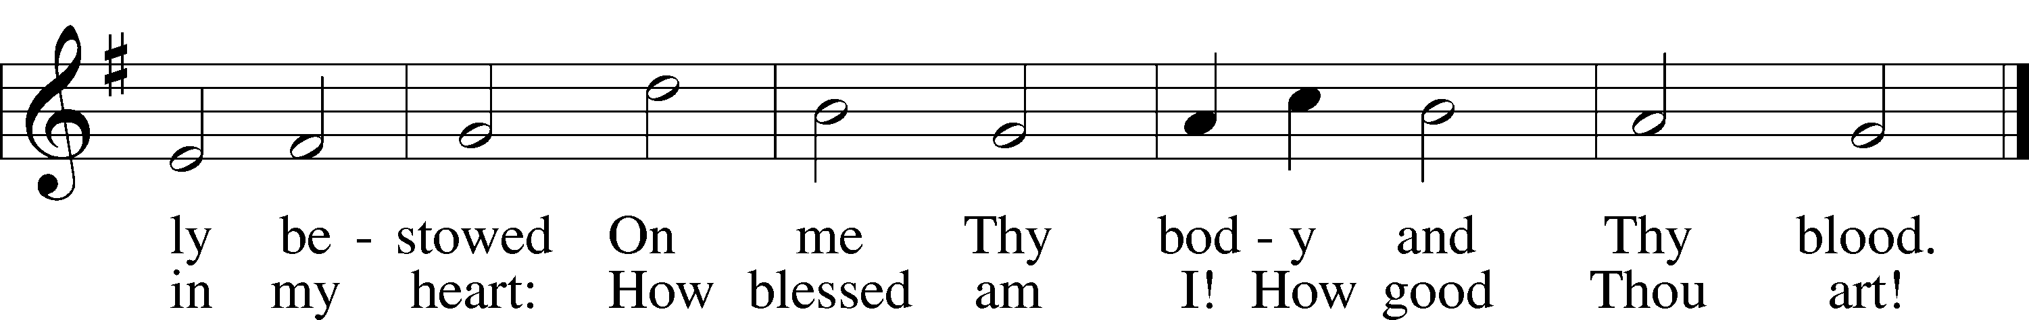
Text: Thomas Hansen Kingo, 1634–1703; tr. Arthur J. Mason, 1851–1928
Tune: Trente quatre Pseaumes de David, 1551, Geneva, ed. Louis Bourgeois
Text and tune: Public domain

Acknowledgments
Divine Service, Setting Four from Lutheran Service Book
Unless otherwise indicated, Scripture quotations are from the ESV® Bible (The Holy Bible, English Standard Version®), copyright © 2001 by Crossway, a publishing ministry of Good News Publishers. Used by permission. All rights reserved.
Created by Lutheran Service Builder © 2024 Concordia Publishing House.

