Confession and Absolution

Divine Service 1

7th Sunday after Pentecost

June 30,2024

Hymn of Invocation: 809 Great Is Thy Faithfulness
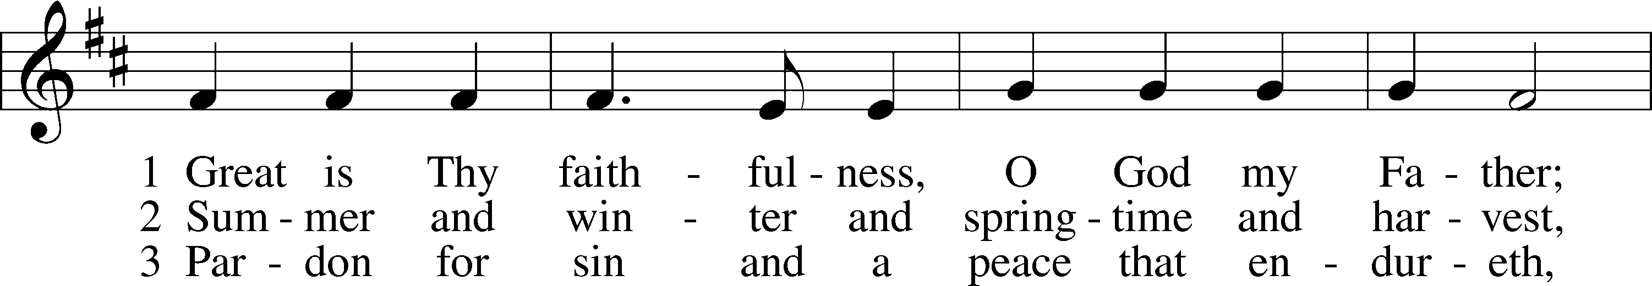
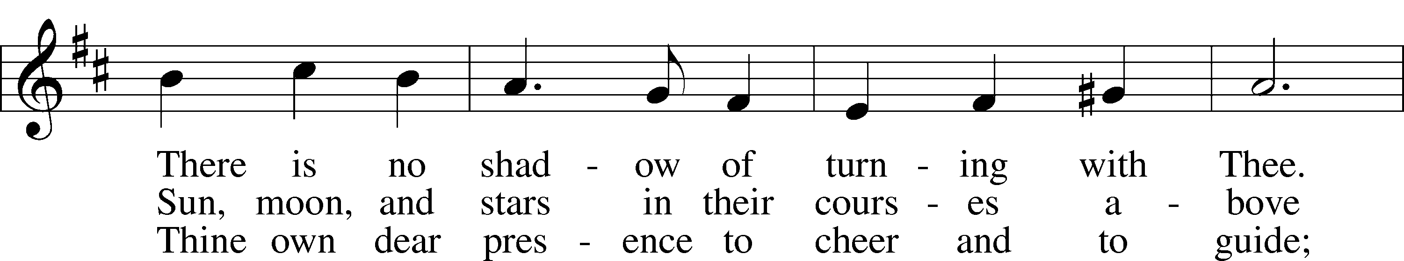
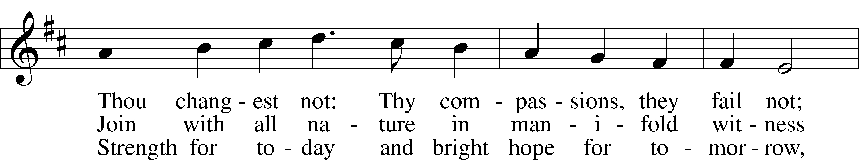
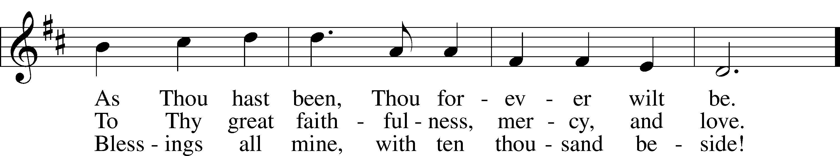
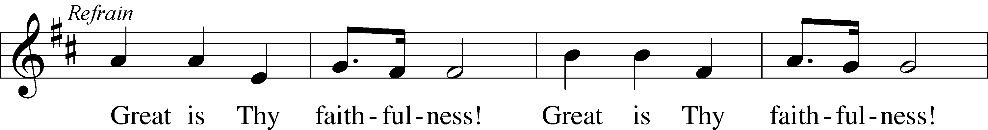
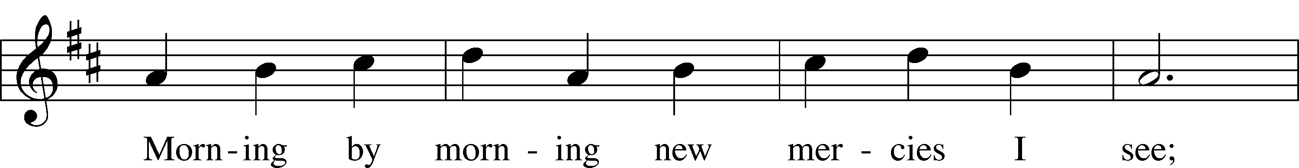
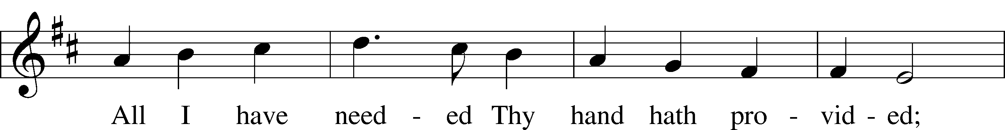
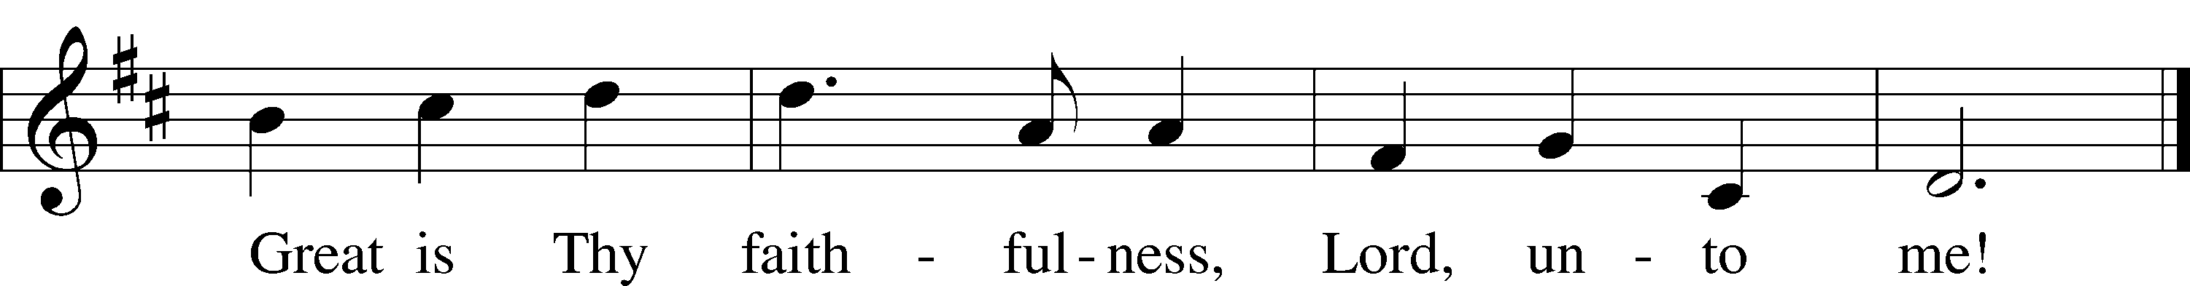
Text: Thomas O. Chisholm, 1866–1960
Tune: William M. Runyan, 1870–1957
Text: Public domain
Tune: Public domain

Stand

The sign of the cross may be made by all in remembrance of their Baptism.

P In the name of the Father and of the T Son and of the Holy Spirit.
C Amen.

P If we say we have no sin, we deceive ourselves, and the truth is not in us.
C But if we confess our sins, God, who is faithful and just, will forgive our sins and cleanse us from all unrighteousness.

Kneel/Stand

Silence for reflection on God’s Word and for self-examination.

P Let us then confess our sins to God our Father.
C Most merciful God, we confess that we are by nature sinful and unclean. We have sinned against You in thought, word, and deed, by what we have done and by what we have left undone. We have not loved You with our whole heart; we have not loved our neighbors as ourselves. We justly deserve Your present and eternal punishment. For the sake of Your Son, Jesus Christ, have mercy on us. Forgive us, renew us, and lead us, so that we may delight in Your will and walk in Your ways to the glory of Your holy name. Amen.

P Almighty God in His mercy has given His Son to die for you and for His sake forgives you all your sins. As a called and ordained servant of Christ, and by His authority, I therefore forgive you all your sins in the name of the Father and of the T Son and of the Holy Spirit.
C Amen.

Stand

Service of the Word

Introit Psalm 121:5–8; antiphon: vv. 1–2
I lift up my eyes to the hills.
From where does my help come?
My help comes from the Lord,
who made heaven and earth.
The Lord is your keeper;
the Lord is your shade on your right hand.
The sun shall not strike you by day,
nor the moon by night.
The Lord will keep you from all evil;
he will keep your life.
The Lord will keep your going out and your coming in
from this time forth and forevermore.
Glory be to the Father and to the Son
and to the Holy Spirit;
as it was in the beginning,
is now, and will be forever. Amen.
I lift up my eyes to the hills.
From where does my help come?
My help comes from the Lord,
who made heaven and earth.

Kyrie LSB 152

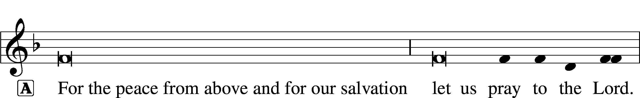

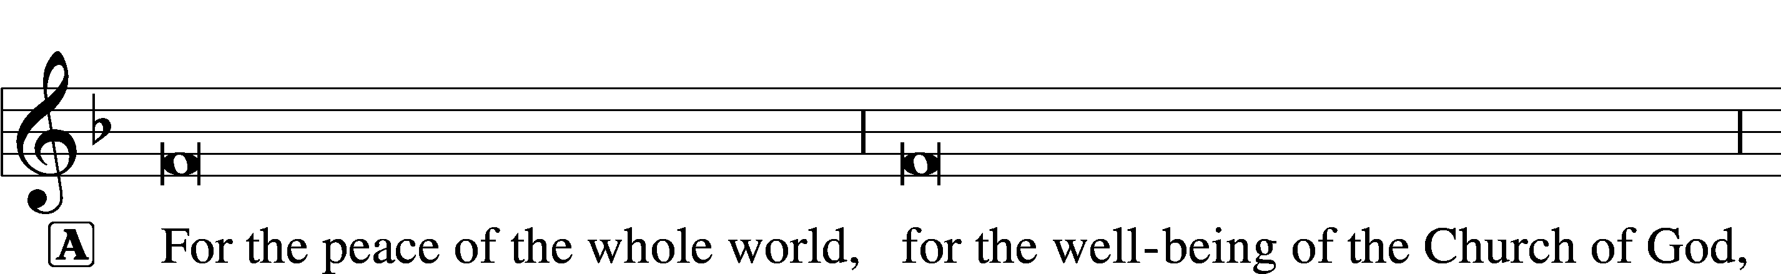

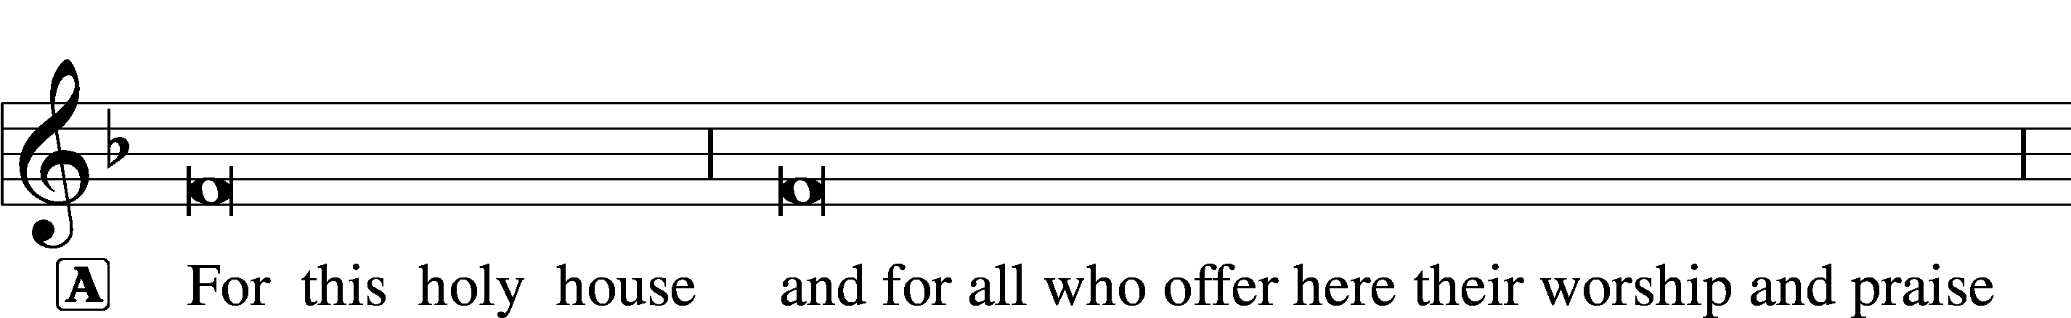

Gloria in Excelsis LSB 154
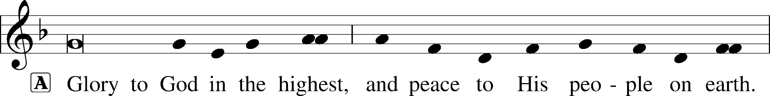
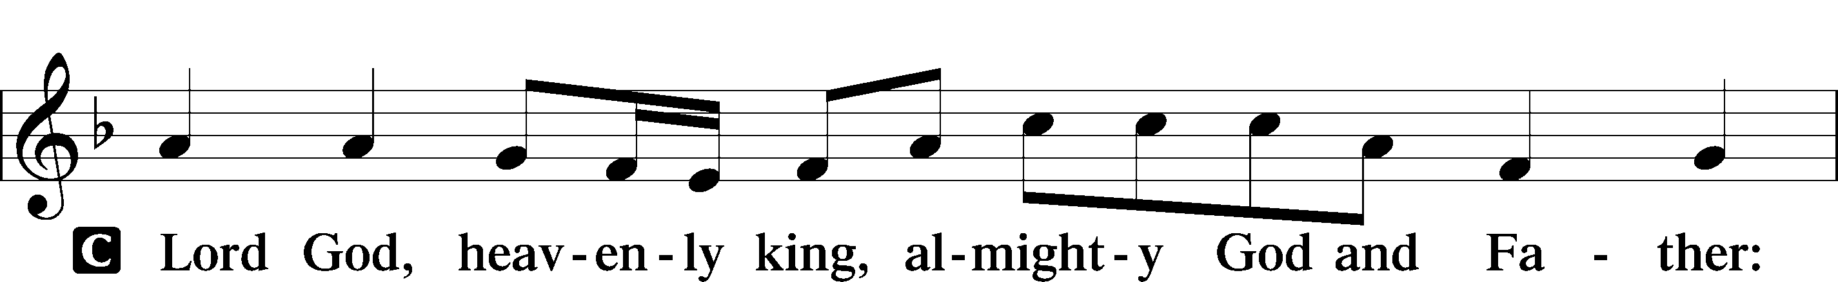
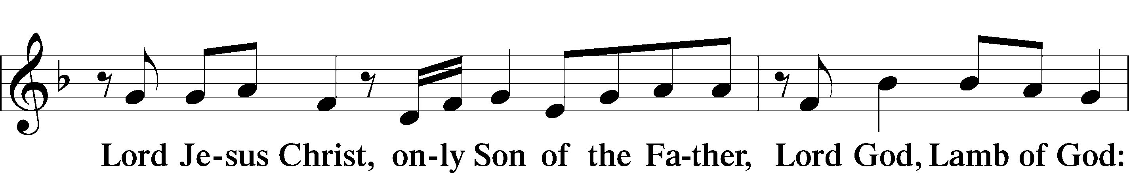
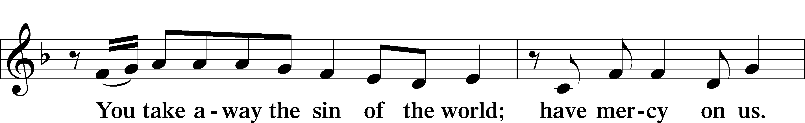
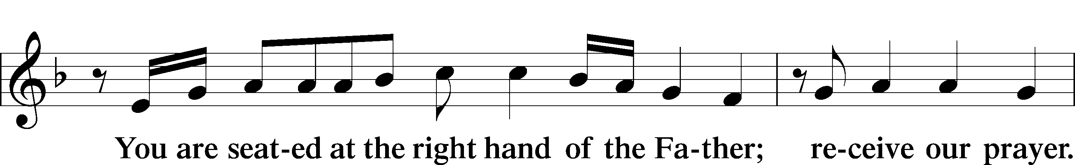
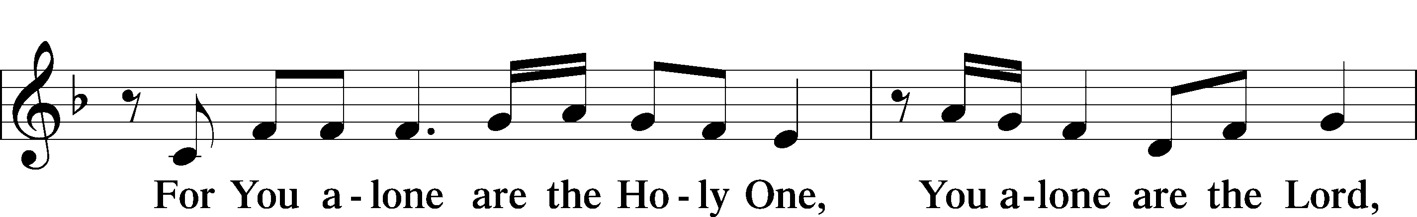
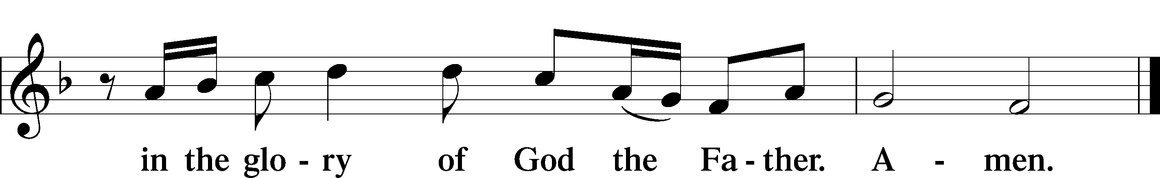

Salutation and Collect of the Day
P The Lord be with you.
C And also with you.

P Let us pray.
Collect for the Word
L Blessed Lord, You have caused all Holy Scriptures to be written for our learning. Grant that we may so hear them, read, mark, learn, and take them to heart that, by the patience and comfort of Your holy Word, we may embrace and ever hold fast the blessed hope of everlasting life; through Jesus Christ, Your Son, our Lord, who lives and reigns with You and the Holy Spirit, one God, now and forever.
C Amen.

C Amen.

Sit

Old Testament Reading Lamentations 3:22–33
22The steadfast love of the Lord never ceases;
his mercies never come to an end;
23they are new every morning;
great is your faithfulness.
24“The Lord is my portion,” says my soul,
“therefore I will hope in him.”
25The Lord is good to those who wait for him,
to the soul who seeks him.
26It is good that one should wait quietly
for the salvation of the Lord.
27It is good for a man that he bear
the yoke in his youth.
28Let him sit alone in silence
when it is laid on him;
29let him put his mouth in the dust—
there may yet be hope;
30let him give his cheek to the one who strikes,
and let him be filled with insults.
31For the Lord will not
cast off forever,
32but, though he cause grief, he will have compassion
according to the abundance of his steadfast love;
33for he does not willingly afflict
or grieve the children of men.

A This is the Word of the Lord.
C Thanks be to God.

Psalm Psalm 30; antiphon: v. 10
Joy Comes in the Morning
1I will extol you, O Lord, for you have drawn me up
and have not let my foes rejoice over me.
2O Lord my God, I cried to you for help,
and you have healed me.
3O Lord, you have brought up my soul from Sheol;
you restored me to life from among those who go down to the pit.
4Sing praises to the Lord, O you his saints,
and give thanks to his holy name.
5For his anger is but for a moment,
and his favor is for a lifetime.
Weeping may tarry for the night,
but joy comes with the morning.
6As for me, I said in my prosperity,
“I shall never be moved.”
7By your favor, O Lord,
you made my mountain stand strong;
you hid your face;
I was dismayed.
8To you, O Lord, I cry,
and to the Lord I plead for mercy:
9“What profit is there in my death,
if I go down to the pit?
Will the dust praise you?
Will it tell of your faithfulness?
10Hear, O Lord, and be merciful to me!
O Lord, be my helper!”
11You have turned for me my mourning into dancing;
you have loosed my sackcloth
and clothed me with gladness,
12that my glory may sing your praise and not be silent.
O Lord my God, I will give thanks to you forever!

Epistle 2 Corinthians 8:1–9, 13–15
Encouragement to Give Generously
1We want you to know, brothers, about the grace of God that has been given among the churches of Macedonia, 2for in a severe test of affliction, their abundance of joy and their extreme poverty have overflowed in a wealth of generosity on their part. 3For they gave according to their means, as I can testify, and beyond their means, of their own free will, 4begging us earnestly for the favor of taking part in the relief of the saints— 5and this, not as we expected, but they gave themselves first to the Lord and then by the will of God to us. 6Accordingly, we urged Titus that as he had started, so he should complete among you this act of grace. 7But as you excel in everything—in faith, in speech, in knowledge, in all earnestness, and in our love for you—see that you excel in this act of grace also.
8I say this not as a command, but to prove by the earnestness of others that your love also is genuine. 9For you know the grace of our Lord Jesus Christ, that though he was rich, yet for your sake he became poor, so that you by his poverty might become rich. . . .
13I do not mean that others should be eased and you burdened, but that as a matter of fairness 14your abundance at the present time should supply their need, so that their abundance may supply your need, that there may be fairness. 15As it is written, “Whoever gathered much had nothing left over, and whoever gathered little had no lack.”

A This is the Word of the Lord.
C Thanks be to God.

Stand

Alleluia and Verse LSB 156
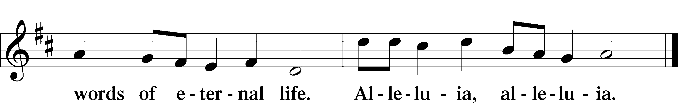

Holy Gospel Mark 5:21–43
P The Holy Gospel according to St. Mark, the fifth chapter.
C Glory to You, O Lord.

Jesus Heals a Woman and Jairus’s Daughter
21When Jesus had crossed again in the boat to the other side, a great crowd gathered about him, and he was beside the sea. 22Then came one of the rulers of the synagogue, Jairus by name, and seeing him, he fell at his feet 23and implored him earnestly, saying, “My little daughter is at the point of death. Come and lay your hands on her, so that she may be made well and live.” 24And he went with him.
And a great crowd followed him and thronged about him. 25And there was a woman who had had a discharge of blood for twelve years, 26and who had suffered much under many physicians, and had spent all that she had, and was no better but rather grew worse. 27She had heard the reports about Jesus and came up behind him in the crowd and touched his garment. 28For she said, “If I touch even his garments, I will be made well.” 29And immediately the flow of blood dried up, and she felt in her body that she was healed of her disease. 30And Jesus, perceiving in himself that power had gone out from him, immediately turned about in the crowd and said, “Who touched my garments?” 31And his disciples said to him, “You see the crowd pressing around you, and yet you say, ‘Who touched me?’” 32And he looked around to see who had done it. 33But the woman, knowing what had happened to her, came in fear and trembling and fell down before him and told him the whole truth. 34And he said to her, “Daughter, your faith has made you well; go in peace, and be healed of your disease.”
35While he was still speaking, there came from the ruler’s house some who said, “Your daughter is dead. Why trouble the Teacher any further?” 36But overhearing what they said, Jesus said to the ruler of the synagogue, “Do not fear, only believe.” 37And he allowed no one to follow him except Peter and James and John the brother of James. 38They came to the house of the ruler of the synagogue, and Jesus saw a commotion, people weeping and wailing loudly. 39And when he had entered, he said to them, “Why are you making a commotion and weeping? The child is not dead but sleeping.” 40And they laughed at him. But he put them all outside and took the child’s father and mother and those who were with him and went in where the child was. 41Taking her by the hand he said to her, “Talitha cumi,” which means, “Little girl, I say to you, arise.” 42And immediately the girl got up and began walking (for she was twelve years of age), and they were immediately overcome with amazement. 43And he strictly charged them that no one should know this, and told them to give her something to eat.

P This is the Gospel of the Lord.
C Praise to You, O Christ.

Sit

Hymn of the Day: 750 If Thou But Trust in God to Guide Thee
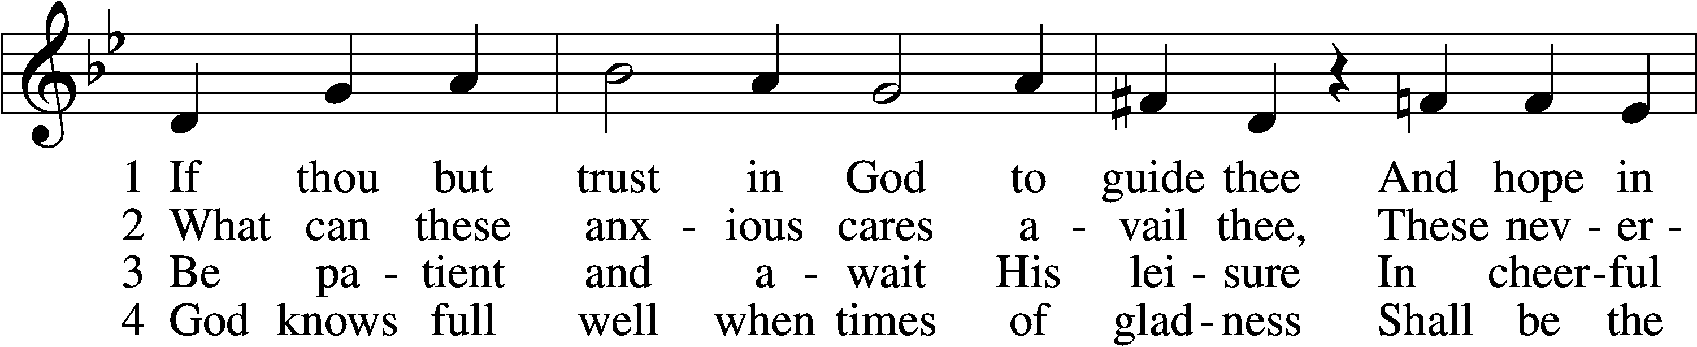
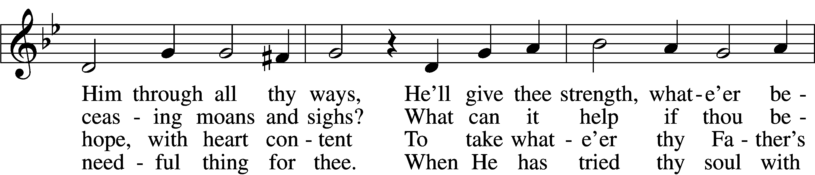
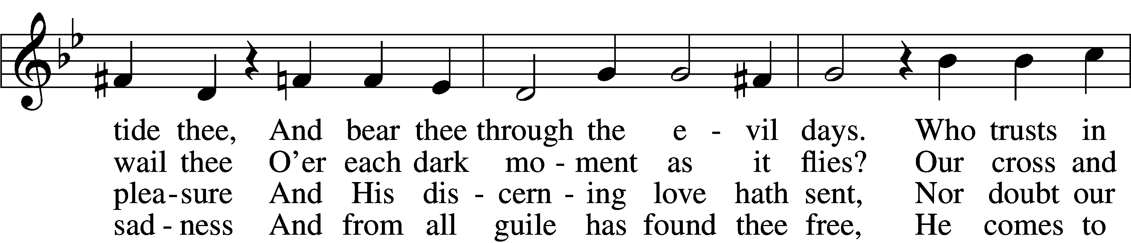
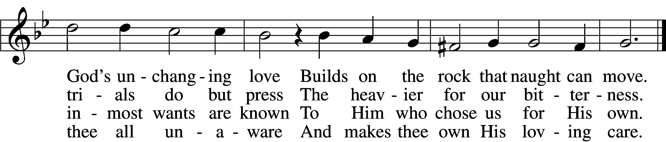

5 Nor think amid the fiery trial
That God hath cast thee off unheard,
That he whose hopes meet no denial
Must surely be of God preferred.
Time passes and much change doth bring
And sets a bound to ev’rything.

6 All are alike before the Highest;
’Tis easy for our God, we know,
To raise thee up, though low thou liest,
To make the rich man poor and low.
True wonders still by Him are wrought
Who setteth up and brings to naught.

7 Sing, pray, and keep His ways unswerving,
Perform thy duties faithfully,
And trust His Word; though undeserving,
Thou yet shalt find it true for thee.
God never yet forsook in need
The soul that trusted Him indeed.
Text: tr. Catherine Winkworth, 1827–78, alt.
Text and tune: Georg Neumark, 1621–81
Text and tune: Public domain

Sermon

Stand

Apostles’ Creed
C I believe in God, the Father Almighty,
maker of heaven and earth.

And in Jesus Christ, His only Son, our Lord,
who was conceived by the Holy Spirit,
born of the virgin Mary,
suffered under Pontius Pilate,
was crucified, died and was buried.
He descended into hell.
The third day He rose again from the dead.
He ascended into heaven
and sits at the right hand of God the Father Almighty.
From thence He will come to judge the living and the dead.

I believe in the Holy Spirit,
the holy Christian Church,
the communion of saints,
the forgiveness of sins,
the resurrection of the body,
and the life T everlasting. Amen.

Prayer of the Church

Sit

Offering

Stand

Offertory LSB 159
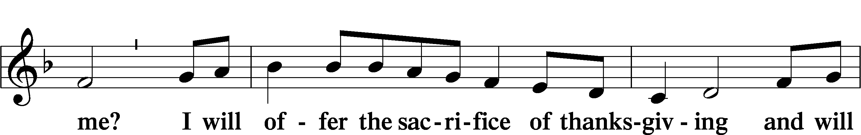
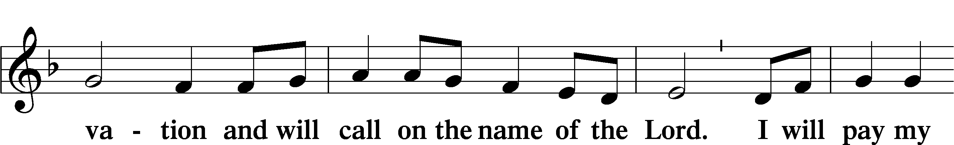
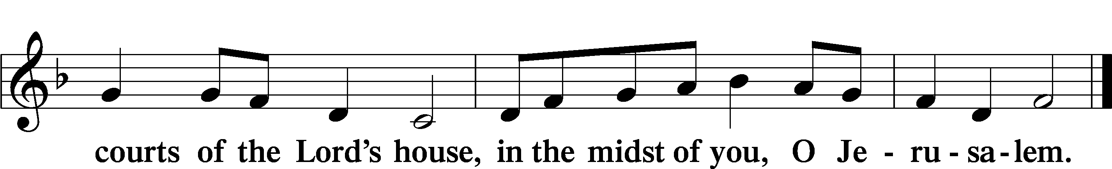

Lord’s Prayer
C Our Father who art in heaven,
hallowed be Thy name,
Thy kingdom come,
Thy will be done on earth
as it is in heaven;
give us this day our daily bread;
and forgive us our trespasses
as we forgive those
who trespass against us;
and lead us not into temptation,
but deliver us from evil.
For Thine is the kingdom
and the power and the glory
forever and ever. Amen.

Collect for the Word
Collect for the Word
Blessed Lord, You have caused all Holy Scriptures to be written for our learning. Grant that we may so hear them, read, mark, learn, and take them to heart that, by the patience and comfort of Your holy Word, we may embrace and ever hold fast the blessed hope of everlasting life; through Jesus Christ, Your Son, our Lord, who lives and reigns with You and the Holy Spirit, one God, now and forever.
C Amen.

Stand

Benediction LSB 166
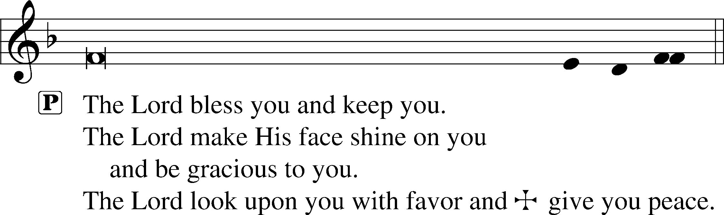

Hymn to Depart: 783 Take My Life and Let It Be
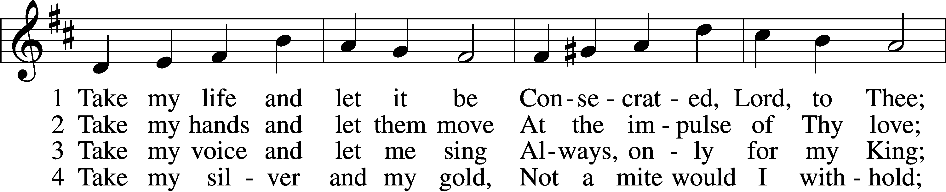
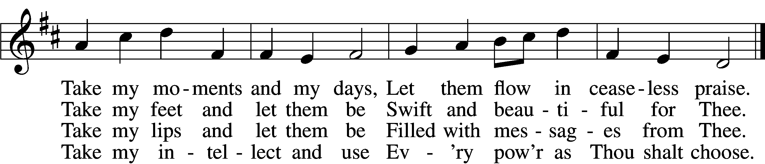

5 Take my will and make it Thine,
It shall be no longer mine;
Take my heart, it is Thine own,
It shall be Thy royal throne.

6 Take my love, my Lord, I pour
At Thy feet its treasure store;
Take myself, and I will be
Ever, only, all for Thee.
Text: Frances R. Havergal, 1836–79
Tune: William H. Havergal, 1793–1870
Text and tune: Public domain

Acknowledgments
Divine Service, Setting One from Lutheran Service Book
Unless otherwise indicated, Scripture quotations are from the ESV® Bible (The Holy Bible, English Standard Version®), copyright © 2001 by Crossway, a publishing ministry of Good News Publishers. Used by permission. All rights reserved.
Created by Lutheran Service Builder © 2024 Concordia Publishing House.

Announcements:
Church Service Phone: 715-438-4200
(Stay on the line for recorded service to start)
Live Stream audio services: http://salem.listentochurch.com
Salem’s Web Page: https://www.salembarron.com/
Pastor Fred Buth: Cell phone:715-642-3050 (H)715-353-2540
Pastor’s Email: salembarronpastor@gmail.com
Office Hours: Monday-Wednesday 9-12
Office email: salembarron@gmail.com
Attendance: 6/23/24-50

Coffee and Snacks: Men’s Club
Elder Today: Josh Millerman
Altar Guild: Nancy Koenig/Marcia Elliott

Schedule for the upcoming week:
Monday: 7:00 pm Elders Wednesday June 26th @ 7:00 pm Call Committee Meeting

As of now there will be No VBS as we do not have someone to direct it.
Looking for a volunteer to be Director of Sunday School, also looking for a 7 & 8th grade Sunday school teacher. If you are interested, please contact Sue M.

Save the Date:
July 28th: Root beer float Sunday. (Proceeds will go to Backpack for Kids)
August 9th: Church & Childcare annual picnic, serving 4:30-6:30pm

Prayers Request:
Those in the nursing home: Joann Jaeger Those Shut-in at home: Char Herman, Joan Church, Joyce Myers, Joyce Koba Those with ongoing health issues: Harrison Fields, Jeanne Perala, Owen Metz, Jeff Bonneville, Daria (Cindy Wright’s friend), Butch L. (Cindy Wright’s Brother-in-law), Melissa Miller. Art Smith (Sue Millerman’s brother), Brenda Sellent (Denise Stabenow’s sister), Sandy Hahn (Cindy Wright’s cousin’s wife) Recovering from surgery: Wyatt Weise, Those who lead our nation: Joe Biden, Kamala Harris, Tony Evers, Rod Nordby Those who serve in our military and law enforcement: Ryan Graf, Chaplain Pon Chanthaphon (Our Adopt-a-Chaplain), Rusty Weise Our Childcare Staff: Melissa Weinert, Denise Stabenow, Katelyn Hendren, Holly Wilhelmi, Janica Skjerly, Jacie Amundson, Emily Young, Zuri Soto, Cathy Anderson For Christ Community Lutheran School – Ask the Lord to provide teachers for the school

SIXTH SUNDAY AFTER PENTECOST (Proper 8B)
The Lord Jesus Is Faithful, and in Mercy He Raises You Up from Death to Life The Lord is faithful. His steadfast love never ceases, and “his mercies never come to an end” (Lam. 3:22–23). To keep us in repentance and to make our faith grow, He causes grief for a while, but He does not cast off forever; in due time, “he will have compassion” (Lam. 3:31–33). Therefore, “hope in him,” and “wait quietly for the salvation of the LORD,” for “the LORD is good to those who wait for him” (Lam. 3:24–26). That is what the woman did who had “a discharge of blood,” and also the ruler whose daughter was “at the point of death.” Each waited on the mercy of the Lord Jesus, and each received His saving help (Mark 5:21–28). The woman had suffered much for 12 years, and the ruler’s daughter had already died before Jesus arrived. Yet at the right time, the woman was immediately “healed of her disease,” and the little girl “got up and began walking” (Mark 5:29, 42). Such is “the grace of our Lord Jesus Christ,” who humbled Himself unto the extreme poverty of death “so that you by his poverty might become rich,” even unto life everlasting (2 Cor. 8:9).

