Hymn: 912 Christ Is Our Cornerstone
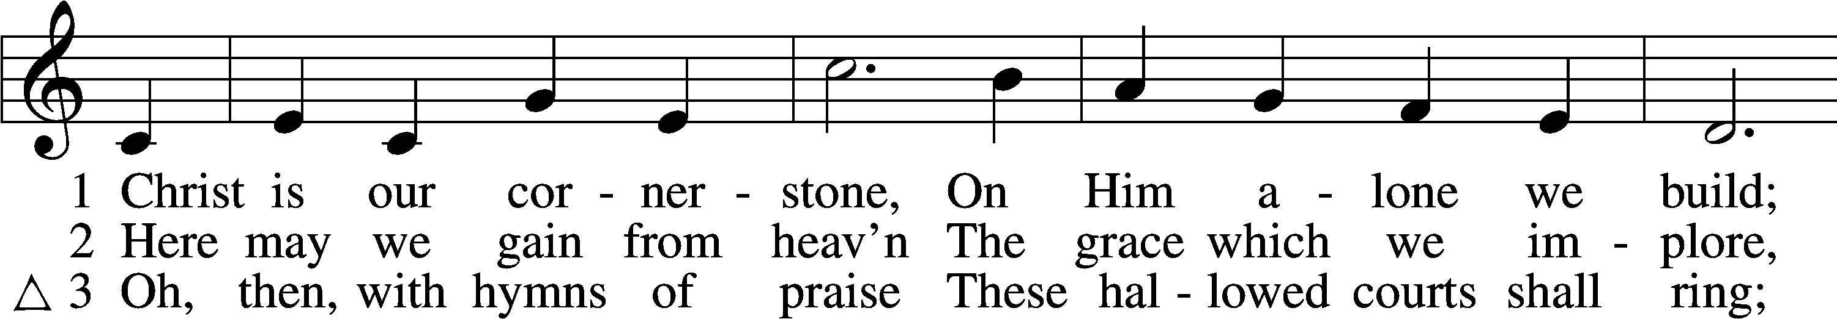
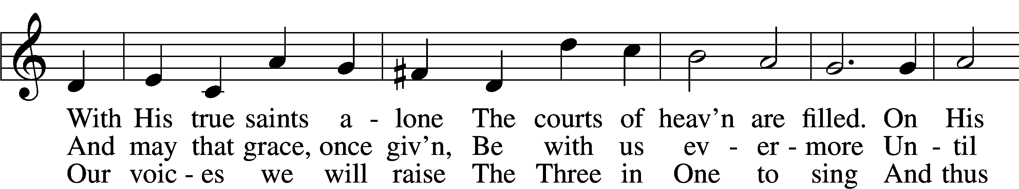
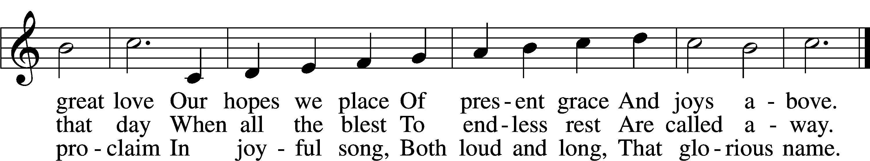
Text: Latin, c. 8th cent.; tr. John Chandler, 1806–76, alt.
Tune: John Darwall, 1731–89
Text and tune: Public domain

Stand

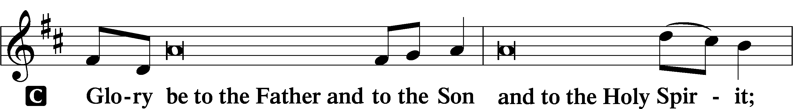
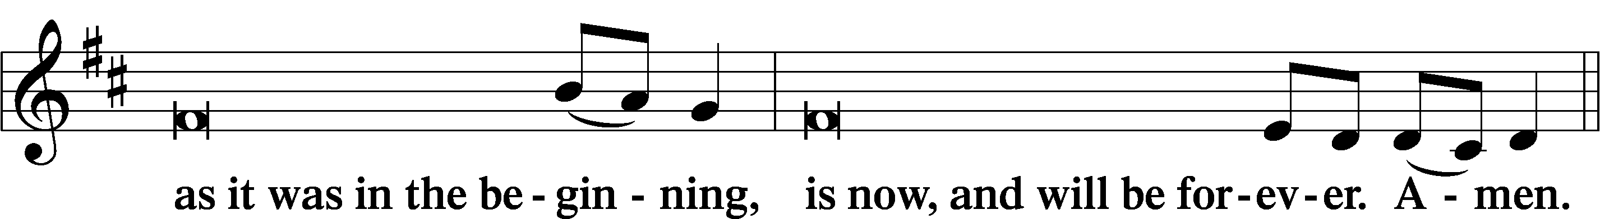
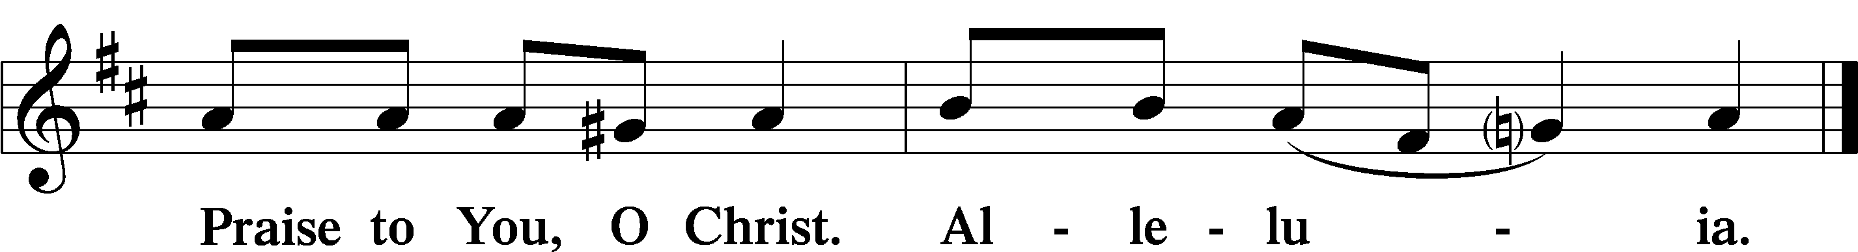

Psalmody

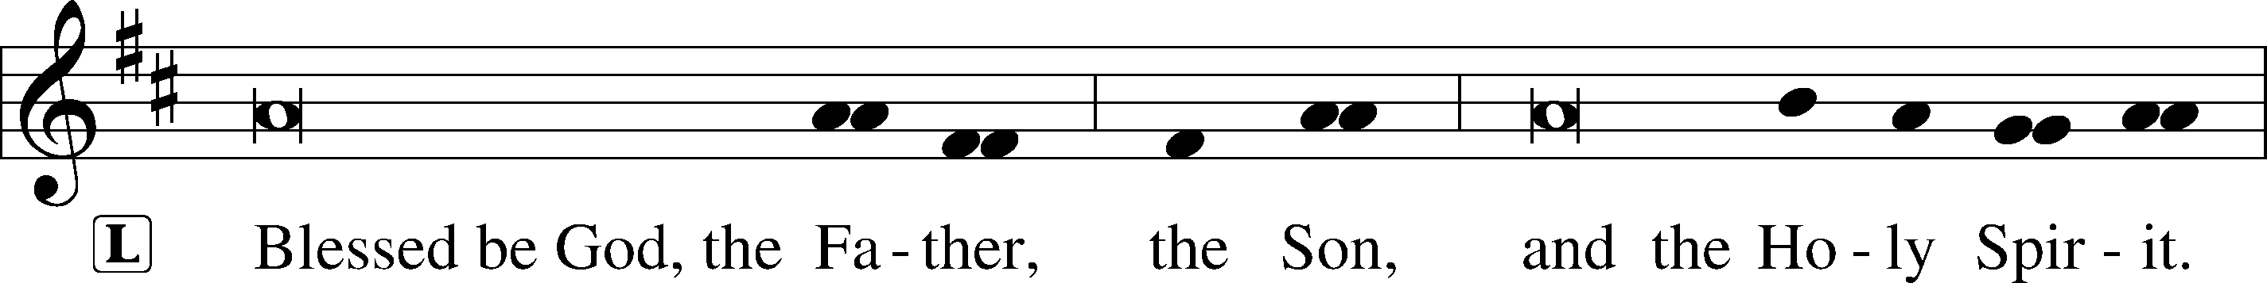

Venite LSB 220
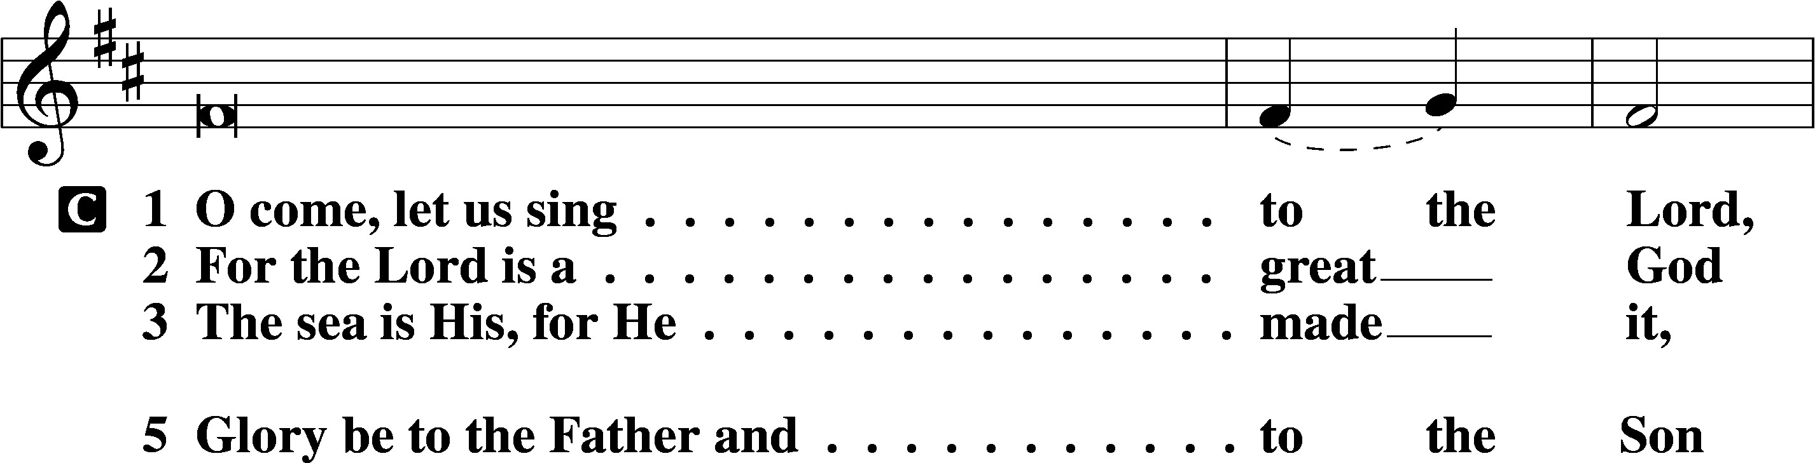
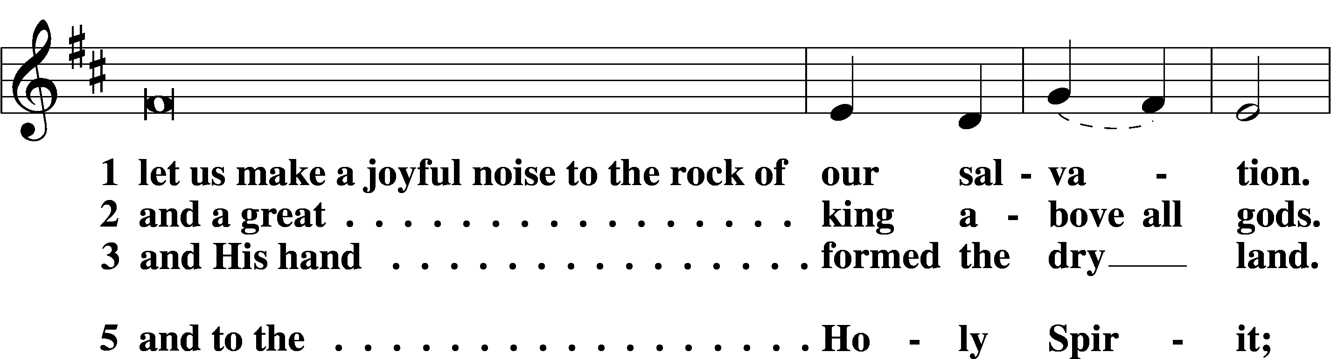
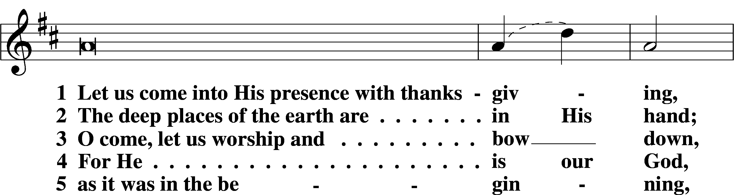
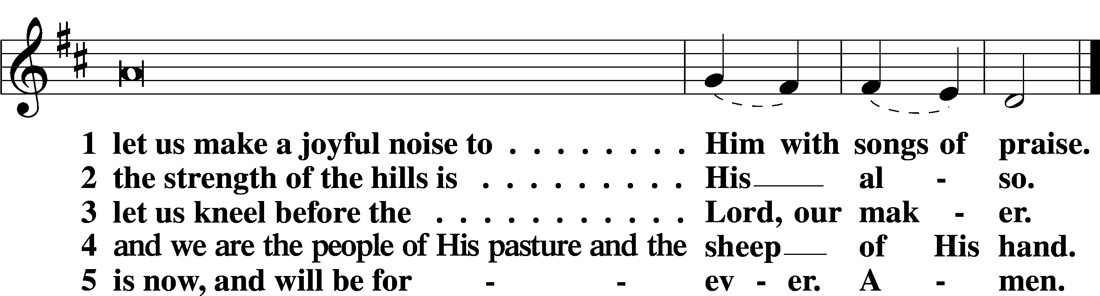

Additional Psalms Psalm 130; antiphon: v. 7
My Soul Waits for the Lord
1Out of the depths
I cry to you, O Lord!
2O Lord, hear my voice!
Let your ears be attentive
to the voice of my pleas for mercy!
3If you, O Lord, should mark iniquities,
O Lord, who could stand?
4But with you there is forgiveness,
that you may be feared.
5I wait for the Lord, my soul waits,
and in his word I hope;
6my soul waits for the Lord
more than watchmen for the morning,
more than watchmen for the morning.
7O Israel, hope in the Lord!
For with the Lord there is steadfast love,
and with him is plentiful redemption.
8And he will redeem Israel
from all his iniquities.

Sit

Office Hymn: 850 God of Grace and God of Glory
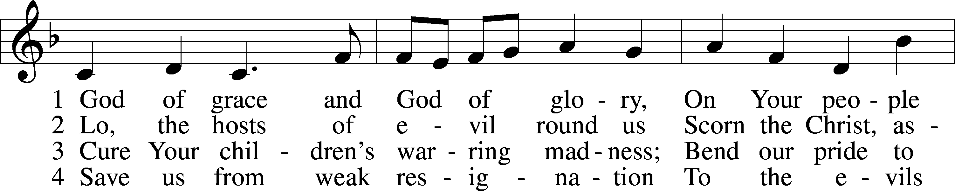
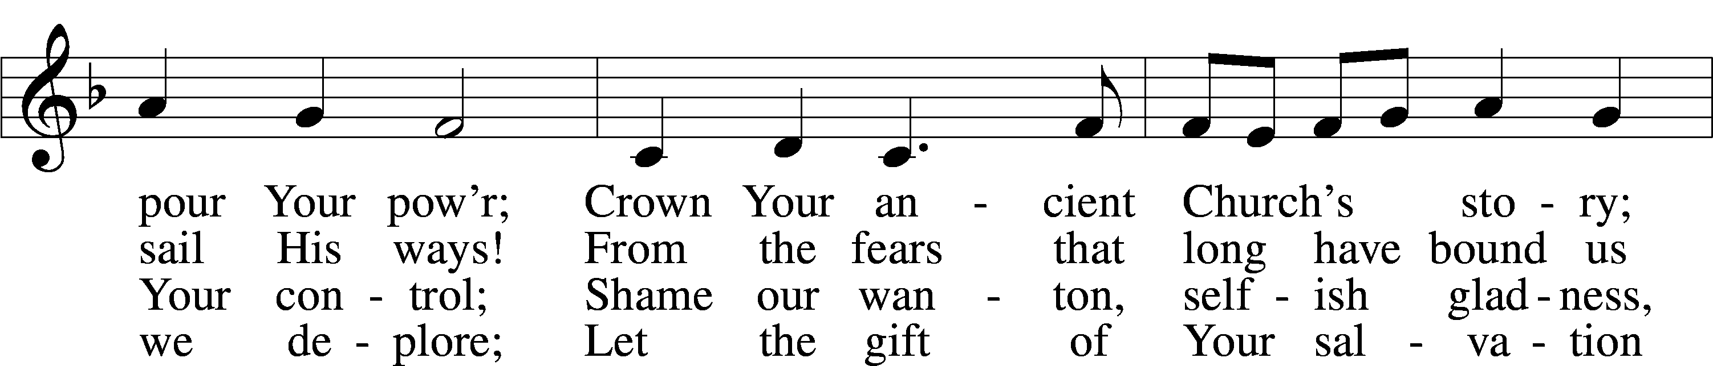
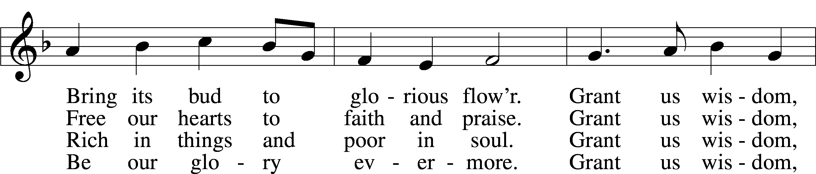
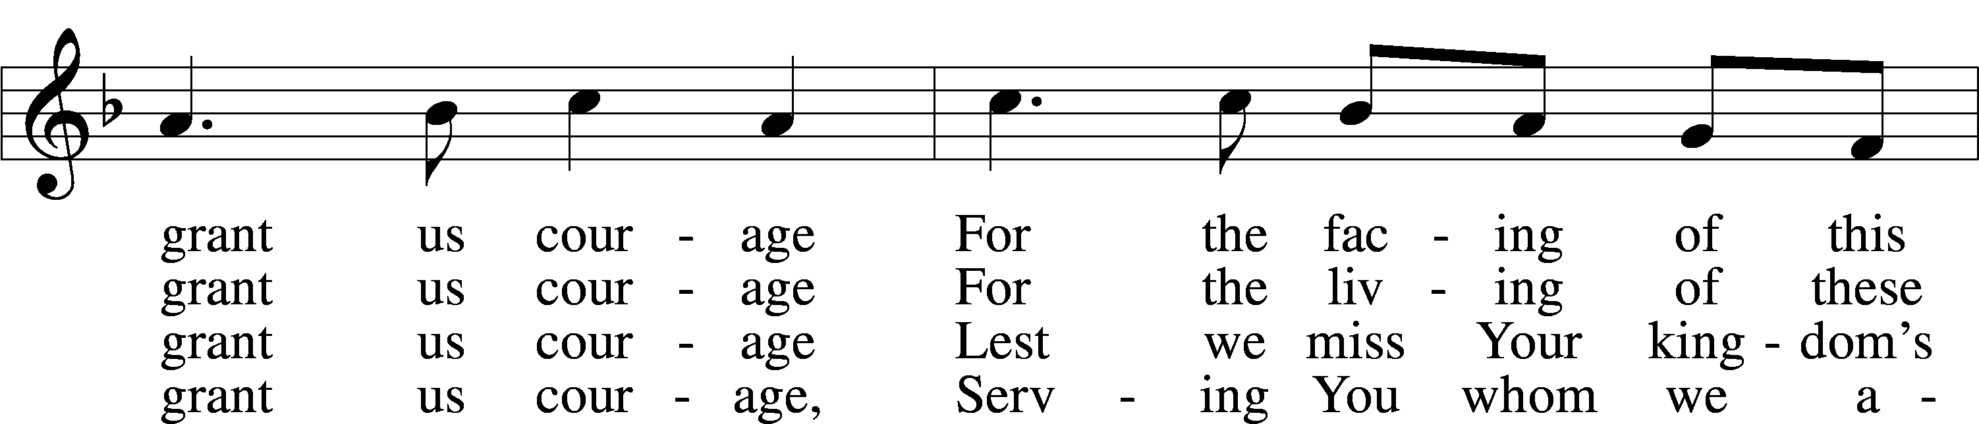
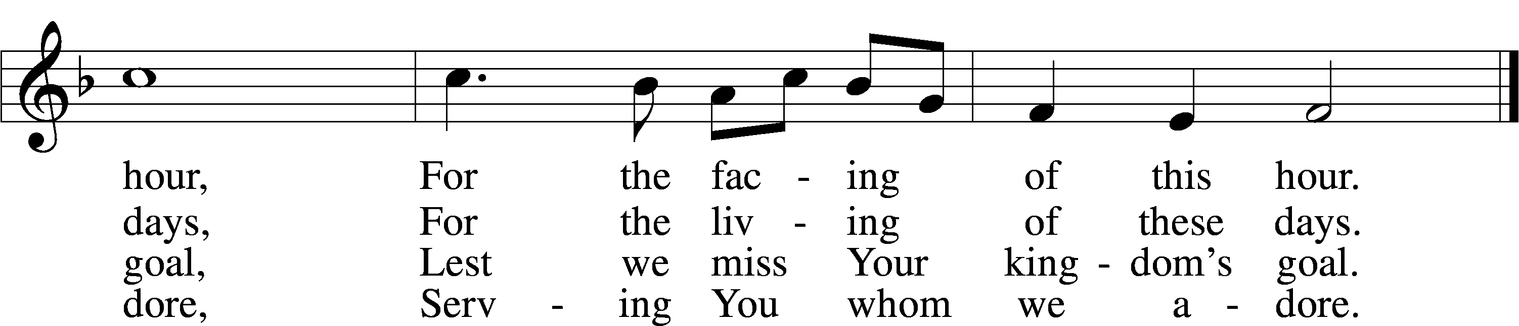
Text: Harry Emerson Fosdick, 1878–1969
Tune: John Hughes, 1873–1932
Text and tune: Public domain

Readings

Reading Genesis 3:8–15
L A reading from Genesis, chapter 3.

8They heard the sound of the Lord God walking in the garden in the cool of the day, and the man and his wife hid themselves from the presence of the Lord God among the trees of the garden. 9But the Lord God called to the man and said to him, “Where are you?” 10And he said, “I heard the sound of you in the garden, and I was afraid, because I was naked, and I hid myself.” 11He said, “Who told you that you were naked? Have you eaten of the tree of which I commanded you not to eat?” 12The man said, “The woman whom you gave to be with me, she gave me fruit of the tree, and I ate.” 13Then the Lord God said to the woman, “What is this that you have done?” The woman said, “The serpent deceived me, and I ate.”
14The Lord God said to the serpent,
“Because you have done this,
cursed are you above all livestock
and above all beasts of the field;
on your belly you shall go,
and dust you shall eat
all the days of your life.
15I will put enmity between you and the woman,
and between your offspring and her offspring;
he shall bruise your head,
and you shall bruise his heel.”

L O Lord, have mercy on us.
C Thanks be to God.

Reading 2 Corinthians 4:13—5:1
L A reading from 2 Corinthians, chapter 4.

13Since we have the same spirit of faith according to what has been written, “I believed, and so I spoke,” we also believe, and so we also speak, 14knowing that he who raised the Lord Jesus will raise us also with Jesus and bring us with you into his presence. 15For it is all for your sake, so that as grace extends to more and more people it may increase thanksgiving, to the glory of God.
16So we do not lose heart. Though our outer nature is wasting away, our inner nature is being renewed day by day. 17For this slight momentary affliction is preparing for us an eternal weight of glory beyond all comparison, 18as we look not to the things that are seen but to the things that are unseen. For the things that are seen are transient, but the things that are unseen are eternal.
Our Heavenly Dwelling
1For we know that if the tent, which is our earthly home, is destroyed, we have a building from God, a house not made with hands, eternal in the heavens.

L O Lord, have mercy on us.
C Thanks be to God.

Reading Mark 3:20–35
L A reading from Mark, chapter 3.

20Then [Jesus] went home, and the crowd gathered again, so that they could not even eat. 21And when his family heard it, they went out to seize him, for they were saying, “He is out of his mind.”
Blasphemy Against the Holy Spirit
22And the scribes who came down from Jerusalem were saying, “He is possessed by Beelzebul,” and “by the prince of demons he casts out the demons.” 23And he called them to him and said to them in parables, “How can Satan cast out Satan? 24If a kingdom is divided against itself, that kingdom cannot stand. 25And if a house is divided against itself, that house will not be able to stand. 26And if Satan has risen up against himself and is divided, he cannot stand, but is coming to an end. 27But no one can enter a strong man’s house and plunder his goods, unless he first binds the strong man. Then indeed he may plunder his house.
28“Truly, I say to you, all sins will be forgiven the children of man, and whatever blasphemies they utter, 29but whoever blasphemes against the Holy Spirit never has forgiveness, but is guilty of an eternal sin”— 30for they had said, “He has an unclean spirit.”
Jesus’ Mother and Brothers
31And his mother and his brothers came, and standing outside they sent to him and called him. 32And a crowd was sitting around him, and they said to him, “Your mother and your brothers are outside, seeking you.” 33And he answered them, “Who are my mother and my brothers?” 34And looking about at those who sat around him, he said, “Here are my mother and my brothers! 35Whoever does the will of God, he is my brother and sister and mother.”

L O Lord, have mercy on us.
C Thanks be to God.

Responsory LSB 221
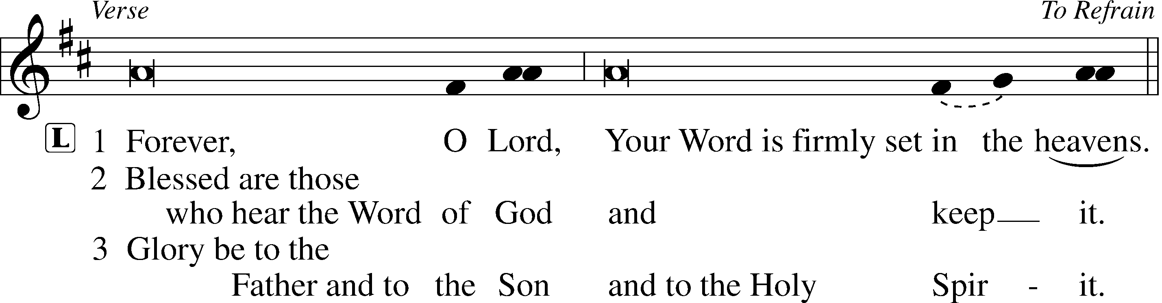
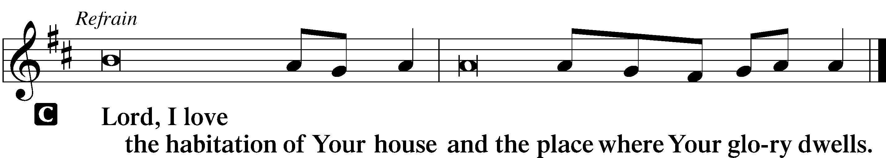

Hymn: 714 Who Trusts in God a Strong Abode
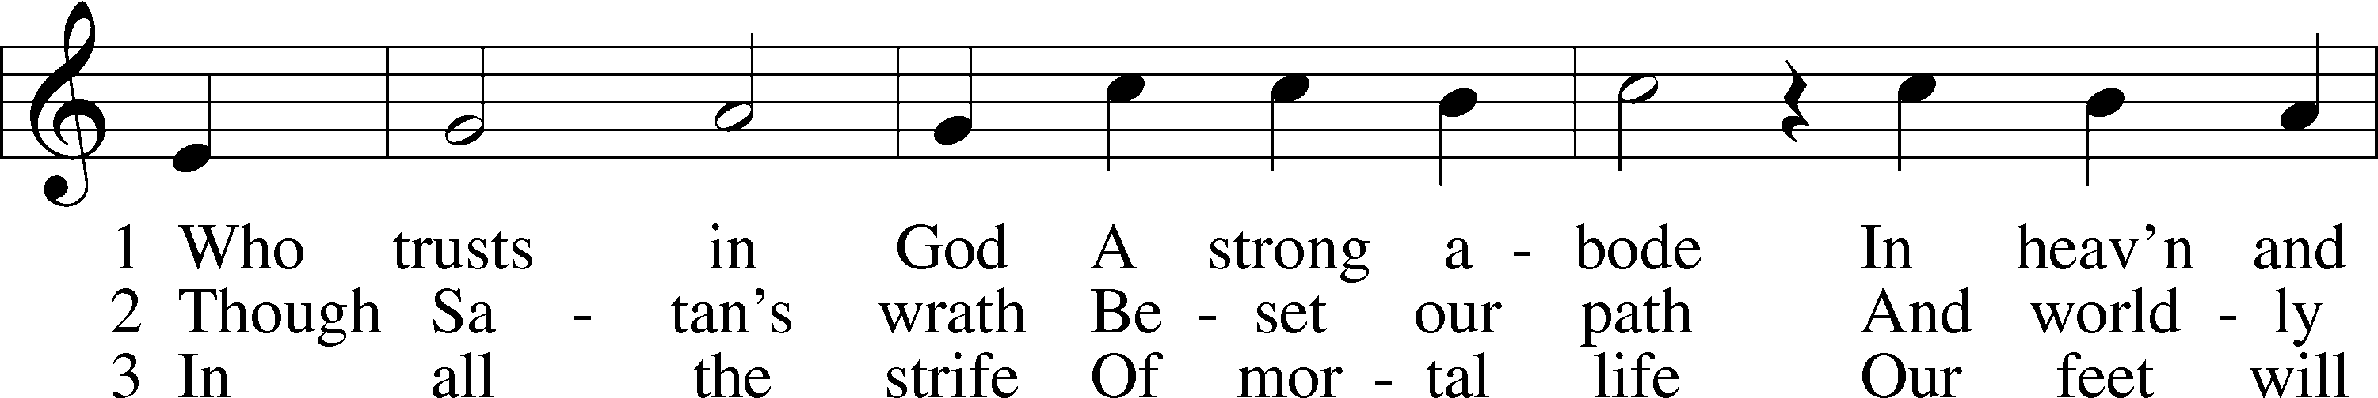
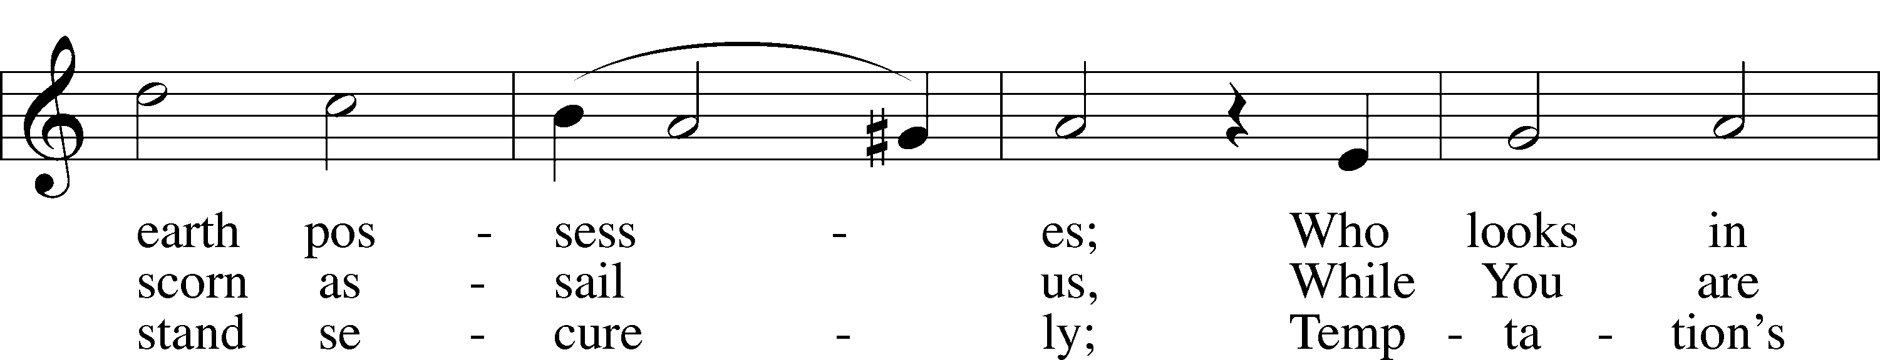
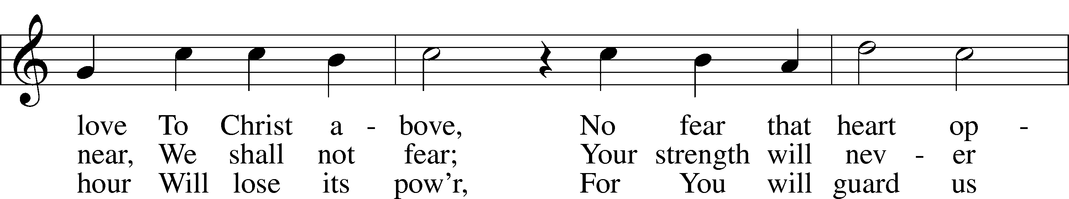
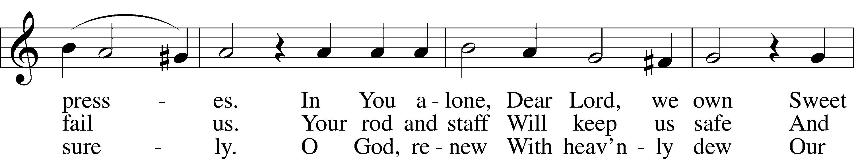
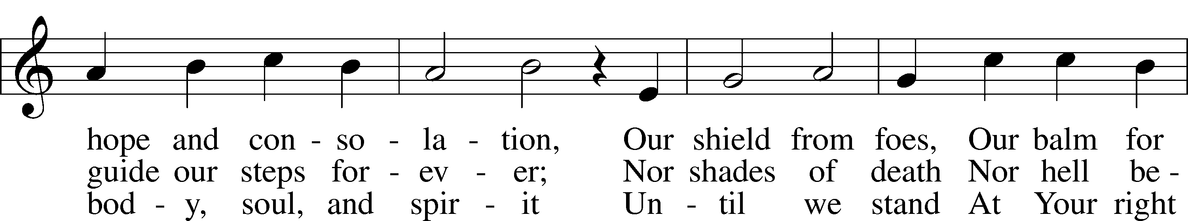
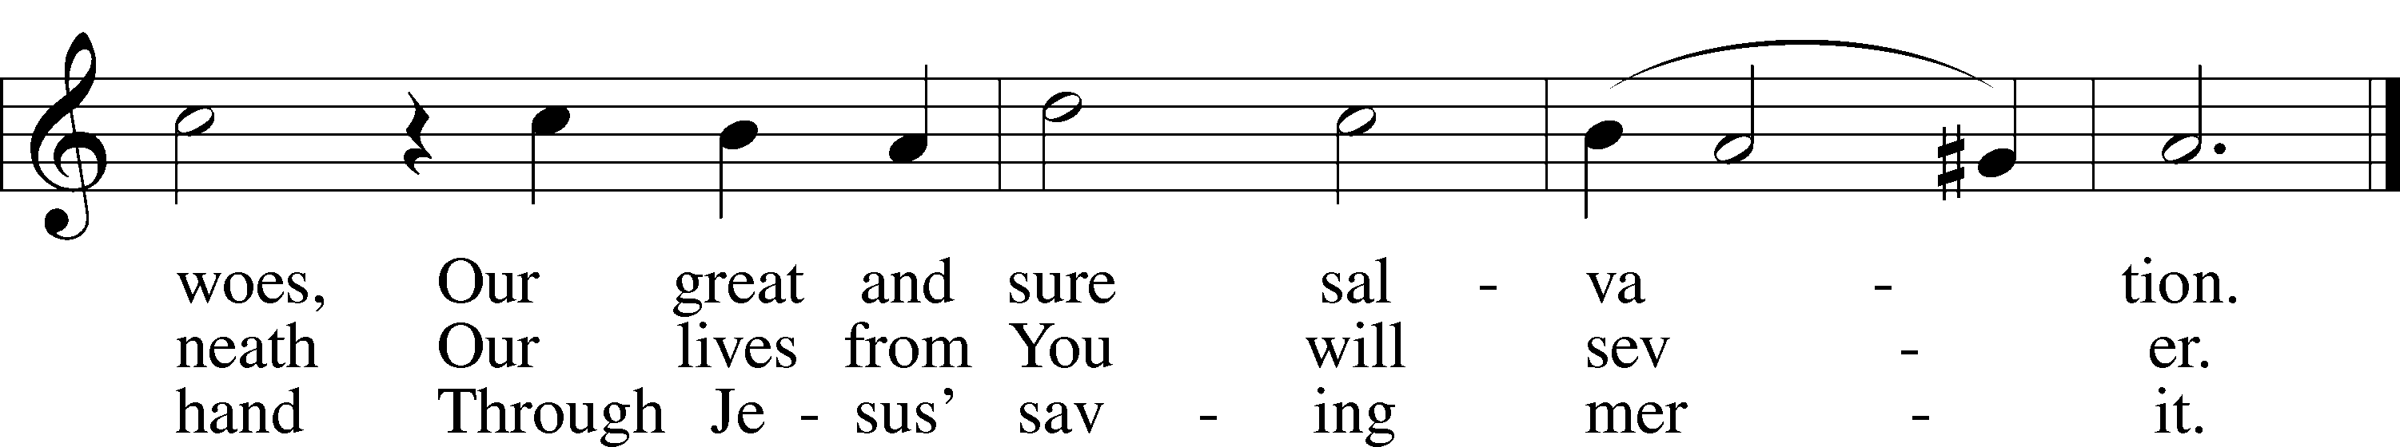
Text: tr. Benjamin H. Kennedy, 1804–99, alt.; (st. 1): Joachim Magdeburg, c. 1525–after 1587; (sts. 2–3): Harmonia cantionum, 1597, Leipzig
Tune: Claudin de Sermisy, c. 1490–1562
Text and tune: Public domain

Sermon

Canticle

Stand

Te Deum LSB 223
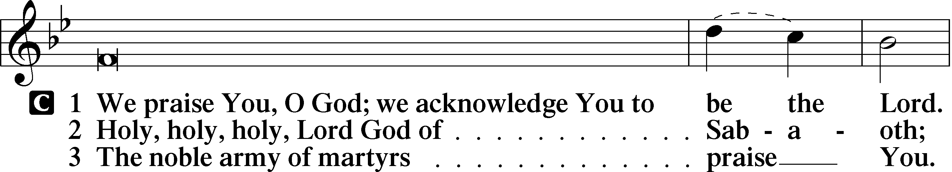
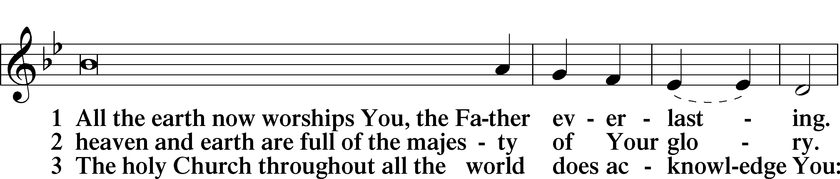
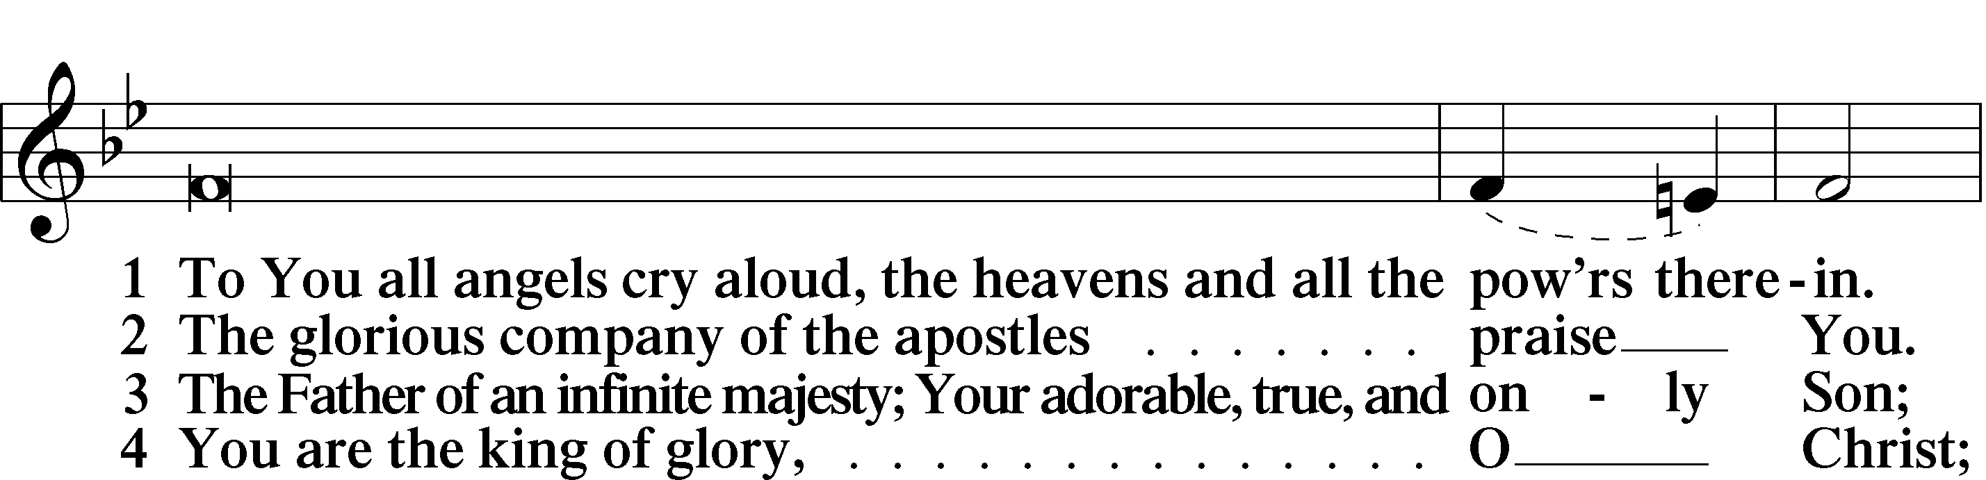
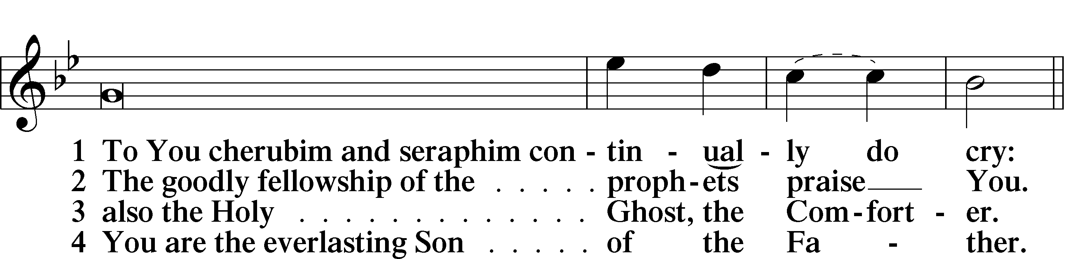
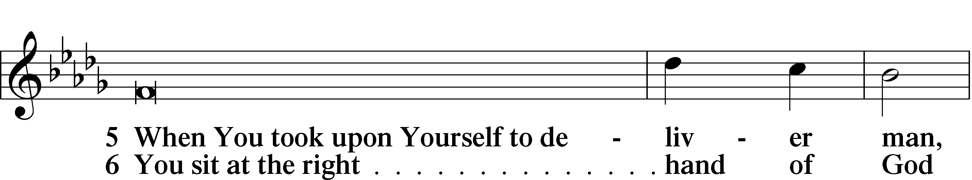
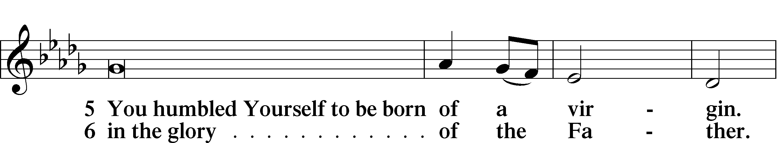
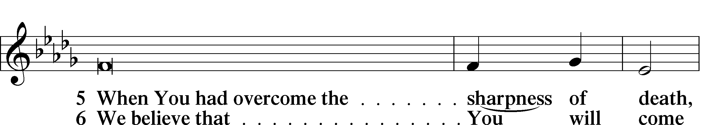
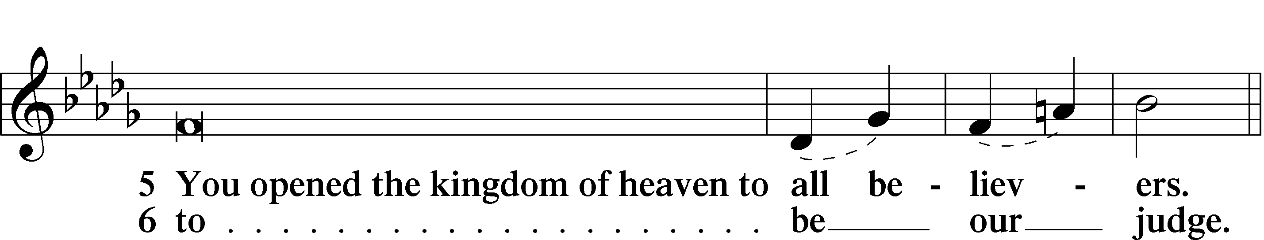
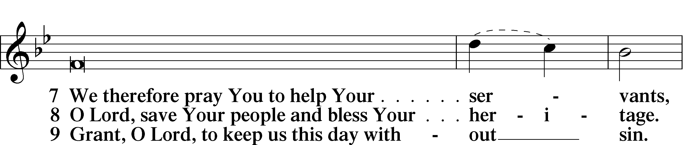
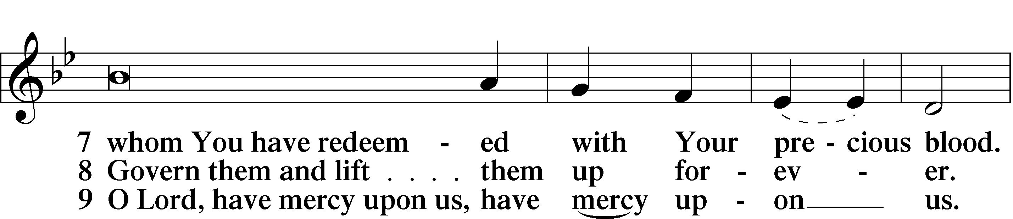
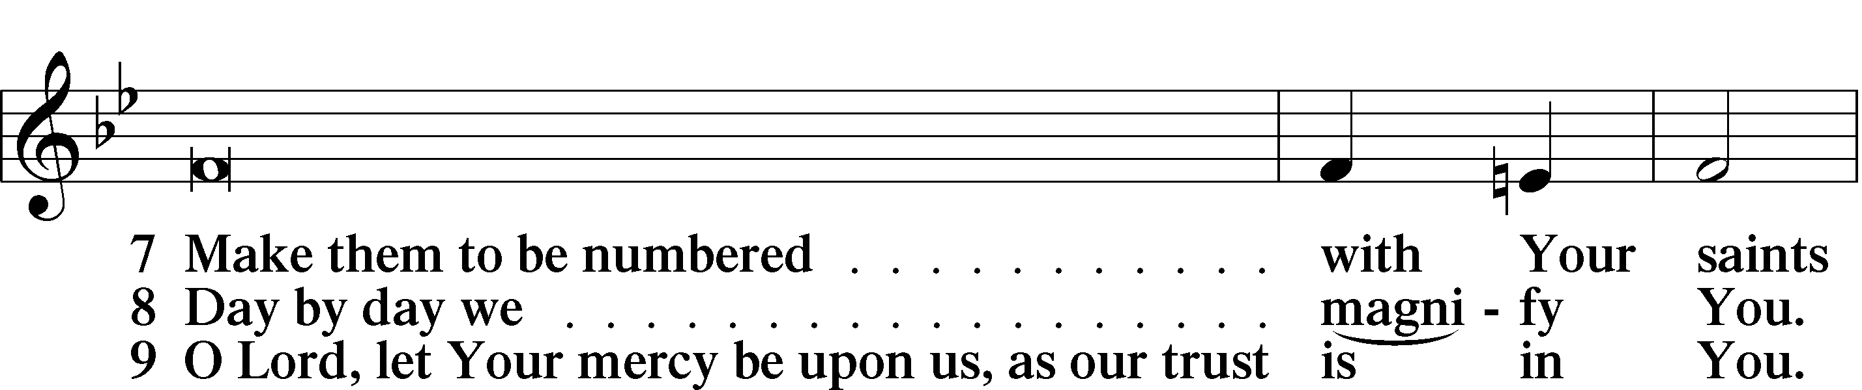
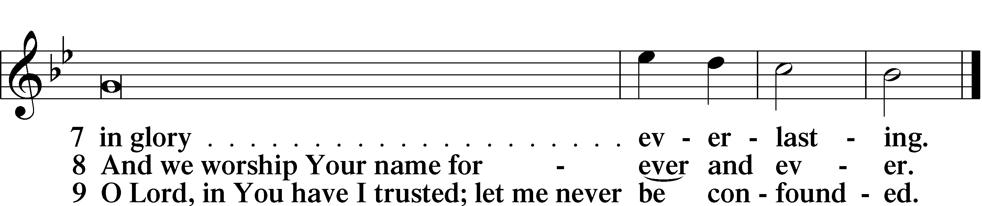

Sit

Offering

Prayer

Kneel/Stand

Kyrie LSB 227
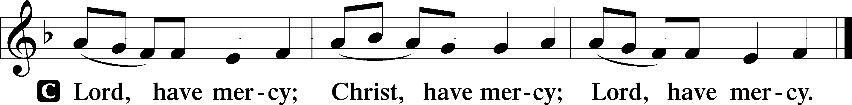

Lord’s Prayer
C Our Father who art in heaven,
hallowed be Thy name,
Thy kingdom come,
Thy will be done on earth
as it is in heaven;
give us this day our daily bread;
and forgive us our trespasses
as we forgive those
who trespass against us;
and lead us not into temptation,
but deliver us from evil.
For Thine is the kingdom
and the power and the glory
forever and ever. Amen.

Collects

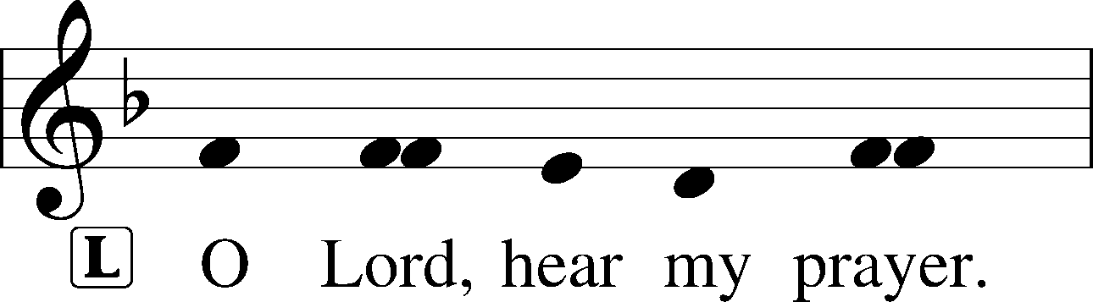
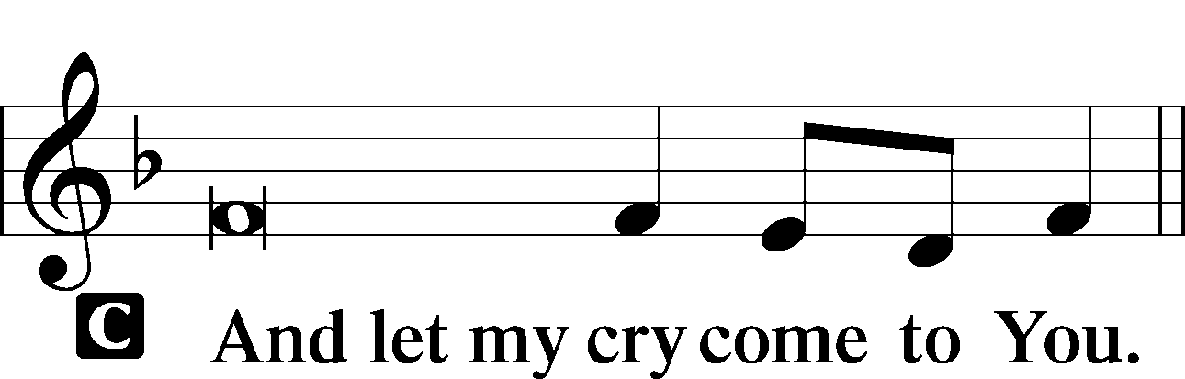

Collect of the Day
Almighty and eternal God, Your Son Jesus triumphed over the prince of demons and freed us from bondage to sin. Help us to stand firm against every assault of Satan, and enable us always to do Your will; through Jesus Christ, our Lord, who lives and reigns with You and the Holy Spirit, one God, now and forever.
C Amen.

Collect for Grace
L O Lord, our heavenly Father, almighty and everlasting God, You have safely brought us to the beginning of this day. Defend us in the same with Your mighty power and grant that this day we fall into no sin, neither run into any kind of danger, but that all our doings, being ordered by Your governance, may be righteous in Your sight; through Jesus Christ, Your Son, our Lord, who lives and reigns with You and the Holy Spirit, one God, now and forever.
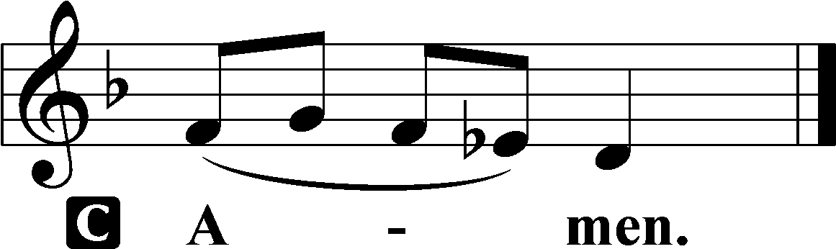

Stand

Benedicamus LSB 228
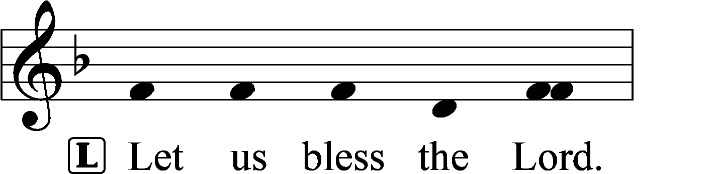
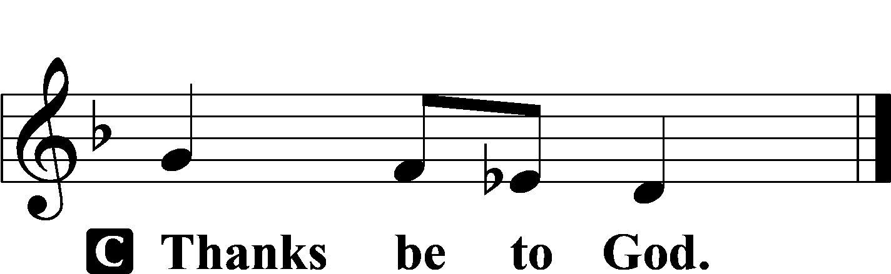

Benediction LSB 228
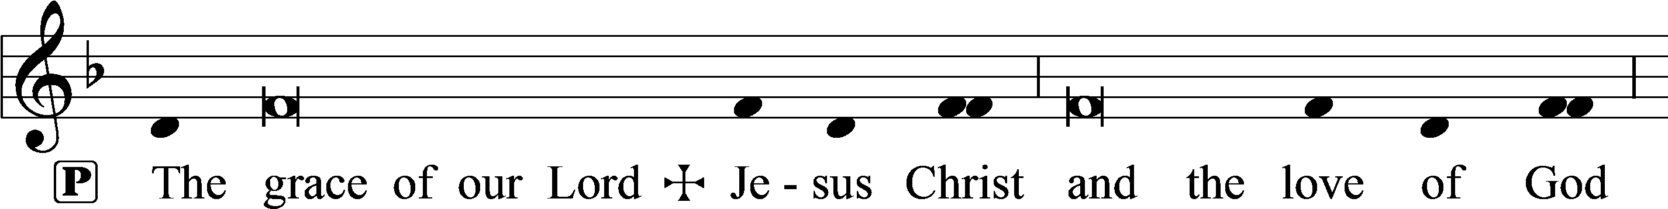
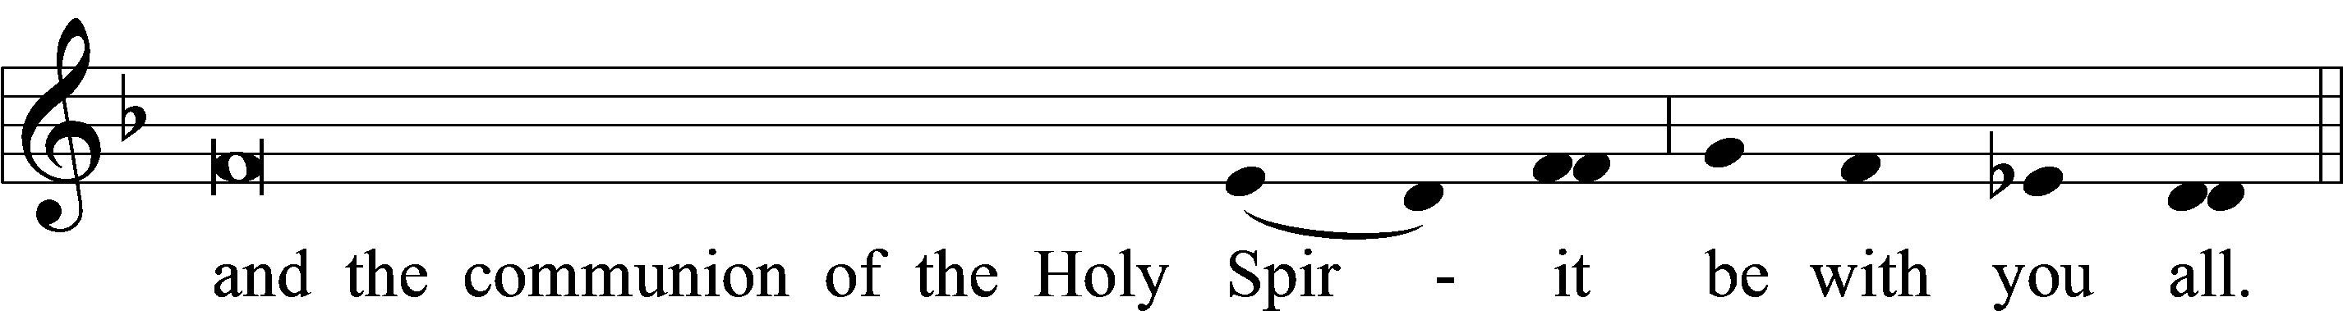

Hymn to Depart: 919 Abide, O Dearest Jesus
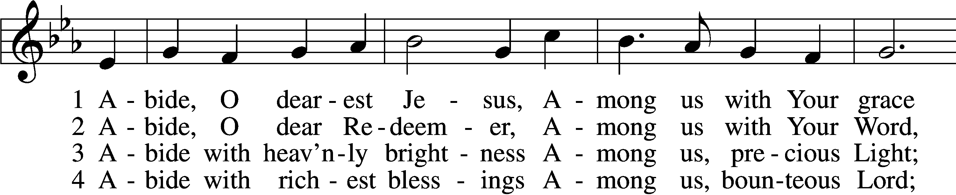
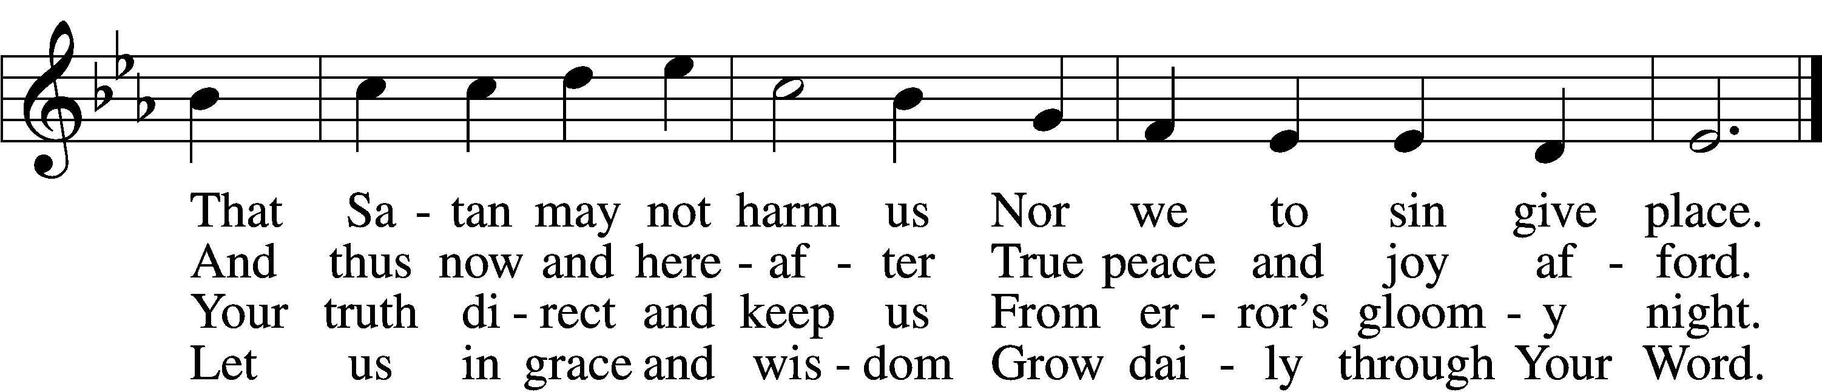

5 Abide with Your protection
Among us, Lord, our strength,
Lest world and Satan fell us
And overcome at length.

6 Abide, O faithful Savior,
Among us with Your love;
Grant steadfastness and help us
To reach our home above.
Text: Josua Stegmann, 1588–1632; tr. August Crull, 1845–1923, alt.
Tune: Melchior Vulpius, c. 1570–1615
Text and tune: Public domain

Acknowledgments
Matins from Lutheran Service Book
Unless otherwise indicated, Scripture quotations are from the ESV® Bible (The Holy Bible, English Standard Version®), copyright © 2001 by Crossway, a publishing ministry of Good News Publishers. Used by permission. All rights reserved.
Created by Lutheran Service Builder © 2024 Concordia Publishing House.

