Divine Service 3

11th Sunday after Pentecost

August 4.2024

Confession and Absolution

Hymn of Invocation: 918 Guide Me, O Thou Great Redeemer
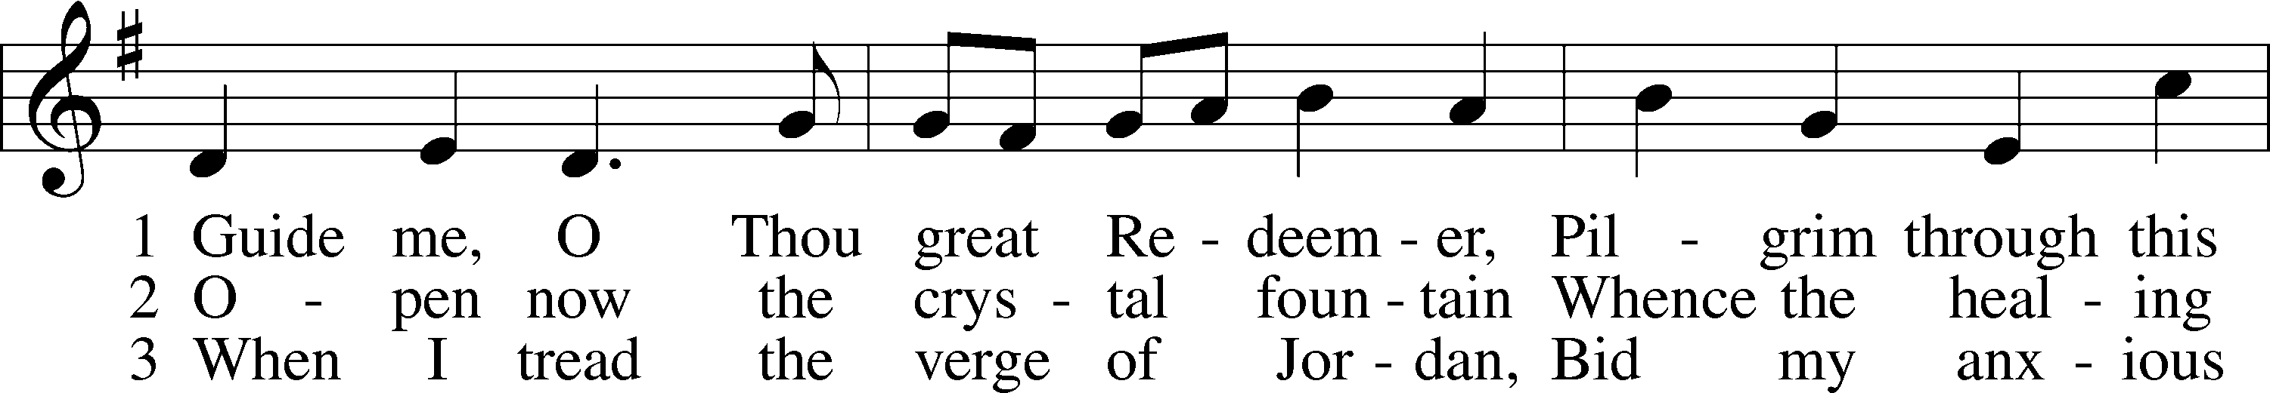
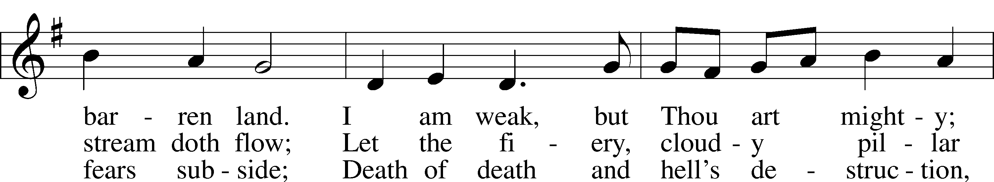
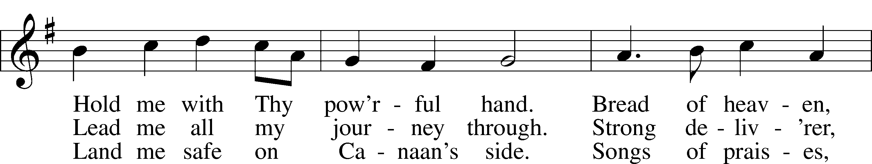
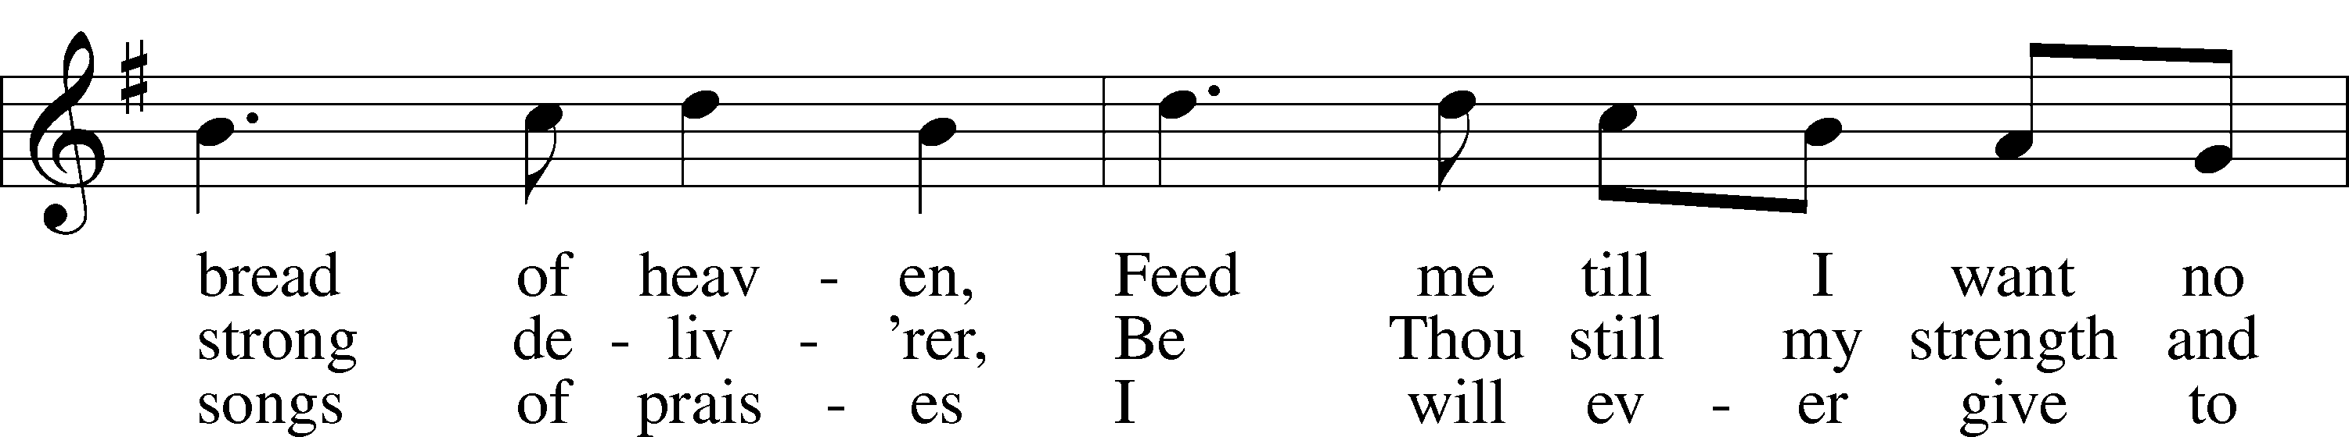
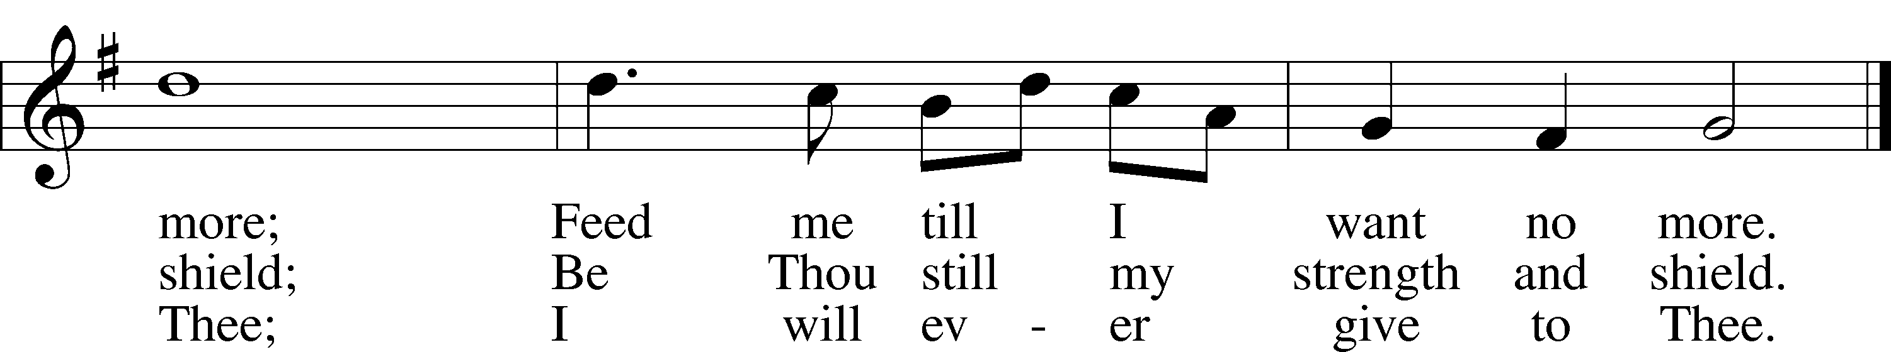
Text: William Williams, 1717–91, abr.; (st. 1): tr. Peter Williams, 1722–96, alt.; (sts. 2–3): tr. William Williams, 1717–91
Tune: John Hughes, 1873–1932
Text and tune: Public domain

Stand

The sign of the cross may be made by all in remembrance of their Baptism.

P In the name of the Father and of the T Son and of the Holy Spirit.
C Amen.

P Beloved in the Lord! Let us draw near with a true heart and confess our sins unto God our Father, beseeching Him in the name of our Lord Jesus Christ to grant us forgiveness.

P Our help is in the name of the Lord,
C who made heaven and earth.
P I said, I will confess my transgressions unto the Lord,
C and You forgave the iniquity of my sin.

Kneel/Stand

Silence for reflection on God’s Word and for self-examination.

P O almighty God, merciful Father,
C I, a poor, miserable sinner, confess unto You all my sins and iniquities with which I have ever offended You and justly deserved Your temporal and eternal punishment. But I am heartily sorry for them and sincerely repent of them, and I pray You of Your boundless mercy and for the sake of the holy, innocent, bitter sufferings and death of Your beloved Son, Jesus Christ, to be gracious and merciful to me, a poor, sinful being.

P Upon this your confession, I, by virtue of my office, as a called and ordained servant of the Word, announce the grace of God unto all of you, and in the stead and by the command of my Lord Jesus Christ I forgive you all your sins in the name of the Father and of the T Son and of the Holy Spirit.
C Amen.

Stand

Service of the Word

Introit Psalm 78:23–25; antiphon: v. 72
With upright heart he shepherded them
and guided them with his skillful hand.
He commanded the skies above
and opened the doors of heaven,
and he rained down on them manna to eat
and gave them the grain of heaven.
Man ate of the bread of the angels;
he sent them food in abundance.
Glory be to the Father and to the Son
and to the Holy Spirit;
as it was in the beginning,
is now, and will be forever. Amen.
With upright heart he shepherded them
and guided them with his skillful hand.

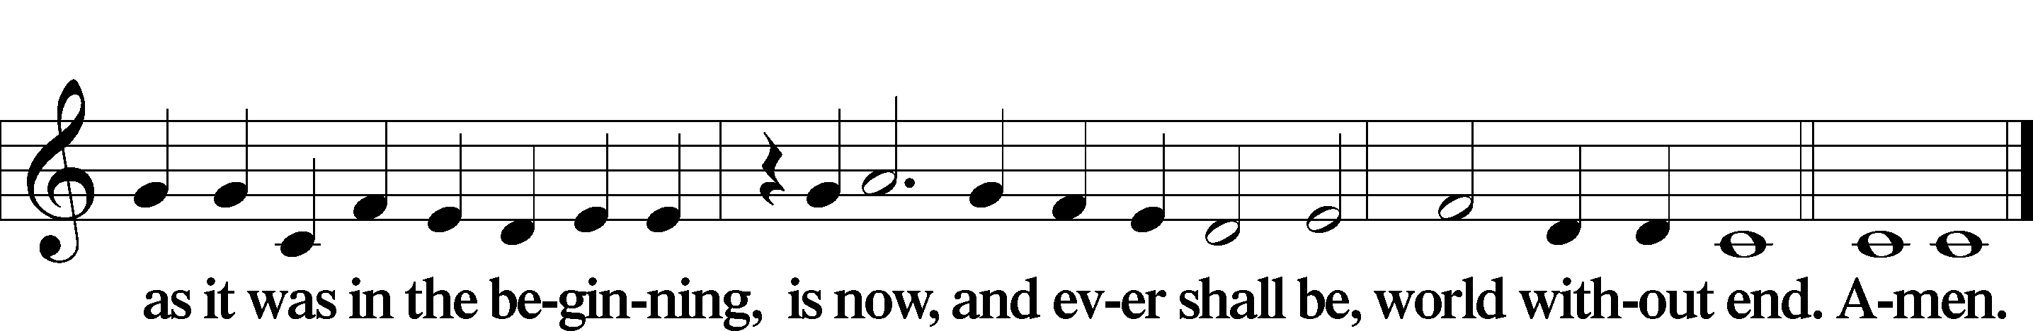

Kyrie LSB 186
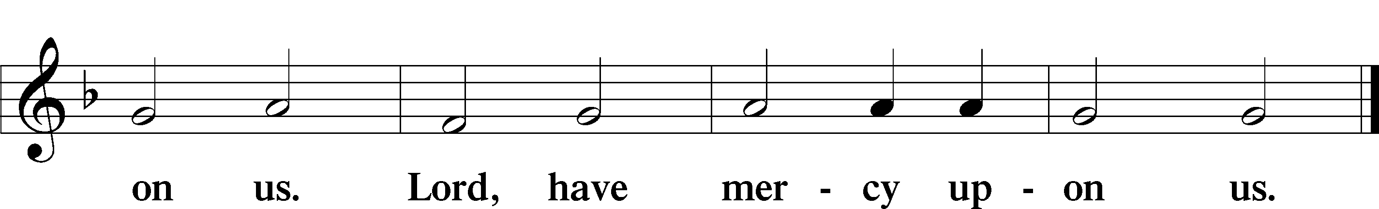

Gloria in Excelsis LSB 187
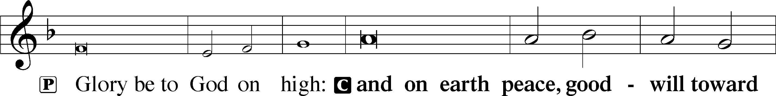
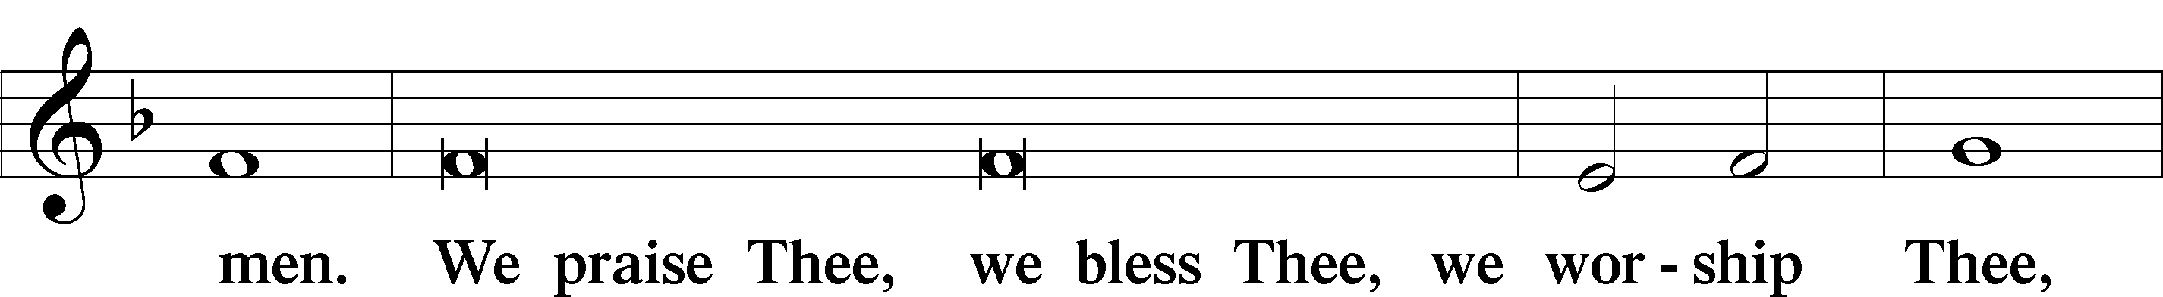
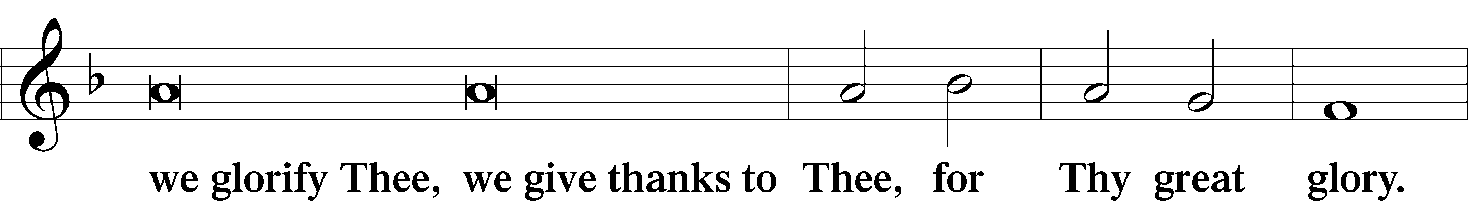
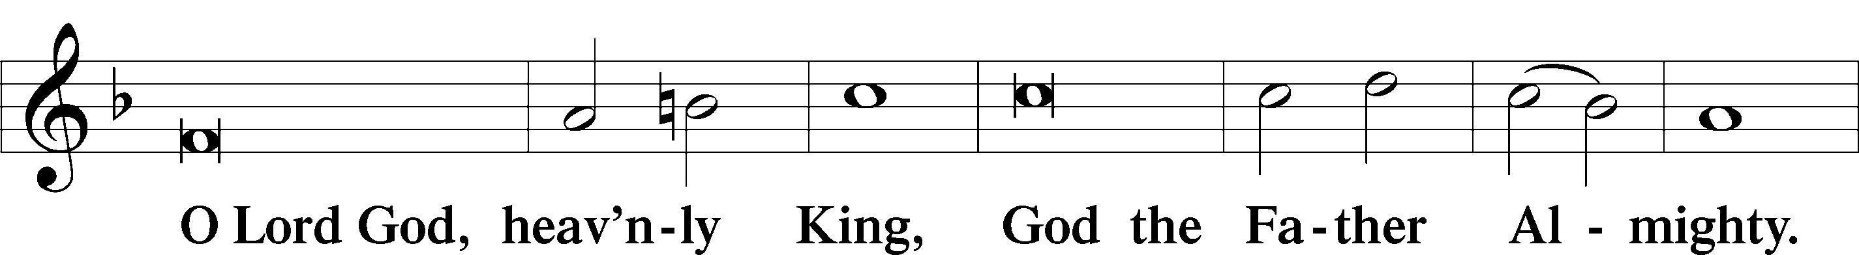
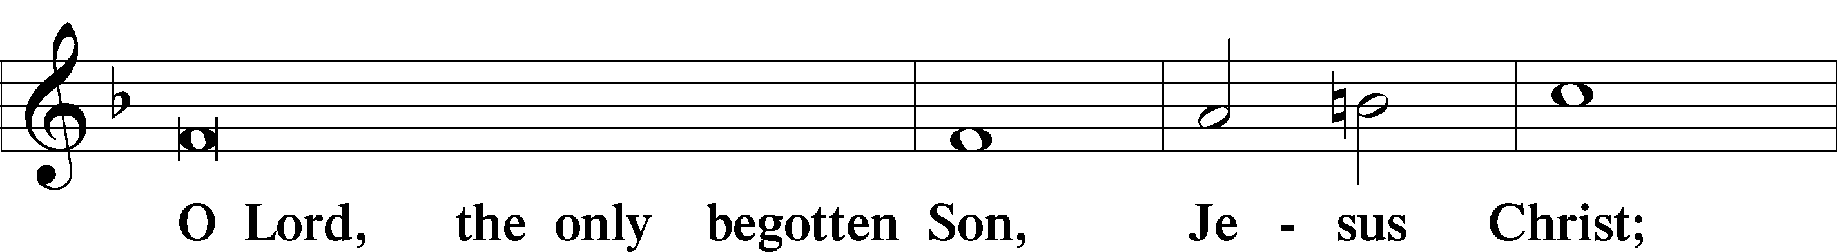
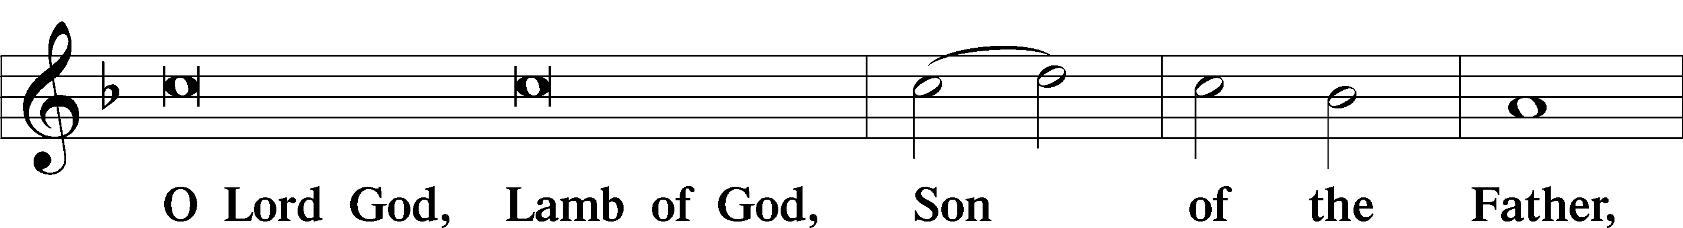
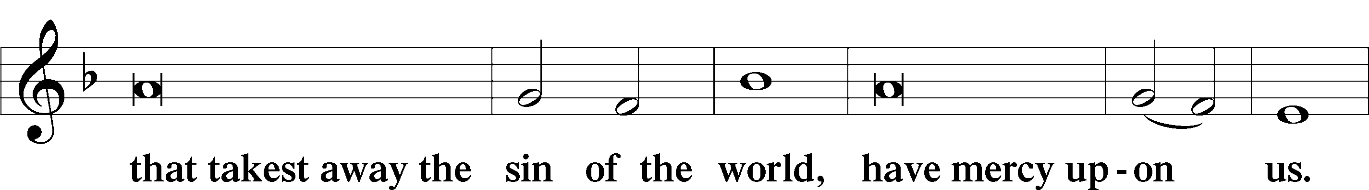
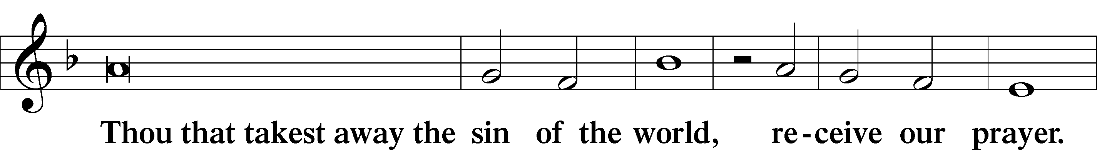
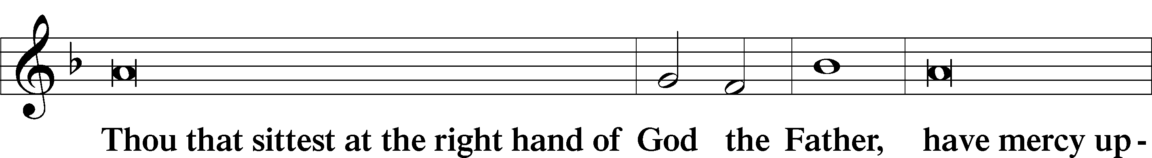
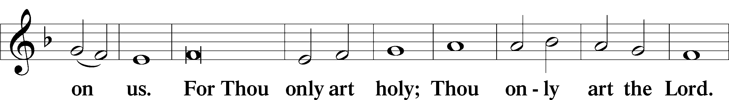
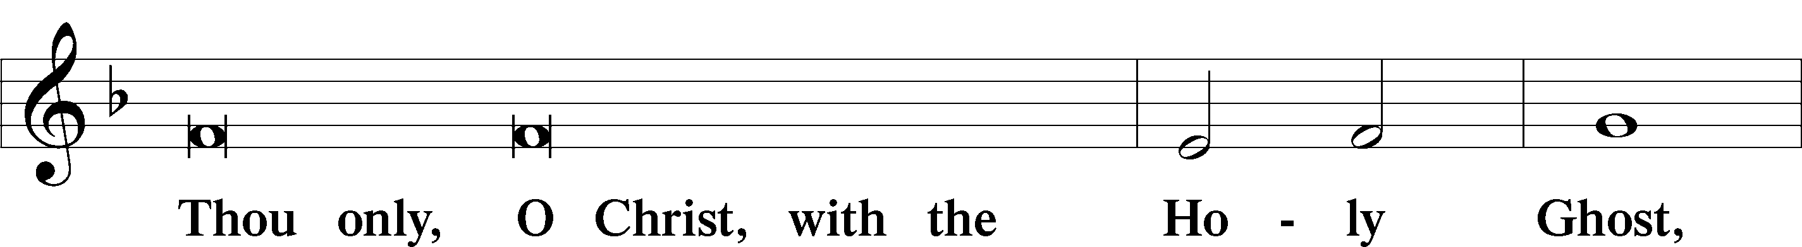
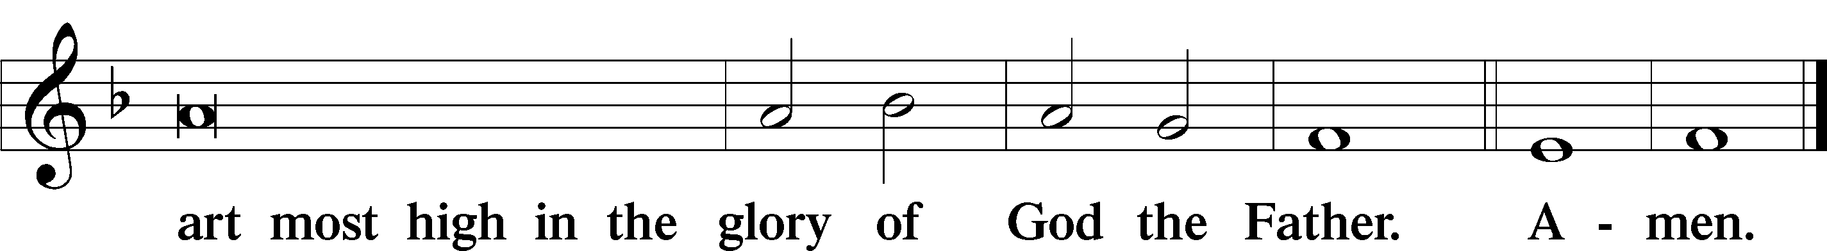

Salutation and Collect of the Day
P The Lord be with you.
C And with thy spirit.

P Let us pray.
Merciful Father, You gave Your Son Jesus as the heavenly bread of life. Grant us faith to feast on Him in Your Word and Sacraments that we may be nourished unto life everlasting; through the same Jesus Christ, our Lord, who lives and reigns with You and the Holy Spirit, one God, now and forever.

C Amen.

Sit

Old Testament Reading Exodus 16:2–15
2The whole congregation of the people of Israel grumbled against Moses and Aaron in the wilderness, 3and the people of Israel said to them, “Would that we had died by the hand of the Lord in the land of Egypt, when we sat by the meat pots and ate bread to the full, for you have brought us out into this wilderness to kill this whole assembly with hunger.”
4Then the Lord said to Moses, “Behold, I am about to rain bread from heaven for you, and the people shall go out and gather a day’s portion every day, that I may test them, whether they will walk in my law or not. 5On the sixth day, when they prepare what they bring in, it will be twice as much as they gather daily.” 6So Moses and Aaron said to all the people of Israel, “At evening you shall know that it was the Lord who brought you out of the land of Egypt, 7and in the morning you shall see the glory of the Lord, because he has heard your grumbling against the Lord. For what are we, that you grumble against us?” 8And Moses said, “When the Lord gives you in the evening meat to eat and in the morning bread to the full, because the Lord has heard your grumbling that you grumble against him—what are we? Your grumbling is not against us but against the Lord.”
9Then Moses said to Aaron, “Say to the whole congregation of the people of Israel, ‘Come near before the Lord, for he has heard your grumbling.’” 10And as soon as Aaron spoke to the whole congregation of the people of Israel, they looked toward the wilderness, and behold, the glory of the Lord appeared in the cloud. 11And the Lord said to Moses, 12“I have heard the grumbling of the people of Israel. Say to them, ‘At twilight you shall eat meat, and in the morning you shall be filled with bread. Then you shall know that I am the Lord your God.’”
13In the evening quail came up and covered the camp, and in the morning dew lay around the camp. 14And when the dew had gone up, there was on the face of the wilderness a fine, flake-like thing, fine as frost on the ground. 15When the people of Israel saw it, they said to one another, “What is it?” For they did not know what it was. And Moses said to them, “It is the bread that the Lord has given you to eat.”

A This is the Word of the Lord.
C Thanks be to God.

Psalm Psalm 145:10–21; antiphon: v. 15
10All your works shall give thanks to you, O Lord,
and all your saints shall bless you!
11They shall speak of the glory of your kingdom
and tell of your power,
12to make known to the children of man your mighty deeds,
and the glorious splendor of your kingdom.
13Your kingdom is an everlasting kingdom,
and your dominion endures throughout all generations.
The Lord is faithful in all his words
and kind in all his works.
14The Lord upholds all who are falling
and raises up all who are bowed down.
15The eyes of all look to you,
and you give them their food in due season.
16You open your hand;
you satisfy the desire of every living thing.
17The Lord is righteous in all his ways
and kind in all his works.
18The Lord is near to all who call on him,
to all who call on him in truth.
19He fulfills the desire of those who fear him;
he also hears their cry and saves them.
20The Lord preserves all who love him,
but all the wicked he will destroy.
21My mouth will speak the praise of the Lord,
and let all flesh bless his holy name forever and ever.

Epistle Ephesians 4:1–16
Unity in the Body of Christ
1I therefore, a prisoner for the Lord, urge you to walk in a manner worthy of the calling to which you have been called, 2with all humility and gentleness, with patience, bearing with one another in love, 3eager to maintain the unity of the Spirit in the bond of peace. 4There is one body and one Spirit—just as you were called to the one hope that belongs to your call— 5one Lord, one faith, one baptism, 6one God and Father of all, who is over all and through all and in all. 7But grace was given to each one of us according to the measure of Christ’s gift. 8Therefore it says,
“When he ascended on high he led a host of captives,
and he gave gifts to men.”
9(In saying, “He ascended,” what does it mean but that he had also descended into the lower parts of the earth? 10He who descended is the one who also ascended far above all the heavens, that he might fill all things.) 11And he gave the apostles, the prophets, the evangelists, the pastors and teachers, 12to equip the saints for the work of ministry, for building up the body of Christ, 13until we all attain to the unity of the faith and of the knowledge of the Son of God, to mature manhood, to the measure of the stature of the fullness of Christ, 14so that we may no longer be children, tossed to and fro by the waves and carried about by every wind of doctrine, by human cunning, by craftiness in deceitful schemes. 15Rather, speaking the truth in love, we are to grow up in every way into him who is the head, into Christ, 16from whom the whole body, joined and held together by every joint with which it is equipped, when each part is working properly, makes the body grow so that it builds itself up in love.

A This is the Word of the Lord.
C Thanks be to God.

Stand

Alleluia LSB 190
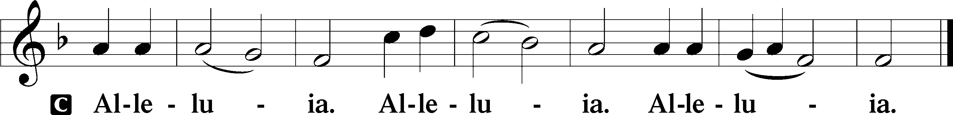

Holy Gospel John 6:22–35
P The Holy Gospel according to St. John, the sixth chapter.
C Glory be to Thee, O Lord.

I Am the Bread of Life
22On the next day the crowd that remained on the other side of the sea saw that there had been only one boat there, and that Jesus had not entered the boat with his disciples, but that his disciples had gone away alone. 23Other boats from Tiberias came near the place where they had eaten the bread after the Lord had given thanks. 24So when the crowd saw that Jesus was not there, nor his disciples, they themselves got into the boats and went to Capernaum, seeking Jesus.
25When they found him on the other side of the sea, they said to him, “Rabbi, when did you come here?” 26Jesus answered them, “Truly, truly, I say to you, you are seeking me, not because you saw signs, but because you ate your fill of the loaves. 27Do not labor for the food that perishes, but for the food that endures to eternal life, which the Son of Man will give to you. For on him God the Father has set his seal.” 28Then they said to him, “What must we do, to be doing the works of God?” 29Jesus answered them, “This is the work of God, that you believe in him whom he has sent.” 30So they said to him, “Then what sign do you do, that we may see and believe you? What work do you perform? 31Our fathers ate the manna in the wilderness; as it is written, ‘He gave them bread from heaven to eat.’” 32Jesus then said to them, “Truly, truly, I say to you, it was not Moses who gave you the bread from heaven, but my Father gives you the true bread from heaven. 33For the bread of God is he who comes down from heaven and gives life to the world.” 34They said to him, “Sir, give us this bread always.”
35Jesus said to them, “I am the bread of life; whoever comes to me shall not hunger, and whoever believes in me shall never thirst.”

P This is the Gospel of the Lord.
C Praise be to Thee, O Christ.

Nicene Creed
C I believe in one God,
the Father Almighty,
maker of heaven and earth
and of all things visible and invisible.

And in one Lord Jesus Christ,
the only-begotten Son of God,
begotten of His Father before all worlds,
God of God, Light of Light,
very God of very God,
begotten, not made,
being of one substance with the Father,
by whom all things were made;
who for us men and for our salvation came down from heaven
and was incarnate by the Holy Spirit of the virgin Mary
and was made man;
and was crucified also for us under Pontius Pilate.
He suffered and was buried.
And the third day He rose again according to the Scriptures
and ascended into heaven
and sits at the right hand of the Father.
And He will come again with glory to judge both the living and the dead,
whose kingdom will have no end.

And I believe in the Holy Spirit,
the Lord and giver of life,
who proceeds from the Father and the Son,
who with the Father and the Son together is worshiped and glorified,
who spoke by the prophets.
And I believe in one holy Christian and apostolic Church,
I acknowledge one Baptism for the remission of sins,
and I look for the resurrection of the dead
and the life T of the world to come. Amen.

Sit

Hymn of the Day: 644 The Church’s One Foundation sts. 1–5
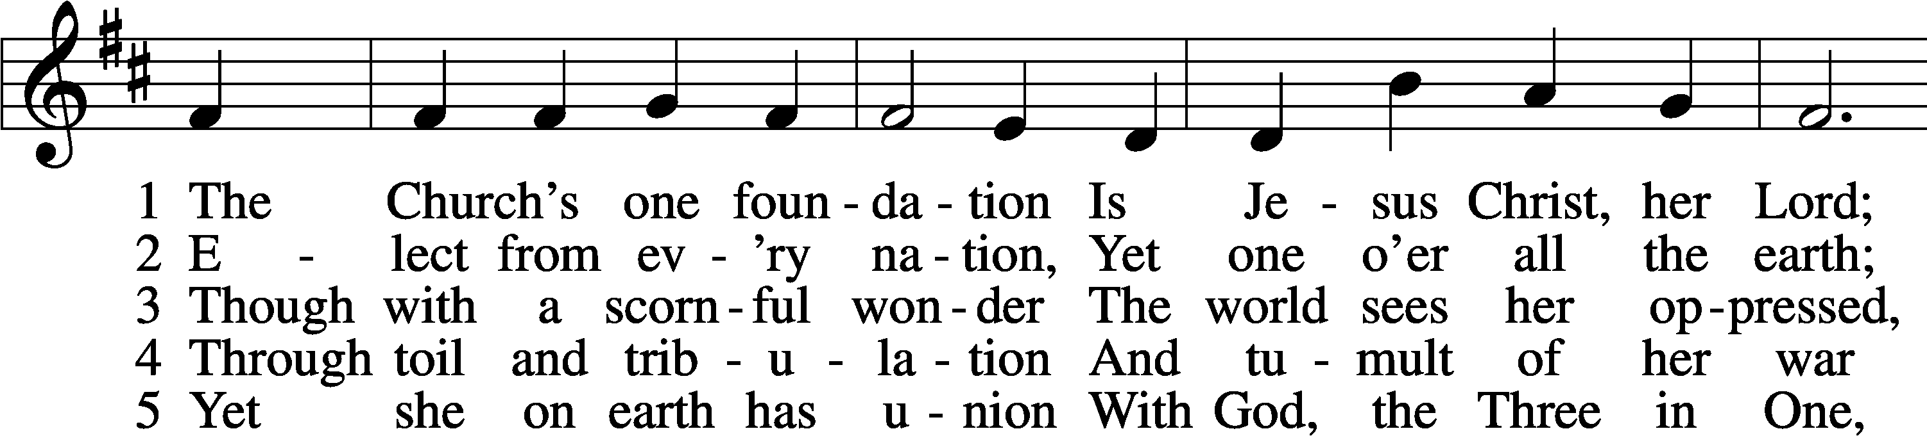
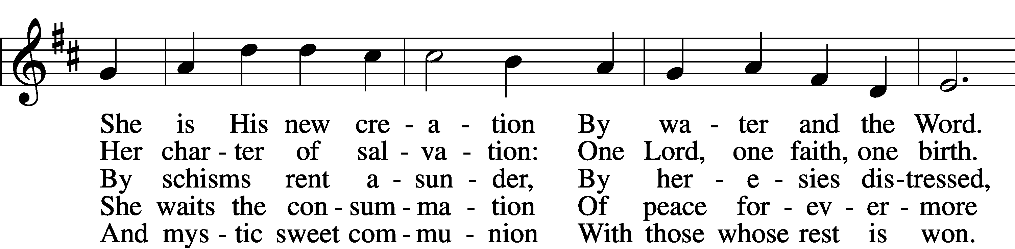
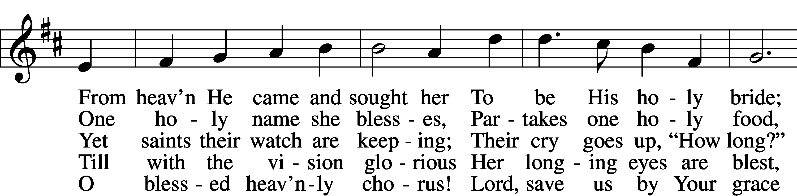
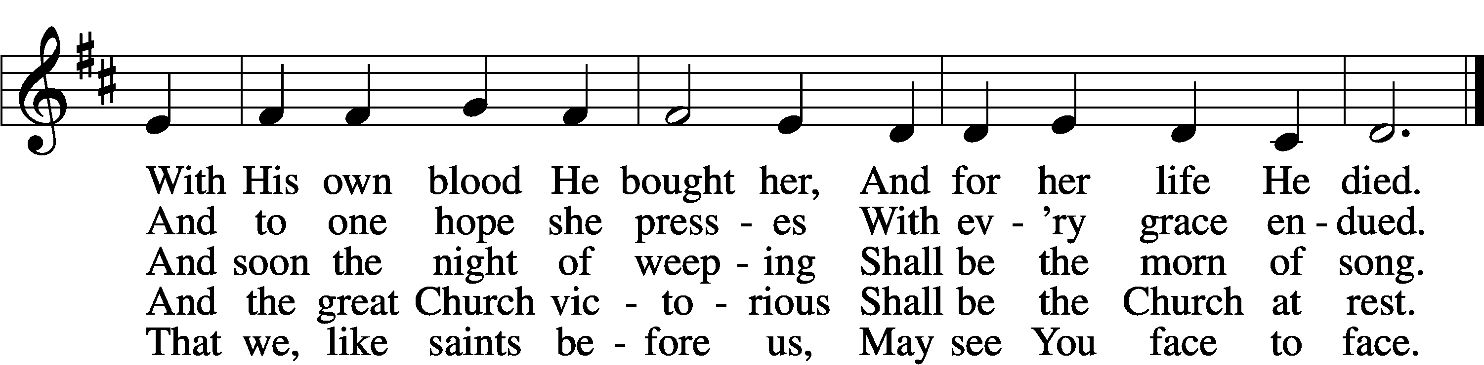
Text: Samuel J. Stone, 1839–1900, alt.
Tune: Samuel S. Wesley, 1810–76
Text and tune: Public domain

Sermon

P The peace of God, which passes all understanding, keep your hearts and minds in Christ Jesus.
C Amen.

Stand

Offertory LSB 192
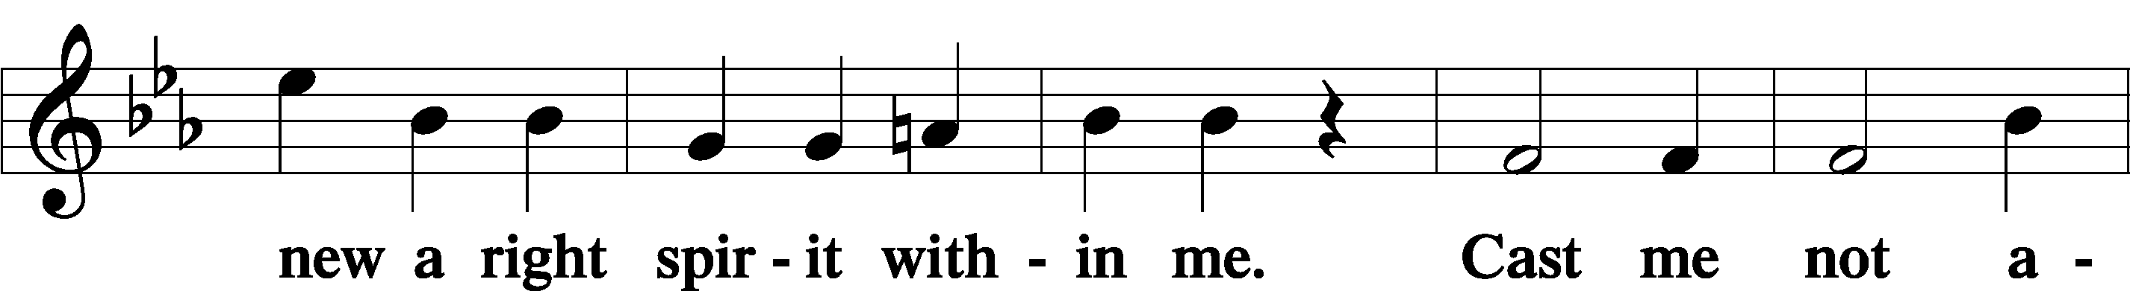
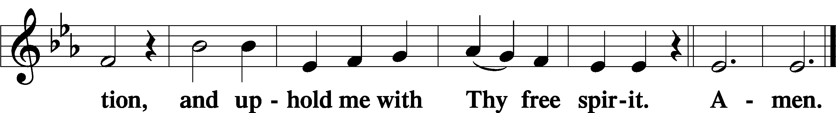

Sit

Offering

Stand

Prayer of the Church

Service of the Sacrament

Preface LSB 194

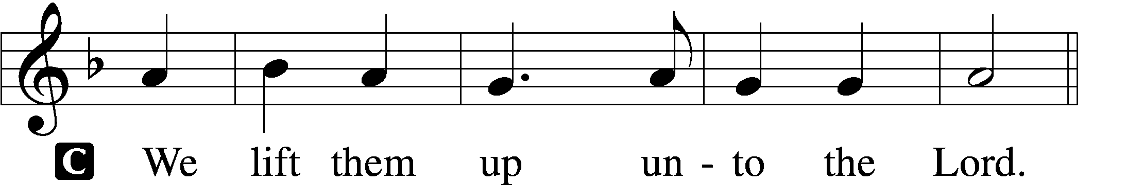

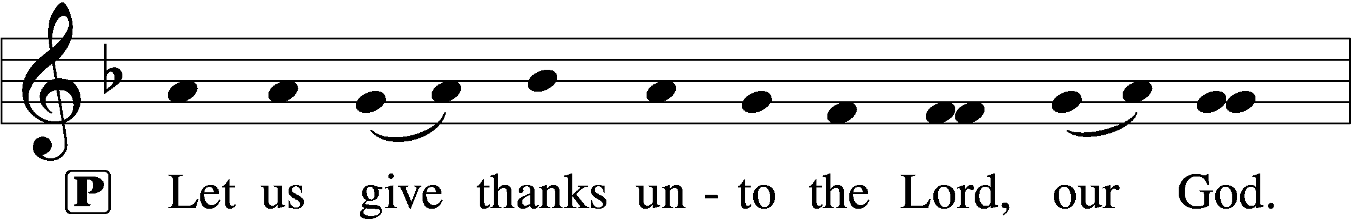
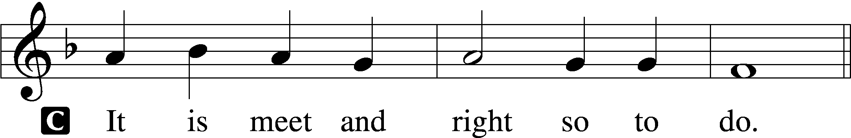

P It is truly meet, right, and salutary that we should at all times and in all places give thanks to You, holy Lord, almighty Father, everlasting God, through Jesus Christ, our Lord, who, having created all things, took on human flesh and was born of the virgin Mary. For our sake He died on the cross and rose from the dead to put an end to death, thus fulfilling Your will and gaining for You a holy people. Therefore with angels and archangels and with all the company of heaven we laud and magnify Your glorious name, evermore praising You and saying:

Sanctus LSB 195
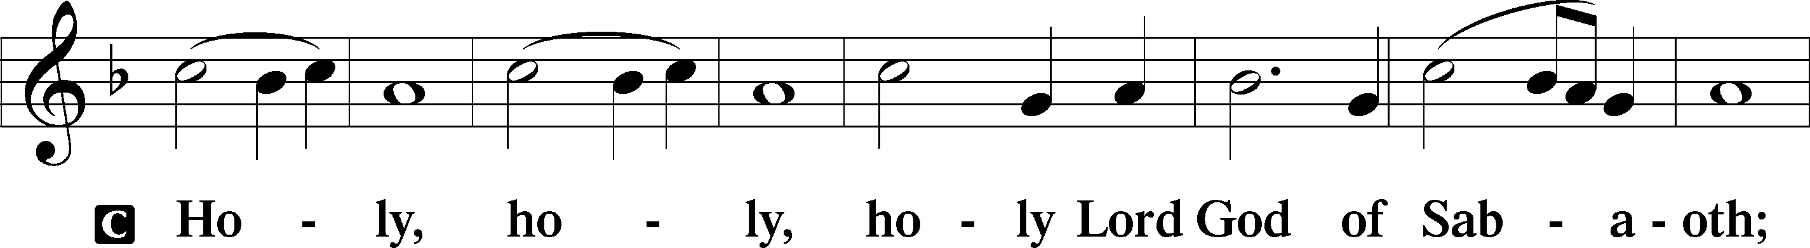
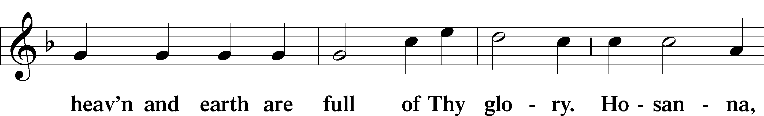
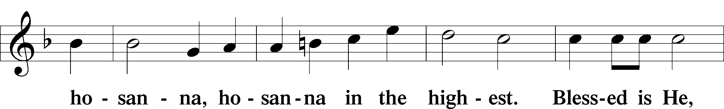
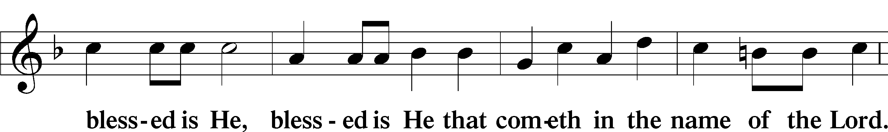
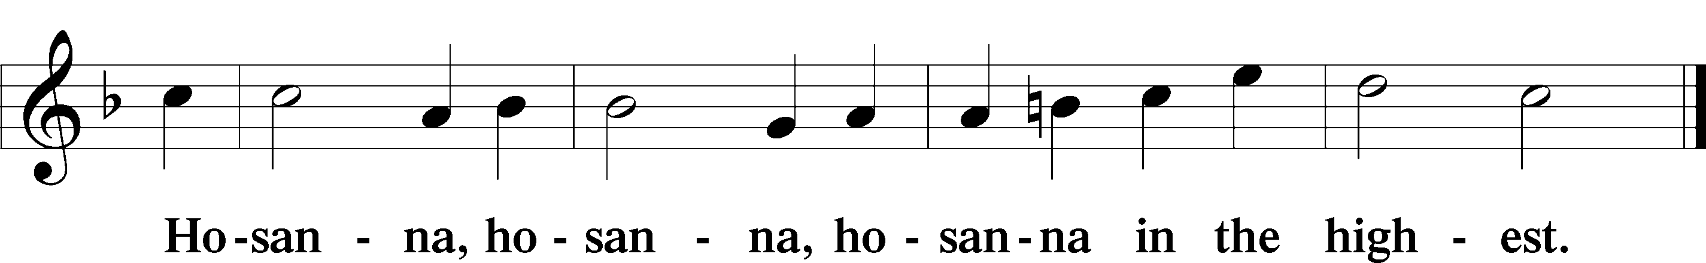

Lord’s Prayer LSB 196
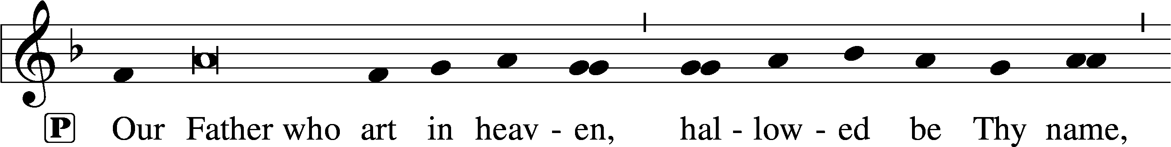
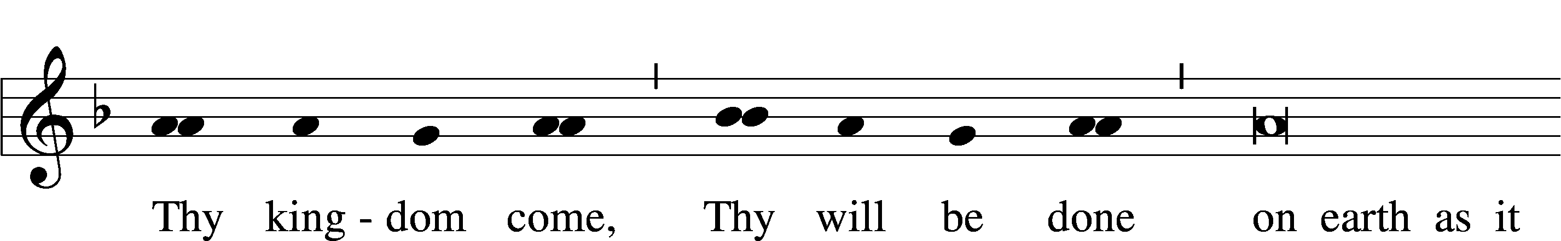
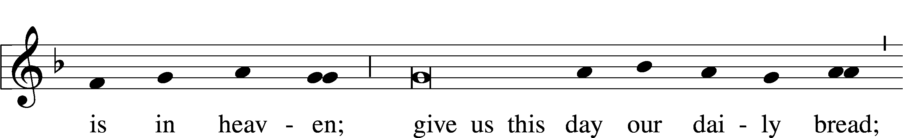
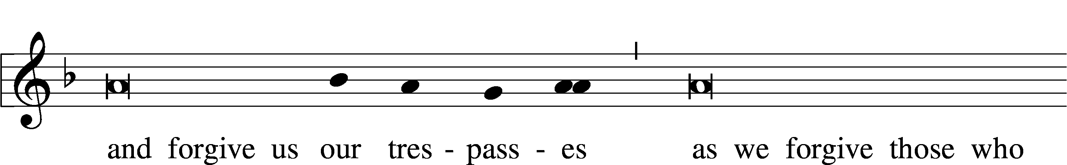
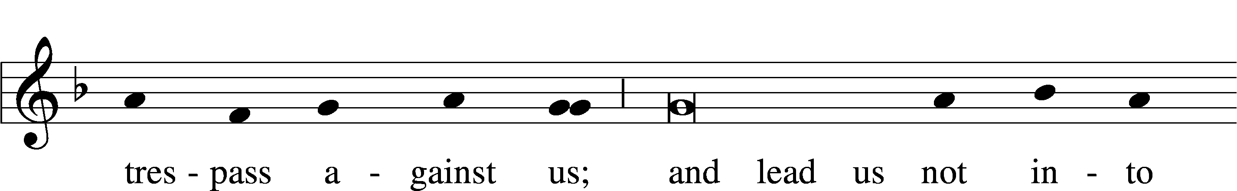
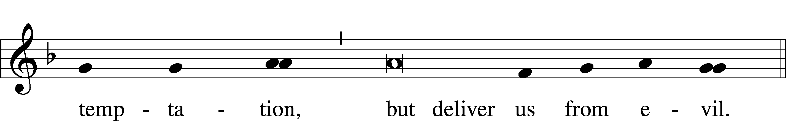

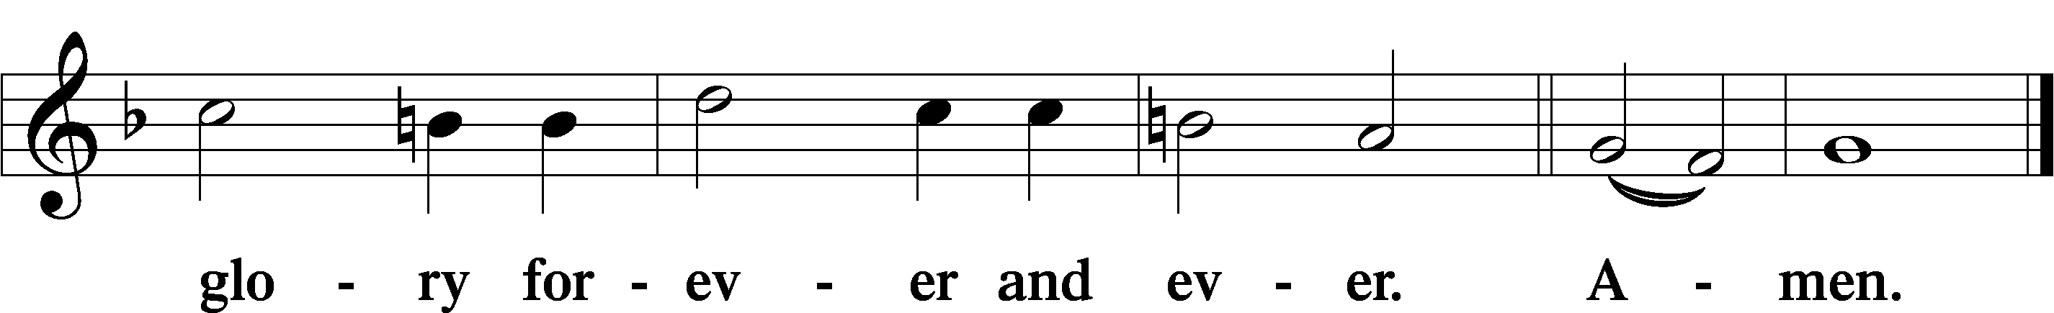

The Words of Our Lord LSB 197
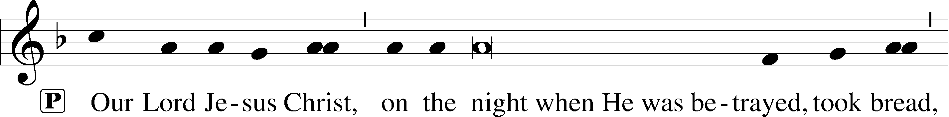
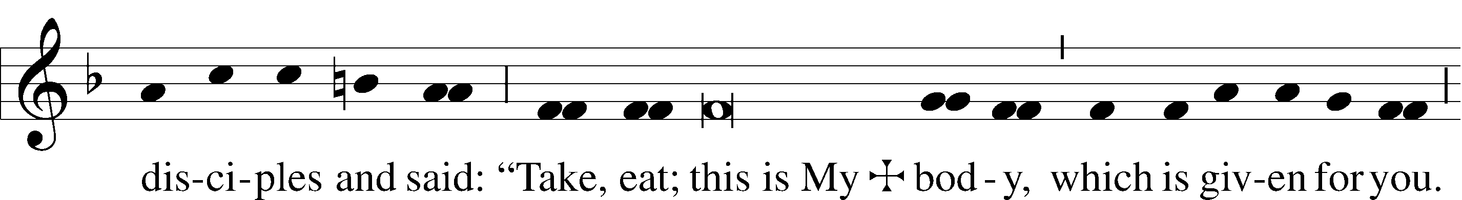
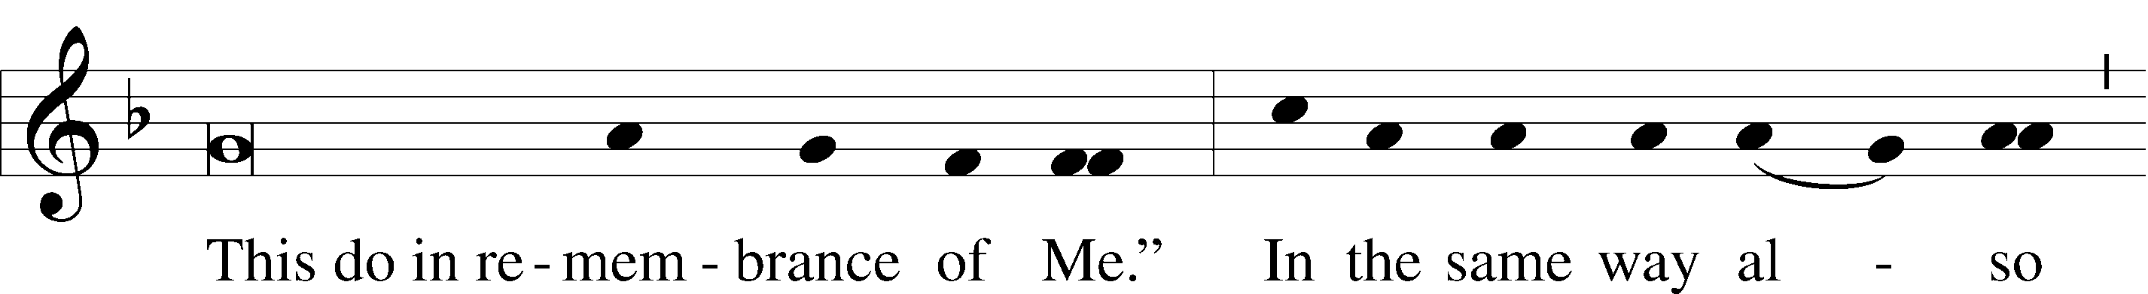
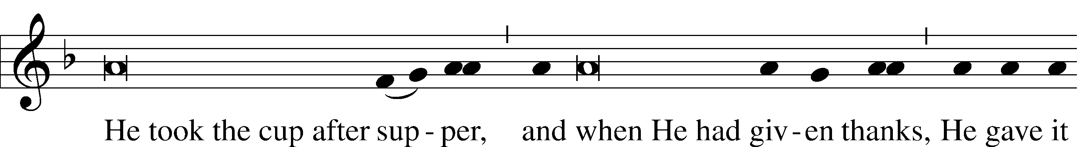
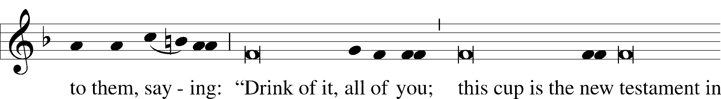
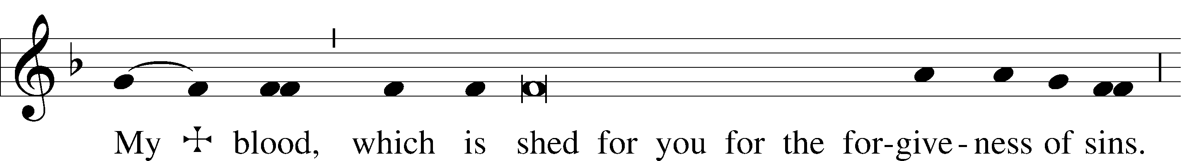
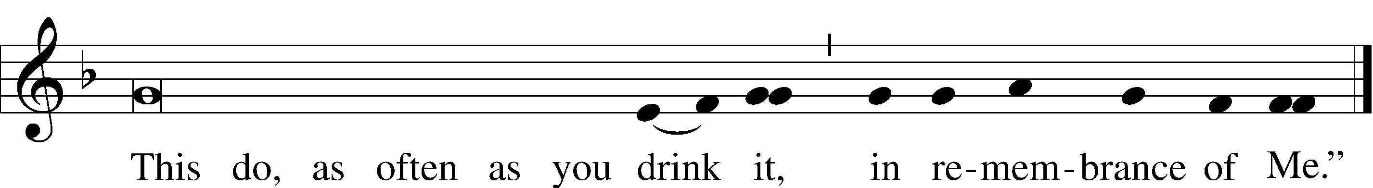

Pax Domini LSB 197
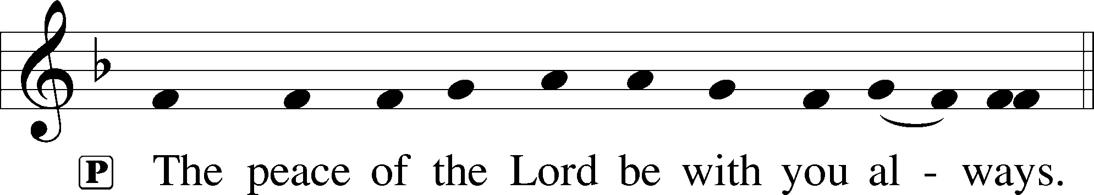

Agnus Dei LSB 198
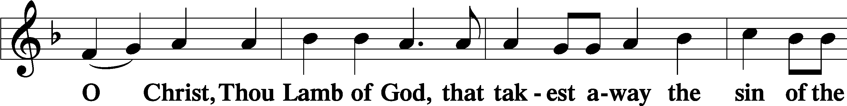
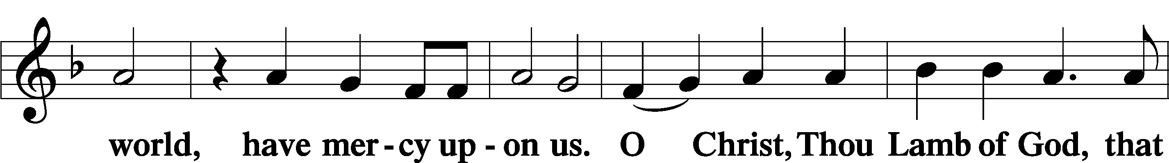
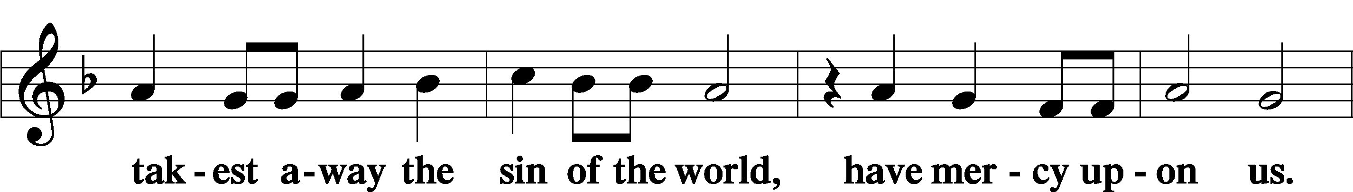
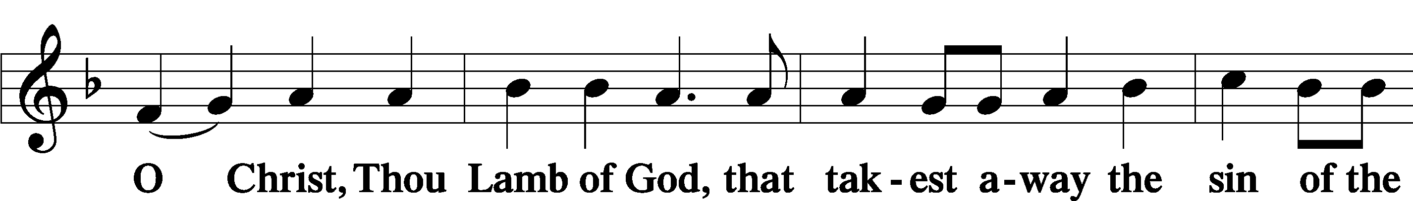

Sit

Distribution

The pastor and those who assist him receive the body and blood of Christ first and then distribute them to those who come to receive, saying:

Take, eat; this is the true body of our Lord and Savior Jesus Christ, given into death for your sins.
Amen.

Take, drink; this is the true blood of our Lord and Savior Jesus Christ, shed for the forgiveness of your sins.
Amen.

In dismissing the communicants, the following is said:

P The body and blood of our Lord Jesus Christ strengthen and preserve you in body and soul to life everlasting. Depart T in peace.
C Amen.

Distribution Hymn: 637 Draw Near and Take the Body of the Lord
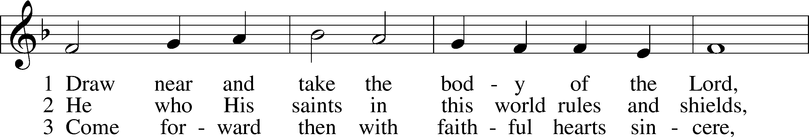
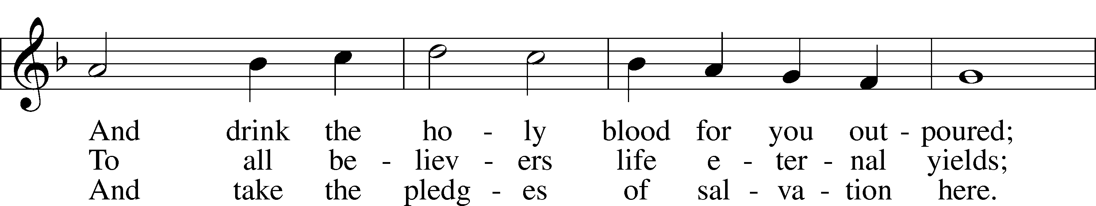
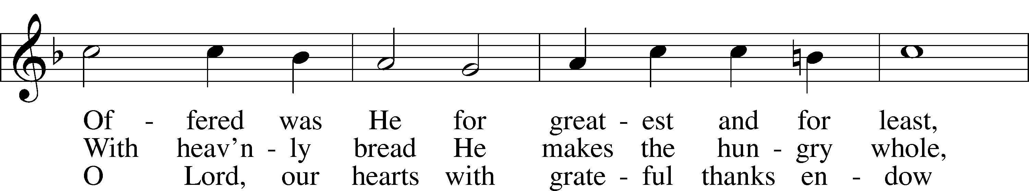
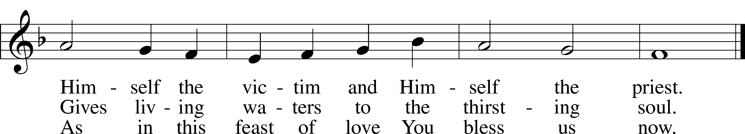
Text: Latin, 7th cent.; tr. John Mason Neale, 1818–66, alt.
Tune: Trente quatre Pseaumes de David, 1551, Geneva, ed. Louis Bourgeois
Text and tune: Public domain

Distribution Hymn: 683 Jesus, Thy Boundless Love to Me
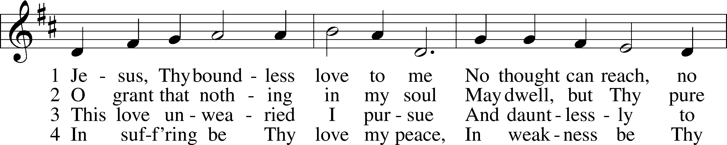
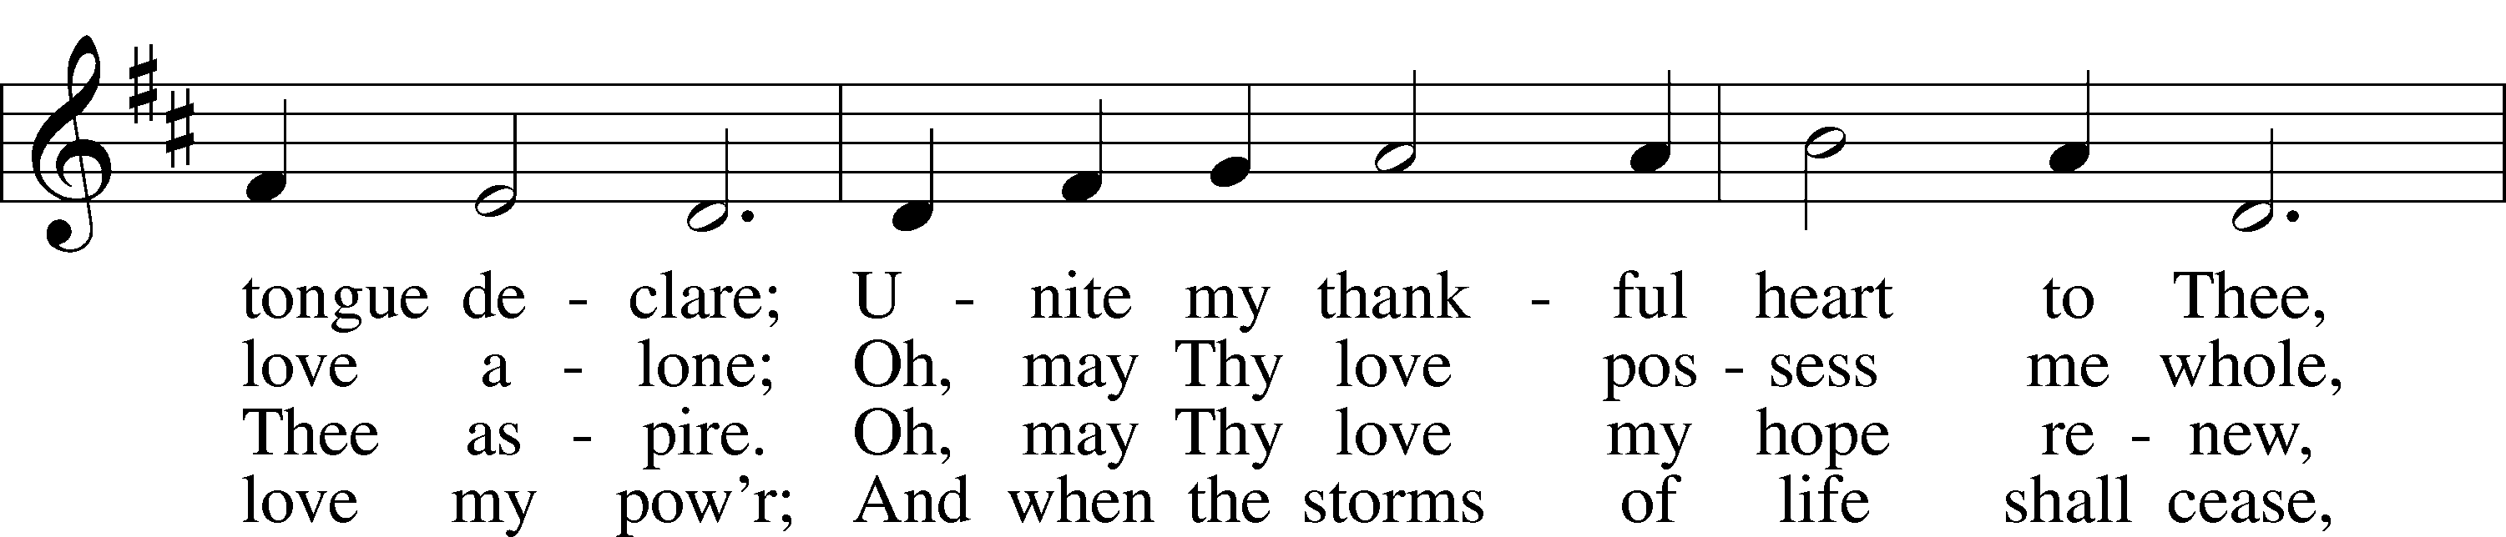
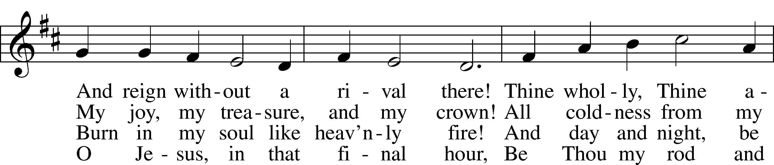
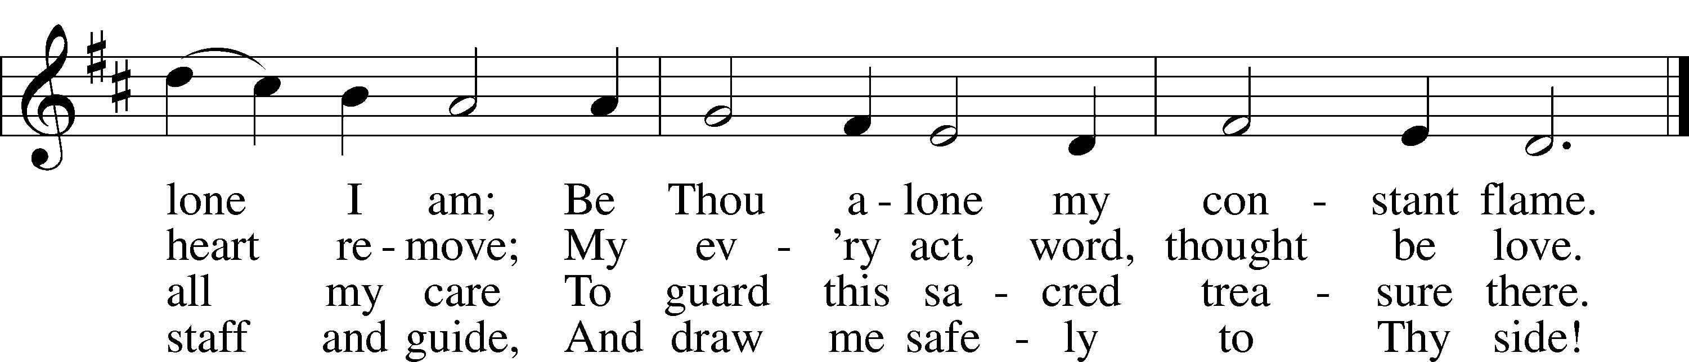
Text: Paul Gerhardt, 1607–76; tr. John B. Wesley, 1703–91, alt.
Tune: Norman Cocker, 1889–1953
Text: Public domain
Tune: © Oxford University Press. Used by permission: LSB Hymn License no. 110005504

Stand

Nunc Dimittis LSB 199
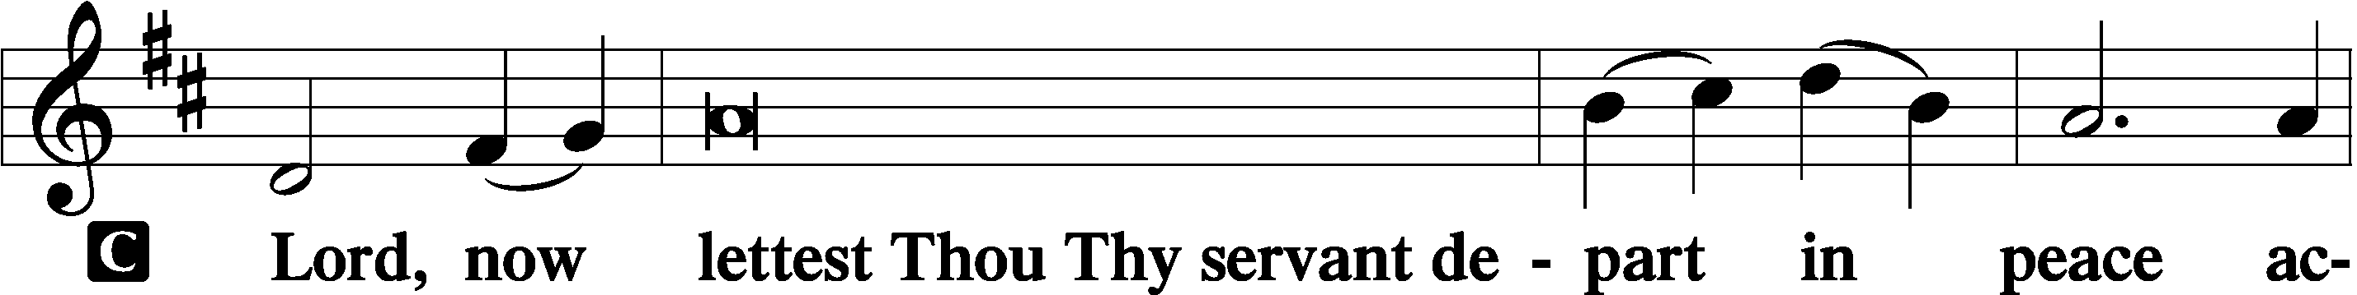

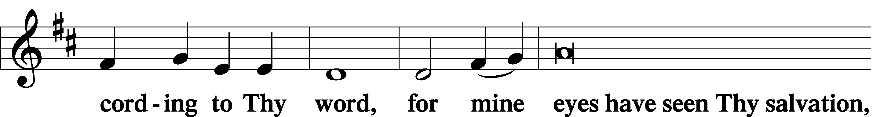

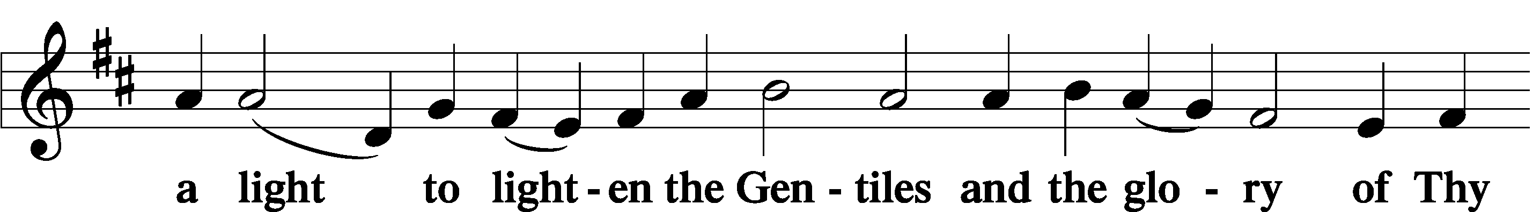

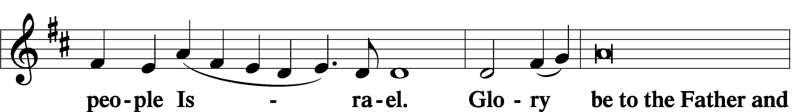

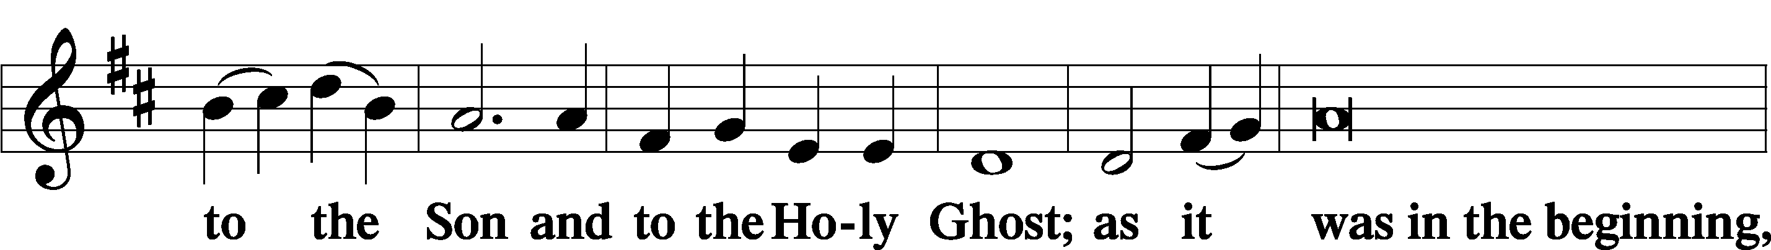

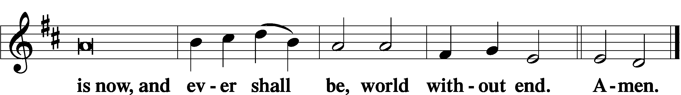

Thanksgiving LSB 200
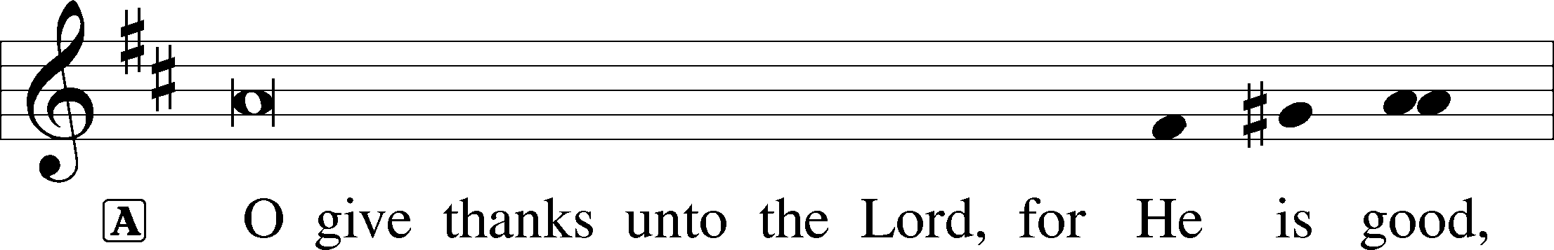

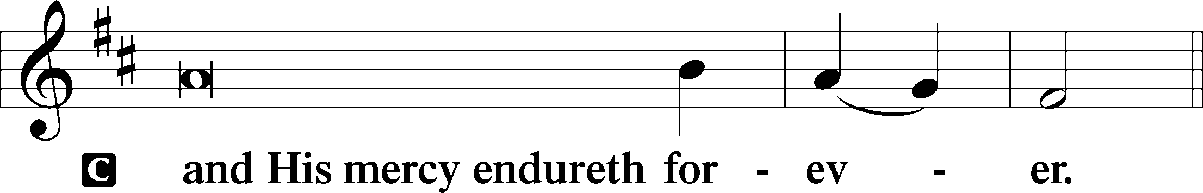

A Let us pray.
We give thanks to You, almighty God, that You have refreshed us through this salutary gift, and we implore You that of Your mercy You would strengthen us through the same in faith toward You and in fervent love toward one another; through Jesus Christ, Your Son, our Lord, who lives and reigns with You and the Holy Spirit, one God, now and forever.

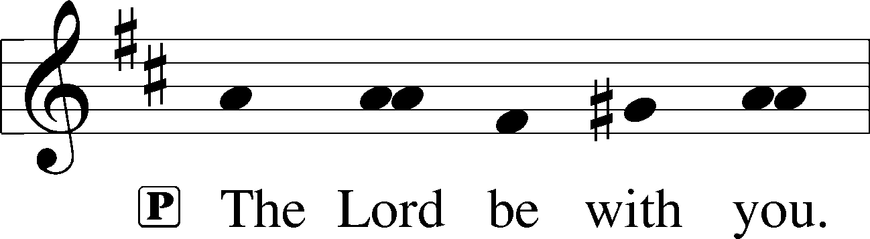

Benedicamus LSB 202
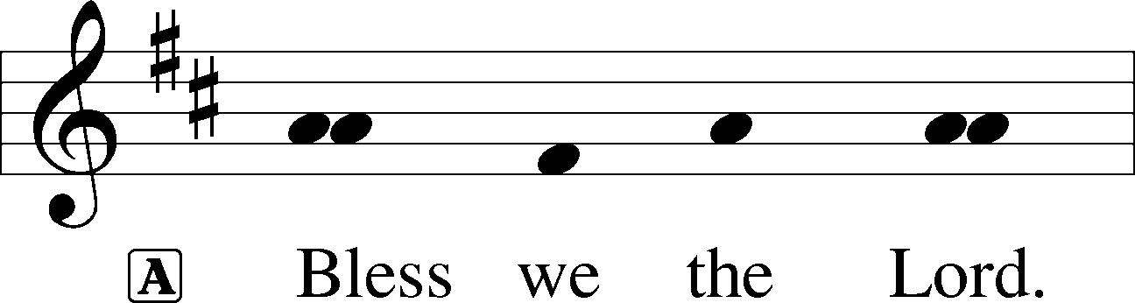

Benediction LSB 202
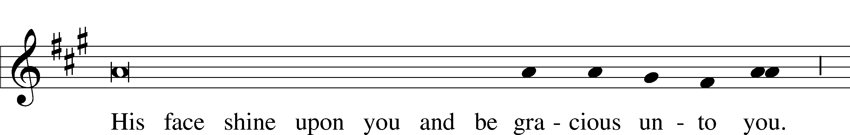

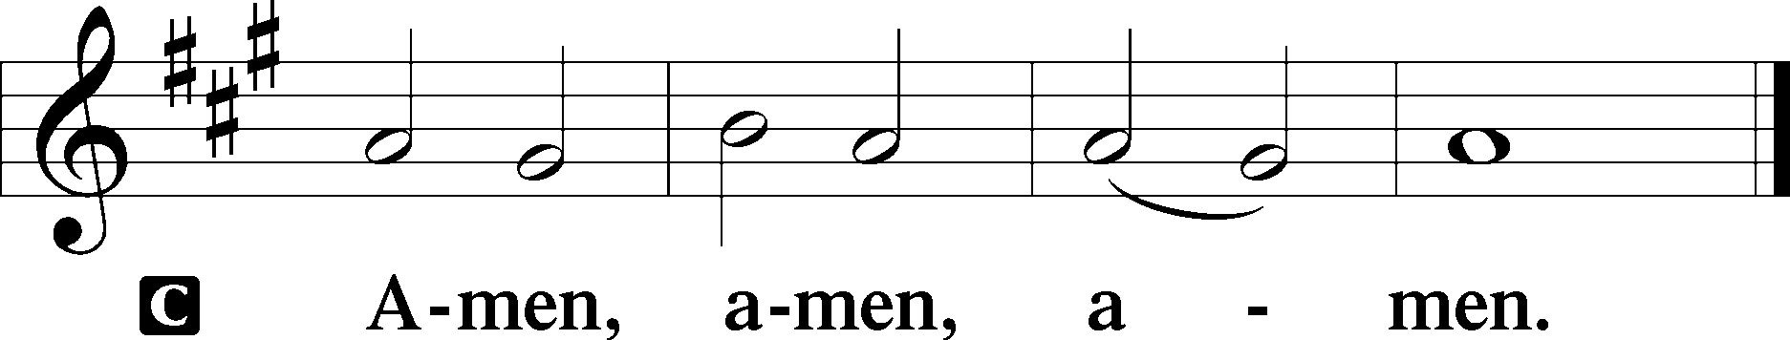

Hymn to Depart: 643 Sent Forth by God’s Blessing
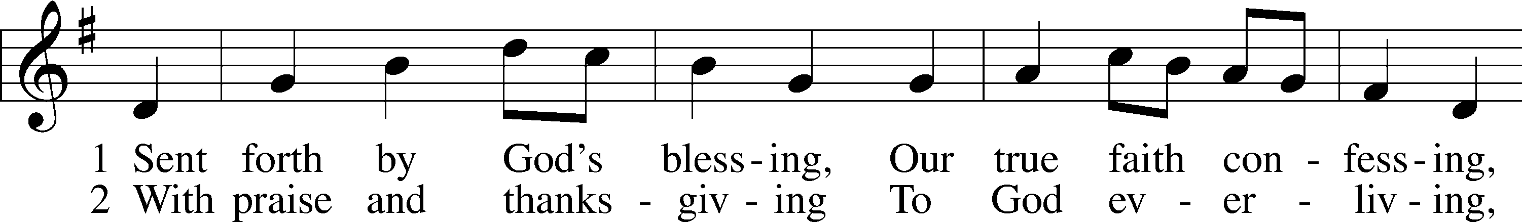
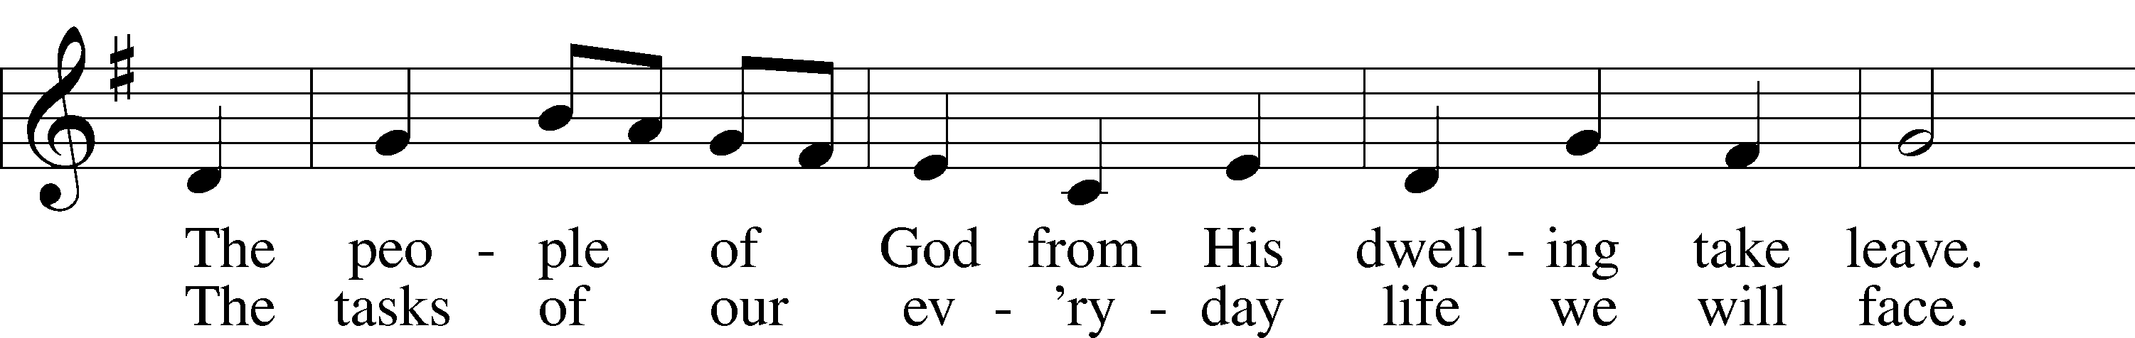
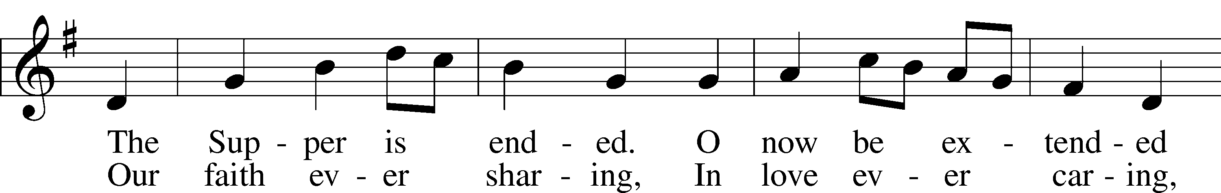
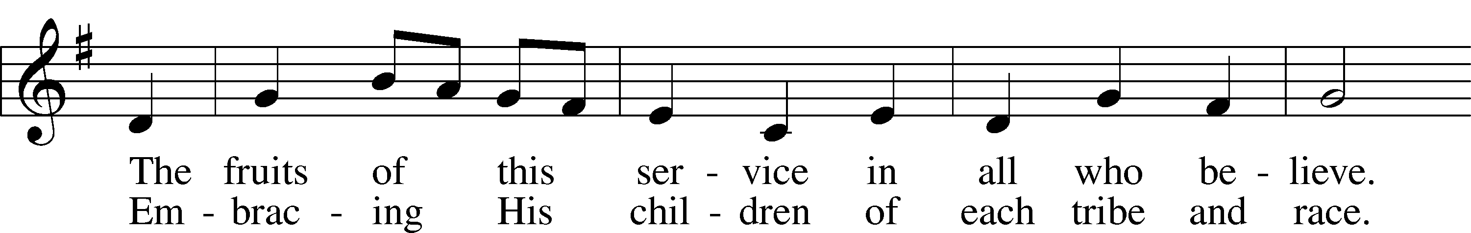
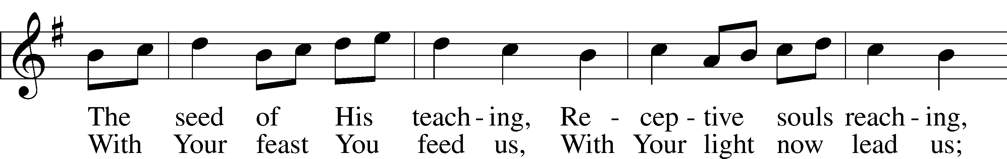
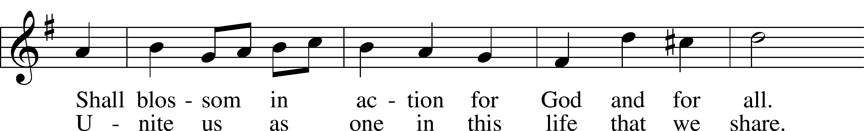
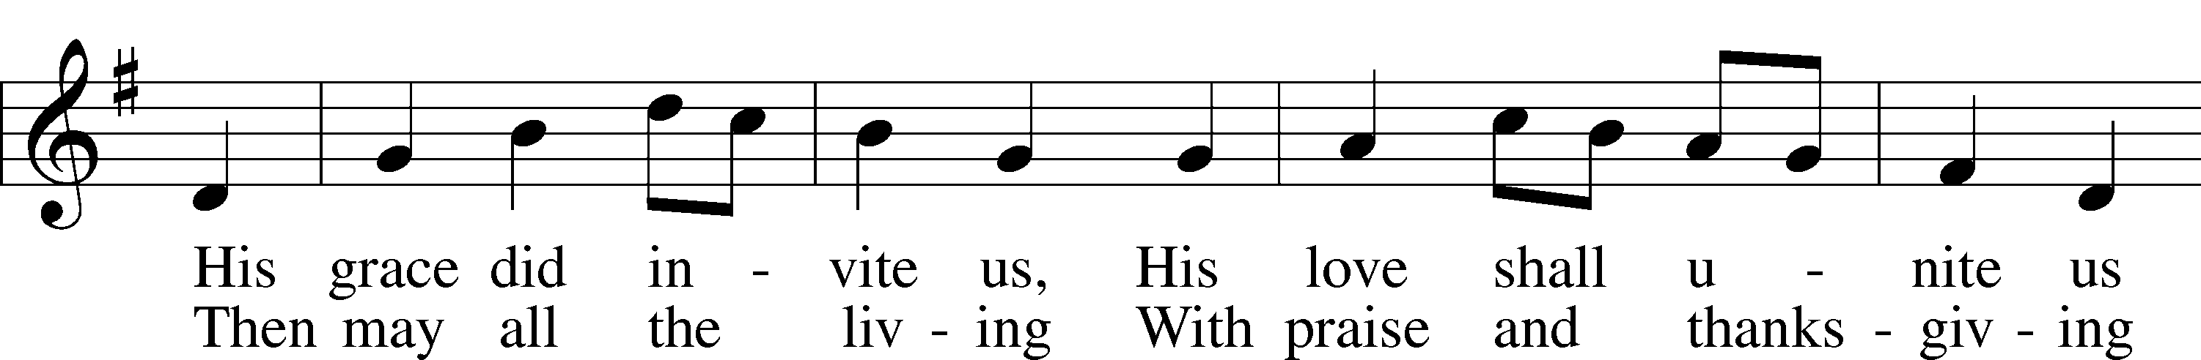
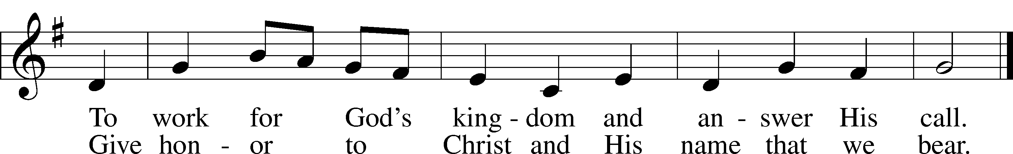
Text: Omer E. Westendorf, 1916–97, alt.
Tune: Welsh
Text: © 1964 World Library Publications. Used by permission: LSB Hymn License no. 110005504
Tune: Public domain

Acknowledgments
Divine Service, Setting Three from Lutheran Service Book
Unless otherwise indicated, Scripture quotations are from the ESV® Bible (The Holy Bible, English Standard Version®), copyright © 2001 by Crossway, a publishing ministry of Good News Publishers. Used by permission. All rights reserved.
Created by Lutheran Service Builder © 2024 Concordia Publishing House.

ELEVENTH SUNDAY AFTER PENTECOST (Proper 13B) Jesus Is the True and Living Bread from Heaven Having rescued Israel “out of the land of Egypt” (Ex. 16:6), the Lord manifested His glory and made Himself known to His people. He fed them with “meat to eat” in the evening and with “bread from heaven” in the morning (Ex. 16:4, 8, 12). But now, the “true bread from heaven,” which the Father gives to you, is the Son, “who comes down from heaven and gives life to the world” (John 6:32–33). Whoever comes to Him “shall not hunger,” and whoever believes in Him “shall never thirst.” He is “the bread of life,” who gives Himself to you as “the food that endures to eternal life” (John 6:27, 35). By the gracious working of God, you believe in Him by the calling of one Spirit through the Gospel, so that you also have “one Lord, one faith, one baptism, one God and Father of all” (Eph. 4:4–6). As you eat His one body in the Holy Supper, so you belong to the one Body of His Church, in which you “are to grow up in every way into him who is the head” (Eph. 4:15).

Announcements:

Church Service Phone: 888-505-1870/715-438-4200
(Stay on the line for recorded service to start)
Live Stream audio services: http://salem.listentochurch.com
Salem’s Web Page: https://www.salembarron.com/
Pastor Fred Buth: Cell phone:715-642-3050 (H)715-353-2540
Pastor’s Email: salembarronpastor@gmail.com
Office Hours: Monday-Wednesday 9-12
Office email: salembarron@gmail.com
Attendance: 7/28-50

Coffee and Snacks:
Elder Today: Tim Dennis
Altar Guild: Nancy Koenig/Marcia Elliott

Schedule for the upcoming week:
Monday: 7pm Elders Tuesday: 8:00 am Men’s Bible Study

Save the Date:
August 9th: Church & Childcare annual picnic, serving 4:30-6:30pm
August 18th: 11:30am. *A special Voter’s Meeting to issue a Divine Call a Pastor to serve Salem congregation

Christ Community Lutheran School is hiring a headmaster. We are open to all levels of experience. Please email a resume’ or questions to administrator@christcommunityls.org
Prayers Request:
Those in the nursing home: Joann Jaeger Those Shut-in at home: Char Herman, Joan Church, Joyce Myers, Joyce Koba Those with ongoing health issues: Harrison Fields, Jeanne Perala, Owen Metz, Jeff Bonneville, Daria (Cindy Wright’s friend), Butch L. (Cindy Wright’s Brother-in-law), Melissa Miller. Art Smith (Sue Millerman’s brother), Brenda Sellent (Denise Stabenow’s sister), Sandy Hahn (Cindy Wright’s cousin’s wife) , Brenda Gustum (Missy Wiese’s mom), Lexi Anderson, Chris Mueller’s uncle Those who lead our nation: Joe Biden, Kamala Harris, Tony Evers, Rod Nordby Those who serve in our military and law enforcement: Ryan Graf, Chaplain Pon Chanthaphon (Our Adopt-a-Chaplain), Rusty Weise Our Childcare Staff: Melissa Weinert, Denise Stabenow, Katelyn Hendren, Holly Wilhelmi, Janica Skjerly, Jacie Amundson, Cathy Anderson For Christ Community Lutheran School – Ask the Lord to provide teachers for the school

