# Matins p.219

Seventh Sunday after the Epiphany

February 23,2025

Hymn: 802 Immortal, Invisible, God Only Wise

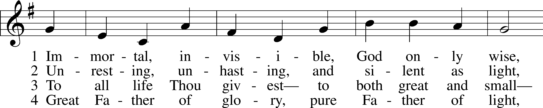

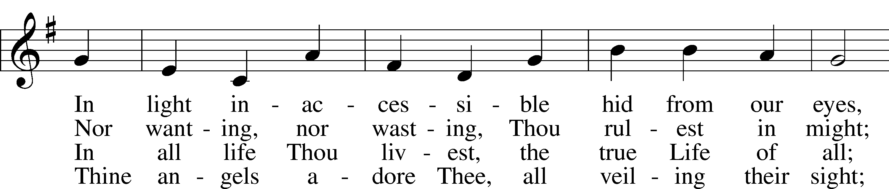

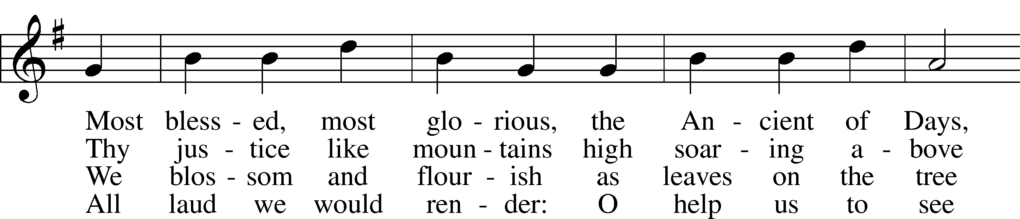

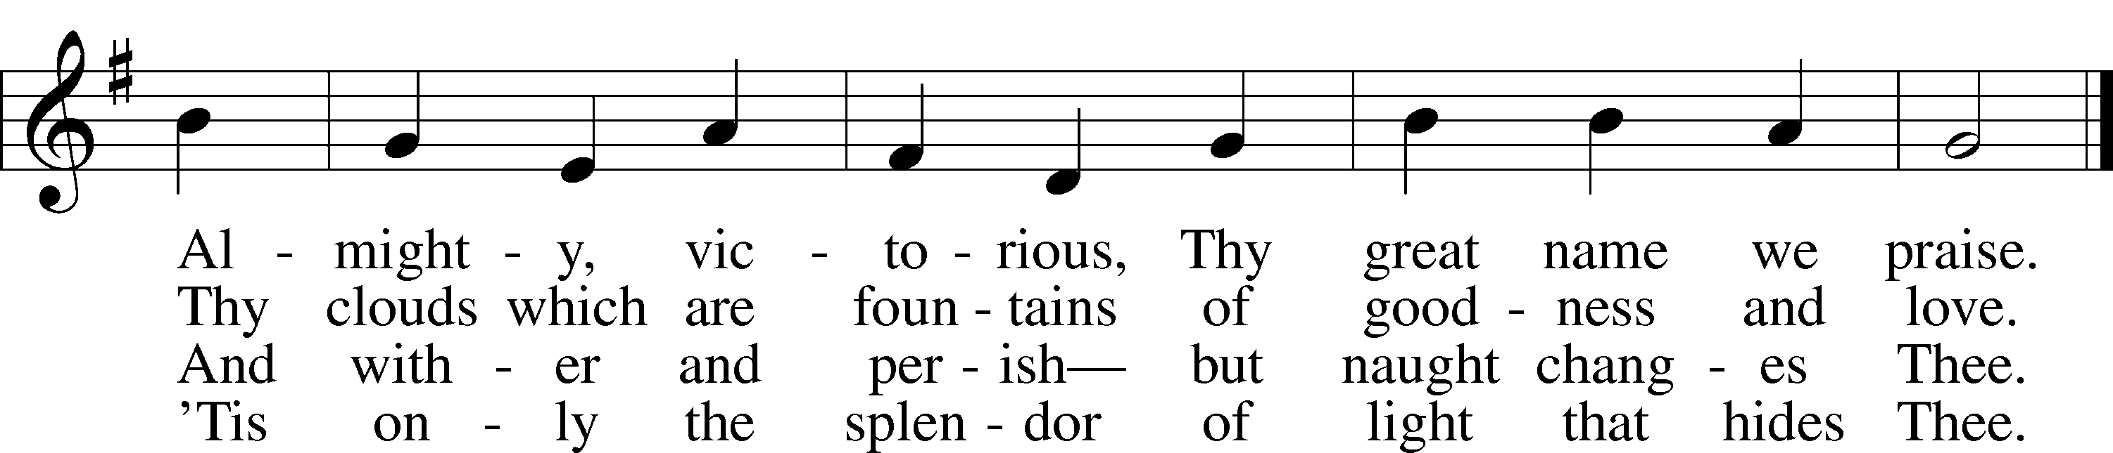

Text: W. Chalmers Smith, 1824–1908, alt.  
Tune: Welsh  
Text and tune: Public domain

Stand









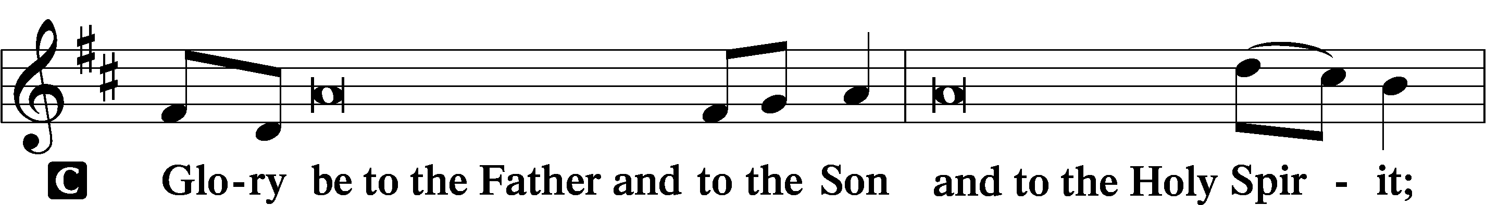

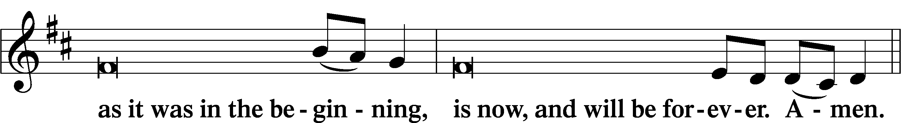

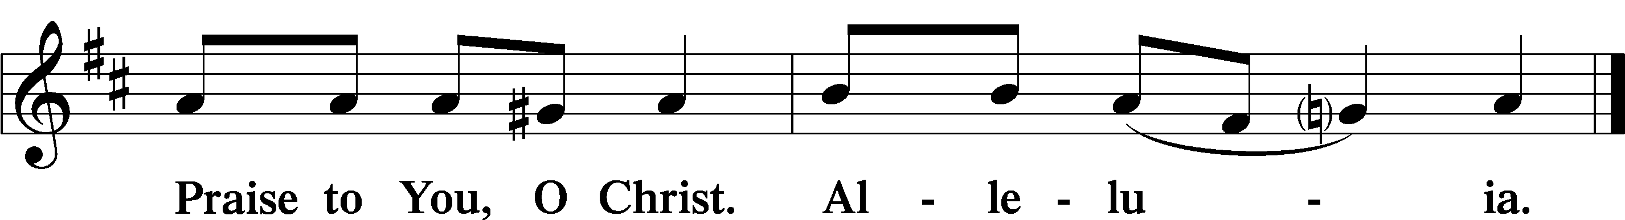

# Psalmody

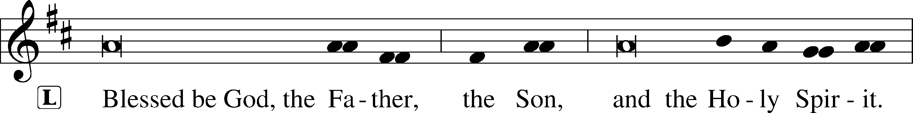



Venite LSB 220

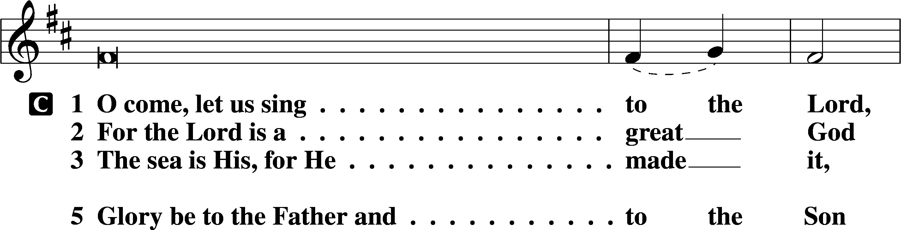

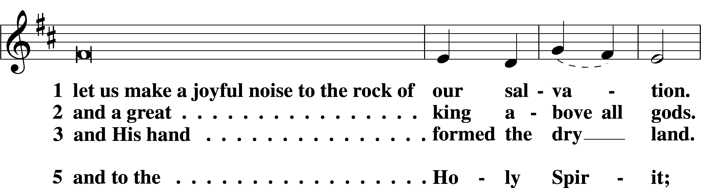

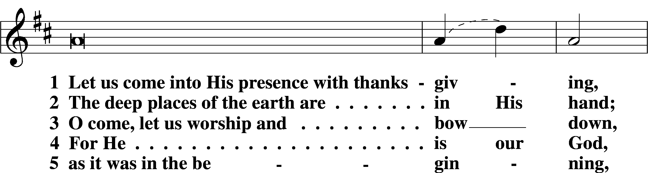

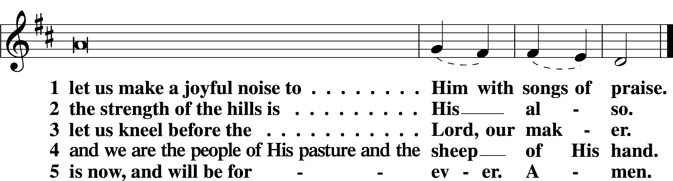





Additional Psalms Psalm 103:1–13; antiphon: v. 8

Bless the Lord, O My Soul

1Bless the Lord, O my soul,  
 and all that is within me,  
 bless his holy name!  
2Bless the Lord, O my soul,  
 and forget not all his benefits,  
3who forgives all your iniquity,  
 who heals all your diseases,  
4who redeems your life from the pit,  
 who crowns you with steadfast love and mercy,  
5who satisfies you with good  
 so that your youth is renewed like the eagle’s.

6The Lord works righteousness  
 and justice for all who are oppressed.  
7He made known his ways to Moses,  
 his acts to the people of Israel.  
8The Lord is merciful and gracious,  
 slow to anger and abounding in steadfast love.  
9He will not always chide,  
 nor will he keep his anger forever.  
10He does not deal with us according to our sins,  
 nor repay us according to our iniquities.  
11For as high as the heavens are above the earth,  
 so great is his steadfast love toward those who fear him;  
12as far as the east is from the west,  
 so far does he remove our transgressions from us.  
13As a father shows compassion to his children,  
 so the Lord shows compassion to those who fear him.

Sit

Office Hymn: 851 Lord of Glory, You Have Bought Us

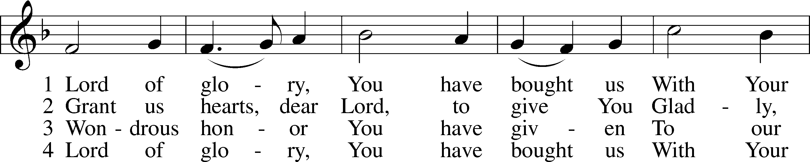

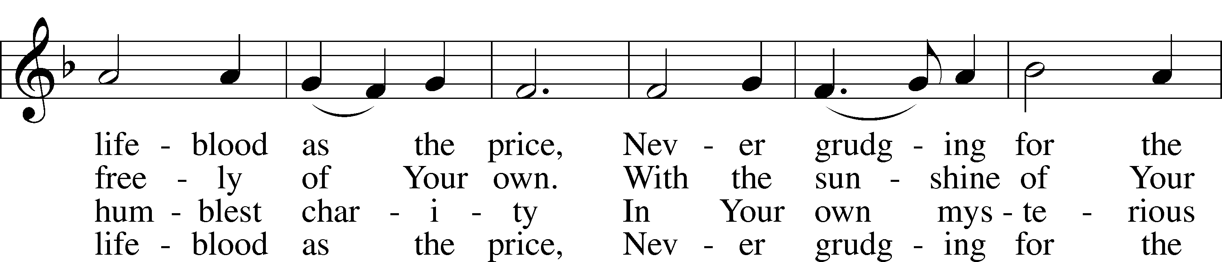

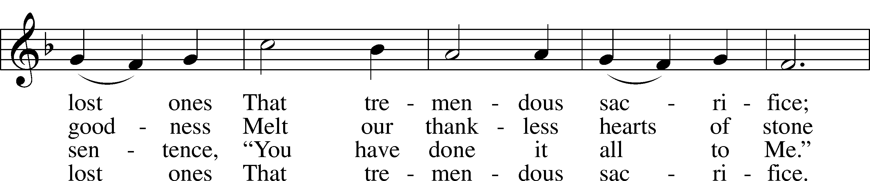

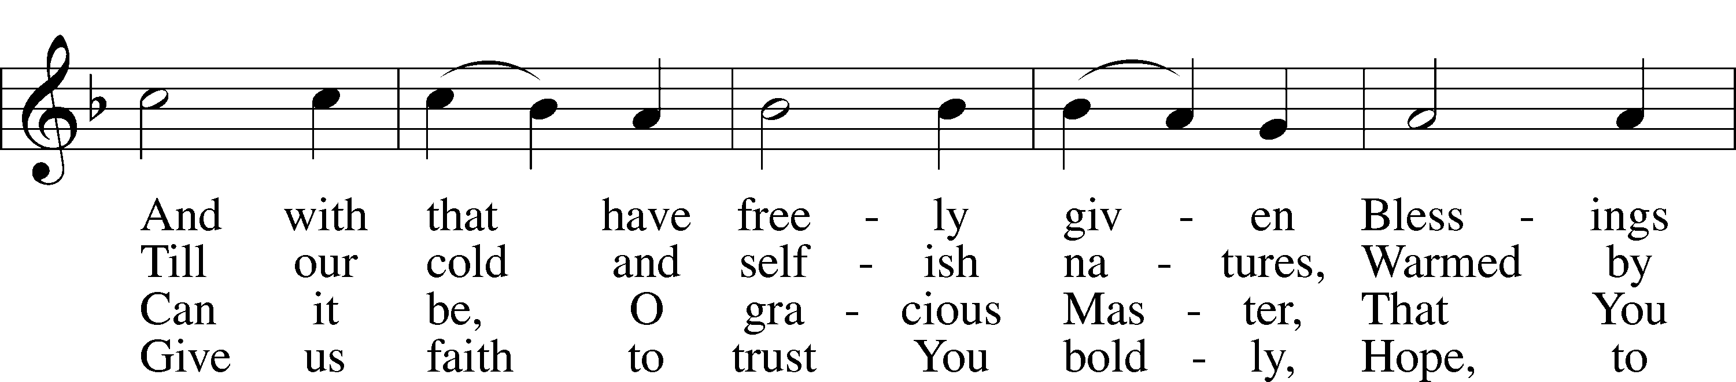

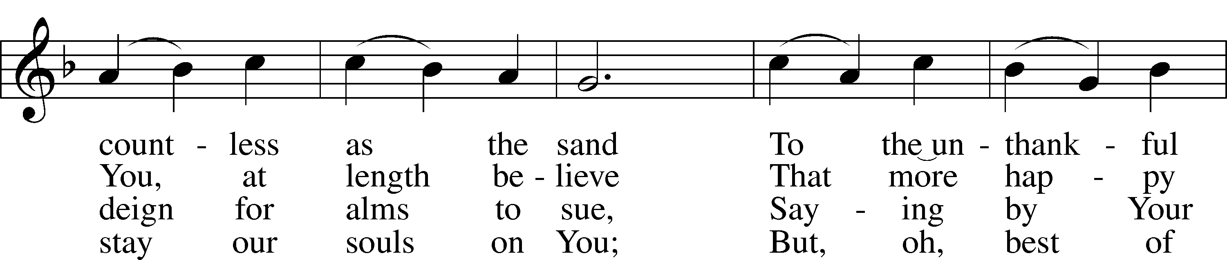

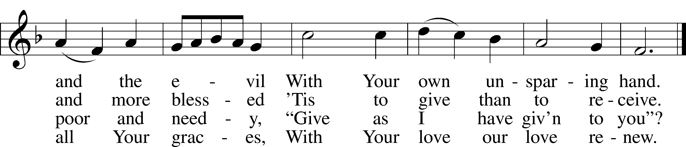

Text: Eliza S. Alderson, 1818–89, alt.  
Tune: Rowland H. Prichard, 1811–87  
Text and tune: Public domain

# Readings

Reading Genesis 45:3–15

L A reading from Genesis, chapter 45.

3 Joseph said to his brothers, “I am Joseph! Is my father still alive?” But his brothers could not answer him, for they were dismayed at his presence.

4So Joseph said to his brothers, “Come near to me, please.” And they came near. And he said, “I am your brother, Joseph, whom you sold into Egypt. 5And now do not be distressed or angry with yourselves because you sold me here, for God sent me before you to preserve life. 6For the famine has been in the land these two years, and there are yet five years in which there will be neither plowing nor harvest. 7And God sent me before you to preserve for you a remnant on earth, and to keep alive for you many survivors. 8So it was not you who sent me here, but God. He has made me a father to Pharaoh, and lord of all his house and ruler over all the land of Egypt. 9Hurry and go up to my father and say to him, ‘Thus says your son Joseph, God has made me lord of all Egypt. Come down to me; do not tarry. 10You shall dwell in the land of Goshen, and you shall be near me, you and your children and your children’s children, and your flocks, your herds, and all that you have. 11There I will provide for you, for there are yet five years of famine to come, so that you and your household, and all that you have, do not come to poverty.’ 12And now your eyes see, and the eyes of my brother Benjamin see, that it is my mouth that speaks to you. 13You must tell my father of all my honor in Egypt, and of all that you have seen. Hurry and bring my father down here.” 14Then he fell upon his brother Benjamin’s neck and wept, and Benjamin wept upon his neck. 15And he kissed all his brothers and wept upon them. After that his brothers talked with him.

L O Lord, have mercy on us.

C **Thanks be to God.**

Reading 1 Corinthians 15:21–26, 30–42

L A reading from 1 Corinthians, chapter 15.

21For as by a man came death, by a man has come also the resurrection of the dead. 22For as in Adam all die, so also in Christ shall all be made alive. 23But each in his own order: Christ the firstfruits, then at his coming those who belong to Christ. 24Then comes the end, when he delivers the kingdom to God the Father after destroying every rule and every authority and power. 25For he must reign until he has put all his enemies under his feet. 26The last enemy to be destroyed is death. . . .

30Why am I in danger every hour? 31I protest, brothers, by my pride in you, which I have in Christ Jesus our Lord, I die every day! 32What do I gain if, humanly speaking, I fought with beasts at Ephesus? If the dead are not raised, “Let us eat and drink, for tomorrow we die.” 33Do not be deceived: “Bad company ruins good morals.” 34Wake up from your drunken stupor, as is right, and do not go on sinning. For some have no knowledge of God. I say this to your shame.

The Resurrection Body

35But someone will ask, “How are the dead raised? With what kind of body do they come?” 36You foolish person! What you sow does not come to life unless it dies. 37And what you sow is not the body that is to be, but a bare kernel, perhaps of wheat or of some other grain. 38But God gives it a body as he has chosen, and to each kind of seed its own body. 39For not all flesh is the same, but there is one kind for humans, another for animals, another for birds, and another for fish. 40There are heavenly bodies and earthly bodies, but the glory of the heavenly is of one kind, and the glory of the earthly is of another. 41There is one glory of the sun, and another glory of the moon, and another glory of the stars; for star differs from star in glory.

42So is it with the resurrection of the dead. What is sown is perishable; what is raised is imperishable.

L O Lord, have mercy on us.

C **Thanks be to God.**

Reading Luke 6:27–38

L A reading from Luke, chapter 6.

Love Your Enemies

27[Jesus said:] “But I say to you who hear, Love your enemies, do good to those who hate you, 28bless those who curse you, pray for those who abuse you. 29To one who strikes you on the cheek, offer the other also, and from one who takes away your cloak do not withhold your tunic either. 30Give to everyone who begs from you, and from one who takes away your goods do not demand them back. 31And as you wish that others would do to you, do so to them.

32“If you love those who love you, what benefit is that to you? For even sinners love those who love them. 33And if you do good to those who do good to you, what benefit is that to you? For even sinners do the same. 34And if you lend to those from whom you expect to receive, what credit is that to you? Even sinners lend to sinners, to get back the same amount. 35But love your enemies, and do good, and lend, expecting nothing in return, and your reward will be great, and you will be sons of the Most High, for he is kind to the ungrateful and the evil. 36Be merciful, even as your Father is merciful.

Judging Others

37“Judge not, and you will not be judged; condemn not, and you will not be condemned; forgive, and you will be forgiven; 38give, and it will be given to you. Good measure, pressed down, shaken together, running over, will be put into your lap. For with the measure you use it will be measured back to you.”

L O Lord, have mercy on us.

C **Thanks be to God.**

Responsory LSB 221

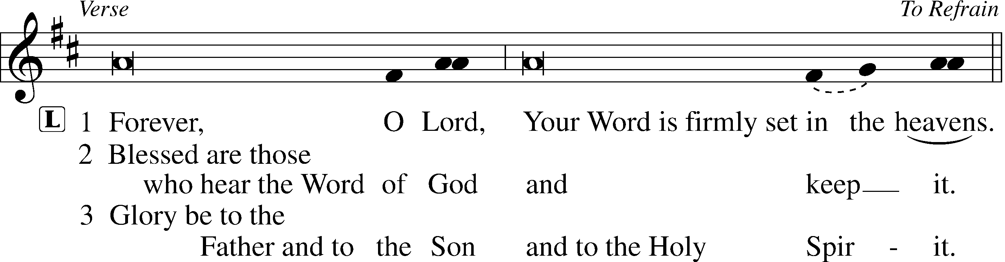

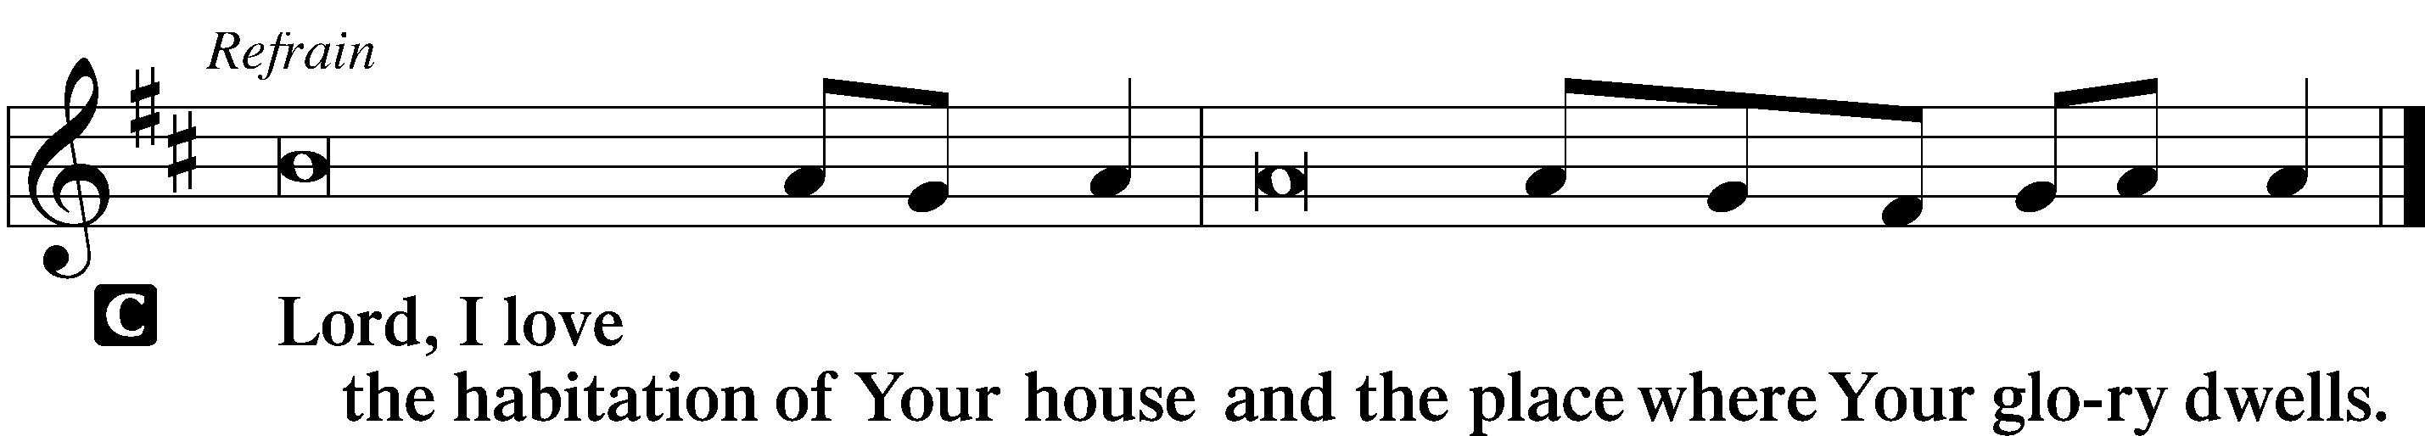

Hymn: 843 “Forgive Our Sins as We Forgive”

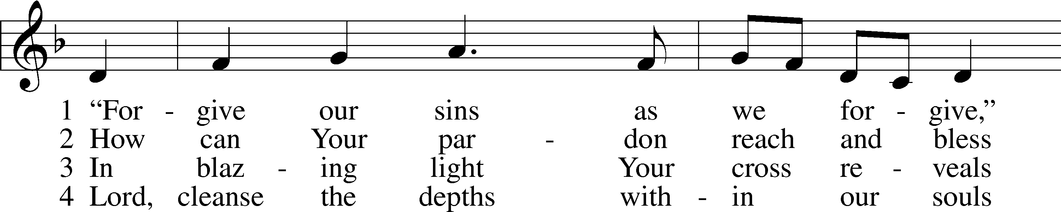

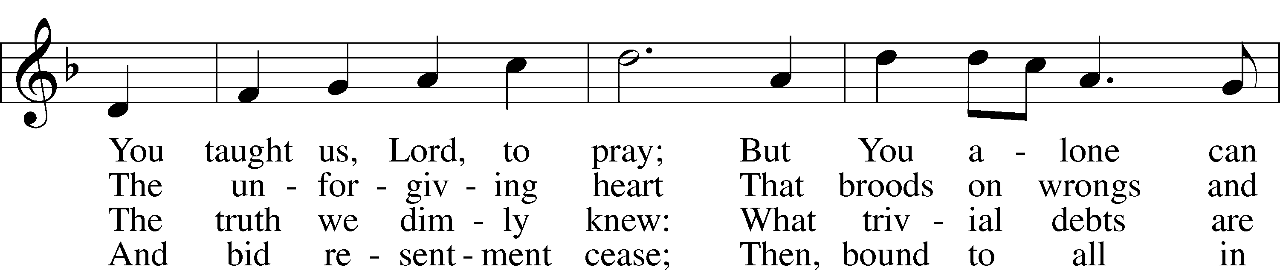

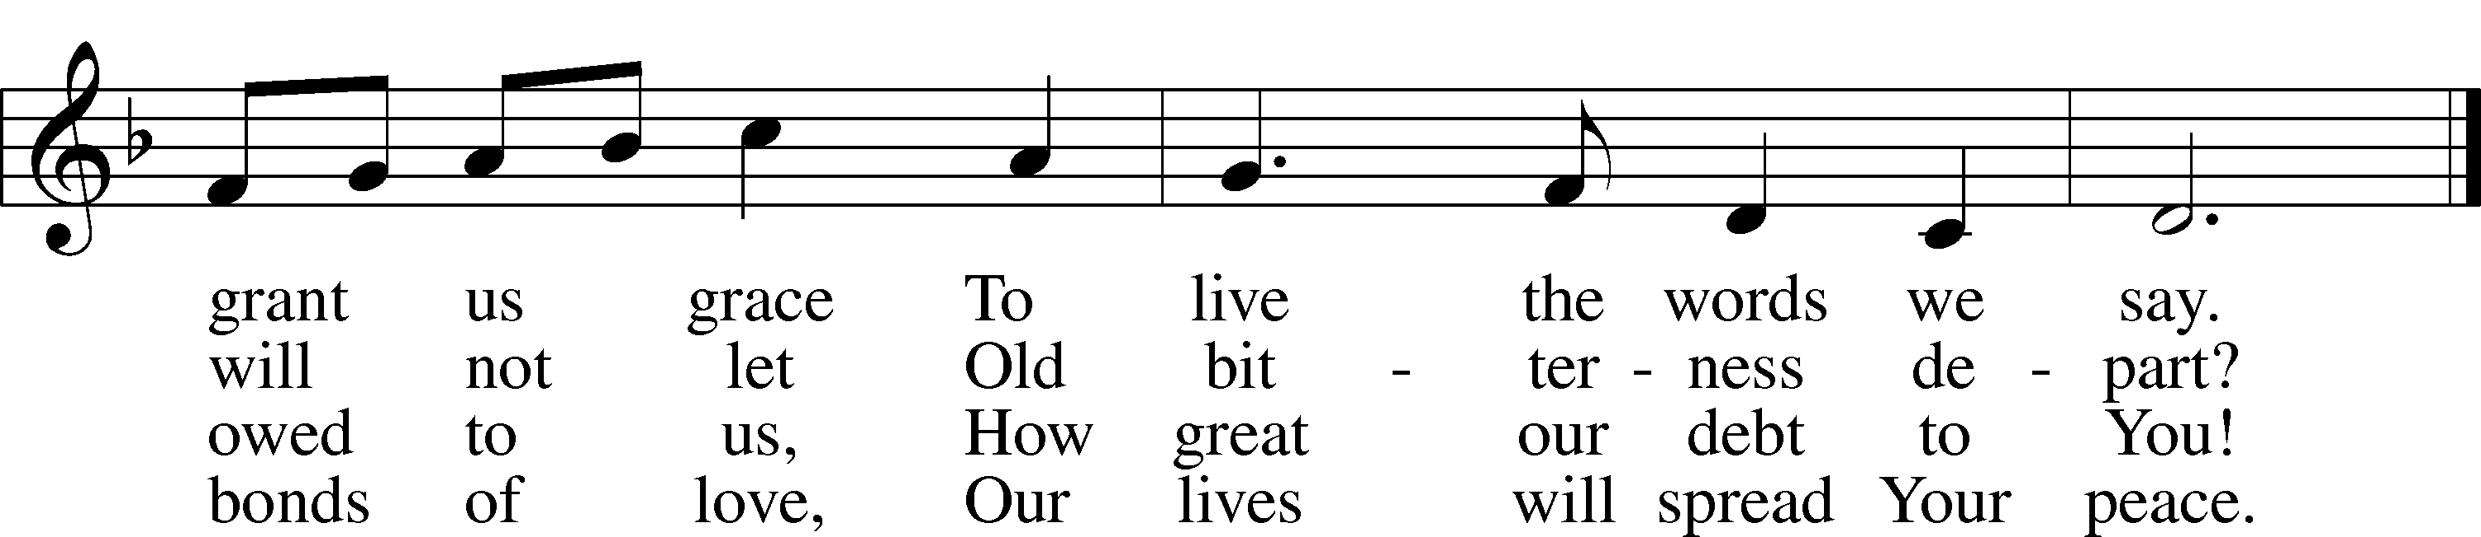

Text: Rosamond E. Herklots, 1905–87, alt.  
Tune: A Supplement to the Kentucky Harmony, 1820, Harrisonburg  
Text: © Oxford University Press. Used by permission: LSB Hymn License no. 110005504  
Tune: Public domain

Sermon

# Canticle

Stand

Te Deum LSB 223

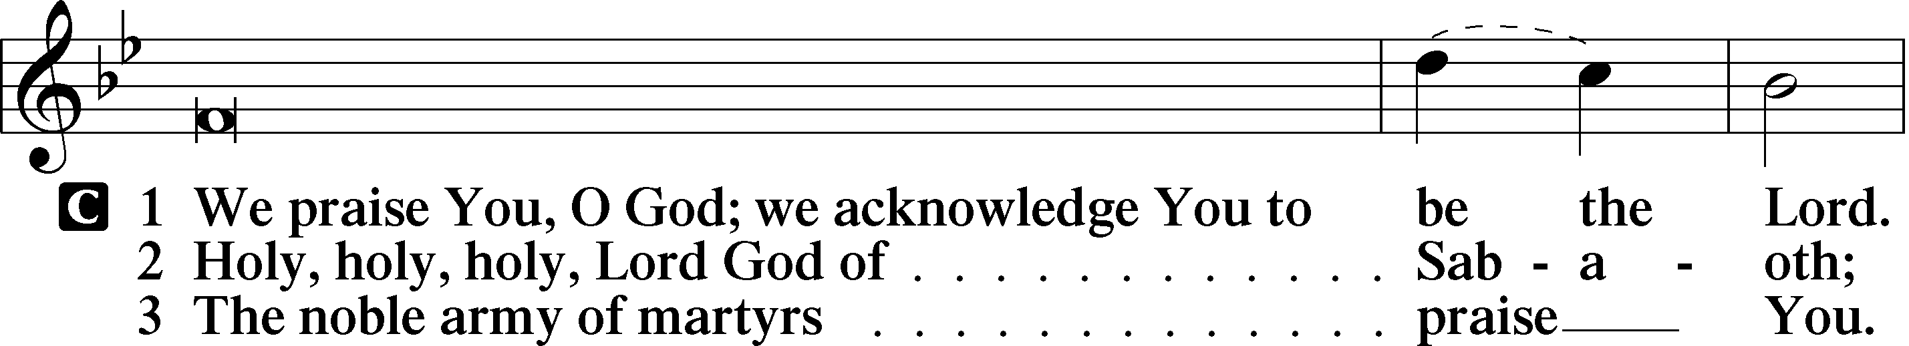

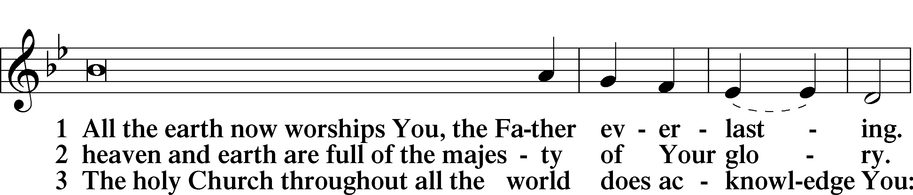

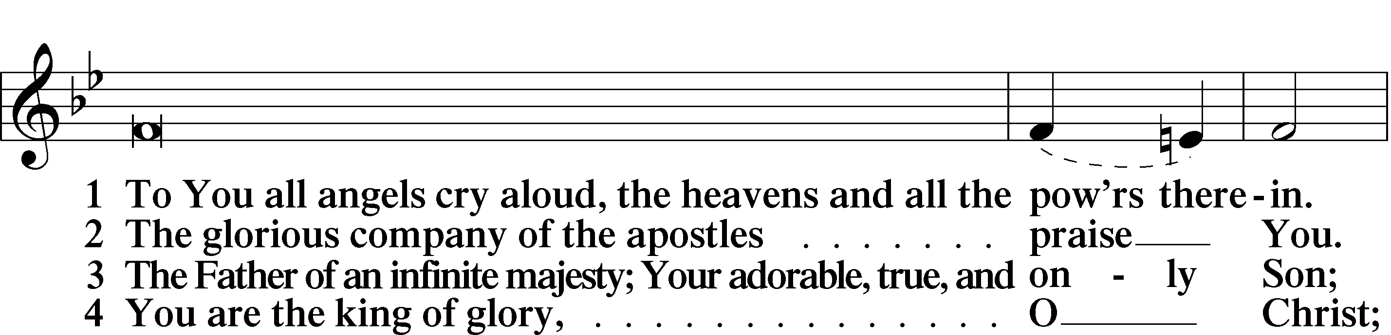

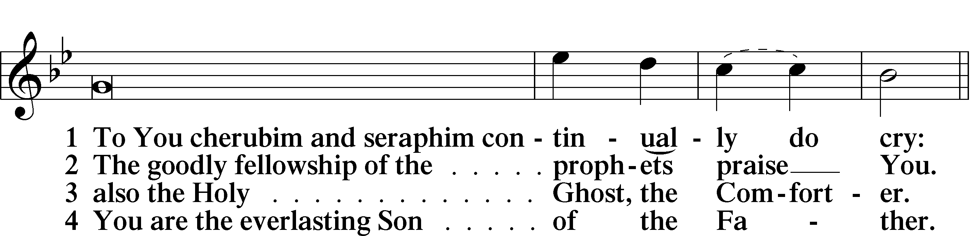

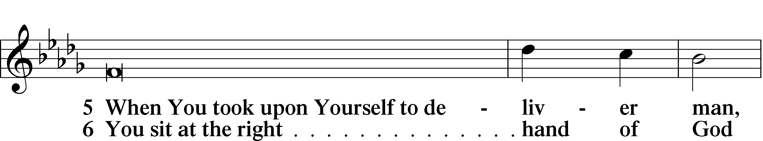

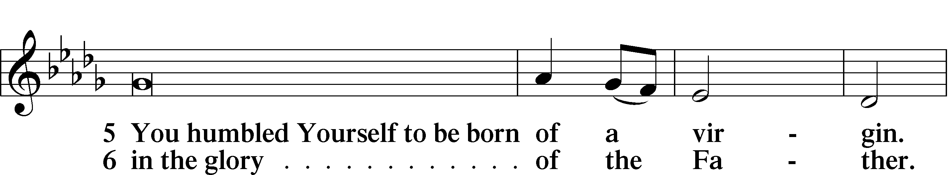

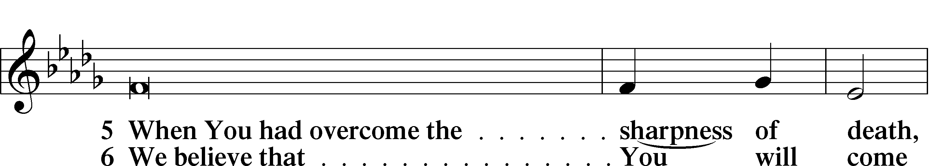

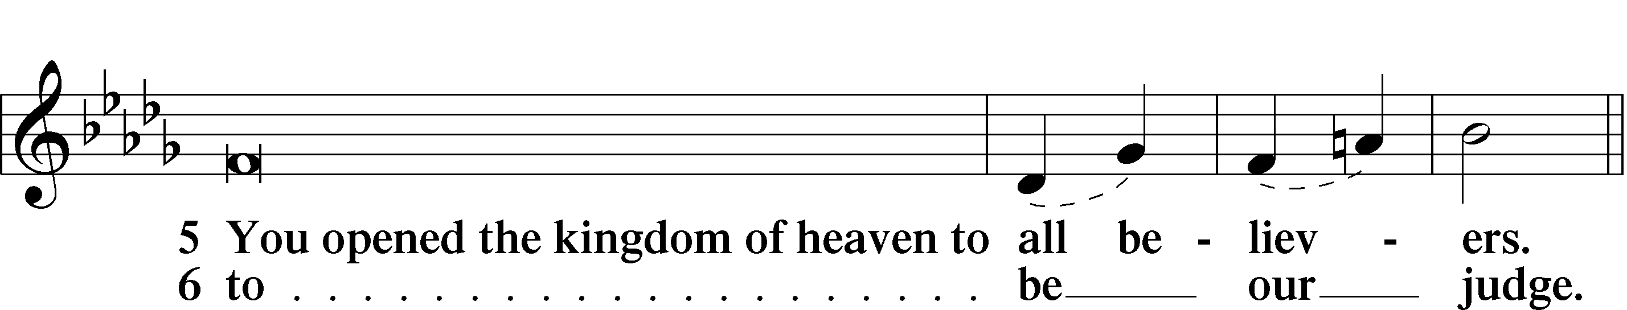

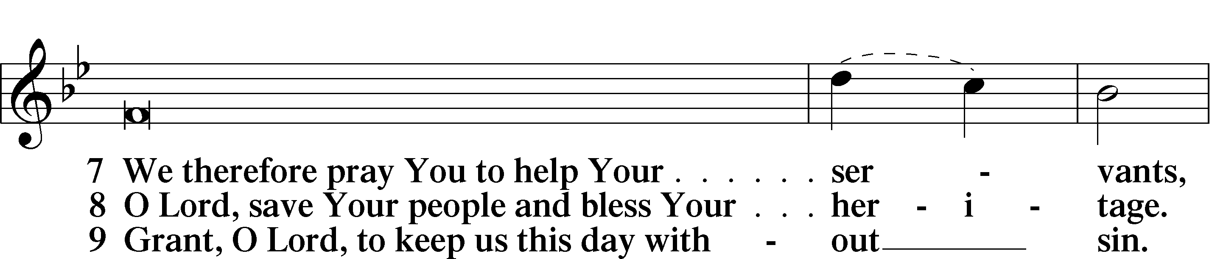

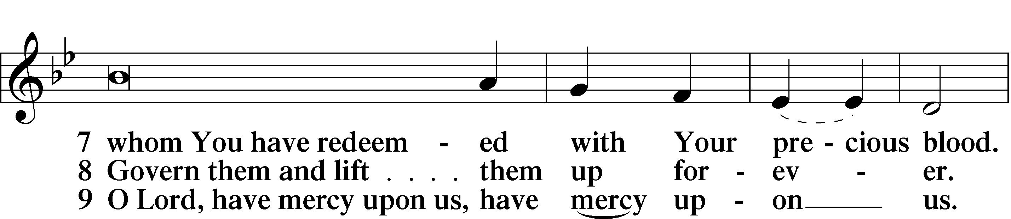

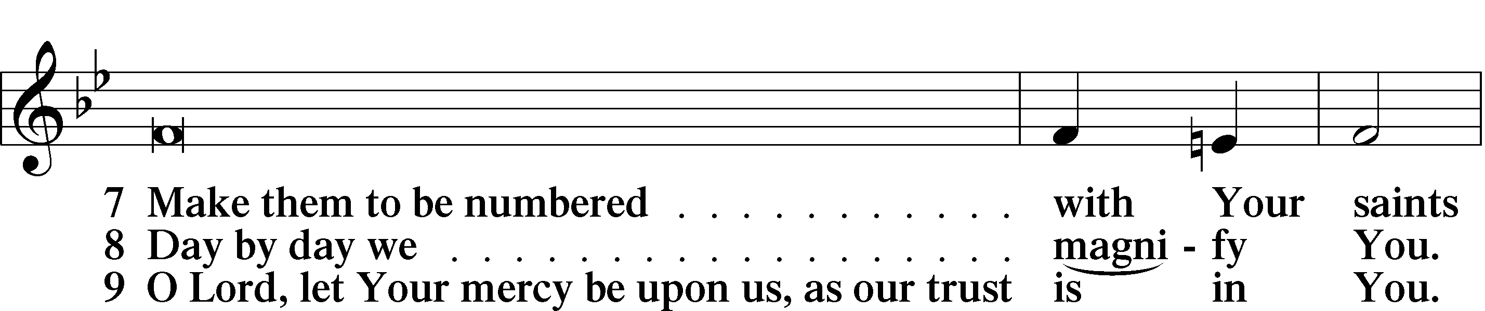

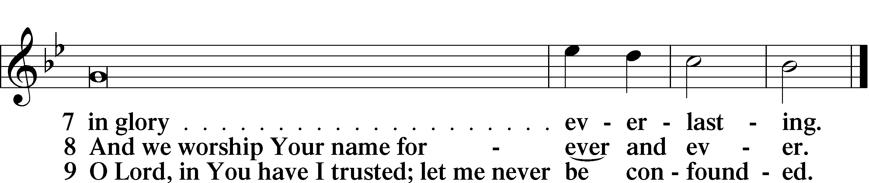

Sit

Offering

# Prayer

Kneel/Stand

Kyrie LSB 227

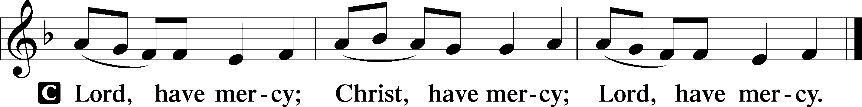

Lord’s Prayer

C **Our Father who art in heaven,**

**hallowed be Thy name,**

**Thy kingdom come,**

**Thy will be done on earth**

**as it is in heaven;**

**give us this day our daily bread;**

**and forgive us our trespasses**

**as we forgive those**

**who trespass against us;**

**and lead us not into temptation,**

**but deliver us from evil.**

**For Thine is the kingdom**

**and the power and the glory**

**forever and ever. Amen.**

Collects

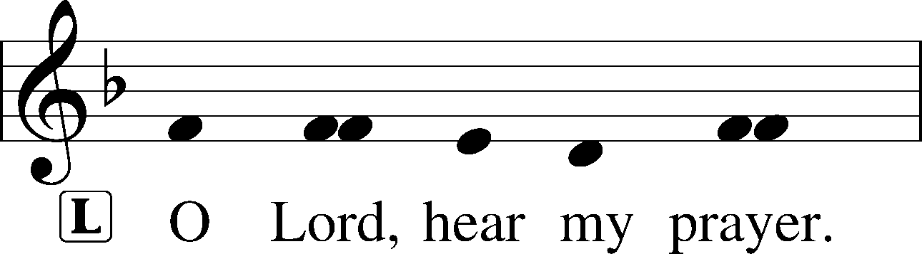

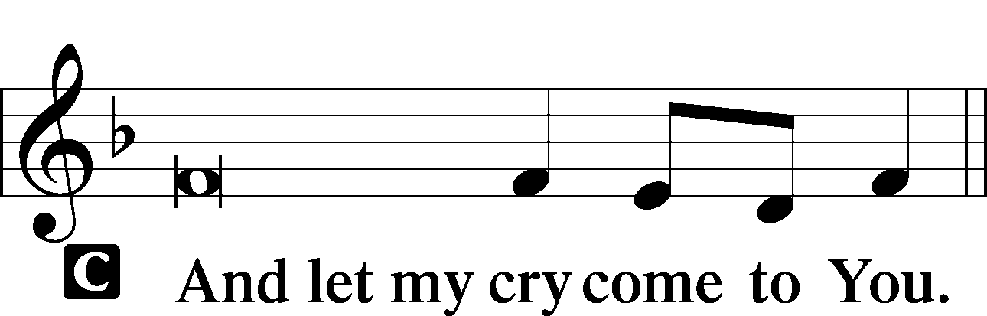

Collect of the Day

O God, the strength of all who put their trust in You, mercifully grant that by Your power we may be defended against all adversity; through Jesus Christ, Your Son, our Lord, who lives and reigns with You and the Holy Spirit, one God, now and forever.

C **Amen.**

Collect for Grace

L O Lord, our heavenly Father, almighty and everlasting God, You have safely brought us to the beginning of this day. Defend us in the same with Your mighty power and grant that this day we fall into no sin, neither run into any kind of danger, but that all our doings, being ordered by Your governance, may be righteous in Your sight; through Jesus Christ, Your Son, our Lord, who lives and reigns with You and the Holy Spirit, one God, now and forever.

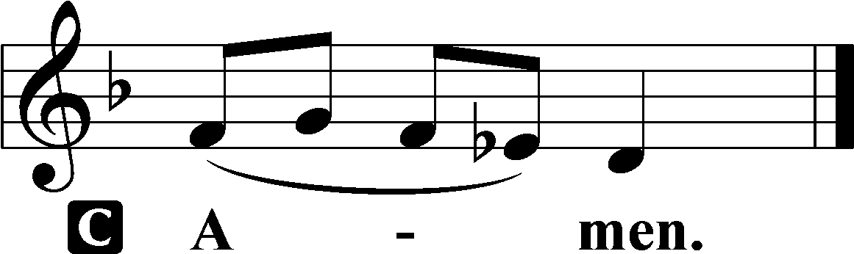

Stand

Benedicamus LSB 228

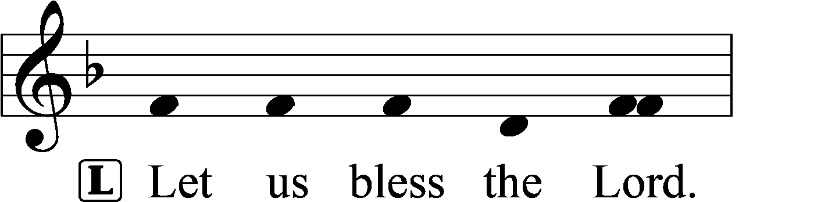

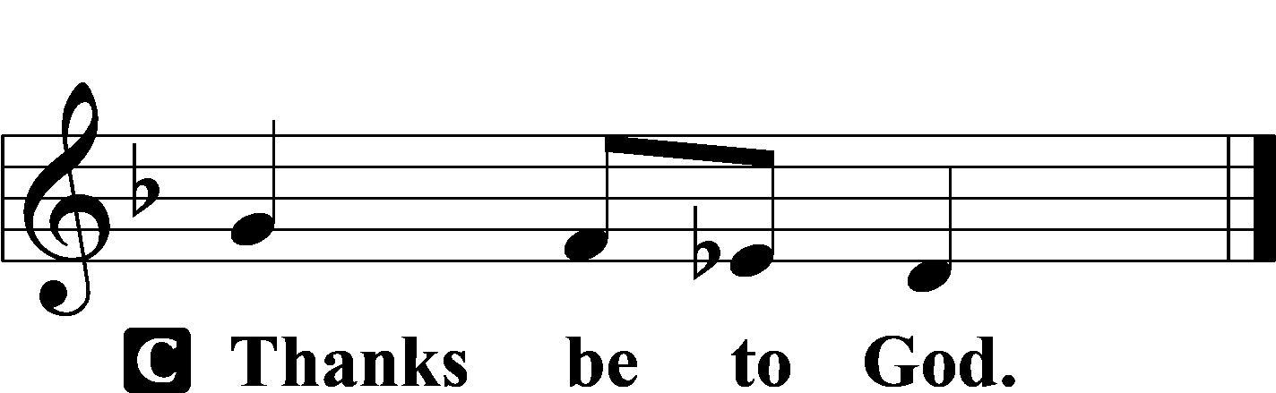

Benediction LSB 228

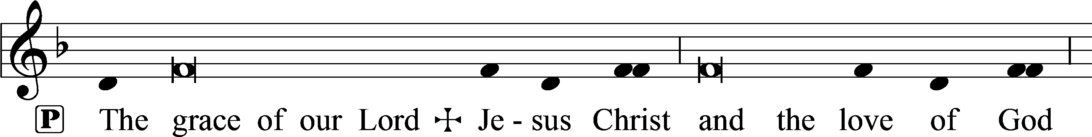

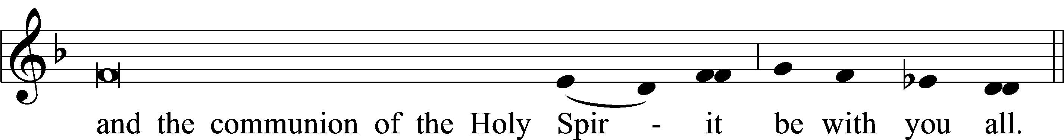



Hymn to Depart: 834 O God, O Lord of Heaven and Earth

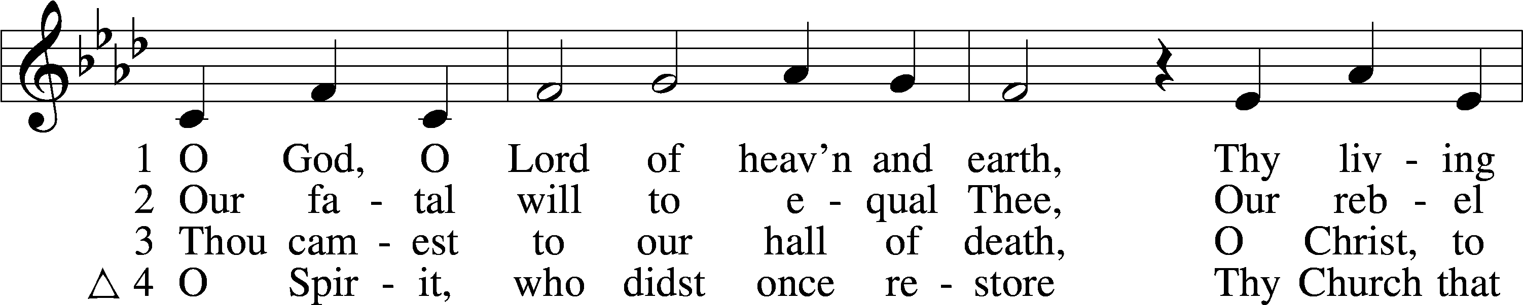

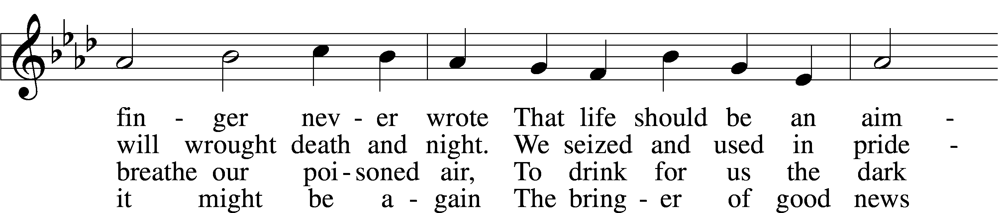

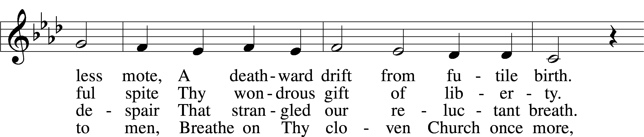

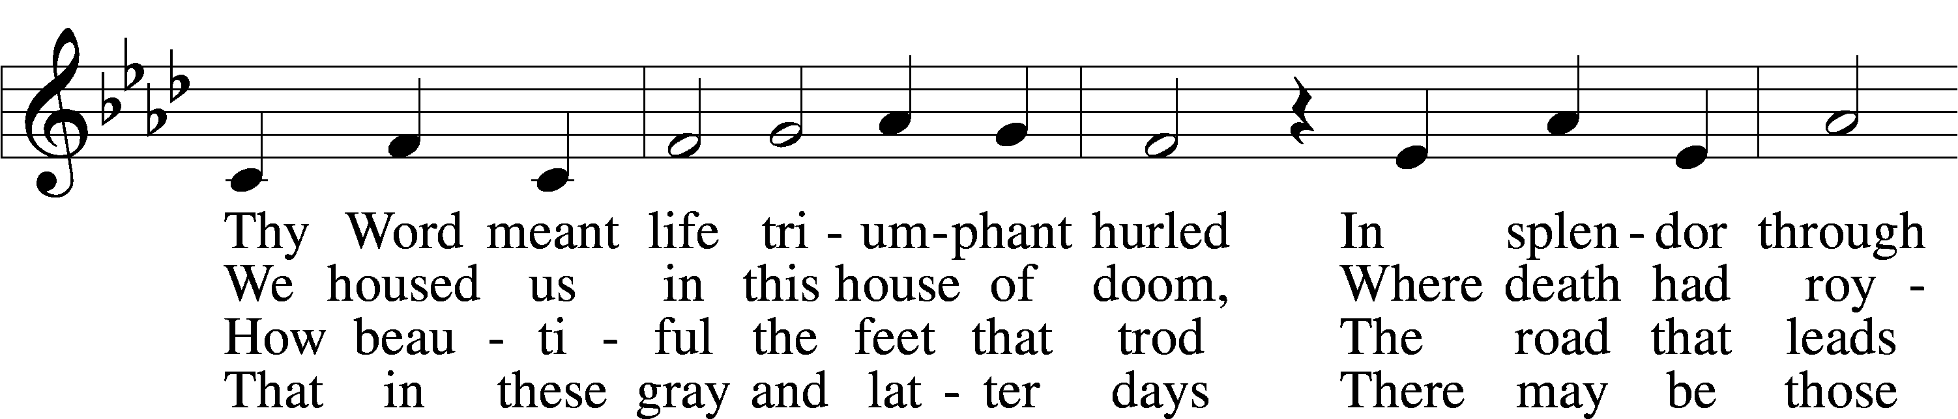

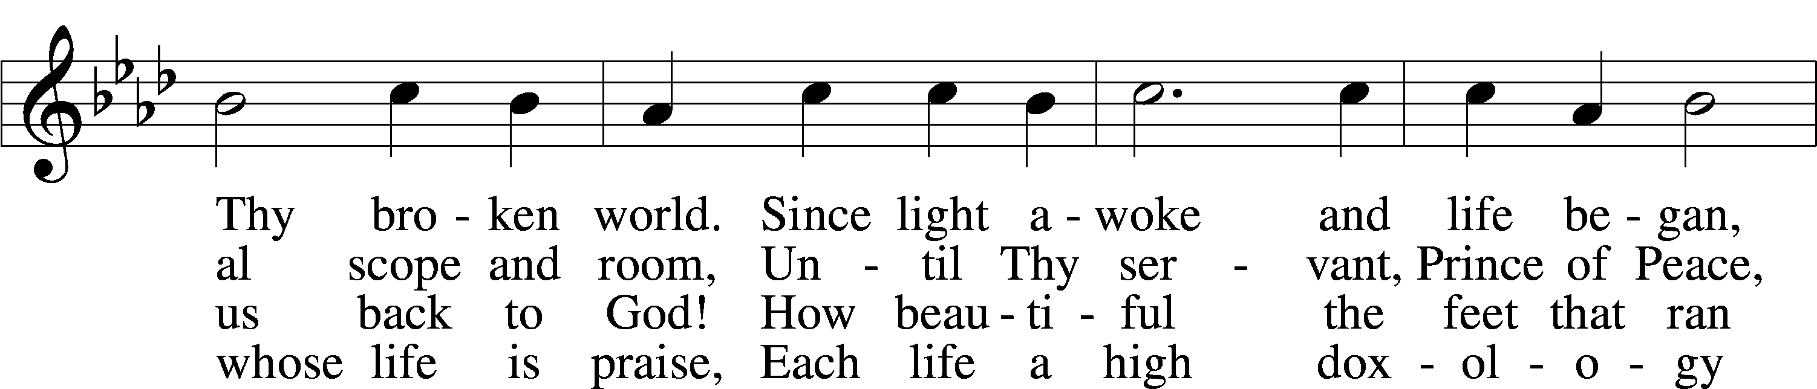

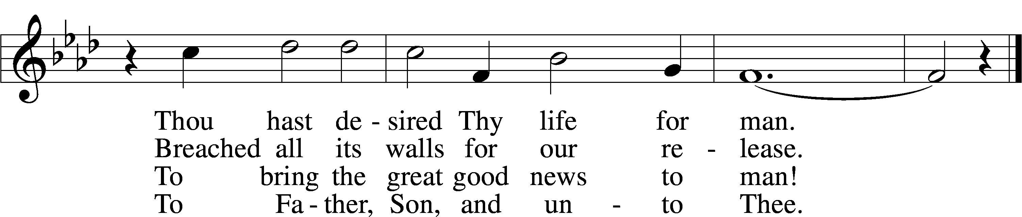

Text: Martin H. Franzmann, 1907–76, alt.  
Tune: Jan O. Bender, 1909–94  
Text and tune: © 1967 Augsburg Fortress. Used by permission: LSB Hymn License no. 110005504

Acknowledgments

Matins from Lutheran Service Book

Unless otherwise indicated, Scripture quotations are from the ESV® Bible (The Holy Bible, English Standard Version®), copyright © 2001 by Crossway, a publishing ministry of Good News Publishers. Used by permission. All rights reserved.

Created by Lutheran Service Builder © 2025 Concordia Publishing House.

**Collect of the Day**

O God, the strength of all who put their trust in You, mercifully grant that by Your power we may be defended against all adversity; through Jesus Christ, Your Son, our Lord, who lives and reigns with You and the Holy Spirit, one God, now and forever.

**As the Son of God Is Merciful and Forgives Your Sins, You Also Be Merciful and Forgive.** Your inheritance as a child of Adam is sin and death, but in Christ you are made alive through His resurrection from the dead (1 Cor. 15:21–22). As you have died with Him in Holy Baptism, so are you raised with Him to newness of life. Therefore, “do not go on sinning” (1 Cor. 15:34). Instead of serving your desires and harming your neighbors, live as “sons of the Most High,” and “be merciful, even as your Father is merciful” (Luke 6:35–36). Deal with others as you would have others deal with you (Luke 6:31, 37–38). As Christ loved you when you were at enmity with Him, as He blessed and prayed for those who abused Him, and as He did good to those who hated Him and hurt Him, so also “love your enemies, do good” (Luke 6:27–29, 35). For God sent His Son to bear the cross and suffer death, not to condemn the guilty, but “to preserve life.” So does He provide a place for you within His Church, where He is near and deals kindly with “you and your children and your children’s children” (Gen. 45:5–10

**Prayers Request:** **Those in the nursing home:** Joann Jaeger, Joan Church **Those Shut-in at home:** Char Herman, Joyce Myers **Those with ongoing health issues:** Owen Metz, Daria (Cindy Wright’s friend), Butch L. (Cindy Wright’s Brother-in-law), Melissa Miller. Art Smith (Sue Millerman’s brother), Brenda Sellent (Denise Stabenow’s sister), Sandy Hahn (Cindy Wright’s cousin’s wife) **,** Brenda Gustum (Missy Wiese’s mom), Lexi Anderson, Marlene Snyder, Shirley Hehl, Ben Cole and his family **Recovering from surgery:** Tim Dennis **Those who lead our nation:** Donald Trump, JD Vance, Tony Evers, Rod Nordby  **Those who serve in our military and law enforcement:** Ryan Graf, Chaplain Pon Chanthaphon (Our Adopt-a-Chaplain), Rusty Weise **Our Childcare Staff:** Melissa Frieburg, Denise Stabenow, Holly Wilhelmi, Janica Skjerly, Jacie Amundson, Cathy Anderson, Alora Provencial, Selene Hansen

**Church Service Phone: 715-438-4200(Chippewa Falls)**

**715-537-4240(local)**

**(Stay on the line for recorded service to start)**

**Live Stream audio services:** [**http://salem.listentochurch.com**](http://salem.listentochurch.com)

**Salem’s Web Page:** <https://www.salembarron.com/>

**Pastor Fred Buth: Cell phone:715-642-3050 (H)715-353-2540**

**Email: salembarronpastor@gmail.com**

**Office Hours: Monday-Wednesday 9-12**

**Attendance:** 2/16-58

**Coffee and Snacks:** Paul & Sue

**Elder Today:** Stan Koenig

**Altar Guild:** Kathy Schuettpelz

**Offering for 2/11/2025**, General Fund $2269, Mission $12, Building $65, Schutz oil 80.59

Pastor will be gone this week. If you have an emergency, please call one of the Elders. Pastor Ike Nicholson from Almena is available to help also.

**Today, February 23rd:** 5-7pm **Snowtubing**, Christie Mountain – Sign up is the back please sign up by February 19th. The price is $5 per child and $10 per adult.

**Save the Date**

**March 16th**: 11am - **Chili and Cookie Contest** - If you would like to make chili or cookies for the contest there is a sign-up sheet in the back. If you would like to just stay and have chili for lunch and enjoy the fellowship you are welcome to do that. For more details see the clip board in the back.

**Baby Bottles from the Pregnancy Help Center are on the back table. Please take one and fill it with your donation. Return it to the church office Thank you**

**St Paul’s Cumberland is hosting:**

