# Divine Service Three - p.184

22nd Sunday after Pentecost

October 20,2024

Hymn: 590 Baptized into Your Name Most Holy

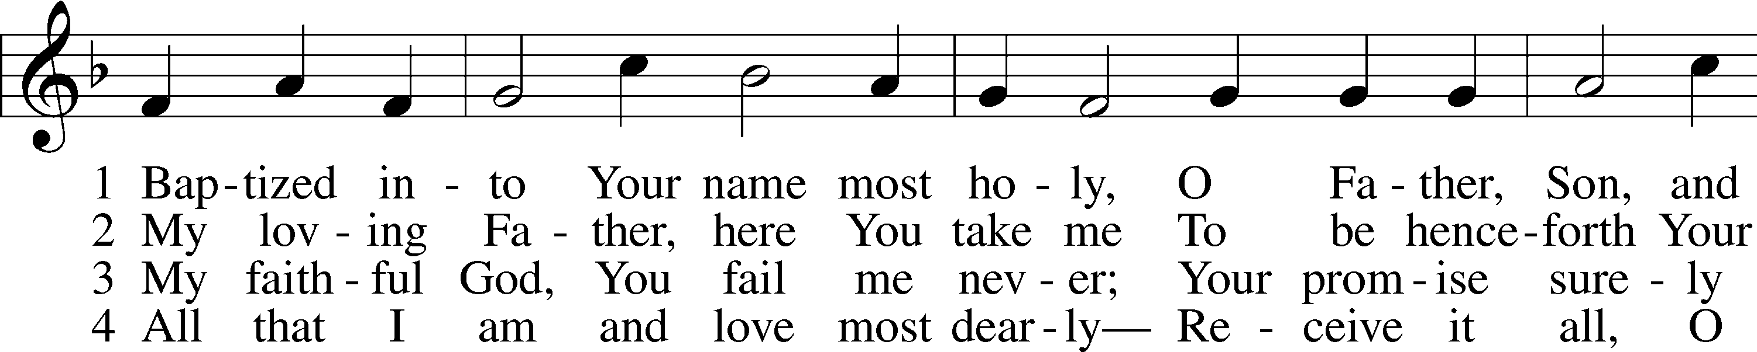

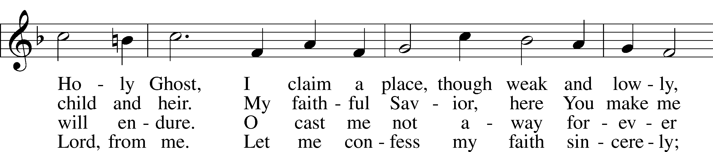

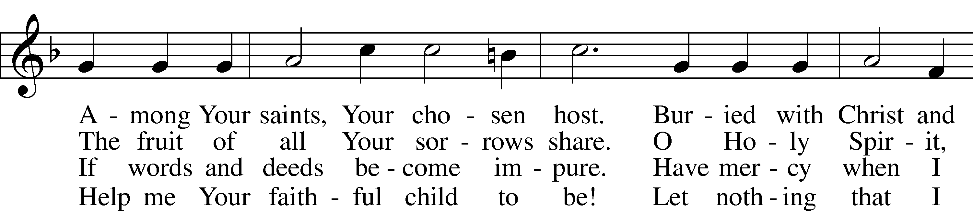

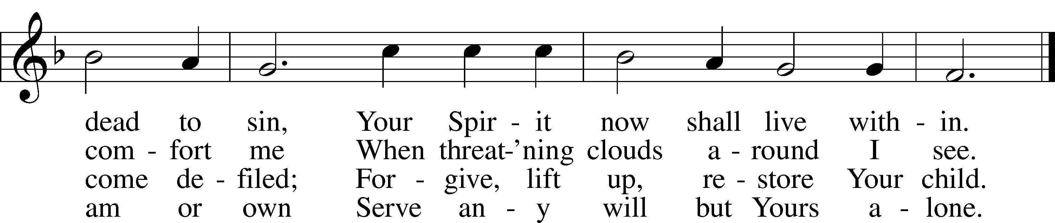

Text: Johann Jacob Rambach, 1693–1735, abr.; tr. Catherine Winkworth, 1827–78, alt.  
Tune: Cornelius Heinrich Dretzel, 1697–1775  
Text and tune: Public domain

P In the name of the Father and of the T Son and of the Holy Spirit.

C **Amen.**

Welcome into membership: Justin Frieburg

Baptism: Collin and Oliver Frieburg

P Beloved in the Lord! Let us draw near with a true heart and confess our sins unto God our Father, beseeching Him in the name of our Lord Jesus Christ to grant us forgiveness.

P Our help is in the name of the Lord,

C **who made heaven and earth.**

P I said, I will confess my transgressions unto the Lord,

C **and You forgave the iniquity of my sin.**

P O almighty God, merciful Father,

C **I, a poor, miserable sinner, confess unto You all my sins and iniquities with which I have ever offended You and justly deserved Your temporal and eternal punishment. But I am heartily sorry for them and sincerely repent of them, and I pray You of Your boundless mercy and for the sake of the holy, innocent, bitter sufferings and death of Your beloved Son, Jesus Christ, to be gracious and merciful to me, a poor, sinful being.**

P Upon this your confession, I, by virtue of my office, as a called and ordained servant of the Word, announce the grace of God unto all of you, and in the stead and by the command of my Lord Jesus Christ I forgive you all your sins in the name of the Father and of the T Son and of the Holy Spirit.

C **Amen.**

# Confession and Absolution

Hymn of Invocation: 907 God Himself Is Present

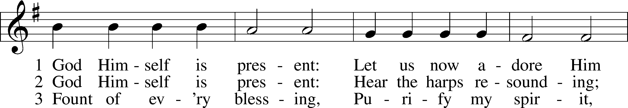

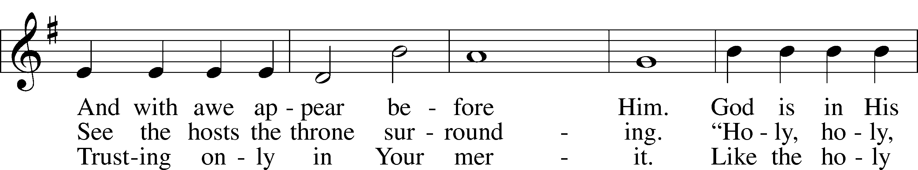

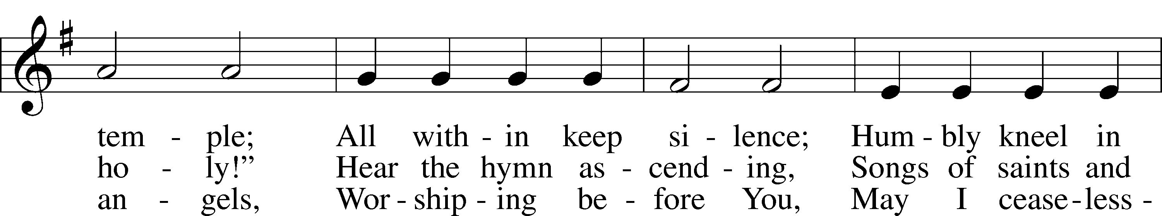

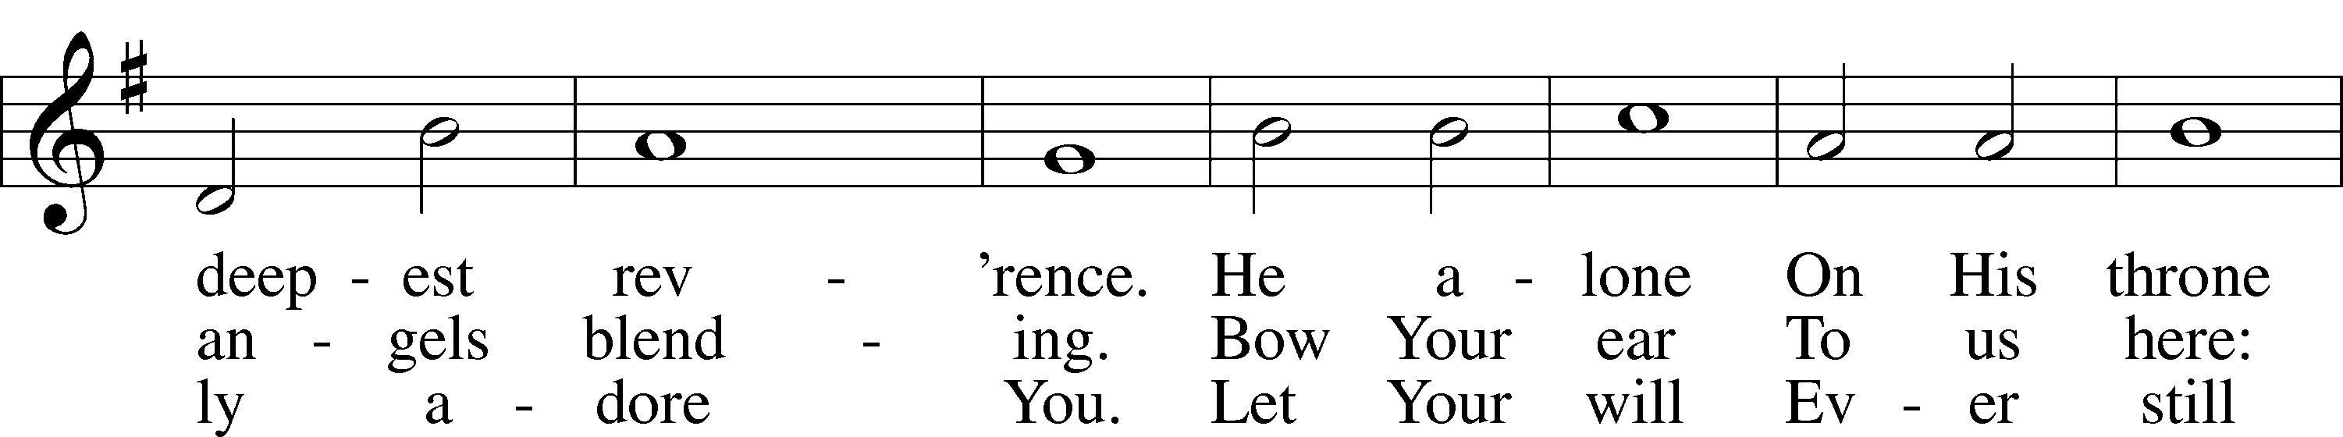

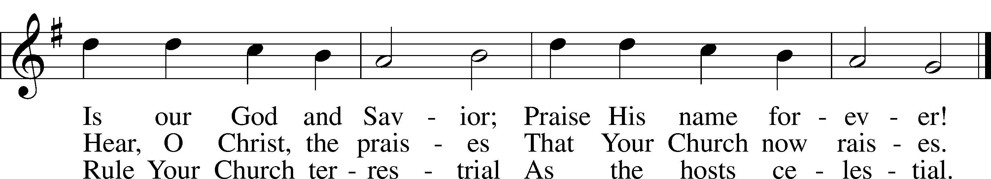

Text: Gerhard Tersteegen, 1697–1769, abr.; tr. Frederick W. Foster, 1760–1835, alt.; tr. John Miller, 1756–90, alt.  
Tune: Joachim Neander, 1650–80  
Text and tune: Public domain

Stand

Silence for reflection on God’s Word and for self-examination.

Stand

# Service of the Word

Introit Psalm 34:1–4, 17; antiphon: v. 18

The Lord is near to the brokenhearted  
 **and saves the crushed in spirit.**I will bless the Lord at all times;  
 **his praise shall continually be in my mouth.**  
My soul makes its boast in the Lord;  
 **let the humble hear and be glad**.  
Oh, magnify the Lord with me,  
 **and let us exalt his name together!**I sought the Lord, and he answered me  
 **and delivered me from all my fears.**  
When the righteous cry for help, the Lord hears  
 **and delivers them out of all their troubles.  
Glory be to the Father and to the Son**  
 **and to the Holy Spirit;**  
**as it was in the beginning,**  
 **is now, and will be forever. Amen.**  
The Lord is near to the brokenhearted  
 **and saves the crushed in spirit**.

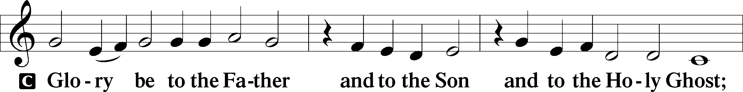

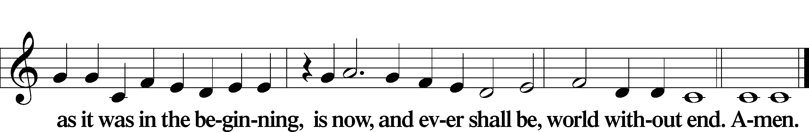

Kyrie LSB 186

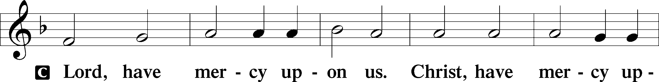

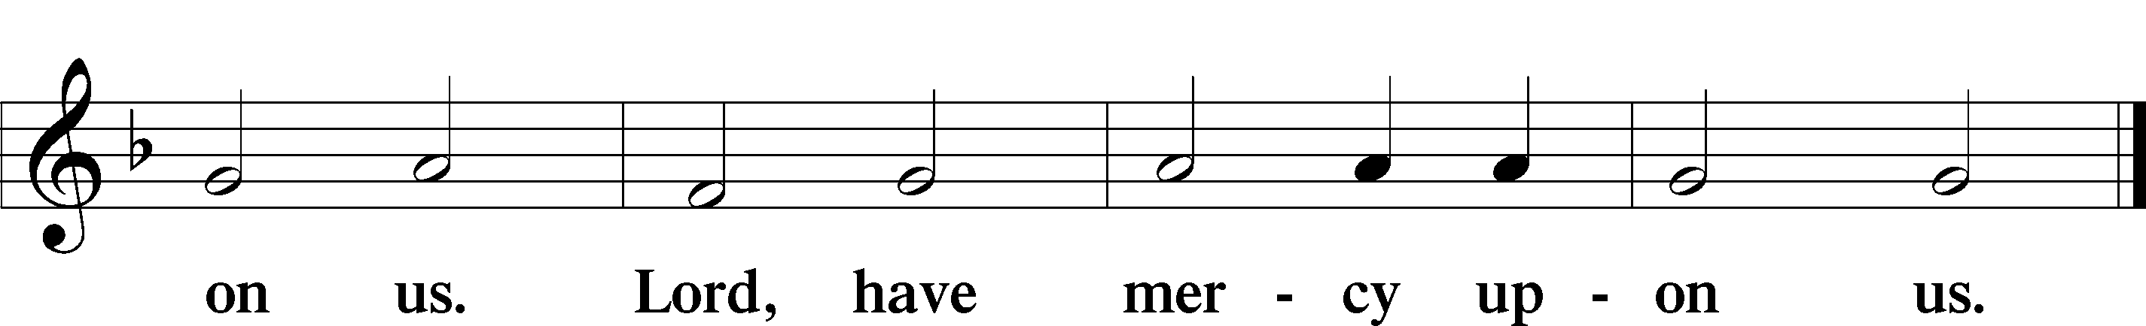

Gloria in Excelsis LSB 187

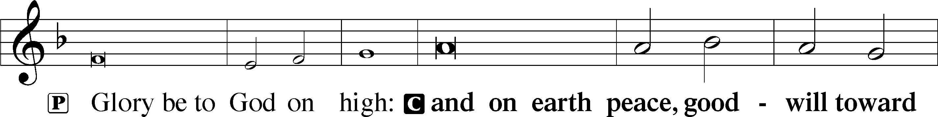

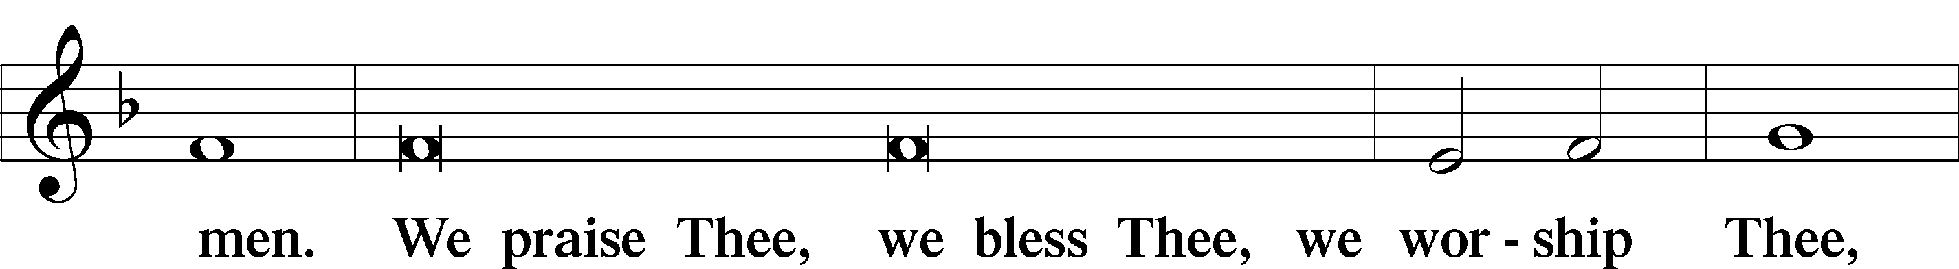

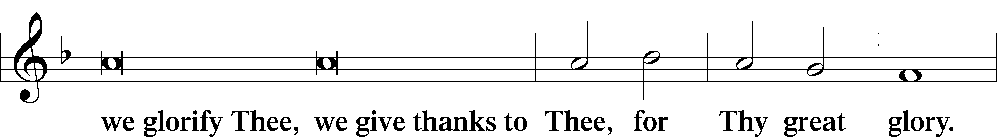

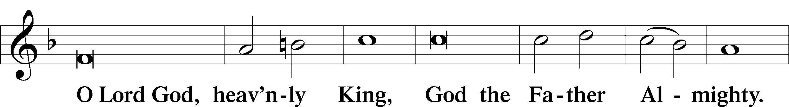

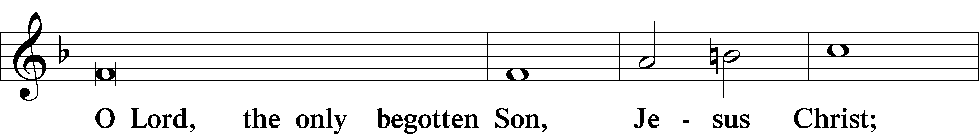

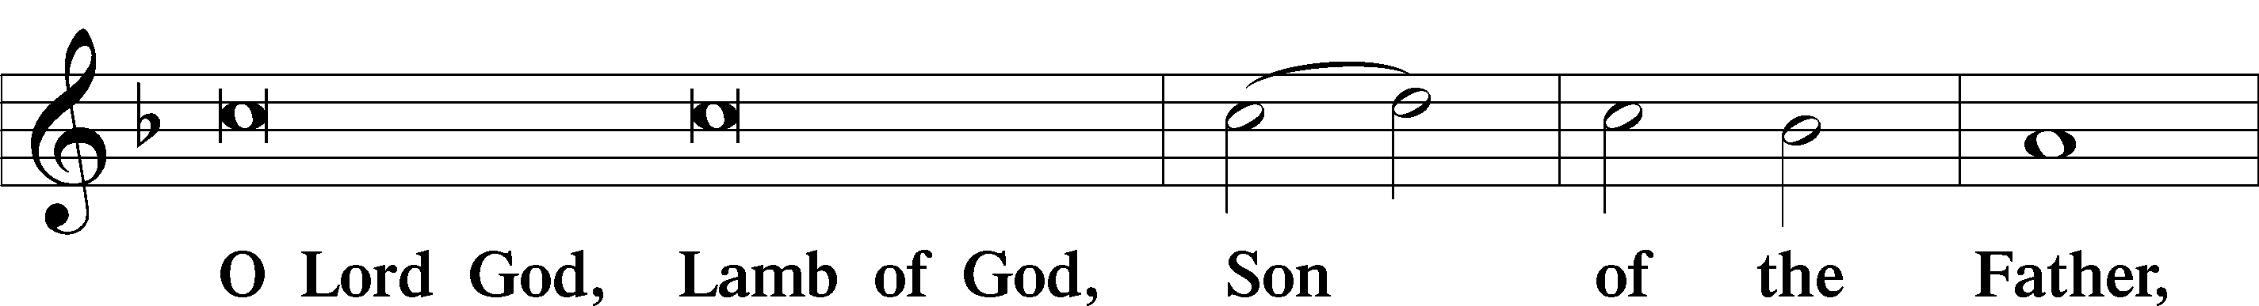

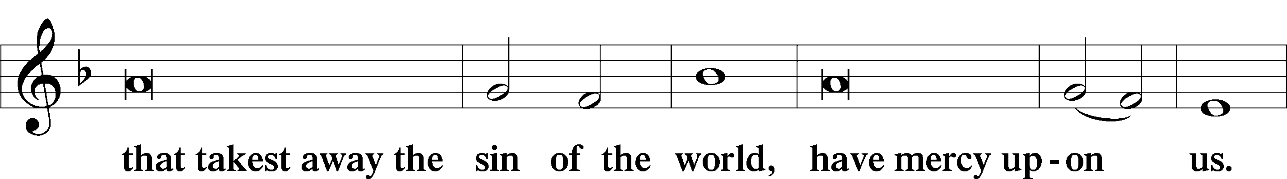

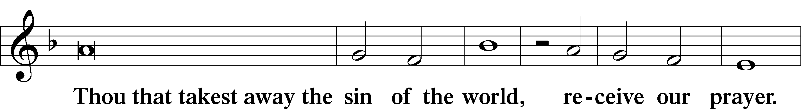

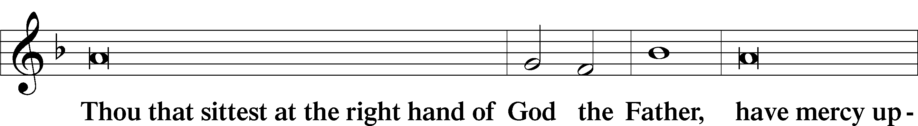

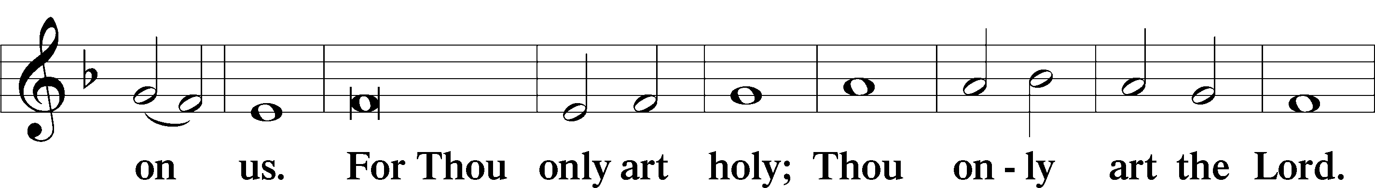

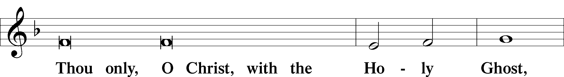

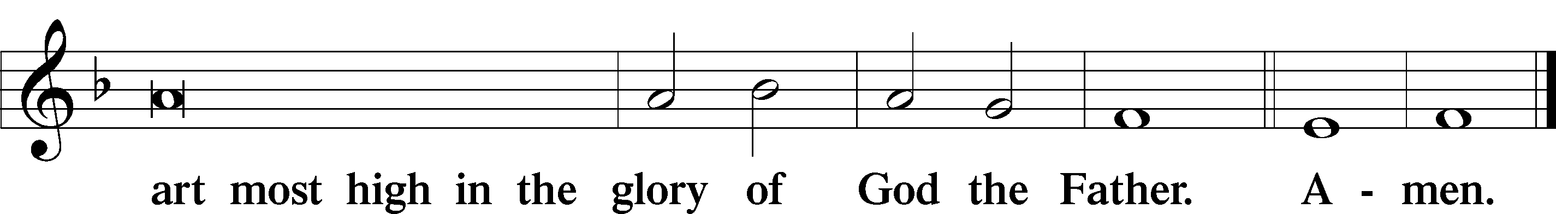

Salutation and Collect of the Day

P The Lord be with you.

C **And with thy spirit.**

P Let us pray.

O God, Your divine wisdom sets in order all things in heaven and on earth. Put away from us all things hurtful and give us those things that are beneficial for us; through Jesus Christ, Your Son, our Lord, who lives and reigns with You and the Holy Spirit, one God, now and forever.

C **Amen.**

Sit

Old Testament Reading Ecclesiastes 5:10–20

10He who loves money will not be satisfied with money, nor he who loves wealth with his income; this also is vanity. 11When goods increase, they increase who eat them, and what advantage has their owner but to see them with his eyes? 12Sweet is the sleep of a laborer, whether he eats little or much, but the full stomach of the rich will not let him sleep.

13There is a grievous evil that I have seen under the sun: riches were kept by their owner to his hurt, 14and those riches were lost in a bad venture. And he is father of a son, but he has nothing in his hand. 15As he came from his mother’s womb he shall go again, naked as he came, and shall take nothing for his toil that he may carry away in his hand. 16This also is a grievous evil: just as he came, so shall he go, and what gain is there to him who toils for the wind? 17Moreover, all his days he eats in darkness in much vexation and sickness and anger.

18Behold, what I have seen to be good and fitting is to eat and drink and find enjoyment in all the toil with which one toils under the sun the few days of his life that God has given him, for this is his lot. 19Everyone also to whom God has given wealth and possessions and power to enjoy them, and to accept his lot and rejoice in his toil—this is the gift of God. 20For he will not much remember the days of his life because God keeps him occupied with joy in his heart.

A This is the Word of the Lord.

C **Thanks be to God.**

Psalm Psalm 119:9–16; antiphon: v. 14

Beth

9How can a young man keep his way pure?  
 By guarding it according to your word.  
10With my whole heart I seek you;  
 let me not wander from your commandments!  
11I have stored up your word in my heart,  
 that I might not sin against you.  
12Blessèd are you, O Lord;  
 teach me your statutes!  
13With my lips I declare  
 all the just decrees of your mouth.  
14In the way of your testimonies I delight  
 as much as in all riches.  
15I will meditate on your precepts  
 and fix my eyes on your ways.  
16I will delight in your statutes;  
 I will not forget your word.

Epistle Hebrews 4:1–13

1Therefore, while the promise of entering his rest still stands, let us fear lest any of you should seem to have failed to reach it. 2For good news came to us just as to them, but the message they heard did not benefit them, because they were not united by faith with those who listened. 3For we who have believed enter that rest, as he has said,

“As I swore in my wrath,  
‘They shall not enter my rest,’”

although his works were finished from the foundation of the world. 4For he has somewhere spoken of the seventh day in this way: “And God rested on the seventh day from all his works.” 5And again in this passage he said,

“They shall not enter my rest.”

6Since therefore it remains for some to enter it, and those who formerly received the good news failed to enter because of disobedience, 7again he appoints a certain day, “Today,” saying through David so long afterward, in the words already quoted,

“Today, if you hear his voice,  
do not harden your hearts.”

8For if Joshua had given them rest, God would not have spoken of another day later on. 9So then, there remains a Sabbath rest for the people of God, 10for whoever has entered God’s rest has also rested from his works as God did from his.

11Let us therefore strive to enter that rest, so that no one may fall by the same sort of disobedience. 12For the word of God is living and active, sharper than any two-edged sword, piercing to the division of soul and of spirit, of joints and of marrow, and discerning the thoughts and intentions of the heart. 13And no creature is hidden from his sight, but all are naked and exposed to the eyes of him to whom we must give account.

A This is the Word of the Lord.

C **Thanks be to God.**

Stand

Alleluia LSB 190

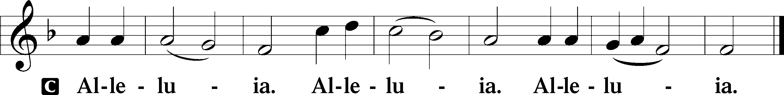

Holy Gospel Mark 10:23–31

P The Holy Gospel according to St. Mark, the tenth chapter.

C **Glory be to Thee, O Lord.**

23Jesus looked around and said to his disciples, “How difficult it will be for those who have wealth to enter the kingdom of God!” 24And the disciples were amazed at his words. But Jesus said to them again, “Children, how difficult it is to enter the kingdom of God! 25It is easier for a camel to go through the eye of a needle than for a rich person to enter the kingdom of God.” 26And they were exceedingly astonished, and said to him, “Then who can be saved?” 27Jesus looked at them and said, “With man it is impossible, but not with God. For all things are possible with God.” 28Peter began to say to him, “See, we have left everything and followed you.” 29Jesus said, “Truly, I say to you, there is no one who has left house or brothers or sisters or mother or father or children or lands, for my sake and for the gospel, 30who will not receive a hundredfold now in this time, houses and brothers and sisters and mothers and children and lands, with persecutions, and in the age to come eternal life. 31But many who are first will be last, and the last first.”

P This is the Gospel of the Lord.

C **Praise be to Thee, O Christ.**

Nicene Creed

C **I believe in one God,**

**the Father Almighty,**

**maker of heaven and earth**

**and of all things visible and invisible.**

**And in one Lord Jesus Christ,**

**the only-begotten Son of God,**

**begotten of His Father before all worlds,**

**God of God, Light of Light,**

**very God of very God,**

**begotten, not made,**

**being of one substance with the Father,**

**by whom all things were made;**

**who for us men and for our salvation came down from heaven**

**and was incarnate by the Holy Spirit of the virgin Mary**

**and was made man;**

**and was crucified also for us under Pontius Pilate.**

**He suffered and was buried.**

**And the third day He rose again according to the Scriptures**

**and ascended into heaven**

**and sits at the right hand of the Father.**

**And He will come again with glory to judge both the living and the dead,**

**whose kingdom will have no end.**

**And I believe in the Holy Spirit,**

**the Lord and giver of life,**

**who proceeds from the Father and the Son,**

**who with the Father and the Son together is worshiped and glorified,**

**who spoke by the prophets.**

**And I believe in one holy Christian and apostolic Church,**

**I acknowledge one Baptism for the remission of sins,**

**and I look for the resurrection of the dead**

**and the life** T **of the world to come. Amen.**

Sit

Hymn of the Day: 850 God of Grace and God of Glory

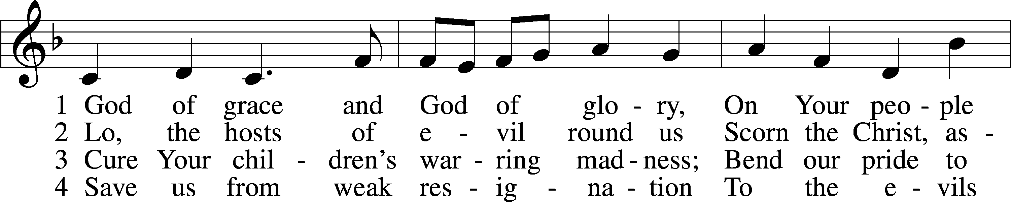

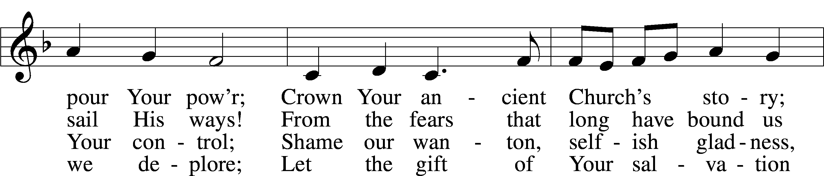

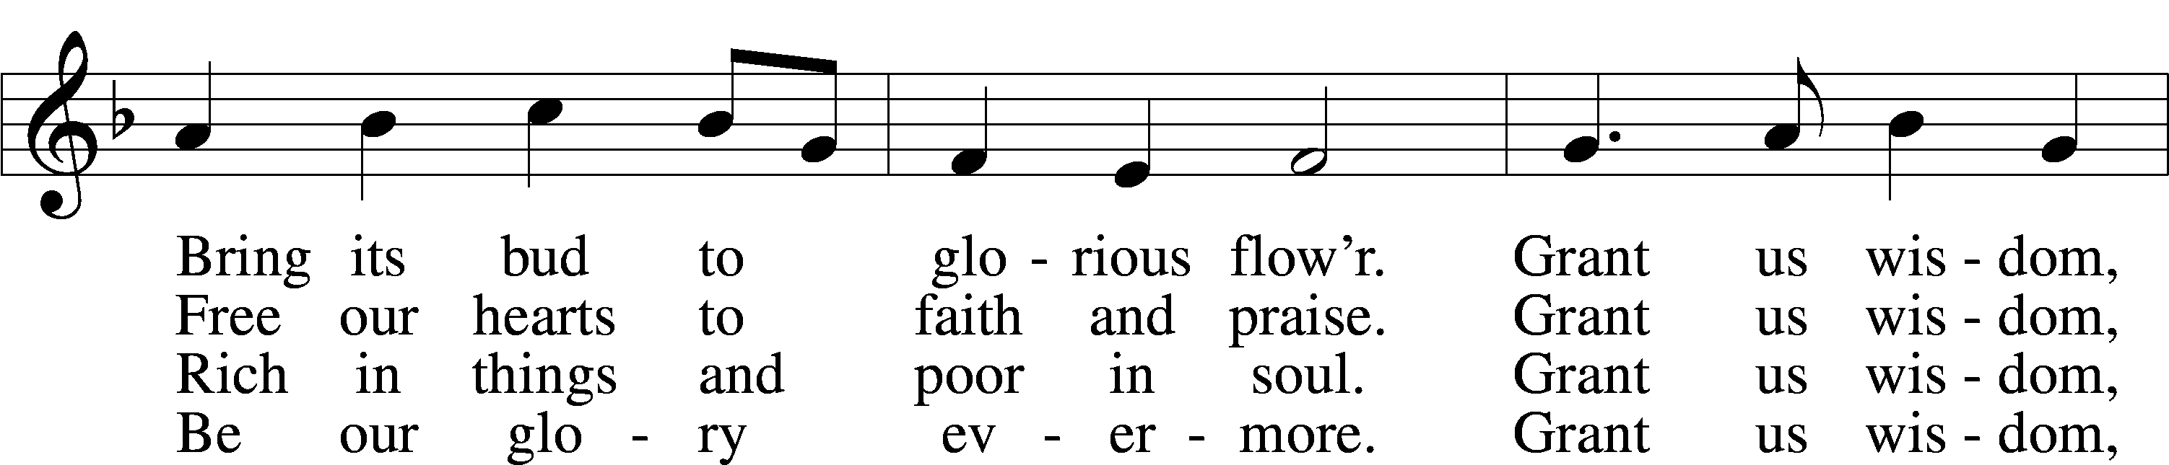

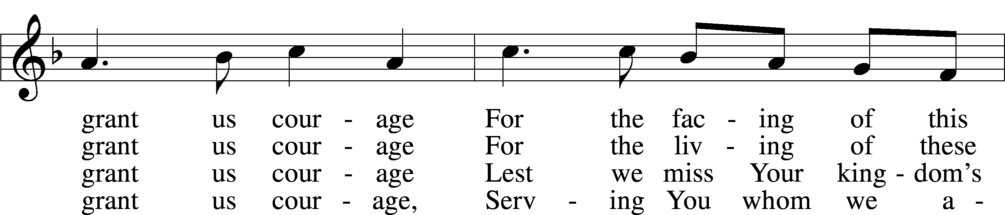

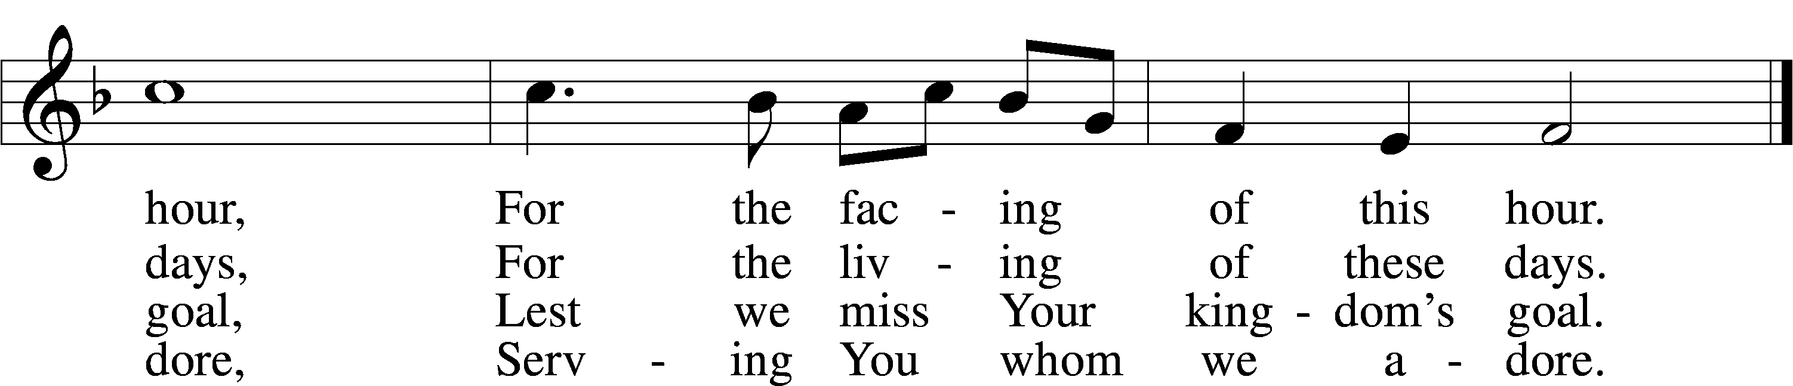

Text: Harry Emerson Fosdick, 1878–1969  
Tune: John Hughes, 1873–1932  
Text and tune: Public domain

Sermon

P The peace of God, which passes all understanding, keep your hearts and minds in Christ Jesus.

C **Amen.**

Stand

Offertory LSB 192

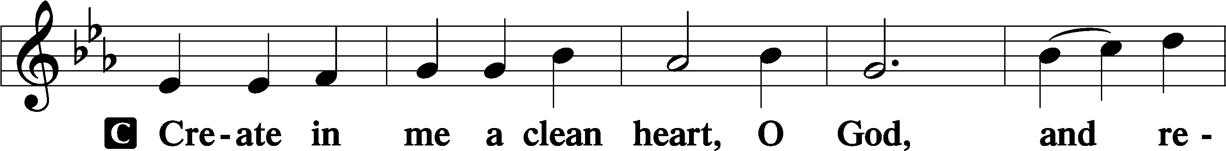

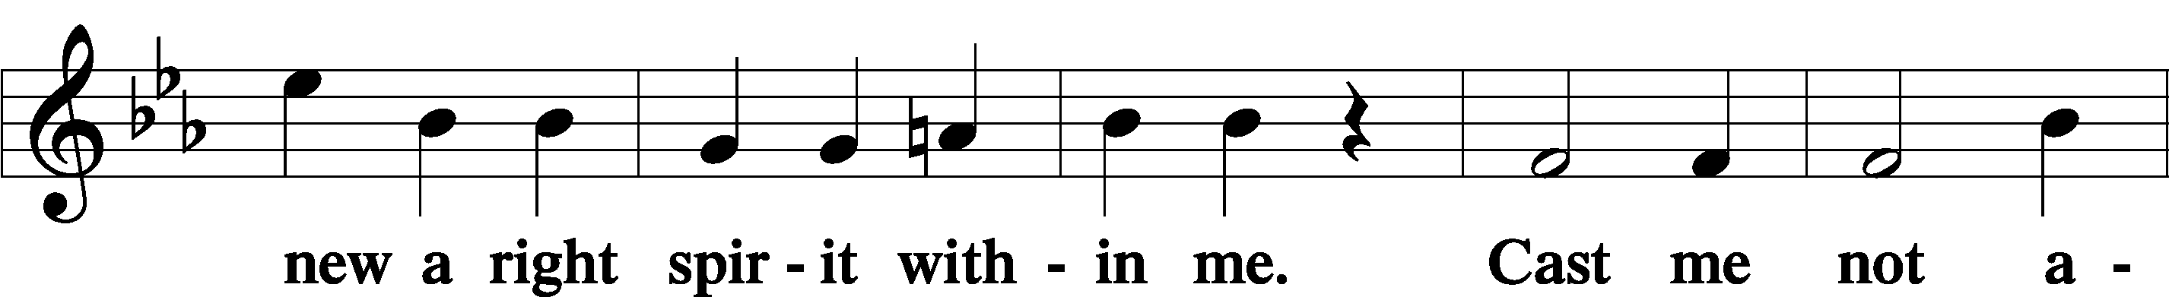

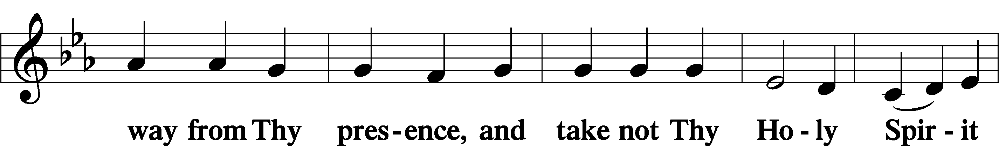

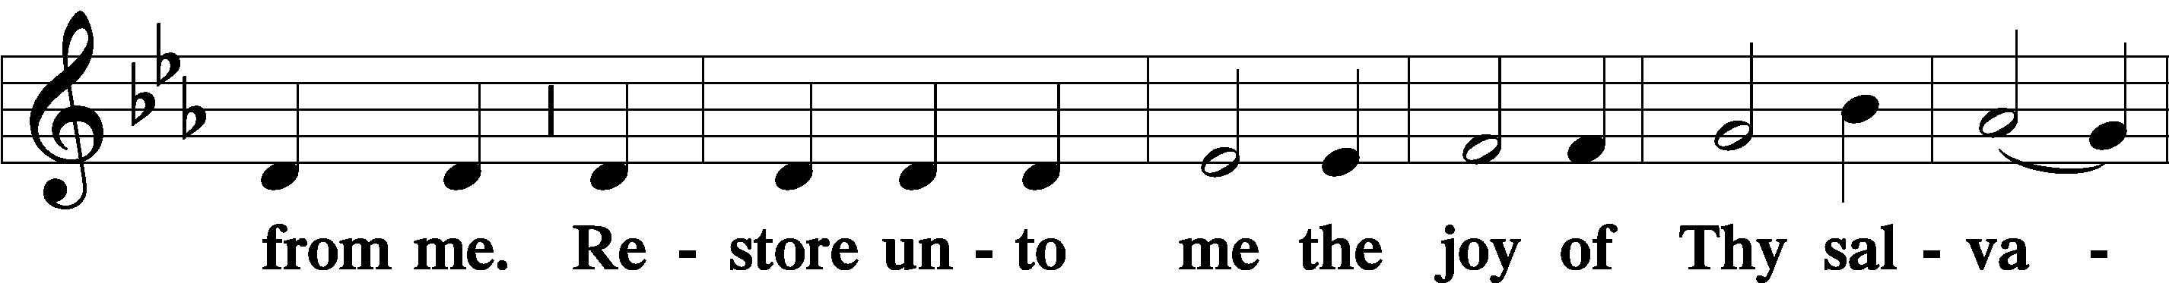

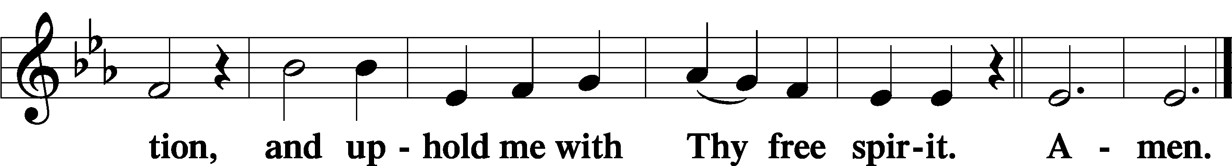

Sit

Offering

Stand

Prayer of the Church

# Service of the Sacrament

Preface LSB 194







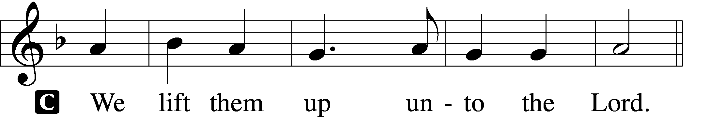

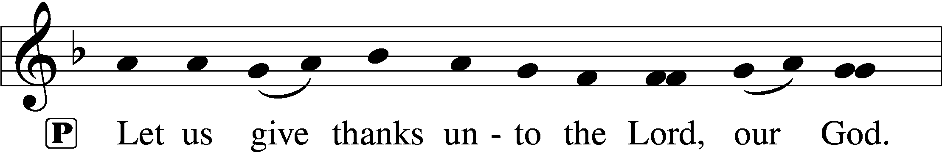

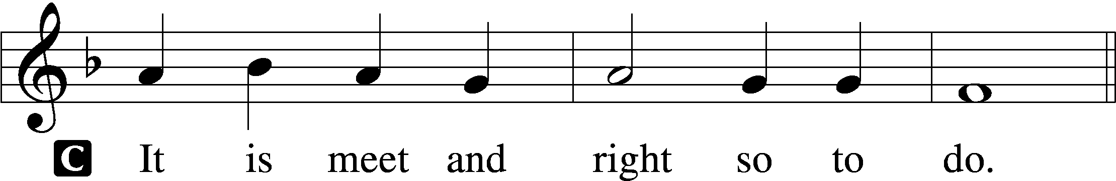

P It is truly meet, right, and salutary that we should at all times and in all places give thanks to You, holy Lord, almighty Father, everlasting God, through Jesus Christ, our Lord. Therefore with angels and archangels and with all the company of heaven we laud and magnify Your glorious name, evermore praising You and saying:

Sanctus LSB 195

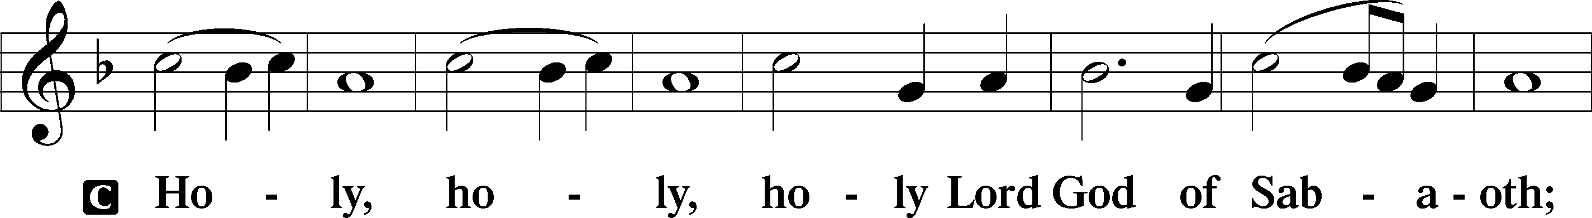

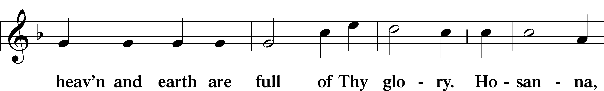

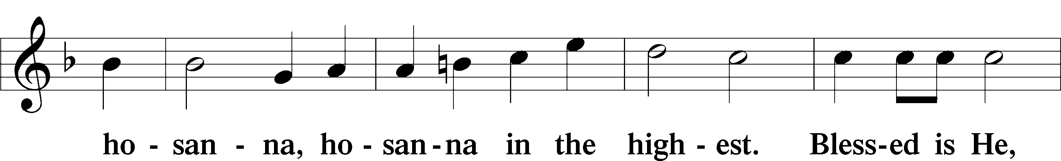

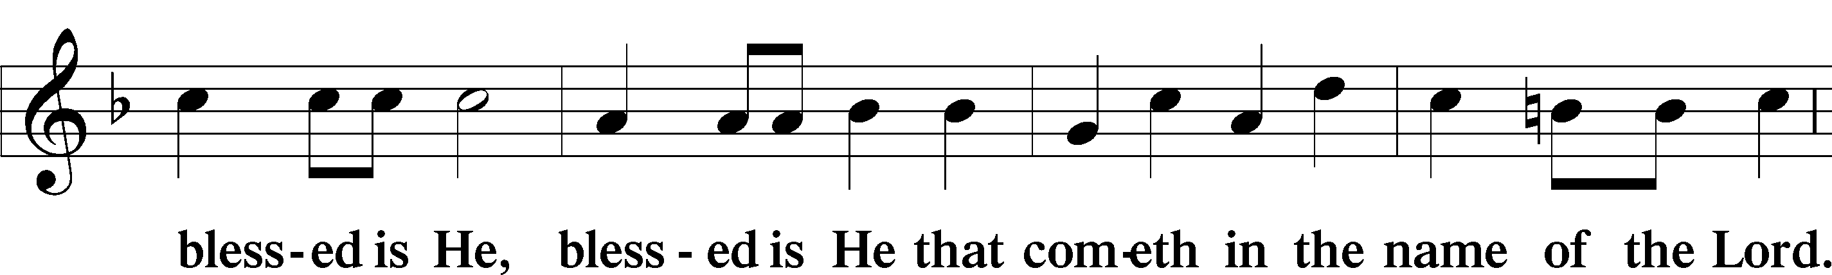

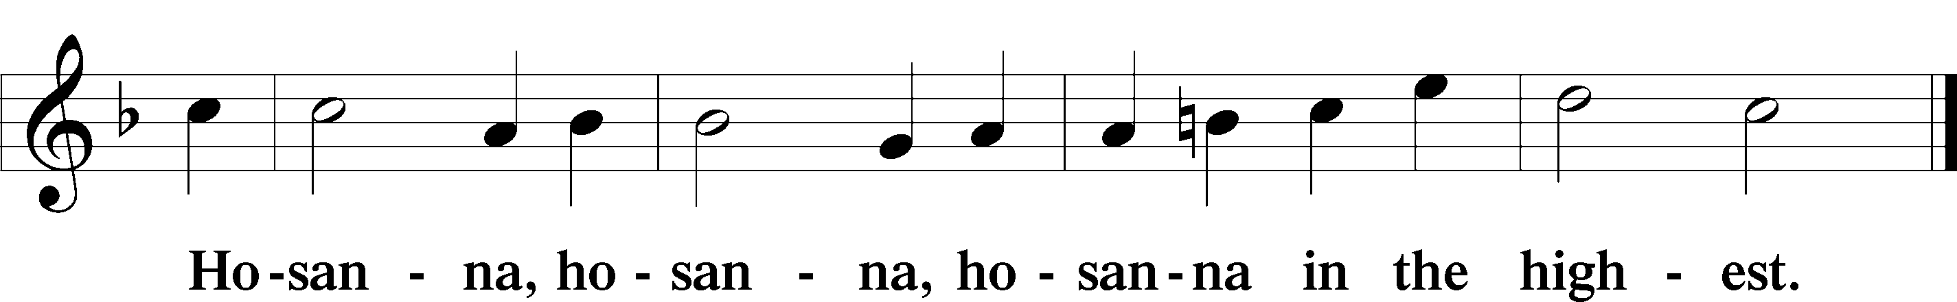

Lord’s Prayer LSB 196

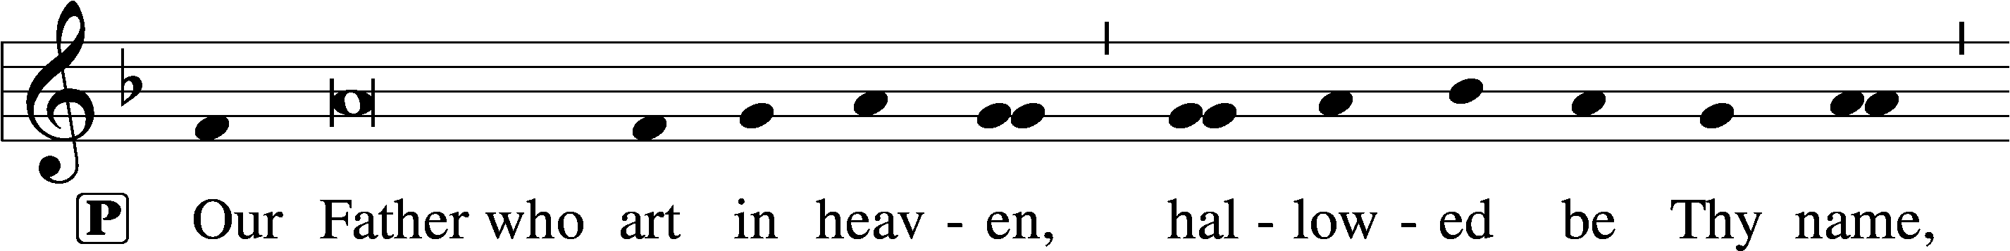

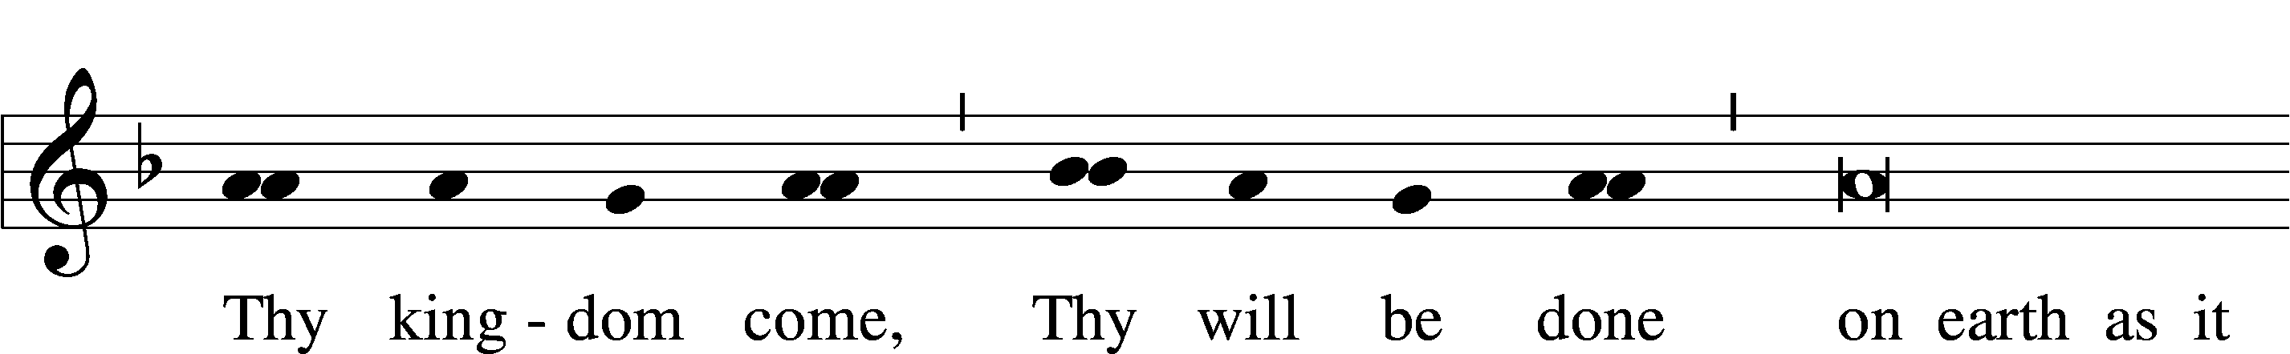

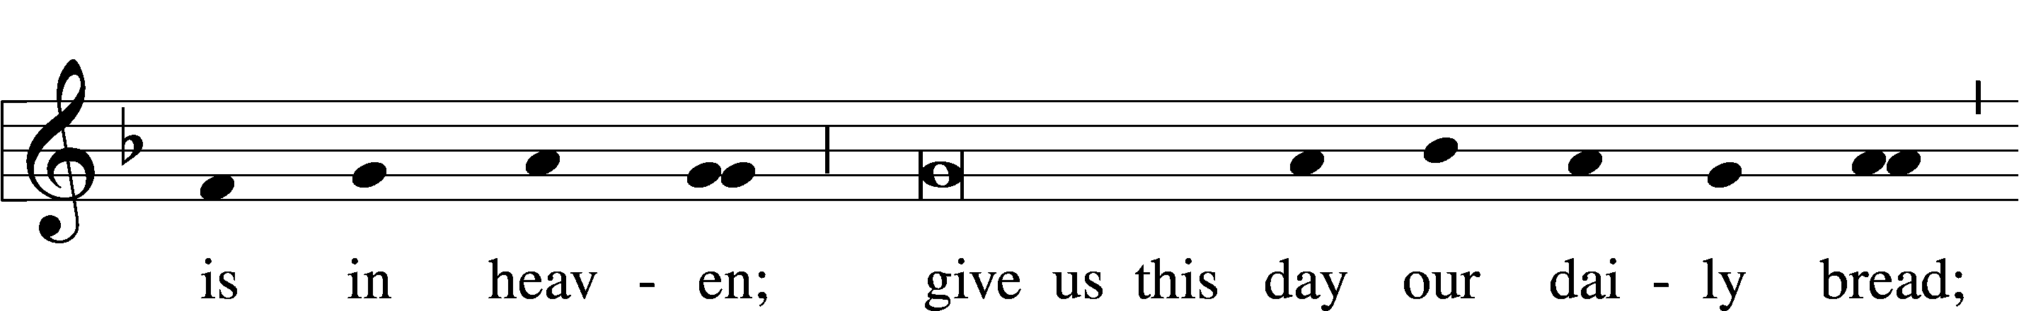

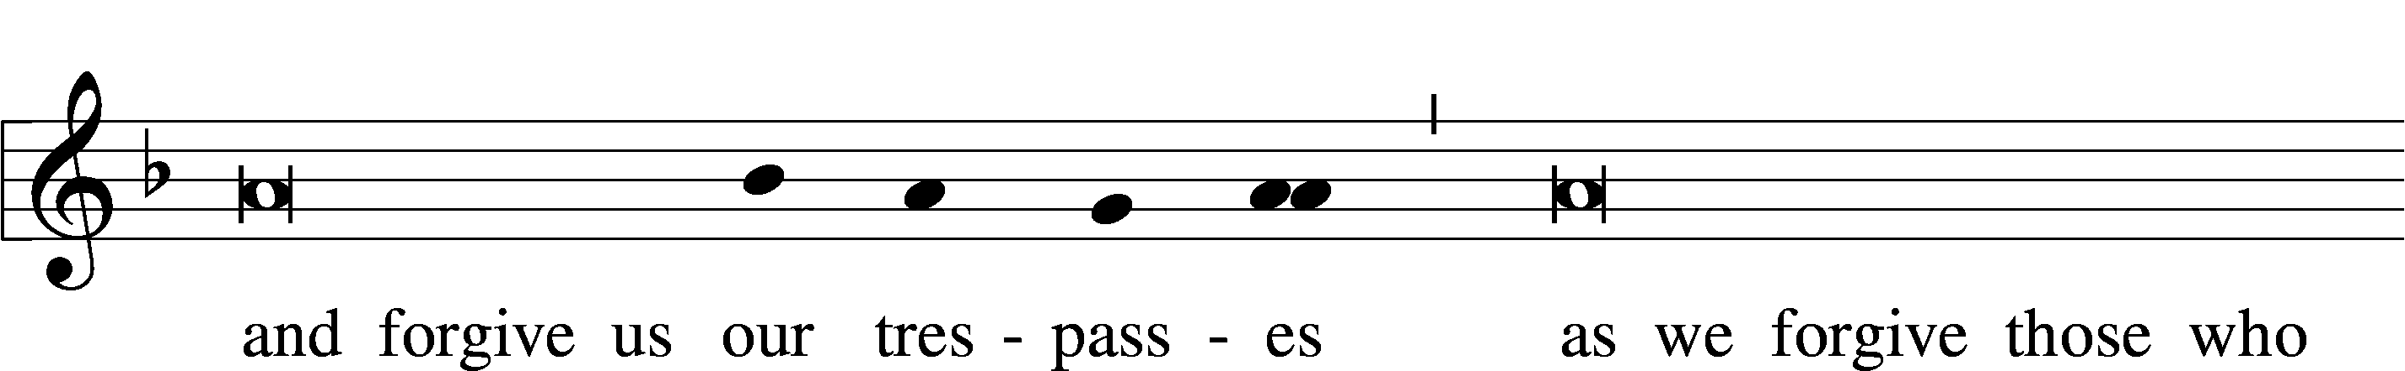

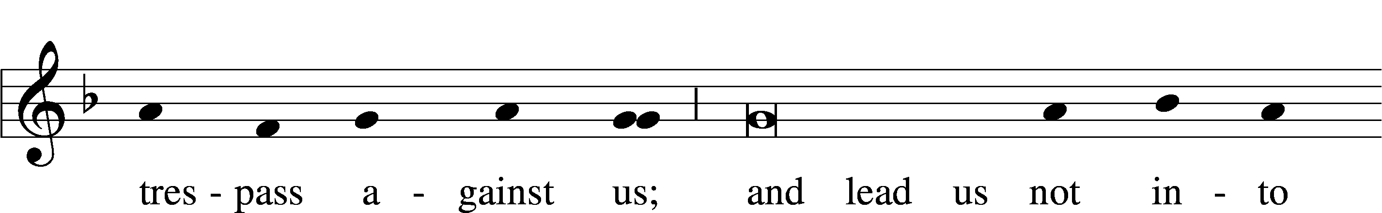

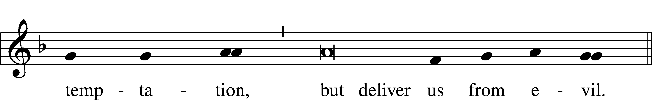

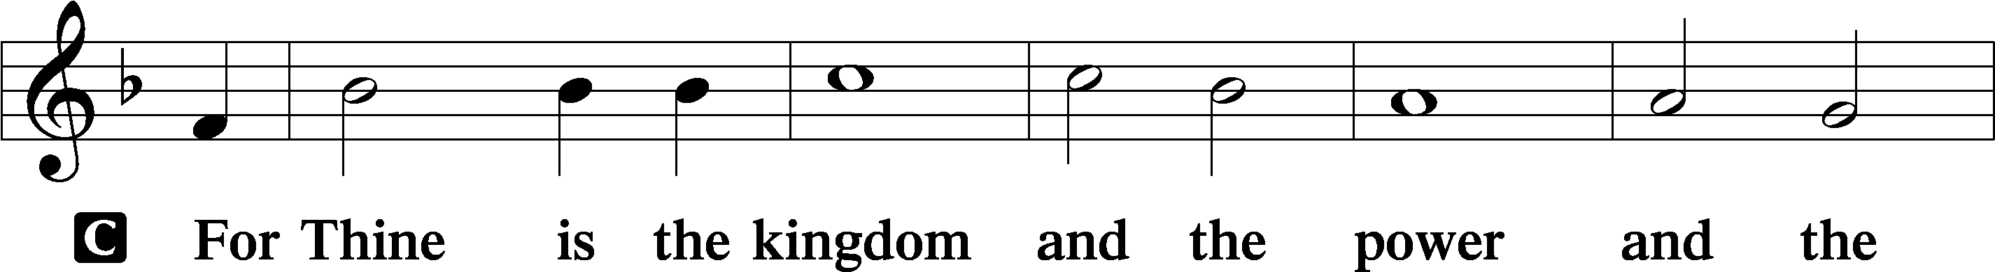

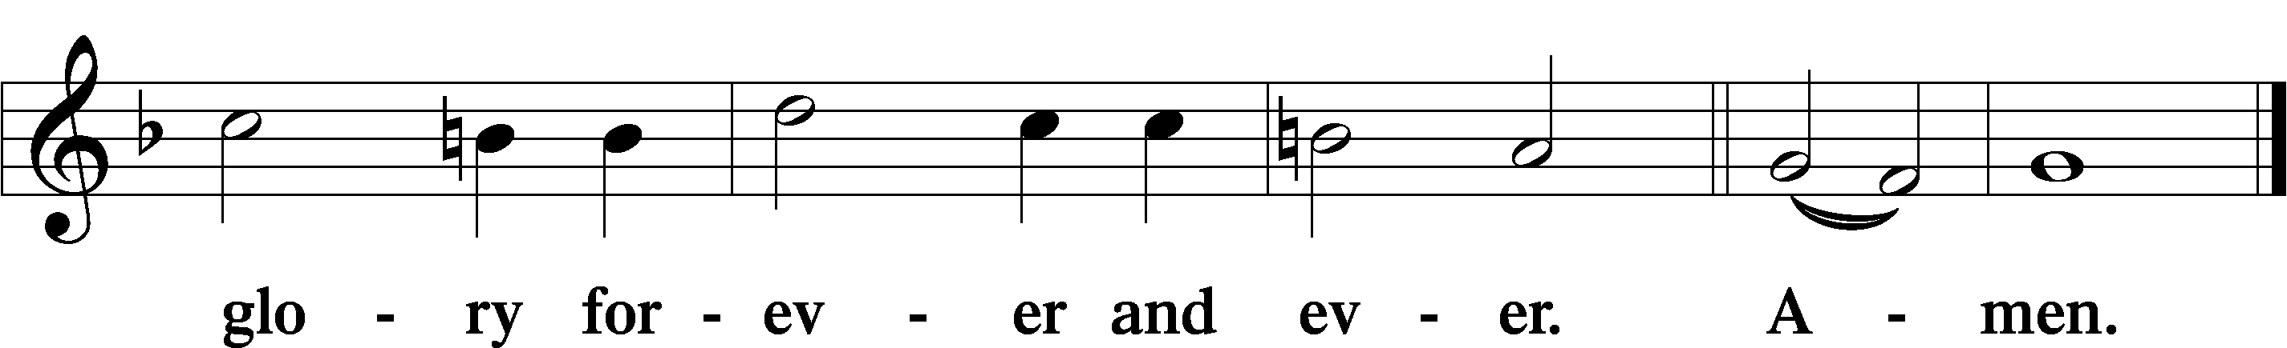

The Words of Our Lord LSB 197

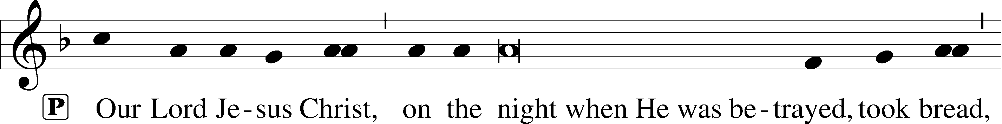

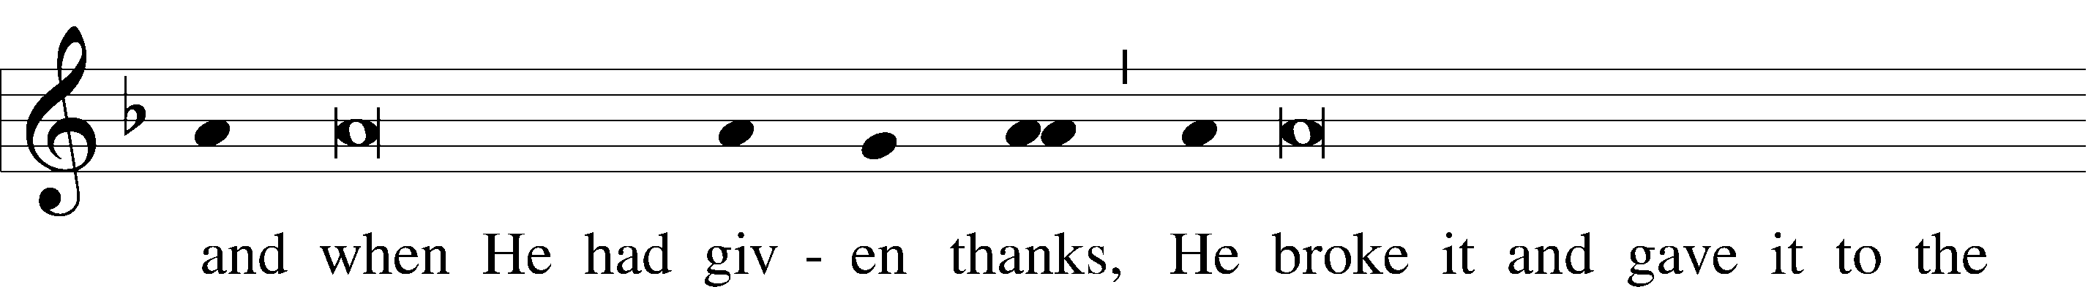

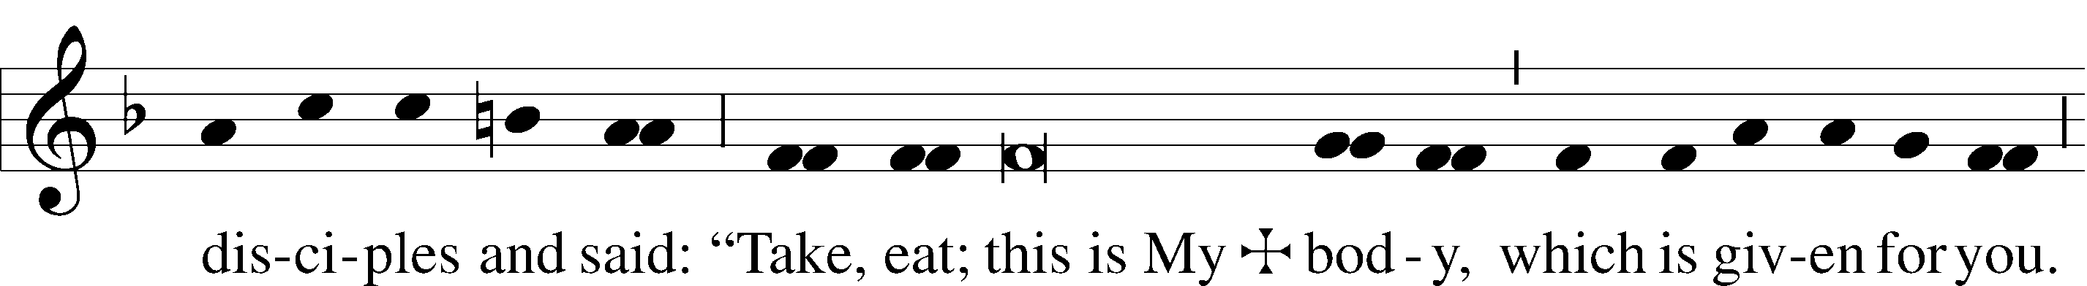

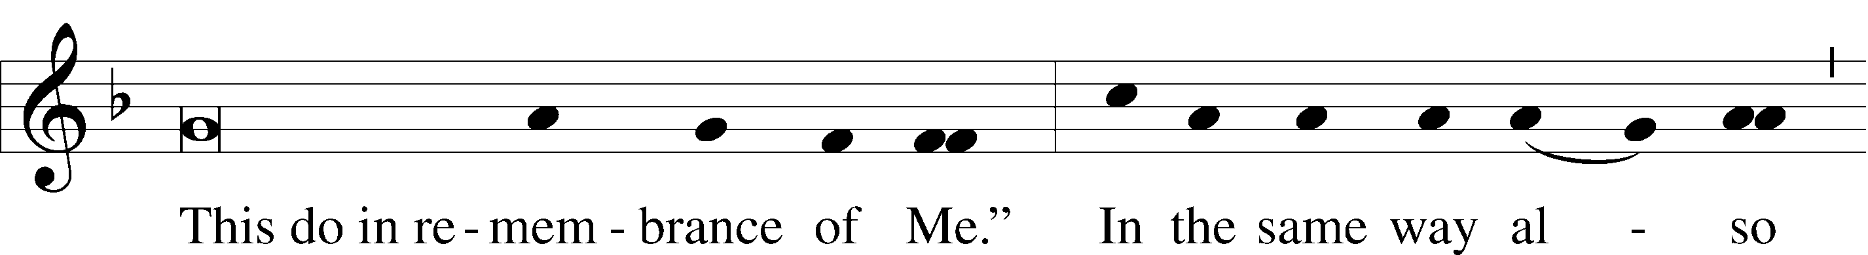

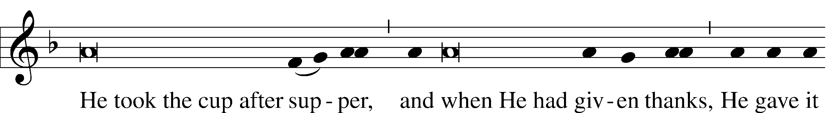

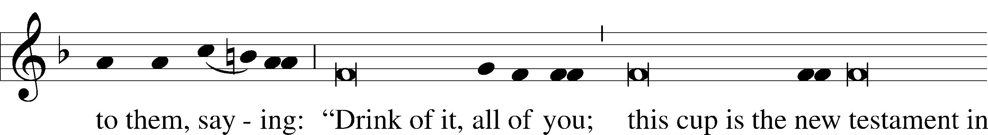

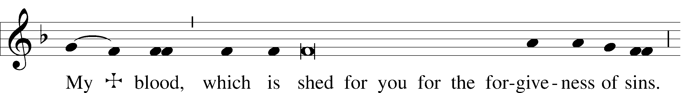

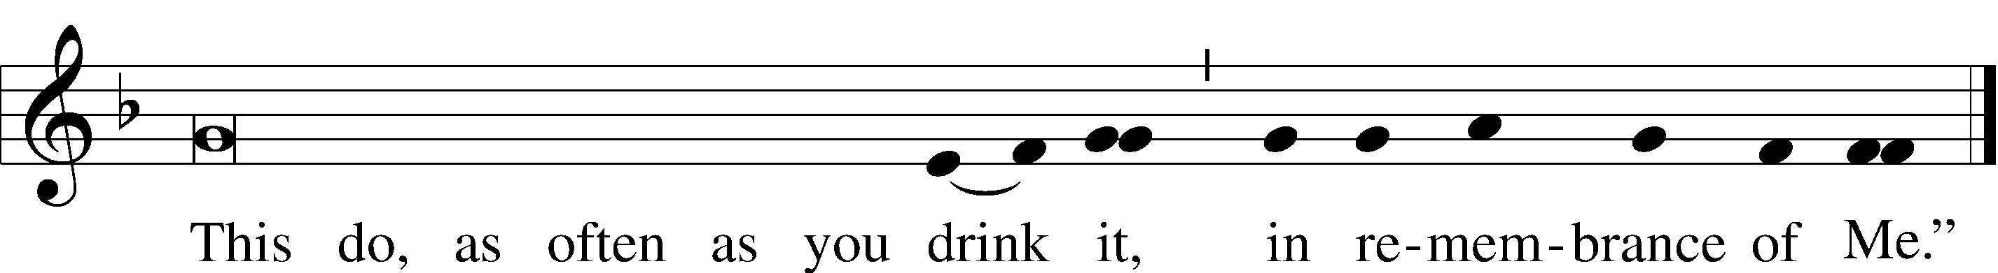

Pax Domini LSB 197

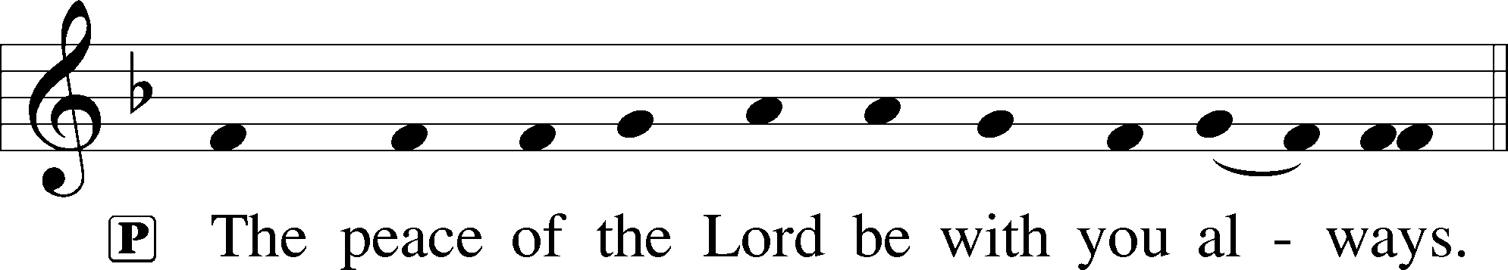

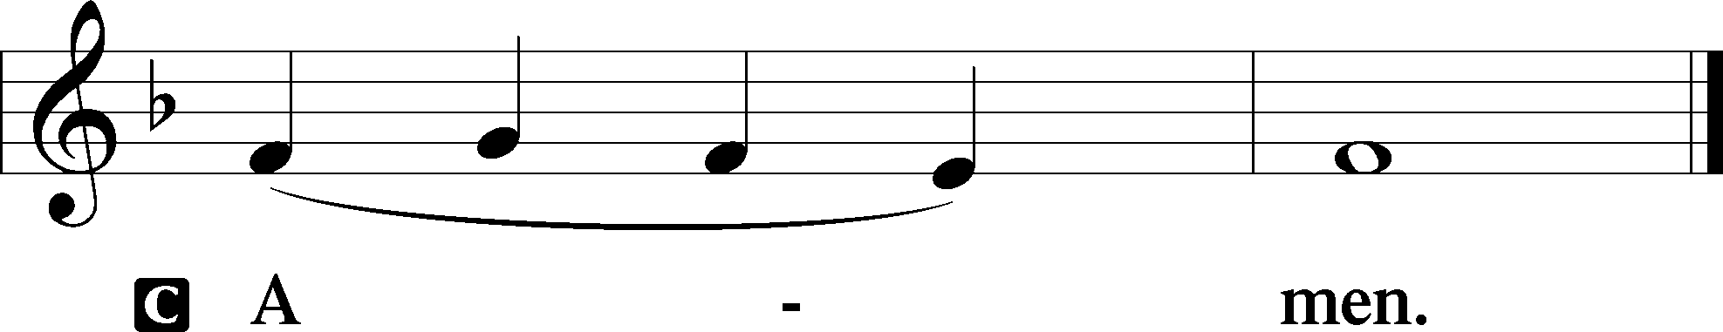

Agnus Dei LSB 198

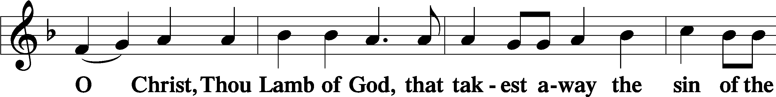

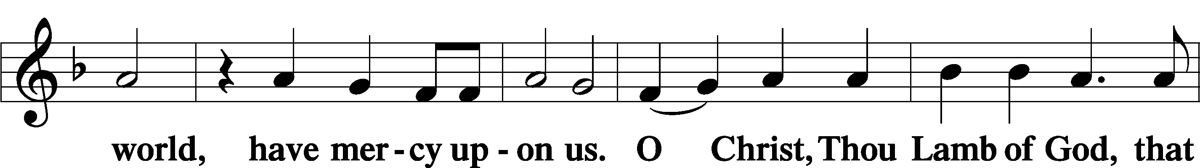

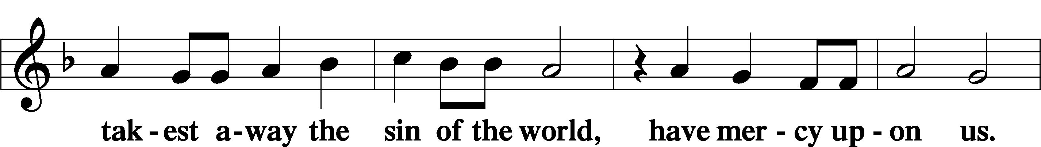

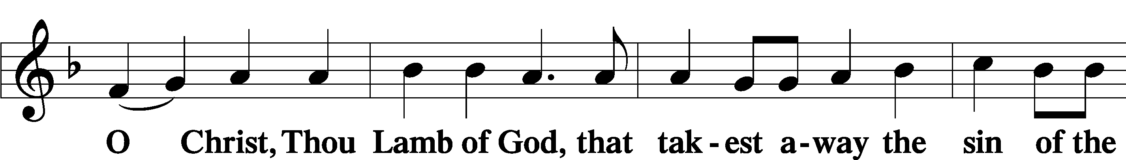

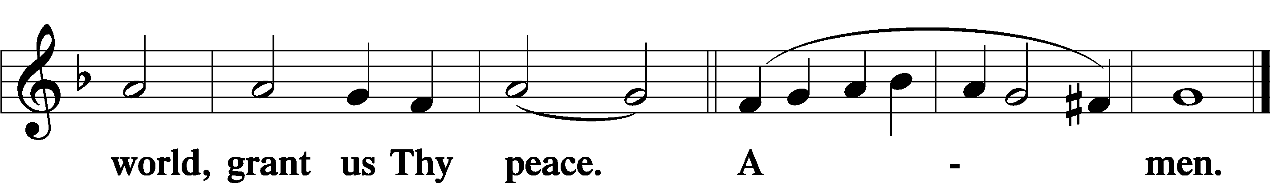

Sit

Distribution

The pastor and those who assist him receive the body and blood of Christ first and then distribute them to those who come to receive, saying:

Take, eat; this is the true body of our Lord and Savior Jesus Christ, given into death for your sins.

**Amen.**

Take, drink; this is the true blood of our Lord and Savior Jesus Christ, shed for the forgiveness of your sins.

**Amen.**

In dismissing the communicants, the following is said:

P The body and blood of our Lord Jesus Christ strengthen and preserve you in body and soul to life everlasting. Depart T in peace.

C **Amen.**

Distribution Hymn: 633 At the Lamb’s High Feast We Sing

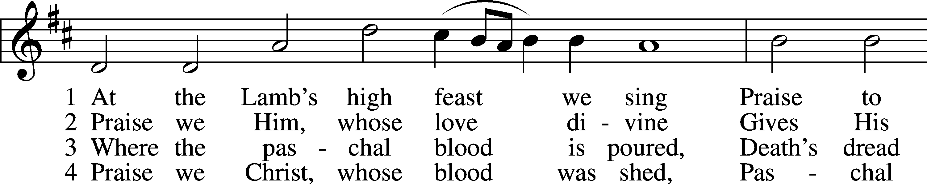

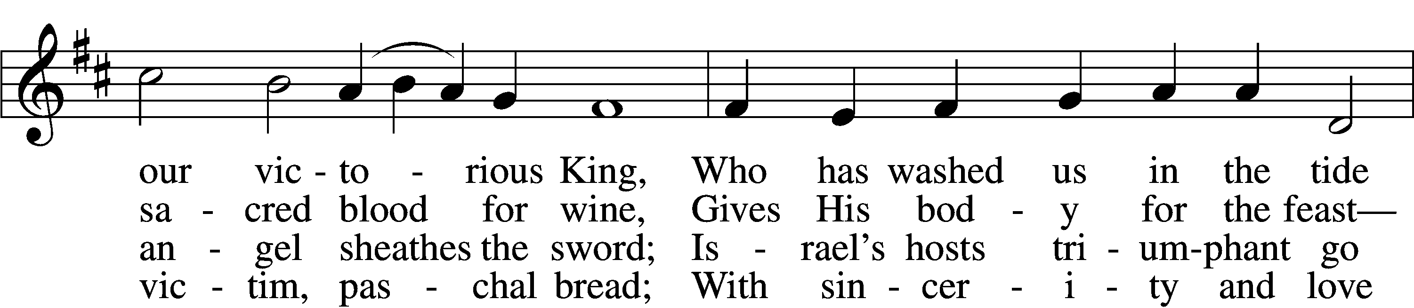

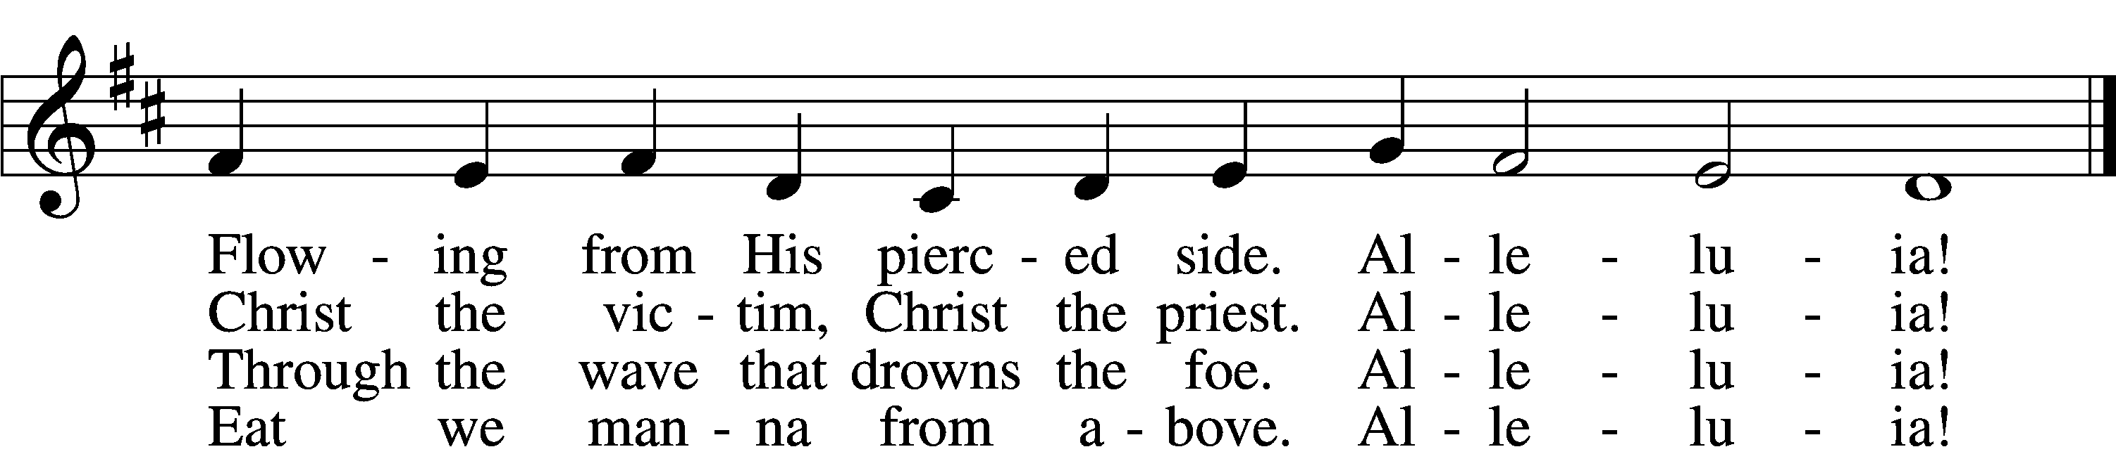

5 Mighty Victim from the sky,  
Hell’s fierce pow’rs beneath You lie;  
You have conquered in the fight,  
You have brought us life and light.  
 Alleluia!

6 Now no more can death appall,  
Now no more the grave enthrall;  
You have opened paradise,  
And Your saints in You shall rise.  
 Alleluia!

7 Easter triumph, Easter joy!  
This alone can sin destroy;  
From sin’s pow’r, Lord, set us free,  
Newborn souls in You to be.  
 Alleluia!

D 8 Father, who the crown shall give,  
Savior, by whose death we live,  
Spirit, guide through all our days:  
Three in One, Your name we praise.  
 Alleluia!

Text: Latin, c. 5th–10th cent.; tr. Robert Campbell, 1814–68, alt.  
Tune: Kirchengeseng, 1566, Ivancice  
Text and tune: Public domain

Distribution Hymn

Stand

Nunc Dimittis LSB 199

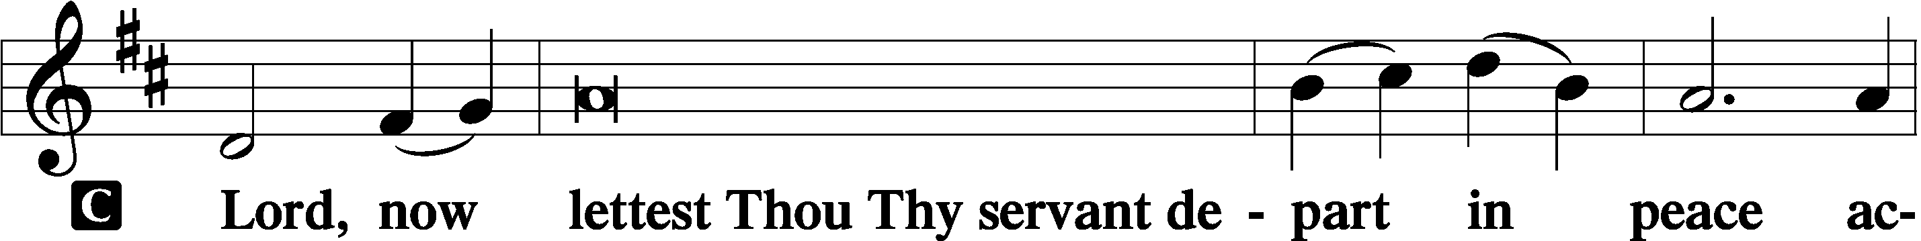

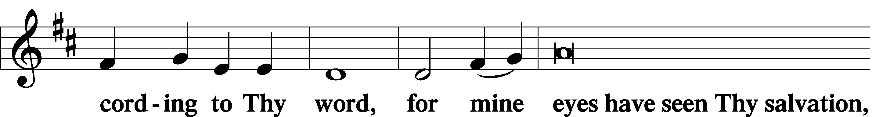

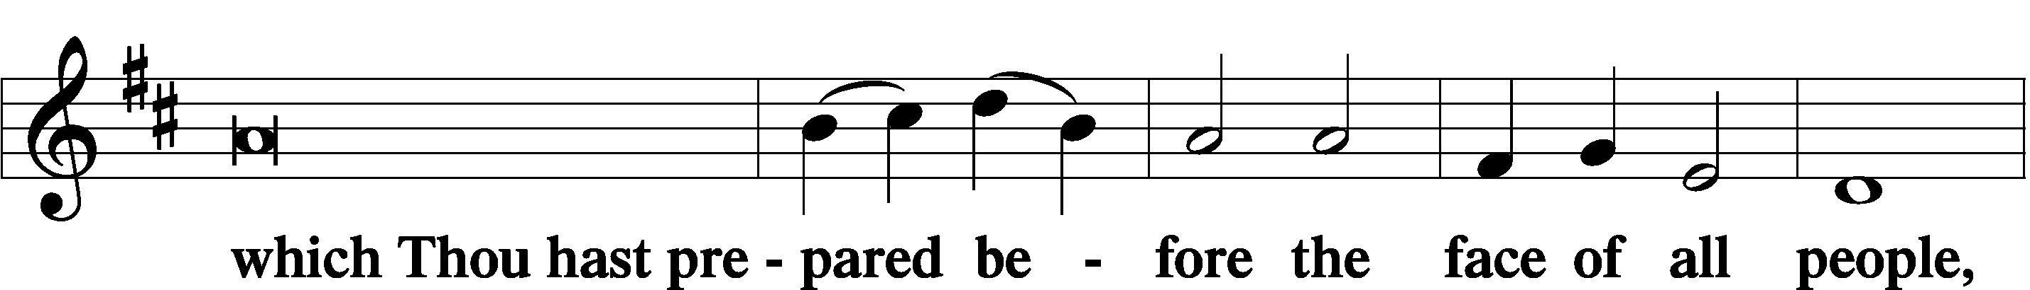

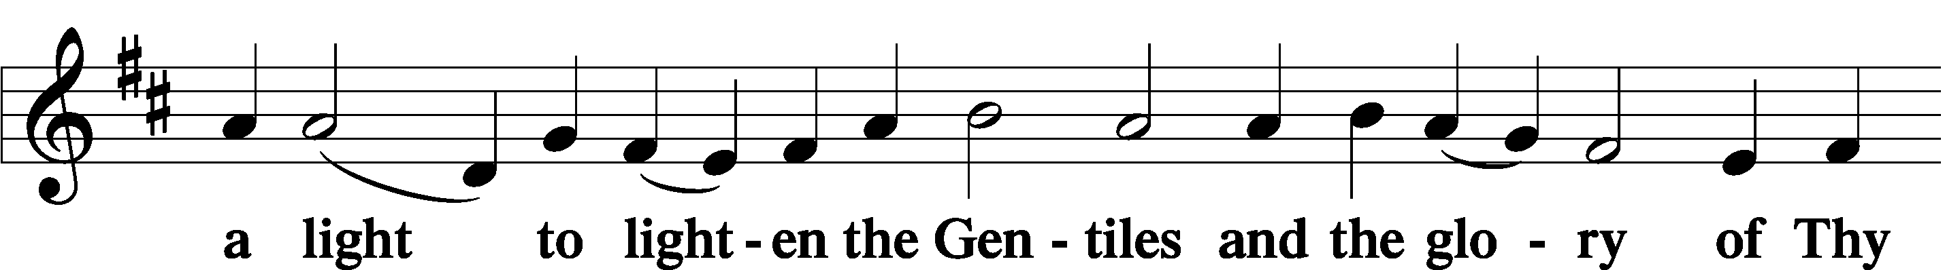

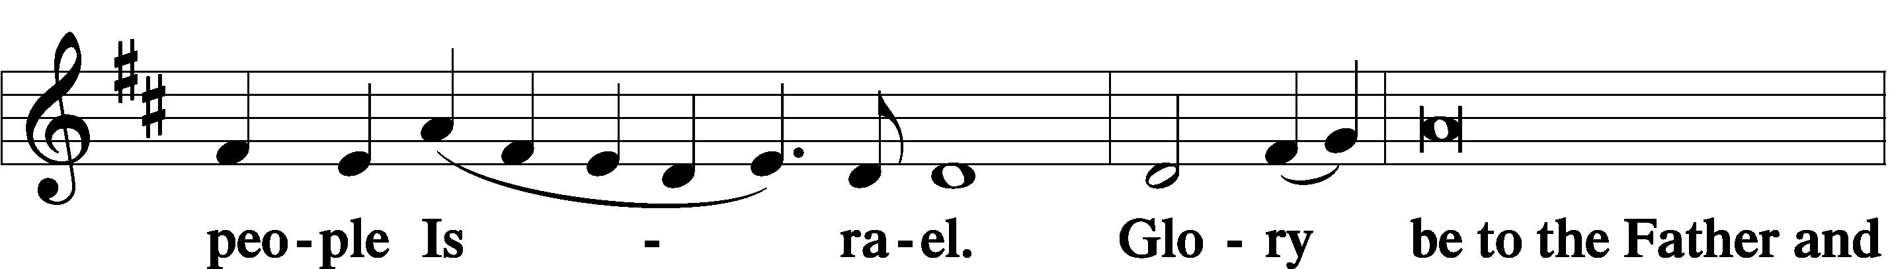

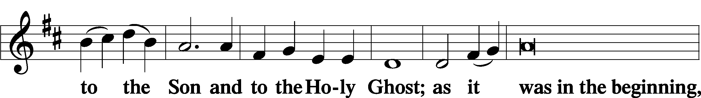

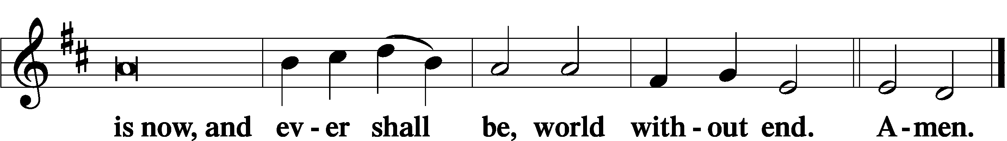

Thanksgiving LSB 200

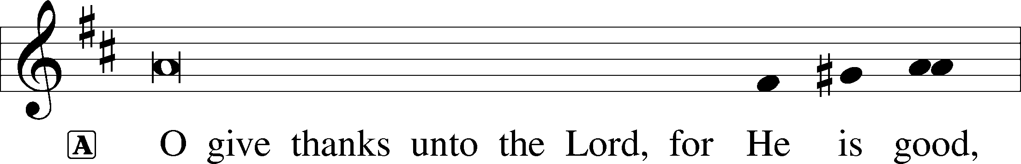

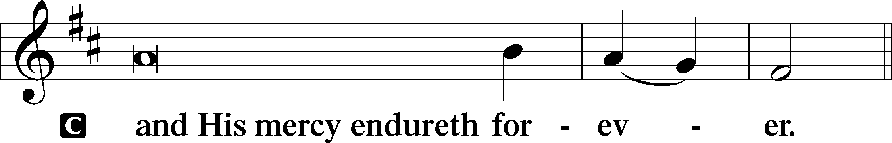

A Let us pray.

We give thanks to You, almighty God, that You have refreshed us through this salutary gift, and we implore You that of Your mercy You would strengthen us through the same in faith toward You and in fervent love toward one another; through Jesus Christ, Your Son, our Lord, who lives and reigns with You and the Holy Spirit, one God, now and forever.

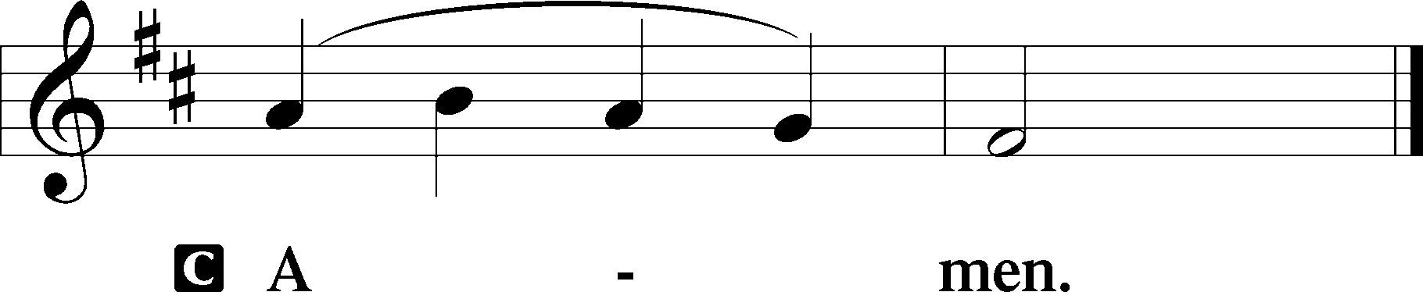

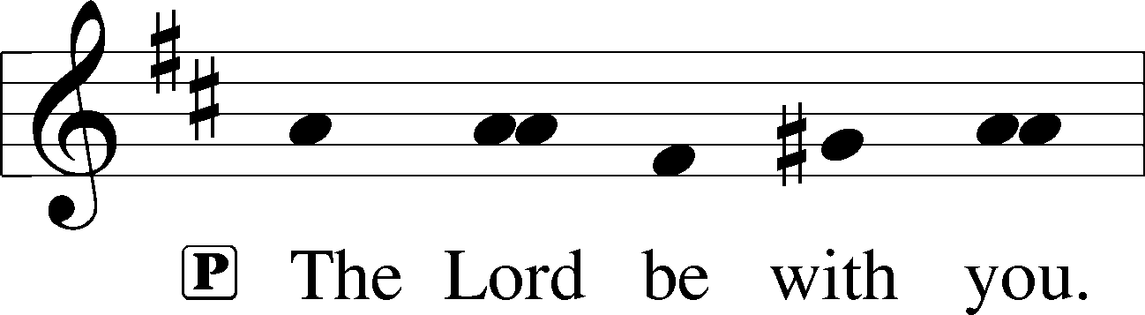

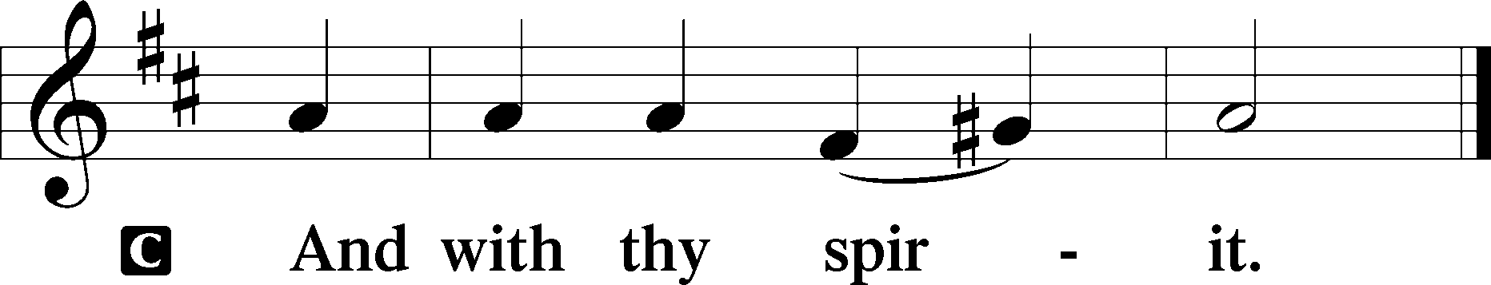

Benedicamus LSB 202

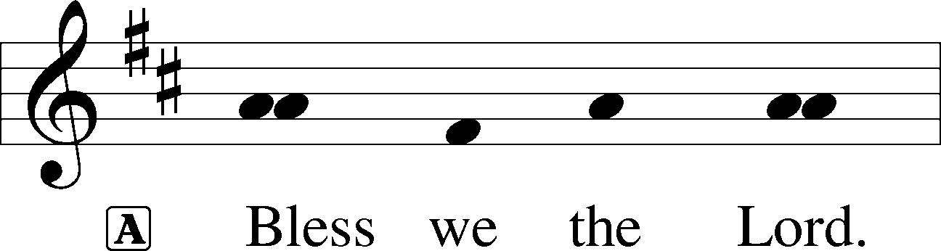

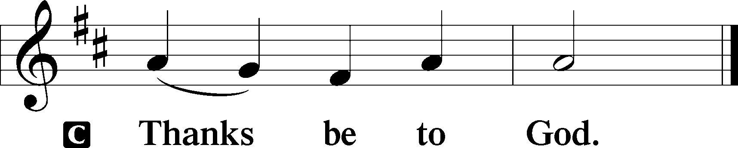

Benediction LSB 202

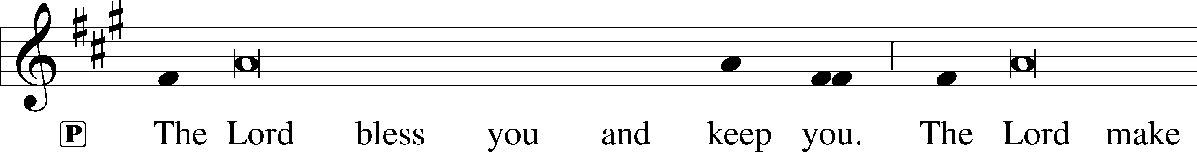

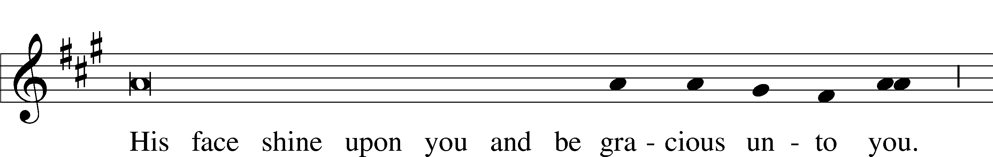

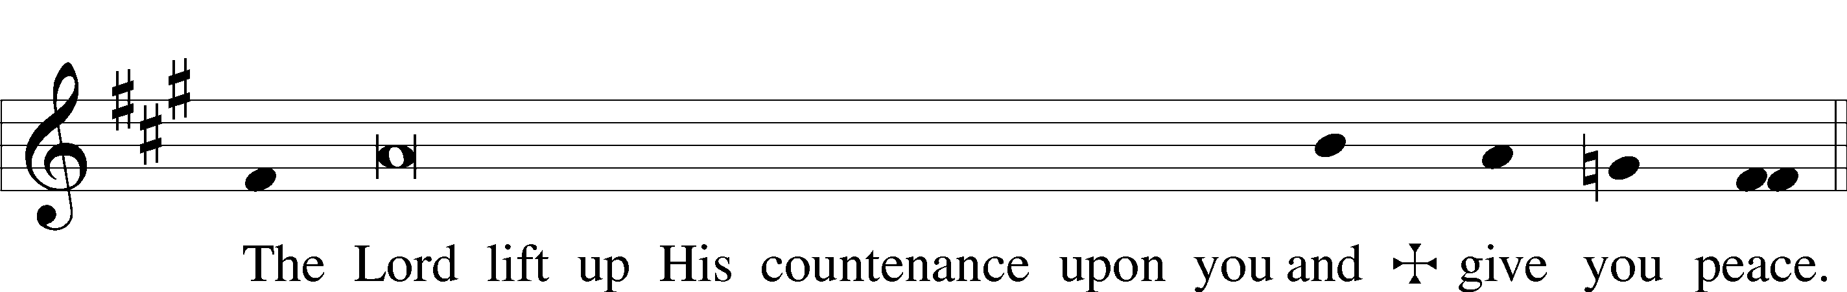

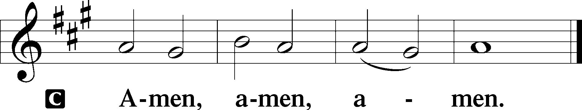

Hymn to Depart: 643 Sent Forth by God’s Blessing

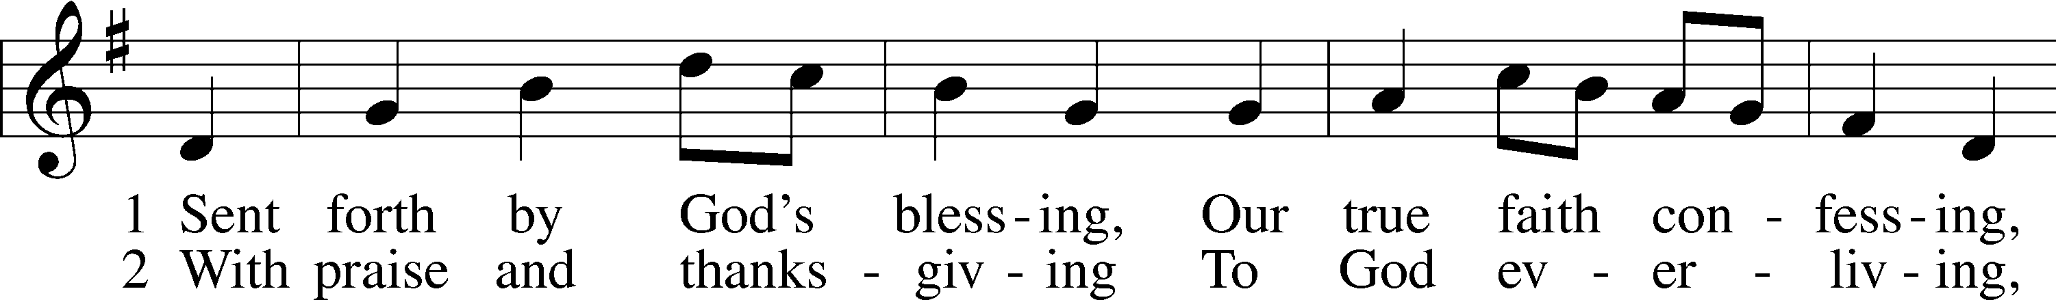

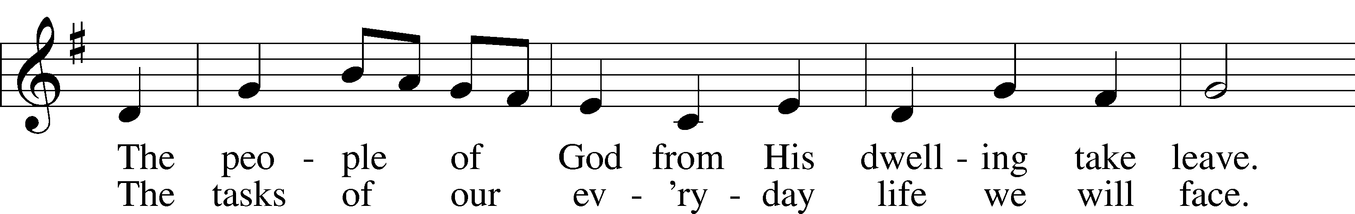

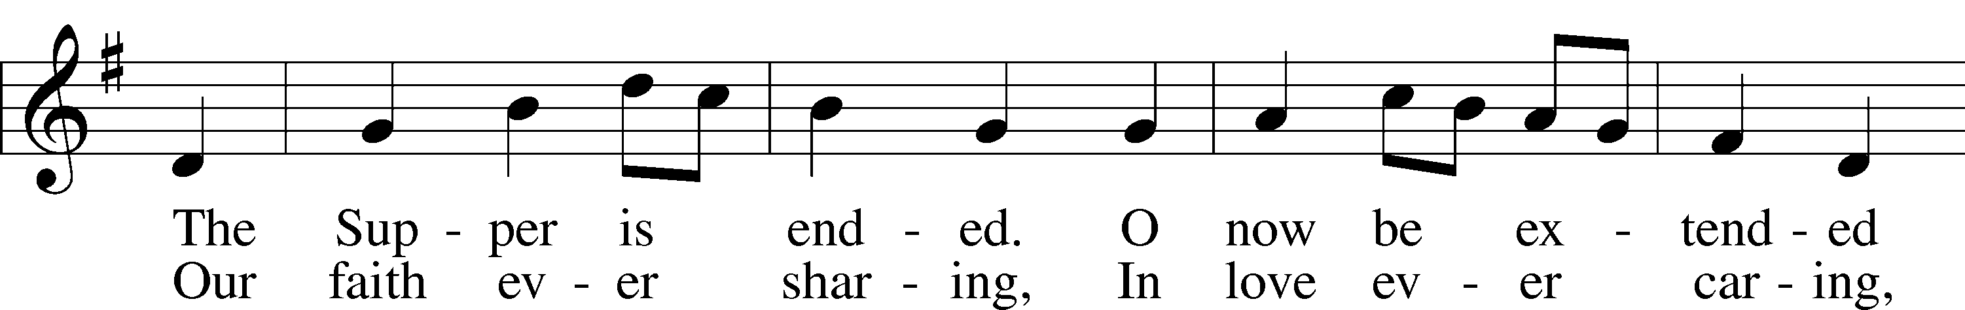

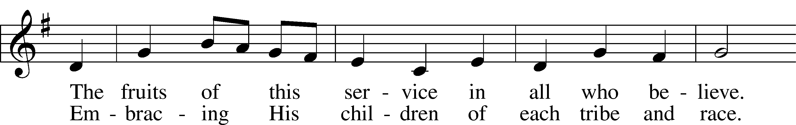

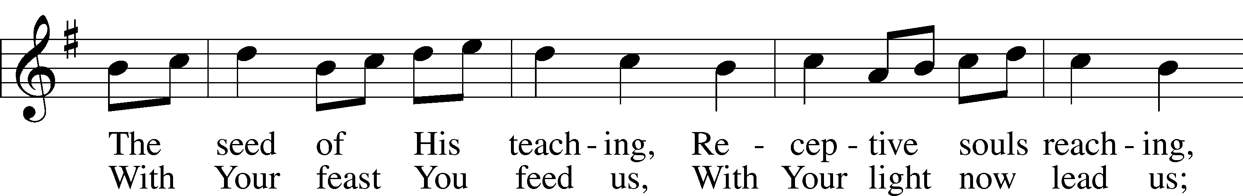

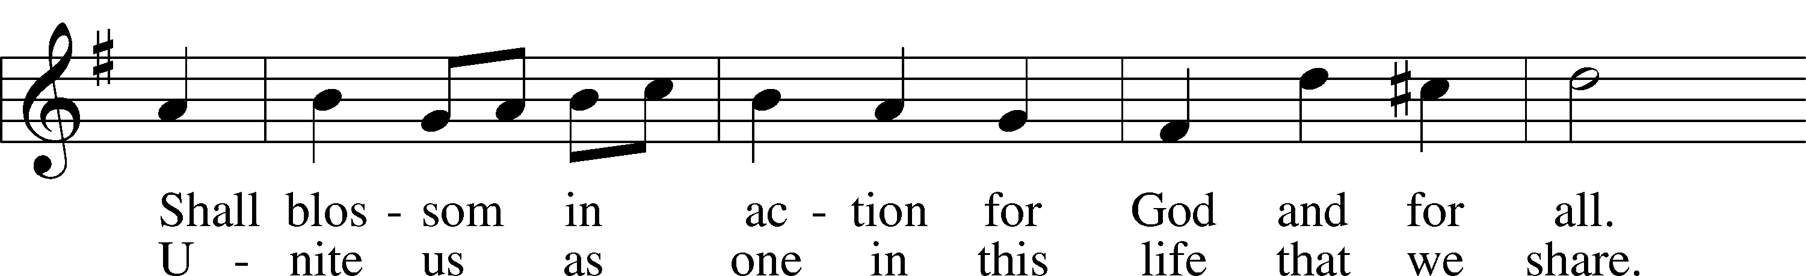

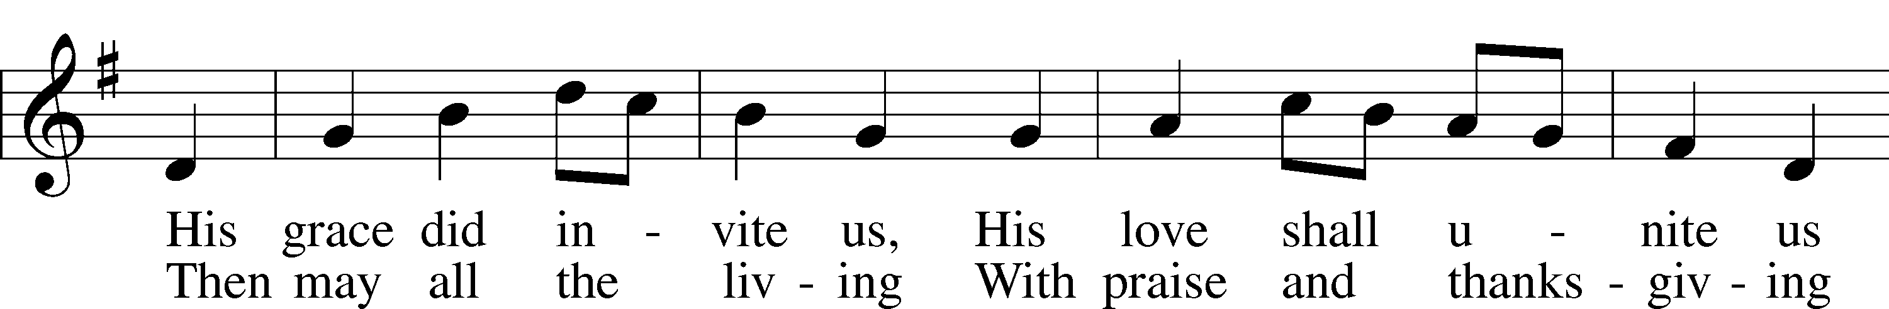

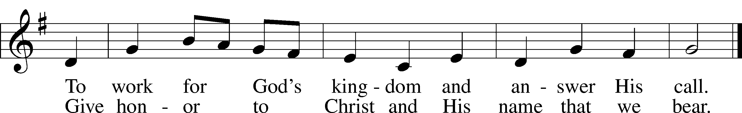

Text: Omer E. Westendorf, 1916–97, alt.  
Tune: Welsh  
Text: © 1964 World Library Publications. Used by permission: LSB Hymn License no. 110005504  
Tune: Public domain

Acknowledgments

Divine Service, Setting Three from Lutheran Service Book

Unless otherwise indicated, Scripture quotations are from the ESV® Bible (The Holy Bible, English Standard Version®), copyright © 2001 by Crossway, a publishing ministry of Good News Publishers. Used by permission. All rights reserved.

Created by Lutheran Service Builder © 2024 Concordia Publishing House.

**Prayers Request:**

**Those in the nursing home:** Joann Jaeger**,** Bernie Pedersen **Those Shut-in at home:** Char Herman, Joan Church, Joyce Myers, Joyce Koba **Those with ongoing health issues:** Harrison Fields, Owen Metz, Daria (Cindy Wright’s friend), Butch L. (Cindy Wright’s Brother-in-law), Melissa Miller. Art Smith (Sue Millerman’s brother), Brenda Sellent (Denise Stabenow’s sister), Sandy Hahn (Cindy Wright’s cousin’s wife) **,** Brenda Gustum (Missy Wiese’s mom), Lexi Anderson, Chris Mueller’s uncle, Pastor and Marlyss Harger **Celebrate with:** Justin and Melissa Frieburg on their wedding yesterday. **Those who lead our nation:** Joe Biden, Kamala Harris, Tony Evers, Rod Nordby  **Those who serve in our military and law enforcement:** Ryan Graf, Chaplain Pon Chanthaphon (Our Adopt-a-Chaplain), Rusty Weise **Our Childcare Staff:** Melissa Weinert, Denise Stabenow, Holly Wilhelmi, Janica Skjerly, Jacie Amundson, Cathy Anderson, Emily Young, Alora Provencial

**Communion Notices:**

Please complete a communion card for our records; they are in the pew in front of you, or request one from an usher. Salem’s communion practice is that of close communion. We invite to our rail those who are members in good standing of sister Missouri Synod parishes. Visitors, please contact the pastor prior to communing. For those who prefer to use the Common Cup, we ask your assistance by holding the cup’s base as you commune **Announcements:**

**Church Service Phone: 715-438-4200**

**(Stay on the line for recorded service to start)**

**Live Stream audio services:** [**http://salem.listentochurch.com**](http://salem.listentochurch.com)

**Salem’s Web Page:** <https://www.salembarron.com/>

**Pastor Fred Buth: Cell phone:715-642-3050 (H)715-353-2540**

**Email: salembarronpastor@gmail.com**

**Office Hours: Monday-Wednesday 9-12**

**Attendance:** 10/13-63

**Coffee and Snacks:** Pastor and Pat Buth

**Elder Today:** Paul Millerman

**Altar Guild:** Mary Ann Thompson

**Schedule for the week**

**Wednesday:** 9am Childcare Chapel

4pm Catechism

**Upcoming Events**

**October 21 –** Call Meeting

**October 26 - Trunk** & Treat (at church)

**October 27** - Congregational/Call Meeting

Just a reminder everyone is welcome to join us on October 27th for Bible study on:

**The Reformation Twelve**

Dr. Marin Luther was the central figure in the Riformation that abegan October 32,1517, but he never could have accomplished it by himself. Twelve people were essential parts of the rise and success of the Reformation, Interestingly enough, most of therm never confesed the faith that Luther discovered: five of them condemned it; one knew nothing of it, and four were indifferent to it, It fact, only two , in addition to Luther could end up being called”Lutherans,” But each of them played a necessary role.

**WORSHIP READERS** Beginning this Sunday’s worship service, we will be having readers to read the Old Testament and Epistle readings. This will be to assist the pastor but also to enrich the service by having other people involved in service to our Lord. We seek God’s blessings as we make this change in our worship services.