

**Salem Lutheran Church**

**Childcare and Preschool**

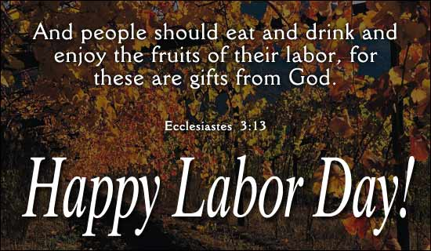

**September 2024**

Pastor’s Page



At the Voters Call Meeting on August 18th, the members of Salem Lutheran Church extended a call to Pastor Daniel Welch to be their nest pastor. As Pastor Welch considers the call pray for him and his family. Also remember the members of his congregation, as we all seek God’s blessings and guidance, and that through the blessings of the Holy Spirit we receive and accept God’s will.

**THE SERVICE OF THE PEW**

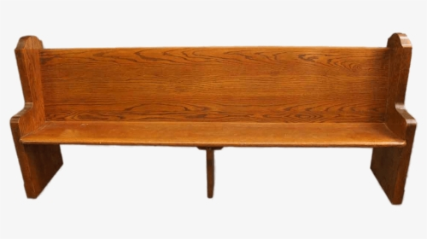

On Sunday – September 8th, 2024 at 9:00 a.m. we will have a special service. I call it the Service of the Pew (Church Pew). Taken from the perspective of the Pew, the Pew will reflect on his service to God and what it means to him, especially as he reflects on the family who sits in his pew. He will reflect on what happens as the family goes through their changes and challenges in life. It can be a real meaningful service for everyone. Invite your friends, join us in worship on Sunday – Sept. 8th.

This will also be Education Sunday – as Sunday School sessions began for the fall. There will be special events for the children, such as Balloon release. Also there will be a potluck meal after the service.

Come and join us. Invite your neighbor and friends. May we bring praise and thanksgiving to our gracious and wonderful God. God’s Blessings!

**HONORING GOD IN OUR LIVES!**

The summer months have passed so quickly, and we are now returning to the fall schedule, with the returning of the children to school and fall activities. This is also a reminder to remember our Lord and His call to worship and celebrate our lives under His grace and mercy. We are reminded of the words of the Third Commandment. “Remember the Sabbath day by keeping it holy!” And Luther’s explanation “We should fear and love God so that we do not despise preaching and His Word, but hold it sacred and gladly hear and learn it.”

As we gather in worship in praise of our gracious God and Savior, God comes to us through Word and Sacrament to strengthen us in faith and to help us grow in our relationship with Him as our Lord and Savior. God is ever present to guide us and to uphold us as we meet the challenges that come to us in our lives. His desire is to be here for us and to hear our prayers and requests. Above all, He wants to assure us of the peace and forgiveness that He offers through His blood bought redemption that we may be assured of life forever with Him as His children of faith. May we continue to renew our faith in Him and in our faith relationship with Him as our Savior.

God’s Blessings

Frederick Buth (vacancy pastor).

**Council Meeting 08/13/24**

**Present:** Pastor Buth, President John Steele, Vice President Josh Millerman, Secretary Emily Steele, Treasurer MaryAnn Thompson, Trustee Tom Lipke, Elder Don Duncan, Board of Education Chris Severt

President John Steele called the meeting to order

Pastor Buth led the council in a prayer and scripture.

**Secretary Report:** Ms. Steele provided an updated copy of the secretary’s report by email. A motion was made to approve the minutes by Chris Severt and seconded by Don Duncan

**Treasurer Report:**

MaryAnn Thompson provided financial reports as of 7/31/24. The church had a July income of $13,250.20. The general Fund balance is $77,960.38: The church net income was $8,013.38. The daycare had a net income of $8,584.63.

Maintenance costs are increased. This is due to continuing repairs to the parsonage. The budget excess for the difference in pastor salary will be placed in a separate fund for better visibility. This fund can be used for parsonage repairs and other expenses incurred in calling a new pastor.

The Gifts and Memorials book is now up to date thanks to MaryAnn Thompson and Jen Millerman. A budget line item for undesignated funds will be added for clarity. From the organization, it was discovered that there are designated library funds. The council discussed using the library fund for Bible/Hymnal/Bible Study materials.

As of September, Ms. Thompson will be in charge of writing checks and designating utility bill pay. Integrity Accounting will handle the remainder of accounting duties.

A motion was made to approve the report by Tom Lipke and seconded by Don Duncan.

**Elder Report:**

Mr. Duncan provided an update from the elders meeting on 07/01/24.

The elders discussed healthcare and wages for the new pastor. They decided to continue paying 50% of an individual health plan and will go off the district guidelines for salary when calling a new pastor. Personal days will be up to 5 days per year depending on experience and mileage will be paid at a rate of $0.67/per mile. PTO will be 21 days, including 3 Sundays. The parsonage will be valued at $1500/month.

MaryAnn Thompson will apply for a grant from LCMS to help pay for the daycare children Bibles.

No new transfers or releases.

The elders discussed circuit lay training.

Mr. Koenig read an email about local organist pay.

Mr. Koenig has purchased a video-based Bible study which will probably start in September.

An informational confirmation meeting will be held September 4th at 6 PM.

A motion to accept the elder report was made by Chris Severt and seconded by MaryAnn Thompson.

**Trustee Report:**

The parsonage repairs are ongoing. A new sink, kitchen floor, and hot water heater have been installed. The church was able to sell the old hot water heater. Mr. Lipke found a reasonably priced electric fireplace to install in the old fireplace. A cleaning crew will be needed for the parsonage in the near future. The repairs are staying within the approved budget.

A motion was made to accept the Trustee report by Don Duncan and seconded by Josh Millerman.

**Board of Ed Report:**

Mr. Severt provided a Board of Education update.

New wood chips were delivered and spread out in the playground area by church volunteers.

The board had the church’s accounting firm provide information regarding the affordability of staff wages. The board wanted to make sure staff raises were financially possible. The BOE approved a staff salary increase of up to $1/hr. per the directors’ discretion. The board approved an annual salary raises from $40,000 to $42,000 for the director.

Ms. Weinert and staff attended the NWD Early Childhood Conference on Friday, August 9th. The group provided positive feedback on the conference.

Ms. Weinert created a Discipline and Guidance Policy. This came about due to the state coming in again due to a parent complaint. Ms. Weinert is also updating the parent handbook regarding items brought from home to the center.

The Sunday School needs a 7-8th grade teacher and a superintendent.

September 8th will be Rally Sunday with a pot luck and will be the 1st day of Sunday School.

Motion was made to accept the report by Don Duncan and seconded by Josh Millerman.

**Pastor Report:** Pastor has asked Duane and Carrie Longmire to teach confirmation class this year**.**

**Old Business:** None

**New Business:** None

A motion to adjourn was made by Chris Sever and seconded by Josh Millerman.

The council closed with Lord’s Prayer.



A Women’s Choir is being formed to sing on Sunday, September 29th. Rehearsals will be held at 6:00 pm on 9/11, 9/18, and 9/25. Please sign up in the back of church.

**Teachers of Salem Youth**

**Confirmation & Weekday Classes**

Duane & Kari Longmire

**Sunday School Teachers**

PK4-2nd – Dwayne Stabenow

3rd-6th – Josh Millerman

7th & 8th – Emily Steele

High School – Paul Millerman

Music – Laurie Hinrichs

Craft – Melissa Weinert & Sue Millerman

Director – Sue Millerman



**September 8: Ricard & Marlene Snyder**

**September 17: Bryan & Sarah Bisonette**



**September 4:**

**Shyanne Pearl Hammann**

**September 8:**

**Grant Stabenow**

**September 12:**

**Isaac Mickelson**

**September 19:**

**Garrett Steele**





**September 7:** Terry Kirkman

# September 8: Debra Church

**September 9:** Will Schuettpelz

**September 12:** Debbie Kuhrt

# September 13: Becky Hamman

# Semtember 16: Duffy Anderson & Barb Mass

# September 19: Kathy Schuettpelz

# September 22 : Summer Hammann

**September 29:** Steven Amdall

**September 30:**  Christopher Weise

**September Greeters**

1 – David Anderson

8 – Dale & Becky Bryan

15 – Nathan Duncan Family

22 – Marilynn Amundson

29 –

How to Contact Us

Pastor Buth – Cell: 715-642-3050 Home: 715-353-2540

Pastor: [salembarronpastor@gmail.com](mailto:salembarronpastor@gmail.com)

Office – (715) 537-3011

Preschool – (715) 537-3011 ext.14

Mary Ann Wheeler, Parish Musician – (715) 205-1158

Church Service Phone –1 (888) 505-1870

Church Email: [salembarron@gmail.com](mailto:salembarron@gmail.com)

**Salem’s Web Page Is:** <https://www.salembarron.com/>

Click on enter the following link and follow the prompts to support Salem.

<https://smile.amazon.com/ch/39-6137330>

**September Ushers**

**Duffy Anderson**

Nathan Duncan

Dale Bryan

Andrew Bryan

Robert Harbaugh

**September/October Leaders**

Darlene Heil 715-637-5483

Jim Thalacker 715-859-2228

Jim & Lori Crawford 715-458-6080

Harvey Germanson 715-637-3890

Scot & Becky Hammann 715-637-0586

Dean & Kim Hanson 715-458-4262

Shirley Heil 715-637-3586

Pastor & Emily Nielsen 715-537-3011

Bernie & Joann Jaeger 715-924-3551

Brad & Carol Kuchera 715-837-1677

Ione Kent 715-234-2489

Joshua & Jennifer Millerman 715-837-1551

Pastor & Kathy Mueller 715-418-0050

Fred & Linda Riebe 715-637-5243

Herb & Deloris Zabel 715-637-5295

**September Elders**

1 – Tim Dennis

8 – Don Duncan

15 – Josh Millerman

22 – Paul Millerman

29 – Stan Koenig





**Coffee Schedule**

1 – Mary Ann Thompson

8 – Rally Sunday – Potluck Brunch

15 – Jen & Josh Millerman Family

22 – Denise & Duane Stabenow

29 – Mary Ann Thompson

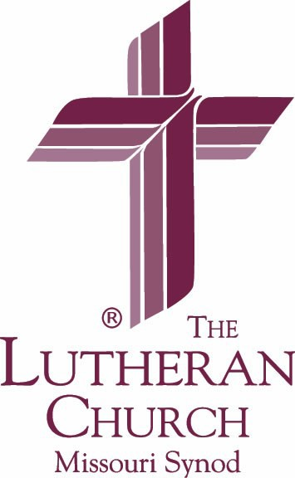**September 2024**

|  |  |  |  |  |  |  |
| --- | --- | --- | --- | --- | --- | --- |
| **Sunday** | **Monday** | **Tuesday** | **Wednesday** | **Thursday** | **Friday** | **Saturday** |

|  |  |  |  |  |  |  |
| --- | --- | --- | --- | --- | --- | --- |
| **1** Green  9:00 am Communion Worship  10:00 Coffee/Snacks | 2  7:00 pm Elders | 3  8 am Bible Class  7:00 pm Men’s Club | 4  4:30 pm YFM  6:30 pm Parent Confirmation Meeting | 5  11 am Bible Class | 6 | 7 |
| 8 Green    9:00 am Worship  10:15 Potluck  Rally Day: Pastor blessing backpacks and handing out Bibles/Catechisms.  See the source image | 9 | 10  8 am Bible Class  7:00pm Council | 11  9 am Childcare Chapel  4 pm Catechism | 12  11 am Bible Class | 13 | 14 |
| 15 Green    9:00 am Communion Worship  10:00 Coffee/Snacks  10:15 Sunday School | 16 | 17  8 am Bible Class | 18  9 am Childcare Chapel  4 pm Catechism | 19  11 am Bible Class | 20 | 21 |
| 22 Green    9:00 am Worship  10:00 Coffee/Snacks  10:15 Sunday School | 23 | 24  8 am Bible Class  5:30 pm BOE Meeting | 25  9 am Childcare Chapel  4 pm Catechism | 26  11 am Bible Class | 27 | 28 |
| 29 Green    9:00 am Worship  10:00 Coffee/Snacks  10:15 Sunday School | 30  4-7 pm Men’s Club Pancake Supper  See the source image |  |  |  |  |  |

C:\Users\Chetek01\Documents\Church\Newsletter\September 2024 Flyer.tif