Salem Messenger

Salem Lutheran Church
Childcare and Preschool

June 2024

HAPPY JUNE!!
(The Article that follows was written by Faye Hovland, musician from First Lutheran – Rice Lake. Written for First Lutheran’s June Newsletter. I share it with you with Faye’s permission.

“The road to life is always under construction.” We are about to set out on our Summer road trips. I wonder how much road construction we’ll have to deal with? The road crews are usually considerate when it comes to warning motorists of upcoming dangerous conditions. (At least, here in Wisconsin they do.). Their signs are often very effective. Once in a while there is a sign that points our thoughts beyond the worldly construction. One sign I recently saw was obviously for the road crew themselves. There was a huge crane and power lines nearby. The sign said simply “Look Up and Live.” Hmmmmm. That says something to you and to me, too, doesn’t it? Often, we see the sign “One Way”. Jesus says, “I am the Way, the Truth and the Life…” One road sign I dread seeing is “Rough Road Ahead.” That’s true in life, too—but often we have no warning for those times. BUT, when that rough road happens, just remember that Jesus is beside us on our journey. There’s a favorite Chorus that often reminds me of that fact. It’s a short song I learned as a child but it’s been a reminder of Jesus’ faithfulness to us on our lifelong journey.

When the road is rough and steep, fix your eyes upon Jesus.
He alone has power to keep. Fix your eyes upon Him.
Jesus is a gracious friend, One on whom you can depend.
He is faithful to the end. Fix your eyes upon Him.
(Author unknown)

So, enjoy your Summer and thank God every day that He is with us on our daily journey, whether we are traveling or just on the road of life. Let’s fix our eyes on Jesus. That insures a smooth path ahead.
Faye Hovland, - Family Life Ministry – First Lutheran – Rice Lake

Men’s Club – May 7, 2024

- Pres. Tom called the meeting to order
- Present: Tom, Jim, Don, Duffy
- Secretary report was read from 4/1/24 meeting by Don.
- Treasure report was given by Jim.
- Don made a motion to purchase 3 bags of Weed & Feed to be used for church and parsonage yard.
- Yard clean up was postponed from 5/7/24 to 5/11/24 at 8am.
- Next meeting will be 9/3/24 to plan for the Pancake Supper.
- Motion by Jim to adjourn, 2nd by Duffy.
- Closed with the Lord’s Prayer
Don Duncan, Sec.
June 1: Hunter Nelson & Marcia Elliott

June 2: Amelia Weise

June 5: Rita Herman & Taylor McGowan

June 6: Roxann Espeseth

June 7: Sarah Forehand

June 9: Kelly Cornelius

June 10: Nathan Duncan

June 11: Ethan Kobernick

June 12: Tim Dennis & Marlene Snyder

June 16: Benjamin Wheeler

June 18: Kaitlyn Klimek

June 21: Wyatt Weise

June 22: Brian Miller

June 25: Melissa Weinert

June 29: Hannah Millerman

June 12: Will & Kathy Schuettpelz

June 18: Mahlon & Barb Maas

June 20: Mark & Amy Dennis

June 25: Rick & Kelly Cornelius

June 27: Fred & Linda Riebe

Baptism Birthday
June 2: Taylor Severt

June 23: Brayden Weinert

June 24: Owen Metz

June 26: Amelia Weise

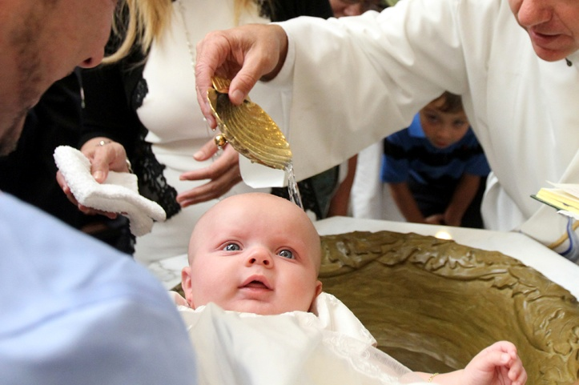

How to Contact Us
Pastor Buth – Cell: 715-642-3050 Home: 715-353-2540
Pastor: salembarronpastor@gmail.com
Office – (715) 537-3011
Preschool – (715) 537-3011 ext.14
Mary Ann Wheeler, Parish Musician – (715) 205-1158
Church Service Phone –1 (888) 505-1870
Church Email: salembarron@gmail.com
Salem’s Web Page Is: https://www.salembarron.com/
Click on enter the following link and follow the prompts to support Salem.
https://smile.amazon.com/ch/39-6137330

Coffee Schedule
2 – Schuettpelz/Fagerlin
9 – Koenig/Elliott
16 – Longmire’s
23 – Paul & Sue
30 – Men’s Club

June Greeters
2 – Will & Kathy Schuettpelz
9 – Fred & Linda Riebe
16 – Mark Dennis Family
23 –
30 –

May/June Work Group
Carol Shearer 715-822-4375
Lucille Wood 715-637-6606
Steve Amdall 715-637-7758
Duane & Kari Longmire 920-595-0899
Shawn Dennis 715-205-1807
Tim & Paula Dennis 715-837-1708
Mary Oscarson 612-790-5464
Holly Johnson 715-637-7758
Sue Weise 715-837-1555
Tom & Debbie Lipke 715-458-4712
Rusty & Melissa Weise 715-764-2084
Melissa Miller 715-641-0263
Earl & Aimee Starck 715-637-3482
Debbie Church 715-296-2749

June Elders
2 – Tim Dennis
9 – Don Duncan
16 – Don Duncan
23 –
30 –

June Ushers
Will Schuettpelz
Mark Dennis
Damen Dennis
Fred Riebe

June 2024

Sunday | Monday | Tuesday | Wednesday | Thursday | Friday | Saturday

 |  |  |  |  |  | 1
2 Green  9:00 am Communion Worship  Special Congregational Meeting  10:00 Coffee/Snacks  10:15 Bible Class | 3  7:00 pm Elders | 4 | 5 | 6 | 7 | 8
9 Green  9:00 am Worship  10:00 Coffee/Snacks  10:15 Bible Class  After Church: YFM Meeting | 10 | 11  7:00pm Council | 12 | 13 | 14 | 15
16 Green  9:00 am Communion Worship  10:00 Coffee/Snacks  10:15 Bible Class | 17 | 18  5:30 pm BOE | 19 | 20 | 21 | 22
23 Green  9:00 am Worship  10:00 Coffee/Snacks  10:15 Bible Class | 24 | 25 | 26 | 27 | 28 | 29
30

9:00 am Worship
10:00 Coffee/Snacks
10:15 Bible Class

