Service for

Freida Lentz

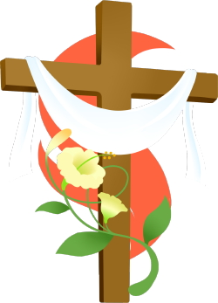

Salem Lutheran Church

1360 E. LaSalle Ave.

Barron, WI 54812

October 10,2024

Born: January 7,1925 Baptized: February 1,1924 Confirmed: October 31,1937

Called to Glory: October 6,2024

Hymn: I *Know* That My Redeemer Lives *LSB 461*

The sign of the cross may be made by all in remembrance of their Baptism.

Invocation *LSB 278*

Remembrance of Baptism *LSB 278*

Psalm 121

Psalm 8

Kyrie *LSB 278*

Salutation and Collect of the Day *LSB 278*

**Special Music: Precious Lord, Take My Hand**

Sit

Epistle Colossians 1:9-14

Verse *LSB 279*

Holy Gospel John 11:17-26

Apostles’ Creed *LSB 279*

Sit

Hymn: I’m But a Stranger Here LSB 748

Sermon

Kneel/Stand

Prayer of the Church

Nunc Dimittis *LSB 281*

Concluding Collect *LSB 281*

Benedicamus *LSB 281*

Benediction and Dismissal *LSB 281*

Hymn: How Great Thou Art LSB 801

Acknowledgments

Funeral Service from Lutheran Service Book

Unless otherwise indicated, Scripture quotations are from the ESV® Bible (The Holy Bible, English Standard Version®), copyright © 2001 by Crossway, a publishing ministry of Good News Publishers. Used by permission. All rights reserved.

Created by Lutheran Service Builder © 2021 Concordia Publishing House.

**Those leading today’s service:**

Preacher and Officiant: Pastor Frederick Buth

Organist: Cindy Wright

Soloists: Lonnie Forehand & Ashley Degerman

The family of Freida invites you to stay for a time of fellowship as we have alunch prepared. Burial is at Wayside Cemetery here in Barron, WI. You are invited to come to the cemetery or stay here and enjoy some fellowship.