Matins

8th Sunday after Pentecost

July 14,2024

Hymn: 913 O Holy Spirit, Enter In
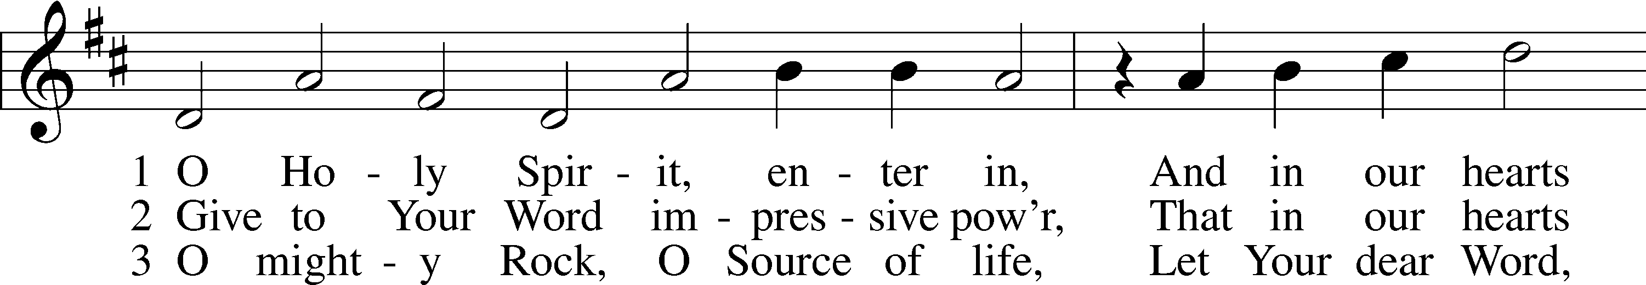
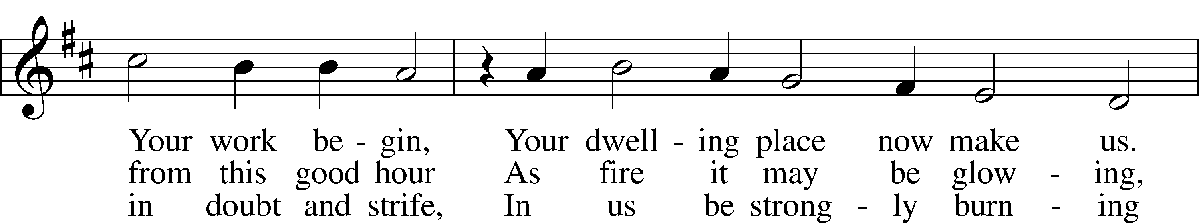
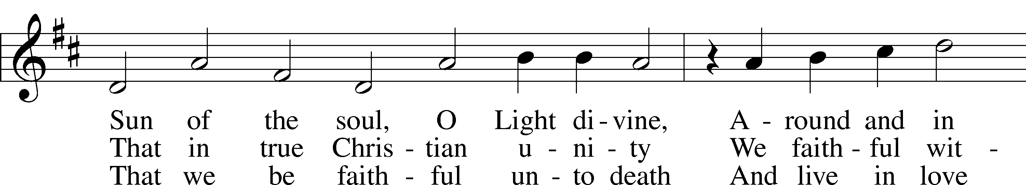
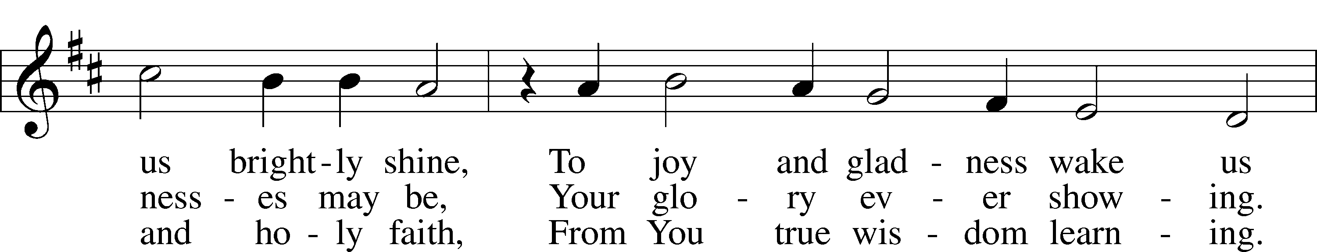
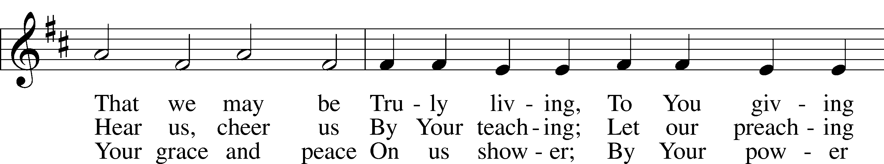
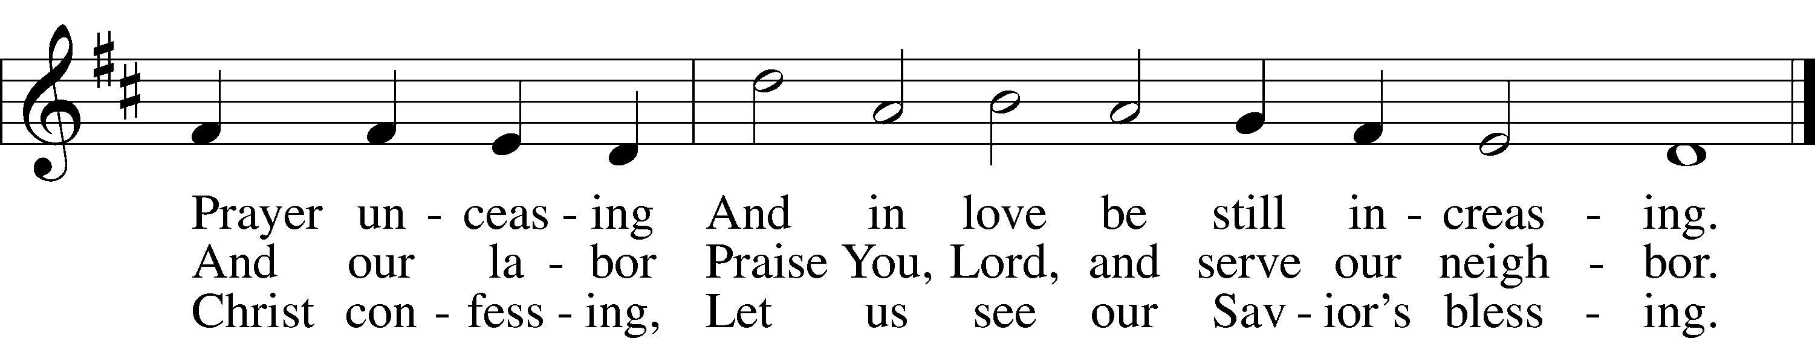
Text: Michael Schirmer, 1606–73, adapt.; (sts. 1, 3): tr. Catherine Winkworth, 1827–78, alt.; (st. 2): tr. The Lutheran Hymnal, 1941, alt.
Tune: Philipp Nicolai, 1556–1608
Text and tune: Public domain

Stand

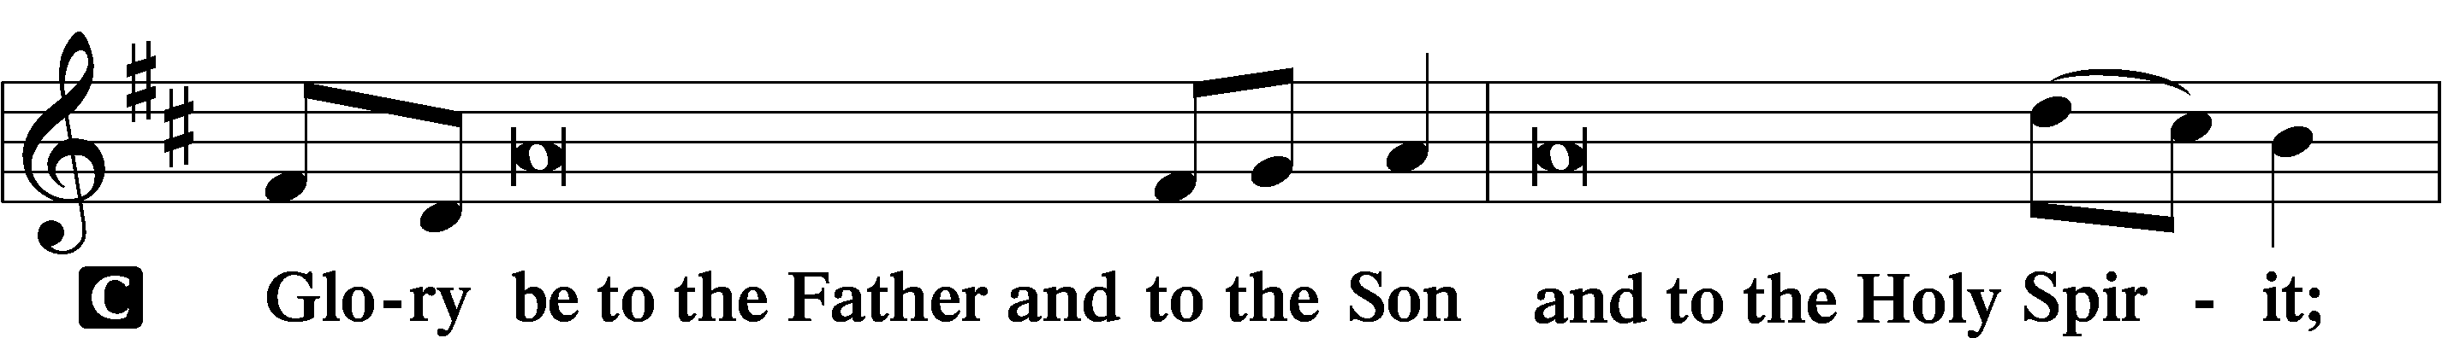
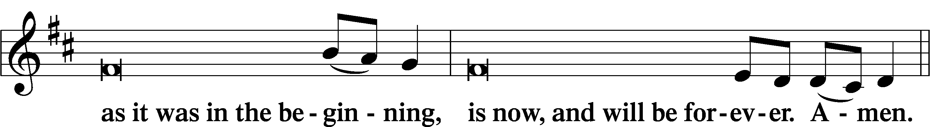
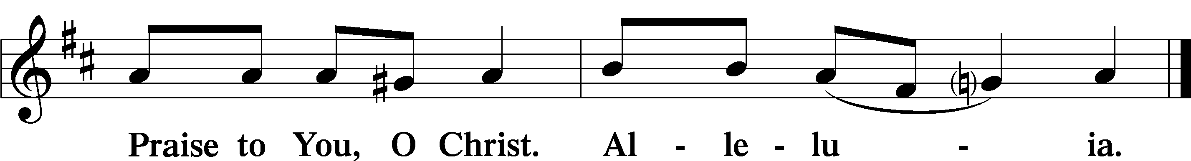

Psalmody

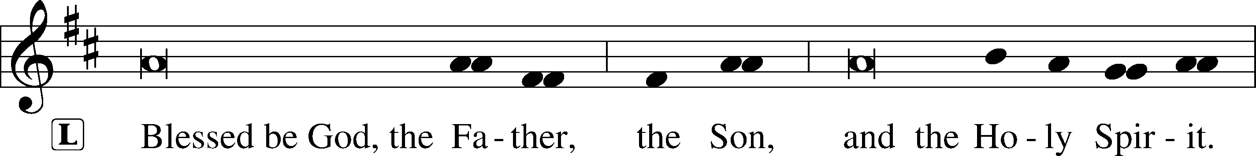

Venite LSB 220
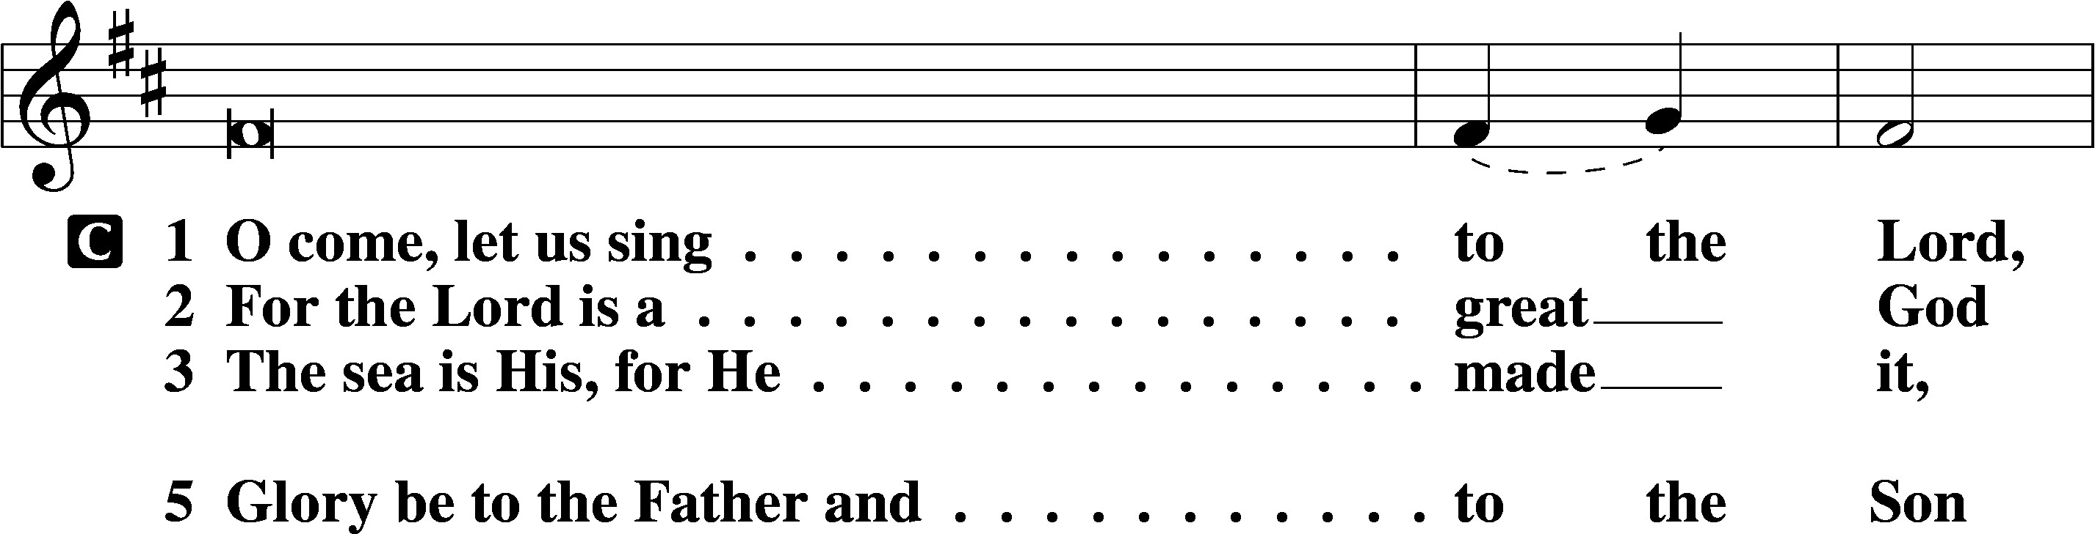
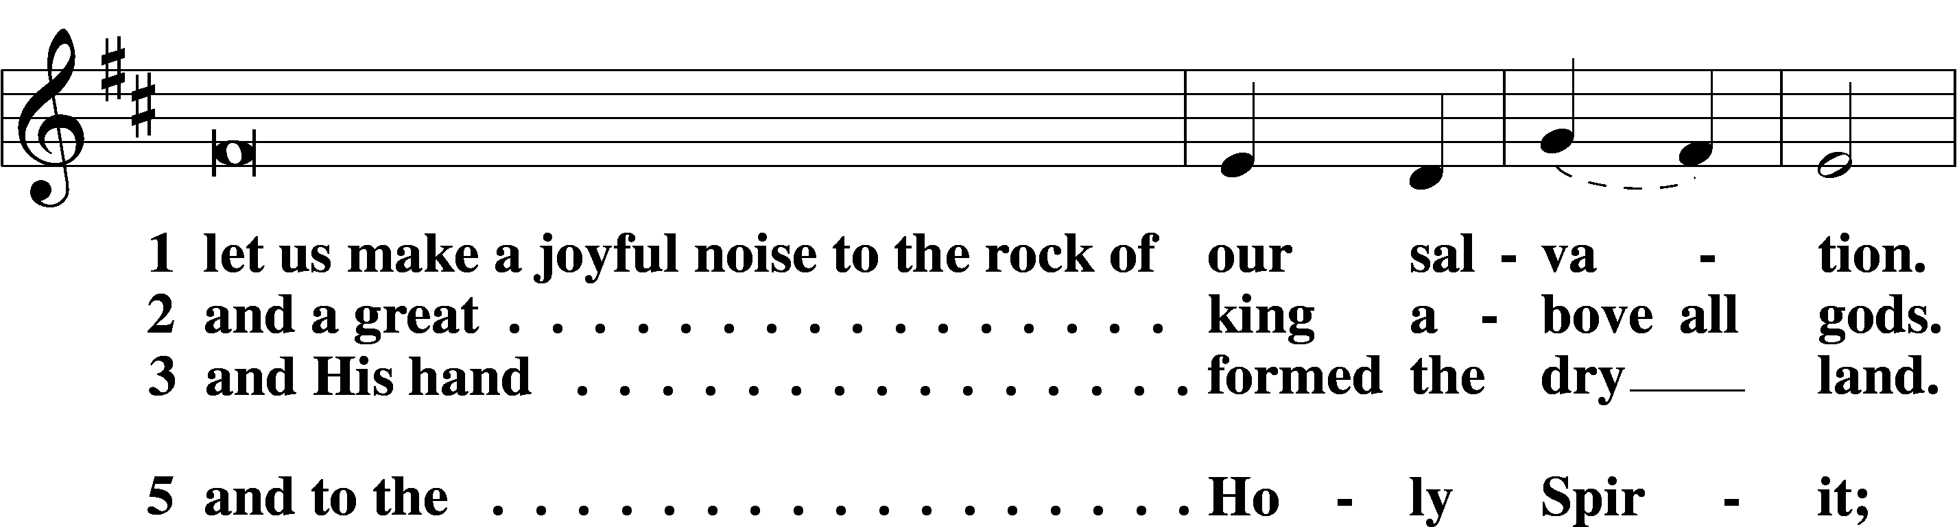
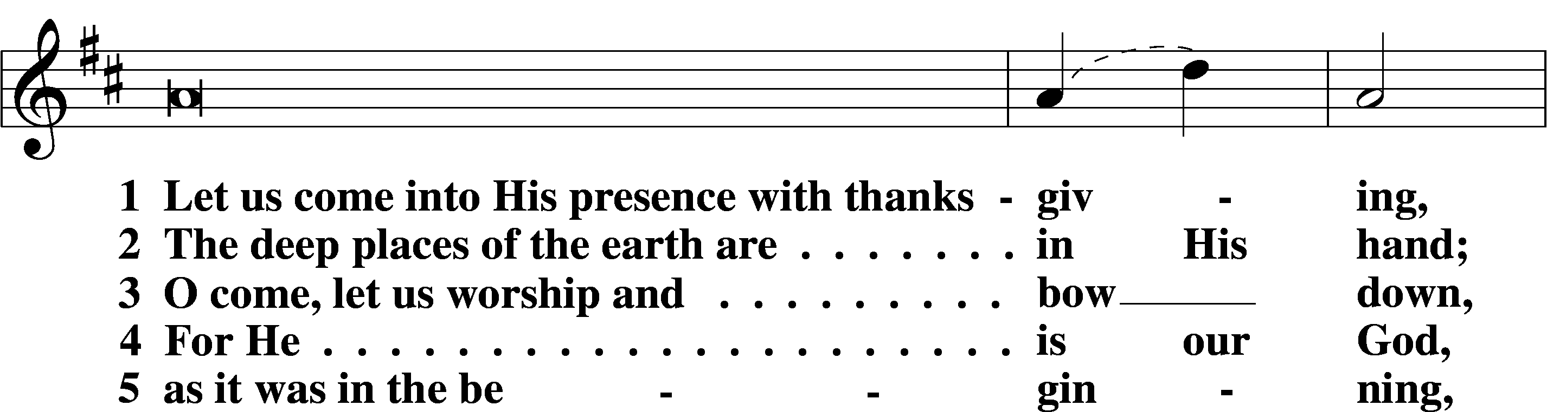
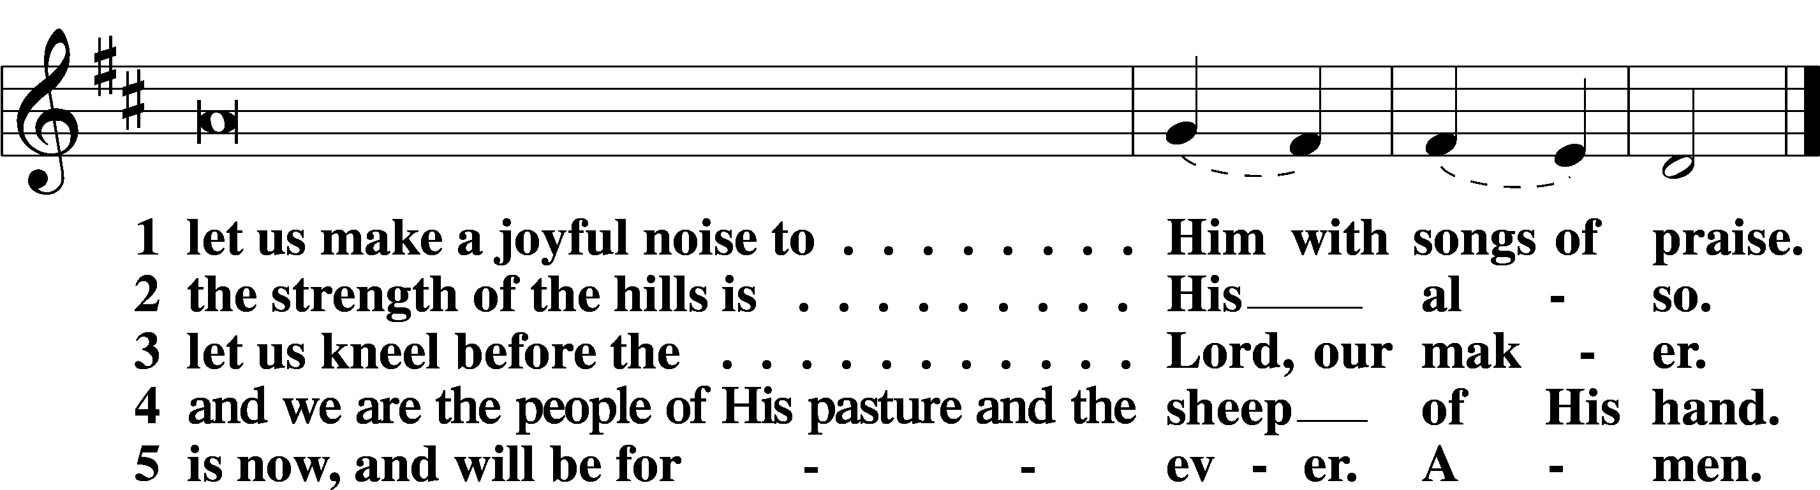

Additional Psalms Psalm 85:8–13; antiphon: v. 7
8Let me hear what God the Lord will speak,
for he will speak peace to his people, to his saints;
but let them not turn back to folly.
9Surely his salvation is near to those who fear him,
that glory may dwell in our land.
10Steadfast love and faithfulness meet;
righteousness and peace kiss each other.
11Faithfulness springs up from the ground,
and righteousness looks down from the sky.
12Yes, the Lord will give what is good,
and our land will yield its increase.
13Righteousness will go before him
and make his footsteps a way.

Sit

Office Hymn: 686 Come, Thou Fount of Every Blessing
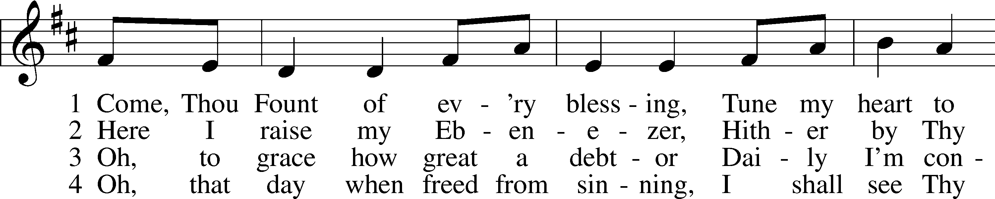
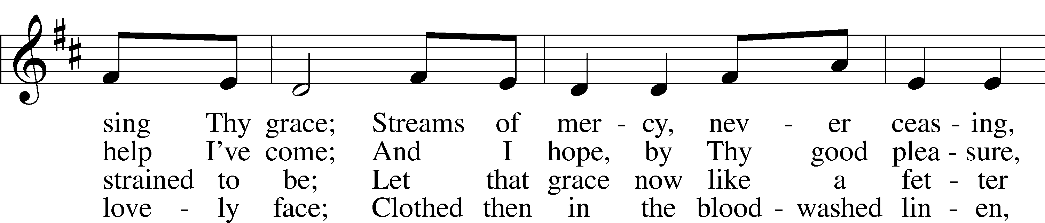
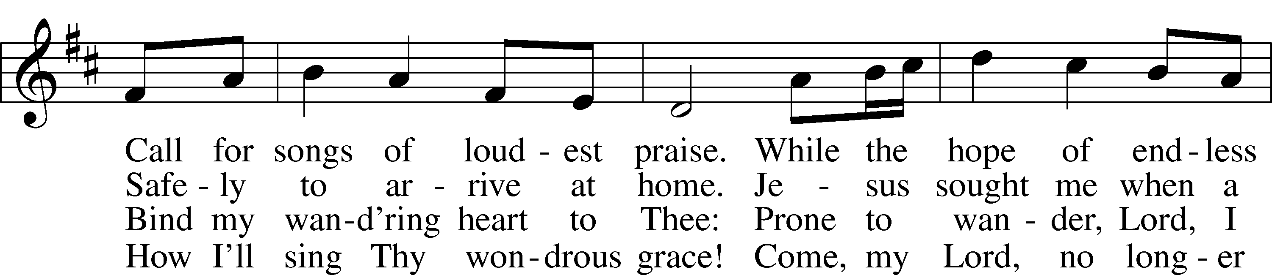
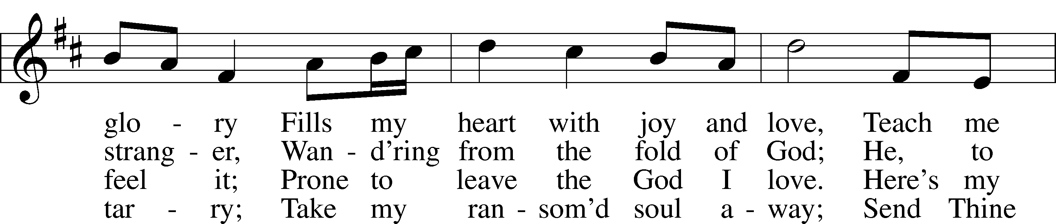
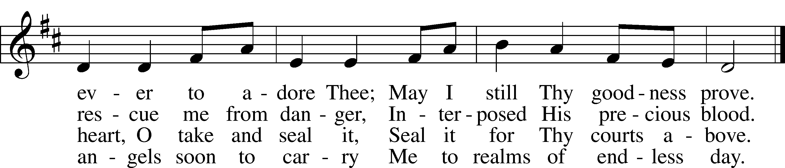
Text: Robert Robinson, 1735–90, alt.
Tune: Repository of Sacred Music, Part Second, 1813, Harrisburg
Text and tune: Public domain

Readings

Reading Amos 7:7–15
L A reading from Amos, chapter 7.

7This is what [the Lord God] showed me: behold, the Lord was standing beside a wall built with a plumb line, with a plumb line in his hand. 8And the Lord said to me, “Amos, what do you see?” And I said, “A plumb line.” Then the Lord said,
“Behold, I am setting a plumb line
in the midst of my people Israel;
I will never again pass by them;
9the high places of Isaac shall be made desolate,
and the sanctuaries of Israel shall be laid waste,
and I will rise against the house of Jeroboam with the sword.”
Amos Accused
10Then Amaziah the priest of Bethel sent to Jeroboam king of Israel, saying, “Amos has conspired against you in the midst of the house of Israel. The land is not able to bear all his words. 11For thus Amos has said,
“‘Jeroboam shall die by the sword,
and Israel must go into exile
away from his land.’”
12And Amaziah said to Amos, “O seer, go, flee away to the land of Judah, and eat bread there, and prophesy there, 13but never again prophesy at Bethel, for it is the king’s sanctuary, and it is a temple of the kingdom.”
14Then Amos answered and said to Amaziah, “I was no prophet, nor a prophet’s son, but I was a herdsman and a dresser of sycamore figs. 15But the Lord took me from following the flock, and the Lord said to me, ‘Go, prophesy to my people Israel.’”

L O Lord, have mercy on us.
C Thanks be to God.

Reading Ephesians 1:3–14
L A reading from Ephesians, chapter 1.

Spiritual Blessings in Christ
3Blessed be the God and Father of our Lord Jesus Christ, who has blessed us in Christ with every spiritual blessing in the heavenly places, 4even as he chose us in him before the foundation of the world, that we should be holy and blameless before him. In love 5he predestined us for adoption as sons through Jesus Christ, according to the purpose of his will, 6to the praise of his glorious grace, with which he has blessed us in the Beloved. 7In him we have redemption through his blood, the forgiveness of our trespasses, according to the riches of his grace, 8which he lavished upon us, in all wisdom and insight 9making known to us the mystery of his will, according to his purpose, which he set forth in Christ 10as a plan for the fullness of time, to unite all things in him, things in heaven and things on earth.
11In him we have obtained an inheritance, having been predestined according to the purpose of him who works all things according to the counsel of his will, 12so that we who were the first to hope in Christ might be to the praise of his glory. 13In him you also, when you heard the word of truth, the gospel of your salvation, and believed in him, were sealed with the promised Holy Spirit, 14who is the guarantee of our inheritance until we acquire possession of it, to the praise of his glory.

L O Lord, have mercy on us.
C Thanks be to God.

Reading Mark 6:14–29
L A reading from Mark, chapter 6.

The Death of John the Baptist
14King Herod heard of it, for Jesus’ name had become known. Some said, “John the Baptist has been raised from the dead. That is why these miraculous powers are at work in him.” 15But others said, “He is Elijah.” And others said, “He is a prophet, like one of the prophets of old.” 16But when Herod heard of it, he said, “John, whom I beheaded, has been raised.” 17For it was Herod who had sent and seized John and bound him in prison for the sake of Herodias, his brother Philip’s wife, because he had married her. 18For John had been saying to Herod, “It is not lawful for you to have your brother’s wife.” 19And Herodias had a grudge against him and wanted to put him to death. But she could not, 20for Herod feared John, knowing that he was a righteous and holy man, and he kept him safe. When he heard him, he was greatly perplexed, and yet he heard him gladly.
21But an opportunity came when Herod on his birthday gave a banquet for his nobles and military commanders and the leading men of Galilee. 22For when Herodias’s daughter came in and danced, she pleased Herod and his guests. And the king said to the girl, “Ask me for whatever you wish, and I will give it to you.” 23And he vowed to her, “Whatever you ask me, I will give you, up to half of my kingdom.” 24And she went out and said to her mother, “For what should I ask?” And she said, “The head of John the Baptist.” 25And she came in immediately with haste to the king and asked, saying, “I want you to give me at once the head of John the Baptist on a platter.” 26And the king was exceedingly sorry, but because of his oaths and his guests he did not want to break his word to her. 27And immediately the king sent an executioner with orders to bring John’s head. He went and beheaded him in the prison 28and brought his head on a platter and gave it to the girl, and the girl gave it to her mother. 29When his disciples heard of it, they came and took his body and laid it in a tomb.

L O Lord, have mercy on us.
C Thanks be to God.

Responsory LSB 221
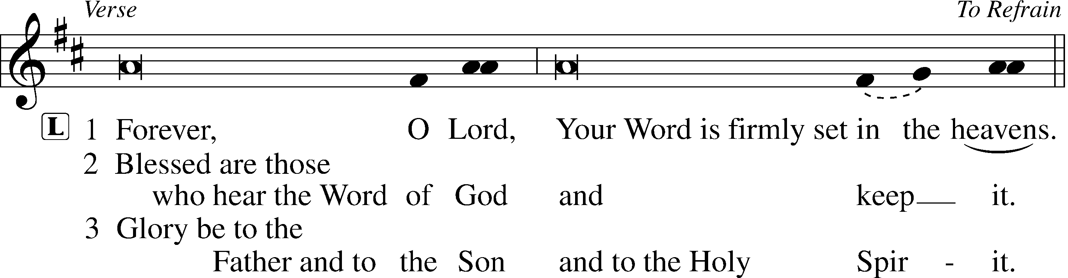
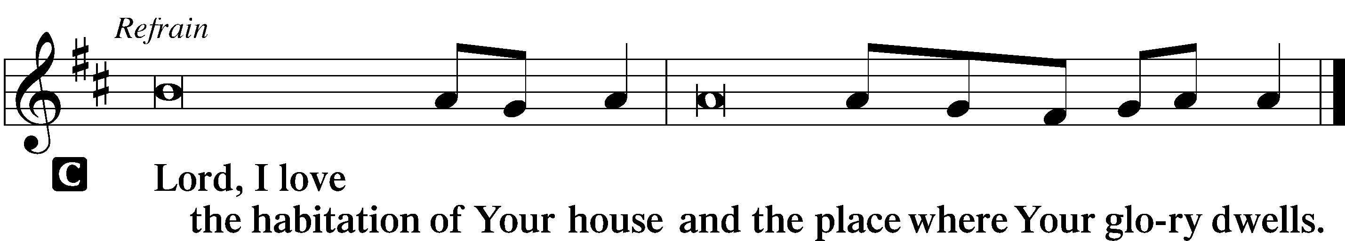

Hymn: 746 Through Jesus’ Blood and Merit
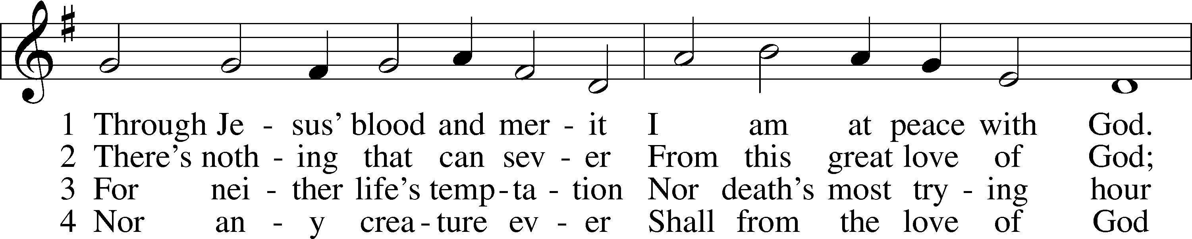
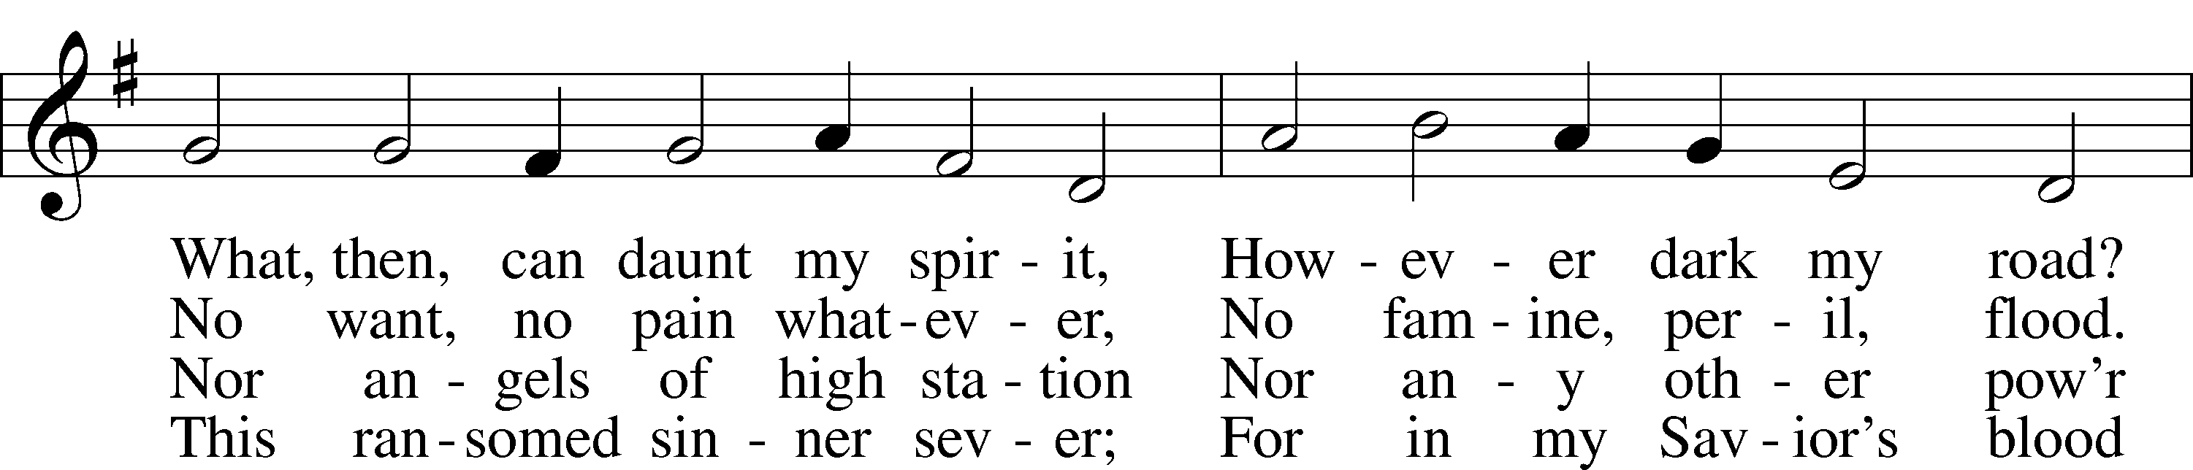
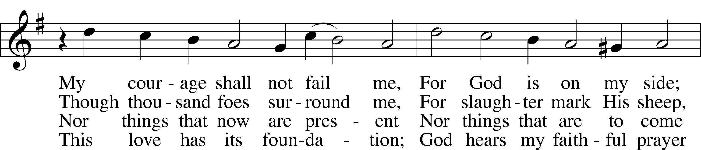
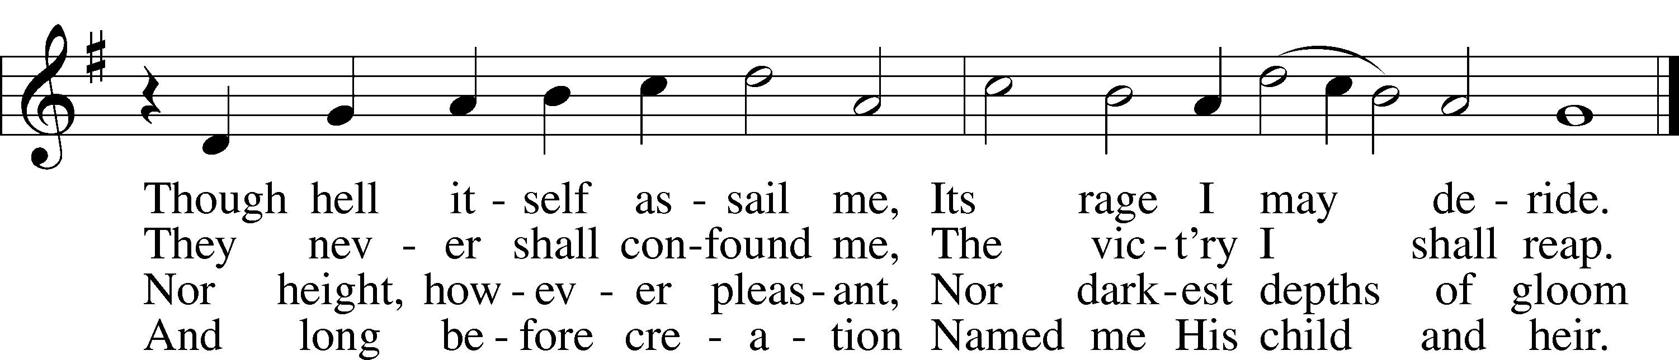
Text: Simon Dach, 1605–59; tr. The Lutheran Hymnal, 1941, alt.
Tune: Musika Teutsch, 1532, Nürnberg
Text and tune: Public domain

Sermon

Canticle

Stand

Te Deum LSB 223
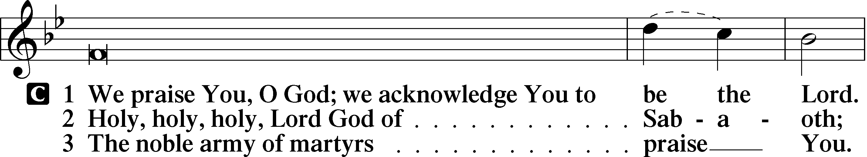
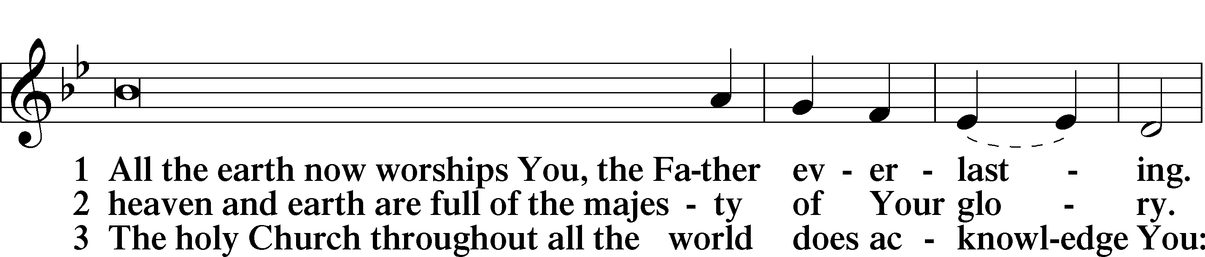
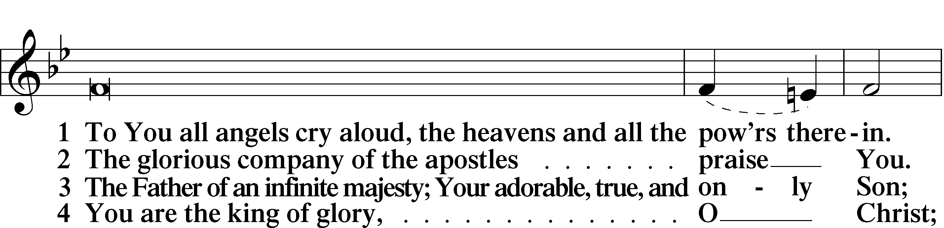
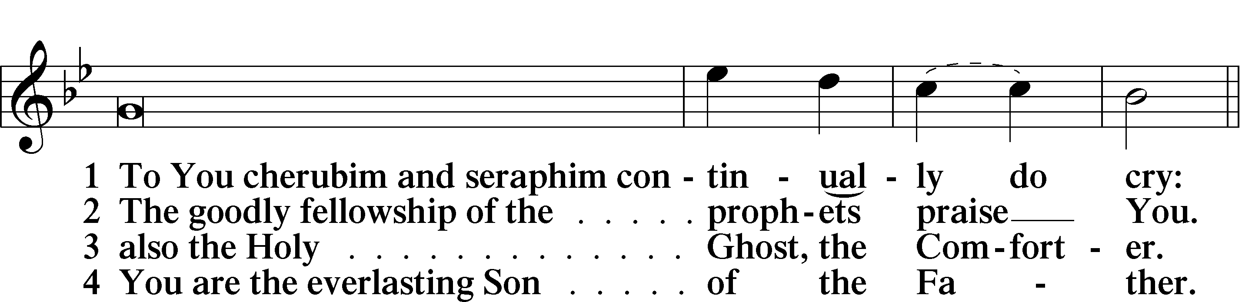
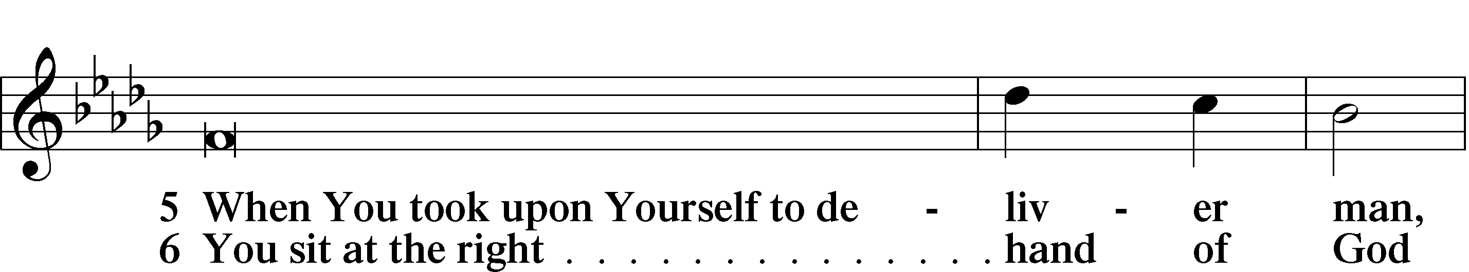
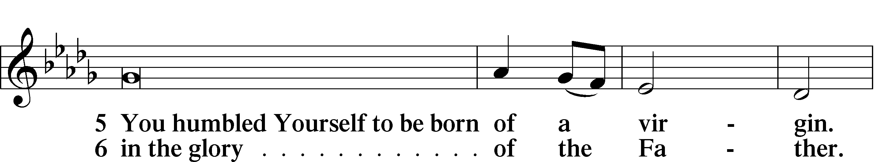
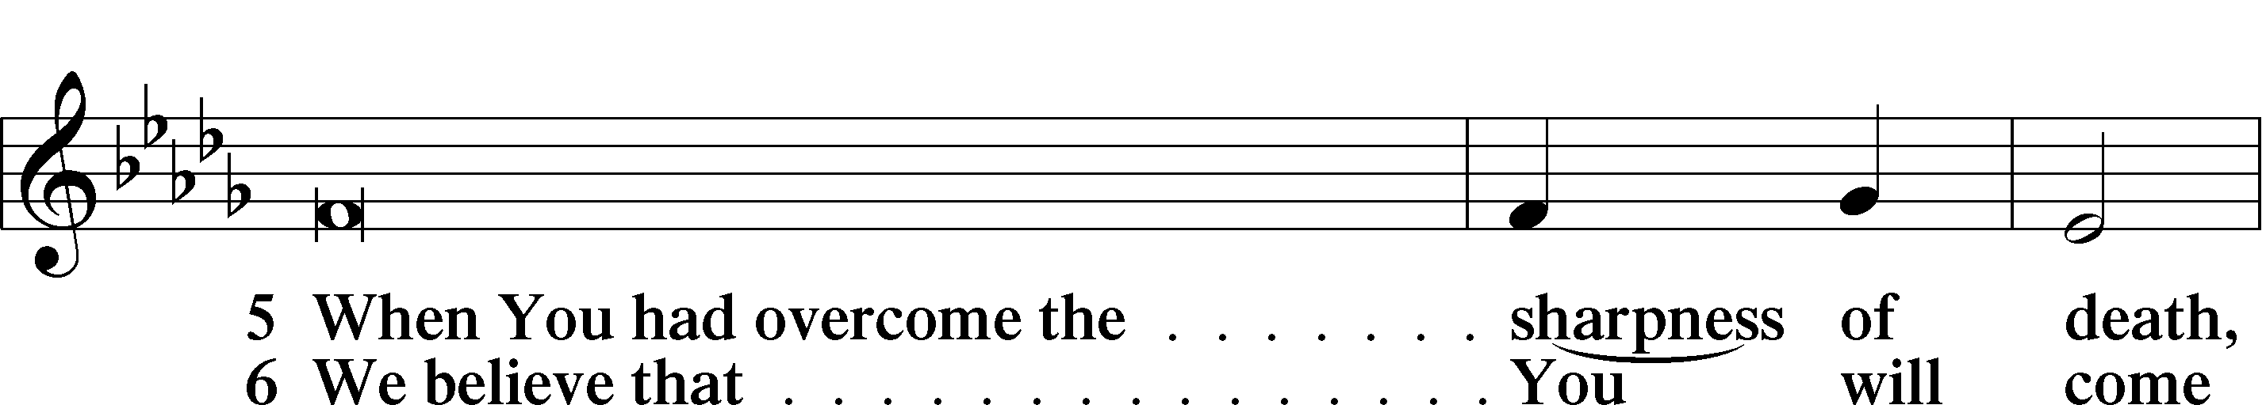
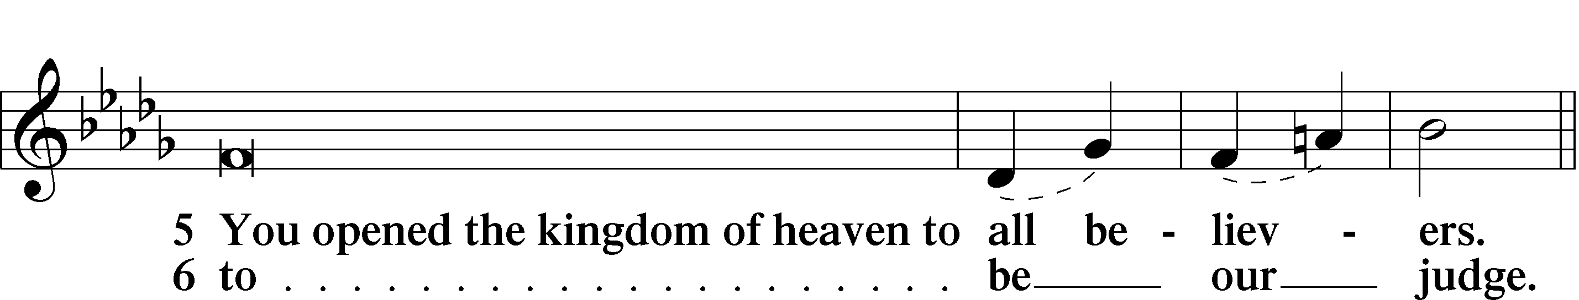
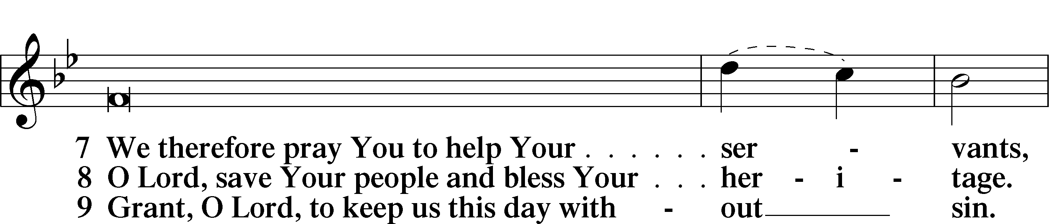
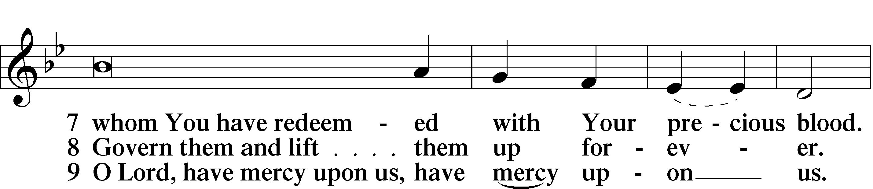
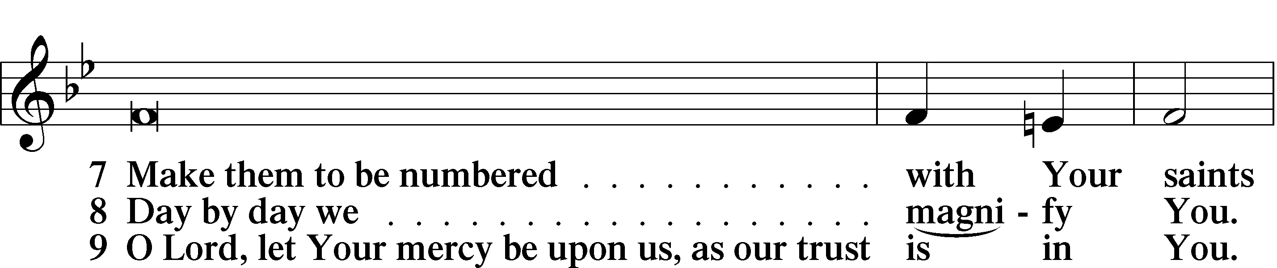
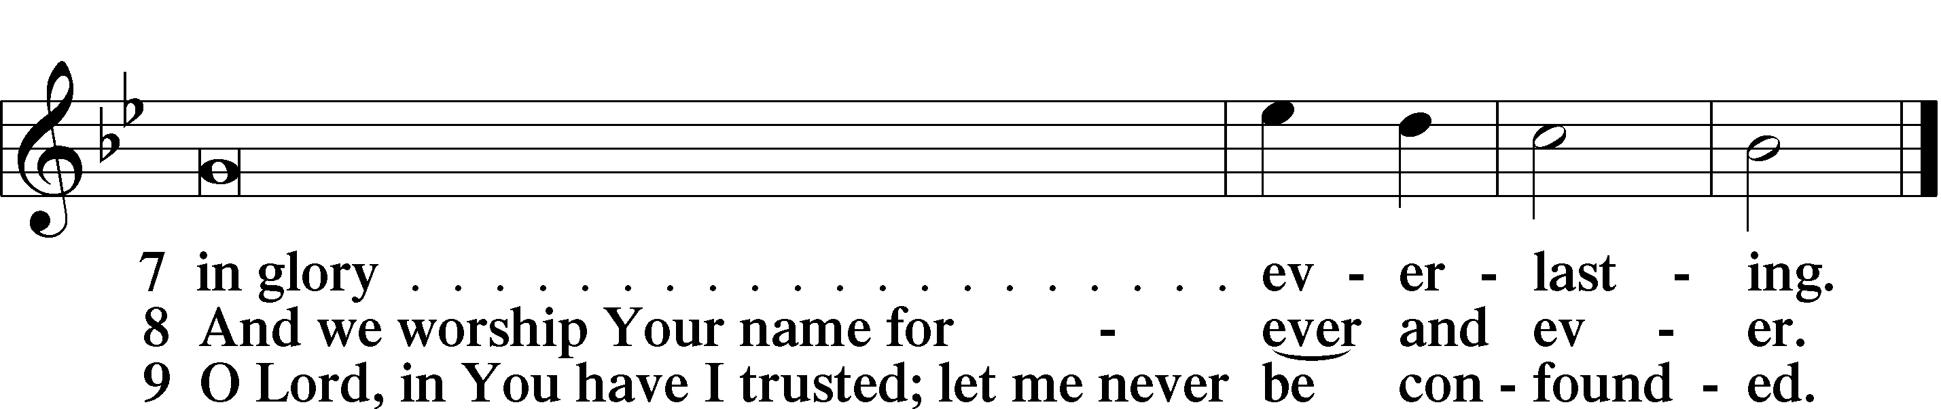

Sit

Offering

Prayer

Kneel/Stand

Kyrie LSB 227
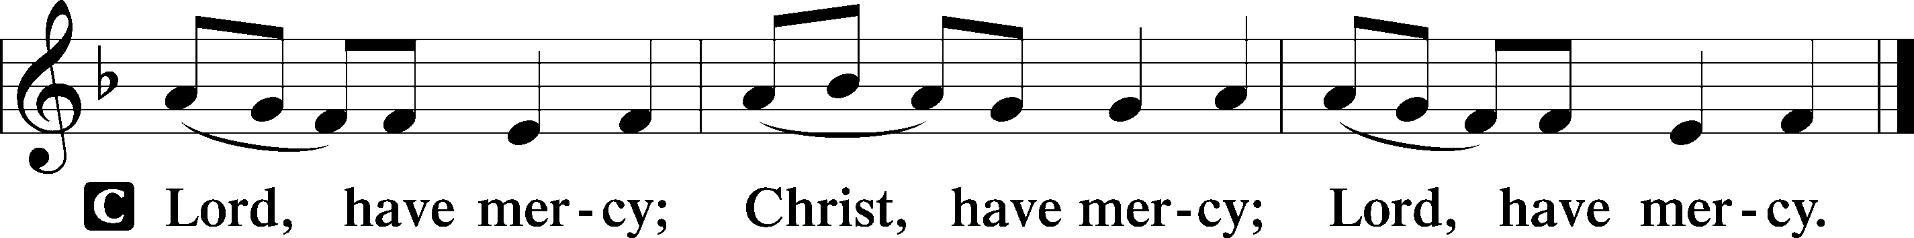

Lord’s Prayer
C Our Father who art in heaven,
hallowed be Thy name,
Thy kingdom come,
Thy will be done on earth
as it is in heaven;
give us this day our daily bread;
and forgive us our trespasses
as we forgive those
who trespass against us;
and lead us not into temptation,
but deliver us from evil.
For Thine is the kingdom
and the power and the glory
forever and ever. Amen.

Collects

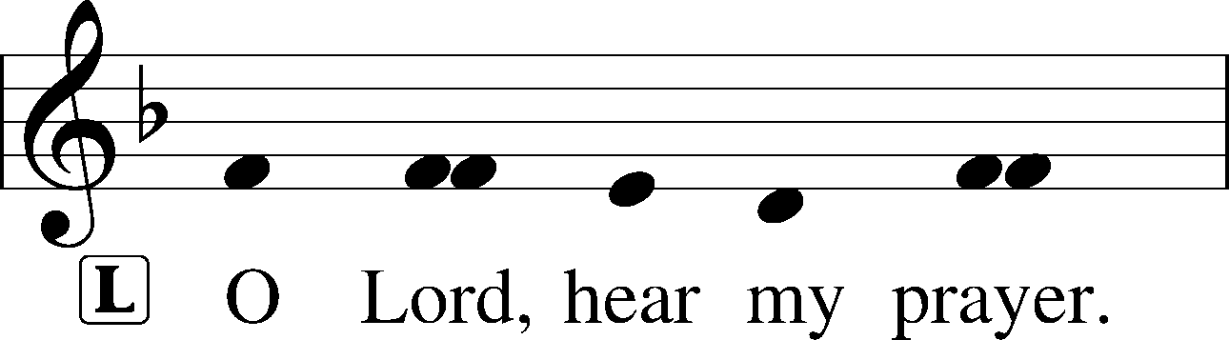
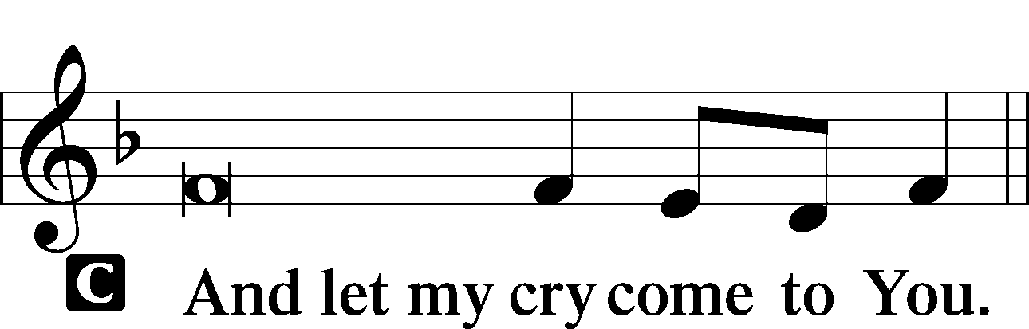

Collect of the Day
O Lord, You granted Your prophets strength to resist the temptations of the devil and courage to proclaim repentance. Give us pure hearts and minds to follow Your Son faithfully even into suffering and death; through the same Jesus Christ, our Lord, who lives and reigns with You and the Holy Spirit, one God, now and forever.
C Amen.

Collect for Grace
L O Lord, our heavenly Father, almighty and everlasting God, You have safely brought us to the beginning of this day. Defend us in the same with Your mighty power and grant that this day we fall into no sin, neither run into any kind of danger, but that all our doings, being ordered by Your governance, may be righteous in Your sight; through Jesus Christ, Your Son, our Lord, who lives and reigns with You and the Holy Spirit, one God, now and forever.
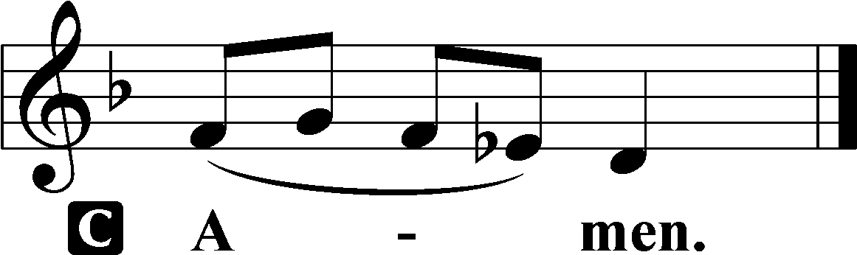

Stand

Benedicamus LSB 228
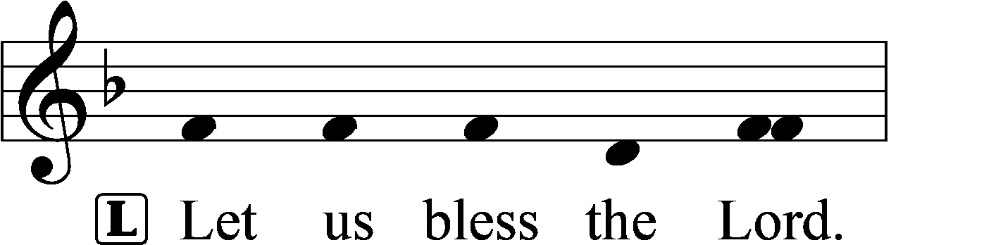
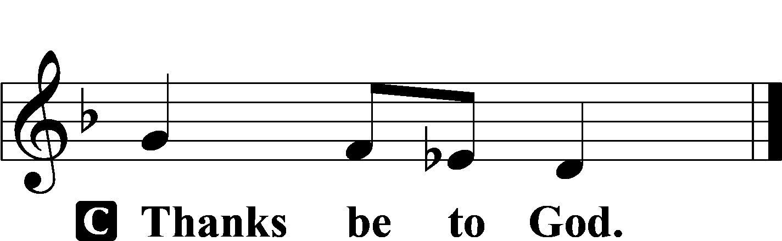

Benediction LSB 228
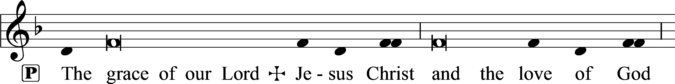
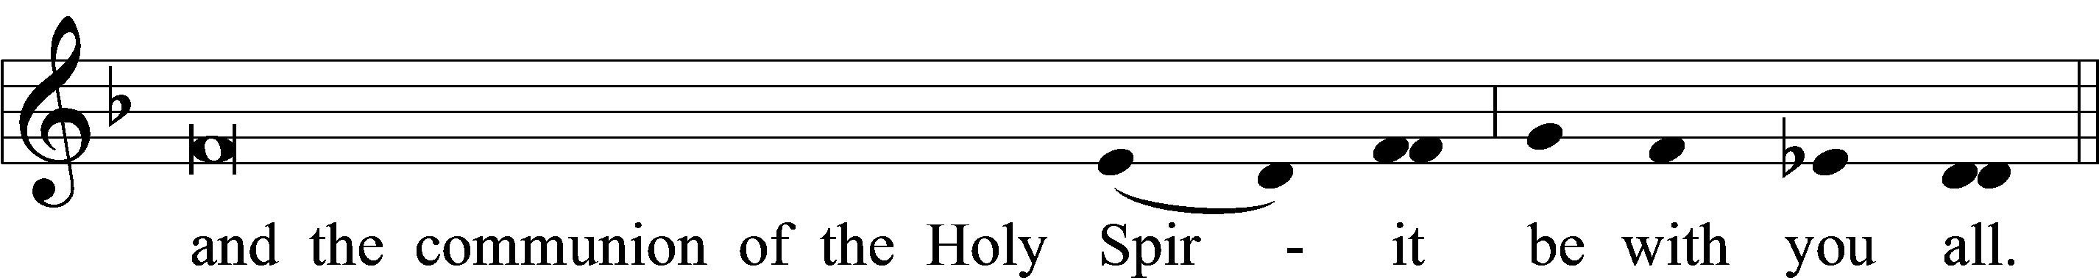

Hymn to Depart: 655 Lord, Keep Us Steadfast in Your Word
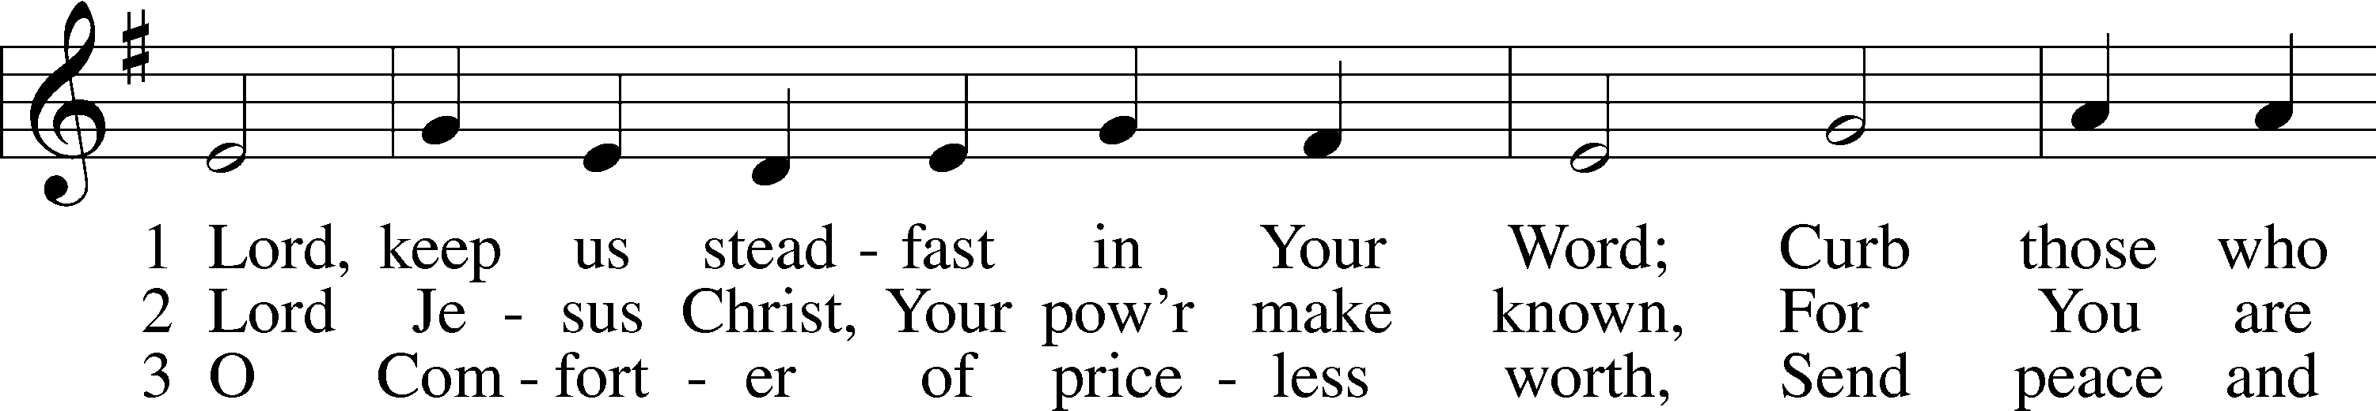
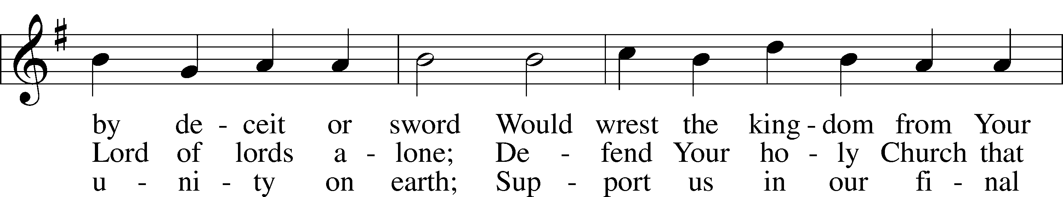
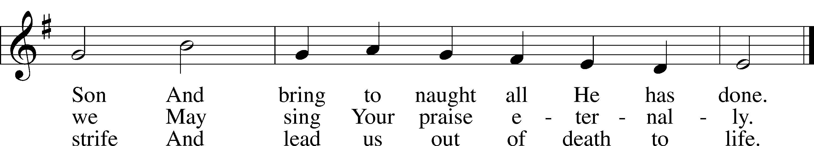
Text: Martin Luther, 1483–1546; tr. Catherine Winkworth, 1827–78, alt.
Tune: Geistliche Lieder auffs new gebessert, 1543, Wittenberg, ed. Joseph Klug
Text and tune: Public domain

Acknowledgments
Matins from Lutheran Service Book
Unless otherwise indicated, Scripture quotations are from the ESV® Bible (The Holy Bible, English Standard Version®), copyright © 2001 by Crossway, a publishing ministry of Good News Publishers. Used by permission. All rights reserved.
Created by Lutheran Service Builder © 2024 Concordia Publishing House.

Church Service Phone: 715-438-4200
(Stay on the line for recorded service to start)
Live Stream audio services: http://salem.listentochurch.com
Salem’s Web Page: https://www.salembarron.com/
Pastor Fred Buth: Cell phone:715-642-3050 (H)715-353-2540
Pastor’s Email: salembarronpastor@gmail.com
Office Hours: Monday-Wednesday 9-12
Office email: salembarron@gmail.com
Attendance:
In-person: 7/7-60
Coffee and Snacks: Bob and Laurie Hinrichs
Elder Today: Don Duncan
Altar Guild: Kathy Schuettpelz
Save the Date:
July 28 – Root beer Floats
August 9th – 4:30-6:30pm Annual Church/Childcare Picnic

Looking for a volunteer to be Director of Sunday School, also looking for a 7 & 8th grade Sunday school teacher. If you are interested, please contact Sue M.

In case of an emergence Please call one of the Elders or Pastor Buth 715-642-3050
Christ Community Lutheran School is hiring a headmaster. We are open to all levels of experience. Please email a resume’ or questions to administrator@christcommunityls.org

Prayers Request:
Those in the nursing home: Joann Jaeger Those Shut-in at home: Char Herman, Joan Church, Joyce Myers, Joyce Koba Those with ongoing health issues: Harrison Fields, Jeanne Perala, Owen Metz, Jeff Bonneville, Daria (Cindy Wright’s friend), Butch L. (Cindy Wright’s Brother-in-law), Melissa Miller. Art Smith (Sue Millerman’s brother), Brenda Sellent (Denise Stabenow’s sister), Sandy Hahn (Cindy Wright’s cousin’s wife) Recovering from surgery: Wyatt Weise, Those who lead our nation: Joe Biden, Kamala Harris, Tony Evers, Rod Nordby Those who serve in our military and law enforcement: Ryan Graf, Chaplain Pon Chanthaphon (Our Adopt-a-Chaplain), Rusty Weise Our Childcare Staff: Melissa Weinert, Denise Stabenow, Katelyn Hendren, Holly Wilhelmi, Janica Skjerly, Jacie Amundson, Cathy Anderson For Christ Community Lutheran School – Ask the Lord to provide teachers for the school
Additional Psalms Psalm 85:8–13; antiphon: v. 7
⁸Let me hear what God the Lord will speak,
for he will speak peace to his people, to his saints;
but let them not turn back to folly.
⁹Surely his salvation is near to those who fear him,
that glory may dwell in our land.
¹⁰Steadfast love and faithfulness meet;
righteousness and peace kiss each other.
¹¹Faithfulness springs up from the ground,
and righteousness looks down from the sky.
¹²Yes, the Lord will give what is good,
and our land will yield its increase.
¹³Righteousness will go before him
and make his footsteps away.

Collect of the Day O Lord, You granted Your prophets strength to resist the temptations of the devil and courage to proclaim repentance. Give us pure hearts and minds to follow Your Son faithfully even into suffering and death; through the same Jesus Christ, our Lord, who lives and reigns with You and the Holy Spirit, one God, now and forever.

EIGHTH SUNDAY AFTER PENTECOST (Proper 10B) The Lord Jesus Brings His People through Death into Life by the Preaching of Repentance Amos did not choose to be a prophet, but the Lord took him “from following the flock” and said to him, “Go, prophesy to my people Israel” (Amos 7:15). It was a hard word given him to preach: King Jeroboam would “die by the sword,” and Israel would “go into exile away from his land” (Amos 7:10–11). For this word, Amos was hated and threatened. St. John the Baptist also suffered for his faithful preaching of repentance. King Herod “sent and seized John and bound him in prison,” even though he knew that John “was a righteous and holy man” (Mark 6:17, 20). Out of pride and fear, Herod “sent an executioner with orders to bring John’s head” (Mark 6:27). Yet in Christ, St. John the Baptist “has been raised from the dead” (Mark 6:14, 16). For Christ is the destruction of death itself “before the foundation of the world,” and even now by faith, “the God and Father of our Lord Jesus Christ” has blessed us in Christ “with every spiritual blessing in the heavenly places” (Eph. 1:3–4). Through Baptism into Christ, you also “were sealed with the promised Holy Spirit” for life and salvation (Eph. 1:13).

