# Service of Prayer and Preaching

18th Sunday after Pentecost

September 22,2024

Hymn: 851 Lord of Glory, You Have Bought Us

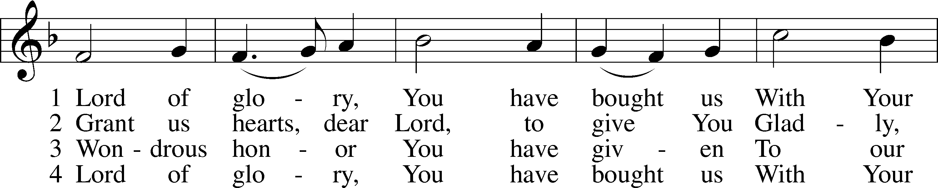

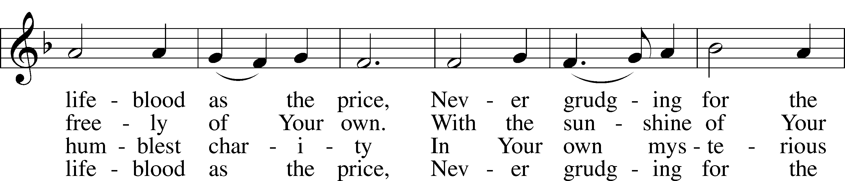

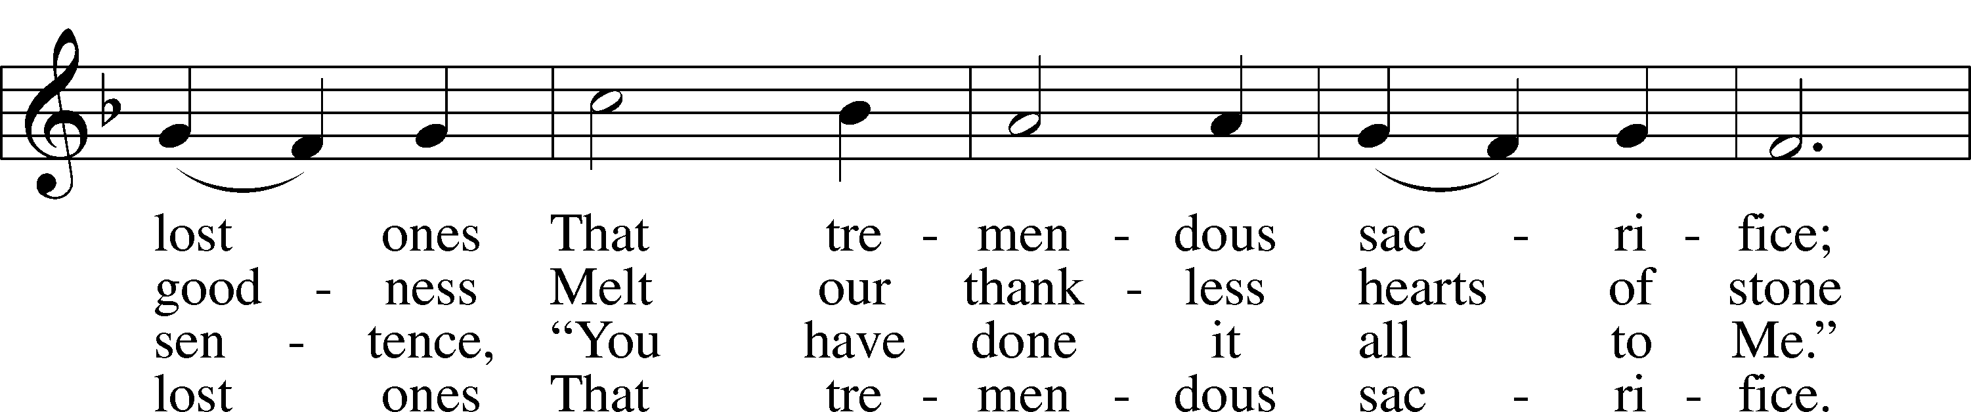

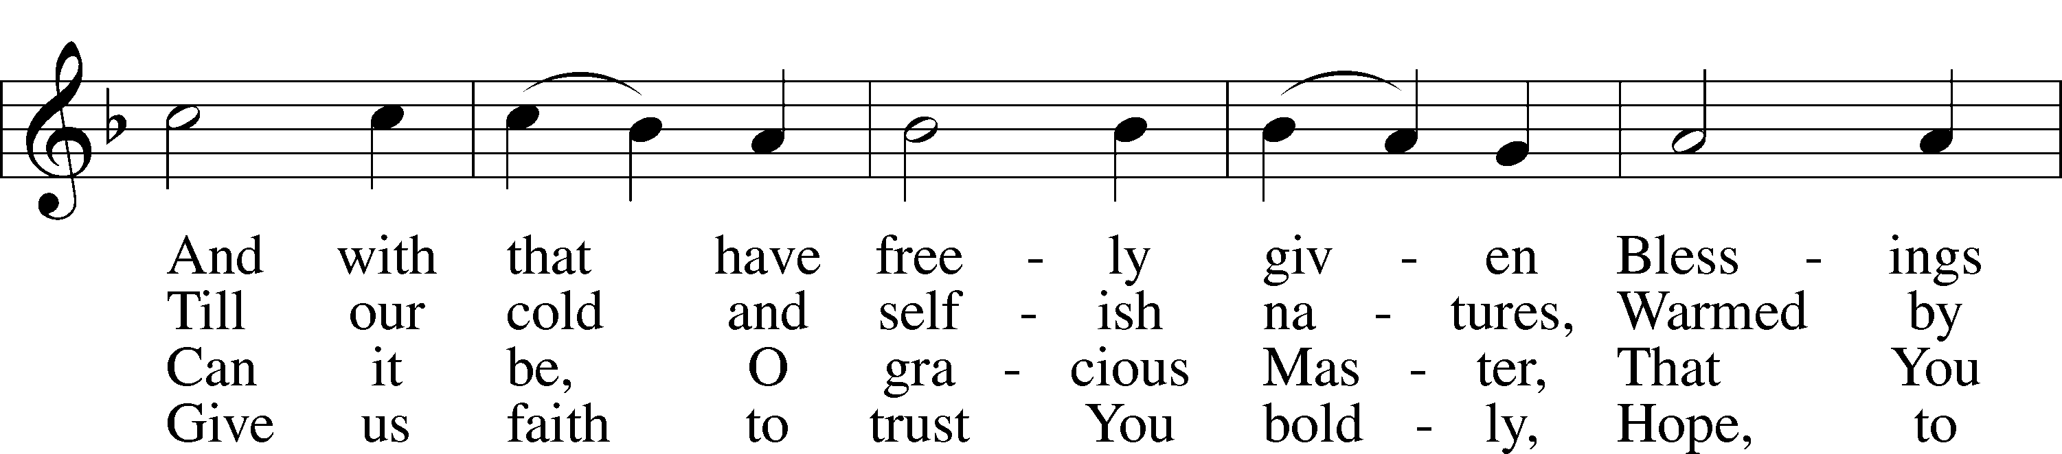

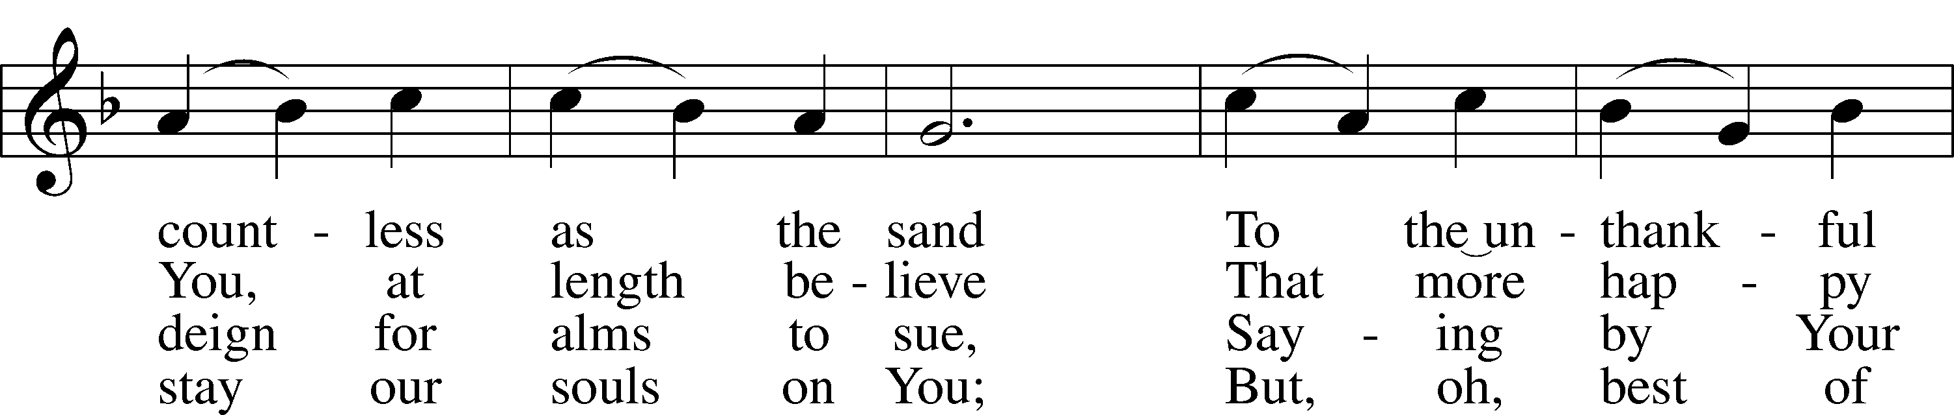

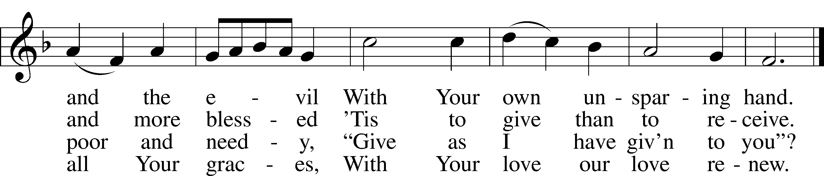

Text: Eliza S. Alderson, 1818–89, alt.  
Tune: Rowland H. Prichard, 1811–87  
Text and tune: Public domain

Stand

Opening Versicles pg.260

L This is the day which the Lord has made;

C **let us rejoice and be glad in it.**

L From the rising of the sun to its setting,

C **the name of the Lord is to be praised.**

L Better is one day in Your courts than a thousand elsewhere;

C **I would rather be a doorkeeper in the house of my God than dwell in the tents of the wicked.**

L Make me to know Your ways, O Lord.

C **Teach me Your paths.**

L Sanctify us in Your truth.

C **Your Word is truth.**

L From the rising of the sun to its setting,

C **the name of the Lord is to be praised.**

C **Glory be to the Father and to the Son and to the Holy Spirit;**  
**as it was in the beginning, is now, and will be forever. Amen.**

Old Testament Canticle LSB 261

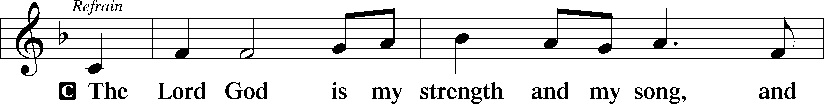

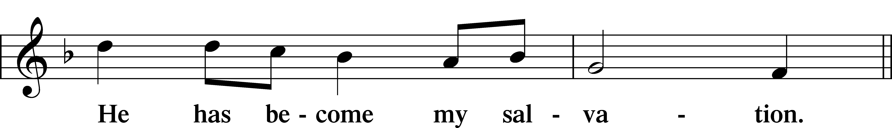

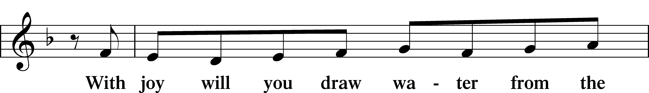

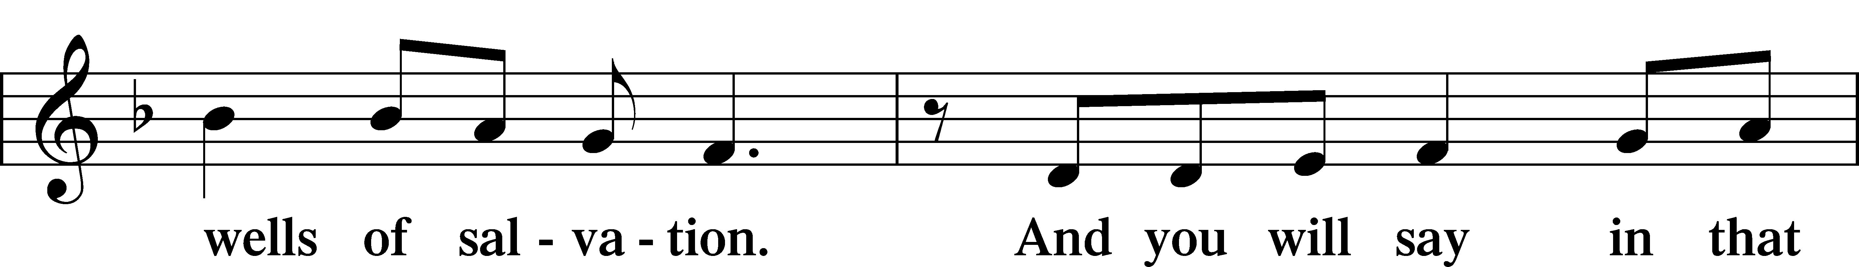

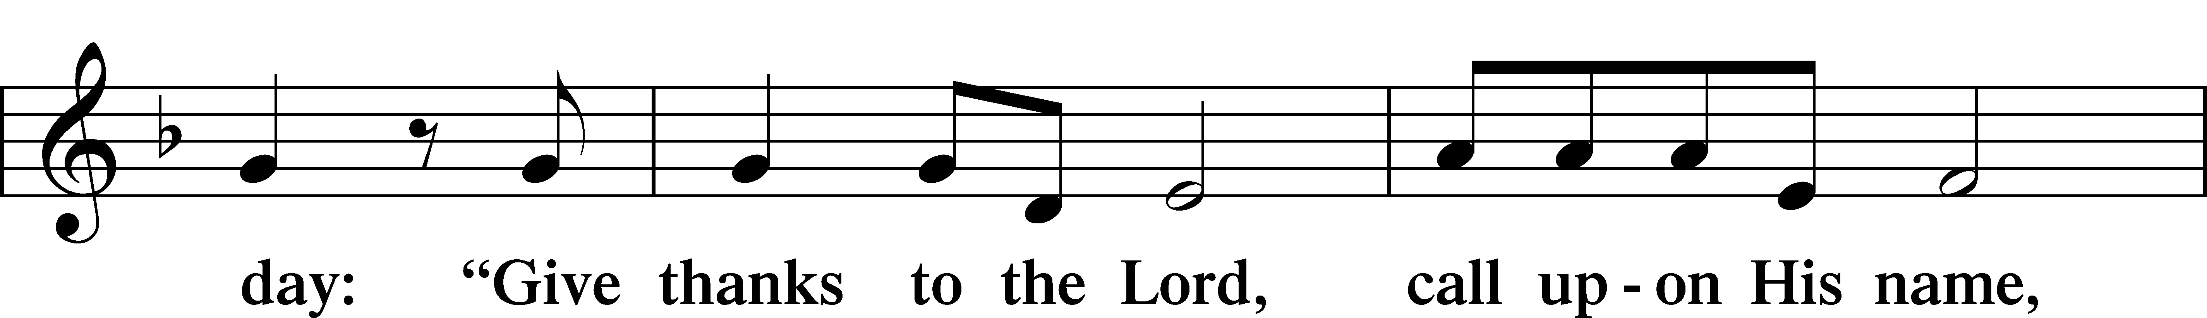

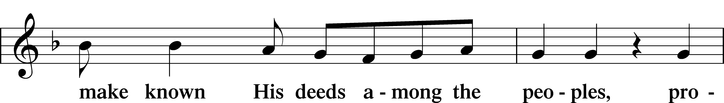

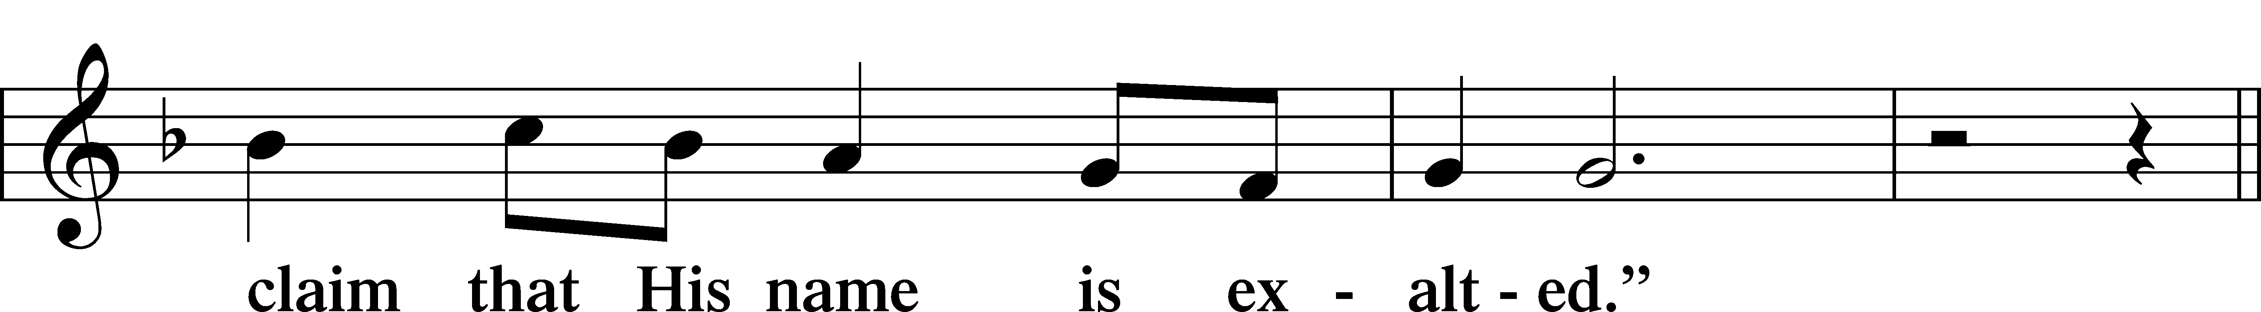

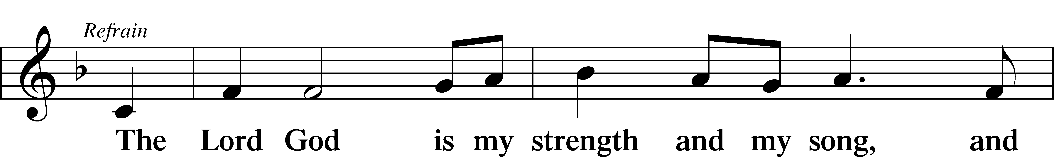

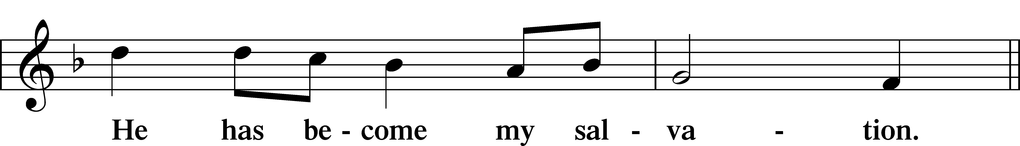

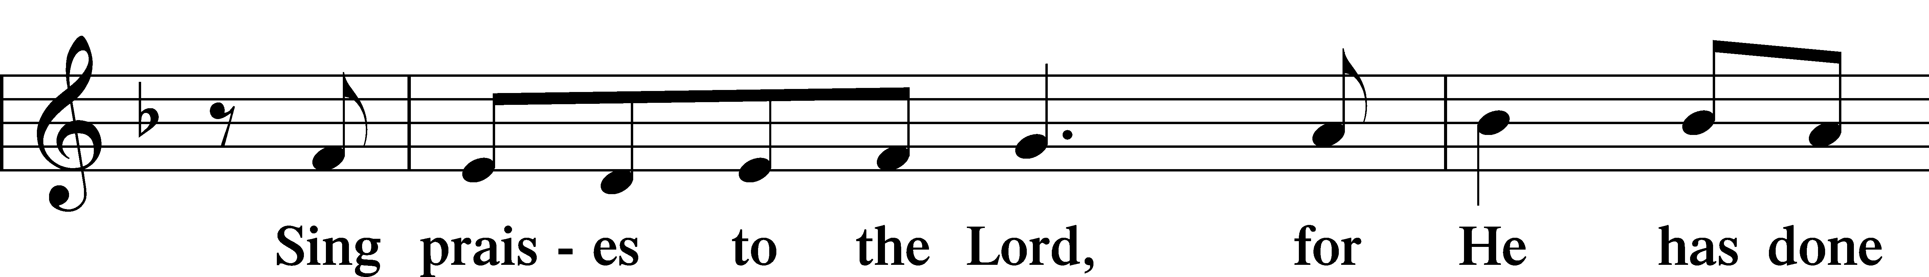

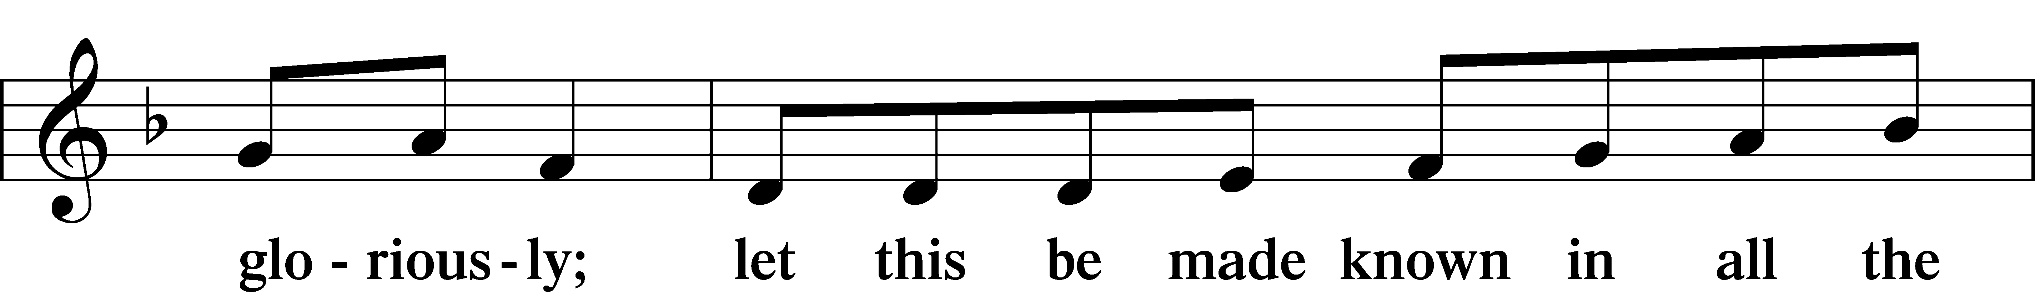

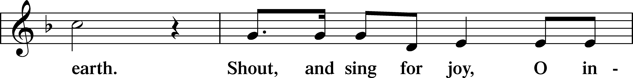

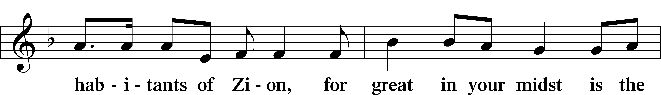

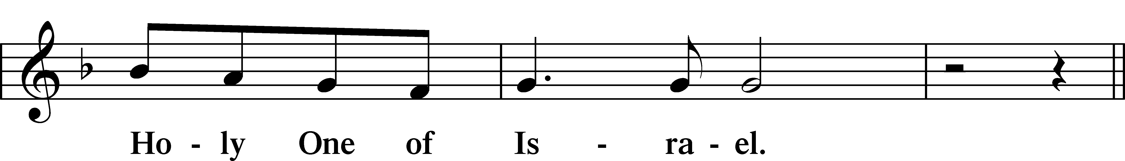

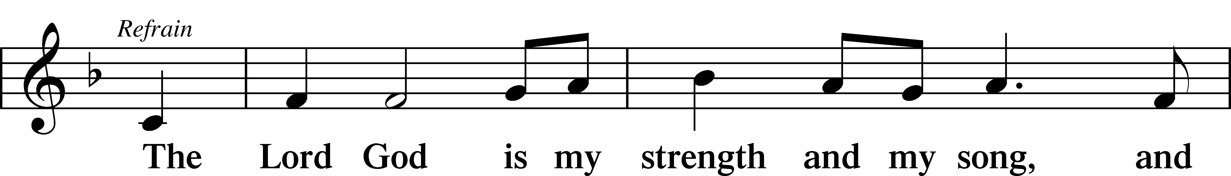

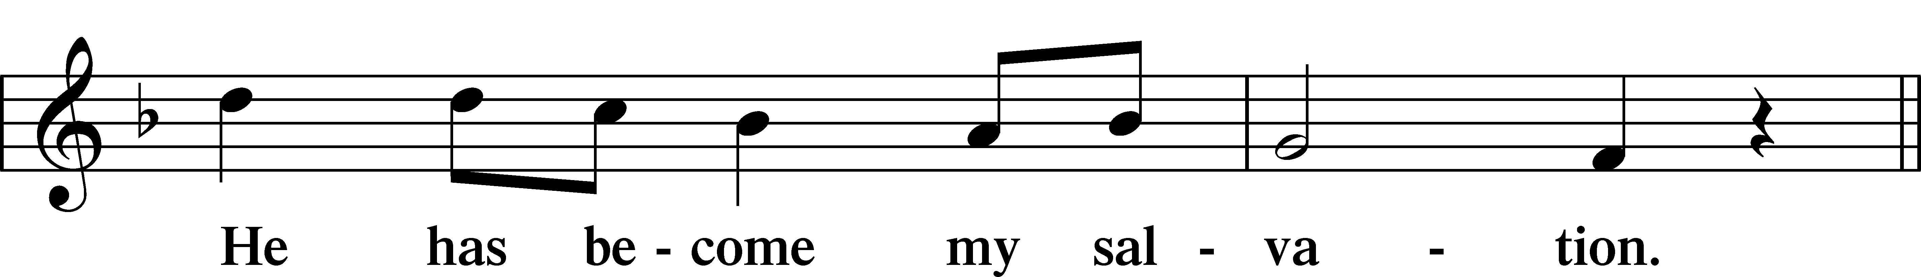

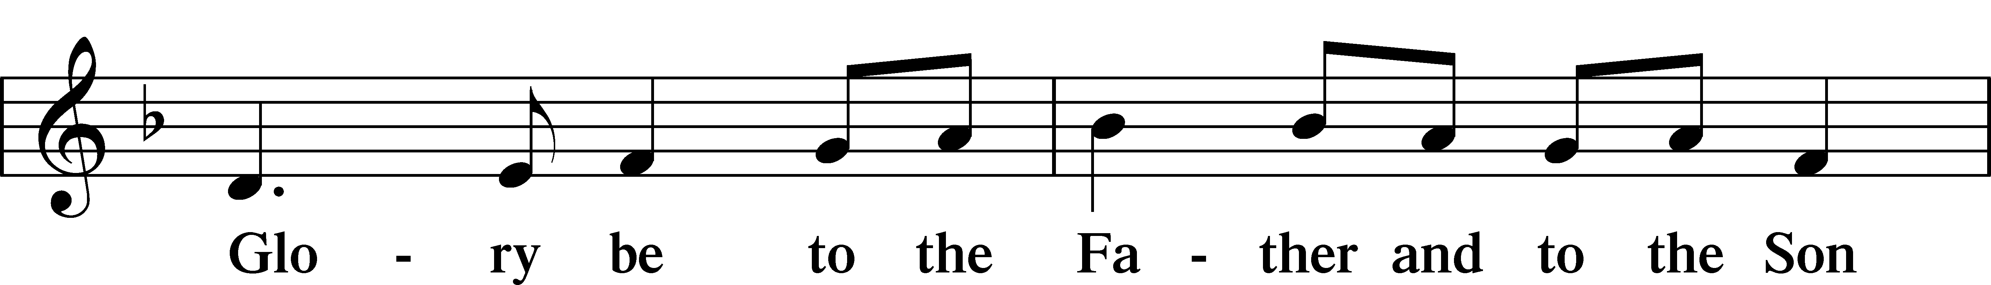

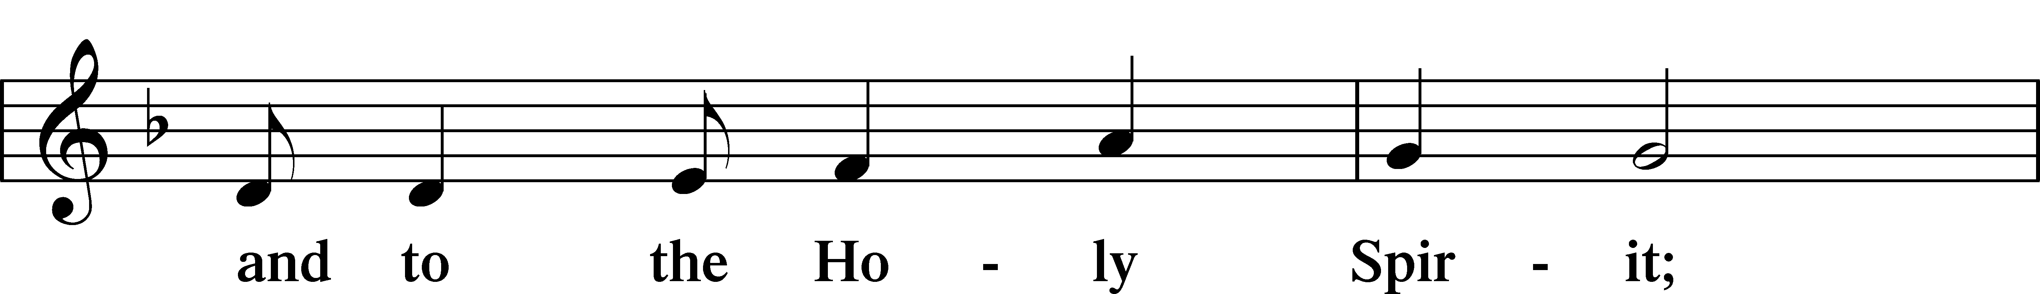

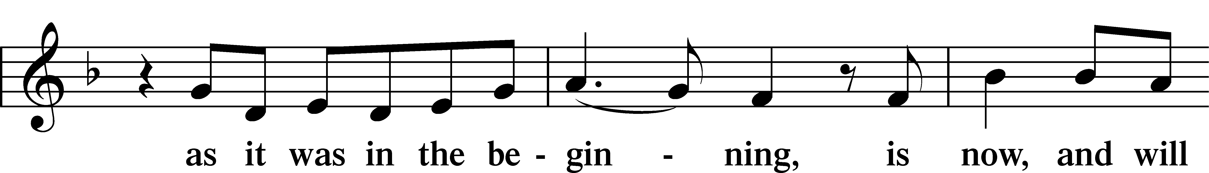

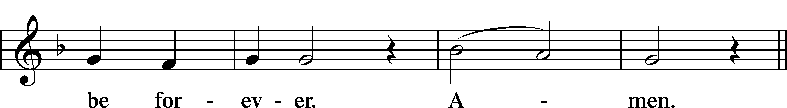

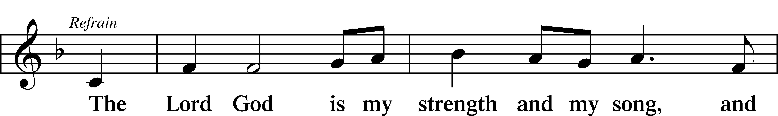

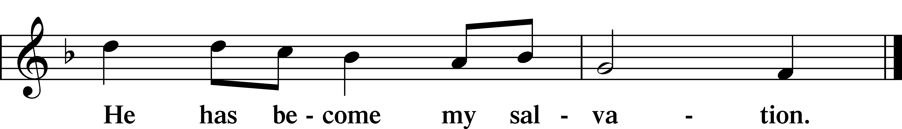

Sit

Readings From Holy Scripture

Reading Jeremiah 11:18–20

L A reading from Jeremiah, the eleventh chapter.

18The Lord made it known to me and I knew;  
 then you showed me their deeds.  
19But I was like a gentle lamb  
 led to the slaughter.  
I did not know it was against me  
 they devised schemes, saying,  
“Let us destroy the tree with its fruit,  
 let us cut him off from the land of the living,  
 that his name be remembered no more.”  
20But, O Lord of hosts, who judges righteously,  
 who tests the heart and the mind,  
let me see your vengeance upon them,  
 for to you have I committed my cause.

L This is the Word of the Lord.

C **Thanks be to God.**

Reading James 3:13—4:10

Wisdom from Above

13Who is wise and understanding among you? By his good conduct let him show his works in the meekness of wisdom. 14But if you have bitter jealousy and selfish ambition in your hearts, do not boast and be false to the truth. 15This is not the wisdom that comes down from above, but is earthly, unspiritual, demonic. 16For where jealousy and selfish ambition exist, there will be disorder and every vile practice. 17But the wisdom from above is first pure, then peaceable, gentle, open to reason, full of mercy and good fruits, impartial and sincere. 18And a harvest of righteousness is sown in peace by those who make peace.

Warning Against Worldliness

1What causes quarrels and what causes fights among you? Is it not this, that your passions are at war within you? 2You desire and do not have, so you murder. You covet and cannot obtain, so you fight and quarrel. You do not have, because you do not ask. 3You ask and do not receive, because you ask wrongly, to spend it on your passions. 4You adulterous people! Do you not know that friendship with the world is enmity with God? Therefore whoever wishes to be a friend of the world makes himself an enemy of God. 5Or do you suppose it is to no purpose that the Scripture says, “He yearns jealously over the spirit that he has made to dwell in us”? 6But he gives more grace. Therefore it says, “God opposes the proud, but gives grace to the humble.” 7Submit yourselves therefore to God. Resist the devil, and he will flee from you. 8Draw near to God, and he will draw near to you. Cleanse your hands, you sinners, and purify your hearts, you double-minded. 9Be wretched and mourn and weep. Let your laughter be turned to mourning and your joy to gloom. 10Humble yourselves before the Lord, and he will exalt you.

Reading Mark 9:30–37

Jesus Again Foretells Death, Resurrection

30[The disciples] went on from there and passed through Galilee. And [Jesus] did not want anyone to know, 31for he was teaching his disciples, saying to them, “The Son of Man is going to be delivered into the hands of men, and they will kill him. And when he is killed, after three days he will rise.” 32But they did not understand the saying, and were afraid to ask him.

Who Is the Greatest?

33And they came to Capernaum. And when he was in the house he asked them, “What were you discussing on the way?” 34But they kept silent, for on the way they had argued with one another about who was the greatest. 35And he sat down and called the twelve. And he said to them, “If anyone would be first, he must be last of all and servant of all.” 36And he took a child and put him in the midst of them, and taking him in his arms, he said to them, 37“Whoever receives one such child in my name receives me, and whoever receives me, receives not me but him who sent me.”

Psalms, hymns, or choral music may be sung between the readings.

Responsory

L Forever, O Lord, Your Word is firmly set in the heavens.

C **Lord, I love the habitation of Your house and the place where Your glory dwells.**

L Blessed are those who hear the Word of God and keep it.

C **Lord, I love the habitation of Your house and the place where Your glory dwells.**

L Glory be to the Father and to the Son and to the Holy Spirit.

C **Lord, I love the habitation of Your house and the place where Your glory dwells.**

Stand

Ten Commandments

C **You shall have no other gods.**

**You shall not misuse the name of the Lord your God.**

**Remember the Sabbath day by keeping it holy.**

**Honor your father and your mother.**

**You shall not murder.**

**You shall not commit adultery.**

**You shall not steal.**

**You shall not give false testimony against your neighbor.**

**You shall not covet your neighbor’s house.**

**You shall not covet your neighbor’s wife, or his manservant or maidservant, his ox or donkey, or anything that belongs to your neighbor.**

Apostles’ Creed

C **I believe in God, the Father Almighty,**

**maker of heaven and earth.**

**And in Jesus Christ, His only Son, our Lord,**

**who was conceived by the Holy Spirit,**

**born of the virgin Mary,**

**suffered under Pontius Pilate,**

**was crucified, died and was buried.**

**He descended into hell.**

**The third day He rose again from the dead.**

**He ascended into heaven**

**and sits at the right hand of God the Father Almighty.**

**From thence He will come to judge the living and the dead.**

**I believe in the Holy Spirit,**

**the holy Christian Church,**

**the communion of saints,**

**the forgiveness of sins,**

**the resurrection of the body,**

**and the life** T **everlasting. Amen.**

Lord’s Prayer

C **Our Father who art in heaven,**

**hallowed be Thy name,**

**Thy kingdom come,**

**Thy will be done on earth**

**as it is in heaven;**

**give us this day our daily bread;**

**and forgive us our trespasses**

**as we forgive those**

**who trespass against us;**

**and lead us not into temptation,**

**but deliver us from evil.**

**For Thine is the kingdom**

**and the power and the glory**

**forever and ever. Amen.**

Sit

Hymn: 661 The Son of God Goes Forth to War

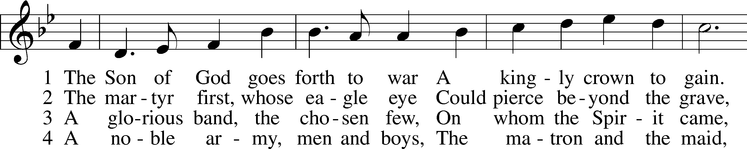

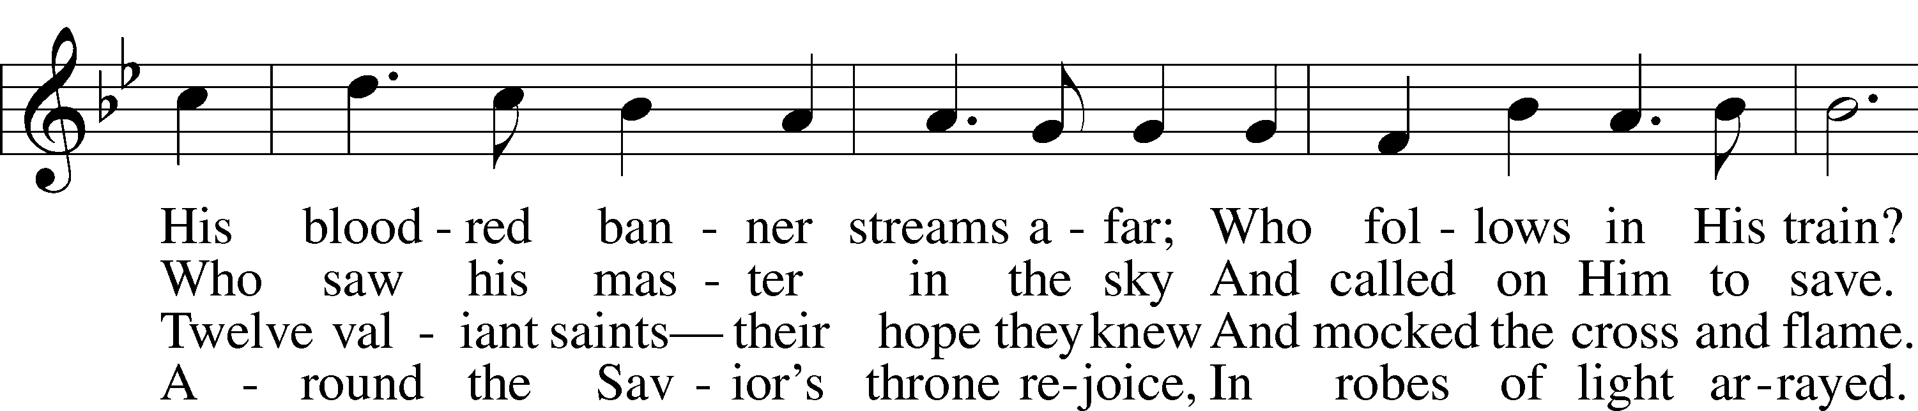

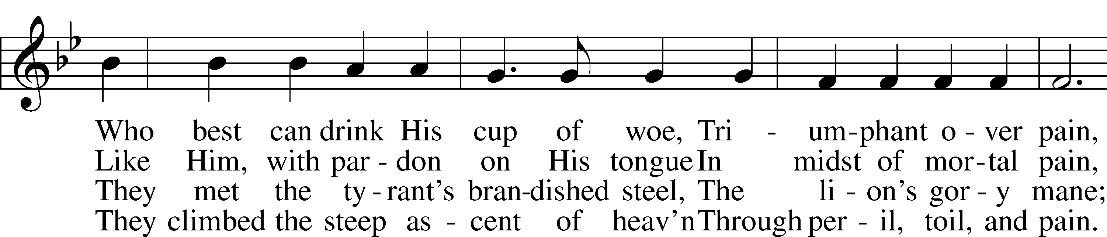

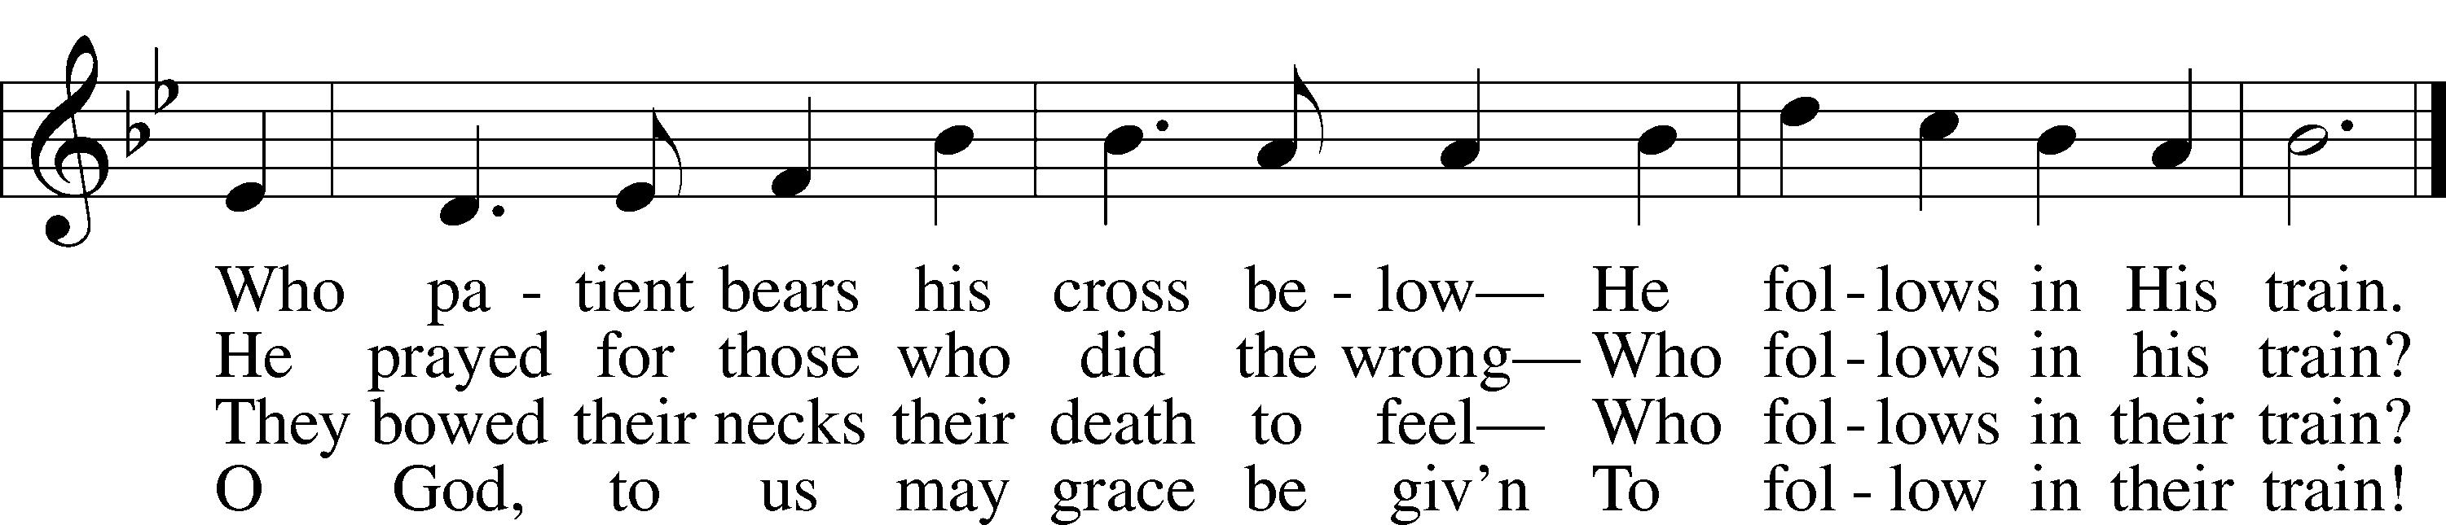

Text: Reginald Heber, 1783–1826, alt.  
Tune: Henry S. Cutler, 1824–1902  
Text and tune: Public domain

Sermon

Hymn: 438 A Lamb Goes Uncomplaining Forth

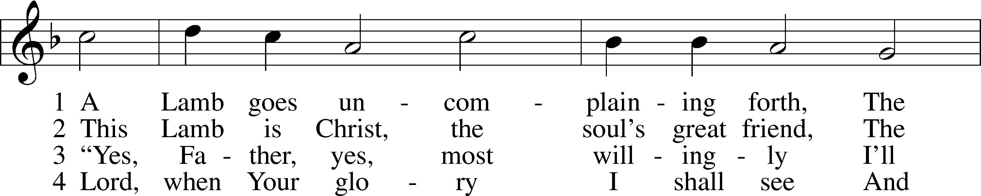

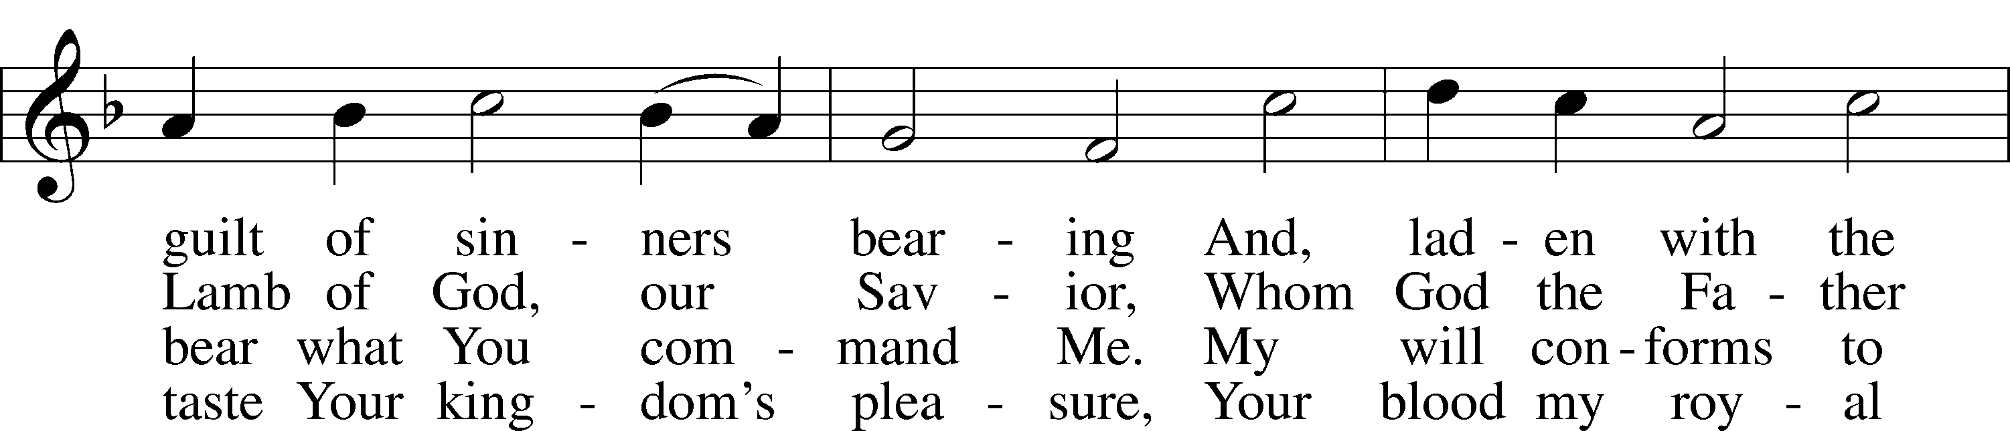

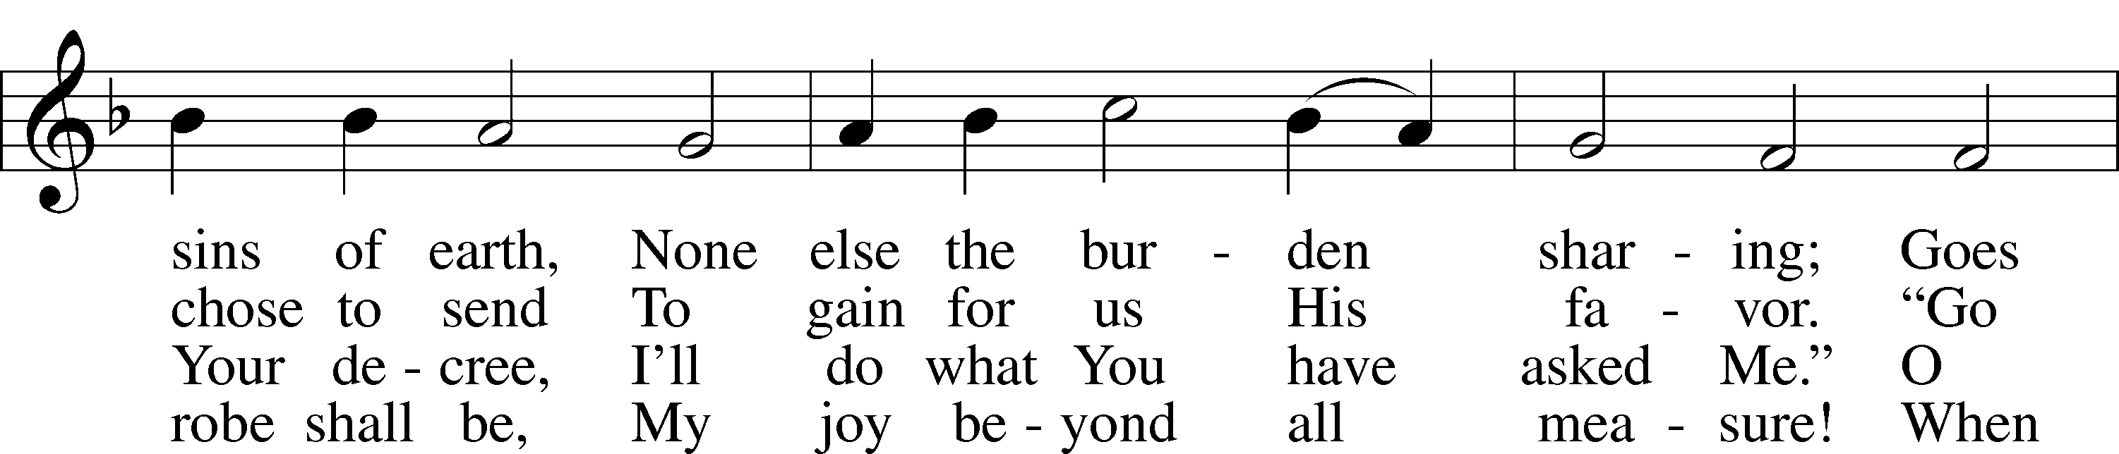

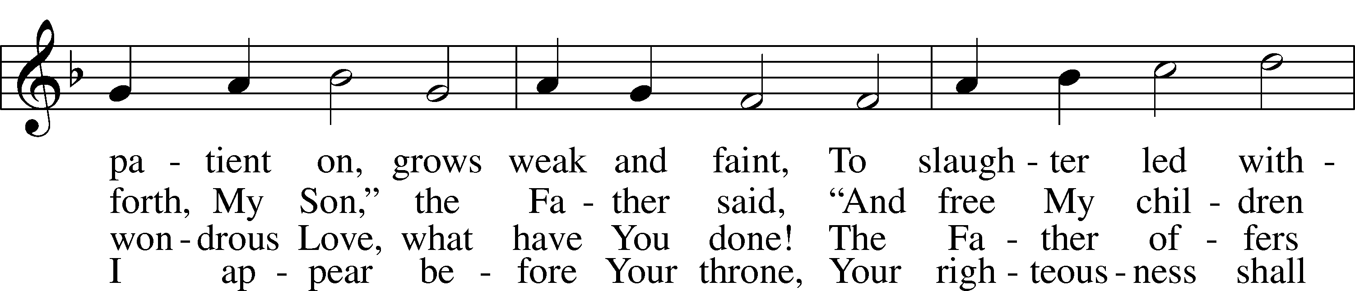

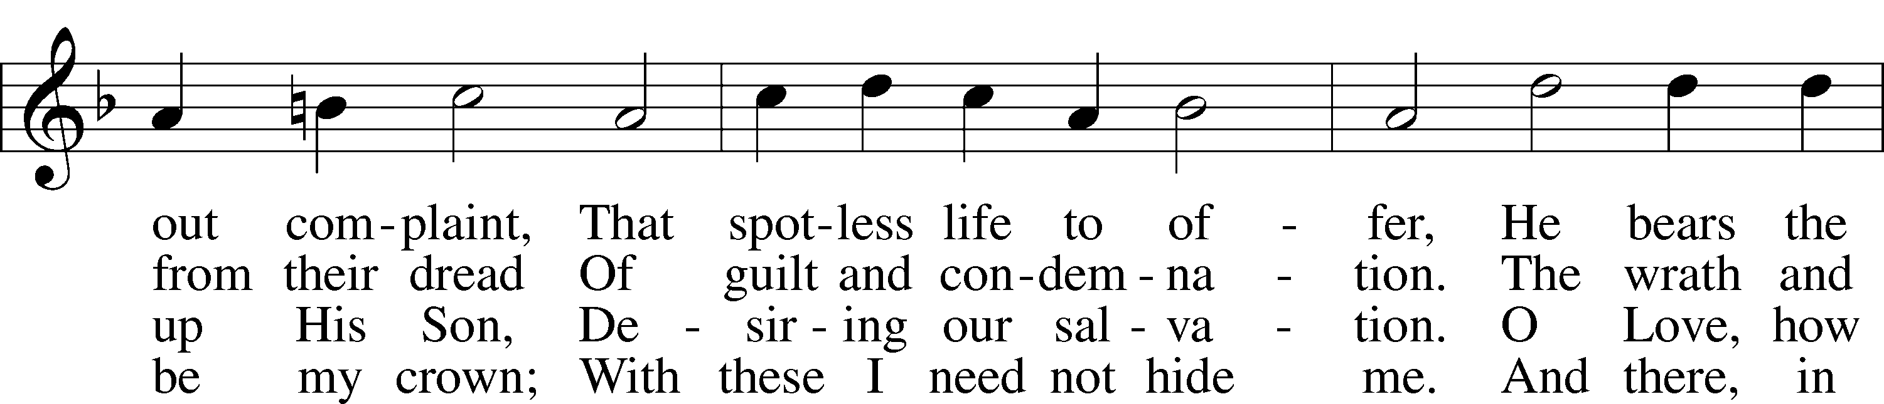

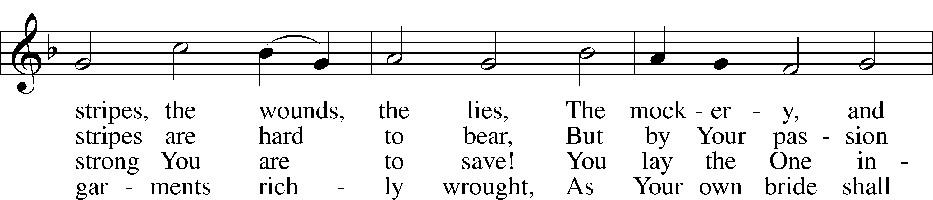

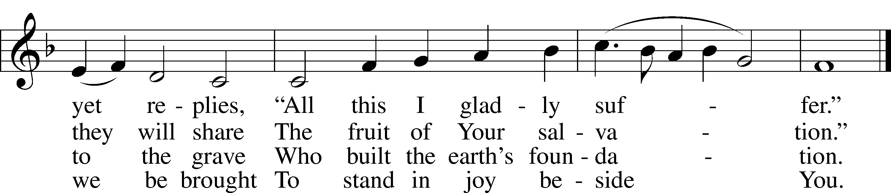

Text: Paul Gerhardt, 1607–76; tr. The Lutheran Hymnal, 1941, alt.  
Tune: Wolfgang Dachstein, c. 1487–1553  
Text: © 1941 Concordia Publishing House. Used by permission: LSB Hymn License no. 110005504  
Tune: Public domain

Offering

What Shall I Offer(printed)

Stand

Prayer

L In peace let us pray to the Lord:

C **Lord, have mercy.**

L For the gift of divine peace and of pardon, with all our heart and with all our mind, let us pray to the Lord:

C **Lord, have mercy.**

L For the holy Christian Church, here and scattered throughout the world, and for the proclamation of the Gospel and the calling of all to faith, let us pray to the Lord:

C **Lord, have mercy.**

L For this nation, for our cities and communities, and for the common welfare of us all, let us pray to the Lord:

C **Lord, have mercy.**

L For seasonable weather and for the fruitfulness of the earth, let us pray to the Lord:

C **Lord, have mercy.**

L For those who labor, for those whose work is difficult or dangerous, and for all who travel, let us pray to the Lord:

C **Lord, have mercy.**

L For all those in need, for the hungry and homeless, for the widowed and orphaned, and for all those in prison, let us pray to the Lord:

C **Lord, have mercy.**

L For the sick and dying and for all those who care for them, let us pray to the Lord:

C **Lord, have mercy.**

L For . . . [additional bids for prayer may be inserted here]. . . let us pray to the Lord:

C **Lord, have mercy.**

L Finally, for these and for all our needs of body and soul, let us pray to the Lord:

C **Lord, have mercy. Christ, have mercy. Lord, have mercy.**

Collect of the Day

L O God, whose strength is made perfect in weakness, grant us humility and childlike faith that we may please You in both will and deed; through Jesus Christ, Your Son, our Lord, who lives and reigns with You and the Holy Spirit, one God, now and forever.

C **Amen.**

Collect for the Word

L Blessed Lord, You have caused all Holy Scriptures to be written for our learning. Grant that we may so hear them, read, mark, learn, and take them to heart that, by the patience and comfort of Your holy Word, we may embrace and ever hold fast the blessed hope of everlasting life; through Jesus Christ, Your Son, our Lord, who lives and reigns with You and the Holy Spirit, one God, now and forever.

C **Amen.**

Morning Prayer

C **I thank You, my heavenly Father, through Jesus Christ, Your dear Son, that You have kept me this night from all harm and danger; and I pray that You would keep me this day also from sin and every evil, that all my doings and life may please You. For into Your hands I commend myself, my body and soul, and all things. Let Your holy angel be with me, that the evil foe may have no power over me.**

**Amen.**

New Testament Canticle LSB 266

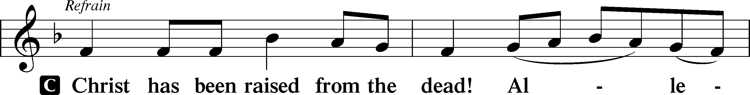

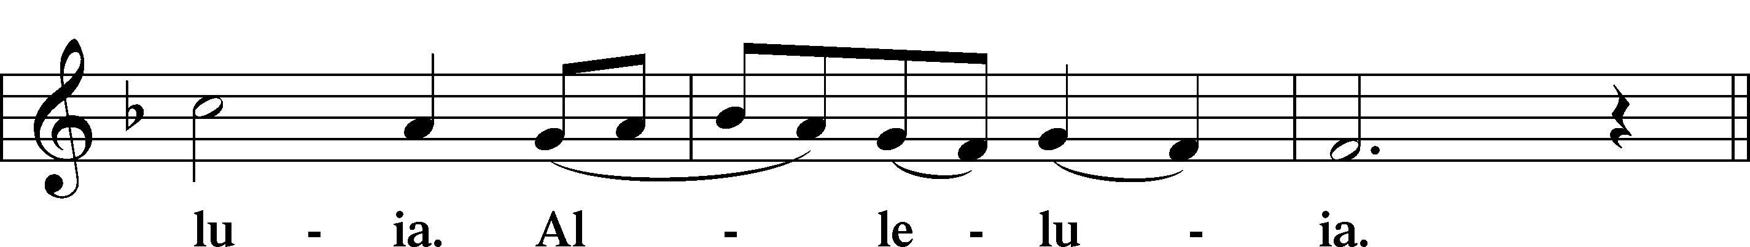

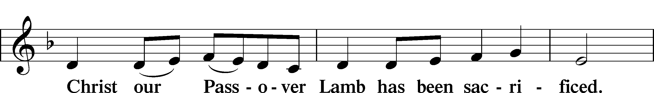

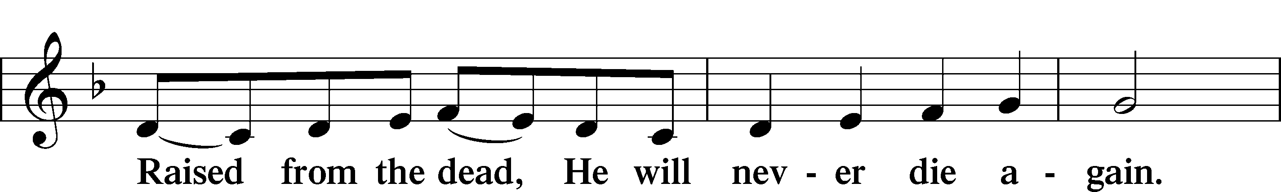

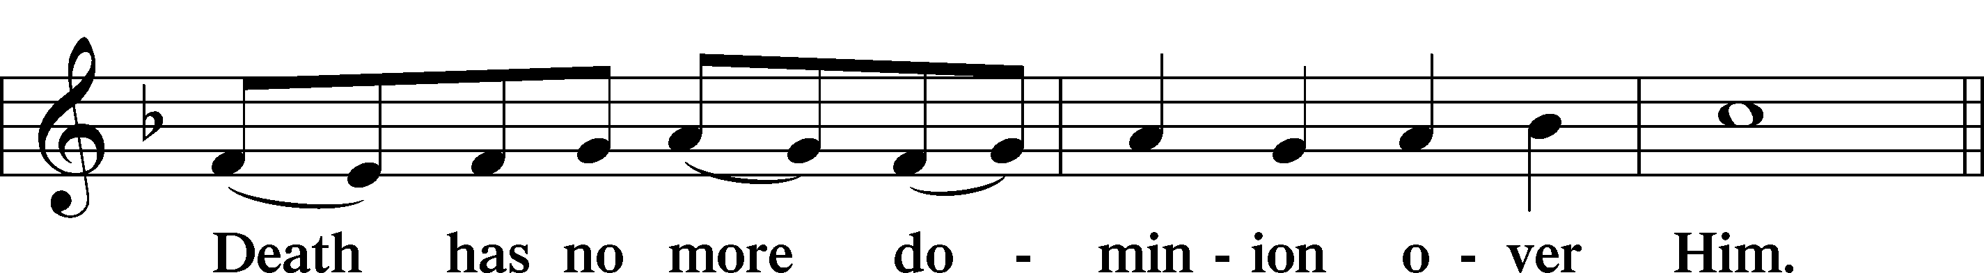

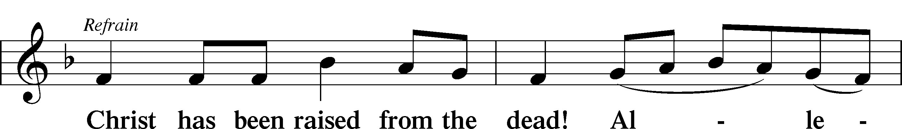

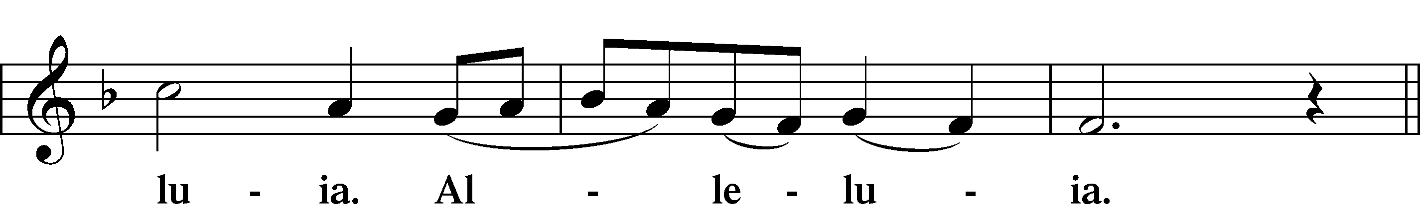

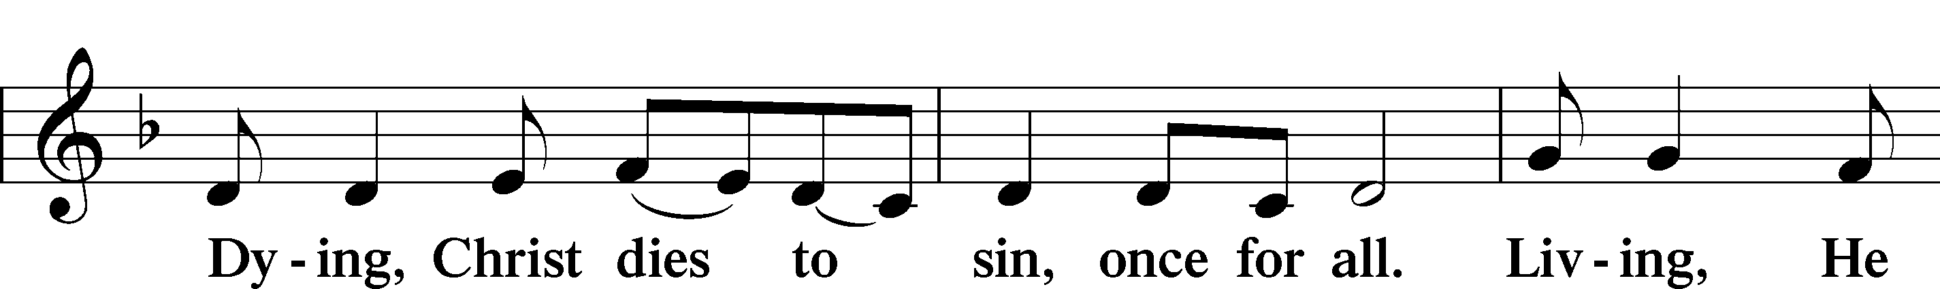

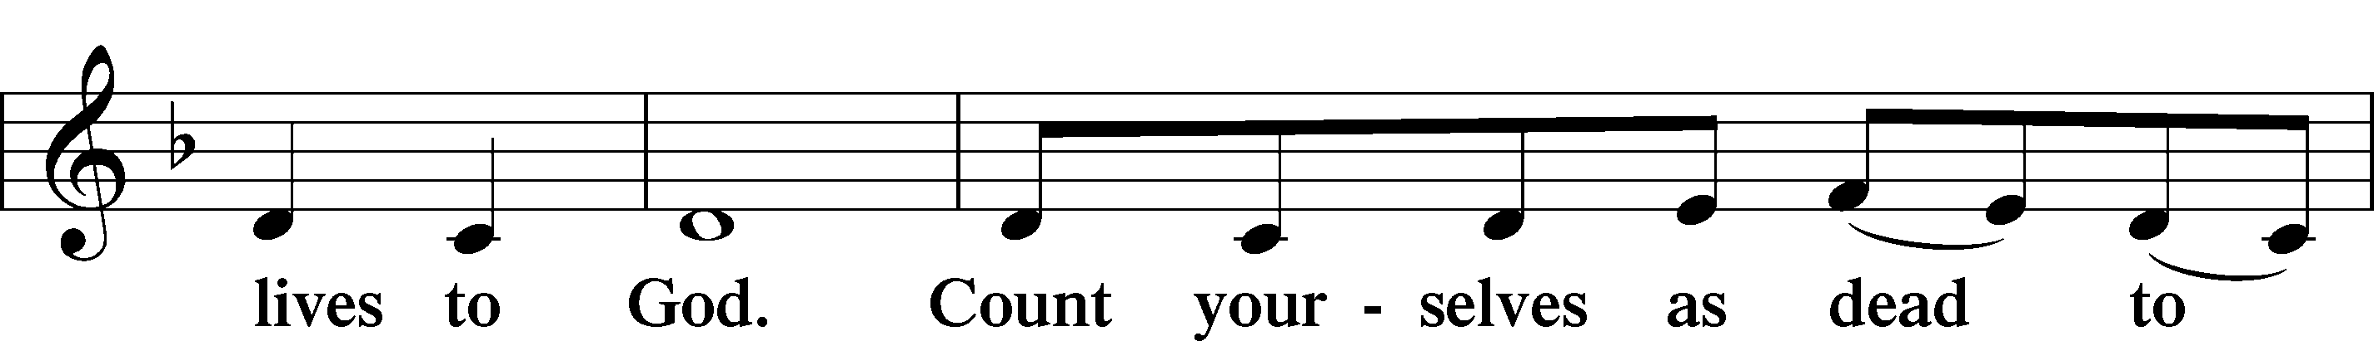

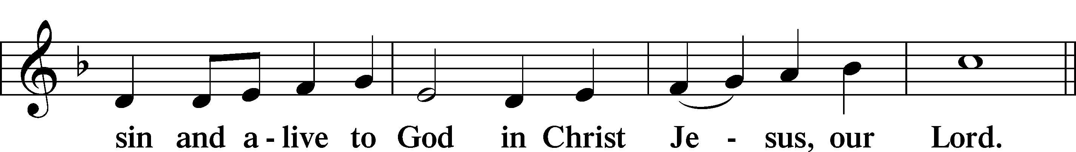

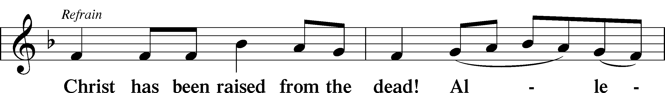

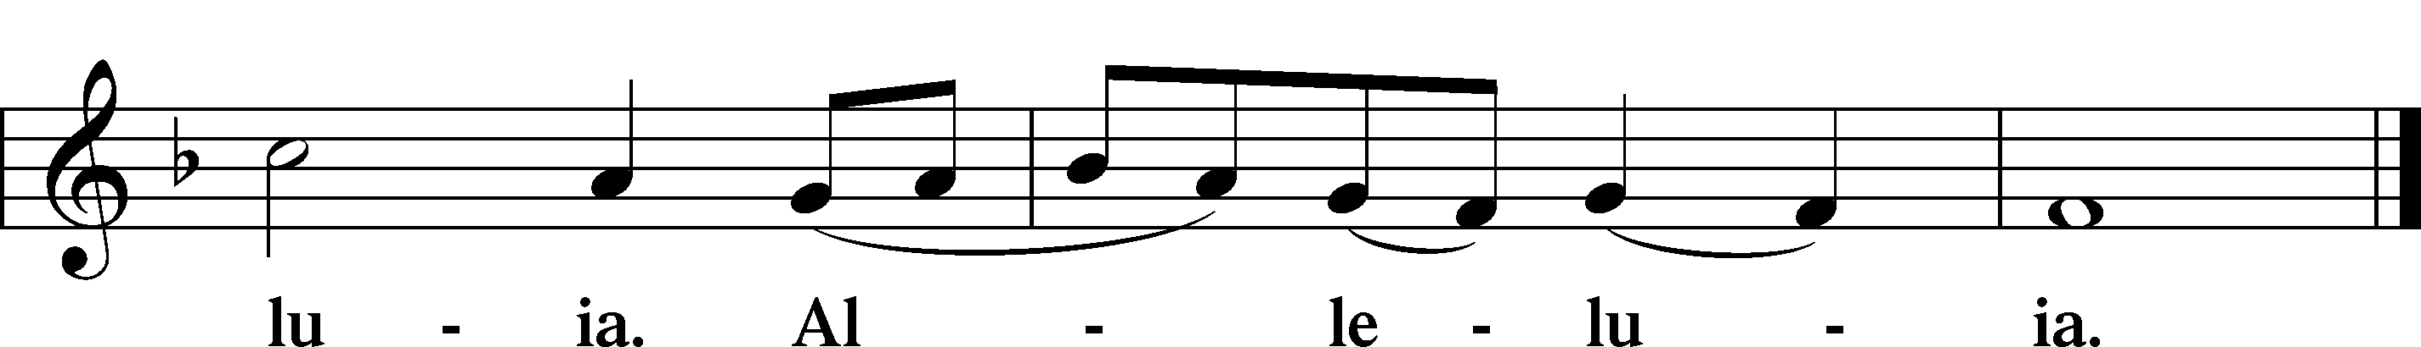

Blessing

L Let us bless the Lord.

C **Thanks be to God.**

L The almighty and merciful Lord, the Father, the T Son, and the Holy Spirit, bless and preserve us.

C **Amen.**

Hymn: 689 Let Me Be Thine Forever

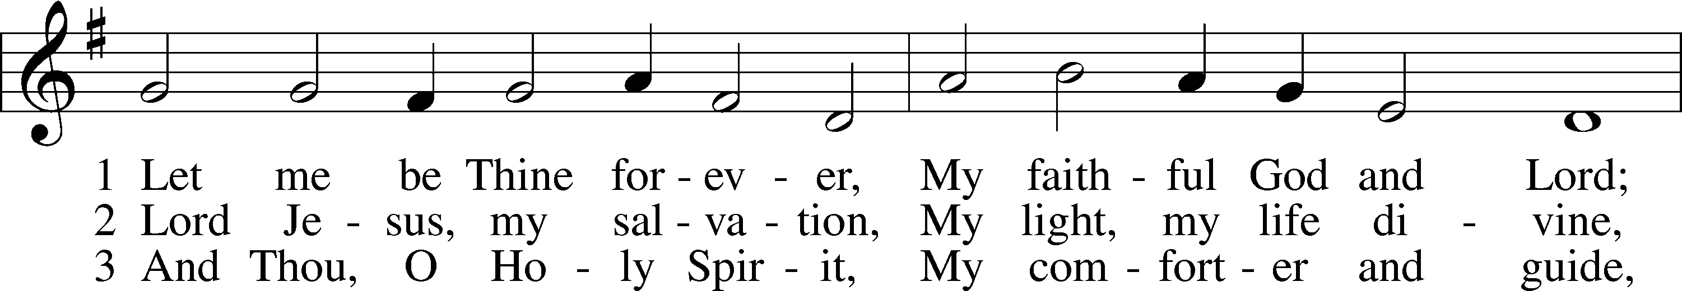

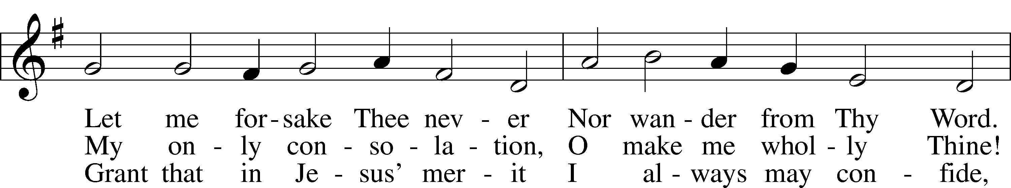

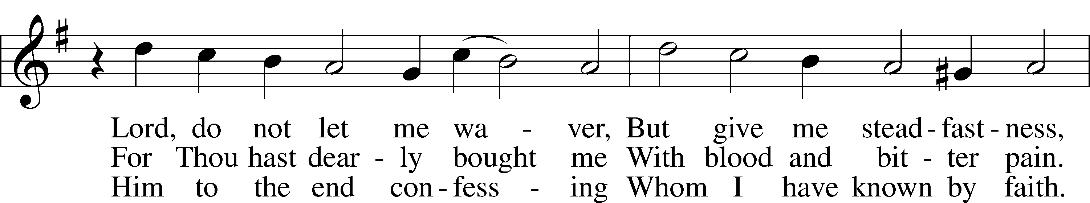

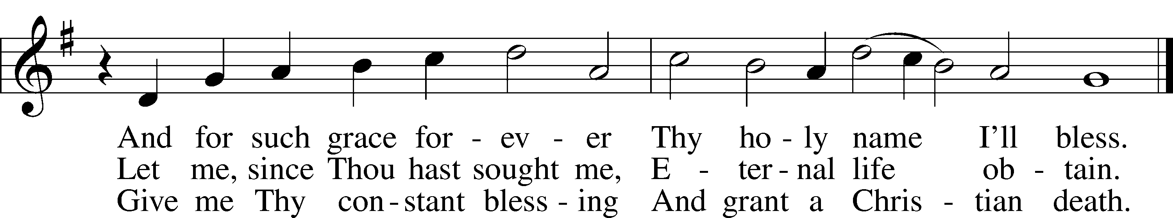

Text: tr. Matthias Loy, 1828–1915, alt.; (st. 1): Nicolaus Selnecker, 1532–92; (sts. 2–3): Gesang-Büchlein, 1688, Rudolstadt  
Tune: Musika Teutsch, 1532, Nürnberg  
Text and tune: Public domain

Acknowledgments

Service of Prayer and Preaching from Lutheran Service Book

Unless otherwise indicated, Scripture quotations are from the ESV® Bible (The Holy Bible, English Standard Version®), copyright © 2001 by Crossway, a publishing ministry of Good News Publishers. Used by permission. All rights reserved.

Created by Lutheran Service Builder © 2024 Concordia Publishing House.

EIGHTEENTH SUNDAY AFTER PENTECOST (Proper 20B)

**Our Father Cares for His Children with the Gospel of His So**n The sinful heart is filled with “bitter jealousy and selfish ambition” (James 3:14), which causes hostility, quarrels and conflicts, even among those who are fellow members of the Body of Christ. This should not be so! Rather, God “opposes the proud” with His Law, in order to humble them unto repentance; He “gives grace to the humble,” in order to exalt them by His Gospel of forgiveness (James 4:6–10). This true “wisdom from above” is found in the gentleness, mercy and peace of our Lord, Jesus Christ, who humbled Himself and sacrificed Himself for the salvation of sinners (James 3:17). He was “like a gentle lamb led to the slaughter,” committing Himself to God, His Father, “who judges righteously, who tests the heart and the mind” (Jer. 11:19–20). Therefore, “after three days,” His Father exalted Him by raising Him from the dead (Mark 9:31). In Holy Baptism, He takes disciples of all ages into His arms like little children. In receiving Him through repentance and faith in His forgiveness of sins, they receive from His Father a share in the glory of His cross and resurrection (Mark 9:36–37).

**Prayers Request:**

**Those in the nursing home:** Joann Jaeger **Those Shut-in at home:** Char Herman, Joan Church, Joyce Myers, Joyce Koba **Those with ongoing health issues:** Harrison Fields, Jeanne Perala, Owen Metz, Jeff Bonneville, Daria (Cindy Wright’s friend), Butch L. (Cindy Wright’s Brother-in-law), Melissa Miller. Art Smith (Sue Millerman’s brother), Brenda Sellent (Denise Stabenow’s sister), Sandy Hahn (Cindy Wright’s cousin’s wife) **,** Brenda Gustum (Missy Wiese’s mom), Lexi Anderson, Chris Mueller’s uncle **Those who lead our nation:** Joe Biden, Kamala Harris, Tony Evers, Rod Nordby  **Those who serve in our military and law enforcement:** Ryan Graf, Chaplain Pon Chanthaphon (Our Adopt-a-Chaplain), Rusty Weise **Our Childcare Staff:** Melissa Weinert, Denise Stabenow, Holly Wilhelmi, Janica Skjerly, Jacie Amundson, Cathy Anderson, Emily Young, Alora Provencial

**Church Service Phone: 715-438-4200**

**(Stay on the line for recorded service to start)**

**Live Stream audio services:** [**http://salem.listentochurch.com**](http://salem.listentochurch.com)

**Salem’s Web Page:** <https://www.salembarron.com/>

**Pastor Fred Buth: Cell phone:715-642-3050 (H)715-353-2540**

**Email: salembarronpastor@gmail.com**

**Office Hours: Monday-Wednesday 9-12**

**Attendance:** 9/15 - 53

**Coffee and Snacks:** Dwayne & Denise Stabenow

**Elder Today:** Paul Millerman

**Altar Guild:** Denise Stabenow

**Schedule for the week:**

**Tuesday:** 8am Men’s Bible Study

**Wednesday:** 9am Childcare Chapel

4pm Catechism

**Save the Date:**

**September 25th:** DQ night 4-9pm(help support our Childcare)

**September 30th** 4/7pm – Pancake Supper