# Service of Prayer and Preaching pg.260

Day of Thanksgiving

November 28,2024

Hymn: 892 Come, Ye Thankful People, Come

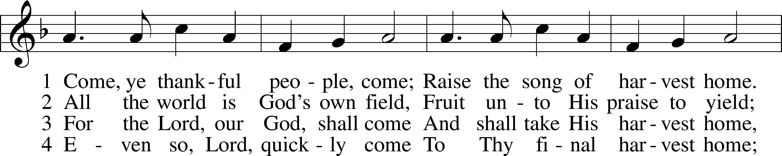

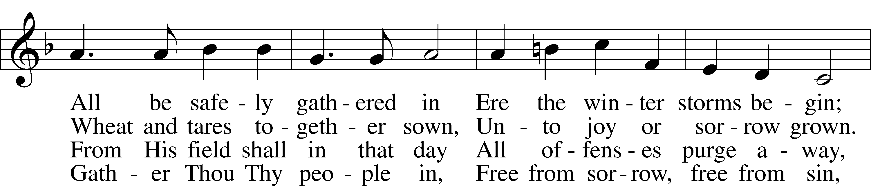

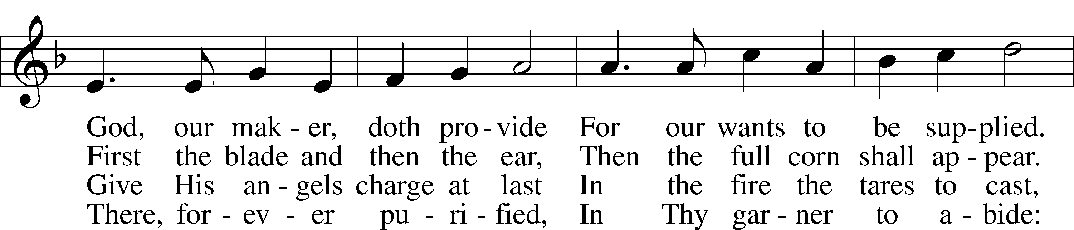

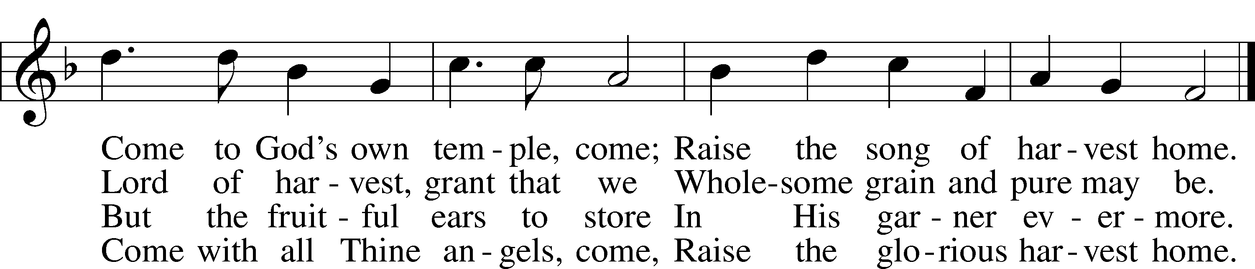

Text: Henry Alford, 1810–71, alt.  
Tune: George J. Elvey, 1816–93  
Text and tune: Public domain

Stand

Opening Versicles

L This is the day which the Lord has made;

C **let us rejoice and be glad in it.**

L From the rising of the sun to its setting,

C **the name of the Lord is to be praised.**

L Better is one day in Your courts than a thousand elsewhere;

C **I would rather be a doorkeeper in the house of my God than dwell in the tents of the wicked.**

L Make me to know Your ways, O Lord.

C **Teach me Your paths.**

L Sanctify us in Your truth.

C **Your Word is truth.**

L From the rising of the sun to its setting,

C **the name of the Lord is to be praised.**

C **Glory be to the Father and to the Son and to the Holy Spirit;**  
**as it was in the beginning, is now, and will be forever. Amen.**

Old Testament Canticle LSB 261

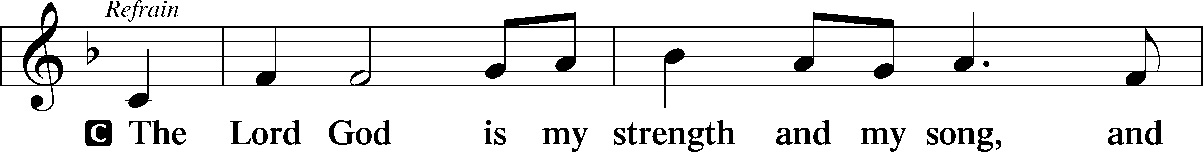

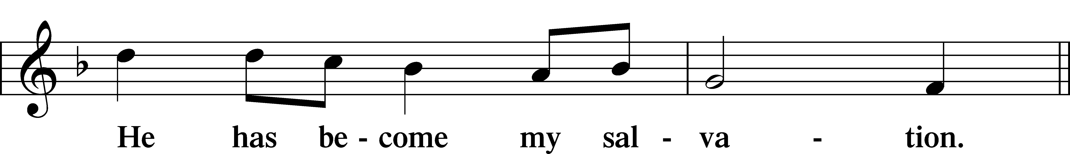

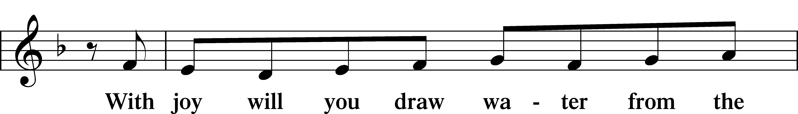

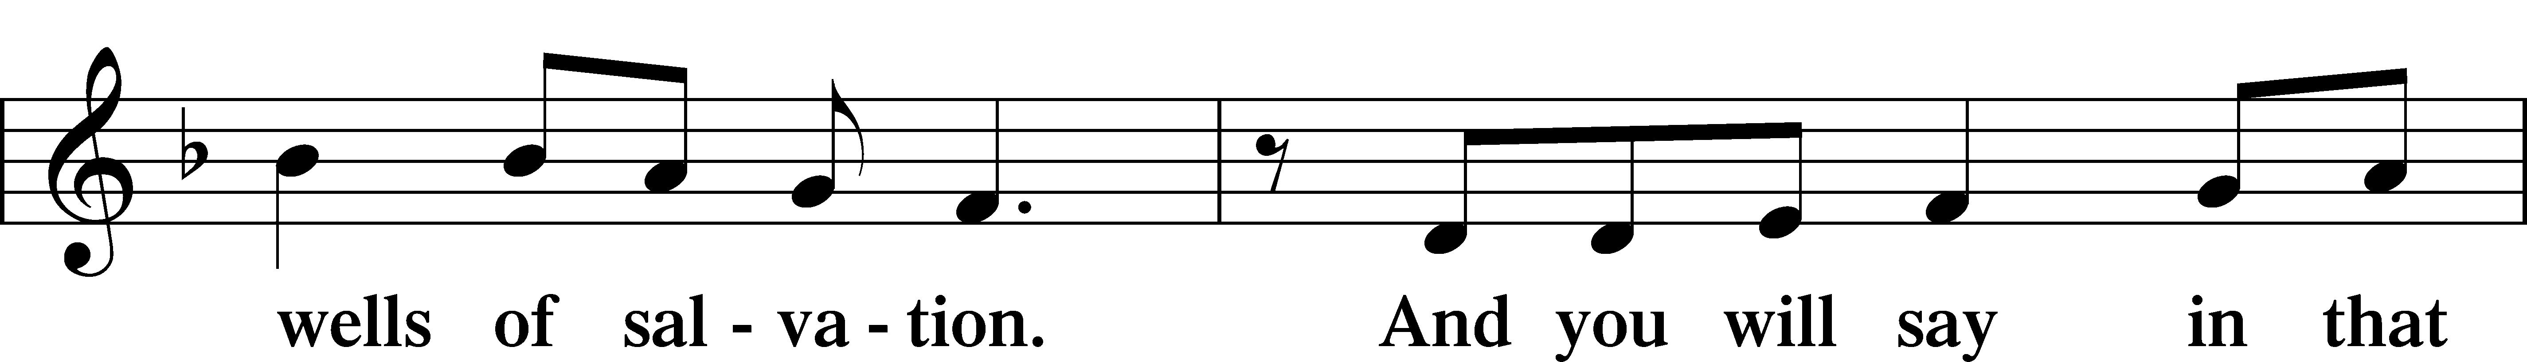

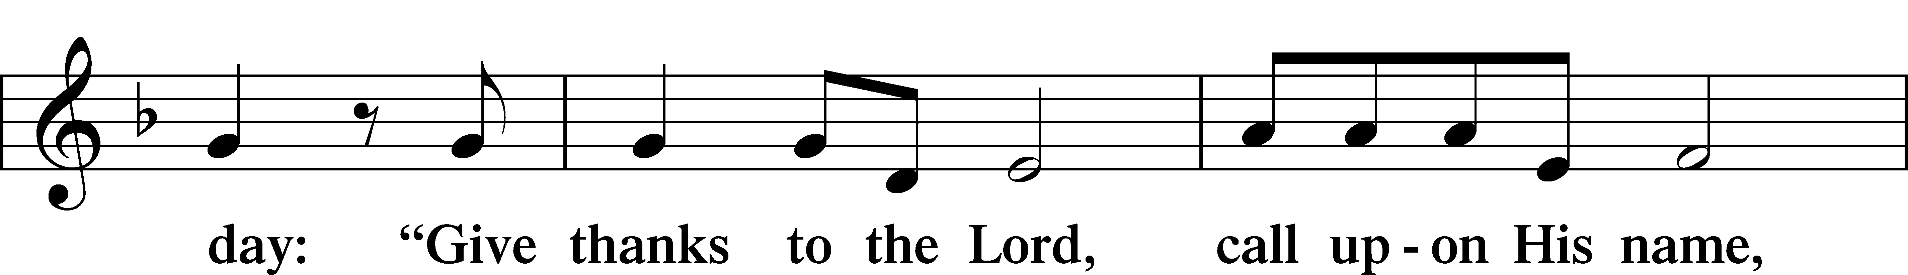

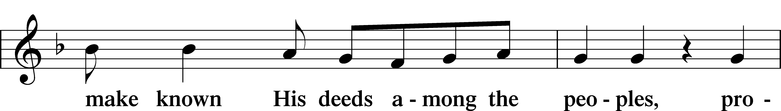

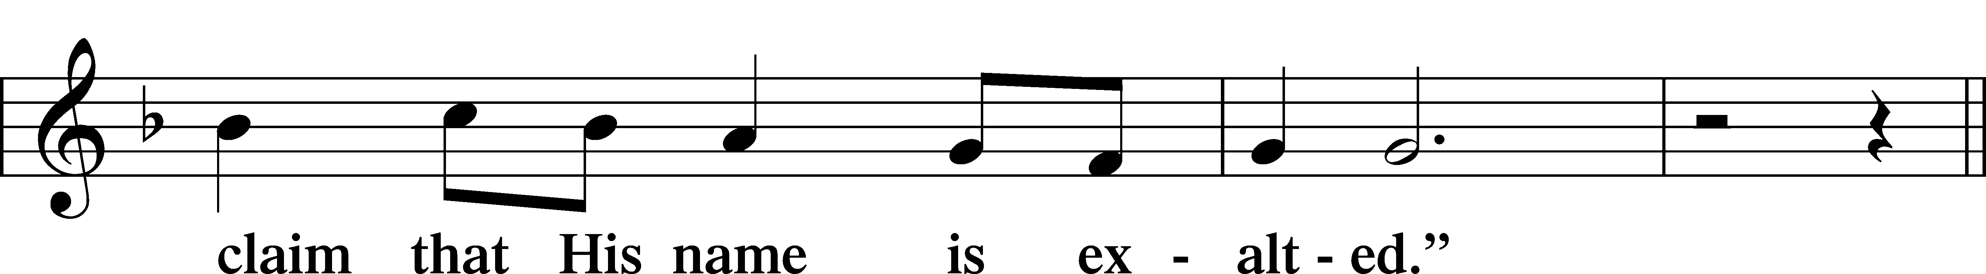

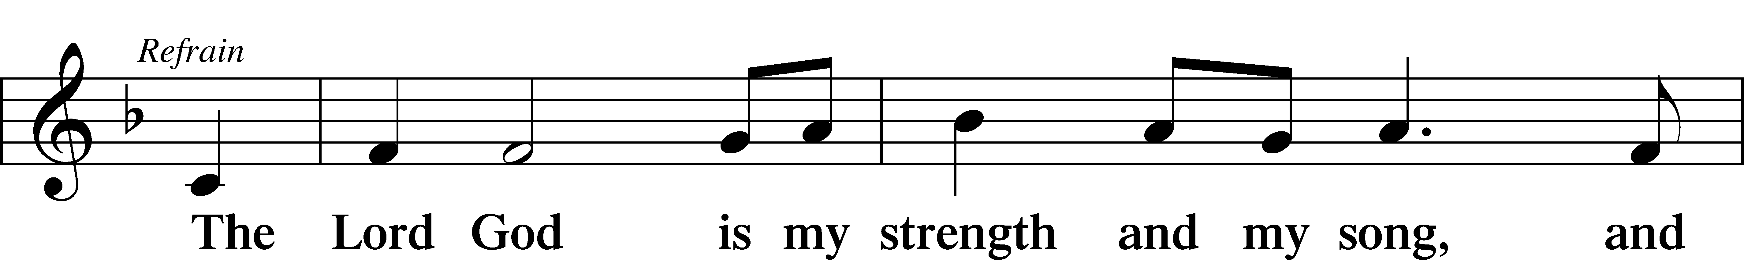

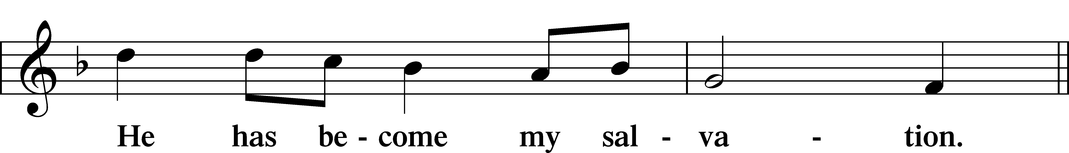

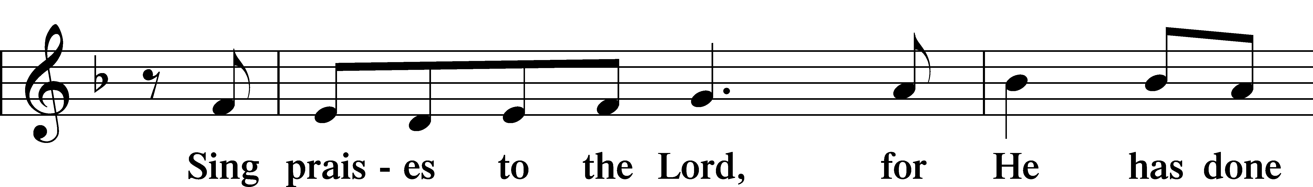

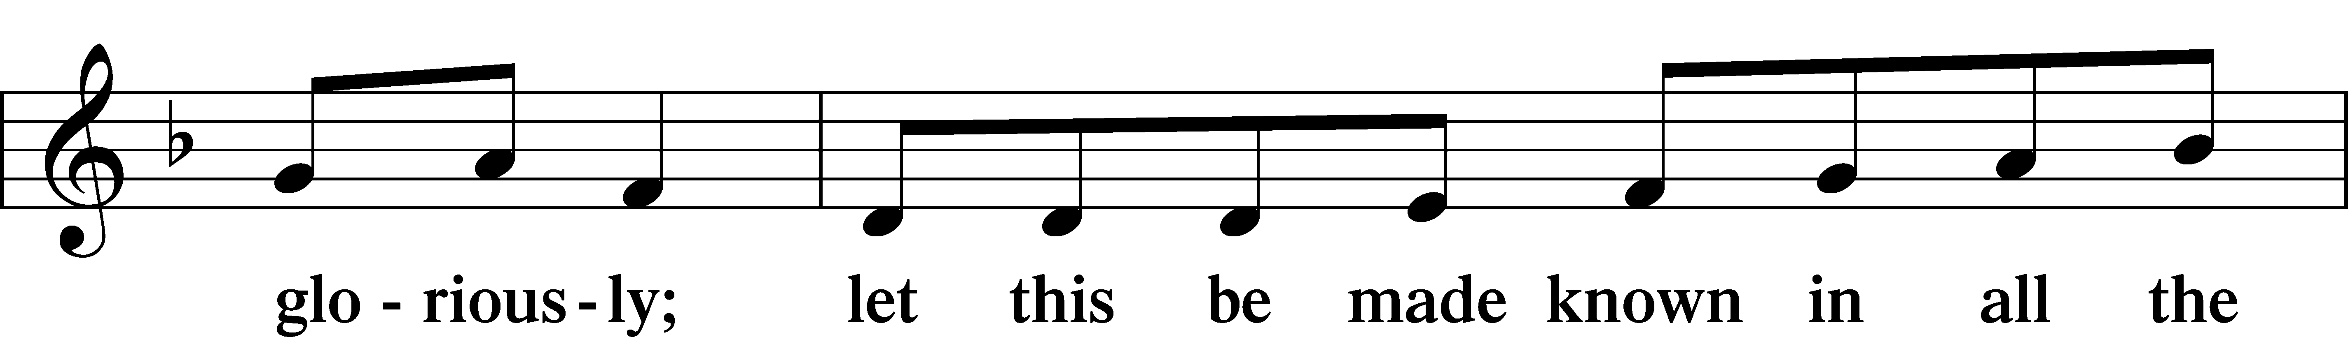

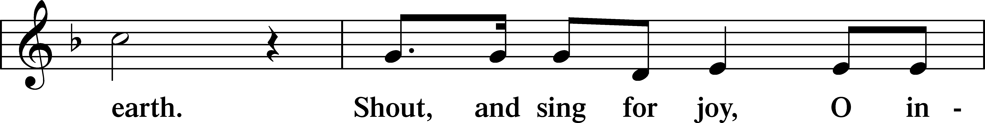

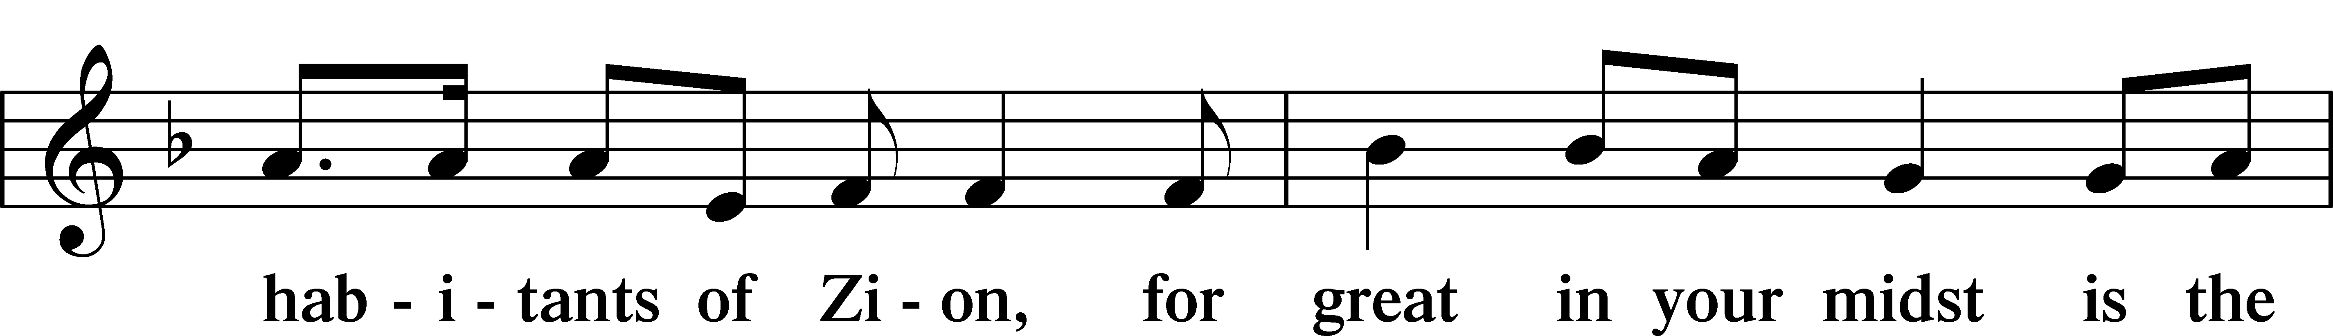

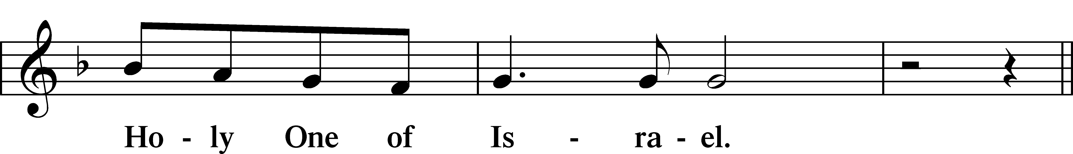

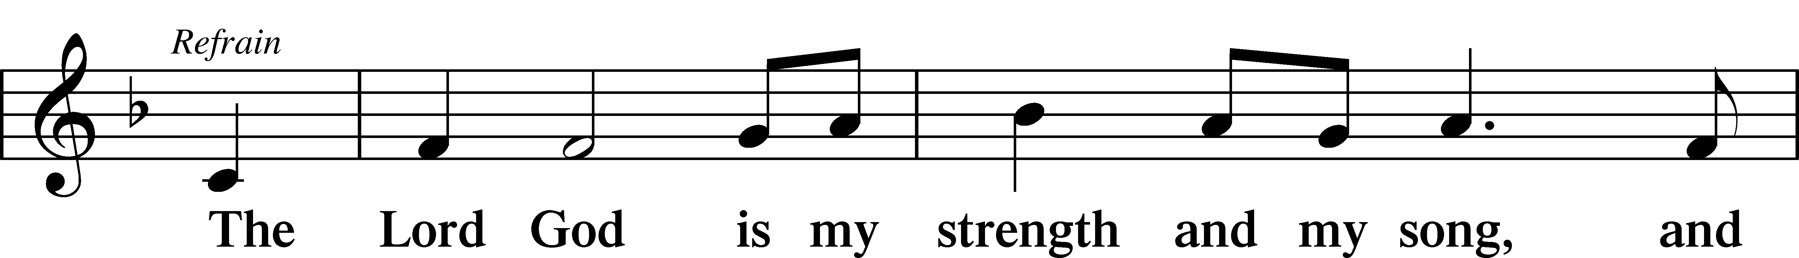

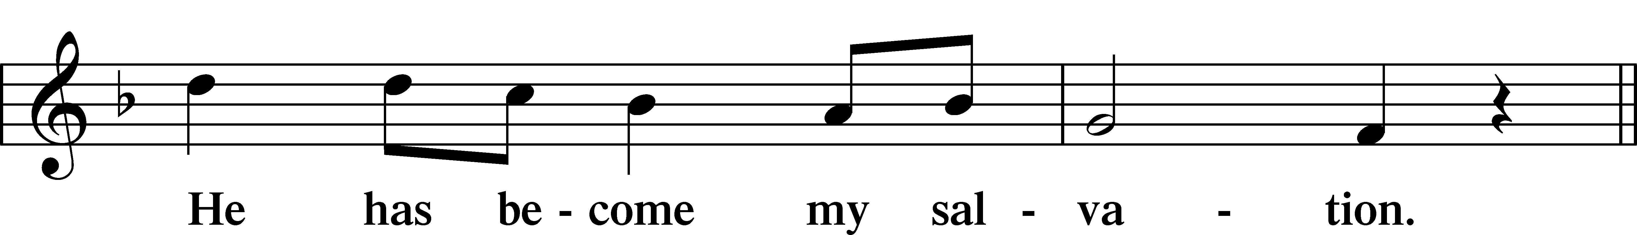

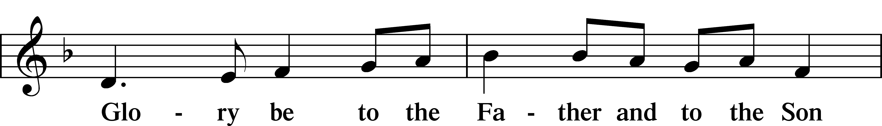

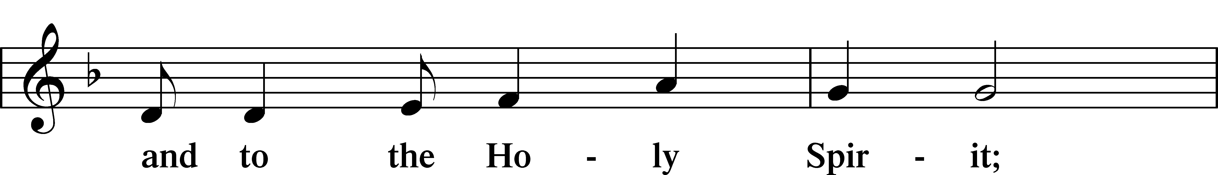

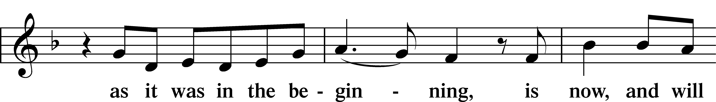

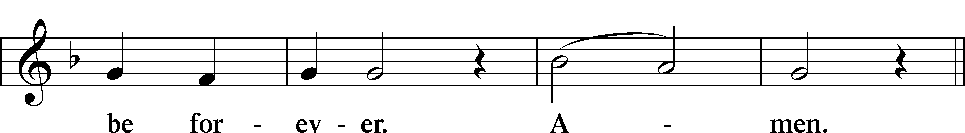

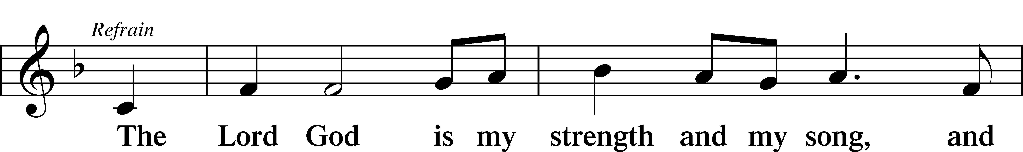

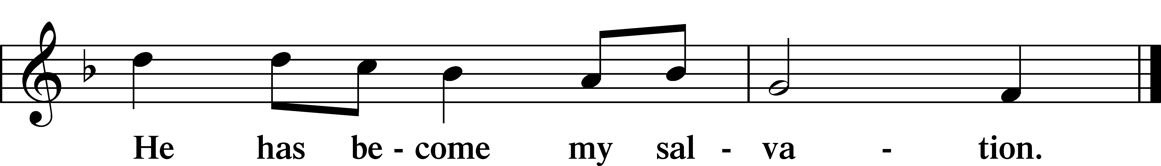

Sit

Readings From Holy Scripture

Reading Deuteronomy 8:1–10

L A reading from Deuteronomy, the eighth chapter.

Remember the Lord Your God

1“The whole commandment that I command you today you shall be careful to do, that you may live and multiply, and go in and possess the land that the Lord swore to give to your fathers. 2And you shall remember the whole way that the Lord your God has led you these forty years in the wilderness, that he might humble you, testing you to know what was in your heart, whether you would keep his commandments or not. 3And he humbled you and let you hunger and fed you with manna, which you did not know, nor did your fathers know, that he might make you know that man does not live by bread alone, but man lives by every word that comes from the mouth of the Lord. 4Your clothing did not wear out on you and your foot did not swell these forty years. 5Know then in your heart that, as a man disciplines his son, the Lord your God disciplines you. 6So you shall keep the commandments of the Lord your God by walking in his ways and by fearing him. 7For the Lord your God is bringing you into a good land, a land of brooks of water, of fountains and springs, flowing out in the valleys and hills, 8a land of wheat and barley, of vines and fig trees and pomegranates, a land of olive trees and honey, 9a land in which you will eat bread without scarcity, in which you will lack nothing, a land whose stones are iron, and out of whose hills you can dig copper. 10And you shall eat and be full, and you shall bless the Lord your God for the good land he has given you.”

L This is the Word of the Lord.

C **Thanks be to God.**

Reading 1 Timothy 2:1–4

Pray for All People

1First of all, then, I urge that supplications, prayers, intercessions, and thanksgivings be made for all people, 2for kings and all who are in high positions, that we may lead a peaceful and quiet life, godly and dignified in every way. 3This is good, and it is pleasing in the sight of God our Savior, 4who desires all people to be saved and to come to the knowledge of the truth.

Reading Luke 17:11–19

Jesus Cleanses Ten Lepers

11On the way to Jerusalem [Jesus] was passing along between Samaria and Galilee. 12And as he entered a village, he was met by ten lepers, who stood at a distance 13and lifted up their voices, saying, “Jesus, Master, have mercy on us.” 14When he saw them he said to them, “Go and show yourselves to the priests.” And as they went they were cleansed. 15Then one of them, when he saw that he was healed, turned back, praising God with a loud voice; 16and he fell on his face at Jesus’ feet, giving him thanks. Now he was a Samaritan. 17Then Jesus answered, “Were not ten cleansed? Where are the nine? 18Was no one found to return and give praise to God except this foreigner?” 19And he said to him, “Rise and go your way; your faith has made you well.”

Psalms, hymns, or choral music may be sung between the readings.

Responsory

L Forever, O Lord, Your Word is firmly set in the heavens.

C **Lord, I love the habitation of Your house and the place where Your glory dwells.**

L Blessed are those who hear the Word of God and keep it.

C **Lord, I love the habitation of Your house and the place where Your glory dwells.**

L Glory be to the Father and to the Son and to the Holy Spirit.

C **Lord, I love the habitation of Your house and the place where Your glory dwells.**

Stand

Apostles’ Creed

C **I believe in God, the Father Almighty,**

**maker of heaven and earth.**

**And in Jesus Christ, His only Son, our Lord,**

**who was conceived by the Holy Spirit,**

**born of the virgin Mary,**

**suffered under Pontius Pilate,**

**was crucified, died and was buried.**

**He descended into hell.**

**The third day He rose again from the dead.**

**He ascended into heaven**

**and sits at the right hand of God the Father Almighty.**

**From thence He will come to judge the living and the dead.**

**I believe in the Holy Spirit,**

**the holy Christian Church,**

**the communion of saints,**

**the forgiveness of sins,**

**the resurrection of the body,**

**and the life** T **everlasting. Amen.**

Hymn: 785 We Praise You, O God

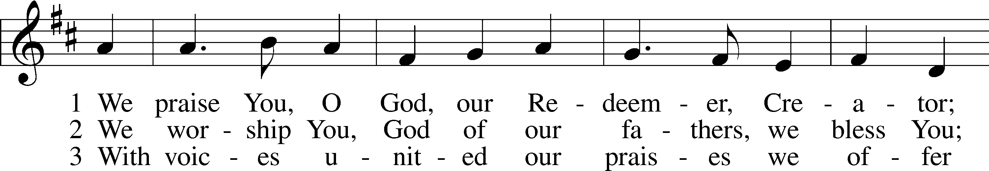

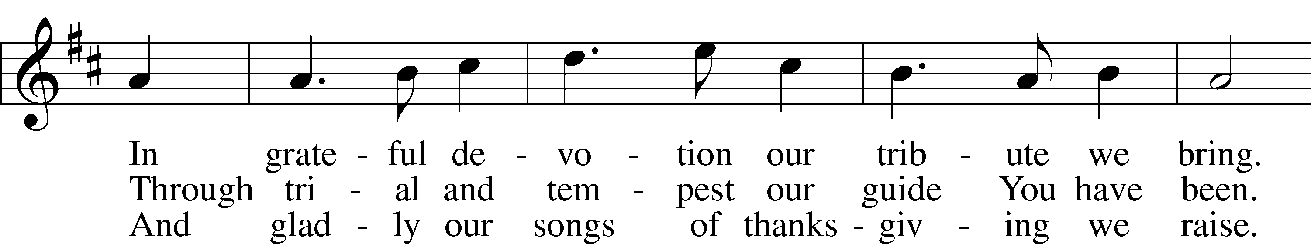

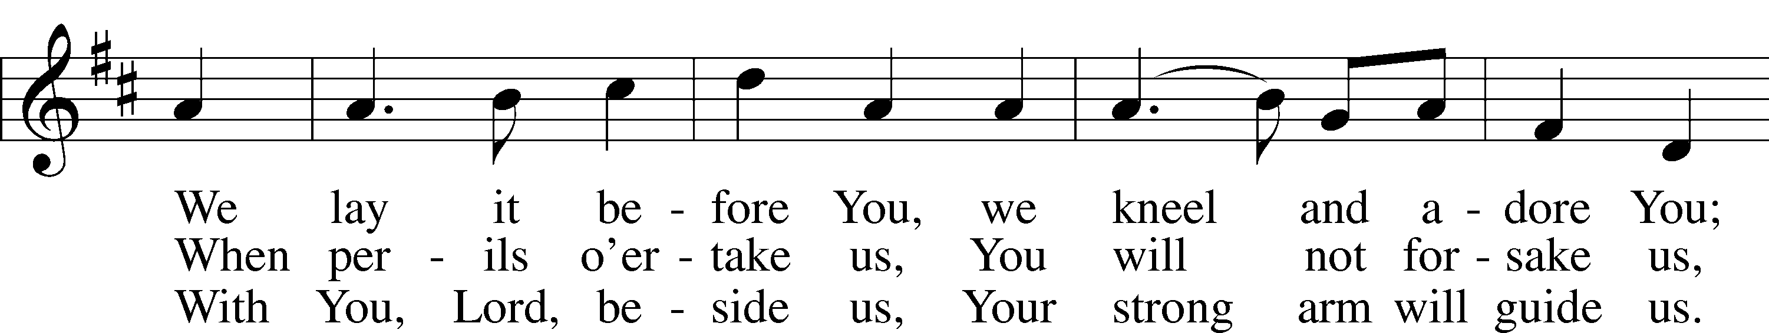

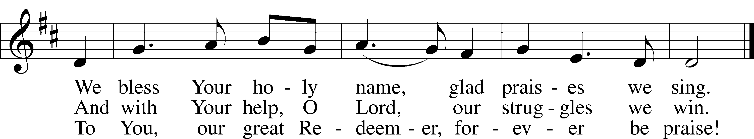

Text: Julia B. Cory, 1882–1963, alt.  
Tune: Nederlandtsch Gedenckclanck, 1626, Haarlem  
Text and tune: Public domain

Sit

Sermon

Hymn: 895 Now Thank We All Our God

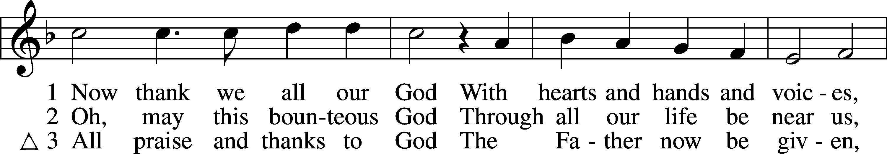

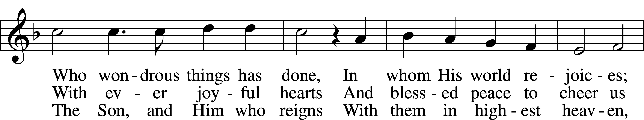

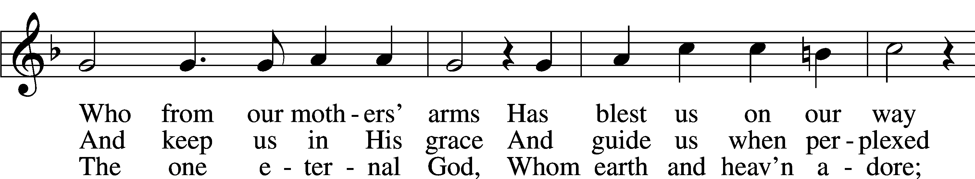

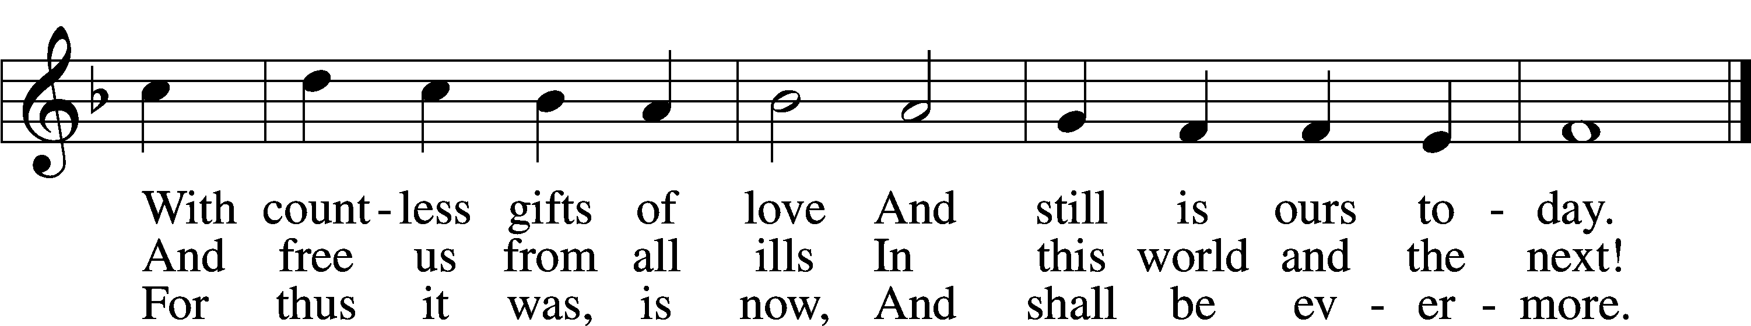

Text: Martin Rinckart, 1586–1649; tr. Catherine Winkworth, 1827–78, alt.  
Tune: Johann Crüger, 1598–1662  
Text and tune: Public domain

Offering

Hymn: 781 We Give Thee But Thine Own vs. 1&2

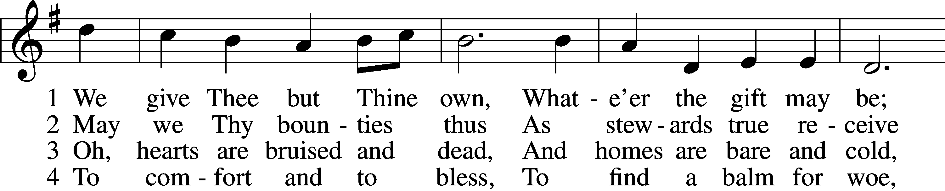

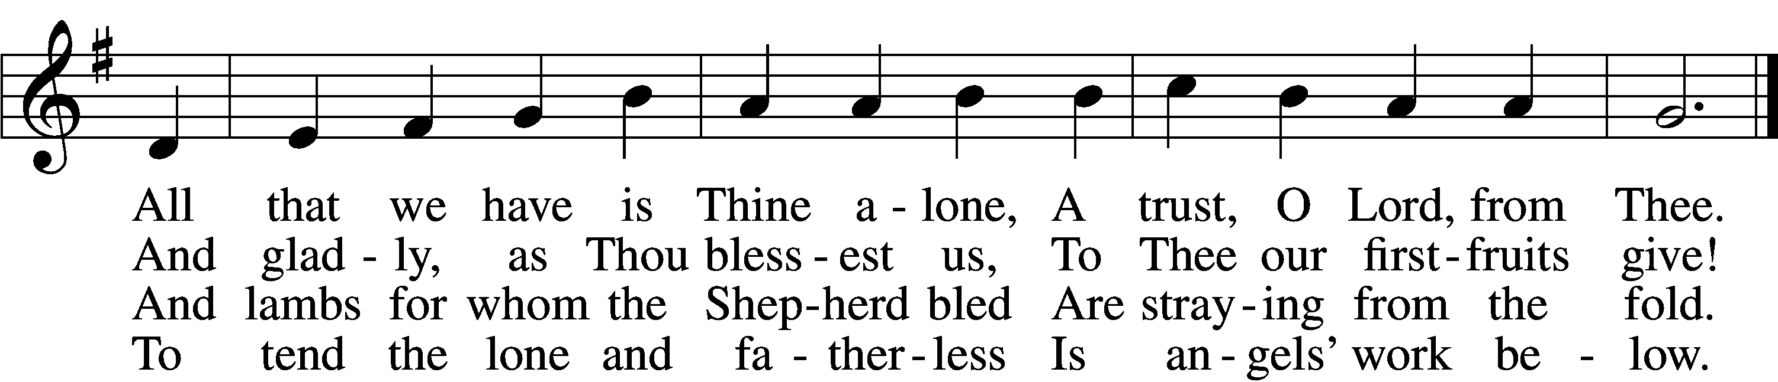

5 The captive to release,  
 To God the lost to bring,  
To teach the way of life and peace,  
 It is a Christ-like thing.

6 And we believe Thy Word,  
 Though dim our faith may be:  
Whate’er for Thine we do, O Lord,  
 We do it unto Thee.

Text: William W. How, 1823–97  
Tune: William H. Monk, 1823–89  
Text and tune: Public domain

**Prayer of the Church**

Lord’s Prayer

C **Our Father who art in heaven,**

**hallowed be Thy name,**

**Thy kingdom come,**

**Thy will be done on earth**

**as it is in heaven;**

**give us this day our daily bread;**

**and forgive us our trespasses**

**as we forgive those**

**who trespass against us;**

**and lead us not into temptation,**

**but deliver us from evil.**

**For Thine is the kingdom**

**and the power and the glory**

**forever and ever. Amen.**

**Collect for the Word**

Morning Prayer

C **I thank You, my heavenly Father, through Jesus Christ, Your dear Son, that You have kept me this night from all harm and danger; and I pray that You would keep me this day also from sin and every evil, that all my doings and life may please You. For into Your hands I commend myself, my body and soul, and all things. Let Your holy angel be with me, that the evil foe may have no power over me.**

**Amen.**

New Testament Canticle LSB 266

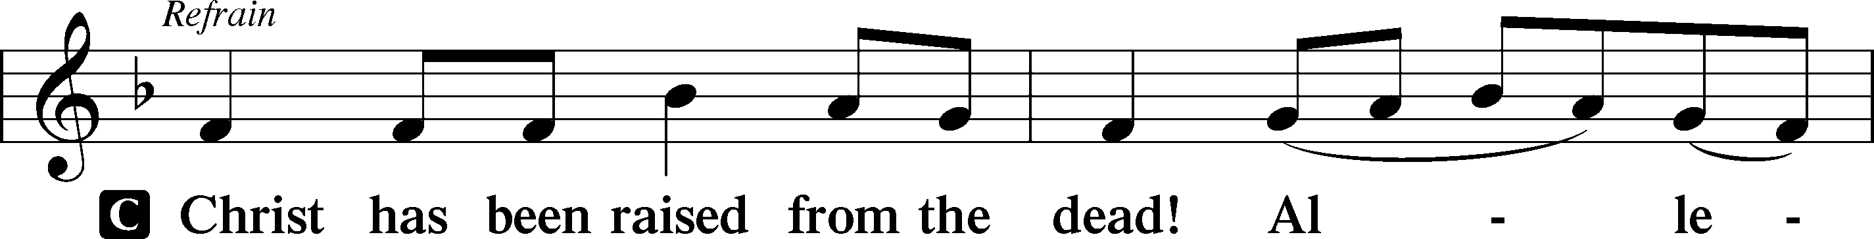

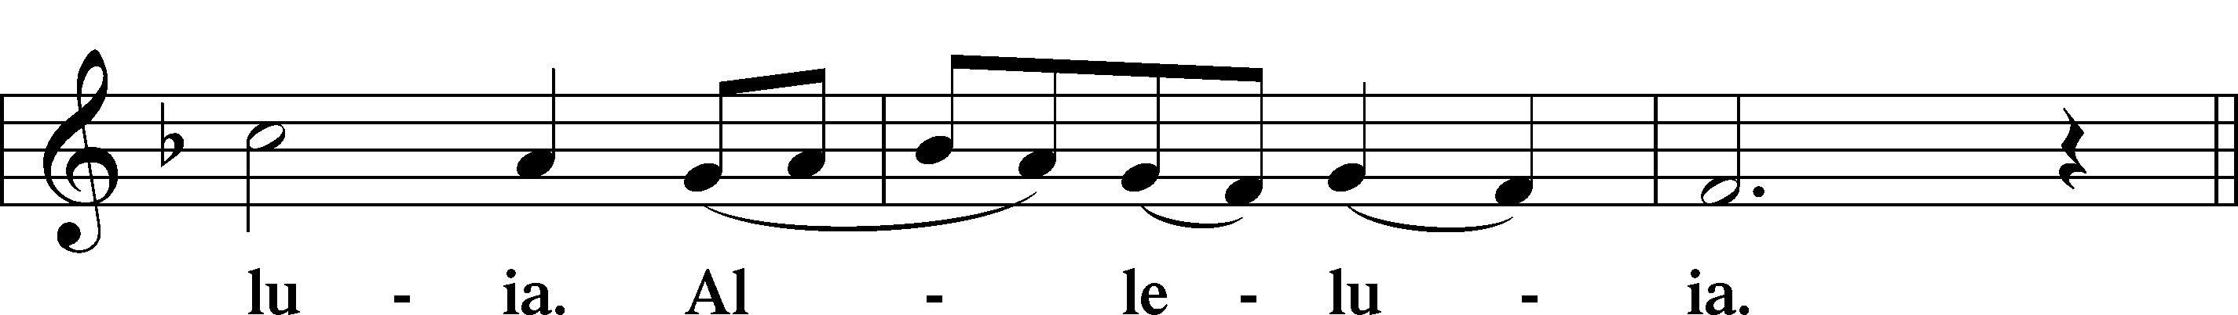

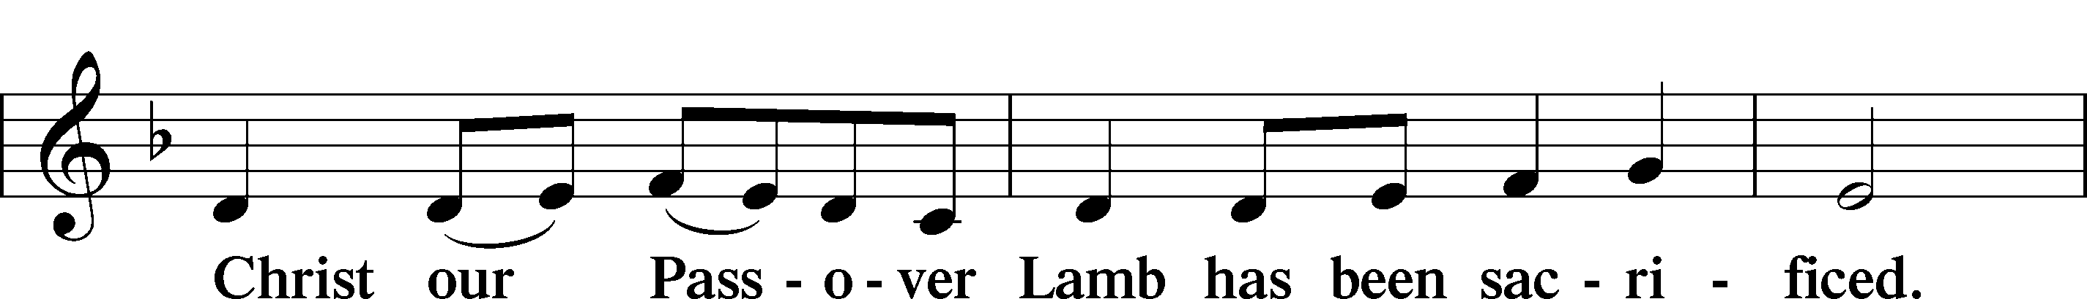

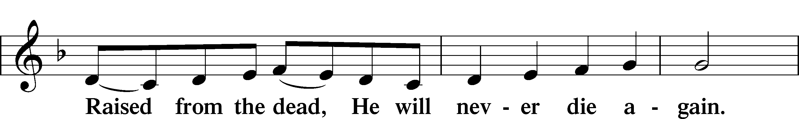

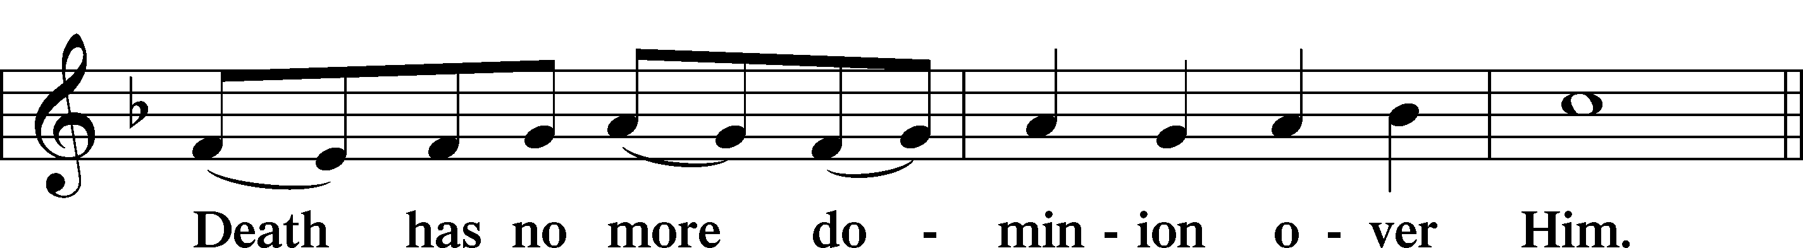

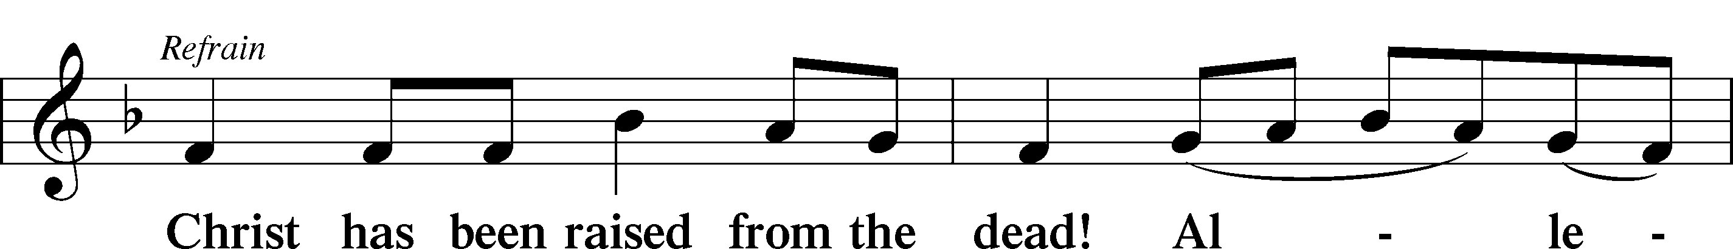

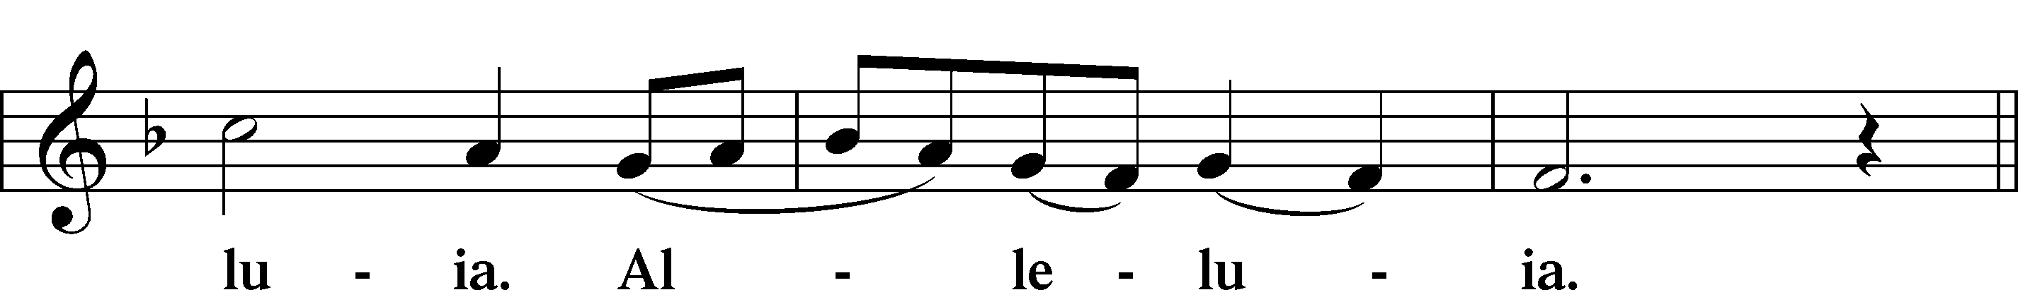

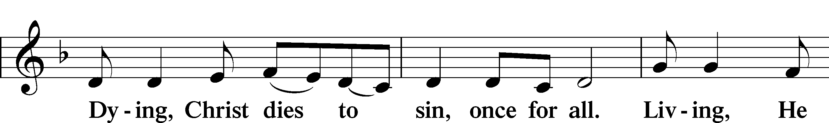

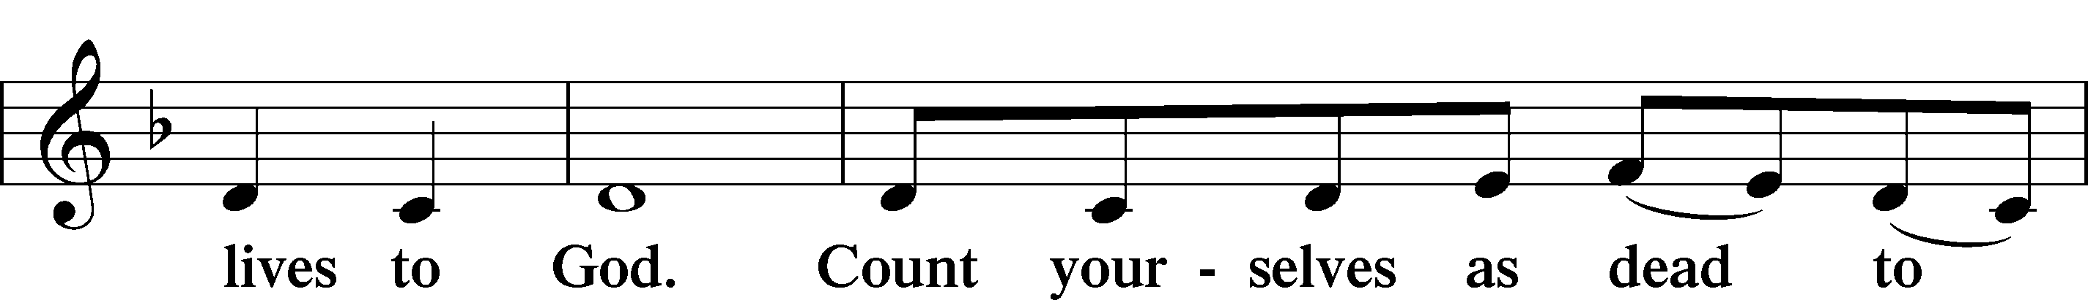

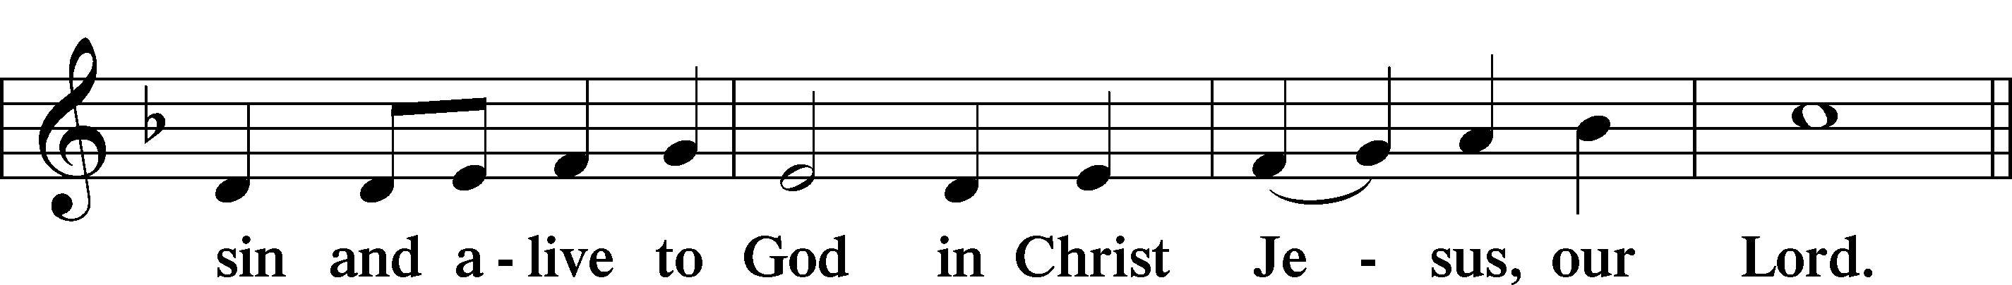

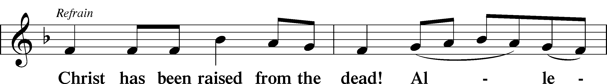

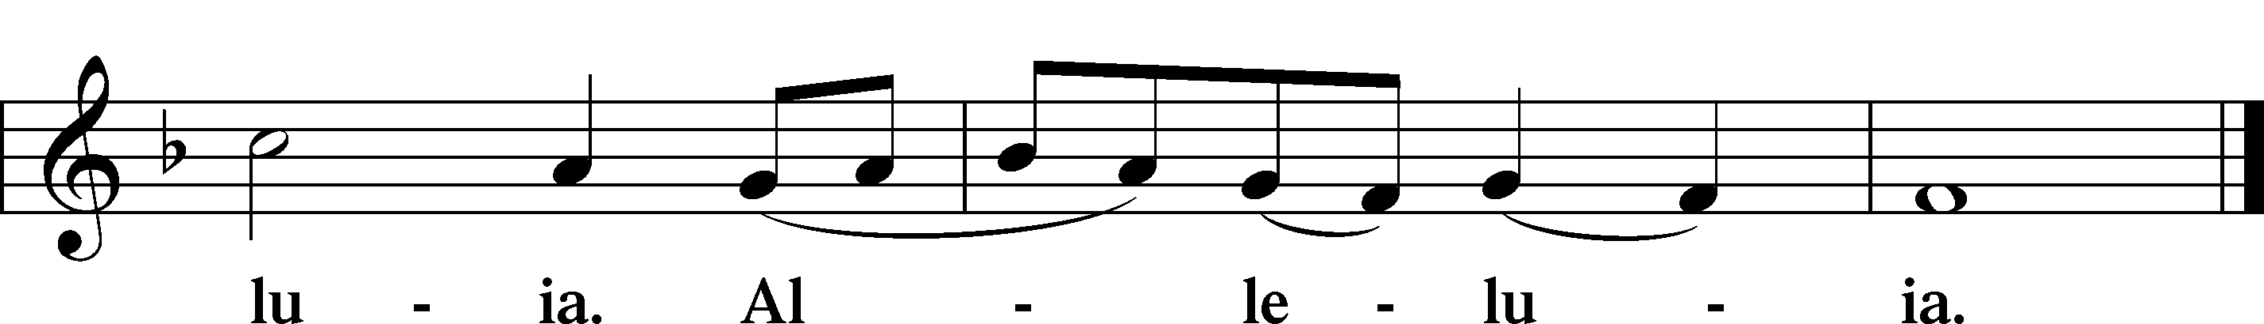

Blessing

L Let us bless the Lord.

C **Thanks be to God.**

L The almighty and merciful Lord, the Father, the T Son, and the Holy Spirit, bless and preserve us.

C **Amen.**

Hymn: 965 God Bless Our Native Land

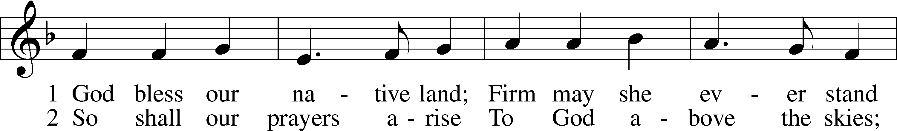

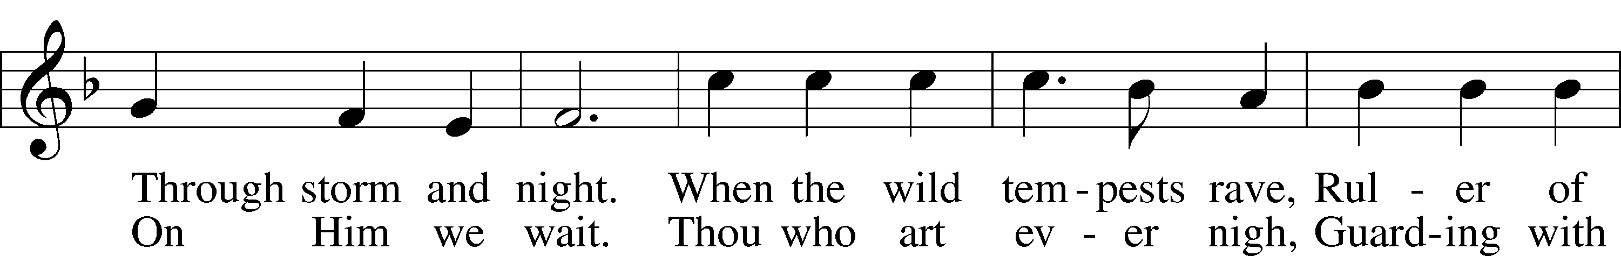

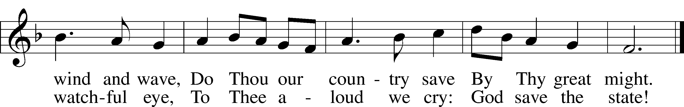

Text (st. 1): Charles T. Brooks, 1813–83, alt.; (st. 2): John S. Dwight, 1813–93, alt.  
Tune: Thesaurus Musicus, c. 1740, London  
Text and tune: Public domain

Acknowledgments

Service of Prayer and Preaching from Lutheran Service Book

Unless otherwise indicated, Scripture quotations are from the ESV® Bible (The Holy Bible, English Standard Version®), copyright © 2001 by Crossway, a publishing ministry of Good News Publishers. Used by permission. All rights reserved.

Created by Lutheran Service Builder © 2024 Concordia Publishing House.

**Prayers Request:**

**Those in the nursing home:** Joann Jaeger**,** Bernie Pedersen **Those Shut-in at home:** Char Herman, Joan Church, Joyce Myers **Those with ongoing health issues:** Harrison Fields, Owen Metz, Daria (Cindy Wright’s friend), Butch L. (Cindy Wright’s Brother-in-law), Melissa Miller. Art Smith (Sue Millerman’s brother), Brenda Sellent (Denise Stabenow’s sister), Sandy Hahn (Cindy Wright’s cousin’s wife) **,** Brenda Gustum (Missy Wiese’s mom), Lexi Anderson, Chris Mueller’s uncle, Pastor and Marlyss Harger **Those who grieve:** Family of Joyce Koba **Those recuperating from Surgery:** Bob Harbaugh, Shirley Hehl **Those who lead our nation:** Joe Biden, Kamala Harris, Tony Evers, Rod Nordby  **Those who serve in our military and law enforcement:** Ryan Graf, Chaplain Pon Chanthaphon (Our Adopt-a-Chaplain), Rusty Weise **Our Childcare Staff:** Melissa Frieburg, Denise Stabenow, Holly Wilhelmi, Janica Skjerly, Jacie Amundson, Cathy Anderson, Emily Young, Alora Provencial

**Church Service Phone: 715-438-4200**

**(Stay on the line for recorded service to start)**

**Live Stream audio services:** [**http://salem.listentochurch.com**](http://salem.listentochurch.com)

**Salem’s Web Page:** <https://www.salembarron.com/>

**Pastor Fred Buth: Cell phone:715-642-3050 (H)715-353-2540**

**Email: salembarronpastor@gmail.com**

**Office Hours: Monday-Wednesday 9-12**

**Attendance:** 11/24-43

**Elder Today:** Paul Millerman

**Altar Guild:** Denise Stabenow & Kari Longmire

**Schedule for the week:**

**Monday:** 7pm Elders

**Tuesday:** 8am Men’s Bible Study

**Wednesday:** Noon – 6:30pm Advent Services 9am Childcare Chapel, 4pm Catechism, DQ Night to support the Childcare Center

**Save the Date:**

**December 1st:** 9:00am -Children’s Christmas Service / Brunch to follow **December 4th:** Noon & 6:30pm **-** Advent Services Start **December 6th**: 7:00pm - Caroling at the Pioneer Museum. We will meet at the museum in front of the Gift Shop. If you have any questions, please feel free to call me. Sue M **December 7th:** 9:00am-2:00pm - Craft & Vendor Show/Bake Sale@ Salem

***Happy Thanksgiving!***

We have Kwik Trip cards:

$20, $25, $50, & $100

They make good Christmas gifts.

Time to order Poinsettias!

Big Buck Contest **December 8th** @6:00pm/Supper

