# Divine Service 1 pg.151

New Year's Eve

December 31,2024

Hymn of Invocation: 733 O God, Our Help in Ages Past sts. 1–6

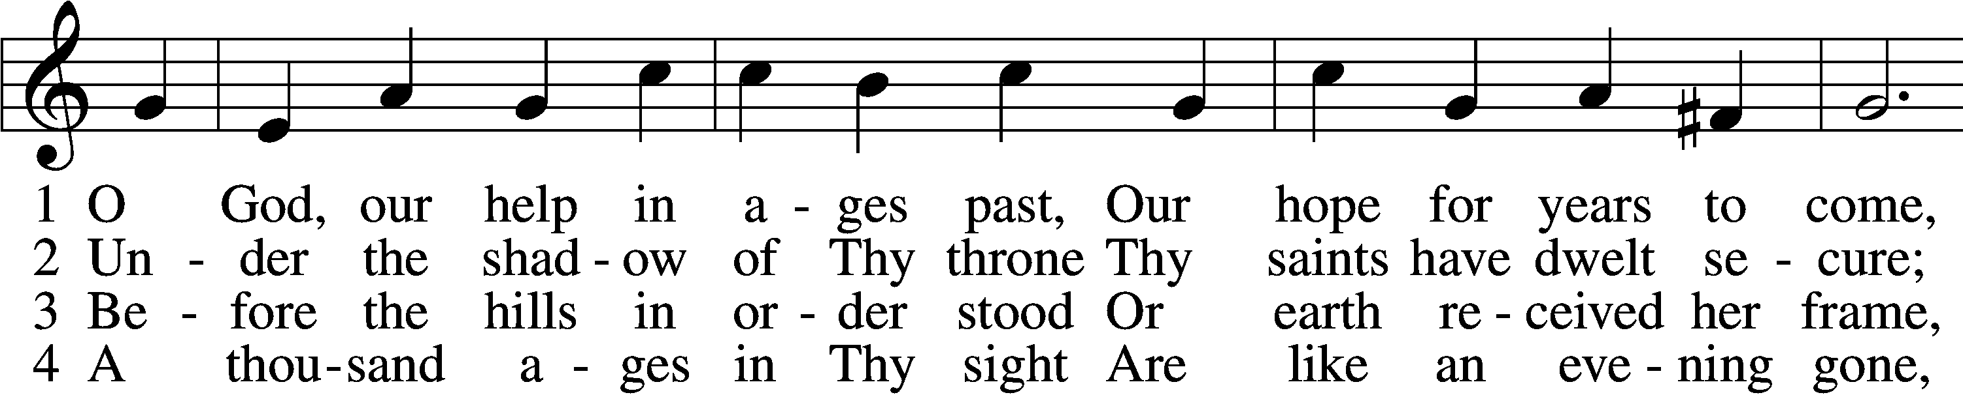

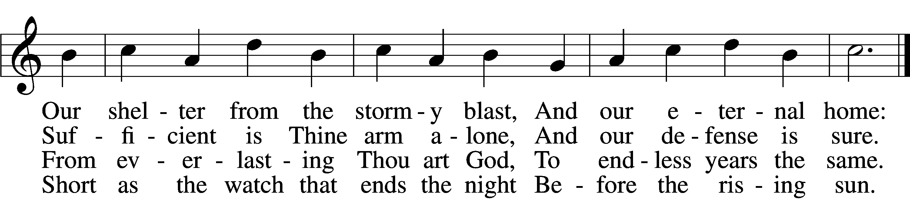

5 Time, like an ever-rolling stream,  
 Soon bears us all away;  
We fly forgotten as a dream  
 Dies at the op’ning day.

6 O God, our help in ages past,  
 Our hope for years to come,  
Be Thou our guard while troubles last  
 And our eternal home!

Text: Isaac Watts, 1674–1748, alt.  
Tune: William Croft, 1678–1727  
Text and tune: Public domain

# Confession and Absolution

The sign of the cross may be made by all in remembrance of their Baptism.

P In the name of the Father and of the T Son and of the Holy Spirit.

C **Amen.**

P If we say we have no sin, we deceive ourselves, and the truth is not in us.

C **But if we confess our sins, God, who is faithful and just, will forgive our sins and cleanse us from all unrighteousness.**

Kneel/Stand

Silence for reflection on God’s Word and for self-examination.

P Let us then confess our sins to God our Father.

C **Most merciful God, we confess that we are by nature sinful and unclean. We have sinned against You in thought, word, and deed, by what we have done and by what we have left undone. We have not loved You with our whole heart; we have not loved our neighbors as ourselves. We justly deserve Your present and eternal punishment. For the sake of Your Son, Jesus Christ, have mercy on us. Forgive us, renew us, and lead us, so that we may delight in Your will and walk in Your ways to the glory of Your holy name. Amen.**

P Almighty God in His mercy has given His Son to die for you and for His sake forgives you all your sins. As a called and ordained servant of Christ, and by His authority, I therefore forgive you all your sins in the name of the Father and of the T Son and of the Holy Spirit.

C **Amen.**

Stand

# Service of the Word

Introit Psalm 98:1–3; antiphon: Psalm 124:8

Our help is in the name of the Lord,  
 who made heaven and earth.  
Oh sing to the Lord a new song, for he has done marvelous things!  
 His right hand and his holy arm have worked salvation for him.  
The Lord has made known his salvation;  
 he has revealed his righteousness in the sight of the nations.  
He has remembered his steadfast love and faithfulness to the house of Israel.  
 All the ends of the earth have seen the salvation of our God.  
**Glory be to the Father and to the Son**  
 **and to the Holy Spirit;**  
**as it was in the beginning,**  
 **is now, and will be forever. Amen.**  
Our help is in the name of the Lord,  
 who made heaven and earth.

Kyrie LSB 152



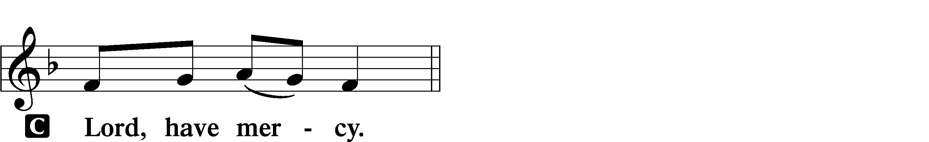

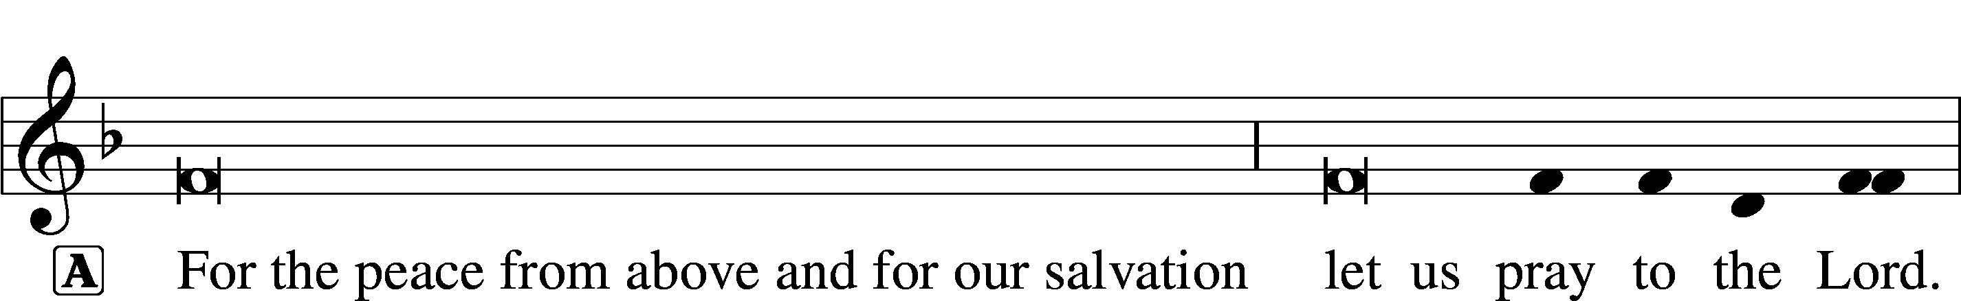

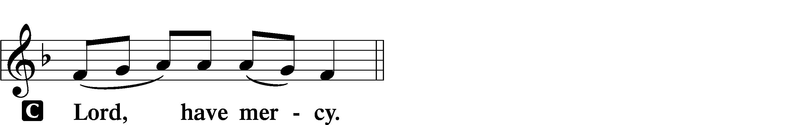

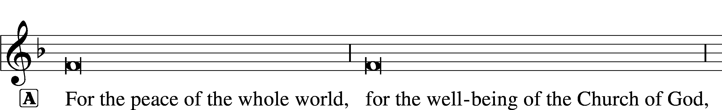

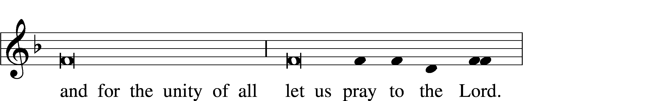

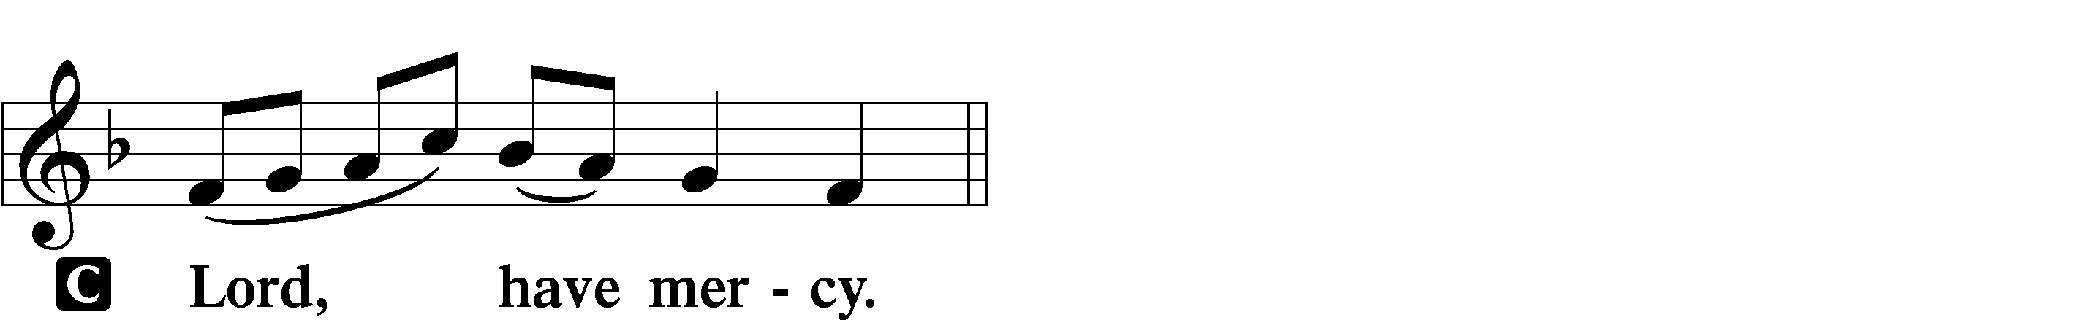

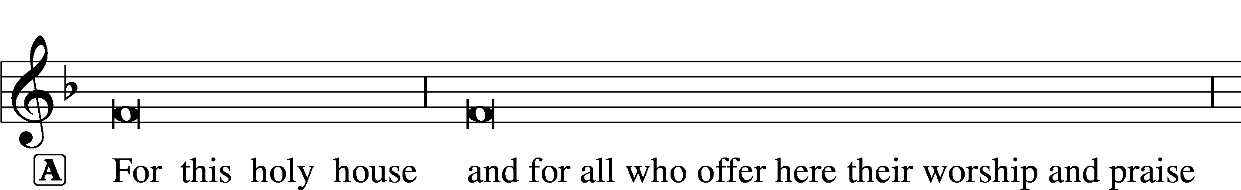

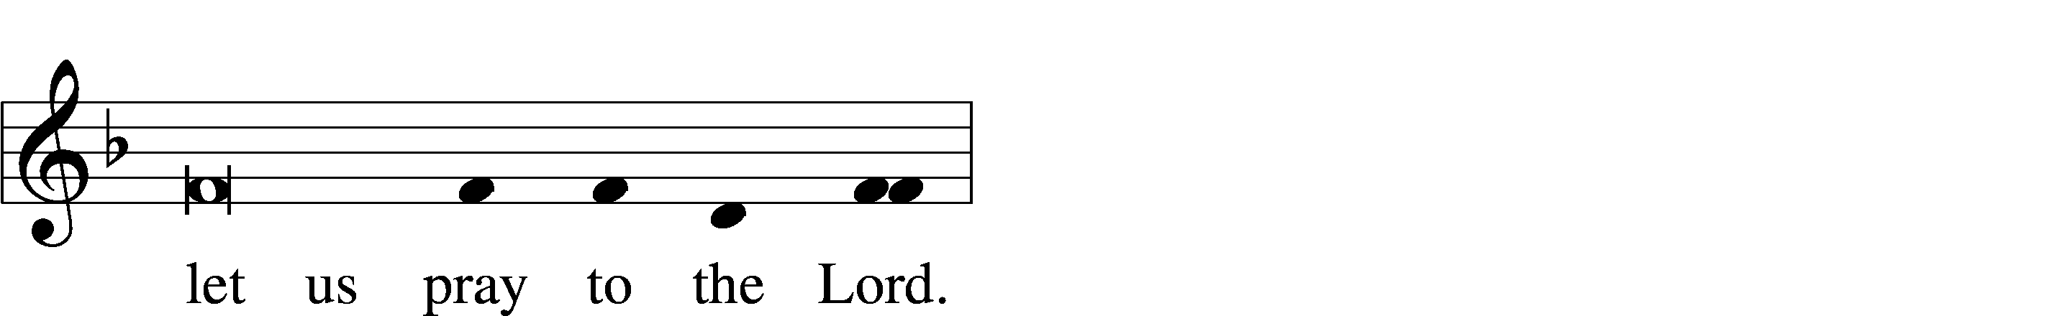

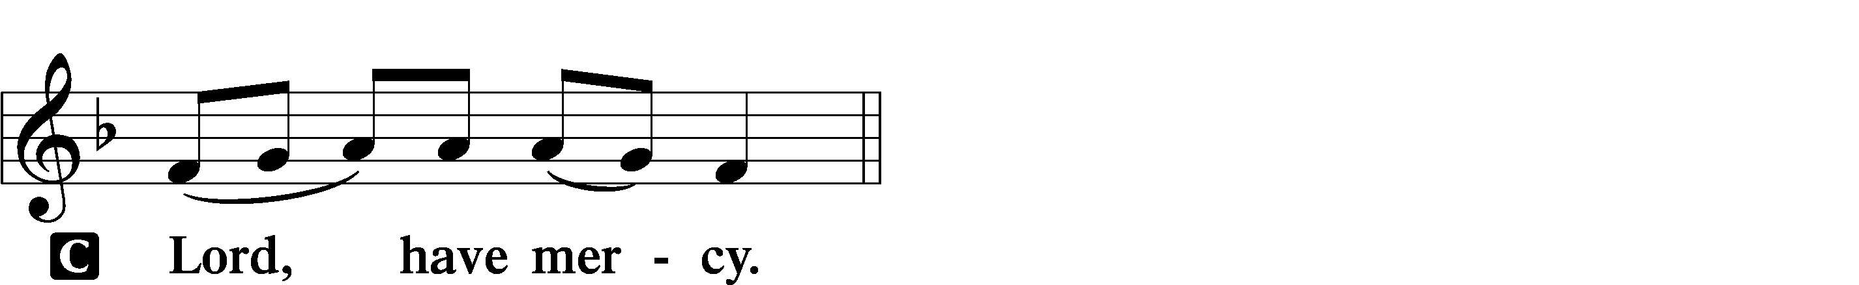

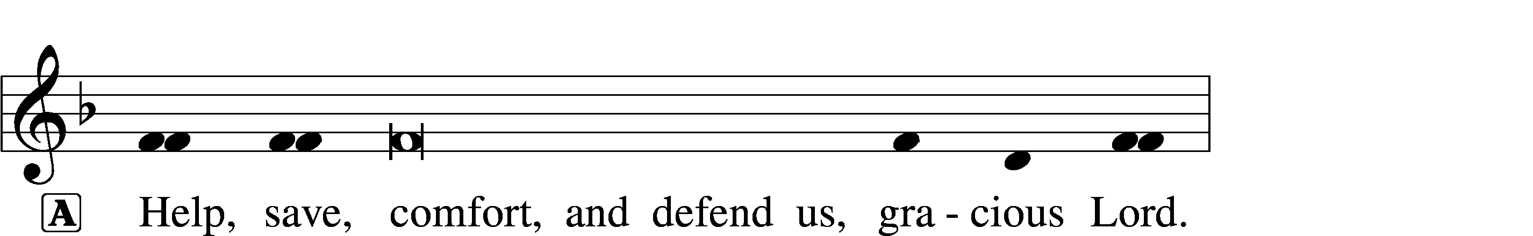



This Is the Feast LSB 155

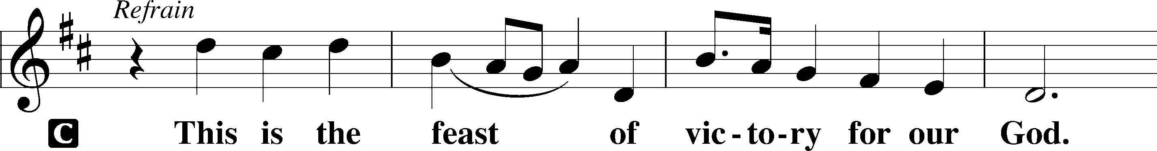

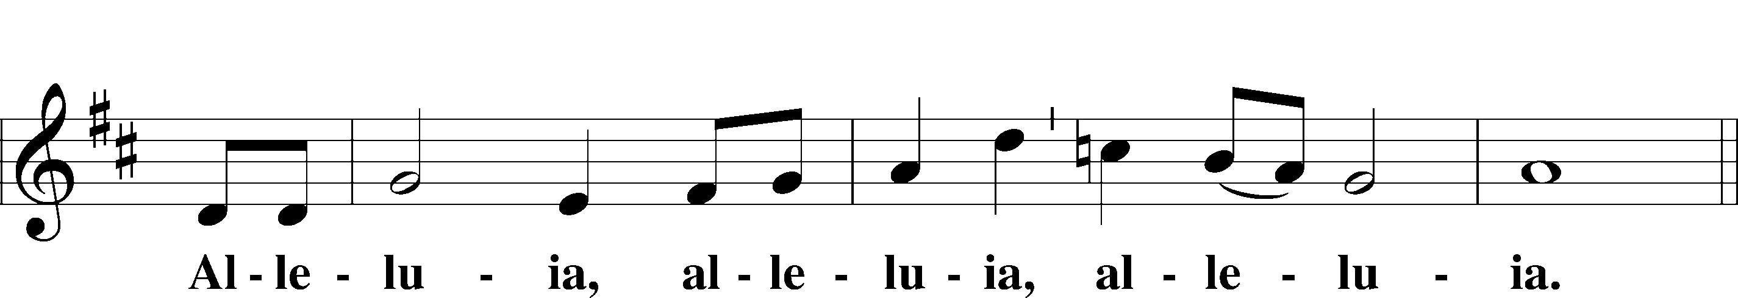

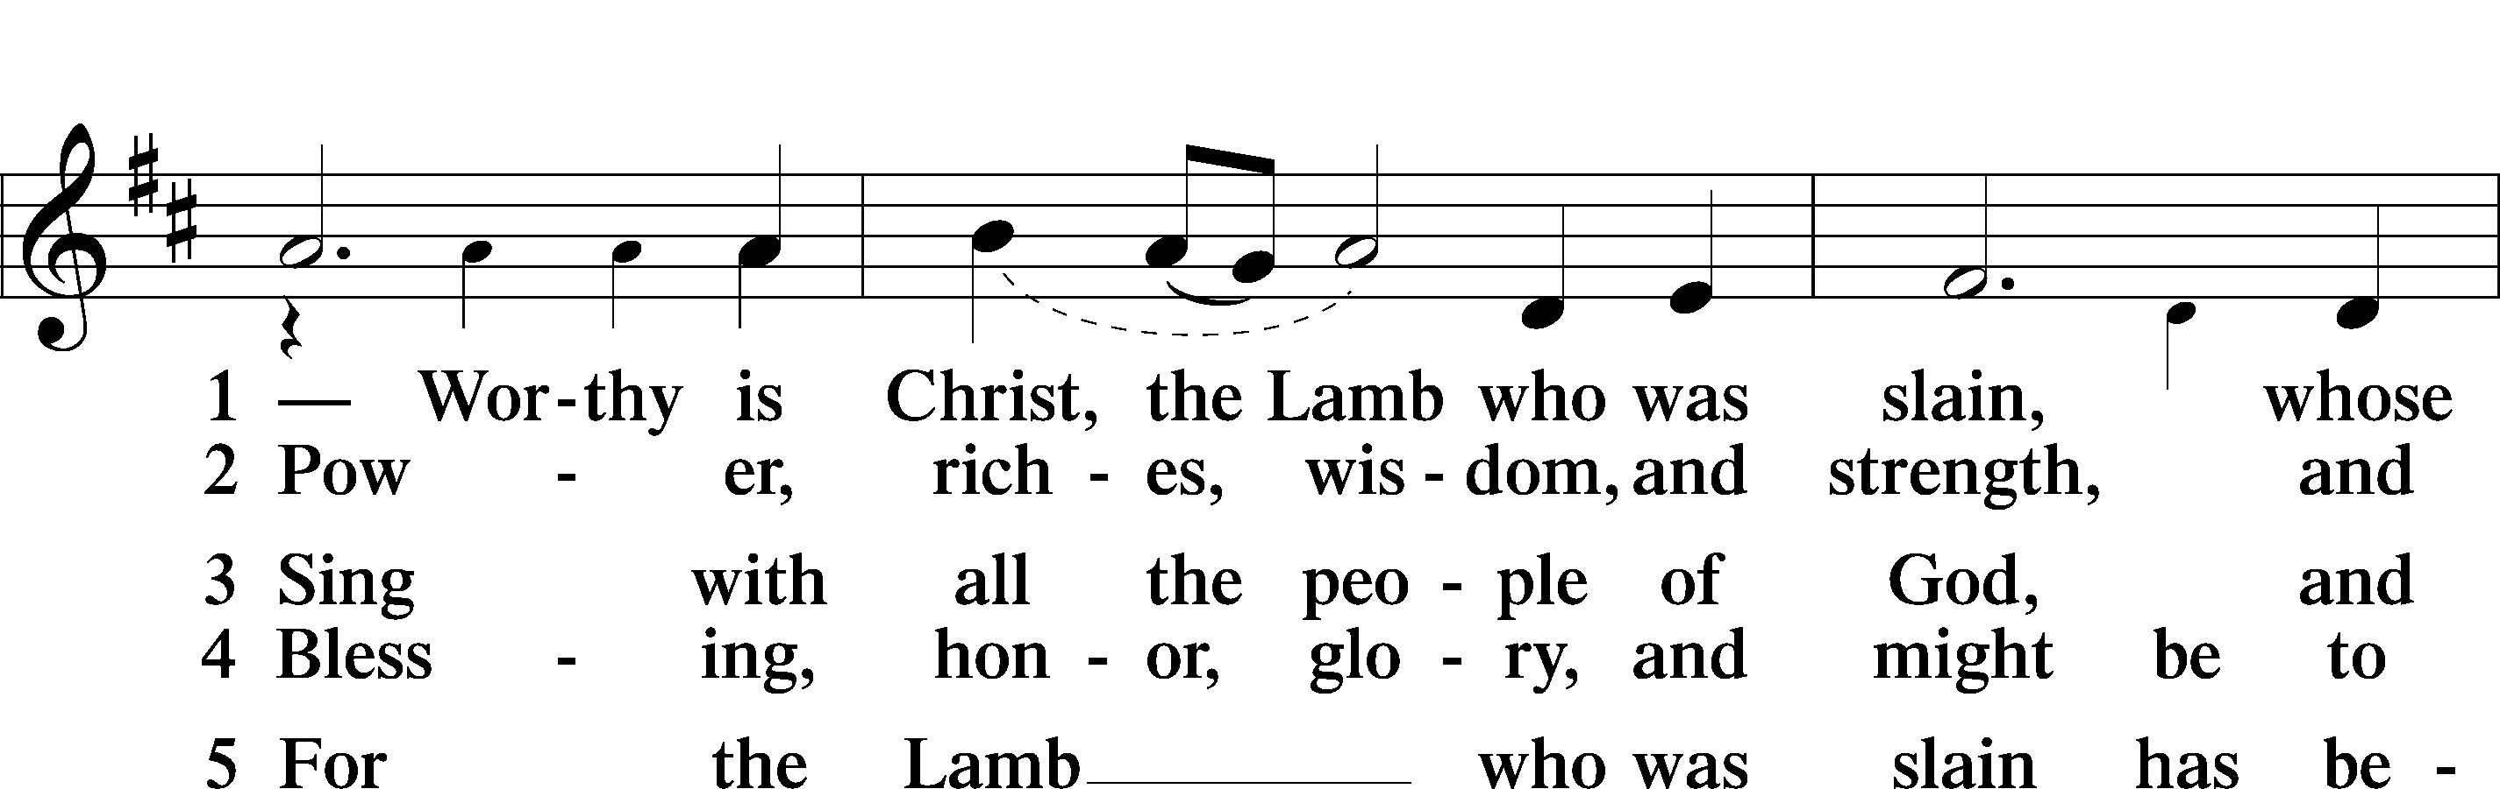

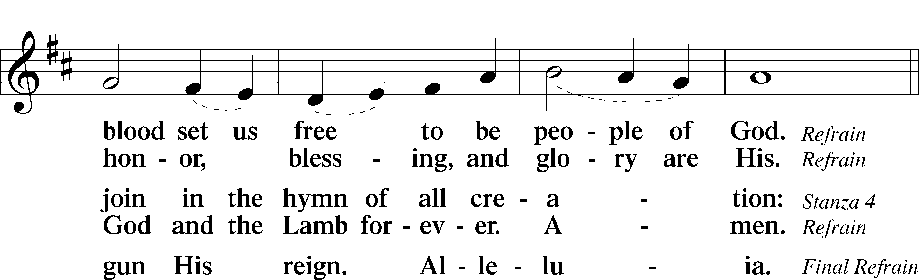

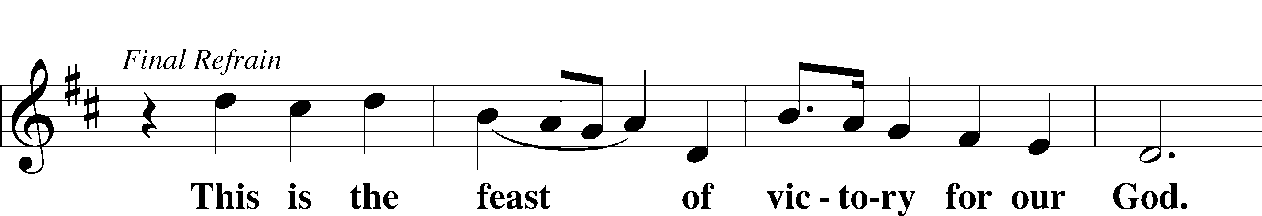

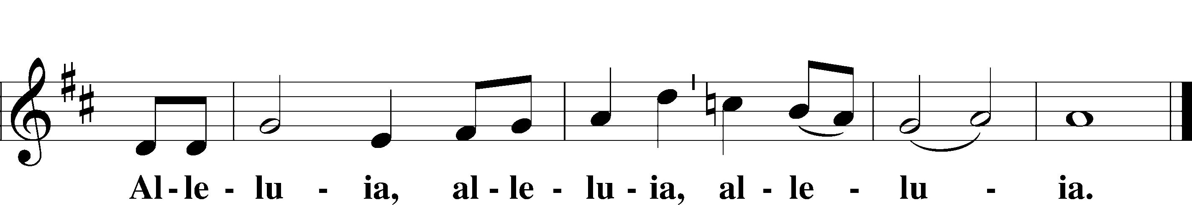

Salutation and Collect of the Day

P The Lord be with you.

C **And also with you.**

P Let us pray.

Eternal God, we commit to Your mercy and forgiveness the year now ending and commend to Your blessing and love the times yet to come. In the new year, abide among us with Your Holy Spirit that we may always trust in the saving name of our Lord Jesus Christ, who lives and reigns with You and the Holy Spirit, one God, now and forever.

C **Amen.**

Sit

Old Testament Reading Isaiah 30:15–17

15For thus said the Lord God, the Holy One of Israel,  
“In returning and rest you shall be saved;  
 in quietness and in trust shall be your strength.”  
But you were unwilling, 16and you said,  
“No! We will flee upon horses”;  
 therefore you shall flee away;  
and, “We will ride upon swift steeds”;  
 therefore your pursuers shall be swift.  
17A thousand shall flee at the threat of one;  
 at the threat of five you shall flee,  
till you are left  
 like a flagstaff on the top of a mountain,  
 like a signal on a hill.

A This is the Word of the Lord.

C **Thanks be to God.**

Epistle Romans 8:31b–39

If God is for us, who can be against us? 32He who did not spare his own Son but gave him up for us all, how will he not also with him graciously give us all things? 33Who shall bring any charge against God’s elect? It is God who justifies. 34Who is to condemn? Christ Jesus is the one who died—more than that, who was raised—who is at the right hand of God, who indeed is interceding for us. 35Who shall separate us from the love of Christ? Shall tribulation, or distress, or persecution, or famine, or nakedness, or danger, or sword? 36As it is written,

“For your sake we are being killed all the day long;  
 we are regarded as sheep to be slaughtered.”

37No, in all these things we are more than conquerors through him who loved us. 38For I am sure that neither death nor life, nor angels nor rulers, nor things present nor things to come, nor powers, 39nor height nor depth, nor anything else in all creation, will be able to separate us from the love of God in Christ Jesus our Lord.

A This is the Word of the Lord.

C **Thanks be to God.**

Stand

Alleluia and Verse LSB 156

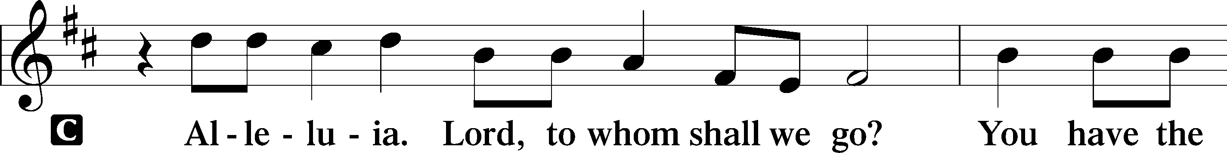

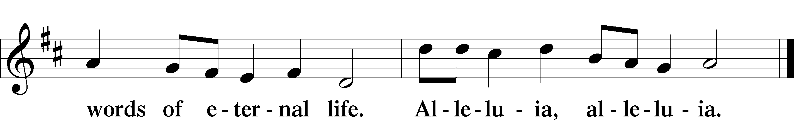

Holy Gospel Luke 12:35–40

P The Holy Gospel according to St. Luke, the twelfth chapter.

C **Glory to You, O Lord.**

You Must Be Ready

35[Jesus said:] “Stay dressed for action and keep your lamps burning, 36and be like men who are waiting for their master to come home from the wedding feast, so that they may open the door to him at once when he comes and knocks. 37Blessed are those servants whom the master finds awake when he comes. Truly, I say to you, he will dress himself for service and have them recline at table, and he will come and serve them. 38If he comes in the second watch, or in the third, and finds them awake, blessed are those servants! 39But know this, that if the master of the house had known at what hour the thief was coming, he would not have left his house to be broken into. 40You also must be ready, for the Son of Man is coming at an hour you do not expect.”

P This is the Gospel of the Lord.

C **Praise to You, O Christ.**

Sit

Hymn of the Day: 899 Across the Sky the Shades of Night

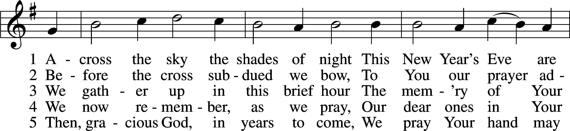

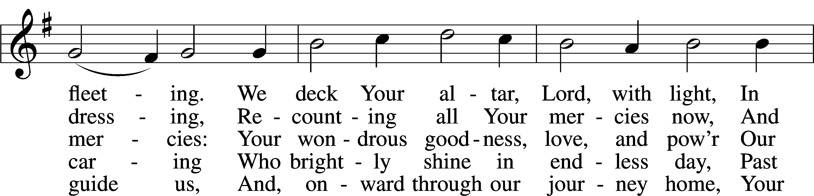

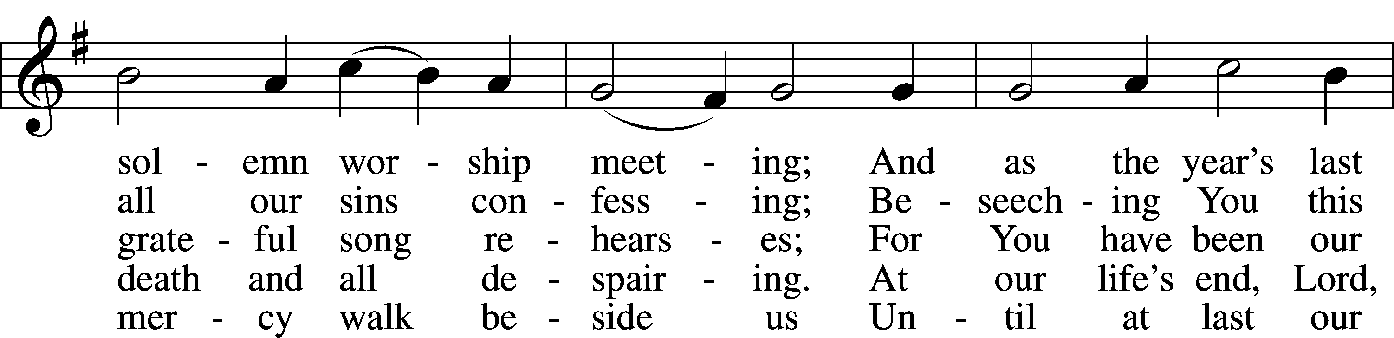

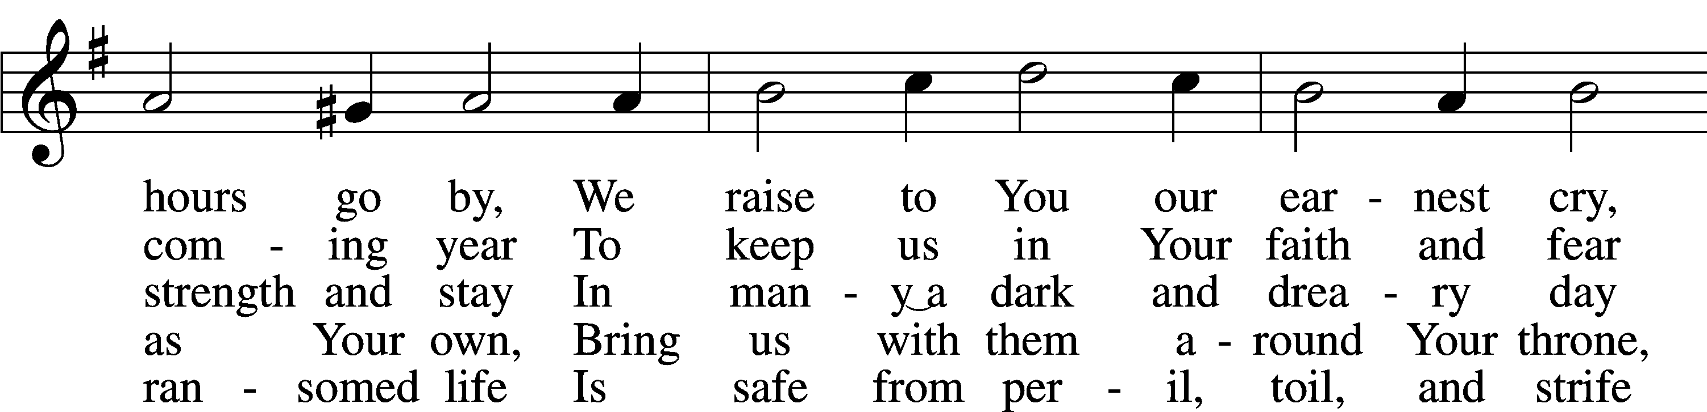

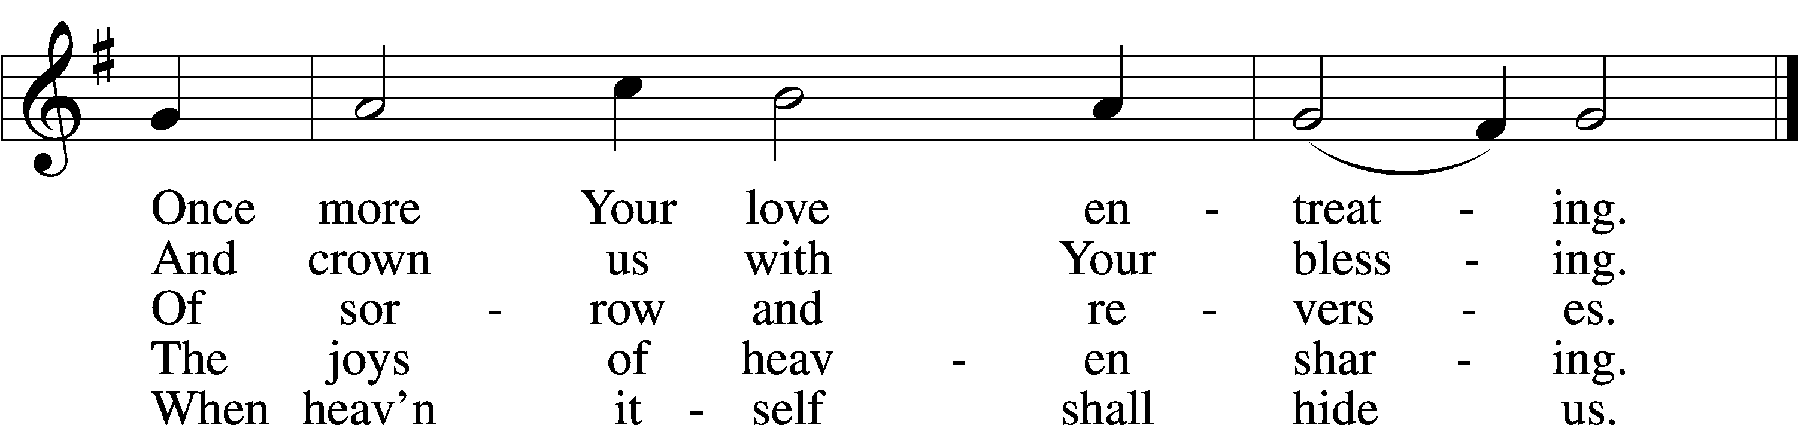

Text (sts. 1–3, 5): James Hamilton, 1819–96, alt.; (st. 4): Gregory J. Wismar, 1946  
Tune: attr. Nicolaus Decius, c. 1485–after 1546  
Text (sts. 1–3, 5): Public domain  
Text (st. 4): © 2006 Concordia Publishing House. Used by permission: LSB Hymn License no. 110005504  
Tune: Public domain

Sermon

Nicene Creed

C **I believe in one God,**

**the Father Almighty,**

**maker of heaven and earth**

**and of all things visible and invisible.**

**And in one Lord Jesus Christ,**

**the only-begotten Son of God,**

**begotten of His Father before all worlds,**

**God of God, Light of Light,**

**very God of very God,**

**begotten, not made,**

**being of one substance with the Father,**

**by whom all things were made;**

**who for us men and for our salvation came down from heaven**

**and was incarnate by the Holy Spirit of the virgin Mary**

**and was made man;**

**and was crucified also for us under Pontius Pilate.**

**He suffered and was buried.**

**And the third day He rose again according to the Scriptures**

**and ascended into heaven**

**and sits at the right hand of the Father.**

**And He will come again with glory to judge both the living and the dead,**

**whose kingdom will have no end.**

**And I believe in the Holy Spirit,**

**the Lord and giver of life,**

**who proceeds from the Father and the Son,**

**who with the Father and the Son together is worshiped and glorified,**

**who spoke by the prophets.**

**And I believe in one holy Christian and apostolic Church,**

**I acknowledge one Baptism for the remission of sins,**

**and I look for the resurrection of the dead**

**and the life** T **of the world to come. Amen.**

Prayer of the Church

Offering

Offertory LSB 159

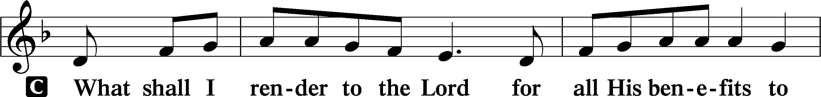

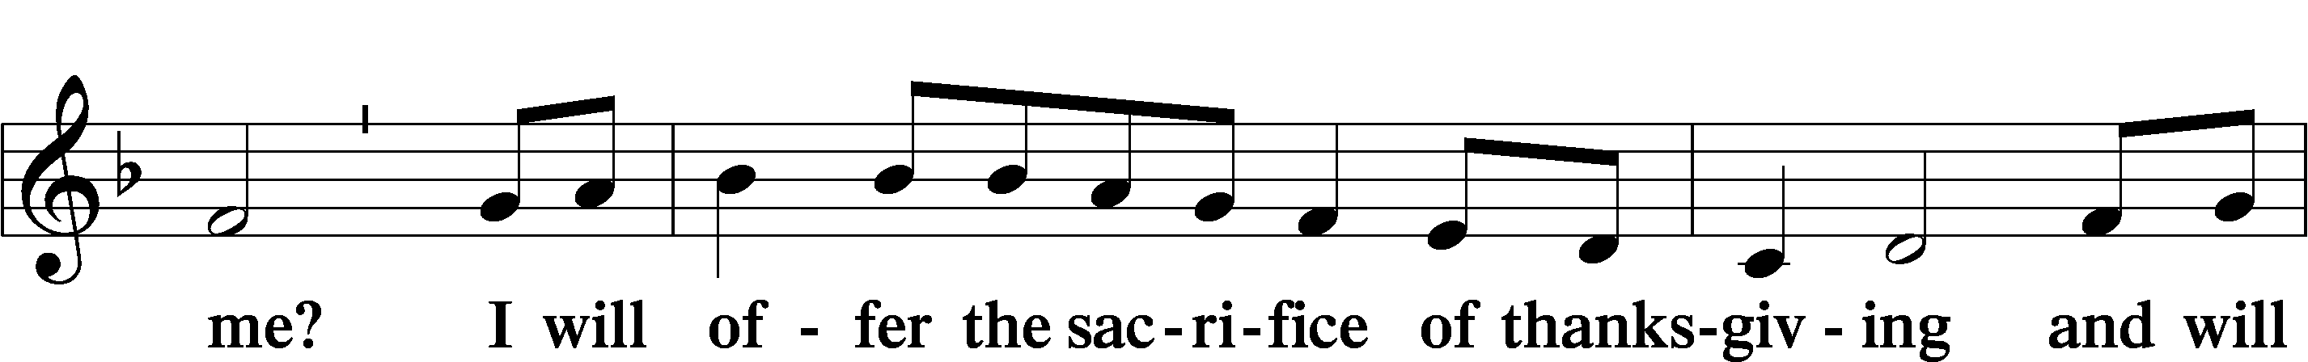

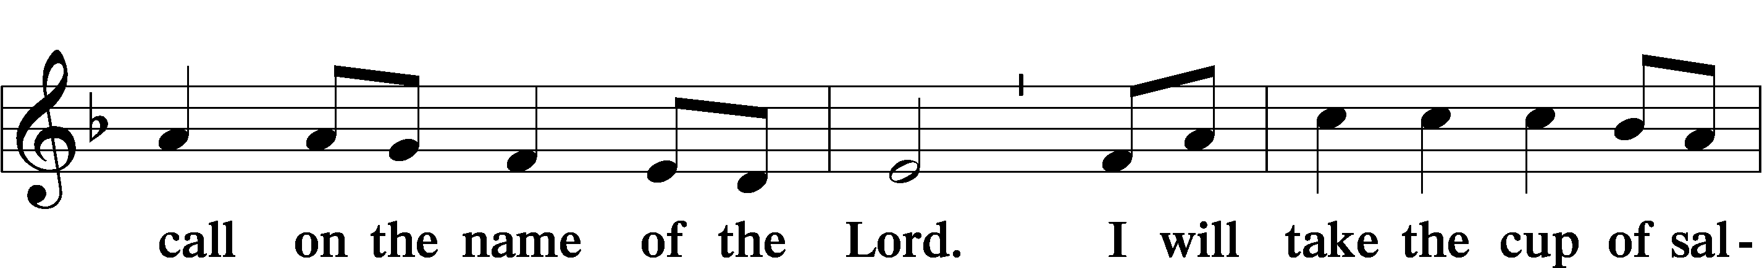

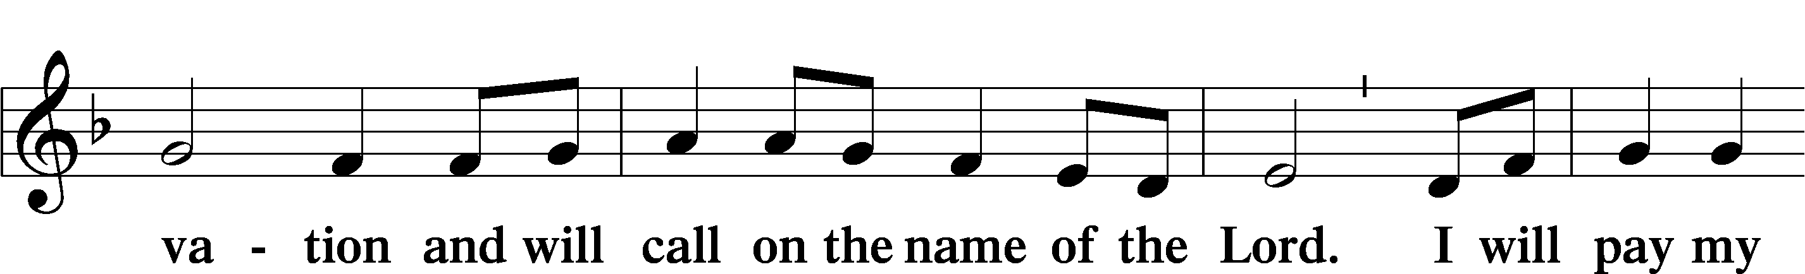

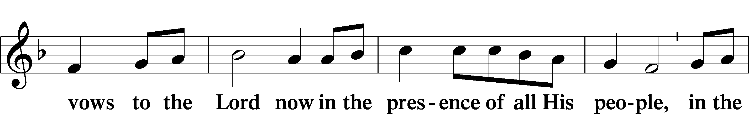

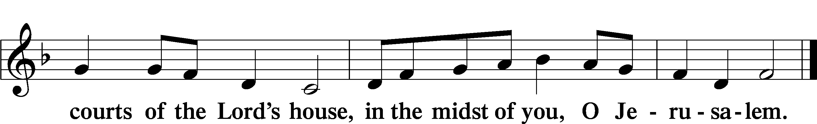

# Service of the Sacrament

Preface LSB 160

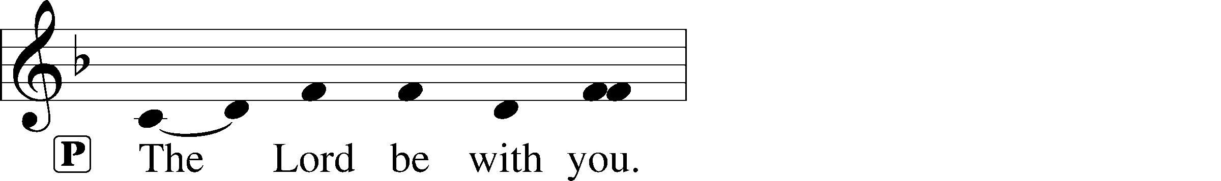

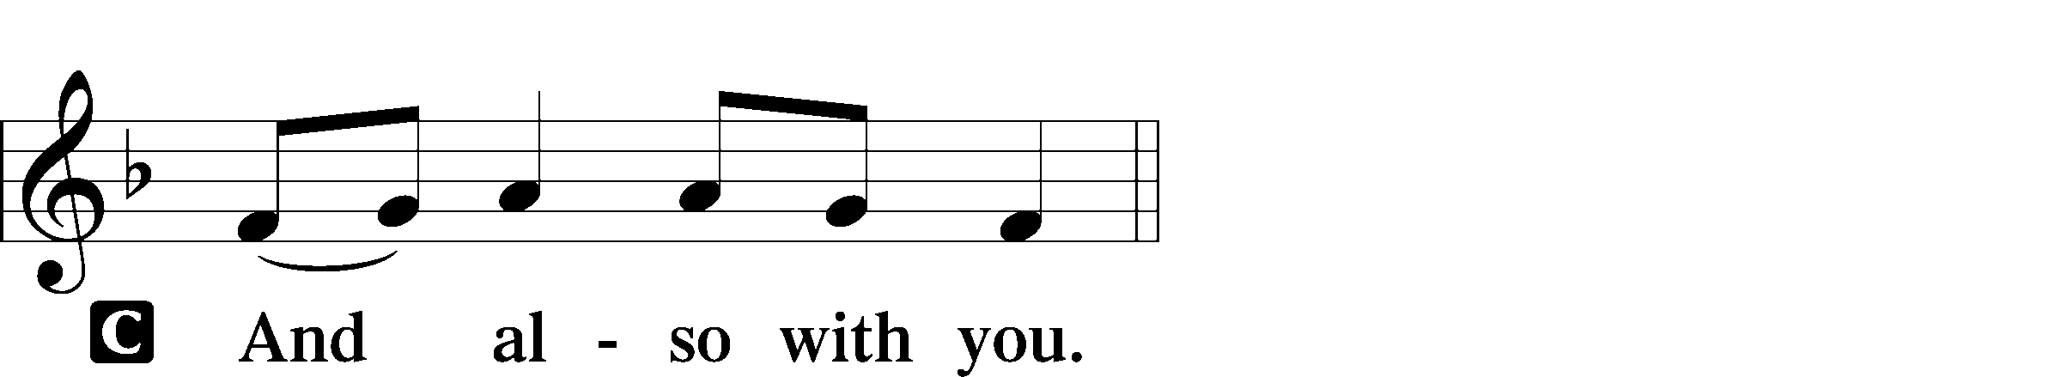

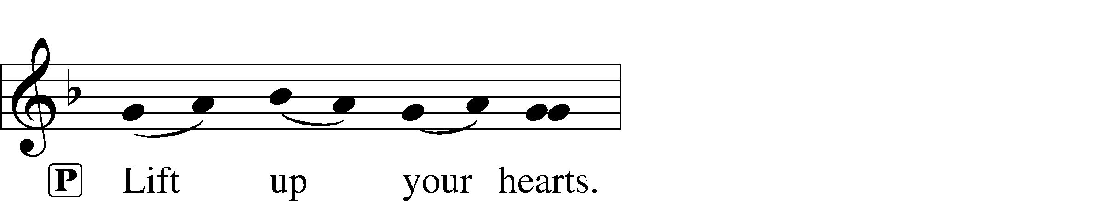



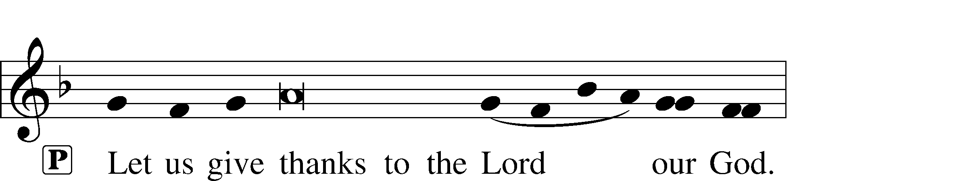

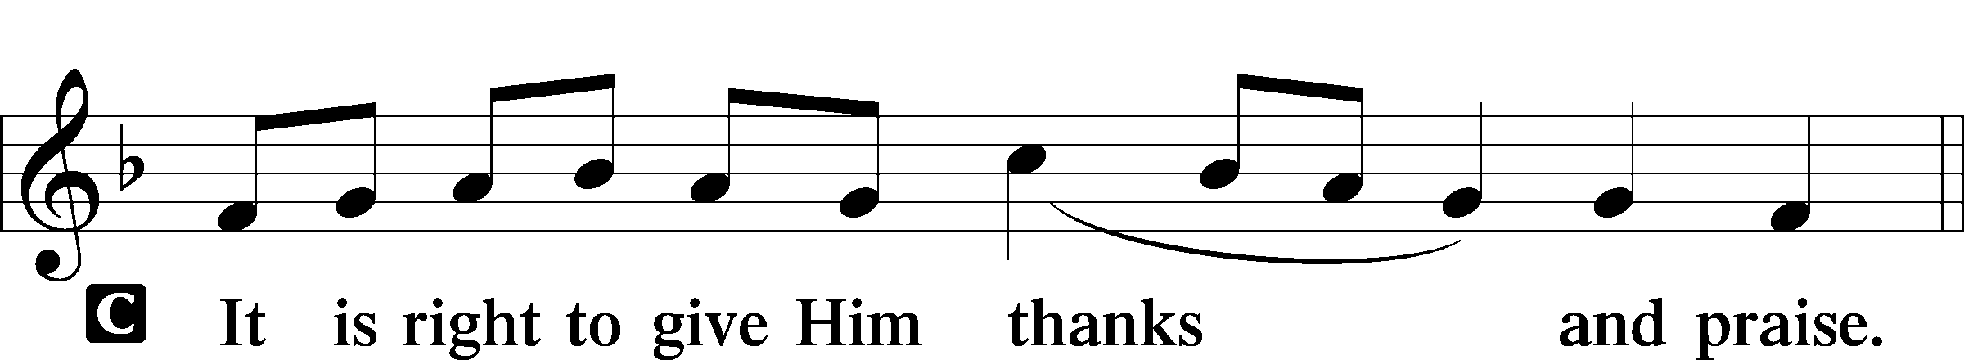

P It is truly good, right, and salutary that we should at all times and in all places give thanks to You, holy Lord, almighty Father, everlasting God, through Jesus Christ, our Lord; for in the mystery of the Word made flesh You have given us a new revelation of Your glory that, seeing You in the person of Your Son, we may know and love those things which are not seen. Therefore with angels and archangels and with all the company of heaven we laud and magnify Your glorious name, evermore praising You and saying:

Sanctus LSB 161

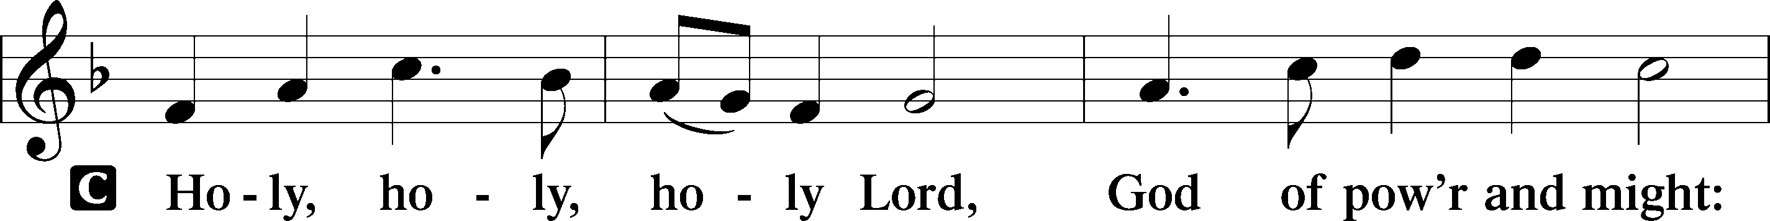

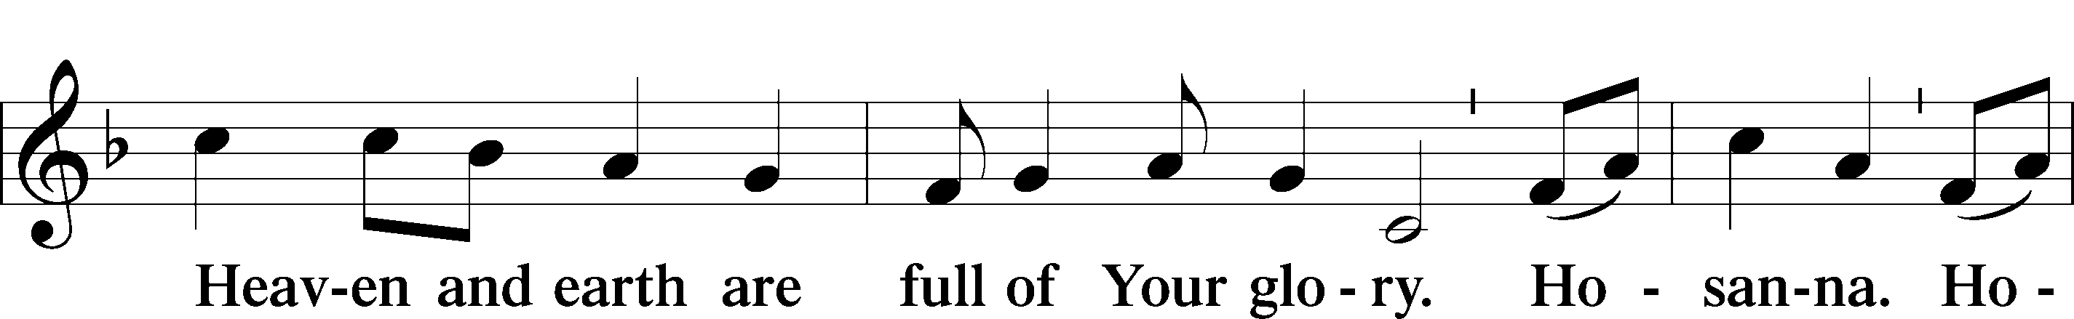

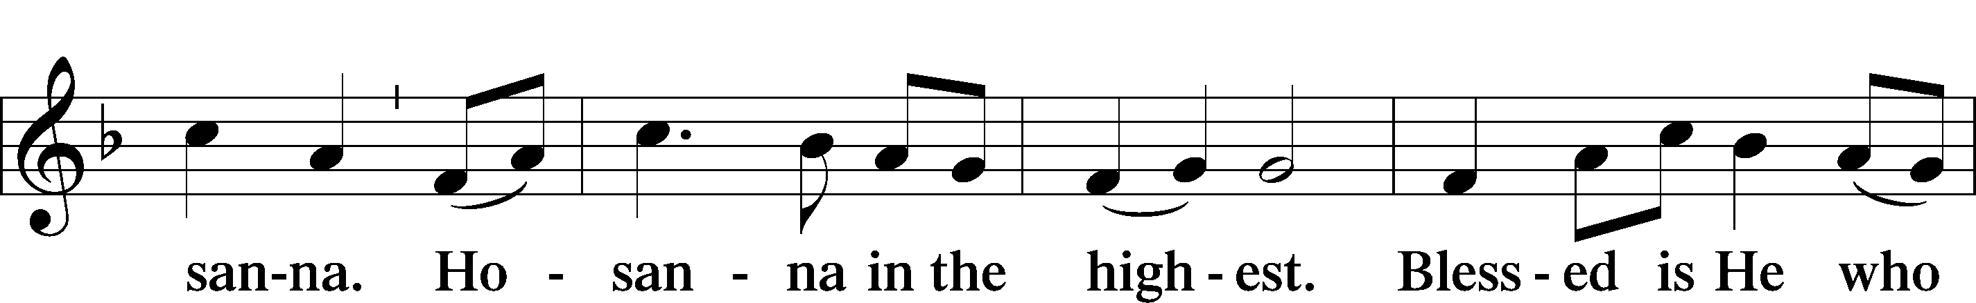

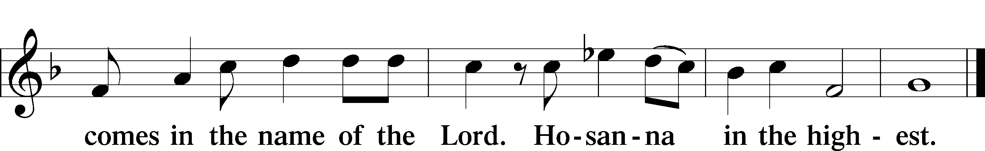

Prayer of Thanksgiving LSB 161

P Blessed are You, Lord of heaven and earth, for You have had mercy on those whom You created and sent Your only-begotten Son into our flesh to bear our sin and be our Savior. With repentant joy we receive the salvation accomplished for us by the all-availing sacrifice of His body and His blood on the cross.

Gathered in the name and the remembrance of Jesus, we beg You, O Lord, to forgive, renew, and strengthen us with Your Word and Spirit. Grant us faithfully to eat His body and drink His blood as He bids us do in His own testament. Gather us together, we pray, from the ends of the earth to celebrate with all the faithful the marriage feast of the Lamb in His kingdom, which has no end. Graciously receive our prayers; deliver and preserve us. To You alone, O Father, be all glory, honor, and worship, with the Son and the Holy Spirit, one God, now and forever.

C **Amen.**

The Words of Our Lord

P Our Lord Jesus Christ, on the night when He was betrayed, took bread, and when He had given thanks, He broke it and gave it to the disciples and said: “Take, eat; this is My T body, which is given for you. This do in remembrance of Me.”

In the same way also He took the cup after supper, and when He had given thanks, He gave it to them, saying: “Drink of it, all of you; this cup is the new testament in My T blood, which is shed for you for the forgiveness of sins. This do, as often as you drink it, in remembrance of Me.”

P As often as we eat this bread and drink this cup, we proclaim the Lord’s death until He comes.

C **Amen. Come, Lord Jesus.**

P O Lord Jesus Christ, only Son of the Father, in giving us Your body and blood to eat and to drink, You lead us to remember and confess Your holy cross and passion, Your blessed death, Your rest in the tomb, Your resurrection from the dead, Your ascension into heaven, and Your coming for the final judgment. So remember us in Your kingdom and teach us to pray:

Lord’s Prayer

C **Our Father who art in heaven,**

**hallowed be Thy name,**

**Thy kingdom come,**

**Thy will be done on earth**

**as it is in heaven;**

**give us this day our daily bread;**

**and forgive us our trespasses**

**as we forgive those**

**who trespass against us;**

**and lead us not into temptation,**

**but deliver us from evil.**

**For Thine is the kingdom**

**and the power and the glory**

**forever and ever. Amen.**

Pax Domini LSB 163

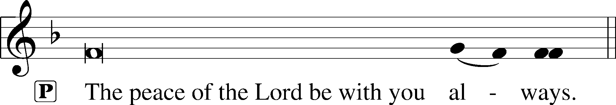



Agnus Dei LSB 163

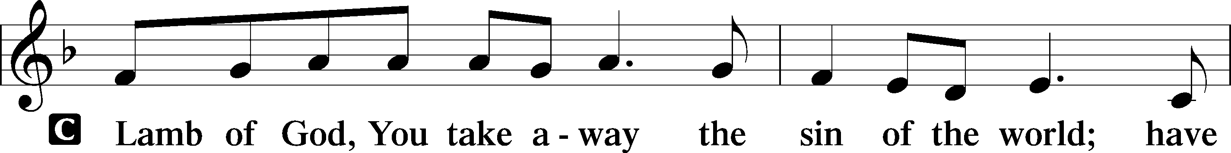

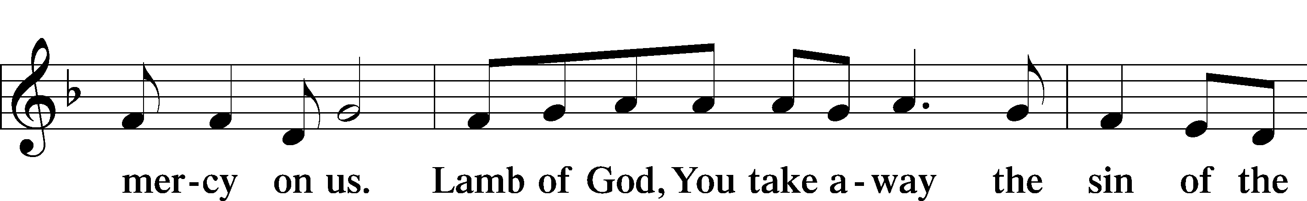

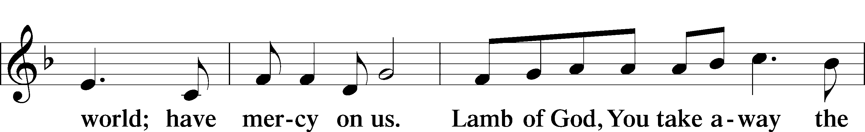

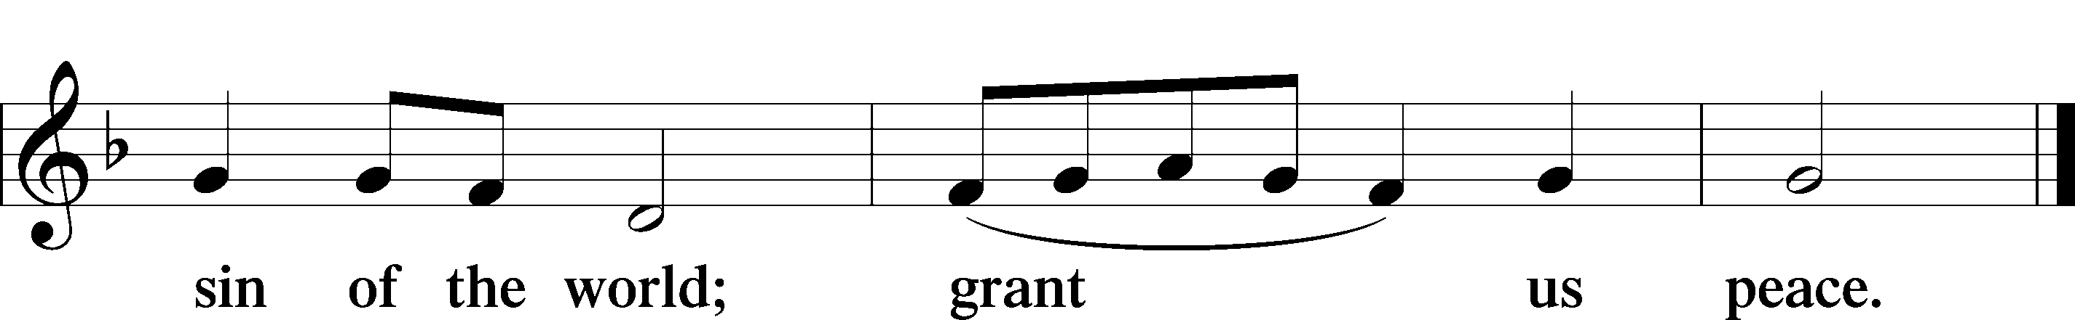

Sit

Distribution

The pastor and those who assist him receive the body and blood of Christ first and then distribute them to those who come to receive, saying:

Take, eat; this is the true body of our Lord and Savior Jesus Christ, given into death for your sins.

**Amen.**

Take, drink; this is the true blood of our Lord and Savior Jesus Christ, shed for the forgiveness of your sins.

**Amen.**

In dismissing the communicants, the following is said:

P The body and blood of our Lord Jesus Christ strengthen and preserve you in body and soul to life everlasting. Depart T in peace.

C **Amen.**

Distribution Hymn: 900 Jesus! Name of Wondrous Love

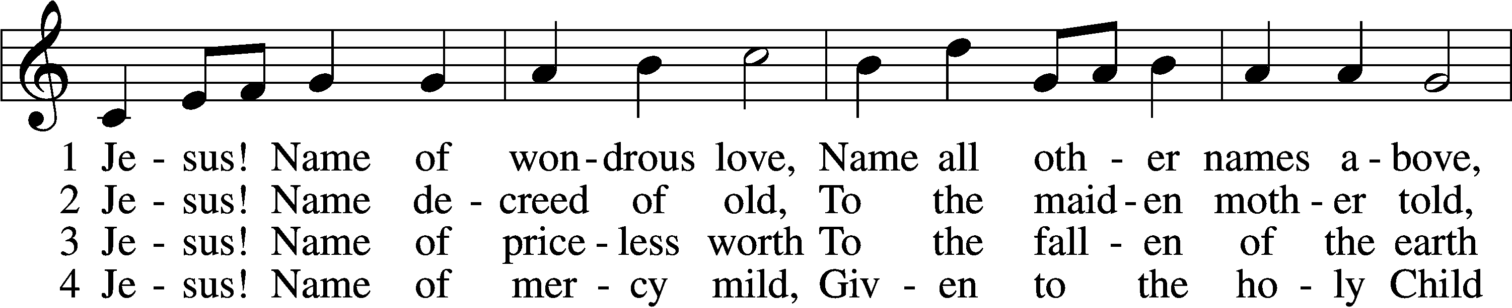

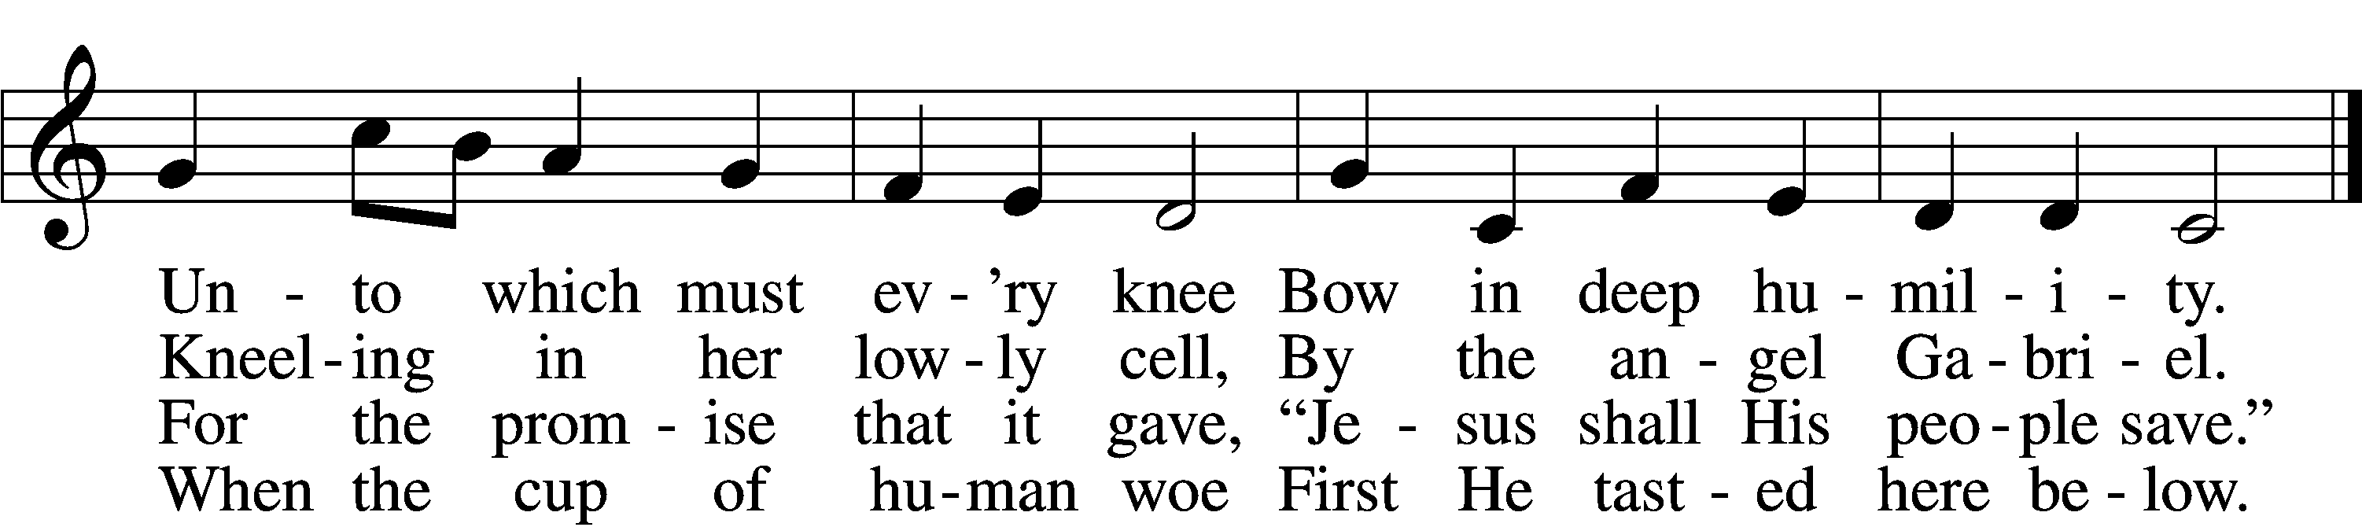

5 Jesus! Only name that’s giv’n  
Under all the mighty heav’n  
Whereby those to sin enslaved  
Burst their fetters and are saved.

6 Jesus! Name of wondrous love,  
Human name of God above;  
Pleading only this, we flee  
Helpless, O our God, to Thee.

Text: William W. How, 1823–97, alt.  
Tune: Geist-reiches Gesang-Buch, 1704, Halle, ed. Johann A. Freylinghausen, alt.  
Text and tune: Public domain

Distribution Hymn: 898 The Ancient Law Departs

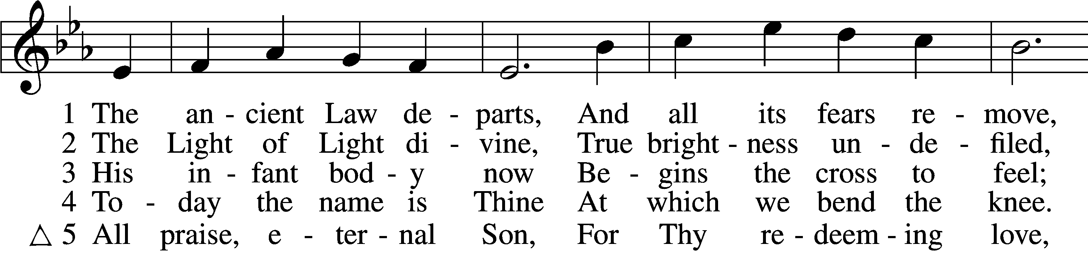

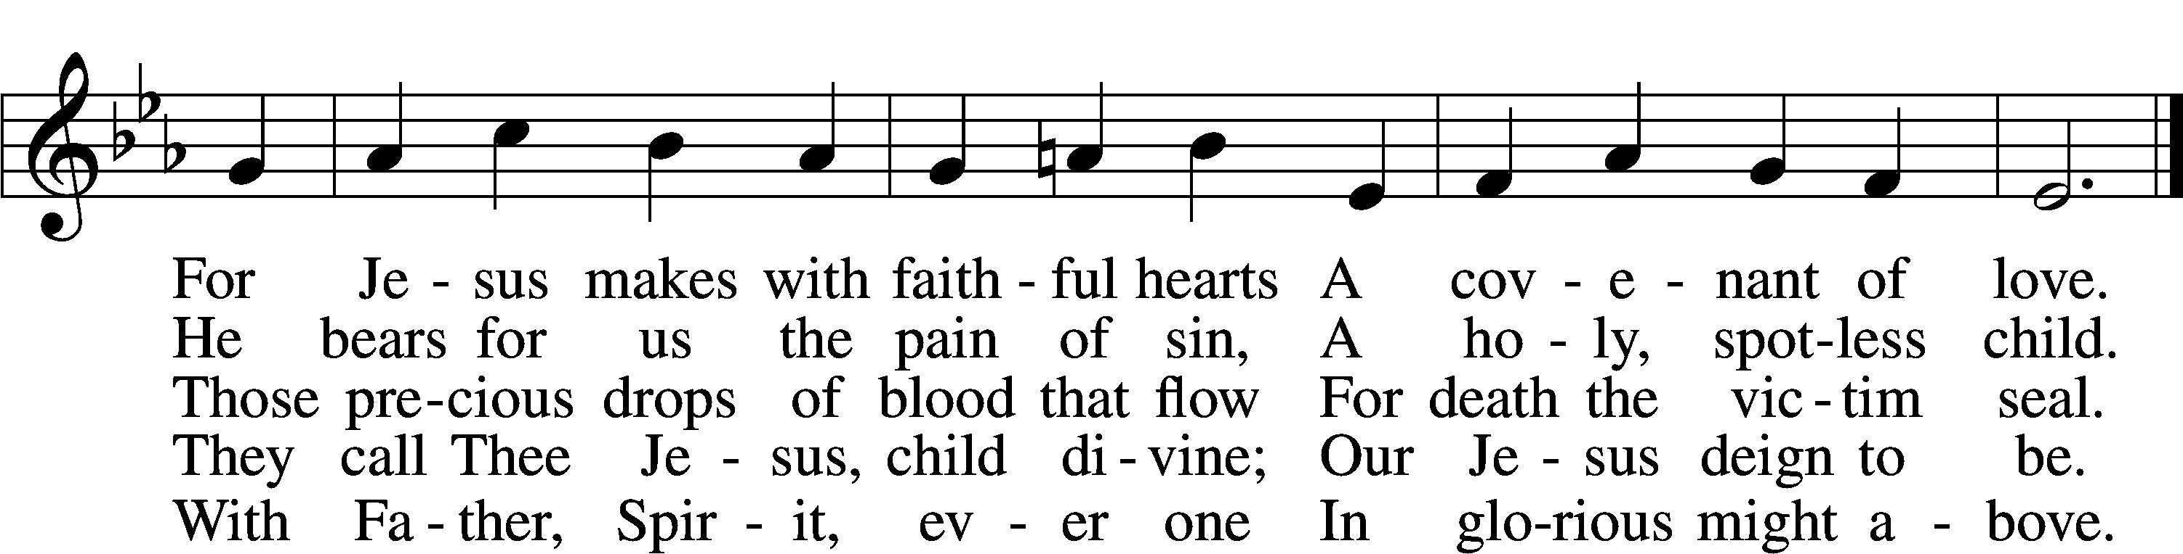

Text: Sebastian Besnault, d. 1724; tr. The Lutheran Hymnal, 1941  
Tune: Johann Sebastian Bach, 1685–1750, adapt.  
Text and tune: Public domain

Stand

Thank the Lord LSB 164

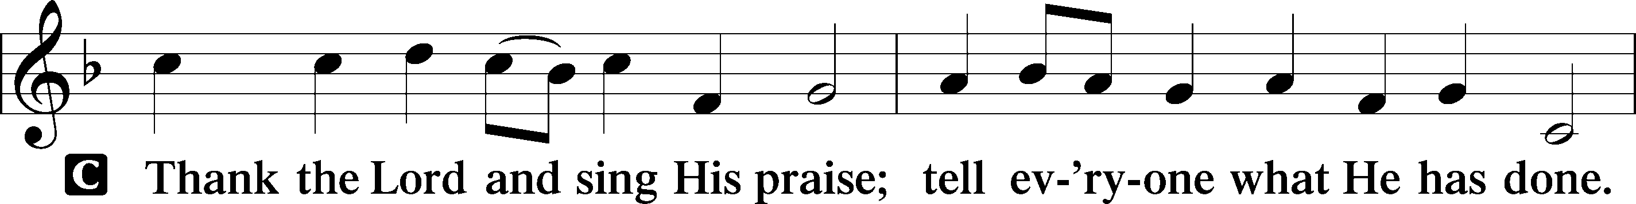

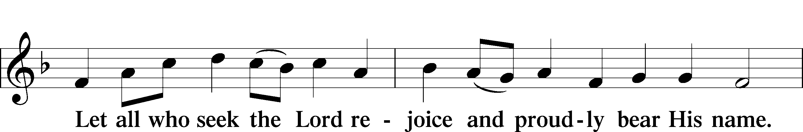

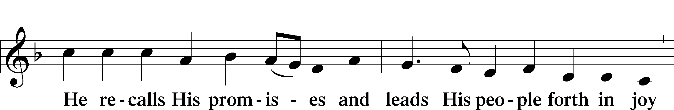

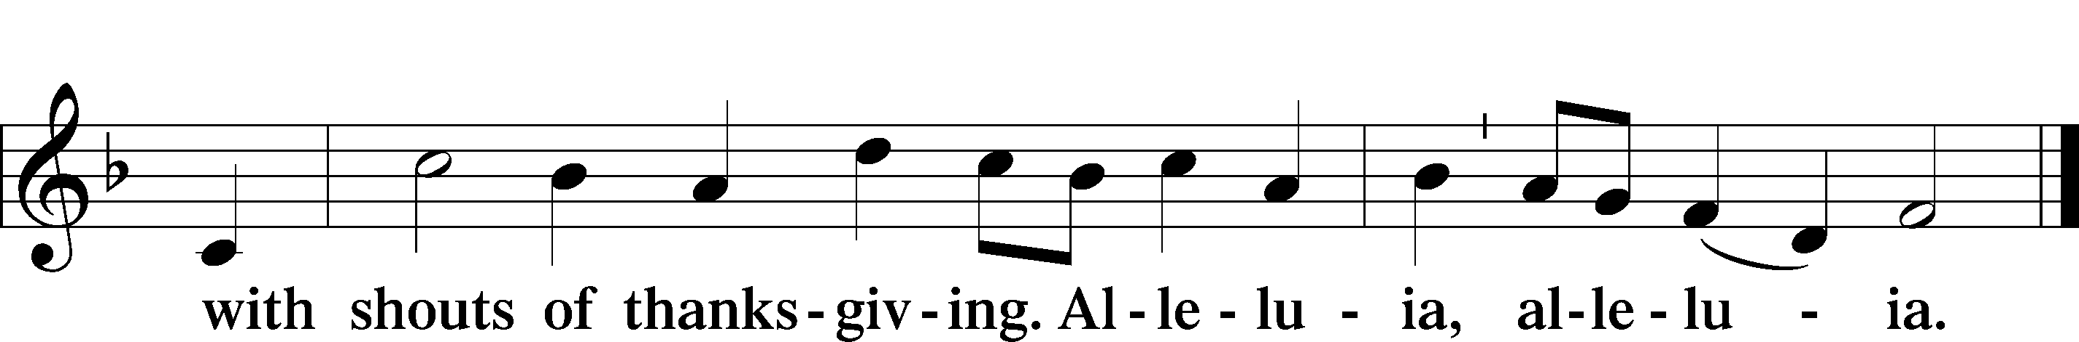

Post-Communion Collect

A Let us pray.

We give thanks to You, almighty God, that You have refreshed us through this salutary gift, and we implore You that of Your mercy You would strengthen us through the same in faith toward You and in fervent love toward one another; through Jesus Christ, Your Son, our Lord, who lives and reigns with You and the Holy Spirit, one God, now and forever.

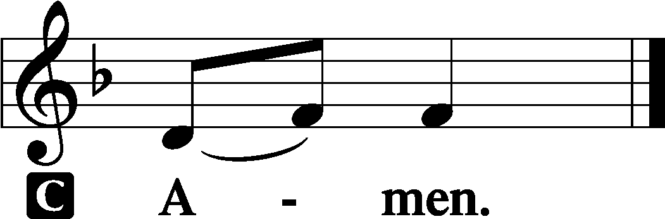

Benediction LSB 166

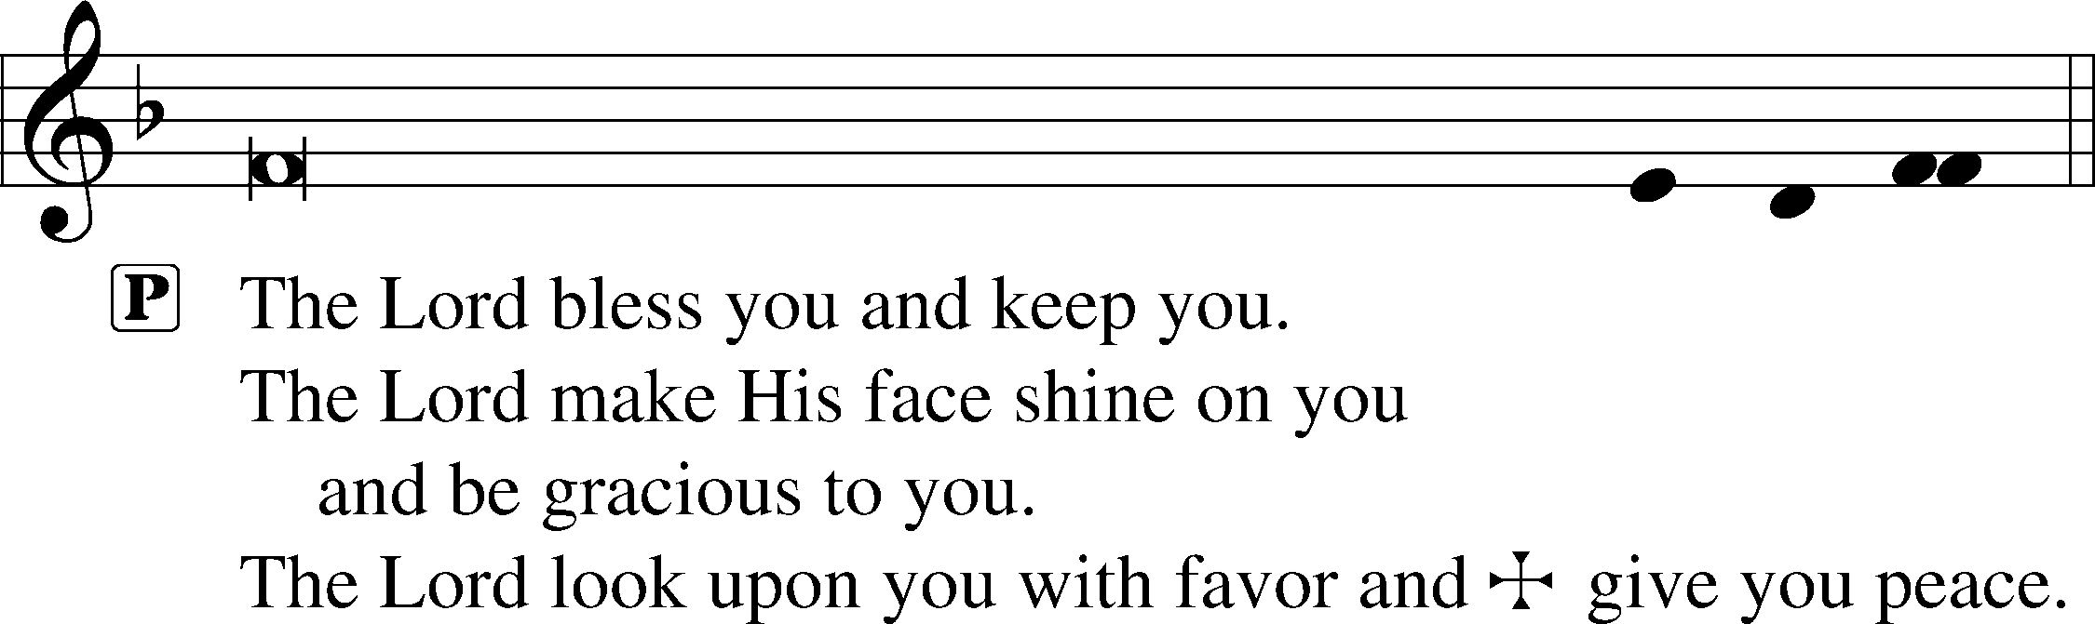



Hymn to Depart: 878 Abide with Me

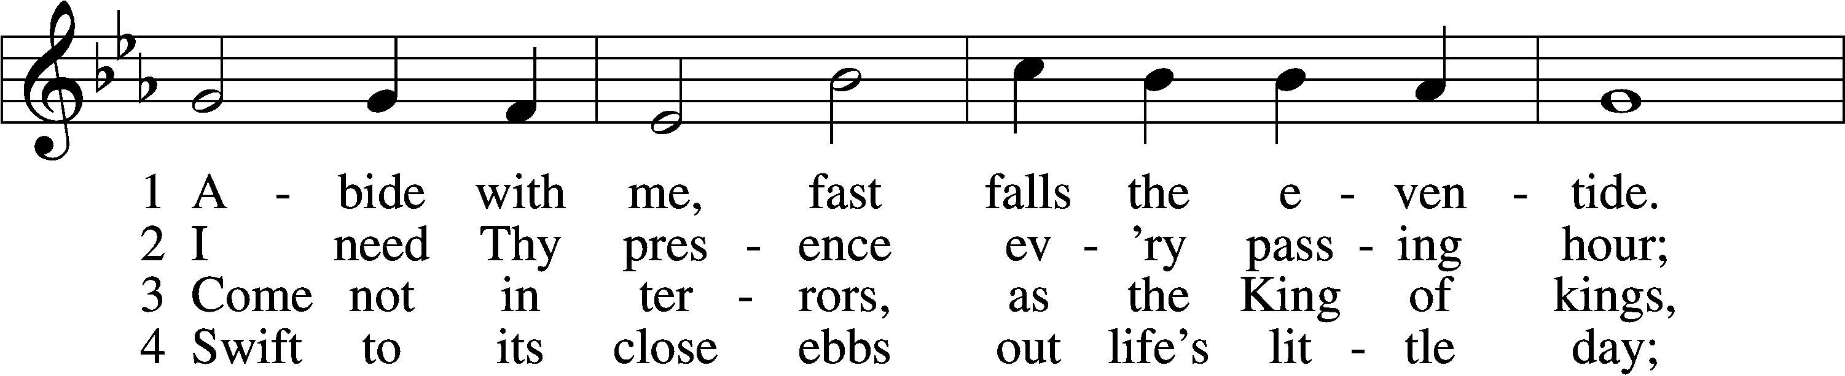

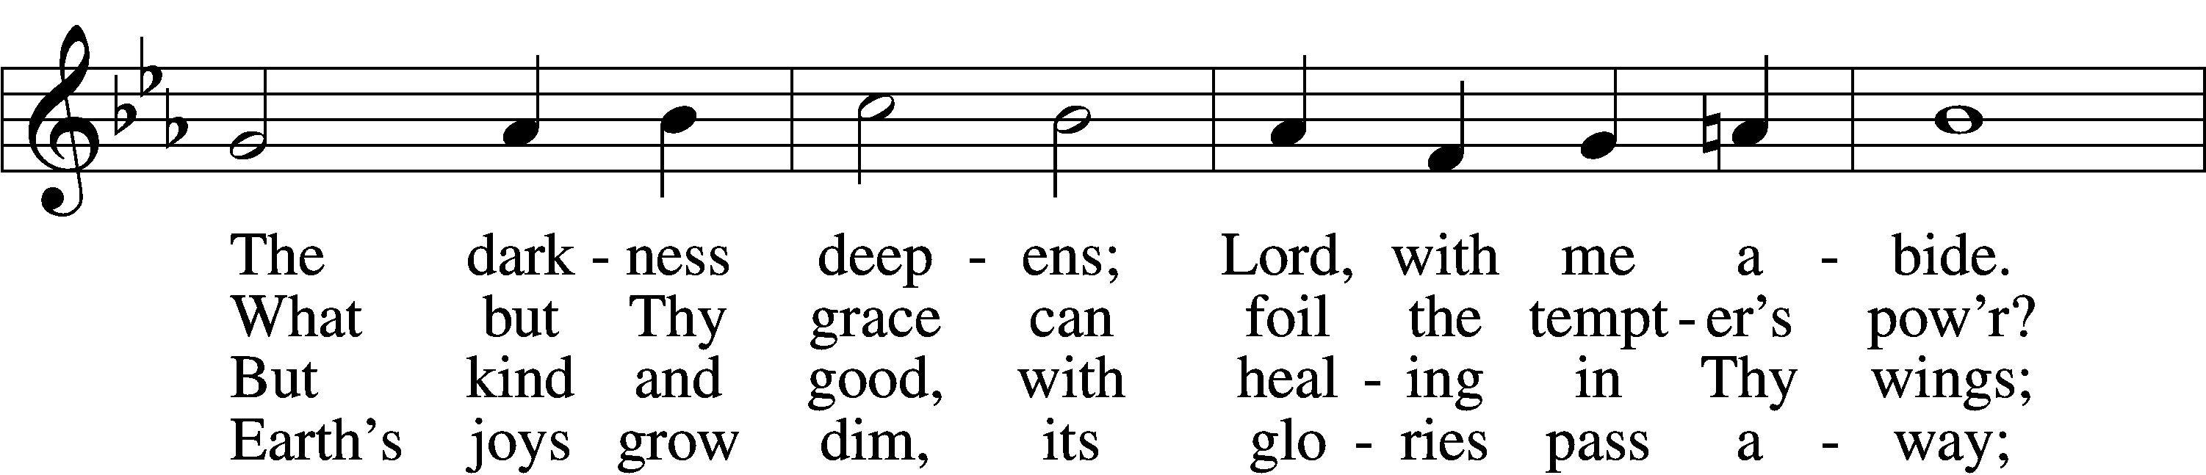

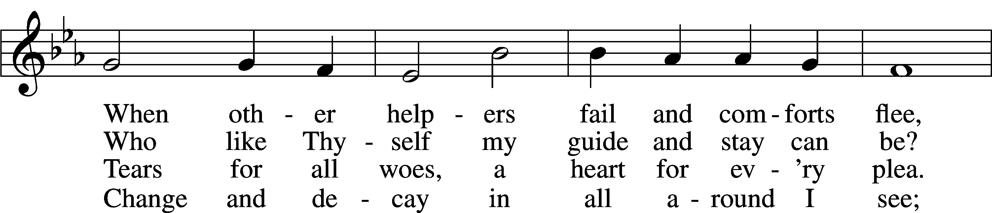

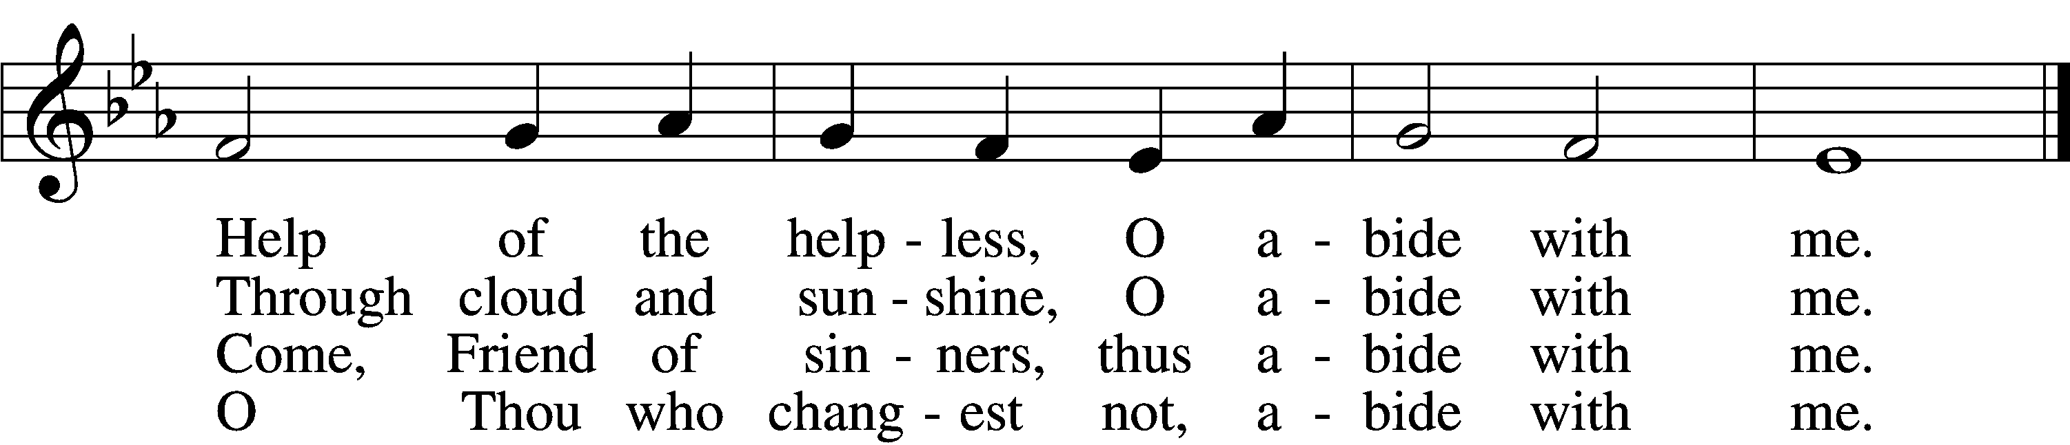

5 I fear no foe with Thee at hand to bless;  
Ills have no weight and tears no bitterness.  
Where is death’s sting? Where, grave, thy victory?  
I triumph still if Thou abide with me!

6 Hold Thou Thy cross before my closing eyes;  
Shine through the gloom, and point me to the skies.  
Heav’n’s morning breaks, and earth’s vain shadows flee;  
In life, in death, O Lord, abide with me.

Text: Henry F. Lyte, 1793–1847, alt.  
Tune: William H. Monk, 1823–89  
Text and tune: Public domain

Acknowledgments

Divine Service, Setting One from Lutheran Service Book

Unless otherwise indicated, Scripture quotations are from the ESV® Bible (The Holy Bible, English Standard Version®), copyright © 2001 by Crossway, a publishing ministry of Good News Publishers. Used by permission. All rights reserved.

Created by Lutheran Service Builder © 2024 Concordia Publishing House.

EVE OF THE CIRCUMCISION AND NAME OF JESUS (NEW YEAR’S EVE) (31 December 2024) **Our Times Are in His Hands** The Church and the world are awake, but for very different reasons. The world counts down to midnight; the Church watches eagerly for her Master who is “coming at an hour” we “do not expect” (Luke 12:40). For many, the changing year brings regrets, fears and desperate wishes for improvement. The world delights in smooth talk and illusions of prosperity at any cost (Is. 30:9–10). It has already forgotten “the Holy One of Israel” born six days earlier (Is. 30:11). The Church ends the calendar year differently. “In returning and rest … in quietness and in trust,” that is, in repentance and faith, for the Holy One saves us, and He is our strength (Is. 30:15). Our times are in His hands (Ps. 31:15), the hands of Mary’s Son — God not only with us, but for us (Matt. 1:23). So, who could be against us? If God has given His Son, “how will he not also with him graciously give us all things?” (Rom. 8:31–32). The Church dresses for action not in fear, but in hope; Christ is coming to serve her with His gifts (Luke 12:37). Who is there to condemn us for the passing year? Christ has died, is raised and intercedes for us! What distress will the new year bring? Nothing can “separate us from the love of God in Christ Jesus our Lord” (Rom. 8:34–39)!

**Prayers Request:**

**Those in the nursing home:** Joann Jaeger **Those Shut-in at home:** Char Herman, Joan Church, Joyce Myers **Those with ongoing health issues:** Harrison Fields, Owen Metz, Daria (Cindy Wright’s friend), Butch L. (Cindy Wright’s Brother-in-law), Melissa Miller. Art Smith (Sue Millerman’s brother), Brenda Sellent (Denise Stabenow’s sister), Sandy Hahn (Cindy Wright’s cousin’s wife) **,** Brenda Gustum (Missy Wiese’s mom), Lexi Anderson, Chris Mueller’s uncle, Pastor and Marlyss Harger, Marlene Synder, Shirley Hehl, Pastor Buechner **Those who lead our nation:** Joe Biden, Kamala Harris, Tony Evers, Rod Nordby  **Those who serve in our military and law enforcement:** Ryan Graf, Chaplain Pon Chanthaphon (Our Adopt-a-Chaplain), Rusty Weise **Our Childcare Staff:** Melissa Frieburg, Denise Stabenow, Holly Wilhelmi, Janica Skjerly, Jacie Amundson, Cathy Anderson, Alora Provencial

**Church Service Phone: 715-438-4200**

**(Stay on the line for recorded service to start)**

**Live Stream audio services:** [**http://salem.listentochurch.com**](http://salem.listentochurch.com)

**Salem’s Web Page:** <https://www.salembarron.com/>

**Pastor Fred Buth: Cell phone:715-642-3050 (H)715-353-2540**

**Pastor’s Email: salembarronpastor@gmail.com**

**Office Hours: Monday-Wednesday 9-12**

**Office email: salembarron@gmail.com**

**Attendance:** 12/29-56

**Coffee and Snacks:**

**Elder Today:** Paul Millerman

**Altar Guild:** Mary Ann Thompson

The offering for 12/24/2024 was the following:

General $3041.75

Mission $647

BLDG $177

Daycare $65

If you would like to be a Lay Delegate or alternate for the North WI District on June 1st & 2nd, in Rothschild WI., please let one of the Elders know or let the office know. Feel free to talk to an Elder if you have any questions.

**All Thrivent members** there will be a meeting right after church on **Sunday January 5th** to decide where the Thrivent choice dollars should go

**Circuit Forum** - Sunday - January 19th, 2025 at 3:00 p.m. at Christ Lutheran Church - Pipe Lake.   Meeting for election of Circuit visitor, and information concerning upcoming District Convention and other business.   Our Congregation will be represented by Lay Delegate.

**Installation of Pastor William Boateng** - January 12th, 2025 at 3:00 p.m. at Shepherd of the Valley - St. Croix Falls.

**Thank You!**  Thank you to all who remembered us with prayers, cards and gifts during this Christmas Season.  You have been very kind and generous in your gratitude to us.  We thank You!  Pastor and Pat Buth