Confession and Absolution

Hymn of Invocation: 904 Blessed Jesus, at Your Word
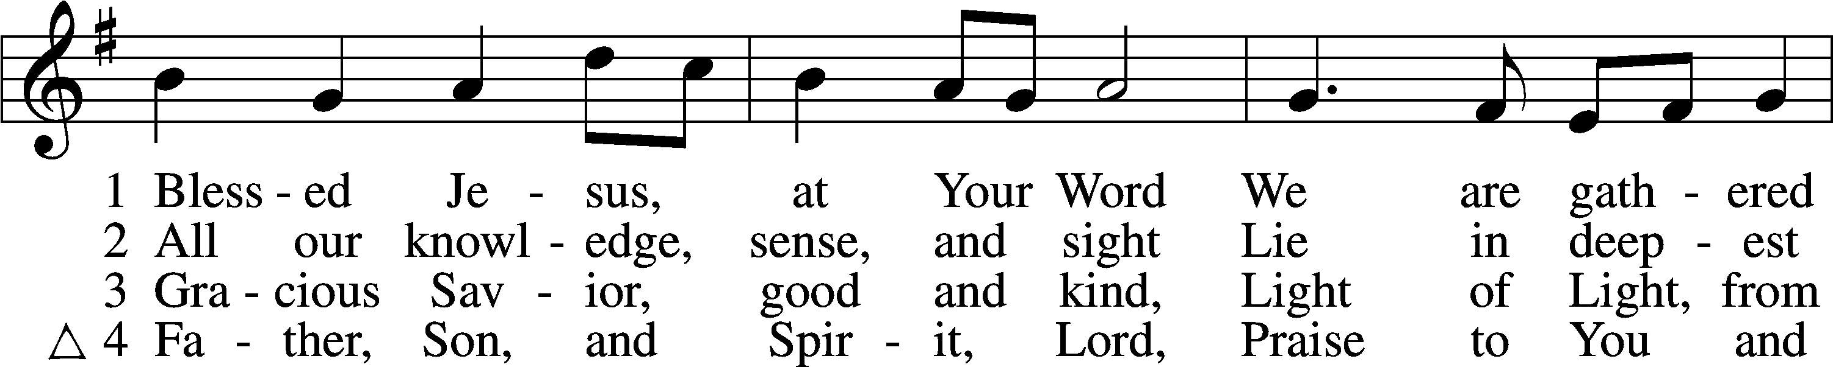
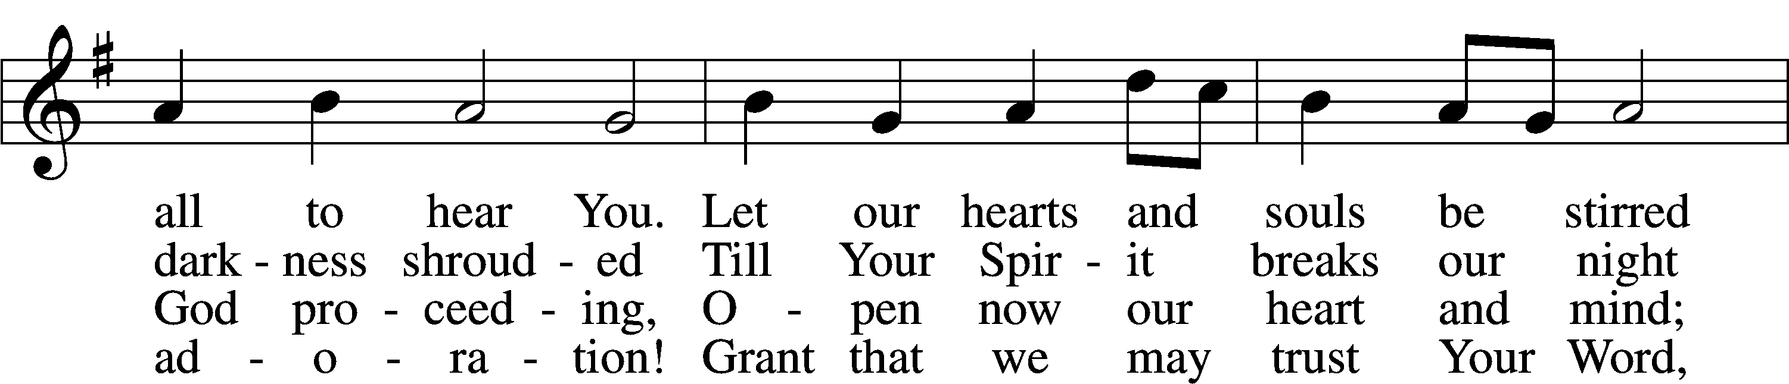
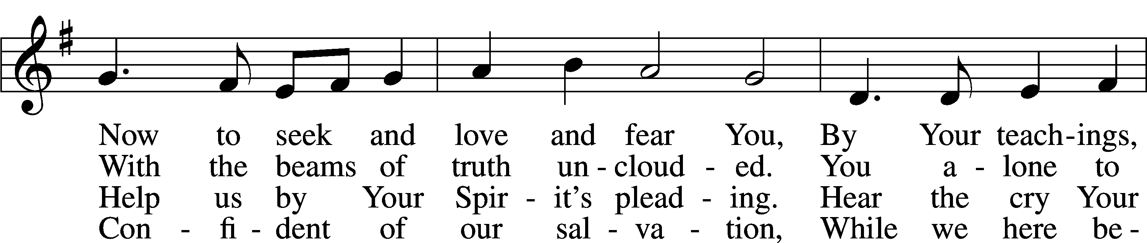
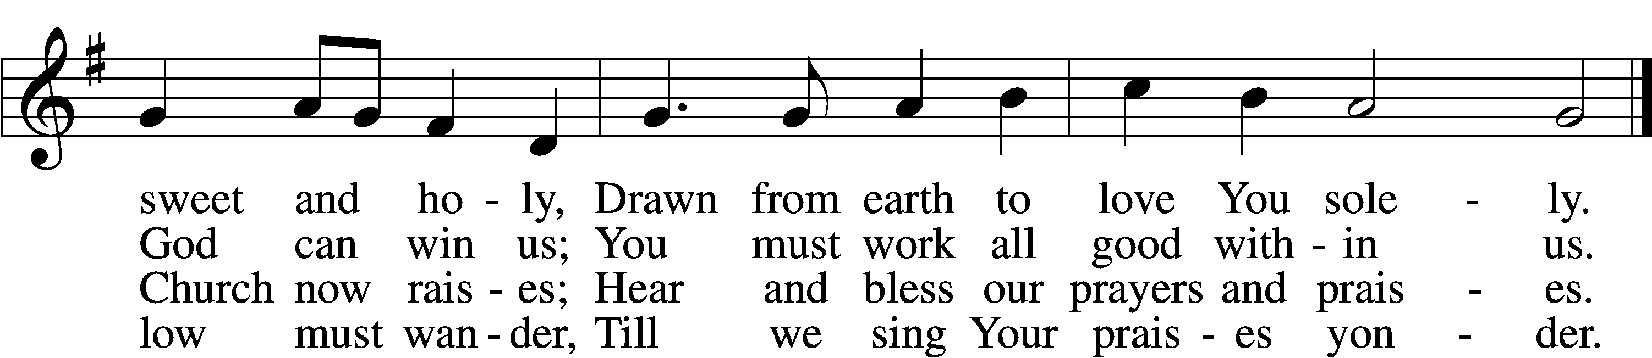
Text (sts. 1–3): Tobias Clausnitzer, 1619–84; (sts. 1–3): tr. Catherine Winkworth, 1827–78, alt.; (st. 4): Geistreiches Gesang-Büchlein, 1707, Berlin; (st. 4): tr. unknown, alt.
Tune: Johann Rudolph Ahle, 1625–73, alt.
Text and tune: Public domain

Stand

The sign of the cross may be made by all in remembrance of their Baptism.

P In the name of the Father and of the T Son and of the Holy Spirit.
C Amen.

P Beloved in the Lord! Let us draw near with a true heart and confess our sins unto God our Father, beseeching Him in the name of our Lord Jesus Christ to grant us forgiveness.

P Our help is in the name of the Lord,
C who made heaven and earth.
P I said, I will confess my transgressions unto the Lord,
C and You forgave the iniquity of my sin.

Kneel/Stand

Silence for reflection on God’s Word and for self-examination.

P O almighty God, merciful Father,
C I, a poor, miserable sinner, confess unto You all my sins and iniquities with which I have ever offended You and justly deserved Your temporal and eternal punishment. But I am heartily sorry for them and sincerely repent of them, and I pray You of Your boundless mercy and for the sake of the holy, innocent, bitter sufferings and death of Your beloved Son, Jesus Christ, to be gracious and merciful to me, a poor, sinful being.

P Upon this your confession, I, by virtue of my office, as a called and ordained servant of the Word, announce the grace of God unto all of you, and in the stead and by the command of my Lord Jesus Christ I forgive you all your sins in the name of the Father and of the T Son and of the Holy Spirit.
C Amen.

Stand

Service of the Word

Introit Psalm 62:5–8; antiphon: v. 1
For God alone my soul waits in silence;
from him comes my salvation.
For God alone, O my soul, wait in silence,
for my hope is from him.
He only is my rock and my salvation, my fortress;
I shall not be shaken.
On God rests my salvation and my glory;
my mighty rock, my refuge is God.
Trust in him at all times, O people; pour out your heart before him;
God is a refuge for us.
Glory be to the Father and to the Son
and to the Holy Spirit;
as it was in the beginning,
is now, and will be forever. Amen.
For God alone my soul waits in silence;
from him comes my salvation.

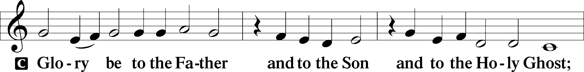
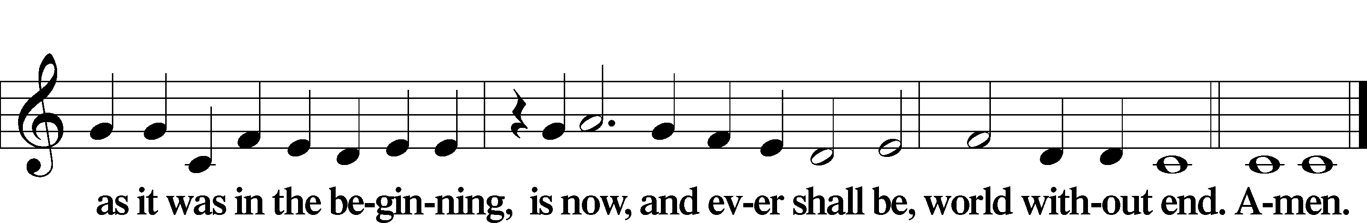

Kyrie LSB 186
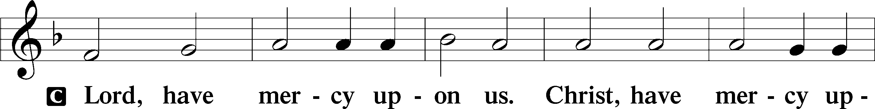
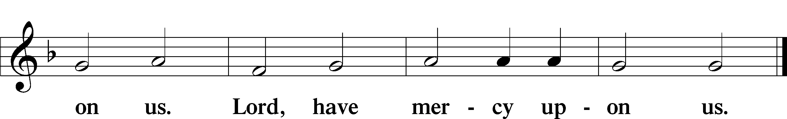

Gloria in Excelsis LSB 187
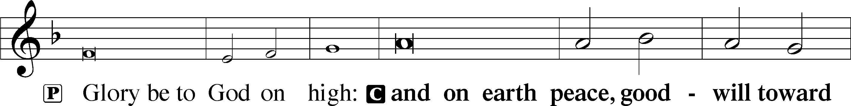
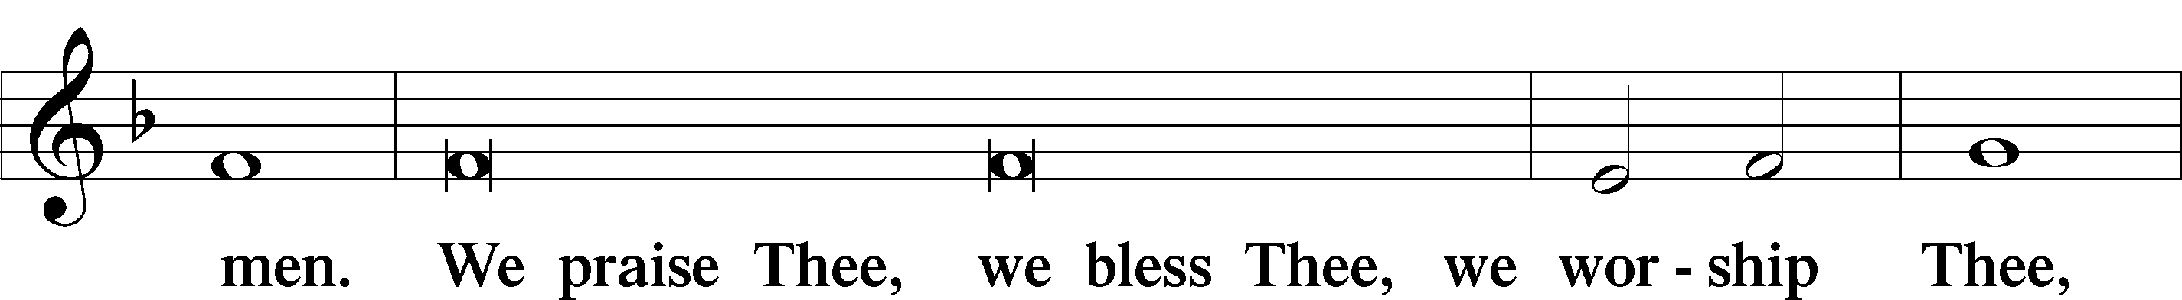
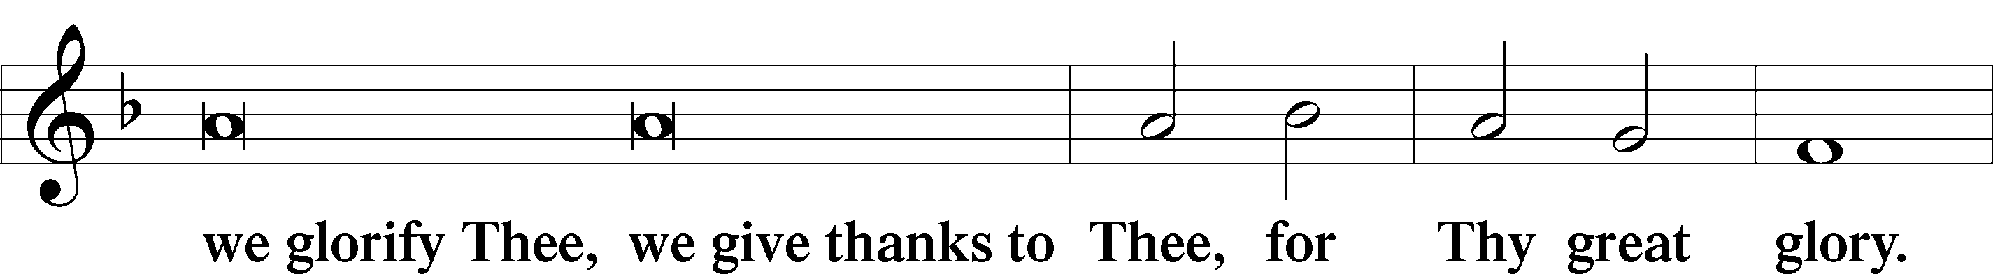
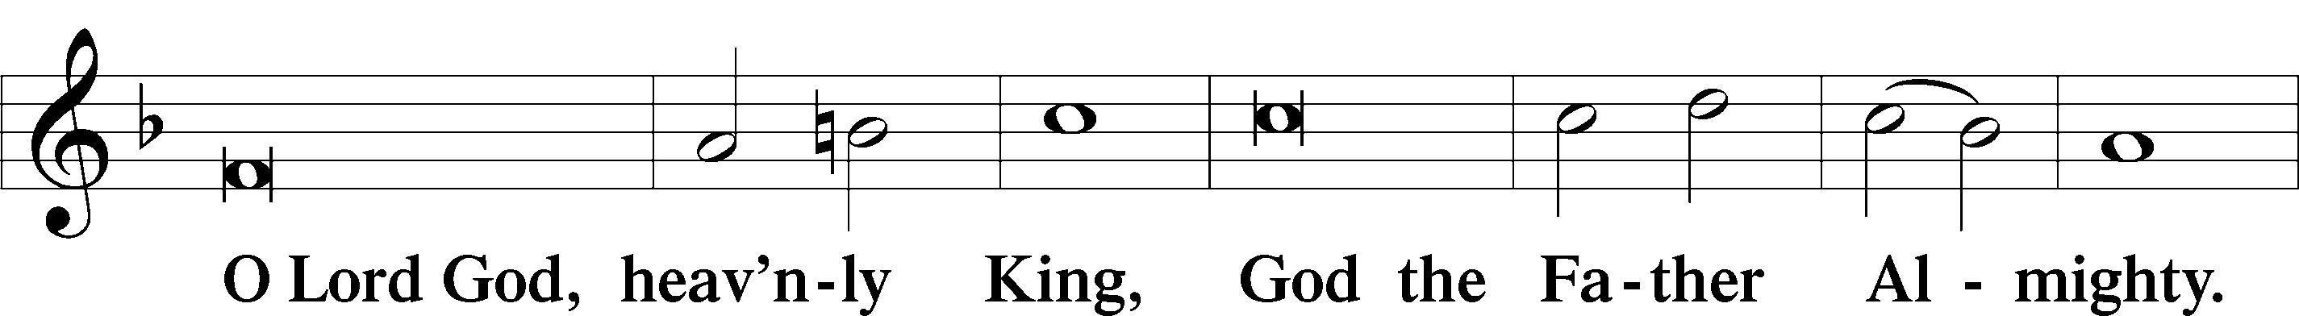
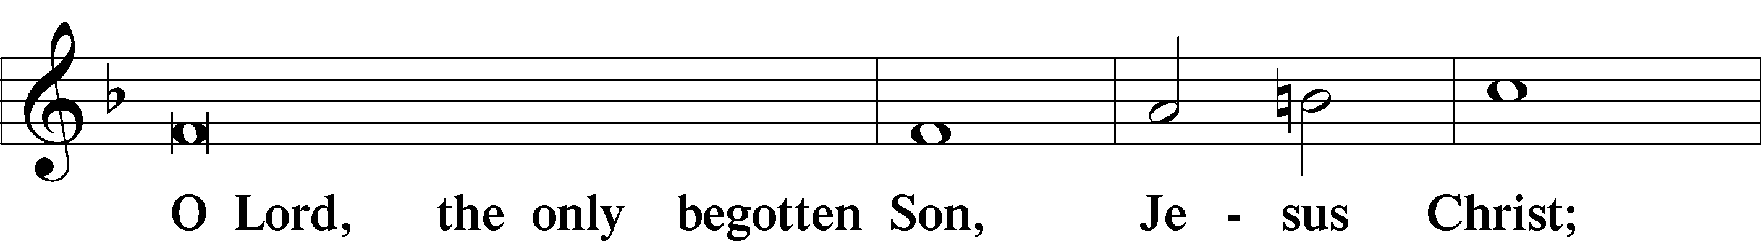
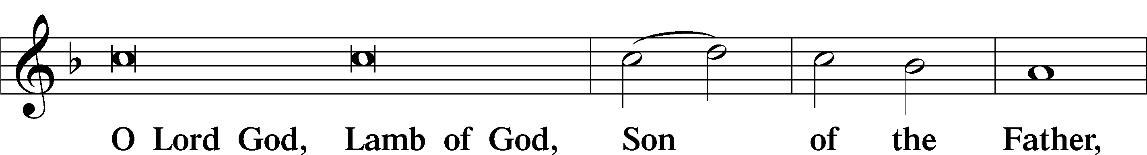
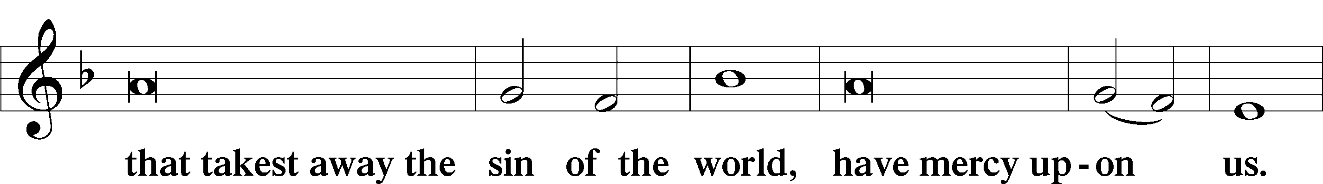
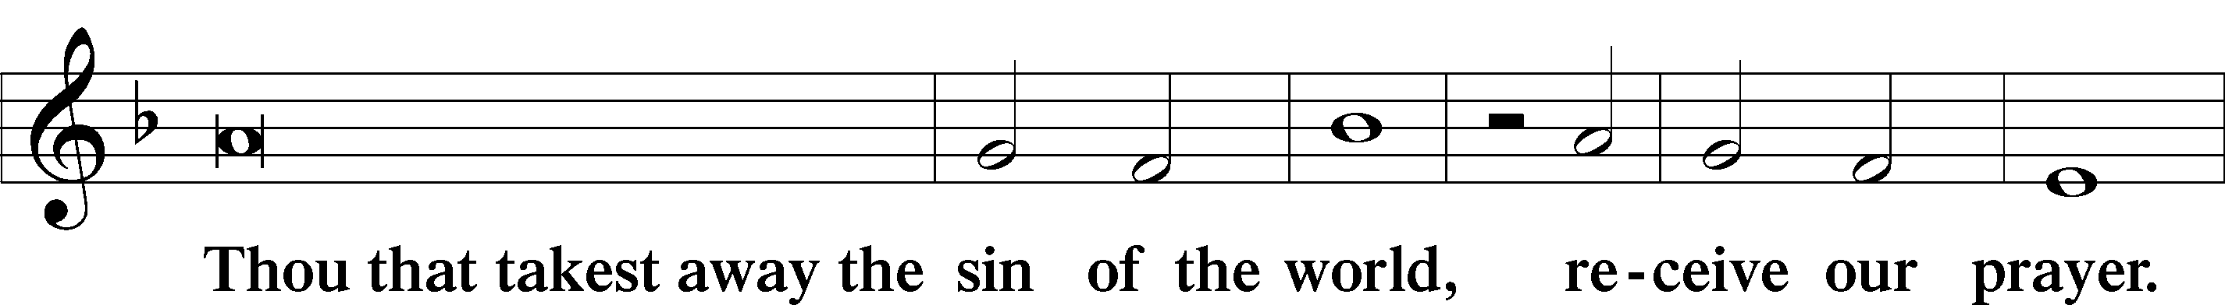
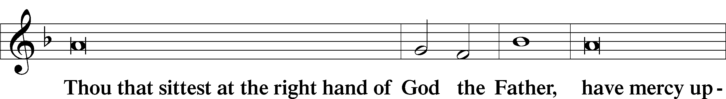
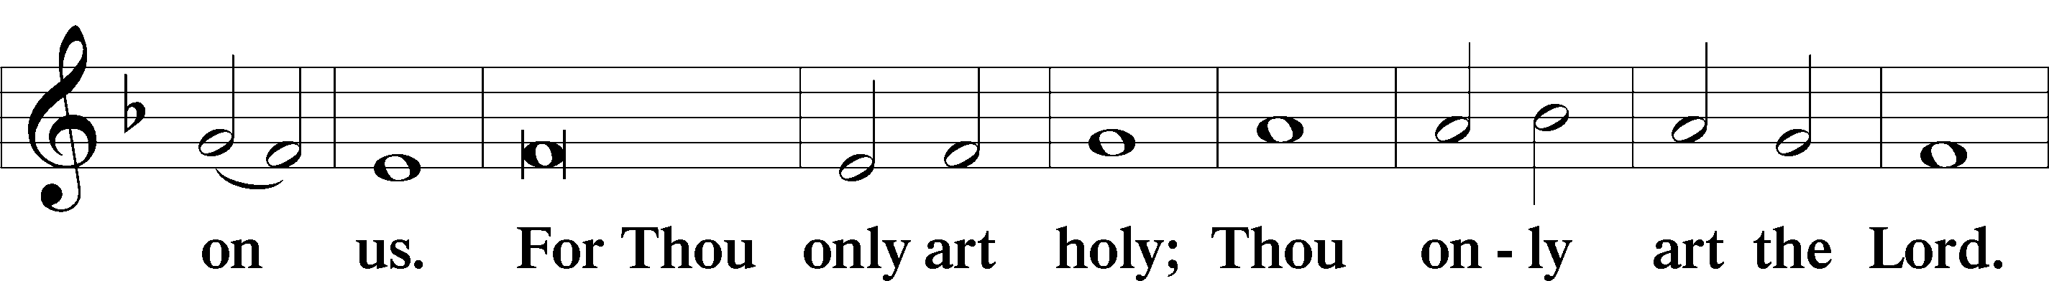
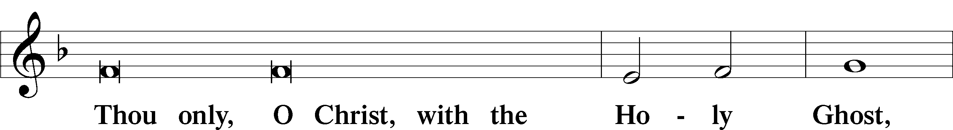
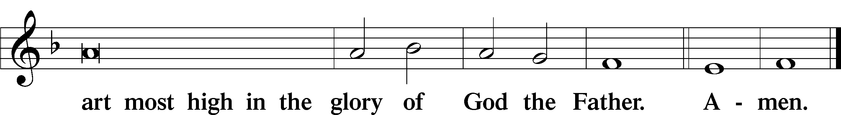

Salutation and Collect of the Day
P The Lord be with you.
C And with thy spirit.

P Let us pray.
Eternal God, Your Son Jesus Christ is our true Sabbath rest. Help us to keep each day holy by receiving His Word of comfort that we may find our rest in Him, who lives and reigns with You and the Holy Spirit, one God, now and forever.

C Amen.

Sit

Old Testament Reading Deuteronomy 5:12–15
12“‘Observe the Sabbath day, to keep it holy, as the Lord your God commanded you. 13Six days you shall labor and do all your work, 14but the seventh day is a Sabbath to the Lord your God. On it you shall not do any work, you or your son or your daughter or your male servant or your female servant, or your ox or your donkey or any of your livestock, or the sojourner who is within your gates, that your male servant and your female servant may rest as well as you. 15You shall remember that you were a slave in the land of Egypt, and the Lord your God brought you out from there with a mighty hand and an outstretched arm. Therefore the Lord your God commanded you to keep the Sabbath day.’”

A This is the Word of the Lord.
C Thanks be to God.

Psalm Psalm 81:1–10; antiphon: v. 13
Oh, That My People Would Listen to Me
1Sing aloud to God our strength;
shout for joy to the God of Jacob!
2Raise a song; sound the tambourine,
the sweet lyre with the harp.
3Blow the trumpet at the new moon,
at the full moon, on our feast day.
4For it is a statute for Israel,
a just decree of the God of Jacob.
5He made it a decree in Joseph
when he went out over the land of Egypt.
I hear a language I had not known:
6“I relieved your shoulder of the burden;
your hands were freed from the basket.
7In distress you called, and I delivered you;
I answered you in the secret place of thunder;
I tested you at the waters of Meribah.
8Hear, O my people, while I admonish you!
O Israel, if you would but listen to me!
9There shall be no strange god among you;
you shall not bow down to a foreign god.
10I am the Lord your God,
who brought you up out of the land of Egypt.
Open your mouth wide, and I will fill it.

Epistle 2 Corinthians 4:5–12
5What we proclaim is not ourselves, but Jesus Christ as Lord, with ourselves as your servants for Jesus’ sake. 6For God, who said, “Let light shine out of darkness,” has shone in our hearts to give the light of the knowledge of the glory of God in the face of Jesus Christ.
Treasures in Jars of Clay
7But we have this treasure in jars of clay, to show that the surpassing power belongs to God and not to us. 8We are afflicted in every way, but not crushed; perplexed, but not driven to despair; 9persecuted, but not forsaken; struck down, but not destroyed; 10always carrying in the body the death of Jesus, so that the life of Jesus may also be manifested in our bodies. 11For we who live are always being given over to death for Jesus’ sake, so that the life of Jesus also may be manifested in our mortal flesh. 12So death is at work in us, but life in you.

A This is the Word of the Lord.
C Thanks be to God.

Stand

Alleluia LSB 190
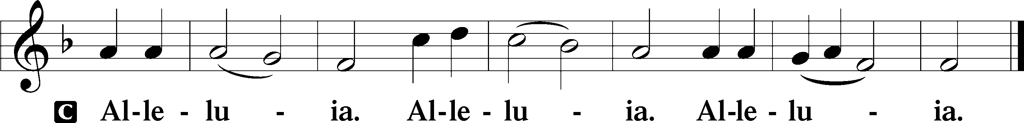

Holy Gospel Mark 2:23—3:6
P The Holy Gospel according to St. Mark, the second chapter.
C Glory be to Thee, O Lord.

Jesus Is Lord of the Sabbath
23One Sabbath [Jesus] was going through the grainfields, and as they made their way, his disciples began to pluck heads of grain. 24And the Pharisees were saying to him, “Look, why are they doing what is not lawful on the Sabbath?” 25And he said to them, “Have you never read what David did, when he was in need and was hungry, he and those who were with him: 26how he entered the house of God, in the time of Abiathar the high priest, and ate the bread of the Presence, which it is not lawful for any but the priests to eat, and also gave it to those who were with him?” 27And he said to them, “The Sabbath was made for man, not man for the Sabbath. 28So the Son of Man is lord even of the Sabbath.”
A Man with a Withered Hand
1Again he entered the synagogue, and a man was there with a withered hand. 2And they watched Jesus, to see whether he would heal him on the Sabbath, so that they might accuse him. 3And he said to the man with the withered hand, “Come here.” 4And he said to them, “Is it lawful on the Sabbath to do good or to do harm, to save life or to kill?” But they were silent. 5And he looked around at them with anger, grieved at their hardness of heart, and said to the man, “Stretch out your hand.” He stretched it out, and his hand was restored. 6The Pharisees went out and immediately held counsel with the Herodians against him, how to destroy him.

P This is the Gospel of the Lord.
C Praise be to Thee, O Christ.

Nicene Creed
C I believe in one God,
the Father Almighty,
maker of heaven and earth
and of all things visible and invisible.

And in one Lord Jesus Christ,
the only-begotten Son of God,
begotten of His Father before all worlds,
God of God, Light of Light,
very God of very God,
begotten, not made,
being of one substance with the Father,
by whom all things were made;
who for us men and for our salvation came down from heaven
and was incarnate by the Holy Spirit of the virgin Mary
and was made man;
and was crucified also for us under Pontius Pilate.
He suffered and was buried.
And the third day He rose again according to the Scriptures
and ascended into heaven
and sits at the right hand of the Father.
And He will come again with glory to judge both the living and the dead,
whose kingdom will have no end.

And I believe in the Holy Spirit,
the Lord and giver of life,
who proceeds from the Father and the Son,
who with the Father and the Son together is worshiped and glorified,
who spoke by the prophets.
And I believe in one holy Christian and apostolic Church,
I acknowledge one Baptism for the remission of sins,
and I look for the resurrection of the dead
and the life T of the world to come. Amen.

Sit

Hymn of the Day: 579 The Law of God Is Good and Wise
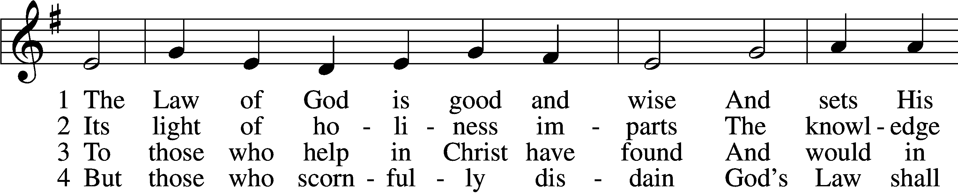
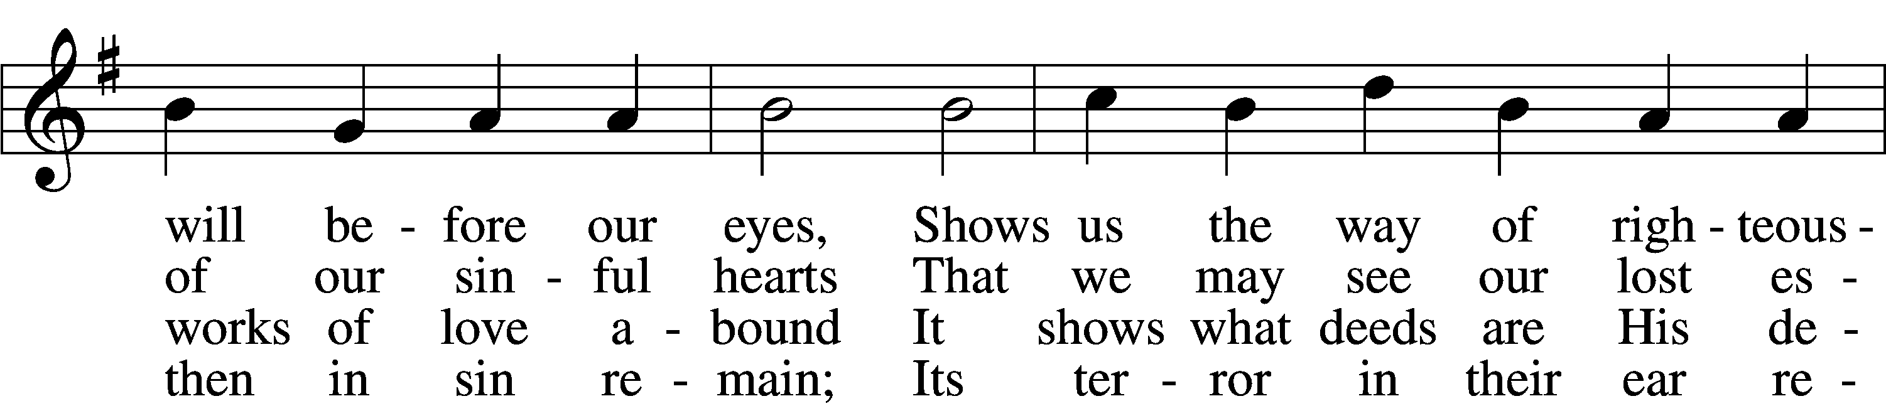
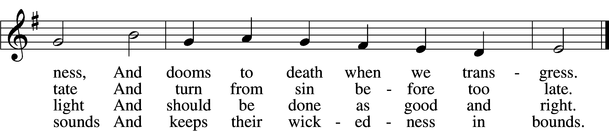

5 The Law is good; but since the fall
Its holiness condemns us all;
It dooms us for our sin to die
And has no pow’r to justify.

6 To Jesus we for refuge flee,
Who from the curse has set us free,
And humbly worship at His throne,
Saved by His grace through faith alone.
Text: Matthias Loy, 1828–1915, alt.
Tune: Geistliche Lieder auffs new gebessert, 1543, Wittenberg, ed. Joseph Klug
Text and tune: Public domain

Sermon

P The peace of God, which passes all understanding, keep your hearts and minds in Christ Jesus.
C Amen.

Stand

Offertory LSB 192
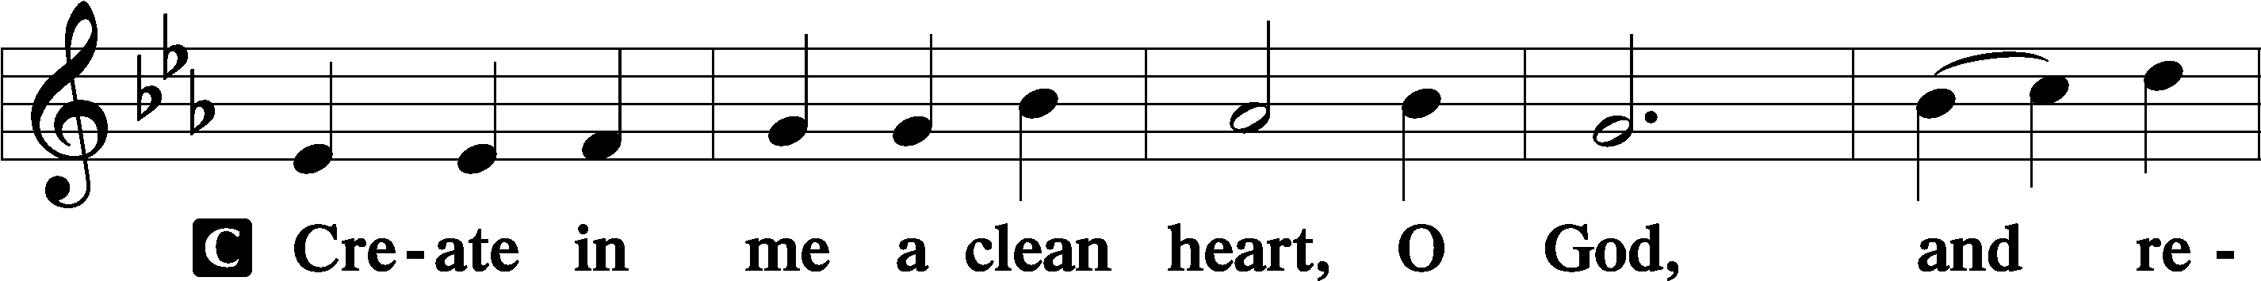
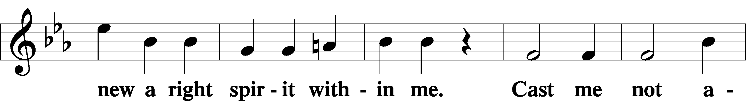
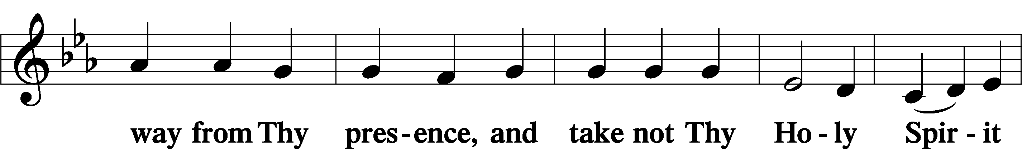
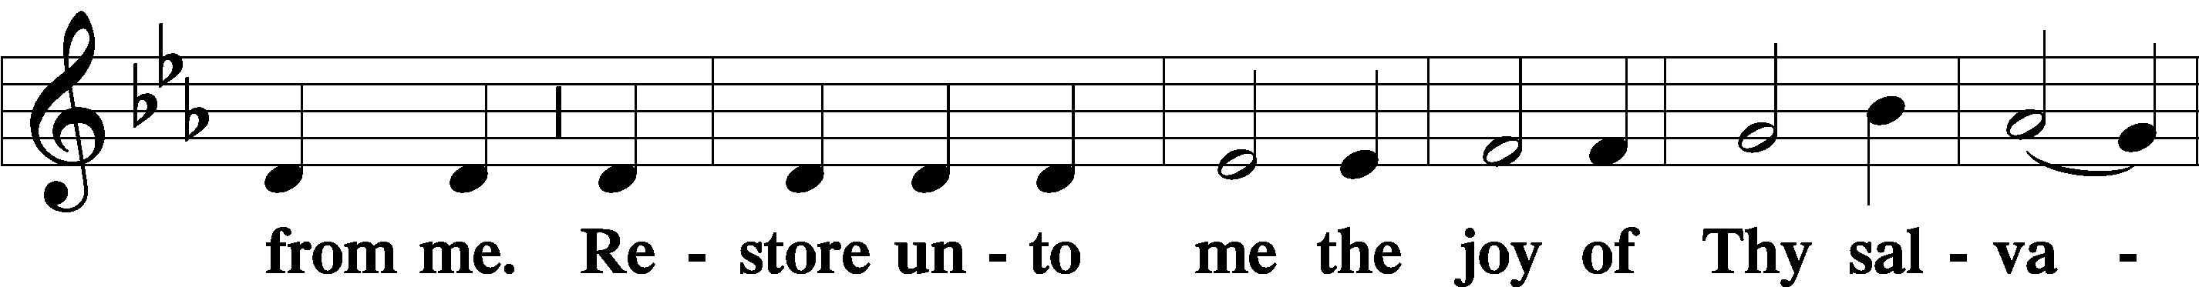
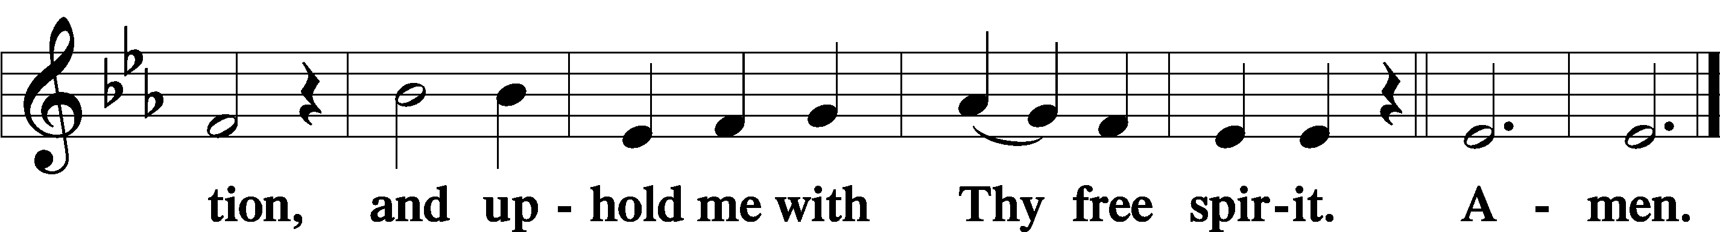

Sit

Offering

Stand

Prayer of the Church

Service of the Sacrament

Preface LSB 194
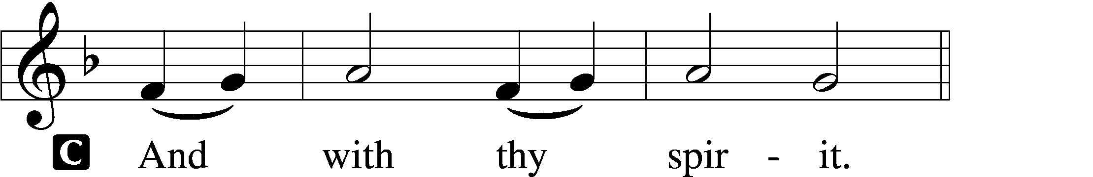

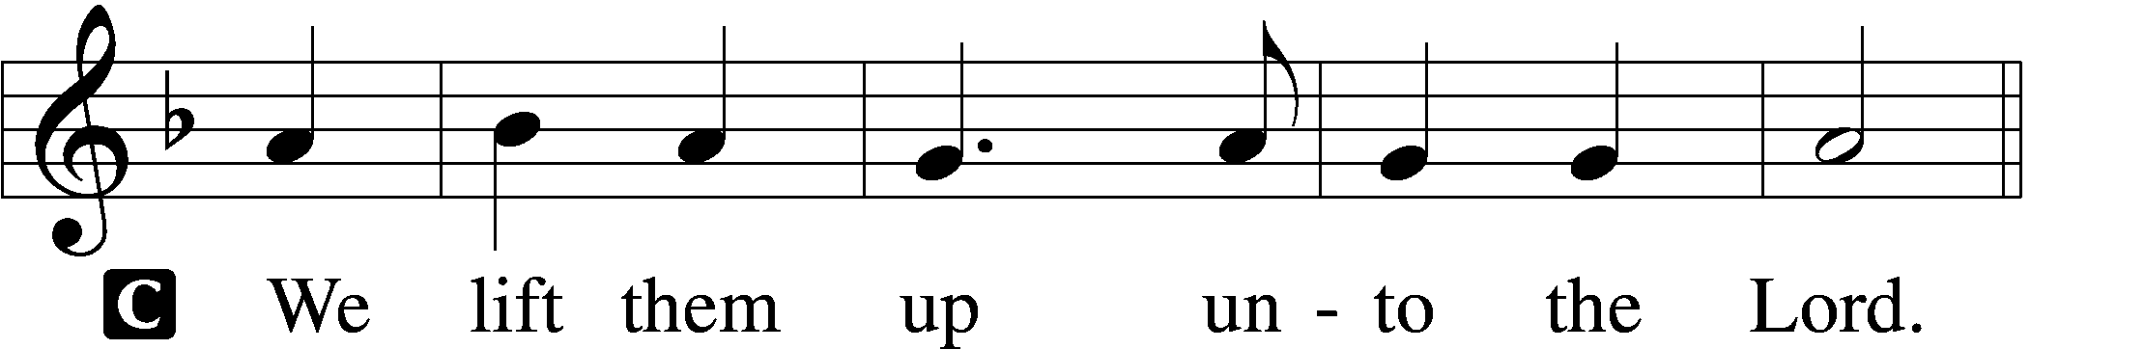

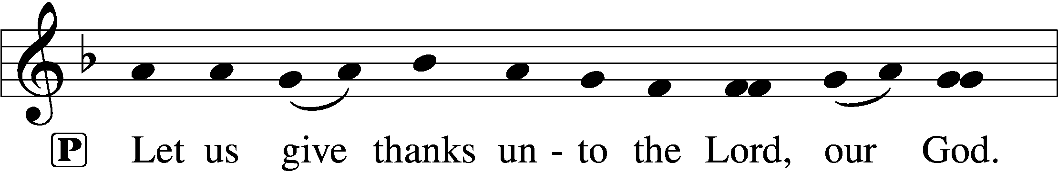
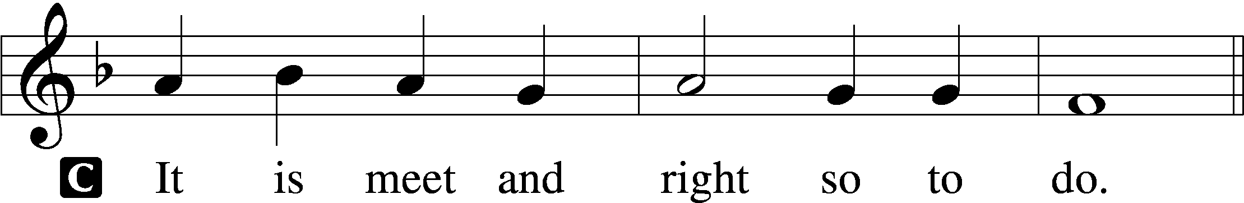

P It is truly meet, right, and salutary that we should at all times and in all places give thanks to You, holy Lord, almighty Father, everlasting God, through Jesus Christ, our Lord. Therefore with angels and archangels and with all the company of heaven we laud and magnify Your glorious name, evermore praising You and saying:

Sanctus LSB 195
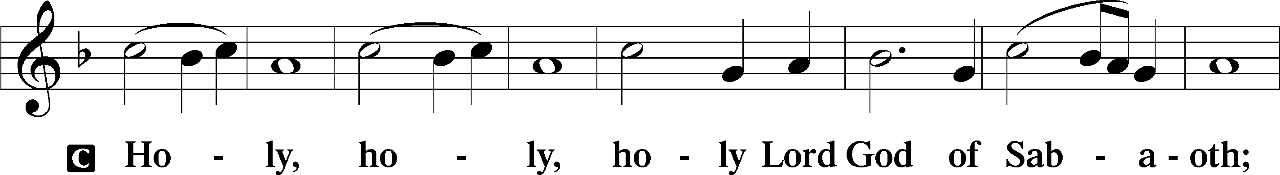
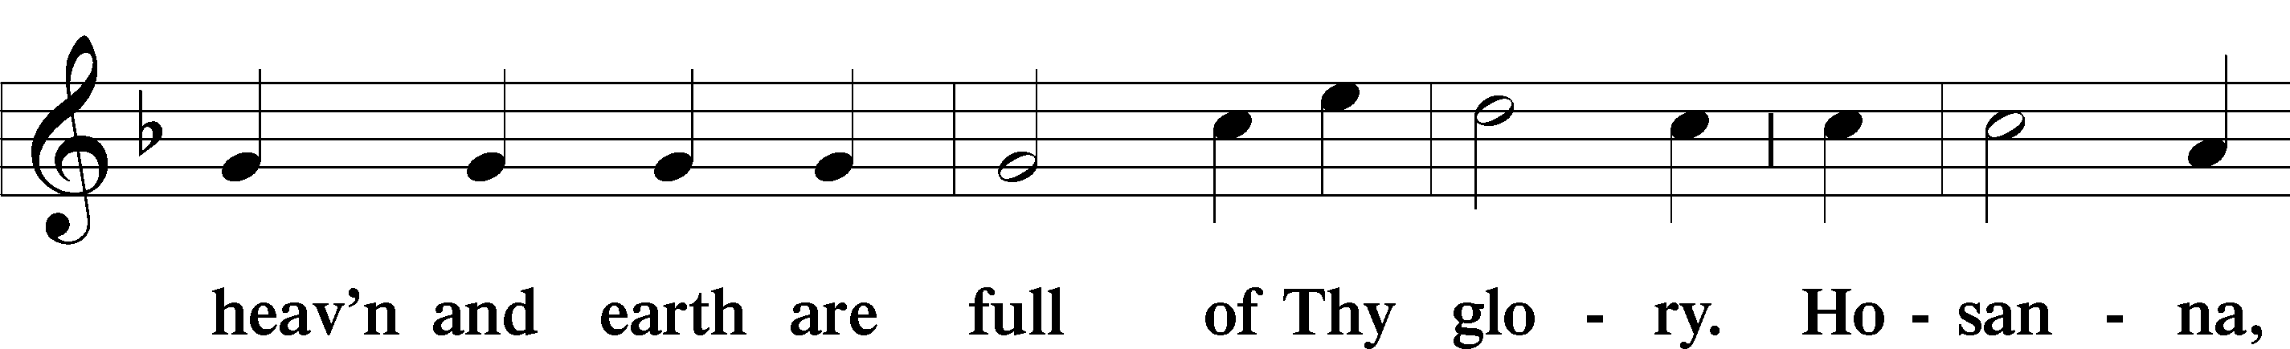
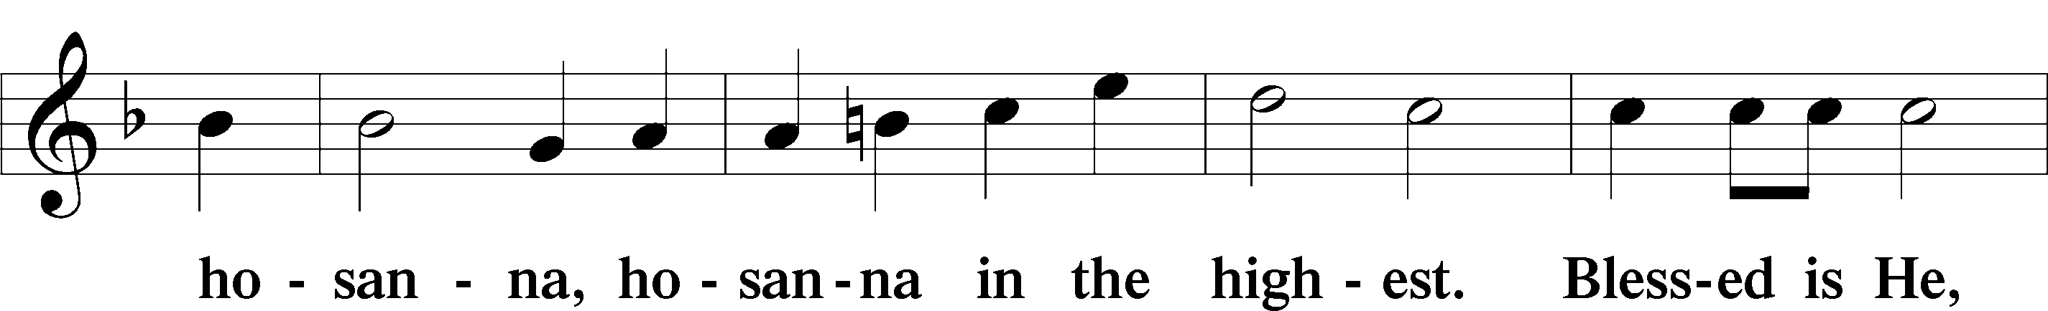
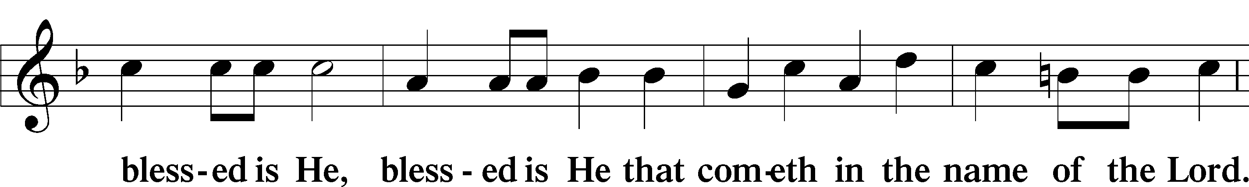
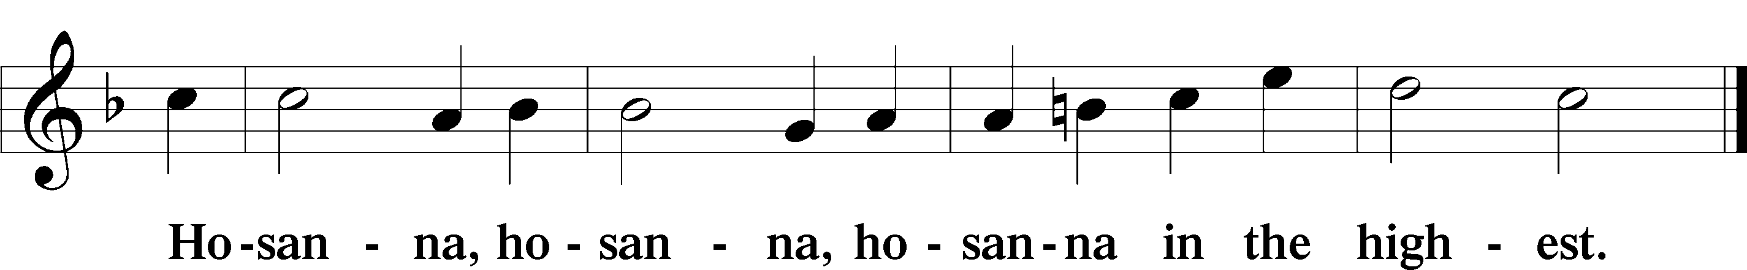

Lord’s Prayer LSB 196
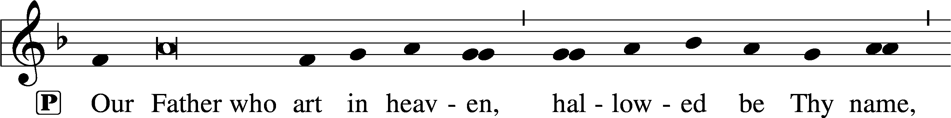
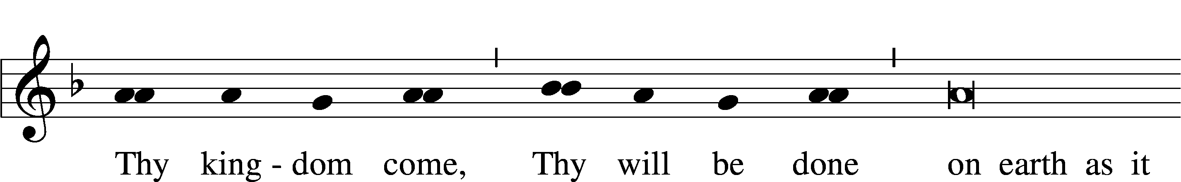
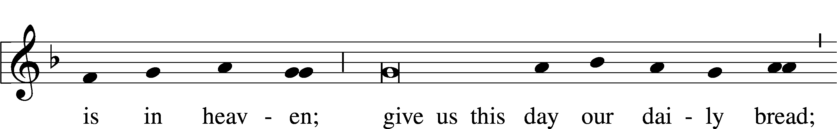
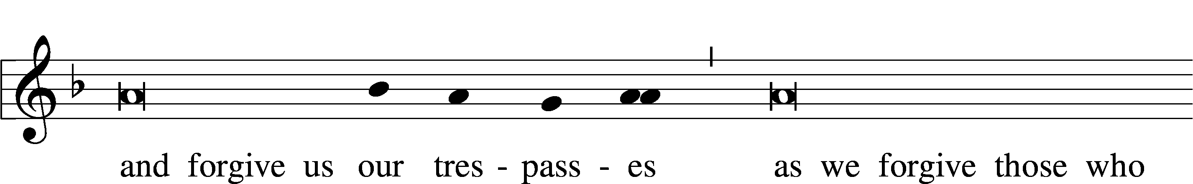
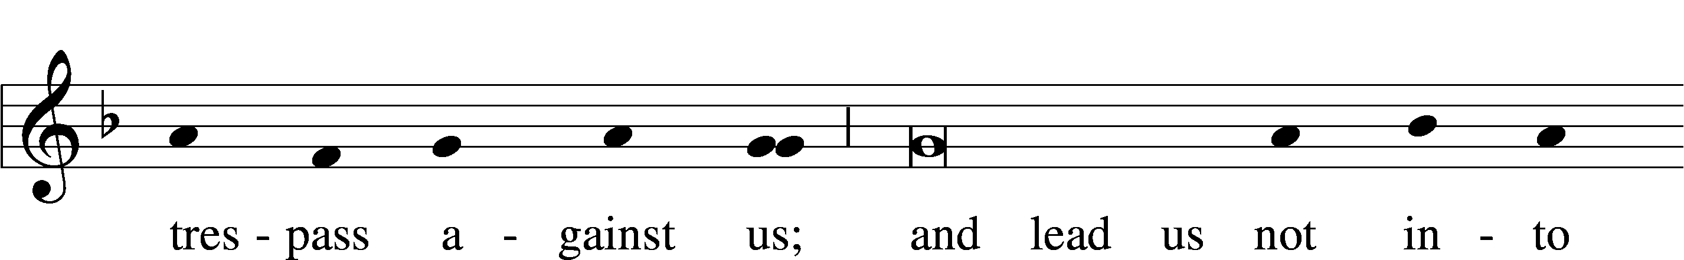
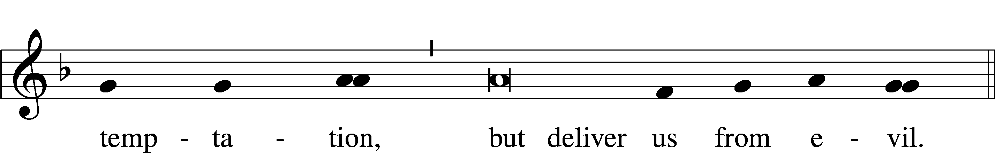

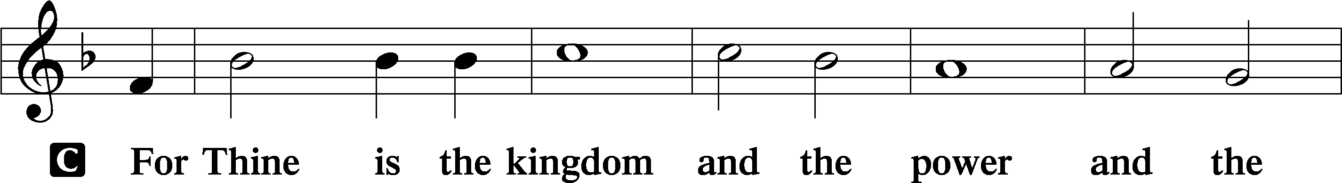
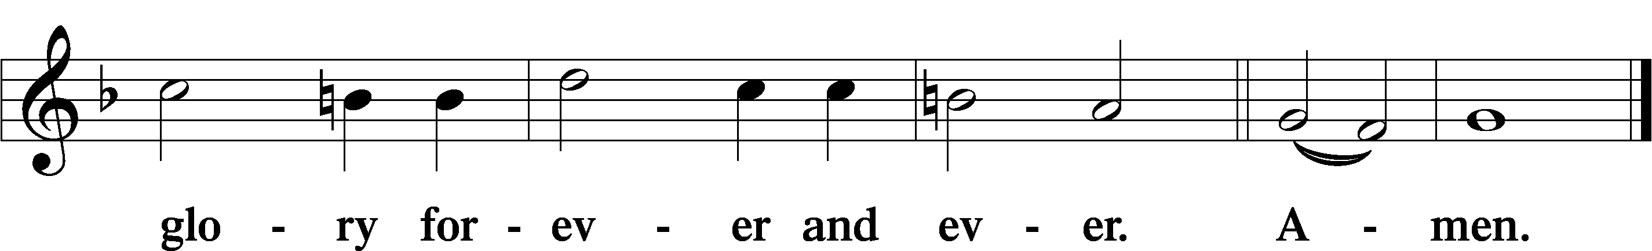

The Words of Our Lord LSB 197
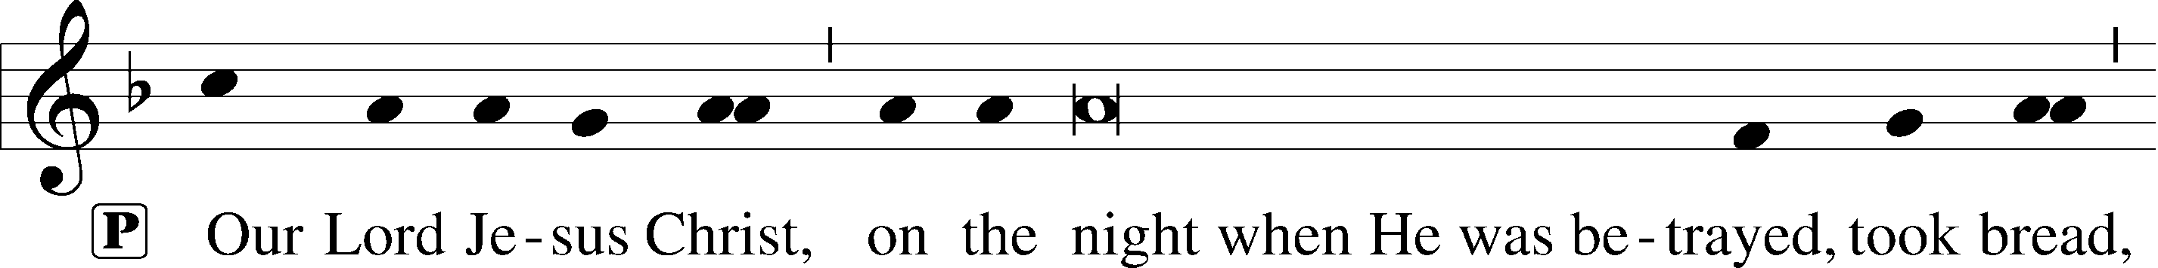
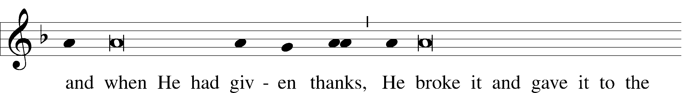
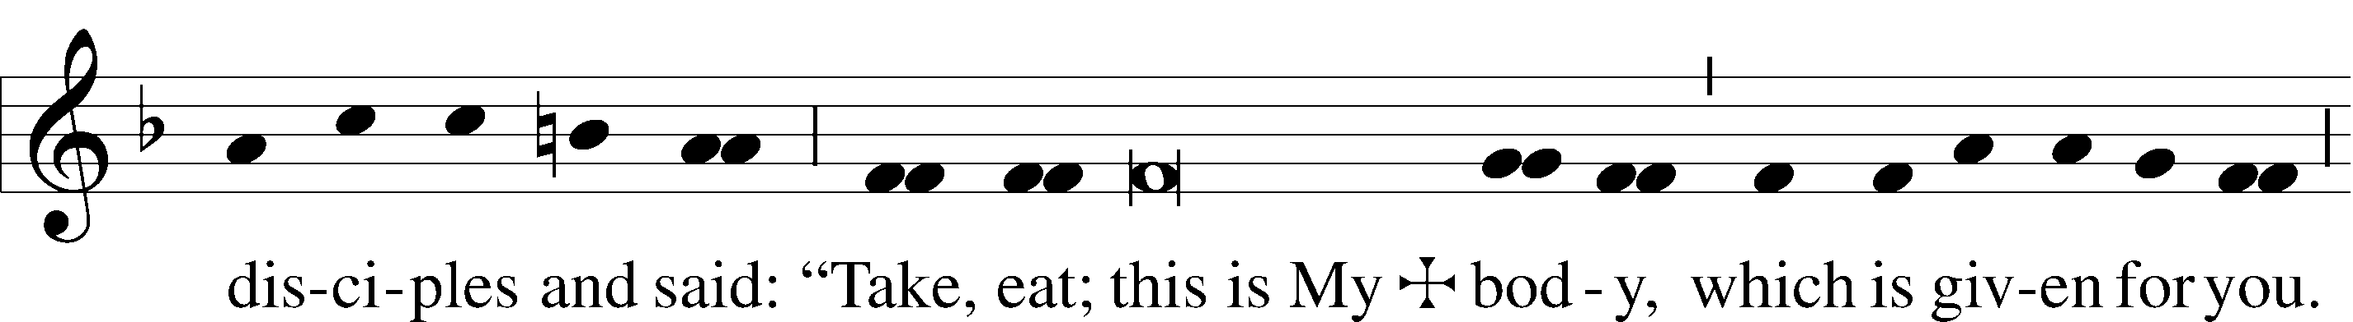
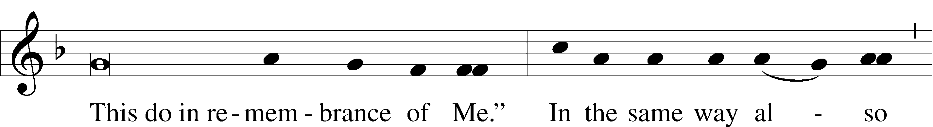
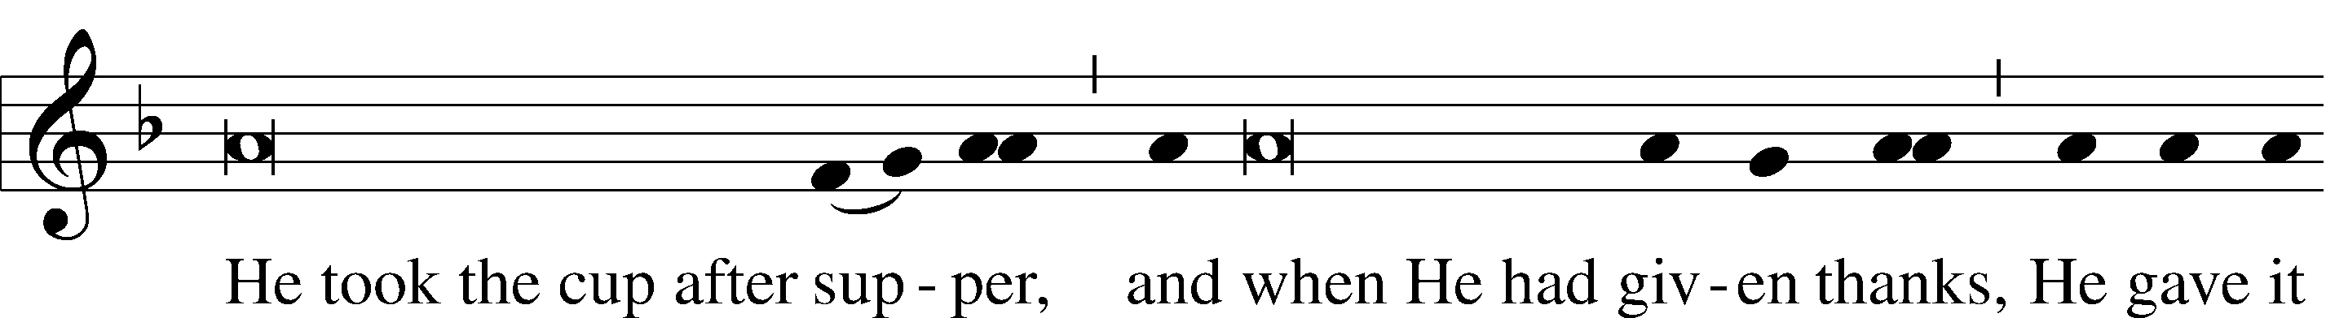
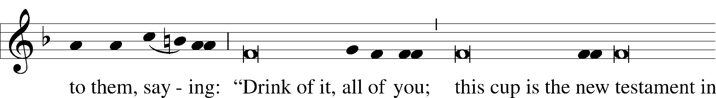
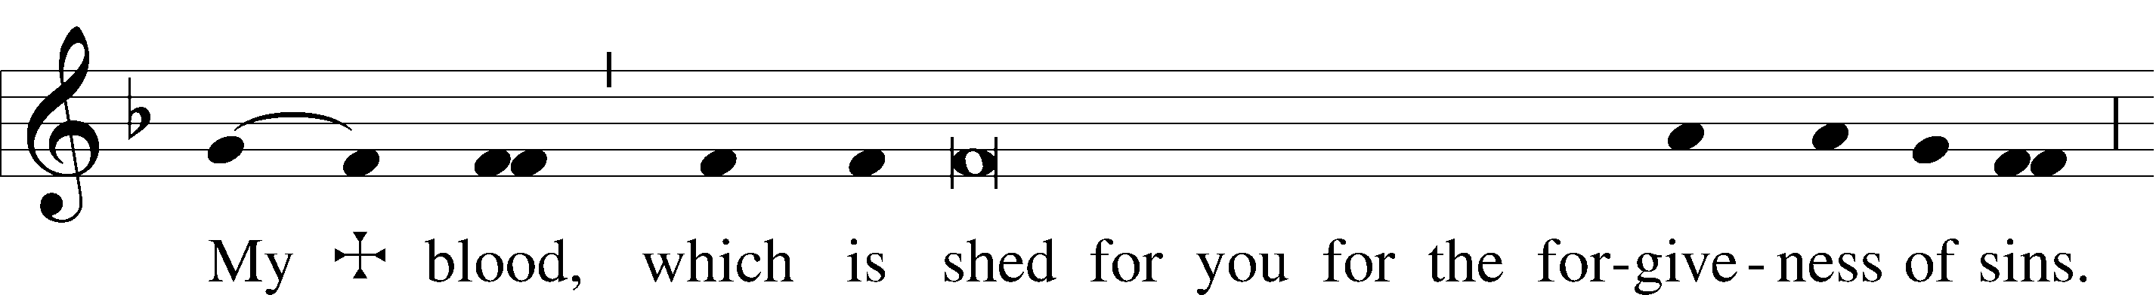
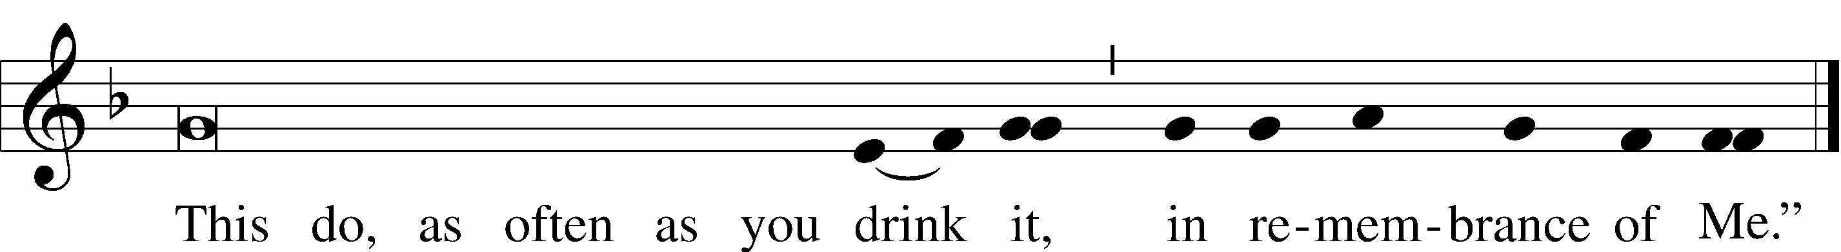

Pax Domini LSB 197
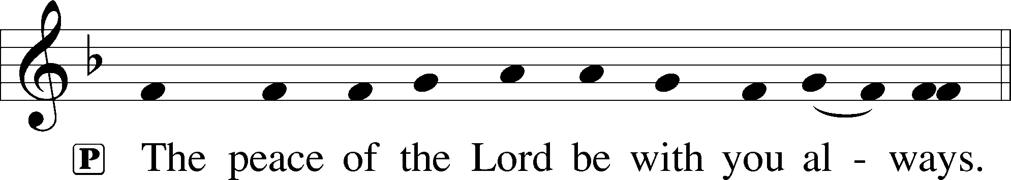

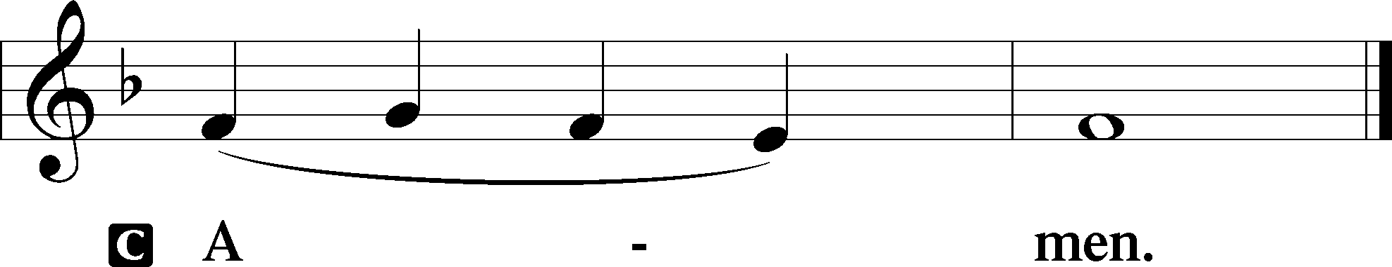

Agnus Dei LSB 198
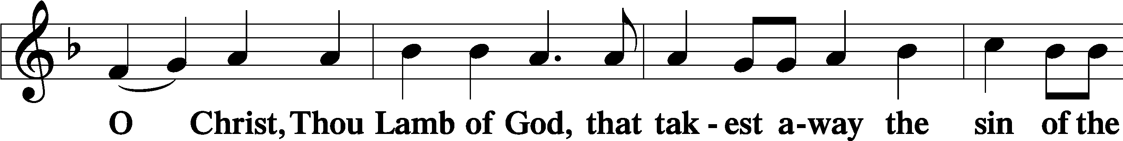
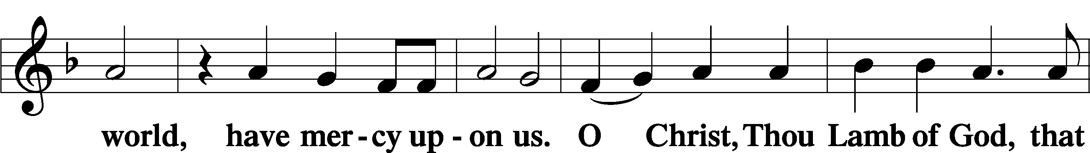
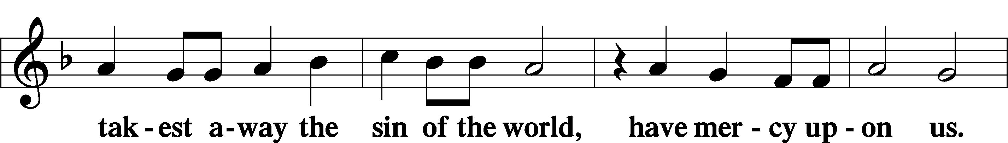
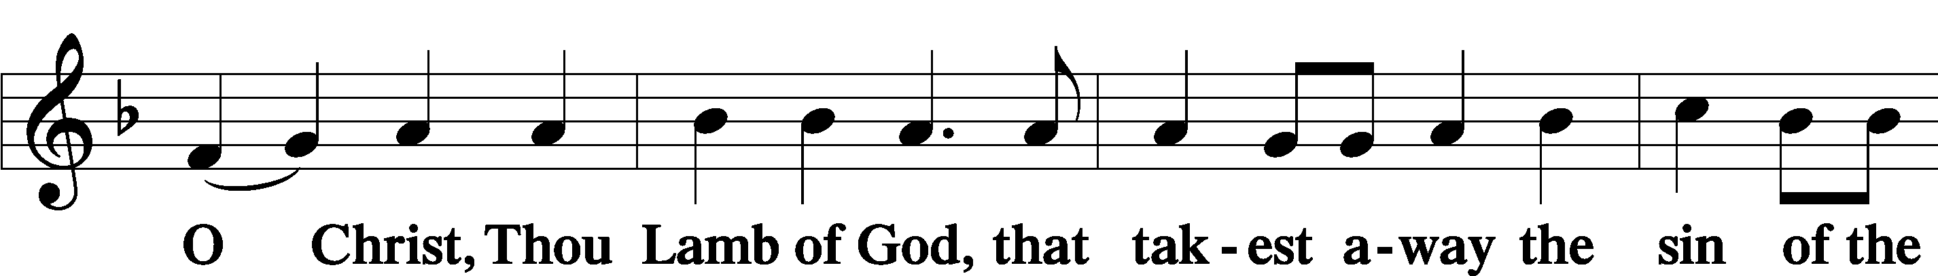
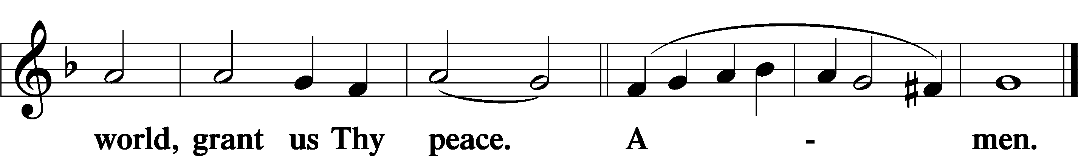

Sit

Distribution

The pastor and those who assist him receive the body and blood of Christ first and then distribute them to those who come to receive, saying:

Take, eat; this is the true body of our Lord and Savior Jesus Christ, given into death for your sins.
Amen.

Take, drink; this is the true blood of our Lord and Savior Jesus Christ, shed for the forgiveness of your sins.
Amen.

In dismissing the communicants, the following is said:

P The body and blood of our Lord Jesus Christ strengthen and preserve you in body and soul to life everlasting. Depart T in peace.
C Amen.

Distribution Hymn: 837 Lift High the Cross sts. ref–6
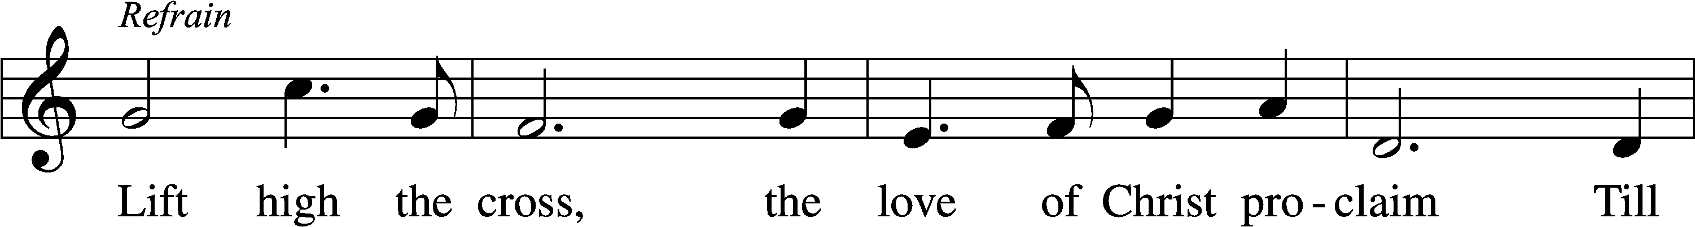
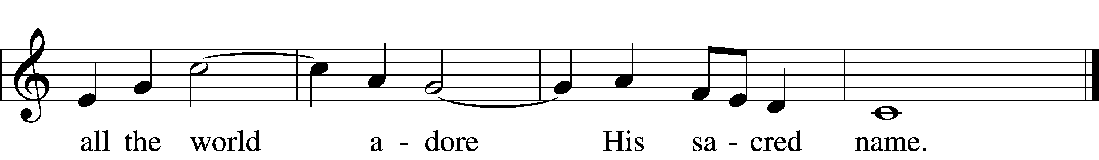
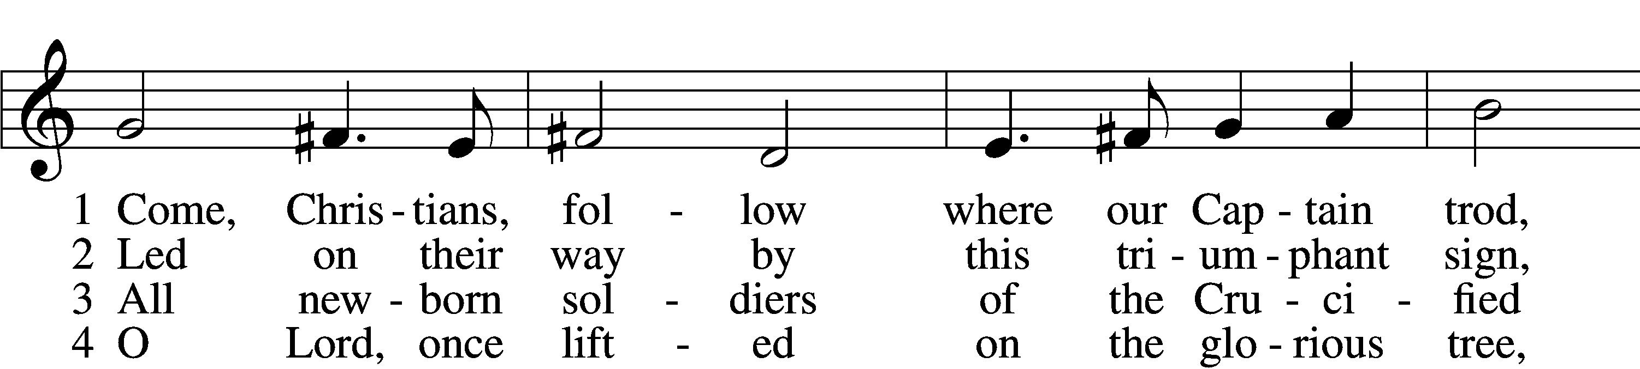
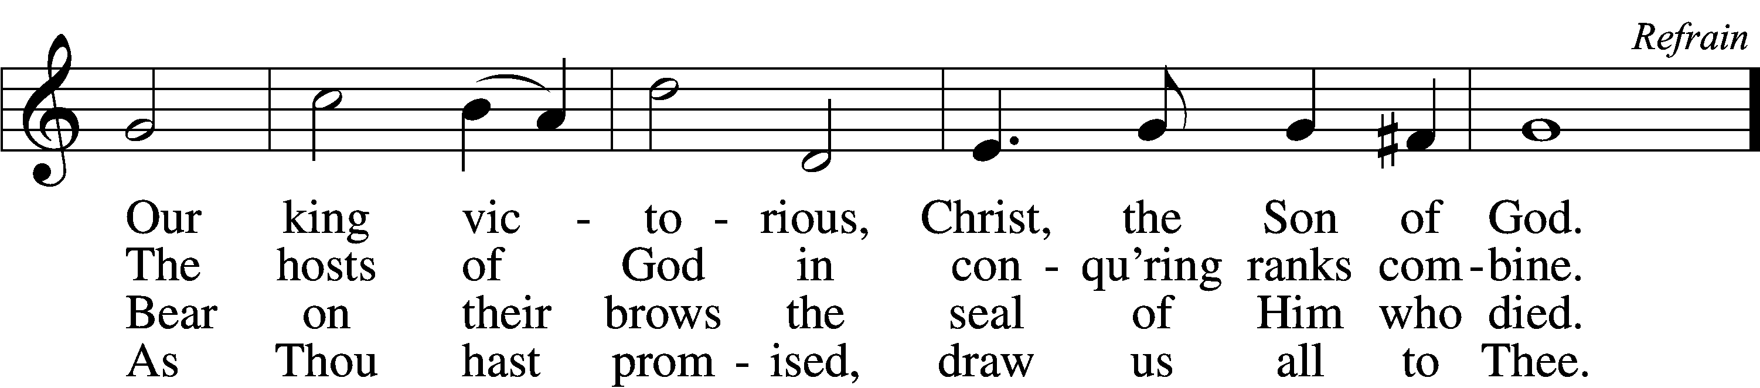

5 Let ev’ry race and ev’ry language tell
Of Him who saves our lives from death and hell. Refrain

6 So shall our song of triumph ever be:
Praise to the Crucified for victory! Refrain
Text: George W. Kitchin, 1827–1912; rev. Michael R. Newbolt, 1874–1956, alt.
Tune: Sydney H. Nicholson, 1875–1947
Text and tune: © 1974 Hope Publishing Co. Used by permission: LSB Hymn License no. 110005504

Distribution Hymn: 617 O Lord, We Praise Thee
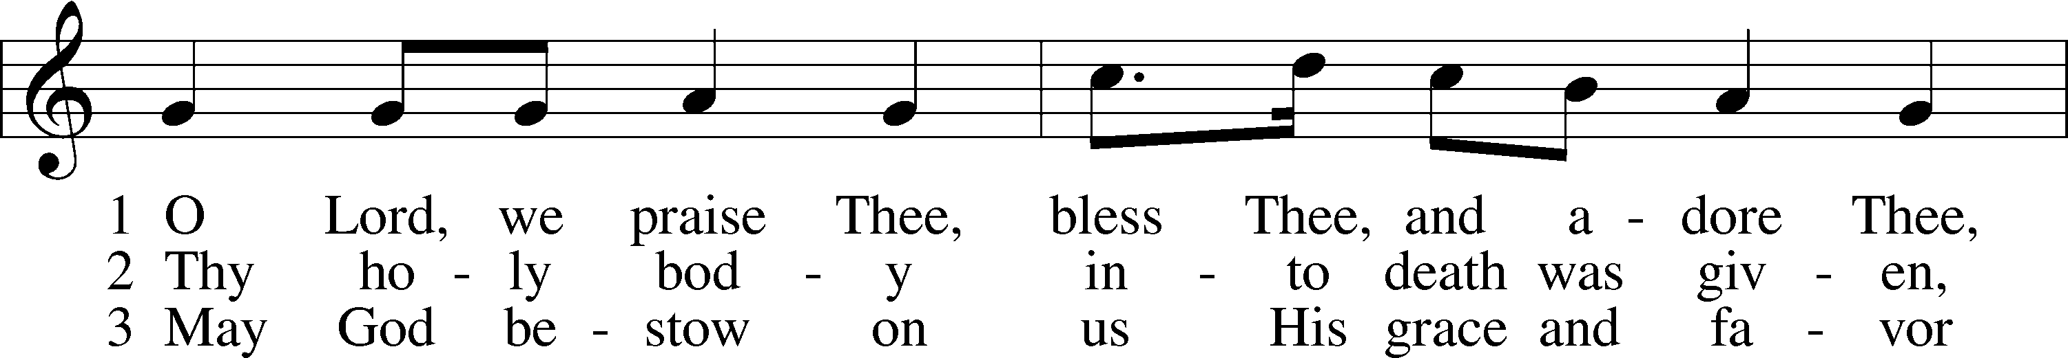
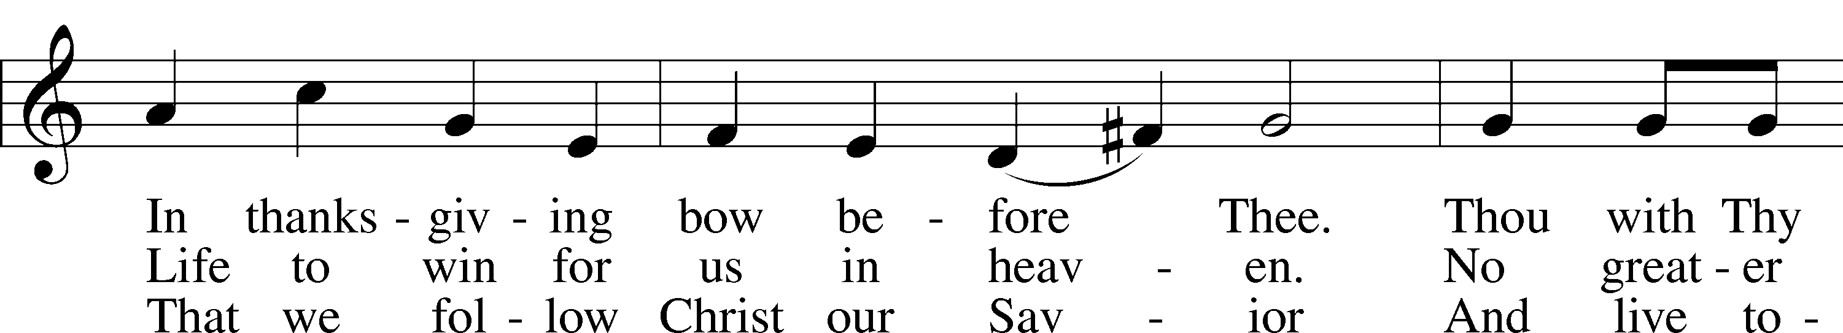
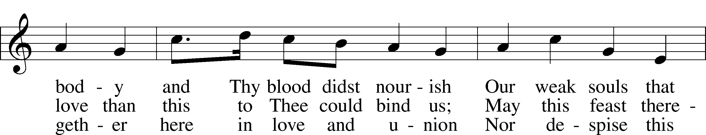
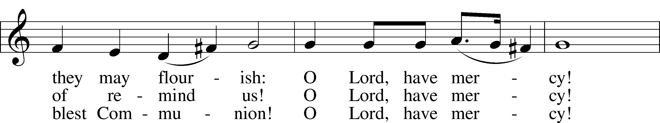
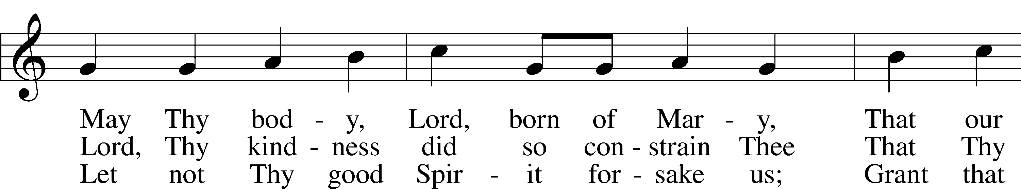
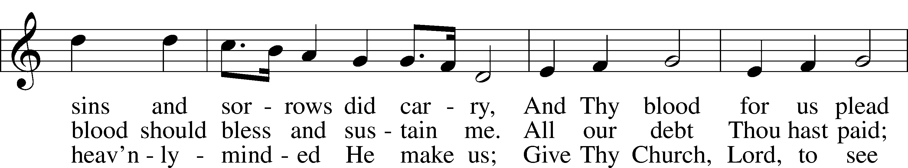
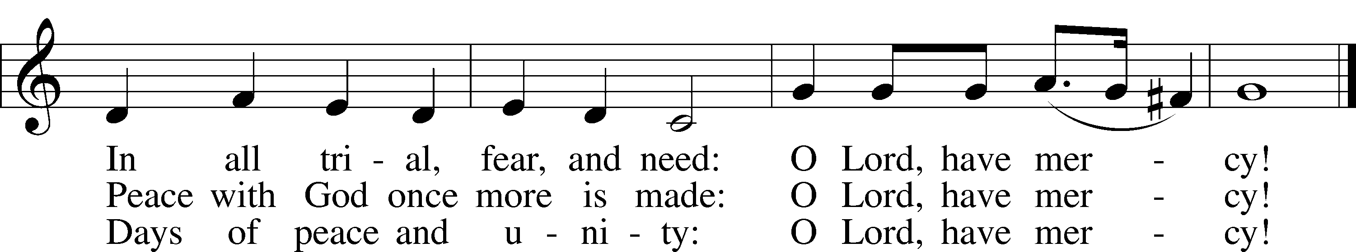
Text: tr. The Lutheran Hymnal, 1941, alt.; (st. 1): German, 14th cent.; (sts. 2–3): Martin Luther, 1483–1546
Tune: Geystliche gesangk Buchleyn, 1524, Wittenberg, ed. Johann Walter
Text: © 1941 Concordia Publishing House. Used by permission: LSB Hymn License no. 110005504
Tune: Public domain

Stand

Nunc Dimittis LSB 199
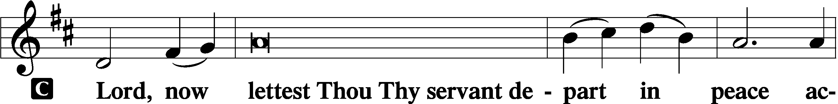

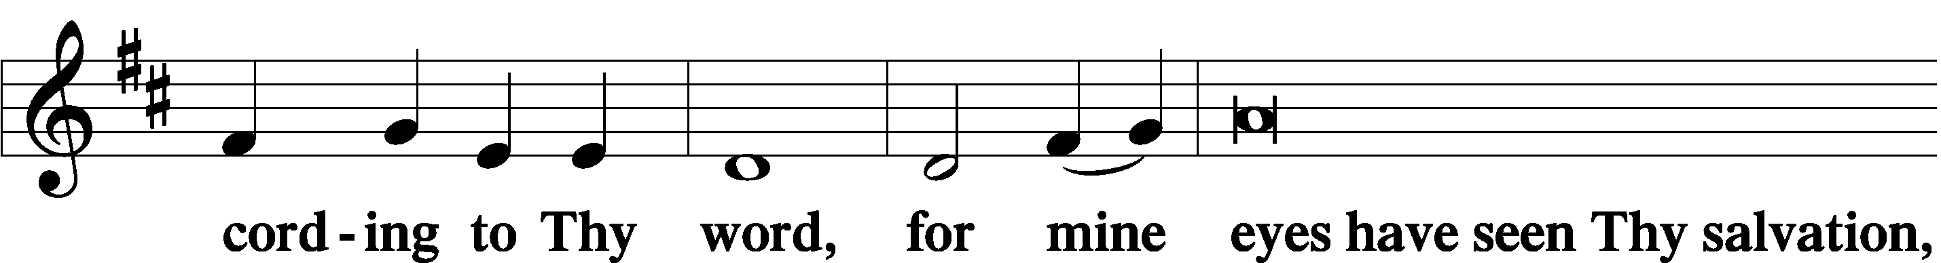

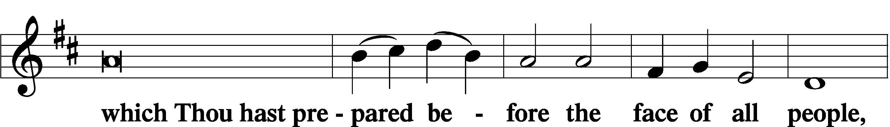

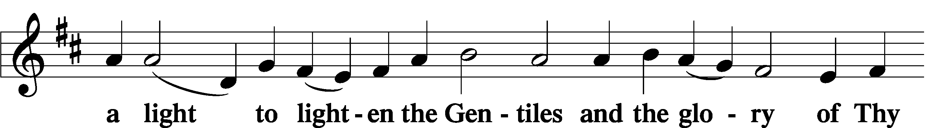

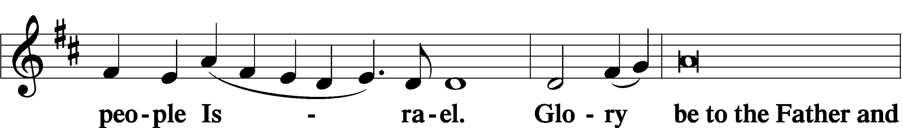

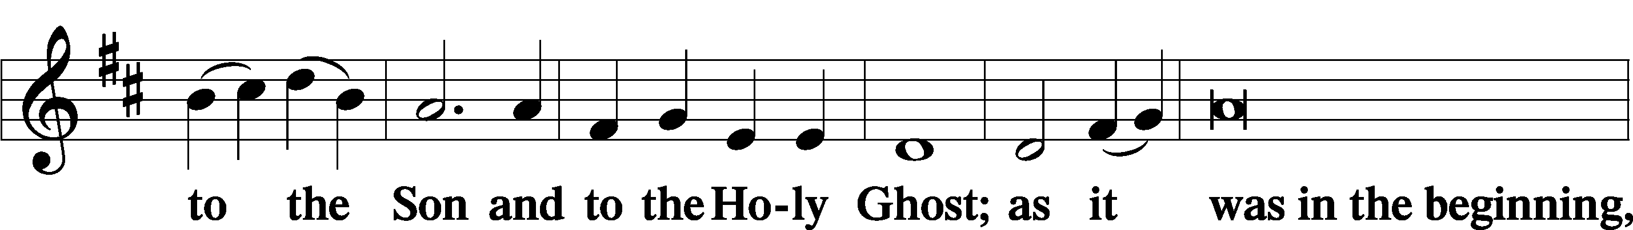

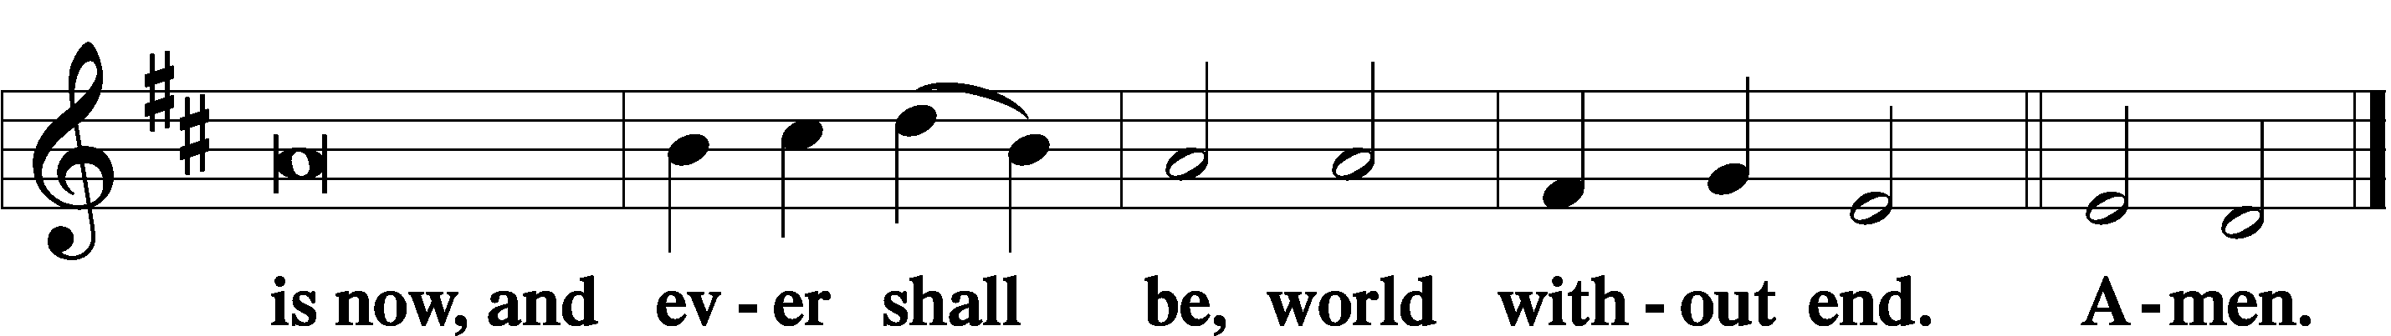

Thanksgiving LSB 200
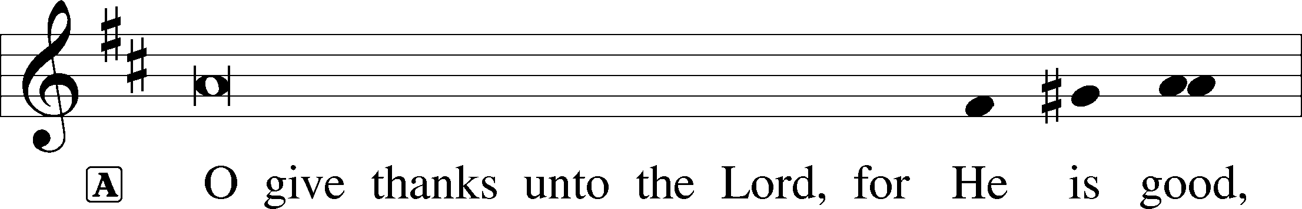

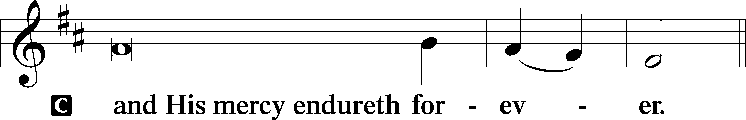

A Let us pray.
We give thanks to You, almighty God, that You have refreshed us through this salutary gift, and we implore You that of Your mercy You would strengthen us through the same in faith toward You and in fervent love toward one another; through Jesus Christ, Your Son, our Lord, who lives and reigns with You and the Holy Spirit, one God, now and forever.

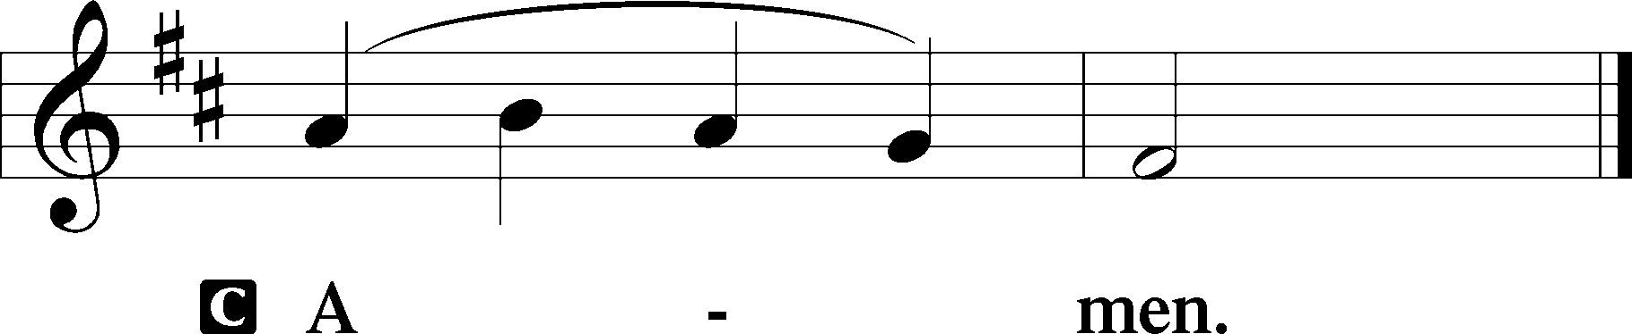

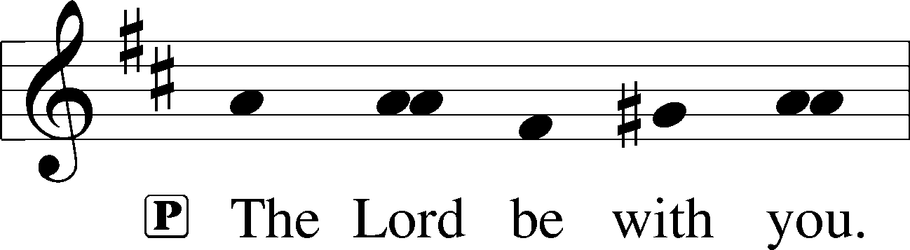

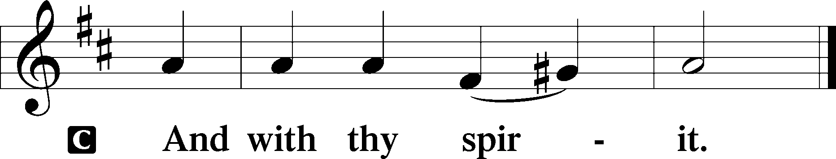

Benedicamus LSB 202
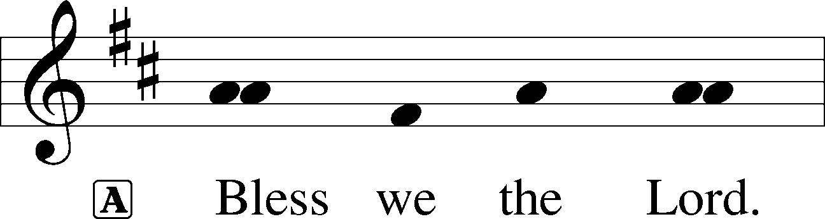

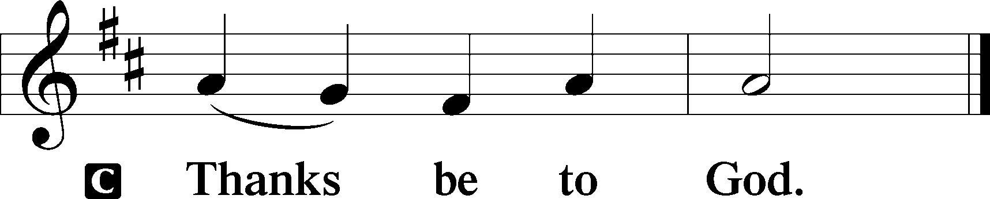

Benediction LSB 202
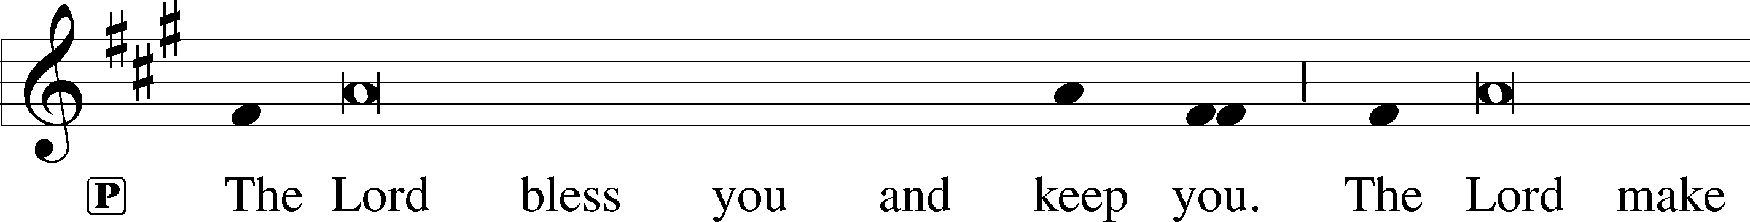
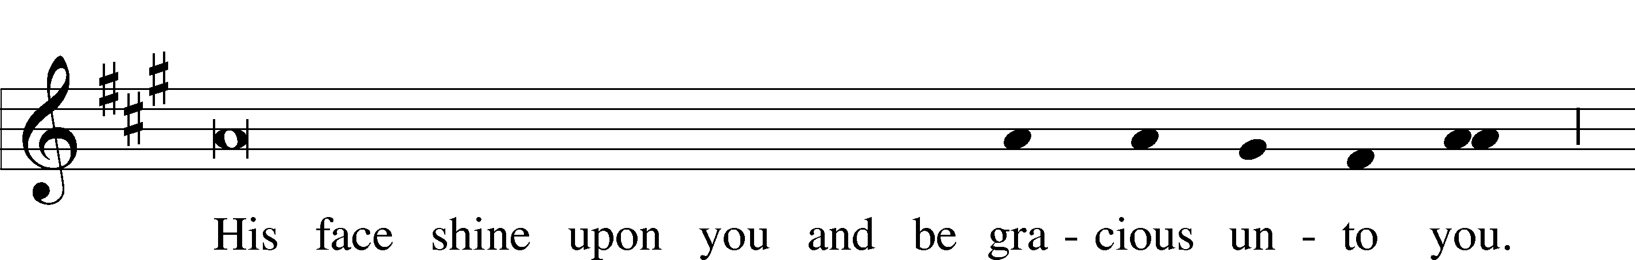
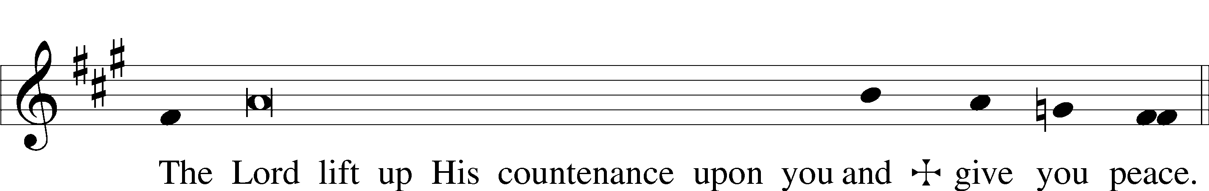

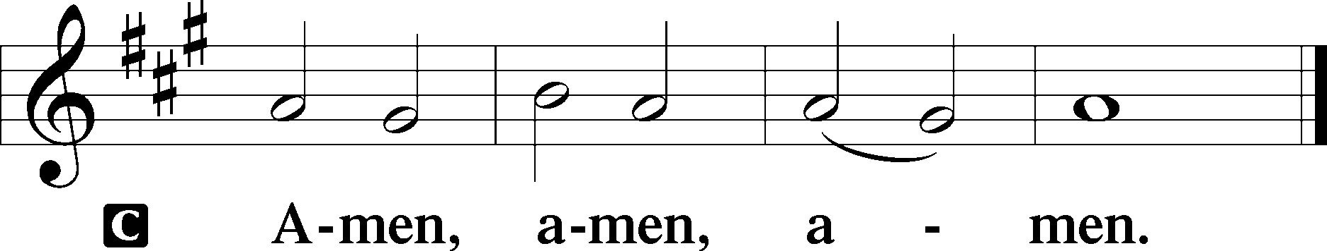

Hymn to Depart: 918 Guide Me, O Thou Great Redeemer
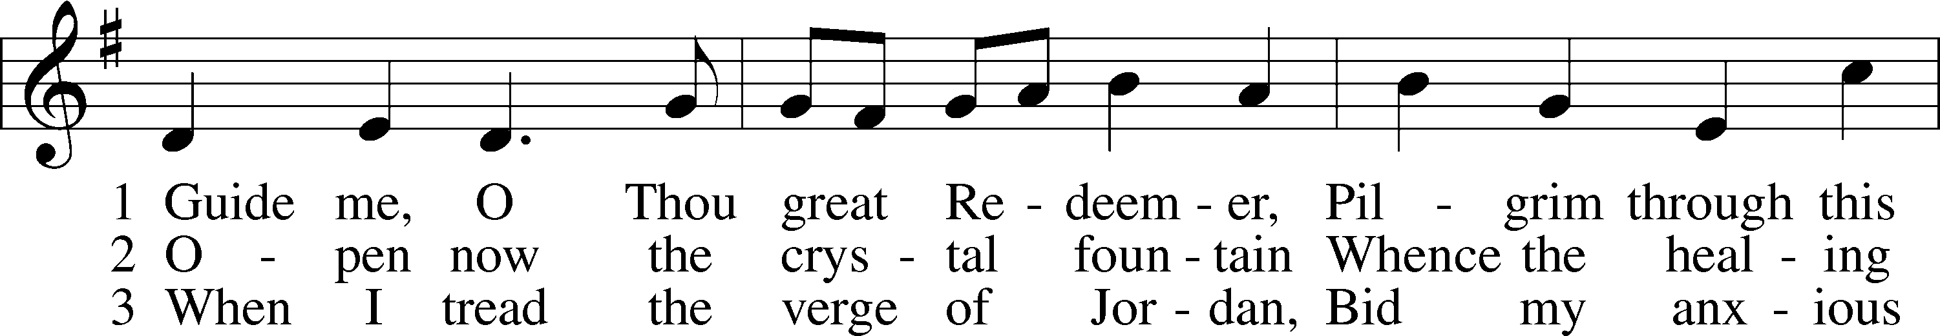
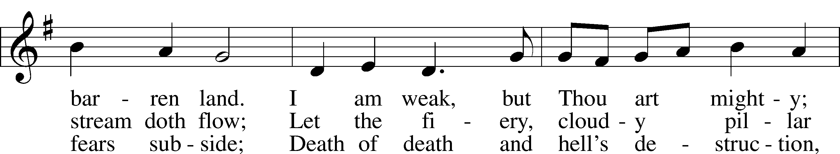
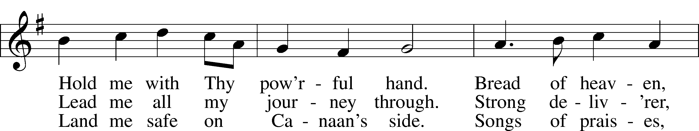
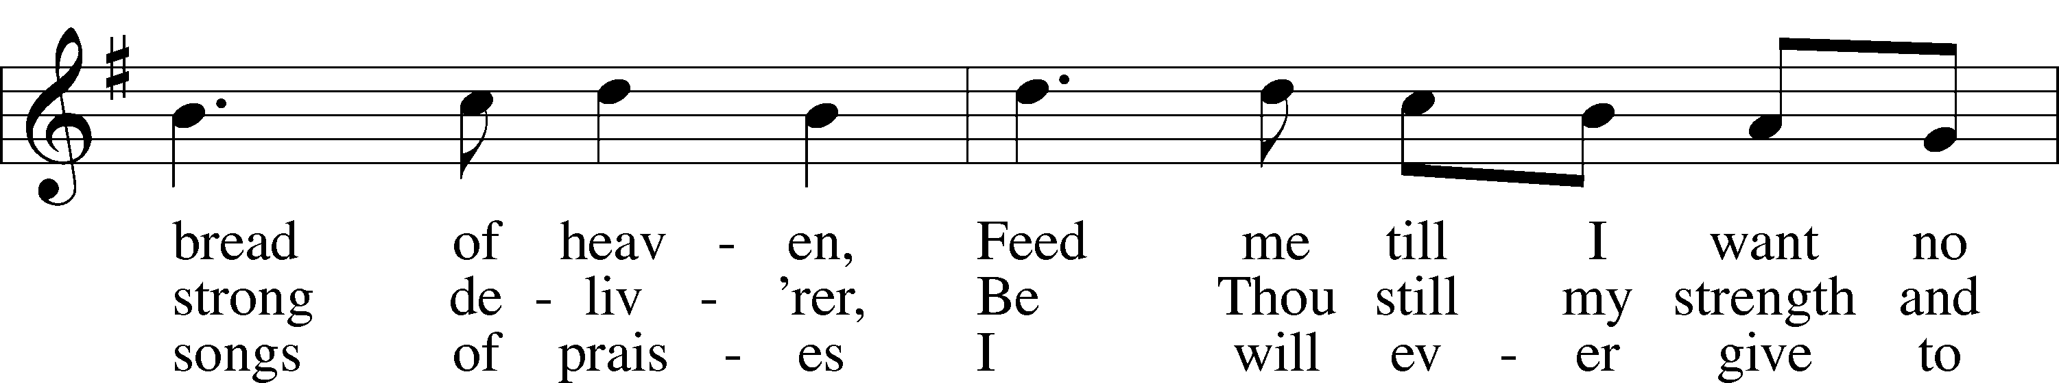
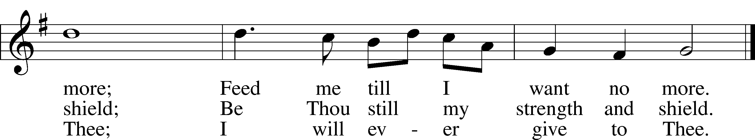
Text: William Williams, 1717–91, abr.; (st. 1): tr. Peter Williams, 1722–96, alt.; (sts. 2–3): tr. William Williams, 1717–91
Tune: John Hughes, 1873–1932
Text and tune: Public domain

Acknowledgments
Divine Service, Setting Three from Lutheran Service Book
Unless otherwise indicated, Scripture quotations are from the ESV® Bible (The Holy Bible, English Standard Version®), copyright © 2001 by Crossway, a publishing ministry of Good News Publishers. Used by permission. All rights reserved.
Created by Lutheran Service Builder © 2024 Concordia Publishing House.

INTRODUCTION TO THE WORSHIP SERVICE
SECOND SUNDAY AFTER PENTECOST (Proper 4B)
Christ Jesus Is the Sabbath Rest that Remains for the People of God Forevermore
The Lord brought the sons of Israel out of Egypt “with a mighty hand and an outstretched arm,” in order to give them rest (Deut. 5:15). When He commanded them to “observe the Sabbath day,” therefore, it meant not doing “any work” but resting in His works (Deut. 5:12, 14). So has the same Lord, Jesus Christ, come in the flesh to fulfill the Law and to become our Sabbath Rest. As David “entered the house of God,” and not only “ate the bread of the Presence” but “also gave it to those who were with him” (Mark 2:26), the Lord Jesus entered the Holy of Holies as our great High Priest, in order to feed us with His flesh as the true bread of the Presence of God. As “lord even of the Sabbath,” He works “to do good,” to heal and “to save life” (Mark 2:28; 3:2, 4). He brings us out of sin and death and gives us rest in His own crucified and risen body. Though it is given “in jars of clay,” the life of Jesus is thereby manifested in our bodies (2 Cor. 4:7–11).

Announcements:

Church Service Phone: 888-505-1870/715-438-4200
(Stay on the line for recorded service to start)
Live Stream audio services: http://salem.listentochurch.com
Salem’s Web Page: https://www.salembarron.com/
Pastor Fred Buth: Cell phone:715-642-3050 (H)715-353-2540
Pastor’s Email: salembarronpastor@gmail.com
Office Hours: Monday-Wednesday 9-12
Office email: salembarron@gmail.com
Attendance:
Call-in line: 5/26- In-person: 5/26-54

Coffee and Snacks: Schuettpelz/Fagerlin
Elder Today: Tim Dennis
Altar Guild: Nancy Koenig/Marcia Elliott

Schedule for the upcoming week:
Monday: 7pm Elders Tuesday: 8:00 am Men’s Bible Study Today – Special meeting (parsonage updates)

We need volunteers to mow the church lawn, please consider this and sign up for a time or two. The paronage is being taken care of, so it is just the church that needs mowing.
Prayers Request:
Those in the nursing home: Joann Jaeger Those Shut-in at home: Char Herman, Joan Church, Joyce Myers, Joyce Koba Those with ongoing health issues: Harrison Fields, Jeanne Perala, Owen Metz, Jeff Bonneville, Daria (Cindy Wright’s friend), Butch L. (Cindy Wright’s Brother-in-law), Melissa Miller. Art Smith (Sue Millerman’s brother), Brenda Sellent (Denise Stabenow’s sister), Sandy Hahn (Cindy Wright’s cousin’s wife) Recovering from surgery: Wyatt Weise, Gail Espeseth Those who lead our nation: Joe Biden, Kamala Harris, Tony Evers, Rod Nordby Those who serve in our military and law enforcement: Ryan Graf, Chaplain Pon Chanthaphon (Our Adopt-a-Chaplain), Rusty Weise Our Childcare Staff: Melissa Weinert, Denise Stabenow, Katelyn Hendren, Holly Wilhelmi, Janica Skjerly, Jacie Amundson, Emily Young, Zuri Soto, Cathy Anderson For Christ Community Lutheran School – Ask the Lord to provide teachers for the school

