Matins

12th Sunday after Pentecost

August 12, 2024

Pg. 219 LSB

Hymn: 684 Come unto Me, Ye Weary
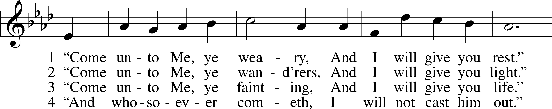
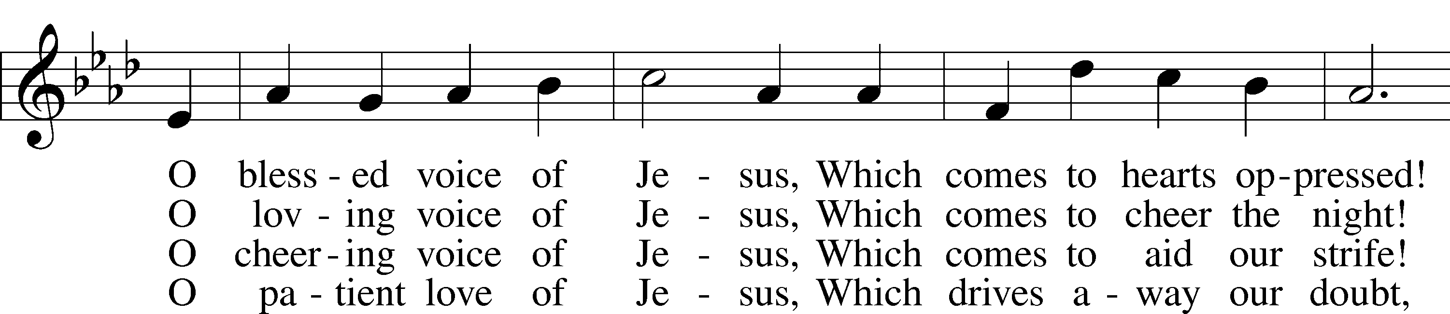
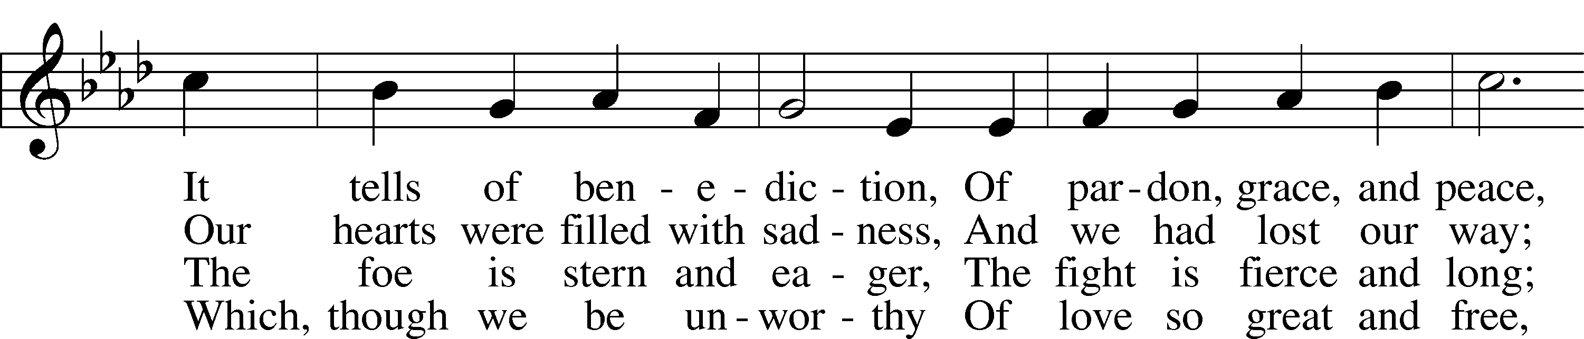
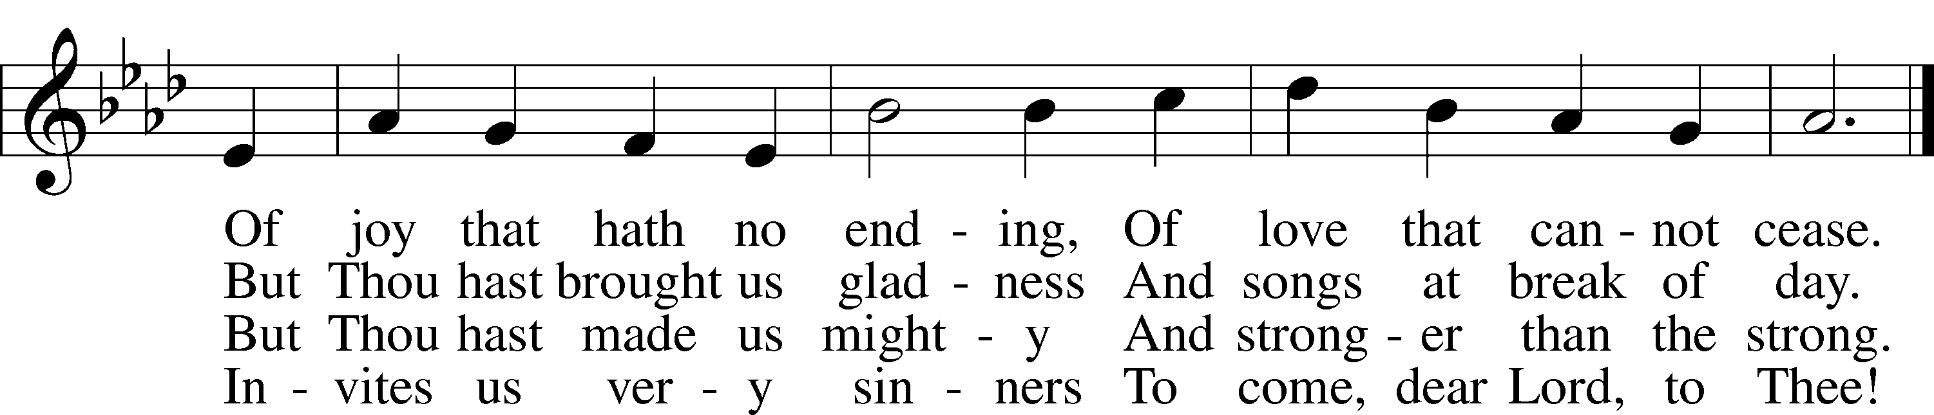
Text: William C. Dix, 1837–98, alt.
Tune: Friedrich K. Anthes, 1812–after 1857
Text and tune: Public domain

Stand

Psalmody

Venite LSB 220
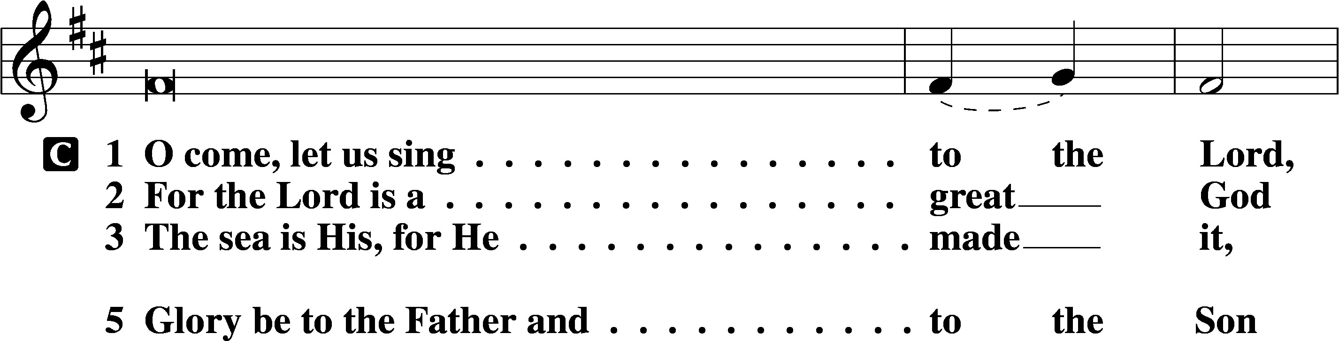
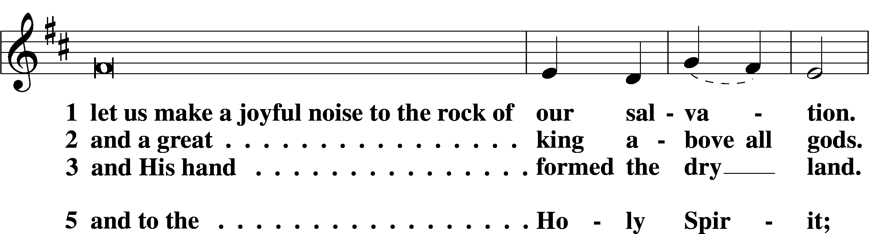
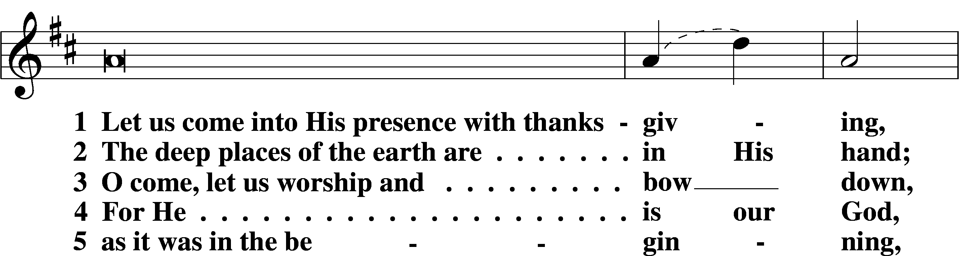
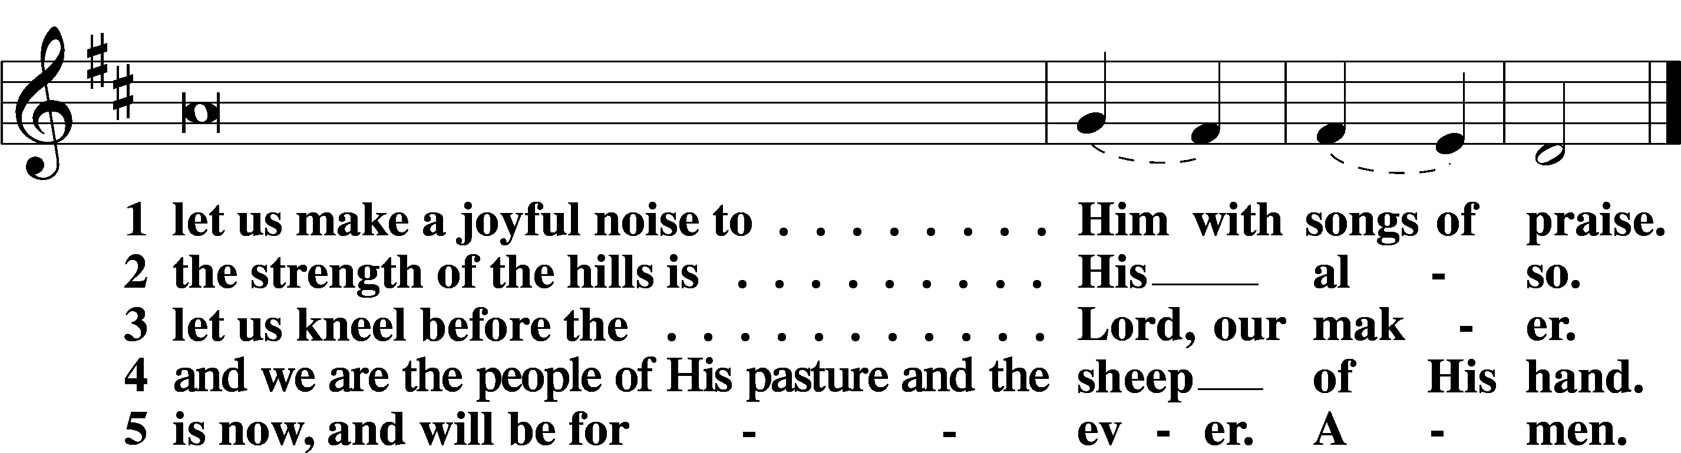

Additional Psalms Psalm 34:1–8; antiphon: v. 3
Taste and See That the Lord Is Good
1I will bless the Lord at all times;
his praise shall continually be in my mouth.
2My soul makes its boast in the Lord;
let the humble hear and be glad.
3Oh, magnify the Lord with me,
and let us exalt his name together!
4I sought the Lord, and he answered me
and delivered me from all my fears.
5Those who look to him are radiant,
and their faces shall never be ashamed.
6This poor man cried, and the Lord heard him
and saved him out of all his troubles.
7The angel of the Lord encamps
around those who fear him,
and delivers them.
8Oh, taste and see that the Lord is good!
Blessèd is the man who takes refuge in him!

Sit

Office Hymn: 850 God of Grace and God of Glory
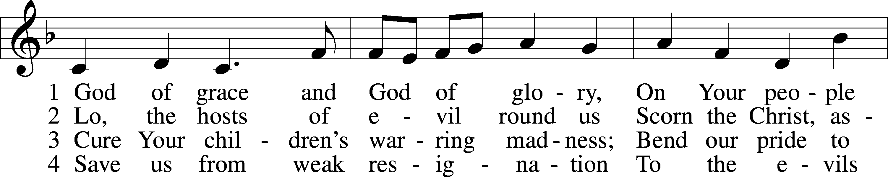
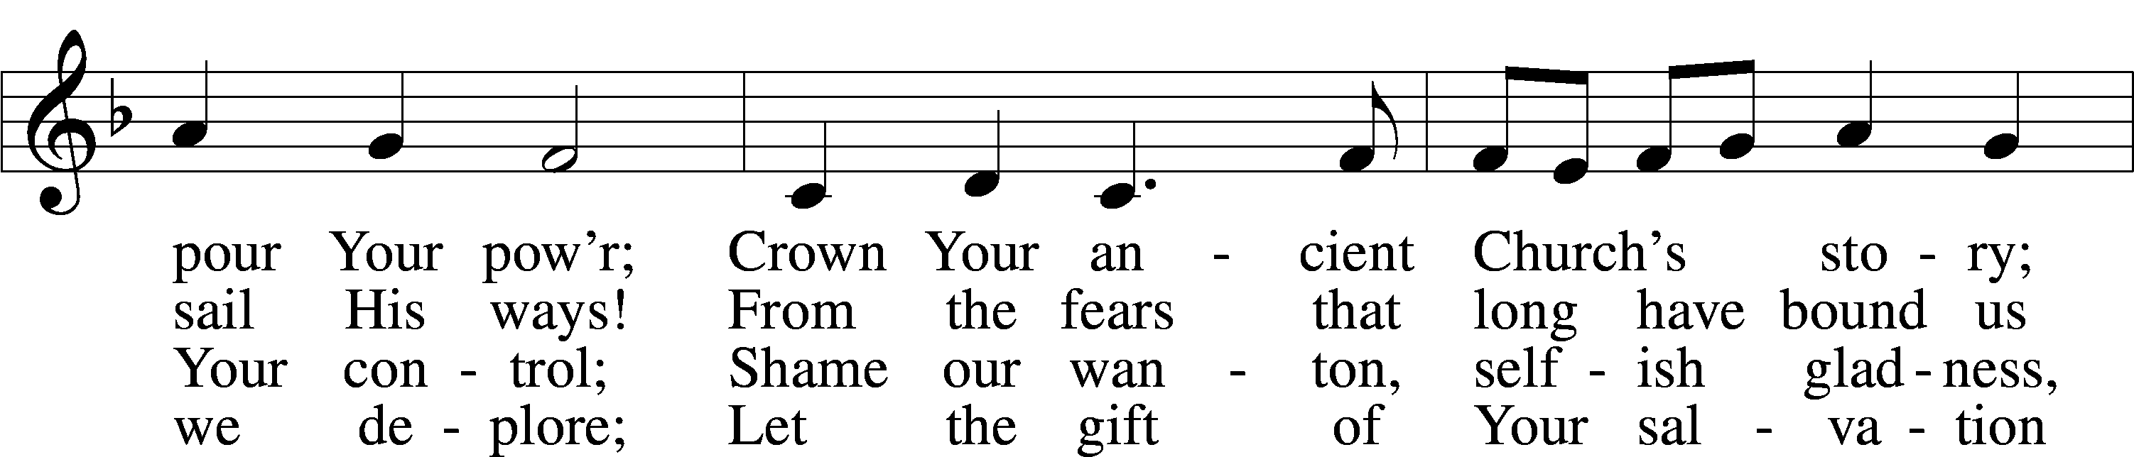
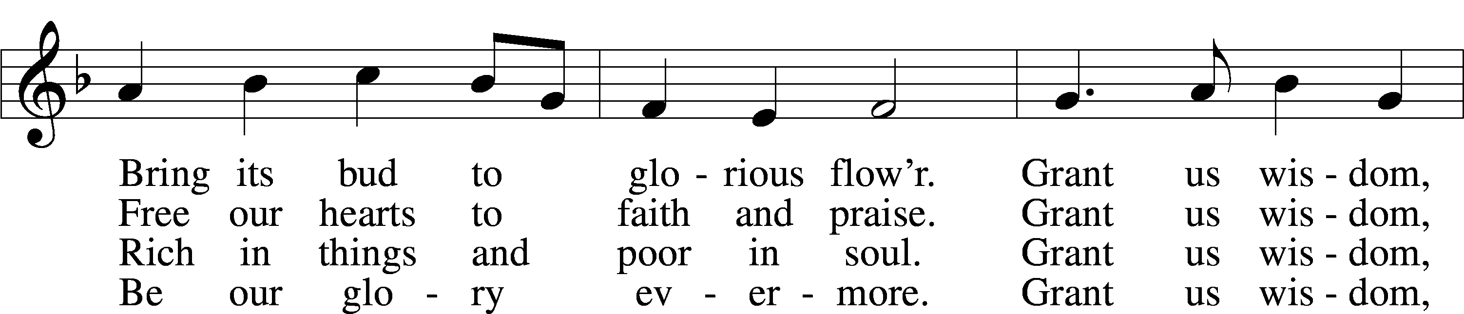
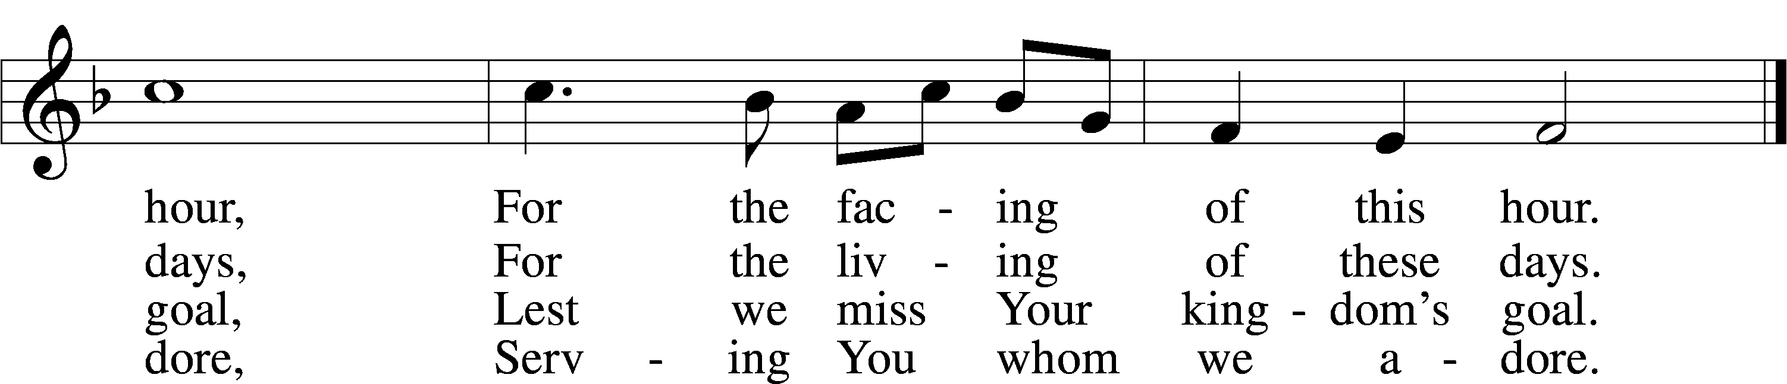
Text: Harry Emerson Fosdick, 1878–1969
Tune: John Hughes, 1873–1932
Text and tune: Public domain

Hymn: 833 Listen, God Is Calling
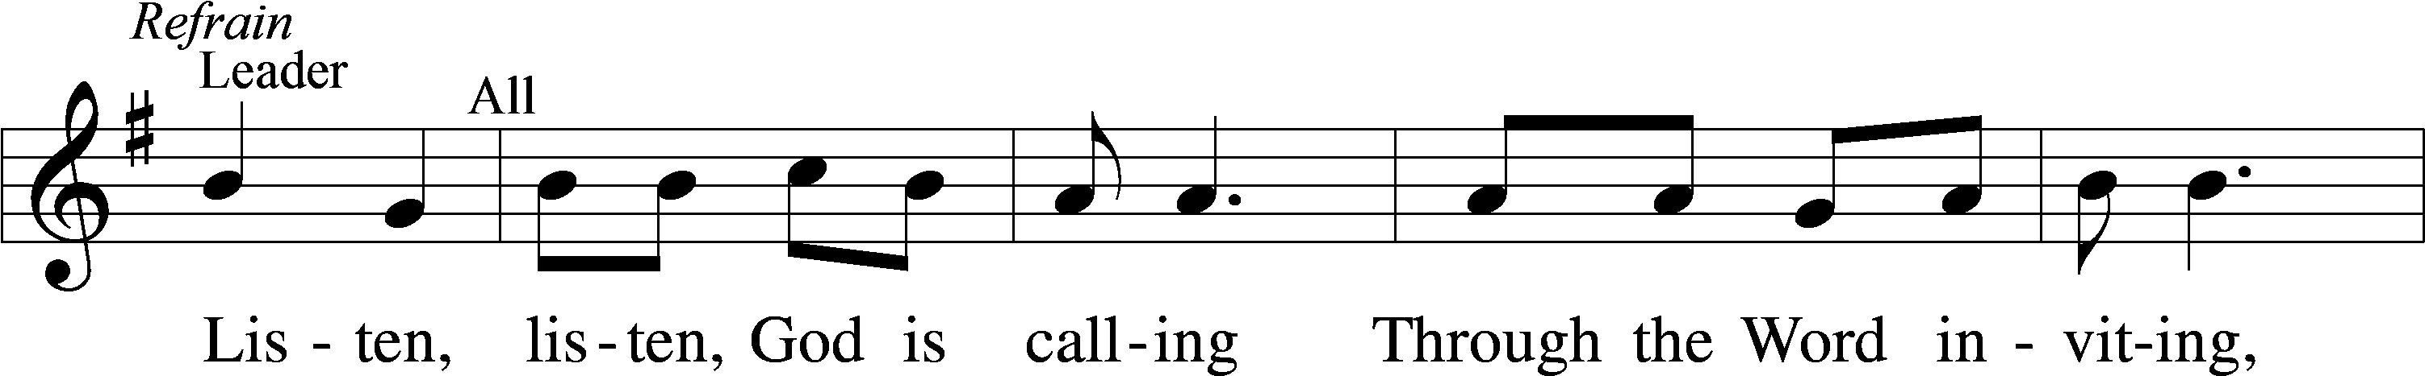
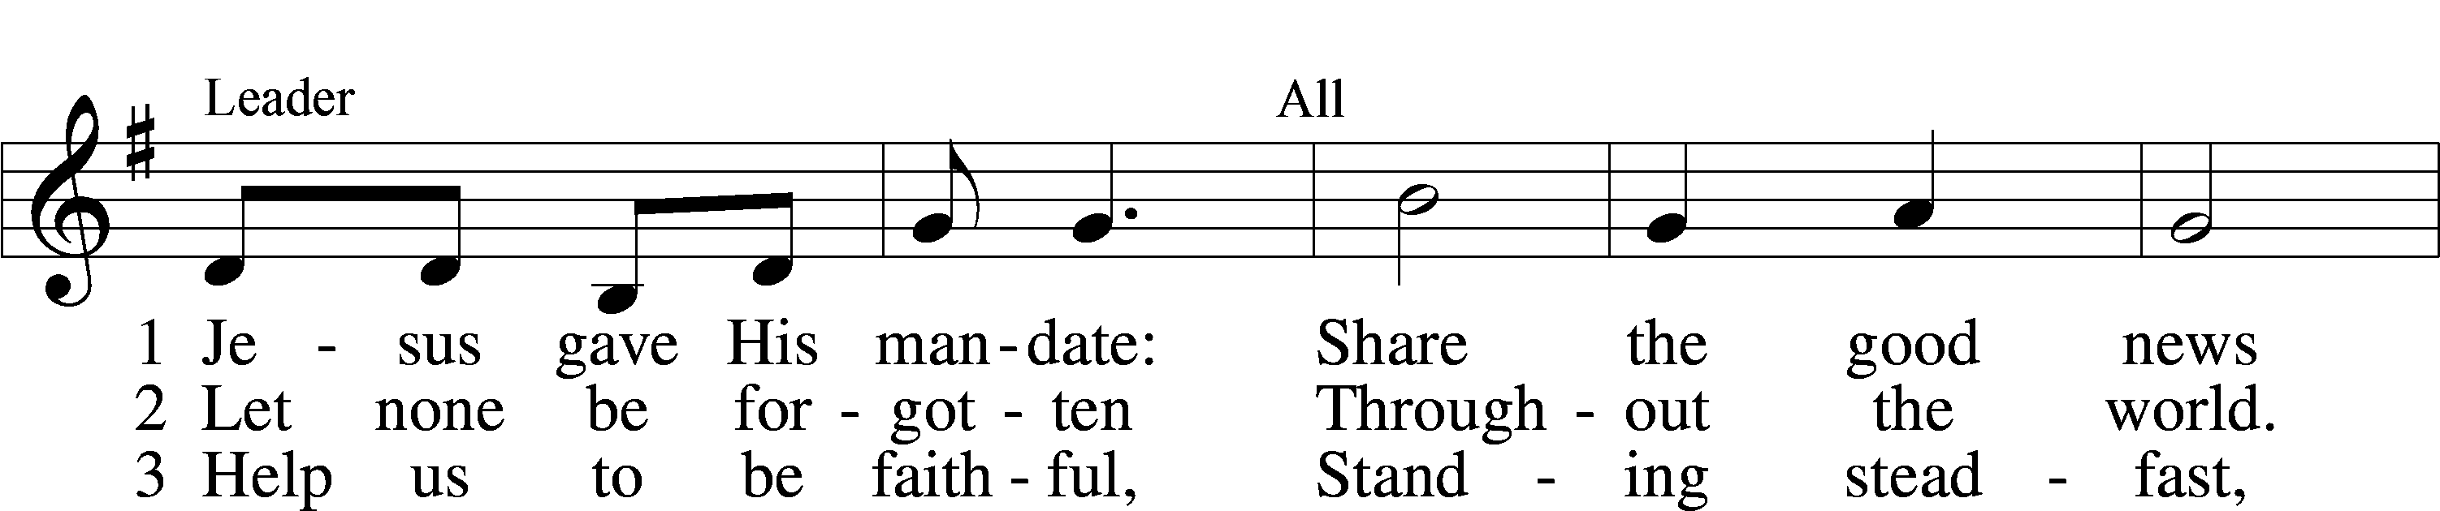
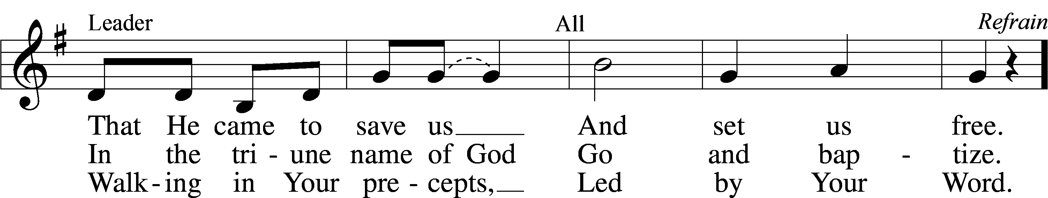
Text: tr. Howard S. Olson, 1922–2010
Text and tune: Kenyan
Text: © Lutheran Theological College, Makumira, Tanzania. Used by permission: LSB Hymn License no. 110005504
Tune: Public domain

Readings

Reading 1 Kings 19:1–8
L A reading from 1 Kings, chapter 19.

Elijah Flees Jezebel
1Ahab told Jezebel all that Elijah had done, and how he had killed all the prophets with the sword. 2Then Jezebel sent a messenger to Elijah, saying, “So may the gods do to me and more also, if I do not make your life as the life of one of them by this time tomorrow.” 3Then he was afraid, and he arose and ran for his life and came to Beersheba, which belongs to Judah, and left his servant there.
4But he himself went a day’s journey into the wilderness and came and sat down under a broom tree. And he asked that he might die, saying, “It is enough; now, O Lord, take away my life, for I am no better than my fathers.” 5And he lay down and slept under a broom tree. And behold, an angel touched him and said to him, “Arise and eat.” 6And he looked, and behold, there was at his head a cake baked on hot stones and a jar of water. And he ate and drank and lay down again. 7And the angel of the Lord came again a second time and touched him and said, “Arise and eat, for the journey is too great for you.” 8And he arose and ate and drank, and went in the strength of that food forty days and forty nights to Horeb, the mount of God.

L O Lord, have mercy on us.
C Thanks be to God.

Reading Ephesians 4:17—5:2
L A reading from Ephesians, chapter 4.

The New Life
17This I say and testify in the Lord, that you must no longer walk as the Gentiles do, in the futility of their minds. 18They are darkened in their understanding, alienated from the life of God because of the ignorance that is in them, due to their hardness of heart. 19They have become callous and have given themselves up to sensuality, greedy to practice every kind of impurity. 20But that is not the way you learned Christ!— 21assuming that you have heard about him and were taught in him, as the truth is in Jesus, 22to put off your old self, which belongs to your former manner of life and is corrupt through deceitful desires, 23and to be renewed in the spirit of your minds, 24and to put on the new self, created after the likeness of God in true righteousness and holiness.
25Therefore, having put away falsehood, let each one of you speak the truth with his neighbor, for we are members one of another. 26Be angry and do not sin; do not let the sun go down on your anger, 27and give no opportunity to the devil. 28Let the thief no longer steal, but rather let him labor, doing honest work with his own hands, so that he may have something to share with anyone in need. 29Let no corrupting talk come out of your mouths, but only such as is good for building up, as fits the occasion, that it may give grace to those who hear. 30And do not grieve the Holy Spirit of God, by whom you were sealed for the day of redemption. 31Let all bitterness and wrath and anger and clamor and slander be put away from you, along with all malice. 32Be kind to one another, tenderhearted, forgiving one another, as God in Christ forgave you.
Walk in Love
1Therefore be imitators of God, as beloved children. 2And walk in love, as Christ loved us and gave himself up for us, a fragrant offering and sacrifice to God.

L O Lord, have mercy on us.
C Thanks be to God.

Reading John 6:35–51
L A reading from John, chapter 6.

35Jesus said to them, “I am the bread of life; whoever comes to me shall not hunger, and whoever believes in me shall never thirst. 36But I said to you that you have seen me and yet do not believe. 37All that the Father gives me will come to me, and whoever comes to me I will never cast out. 38For I have come down from heaven, not to do my own will but the will of him who sent me. 39And this is the will of him who sent me, that I should lose nothing of all that he has given me, but raise it up on the last day. 40For this is the will of my Father, that everyone who looks on the Son and believes in him should have eternal life, and I will raise him up on the last day.”
41So the Jews grumbled about him, because he said, “I am the bread that came down from heaven.” 42They said, “Is not this Jesus, the son of Joseph, whose father and mother we know? How does he now say, ‘I have come down from heaven’?” 43Jesus answered them, “Do not grumble among yourselves. 44No one can come to me unless the Father who sent me draws him. And I will raise him up on the last day. 45It is written in the Prophets, ‘And they will all be taught by God.’ Everyone who has heard and learned from the Father comes to me— 46not that anyone has seen the Father except he who is from God; he has seen the Father. 47Truly, truly, I say to you, whoever believes has eternal life. 48I am the bread of life. 49Your fathers ate the manna in the wilderness, and they died. 50This is the bread that comes down from heaven, so that one may eat of it and not die. 51I am the living bread that came down from heaven. If anyone eats of this bread, he will live forever. And the bread that I will give for the life of the world is my flesh.”

L O Lord, have mercy on us.
C Thanks be to God.

Responsory LSB 221
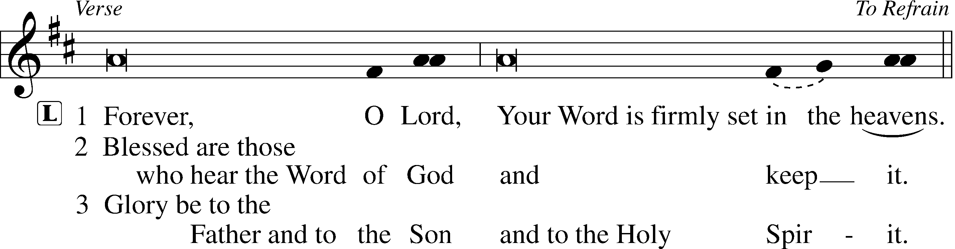
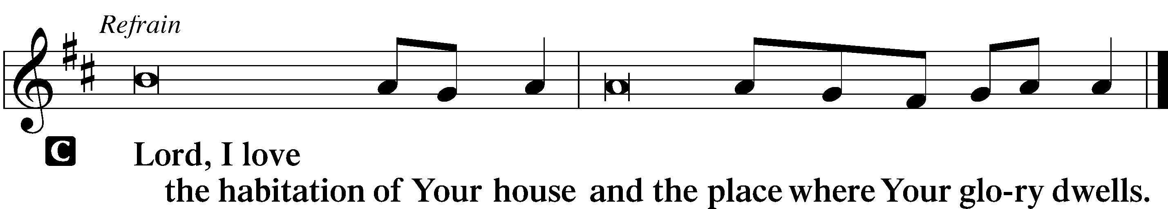

Hymn: 745 In God, My Faithful God
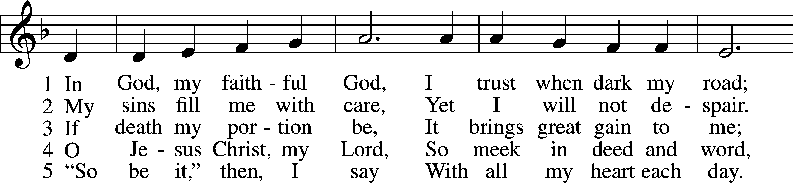
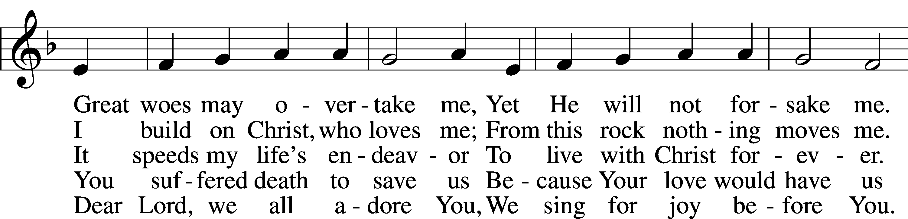
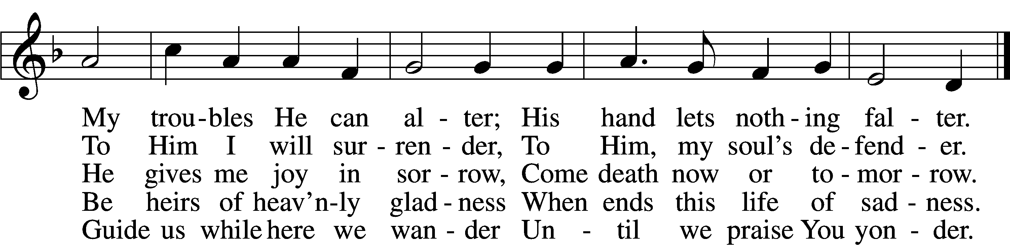
Text: Veer schöne nye Geistlike Leder, before 1603, Lübeck; tr. Catherine Winkworth, 1827–78, alt.
Tune: Kurtzweilige teutsche Lieder, 1576, Nürnberg, alt.
Text and tune: Public domain

Sermon

Canticle

Stand

Te Deum LSB 223
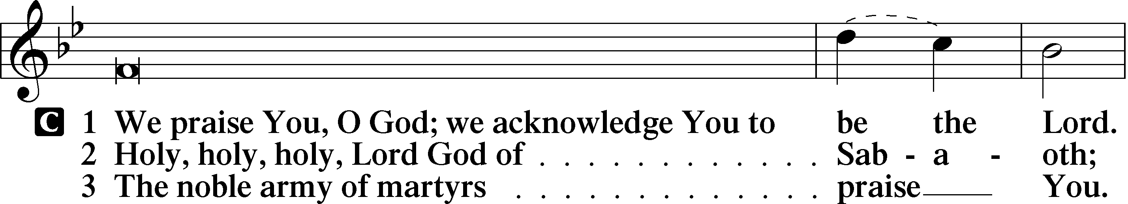
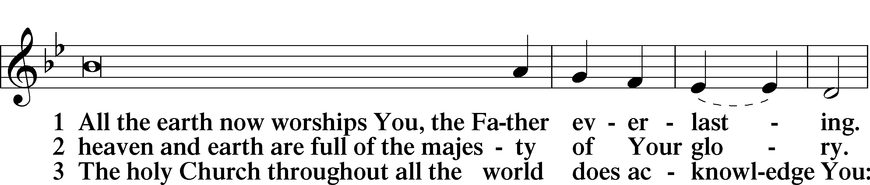
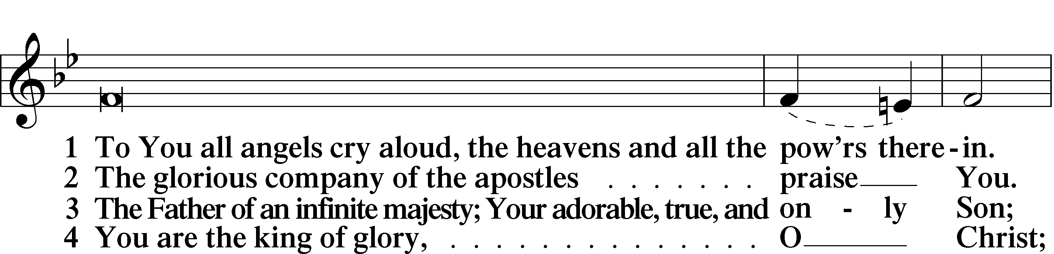
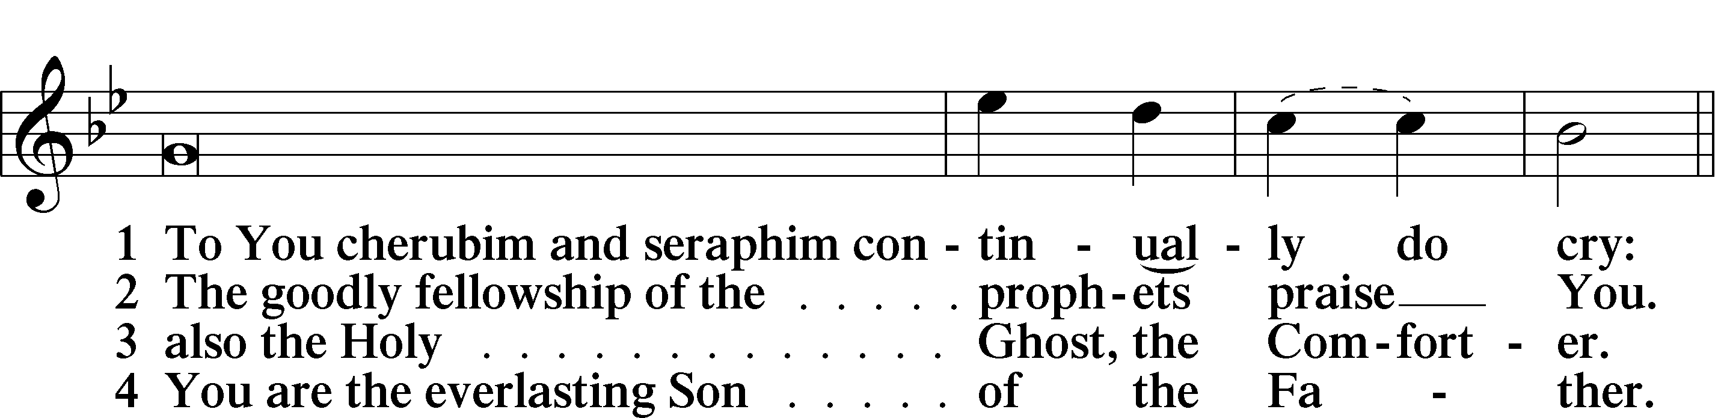
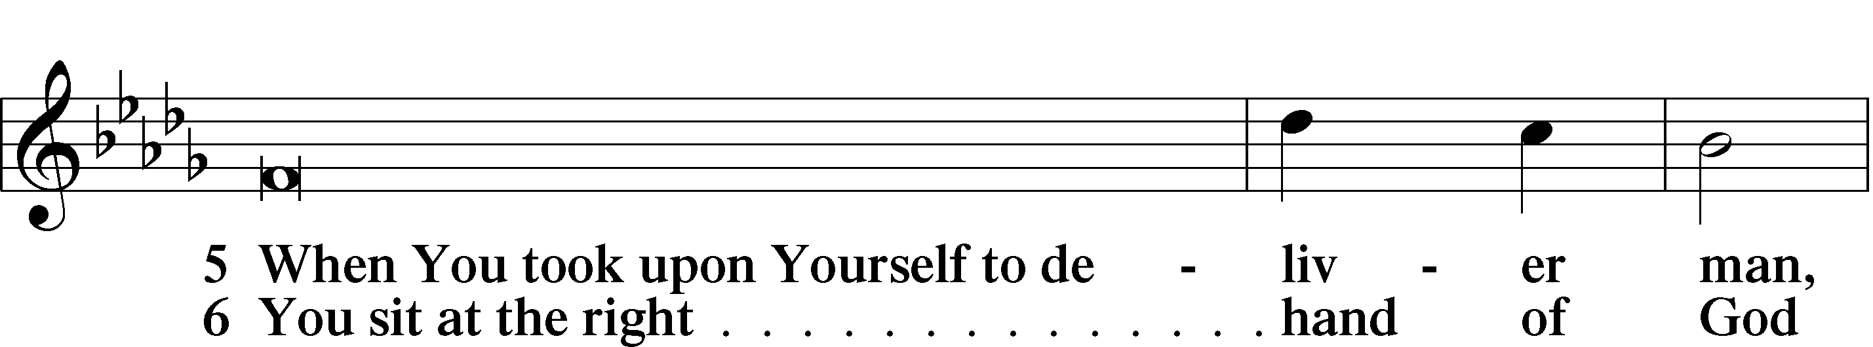
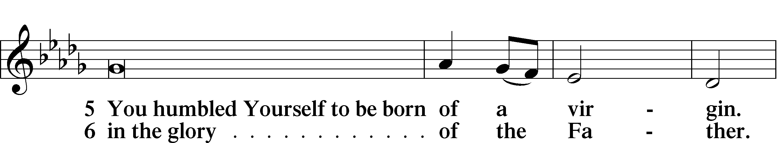
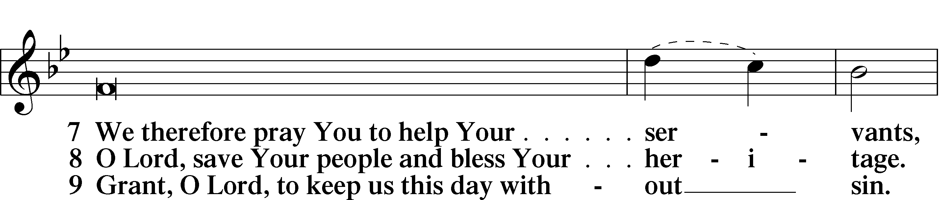
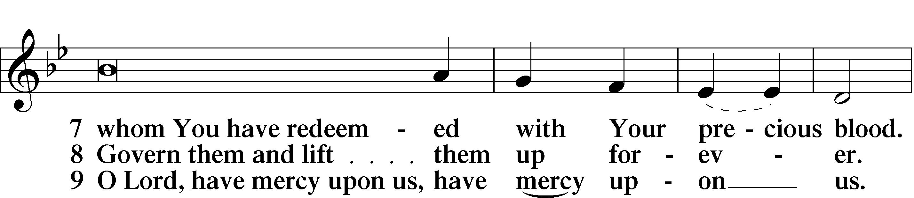
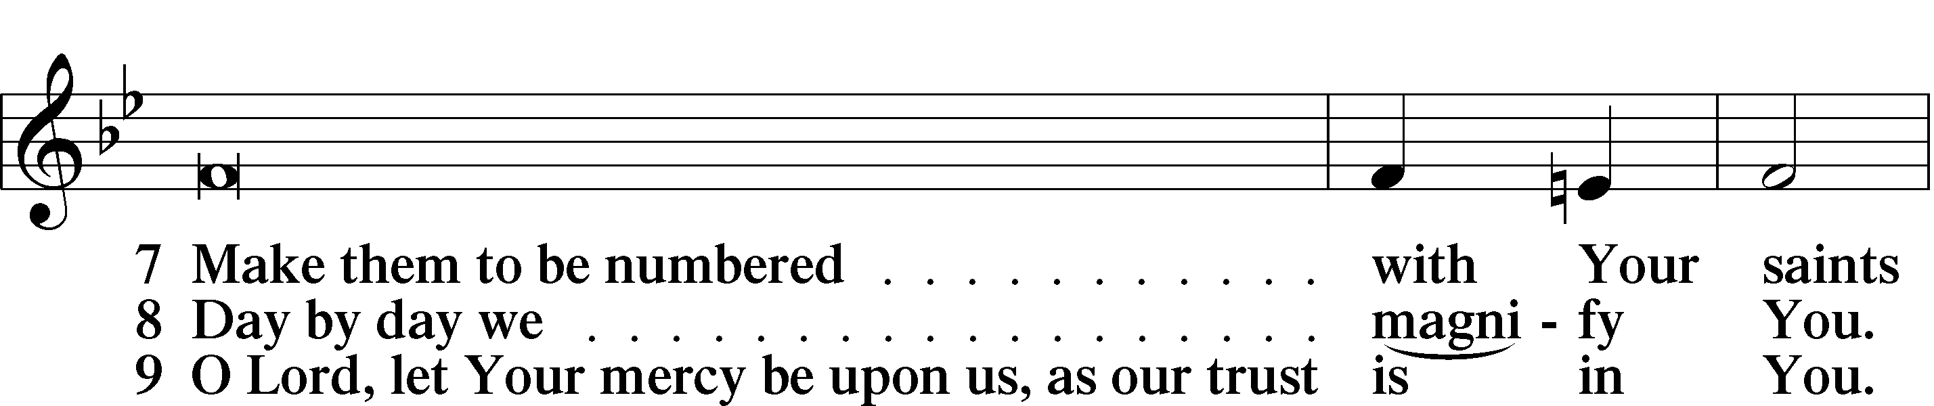
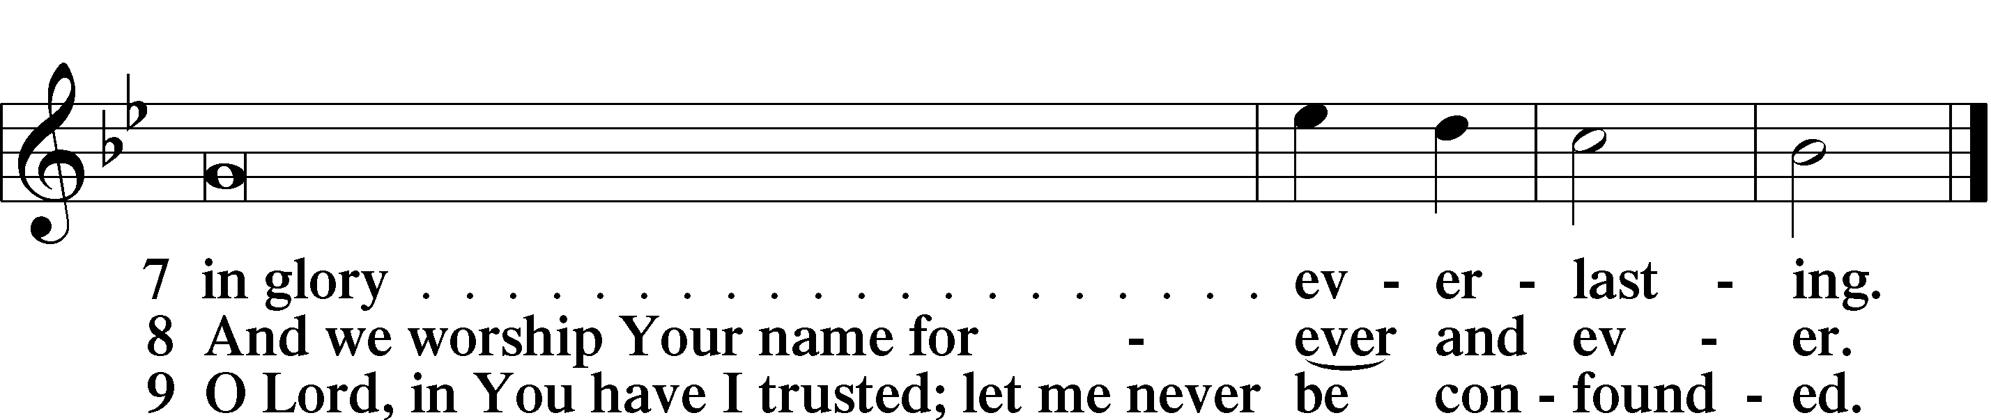

Sit

Offering

Prayer

Kneel/Stand

Kyrie LSB 227

Lord’s Prayer
C Our Father who art in heaven,
hallowed be Thy name,
Thy kingdom come,
Thy will be done on earth
as it is in heaven;
give us this day our daily bread;
and forgive us our trespasses
as we forgive those
who trespass against us;
and lead us not into temptation,
but deliver us from evil.
For Thine is the kingdom
and the power and the glory
forever and ever. Amen.

Collects

Collect of the Day
Gracious Father, Your blessed Son came down from heaven to be the true bread that gives life to the world. Grant that Christ, the bread of life, may live in us and we in Him, who lives and reigns with You and the Holy Spirit, one God, now and forever.
C Amen.

Collect for Grace
L O Lord, our heavenly Father, almighty and everlasting God, You have safely brought us to the beginning of this day. Defend us in the same with Your mighty power and grant that this day we fall into no sin, neither run into any kind of danger, but that all our doings, being ordered by Your governance, may be righteous in Your sight; through Jesus Christ, Your Son, our Lord, who lives and reigns with You and the Holy Spirit, one God, now and forever.

Stand

Benedicamus LSB 228

Benediction LSB 228

Hymn to Depart: 921 On What Has Now Been Sown
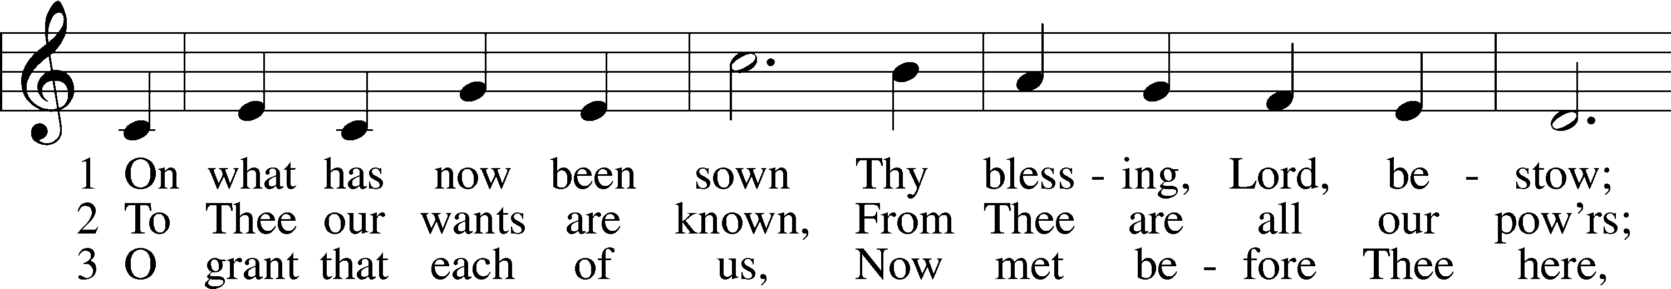
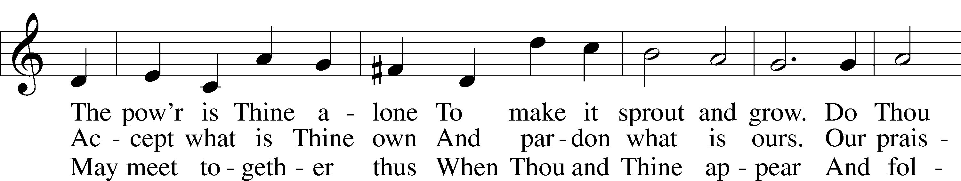
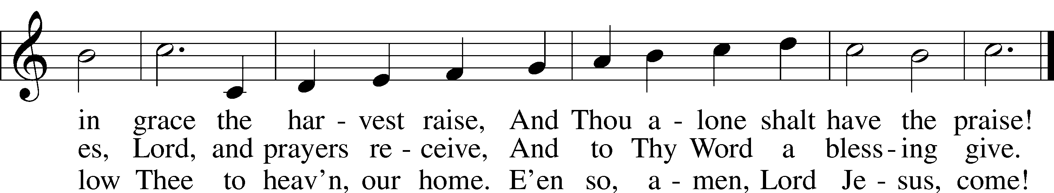
Text: John Newton, 1725–1807, alt.
Tune: John Darwall, 1731–89
Text and tune: Public domain

Acknowledgments
Matins from Lutheran Service Book
Unless otherwise indicated, Scripture quotations are from the ESV® Bible (The Holy Bible, English Standard Version®), copyright © 2001 by Crossway, a publishing ministry of Good News Publishers. Used by permission. All rights reserved.
Created by Lutheran Service Builder © 2024 Concordia Publishing House.

The Lord Jesus Feeds Us with His Flesh, in Order to Strengthen Us with His Own Life God the Father sent His Son into the world, so that the world might have life in Him. Now He “draws” you to His Son, Christ Jesus, by the preaching of His Gospel. “Everyone who has heard and learned from the Father” comes to Jesus, who will never cast him out but “will raise him up on the last day” (John 6:44–45). He is “the bread of life,” who “comes down from heaven” in the flesh, that you may eat of Him and “live forever” (John 6:48–51). Although “the journey is too great for you,” in the strength of this food you shall come to “the mount of God.” Do not be afraid, and do not despair, but “arise and eat” (1 Kings 19:5–8). And “no longer walk as the Gentiles do, in the futility of their minds” (Eph. 4:17), but “walk in love, as Christ loved us and gave himself up for us” (Eph. 5:2). In Him, you have been “created after the likeness of God in true righteousness and holiness” (Eph. 4:24). Therefore, “be imitators of God, as beloved children” (Eph. 5:1), by “forgiving one another, as God in Christ forgave you”
Church Service Phone: 715-438-4200
(Stay on the line for recorded service to start)
Live Stream audio services: http://salem.listentochurch.com
Salem’s Web Page: https://www.salembarron.com/
Pastor Fred Buth: Cell phone:715-642-3050 (H)715-353-2540
Pastor’s Email: salembarronpastor@gmail.com
Office Hours: Monday-Wednesday 9-12
Office email: salembarron@gmail.com
Attendance:
In-person: 8/4-48
Coffee and Snacks: YFM
Elder Today: Don Duncan
Altar Guild: Denise Stabenow

Save the Date:
August 18th: 10:00 Potluck after church, 11:45am. *A special Voter’s Meeting to issue a Divine Call to a Pastor to serve Salem congregation
September 4th: 6:30pm Parent confirmation meeting

Looking for a volunteer to be Director of Sunday School, also looking for a 7 & 8th grade Sunday school teacher. If you are interested, please contact Sue M.

In case of an emergence Please call one of the Elders or Pastor Buth 715-642-3050
Christ Community Lutheran School is hiring a headmaster. We are open to all levels of experience. Please email a resume’ or questions to administrator@christcommunityls.org

Prayers Request:
Those in the nursing home: Joann Jaeger Those Shut-in at home: Char Herman, Joan Church, Joyce Myers, Joyce Koba Those with ongoing health issues: Harrison Fields, Jeanne Perala, Owen Metz, Jeff Bonneville, Daria (Cindy Wright’s friend), Butch L. (Cindy Wright’s Brother-in-law), Melissa Miller. Art Smith (Sue Millerman’s brother), Brenda Sellent (Denise Stabenow’s sister), Sandy Hahn (Cindy Wright’s cousin’s wife) , Brenda Gustum (Missy Wiese’s mom), Lexi Anderson, Chris Mueller’s uncle Those who lead our nation: Joe Biden, Kamala Harris, Tony Evers, Rod Nordby Those who serve in our military and law enforcement: Ryan Graf, Chaplain Pon Chanthaphon (Our Adopt-a-Chaplain), Rusty Weise Our Childcare Staff: Melissa Weinert, Denise Stabenow, Katelyn Hendren, Holly Wilhelmi, Janica Skjerly, Jacie Amundson, Cathy Anderson, Emily Young For Christ Community Lutheran School – Ask the Lord to provide teachers for the school

