# Funeral Service for Marjorie Newville

June 8, 1934 - January 3, 2025

January 11, 2025

Hymn: 744 Amazing Grace

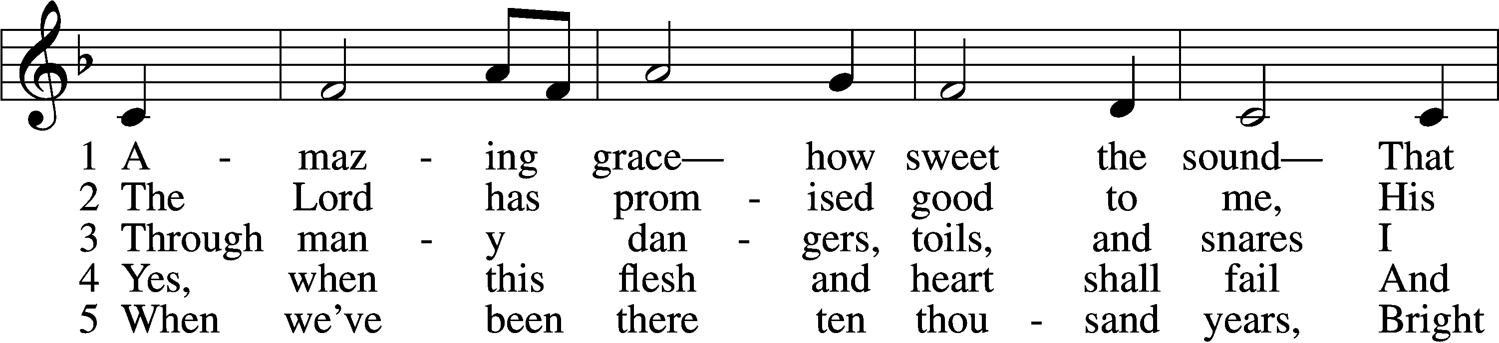

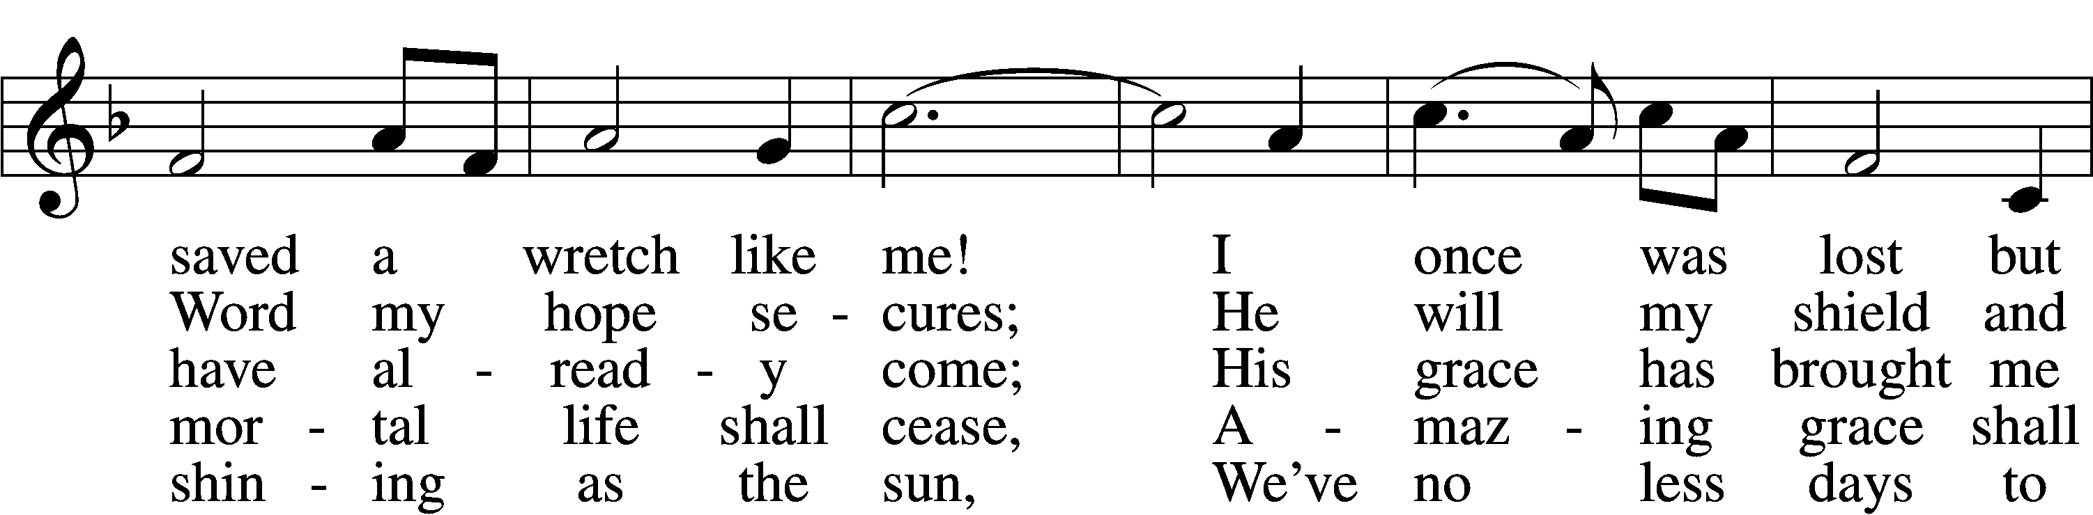

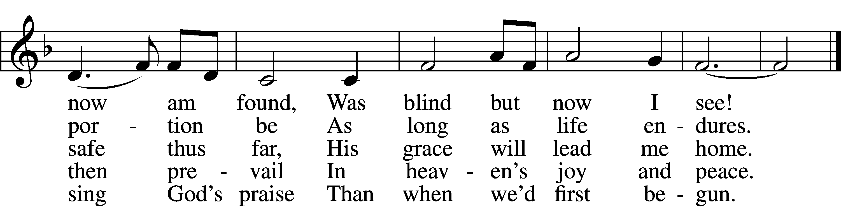

Text (sts. 1–4): John Newton, 1725–1807, alt.; (st. 5): A Collection of Sacred Ballads, 1790, Richmond  
Tune: Columbian Harmony, 1829, Cincinnati  
Text and tune: Public domain

Stand

The sign of the cross may be made by all in remembrance of their Baptism.

Invocation

P In the name of the Father and of the T Son and of the Holy Spirit.

C **Amen.**

The casket may be covered with a funeral pall.

Remembrance of Baptism

P In Holy Baptism Marjorie was clothed with the robe of Christ’s righteousness that covered all her sin. St. Paul says: “Do you not know that all of us who have been baptized into Christ Jesus were baptized into His death?”

C **We were buried therefore with Him by baptism into death, in order that, just as Christ was raised from the dead by the glory of the Father, we too might walk in newness of life. For if we have been united with Him in a death like His, we shall certainly be united with Him in a resurrection like His.**

Introit

Kyrie

P Lord, have mercy upon us.

C **Christ, have mercy upon us.**

**Lord, have mercy upon us.**

Salutation and Collect of the Day

P The Lord be with you.

C **And also with you.**

P Let us pray.

O God of grace and mercy, we give thanks for Your loving-kindness shown to Marjorie and to all Your servants who, having finished their course in faith, now rest from their labors. Grant that we also may be faithful unto death and receive the crown of eternal life; through Jesus Christ, Your Son, our Lord, who lives and reigns with You and the Holy Spirit, one God, now and forever.

C **Amen.**

Sit

Old Testament Reading Isaiah 61:1–3, 10–11

The Year of the Lord’s Favor

1The Spirit of the Lord God is upon me,  
 because the Lord has anointed me  
to bring good news to the poor;  
 he has sent me to bind up the brokenhearted,  
to proclaim liberty to the captives,  
 and the opening of the prison to those who are bound;  
2to proclaim the year of the Lord’s favor,  
 and the day of vengeance of our God;  
 to comfort all who mourn;  
3to grant to those who mourn in Zion—  
 to give them a beautiful headdress instead of ashes,  
the oil of gladness instead of mourning,  
 the garment of praise instead of a faint spirit;  
that they may be called oaks of righteousness,  
 the planting of the Lord, that he may be glorified.

10I will greatly rejoice in the Lord;  
 my soul shall exult in my God,  
for he has clothed me with the garments of salvation;  
 he has covered me with the robe of righteousness,  
as a bridegroom decks himself like a priest with a beautiful headdress,  
 and as a bride adorns herself with her jewels.  
11For as the earth brings forth its sprouts,  
 and as a garden causes what is sown in it to sprout up,  
so the Lord God will cause righteousness and praise  
 to sprout up before all the nations.

A This is the Word of the Lord.

C **Thanks be to God.**

Psalm Psalm 23

The Lord Is My Shepherd

1The Lord is my shepherd;  
 I shall not want.  
2He makes me lie down in green pastures.  
 He leads me beside still waters.  
3He restores my soul.  
 He leads me in paths of righteousness for his name’s sake.

4Even though I walk through the valley of the shadow of death,  
I will fear no evil, for you are with me;  
 your rod and your staff, they comfort me.

5You prepare a table before me  
in the presence of my enemies;  
 you anoint my head with oil;  
 my cup overflows.  
6Surely goodness and mercy shall follow me  
all the days of my life,  
 and I shall dwell in the house of the Lord forever.

Epistle Romans 6:1–11

Dead to Sin, Alive to God

1What shall we say then? Are we to continue in sin that grace may abound? 2By no means! How can we who died to sin still live in it? 3Do you not know that all of us who have been baptized into Christ Jesus were baptized into his death? 4We were buried therefore with him by baptism into death, in order that, just as Christ was raised from the dead by the glory of the Father, we too might walk in newness of life.

5For if we have been united with him in a death like his, we shall certainly be united with him in a resurrection like his. 6We know that our old self was crucified with him in order that the body of sin might be brought to nothing, so that we would no longer be enslaved to sin. 7For one who has died has been set free from sin. 8Now if we have died with Christ, we believe that we will also live with him. 9We know that Christ being raised from the dead will never die again; death no longer has dominion over him. 10For the death he died he died to sin, once for all, but the life he lives he lives to God. 11So you also must consider yourselves dead to sin and alive to God in Christ Jesus.

A This is the Word of the Lord.

C **Thanks be to God.**

Stand

Verse

A Alleluia, alleluia.

Jesus Christ is the firstborn of the dead;

C **to Him be glory and power forever.**

**Alleluia.**

Holy Gospel John 11:17–27

P The Holy Gospel according to St. John, the eleventh chapter.

C **Glory to You, O Lord.**

I Am the Resurrection and the Life

17Now when Jesus came, he found that Lazarus had already been in the tomb four days. 18Bethany was near Jerusalem, about two miles off, 19and many of the Jews had come to Martha and Mary to console them concerning their brother. 20So when Martha heard that Jesus was coming, she went and met him, but Mary remained seated in the house. 21Martha said to Jesus, “Lord, if you had been here, my brother would not have died. 22But even now I know that whatever you ask from God, God will give you.” 23Jesus said to her, “Your brother will rise again.” 24Martha said to him, “I know that he will rise again in the resurrection on the last day.” 25Jesus said to her, “I am the resurrection and the life. Whoever believes in me, though he die, yet shall he live, 26and everyone who lives and believes in me shall never die. Do you believe this?” 27She said to him, “Yes, Lord; I believe that you are the Christ, the Son of God, who is coming into the world.”

P This is the Gospel of the Lord.

C **Praise to You, O Christ.**

Apostles’ Creed

P God has made us His people through our Baptism into Christ. Living together in trust and hope, we confess our faith.

C **I believe in God, the Father Almighty,**  
 **maker of heaven and earth.**  
  
**And in Jesus Christ, His only Son, our Lord,**  
 **who was conceived by the Holy Spirit,**  
 **born of the virgin Mary,**  
 **suffered under Pontius Pilate,**  
 **was crucified, died and was buried.**  
 **He descended into hell.**  
 **The third day He rose again from the dead.**  
 **He ascended into heaven**  
 **and sits at the right hand of God the Father Almighty.**  
 **From thence He will come to judge the living and the dead.**  
  
**I believe in the Holy Spirit,**  
 **the holy Christian Church,**  
 **the communion of saints,**  
 **the forgiveness of sins,**  
 **the resurrection of the body,**  
 **and the life** T **everlasting. Amen.**

Sit

Hymn of the Day: 801 How Great Thou Art

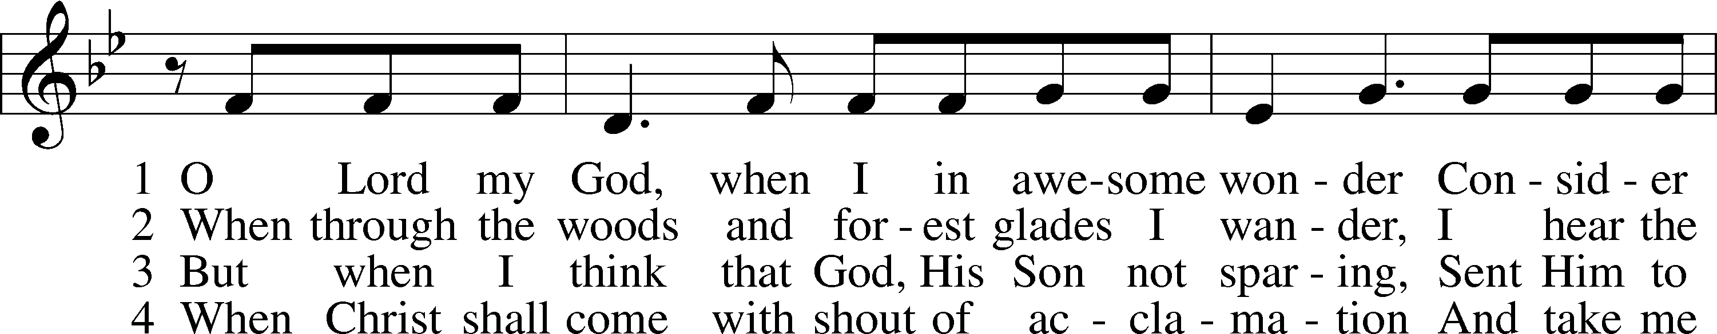

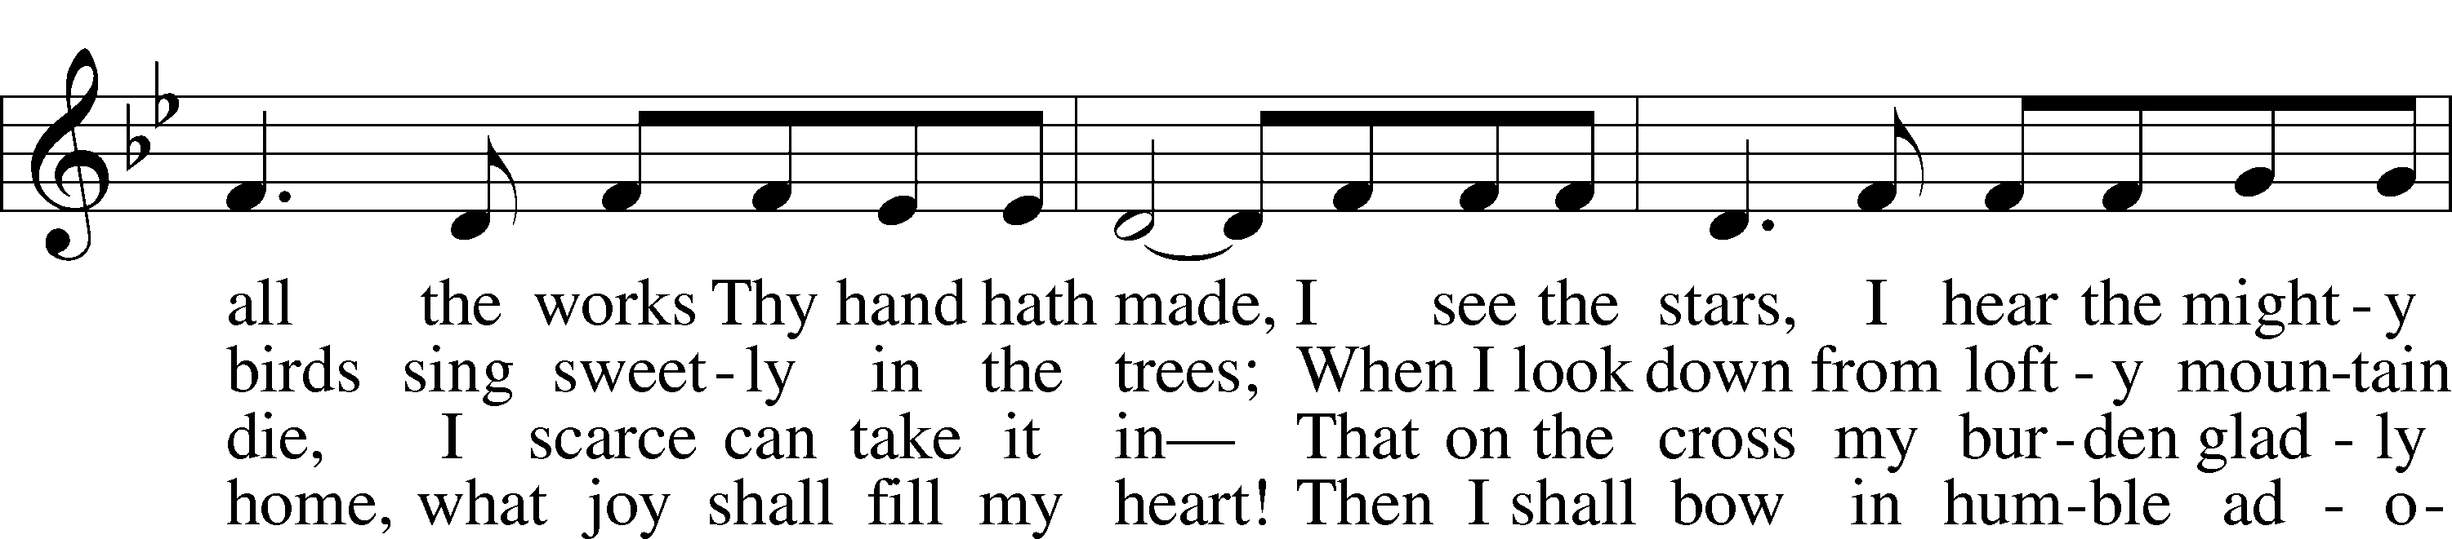

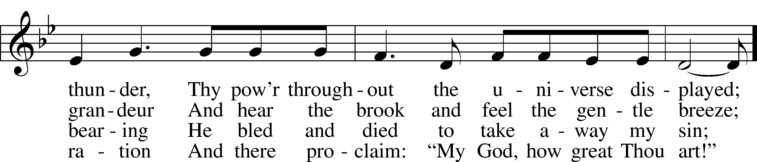

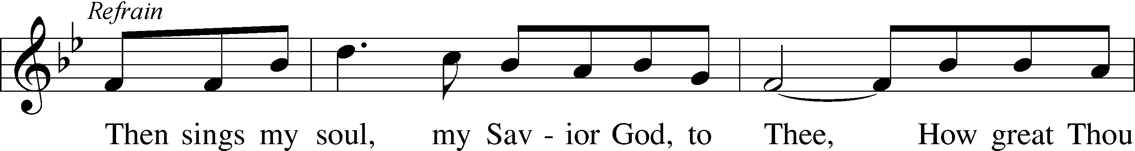

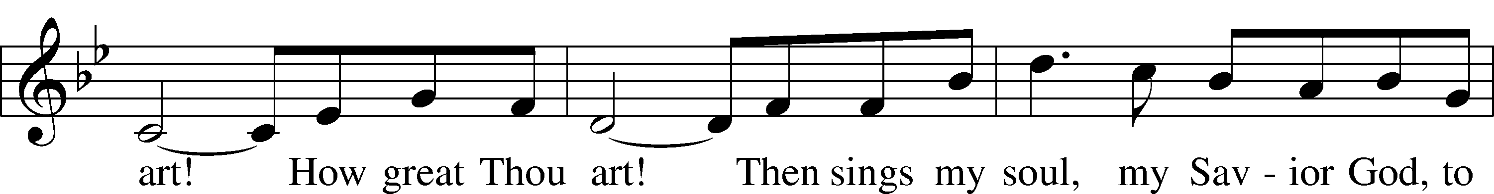

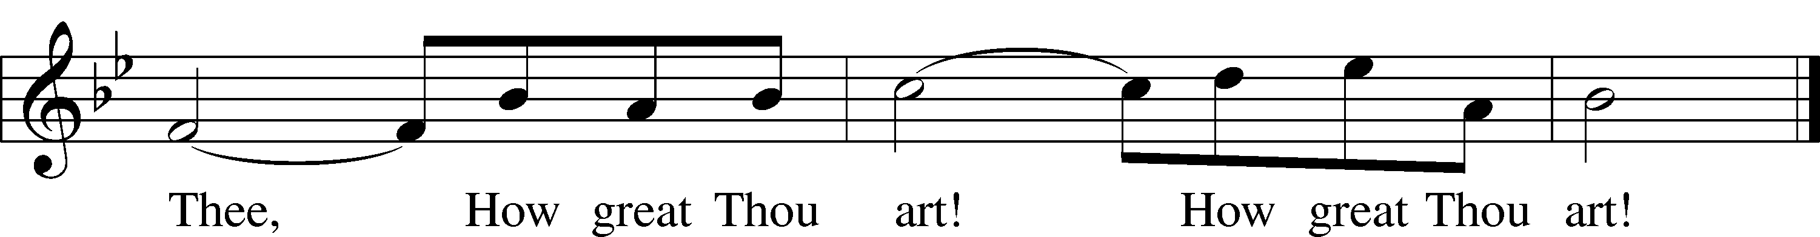

Text: Carl Gustaf Boberg, 1859–1940; tr. Stuart W. K. Hine, 1899–1989  
Tune: Swedish; arr. Stuart W. K. Hine, 1899–1989  
Text and tune: © 1949, 1953 The Stuart Hine Trust, admin. EMI CMG and Hope Publishing Co. Used by permission: LSB Hymn License no. 110005504

Sermon "What the Best Teachers Teach Best"

Reading John 6:68–69

68Simon Peter answered him, “Lord, to whom shall we go? You have the words of eternal life, 69and we have believed, and have come to know, that you are the Holy One of God.”

Hymn: 392 God Loves Me Dearly

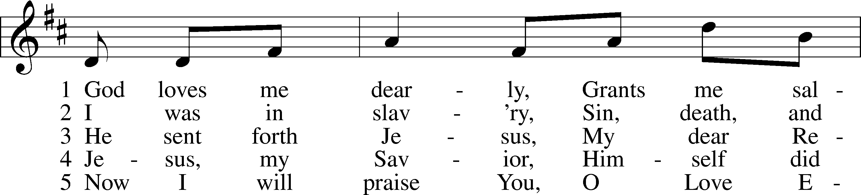

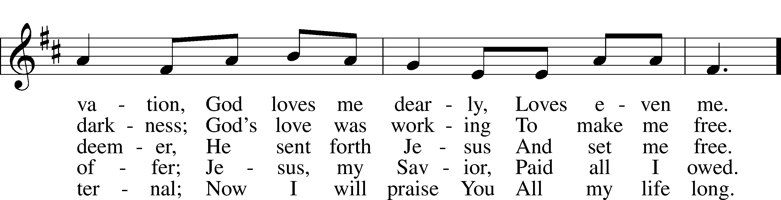

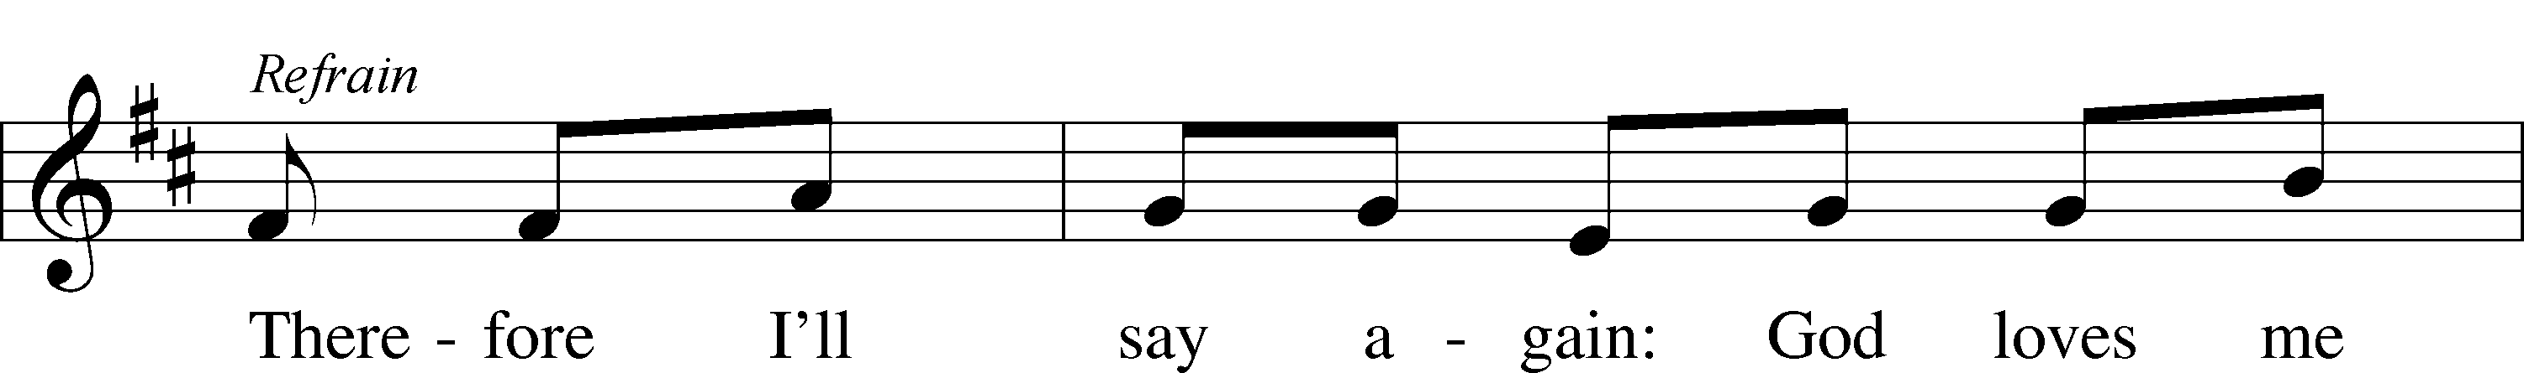

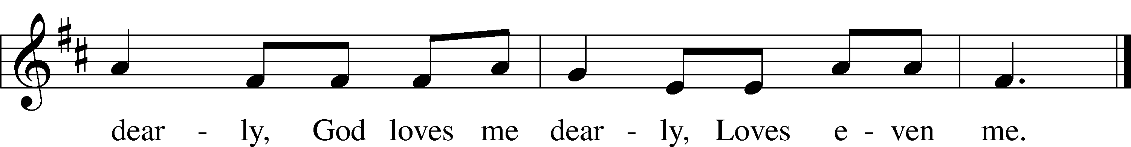

Text: August Rische, 1819–1906; tr. composite  
Tune: German  
Text and tune: Public domain

Kneel/Stand

Prayer of the Church

P Let us pray to the Lord, our God and Father, who raised Jesus from the dead.

P Almighty God, You have knit Your chosen people together into one communion in the mystical body of Your Son, Jesus Christ, our Lord. Give to Your whole Church in heaven and on earth Your light and peace. Lord, in Your mercy,

C **hear our prayer.**

P Grant that all who have been baptized into Christ’s death and resurrection may die to sin and rise to newness of life and so pass with Him through the gate of death and the grave to our joyful resurrection. Lord, in Your mercy,

C **hear our prayer.**

P Grant that all who have been nourished by the holy body and blood of Your Son may be raised to immortality and incorruption to be seated with Him at Your heavenly banquet. Lord, in Your mercy,

C **hear our prayer.**

P Give to the family of Marjorie and to all who mourn comfort in their grief and a sure confidence in Your loving care that, casting all their sorrow on You, they may know the consolation of Your love. Lord, in Your mercy,

C **hear our prayer.**

P Give courage and faith to the bereaved, that within the communion of Your Church they may have strength to meet the days ahead in the assurance of a holy and certain hope and in the joyful expectation of eternal life with those they love who have departed in the faith. Lord, in Your mercy,

C **hear our prayer.**

P Help us, we pray, in the midst of things we cannot understand, to believe and find comfort in the communion of saints, the forgiveness of sins, the resurrection of the body, and the life everlasting. Lord, in Your mercy,

C **hear our prayer.**

P Receive our thanks for Marjorie and for all the blessings You bestowed on her in this earthly life. Bring us at last to our heavenly home that with her we may see You face to face in the joys of paradise. Lord, in Your mercy,

C **hear our prayer.**

P O God of all grace, You sent Your Son, our Savior Jesus Christ, to bring life and immortality to light. We give You thanks that by His death He destroyed the power of death and by His resurrection He opened the kingdom of heaven to all believers. Strengthen us in the confidence that because He lives we shall live also, and that neither death nor life nor things present nor things to come will be able to separate us from Your love, which is in Christ Jesus, our Lord, who lives and reigns with You and the Holy Spirit, one God, now and forever.

C **Amen.**

Lord’s Prayer

P Taught by our Lord and trusting His promises, we are bold to pray:

C **Our Father who art in heaven,**

**hallowed be Thy name,**

**Thy kingdom come,**

**Thy will be done on earth**

**as it is in heaven;**

**give us this day our daily bread;**

**and forgive us our trespasses**

**as we forgive those**

**who trespass against us;**

**and lead us not into temptation,**

**but deliver us from evil.**

**For Thine is the kingdom**

**and the power and the glory**

**forever and ever. Amen.**

Nunc Dimittis

A “I am the resurrection and the life,” says the Lord. “He who believes in Me will live, even though he dies; and whoever lives and believes in Me will never die.”

C **Lord, now You let Your servant go in peace;**

**Your word has been fulfilled.**

**My own eyes have seen the salvation**

**which You have prepared in the sight of every people:**

**a light to reveal You to the nations**

**and the glory of Your people Israel.**

**Glory be to the Father and to the Son and to the Holy Spirit;**

**as it was in the beginning, is now, and will be forever. Amen.**

A “I am the resurrection and the life,” says the Lord. “He who believes in Me will live, even though he dies; and whoever lives and believes in Me will never die.”

Concluding Collect

P The Lord be with you.

C **And also with you.**

P Let us pray.

Lord God, our shepherd, You gather the lambs of Your flock into the arms of Your mercy and bring them home. Comfort us with the certain hope of the resurrection to everlasting life and a joyful reunion with those we love who have died in the faith; through Jesus Christ, Your Son, our Lord, who lives and reigns with You and the Holy Spirit, one God, now and forever.

C **Amen.**

The pastor may place his hand on the head of the casket as he says:

P May God the Father, who created this body; may God the T Son, who by His blood redeemed this body; may God the Holy Spirit, who by Holy Baptism sanctified this body to be His temple, keep these remains to the day of the resurrection of all flesh.

C **Amen.**

P Let us pray.

Almighty God, by the death of Your Son Jesus Christ You destroyed death, by His rest in the tomb You sanctified the graves of Your saints, and by His bodily resurrection You brought life and immortality to light so that all who die in Him abide in peace and hope. Receive our thanks for the victory over death and the grave that He won for us. Keep us in everlasting communion with all who wait for Him on earth and with all in heaven who are with Him, for He is the resurrection and the life, even Jesus Christ, our Lord.

C **Amen.**

Benedicamus

L Let us bless the Lord.

C **Thanks be to God.**

Benediction and Dismissal

P The Lord bless you and keep you.  
The Lord make His face shine upon you and be gracious unto you.  
The Lord lift up His countenance upon you and T give you peace.

C **Amen.**

P Let us go forth in peace,

C **in the name of the Lord. Amen.**

Hymn: 878 Abide with Me

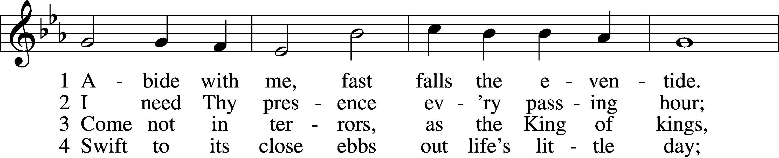

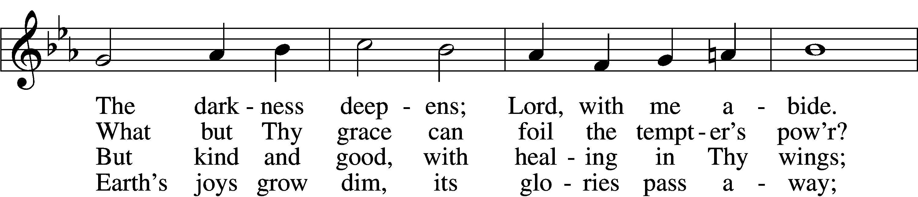

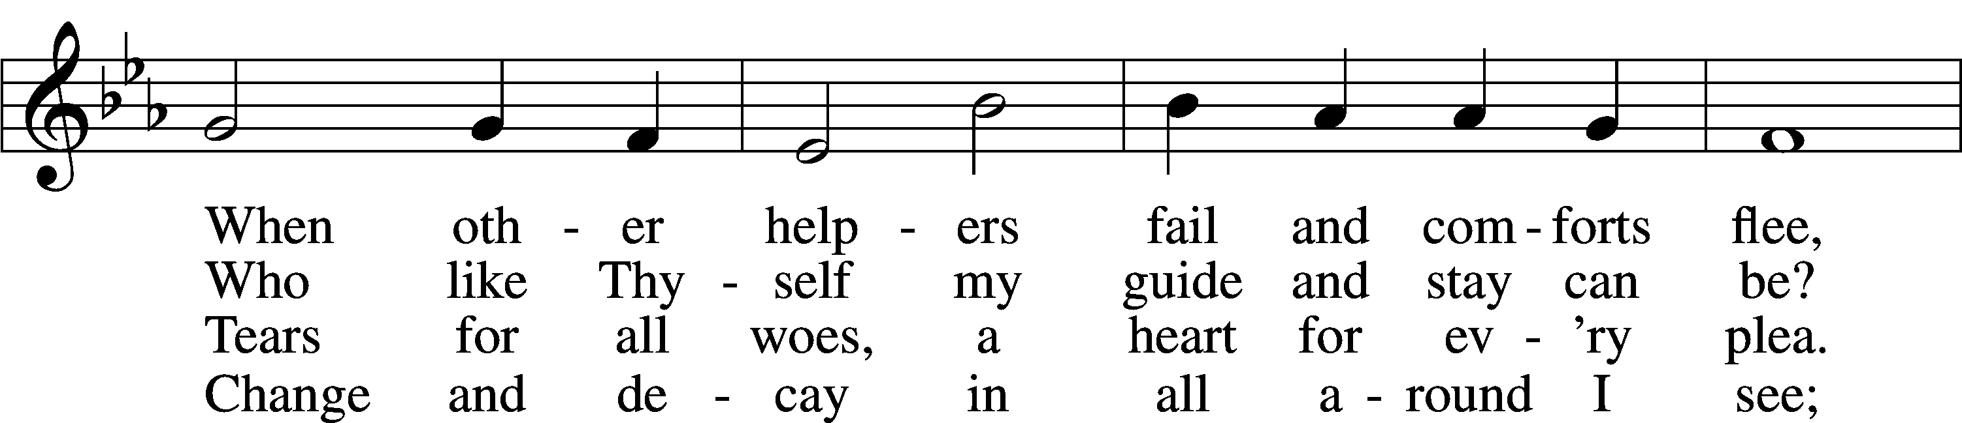

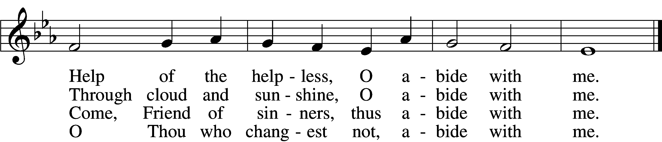

5 I fear no foe with Thee at hand to bless;  
Ills have no weight and tears no bitterness.  
Where is death’s sting? Where, grave, thy victory?  
I triumph still if Thou abide with me!

6 Hold Thou Thy cross before my closing eyes;  
Shine through the gloom, and point me to the skies.  
Heav’n’s morning breaks, and earth’s vain shadows flee;  
In life, in death, O Lord, abide with me.

Text: Henry F. Lyte, 1793–1847, alt.  
Tune: William H. Monk, 1823–89  
Text and tune: Public domain

Acknowledgments

Funeral Service from Lutheran Service Book

Unless otherwise indicated, Scripture quotations are from the ESV® Bible (The Holy Bible, English Standard Version®), copyright © 2001 by Crossway, a publishing ministry of Good News Publishers. Used by permission. All rights reserved.

Created by Lutheran Service Builder © 2025 Concordia Publishing House.

Officiant: Rev. Ronald Mueller

Organist: Cindy Wright

A lunch has been prepared for the family and friends of Marjorie by the members of Salem. Feel free to go through the meal line immediately following the service.