# Confession and Absolution

Divine Service 3

7th Sunday after Pentecost

July 7,2024

Hymn of Invocation: 497 Come, Holy Ghost, God and Lord

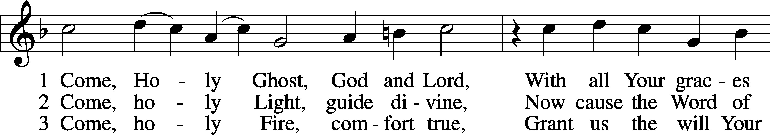

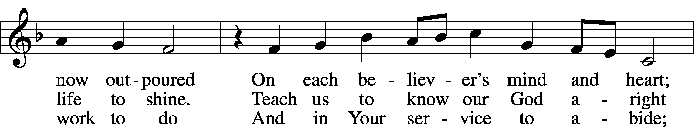

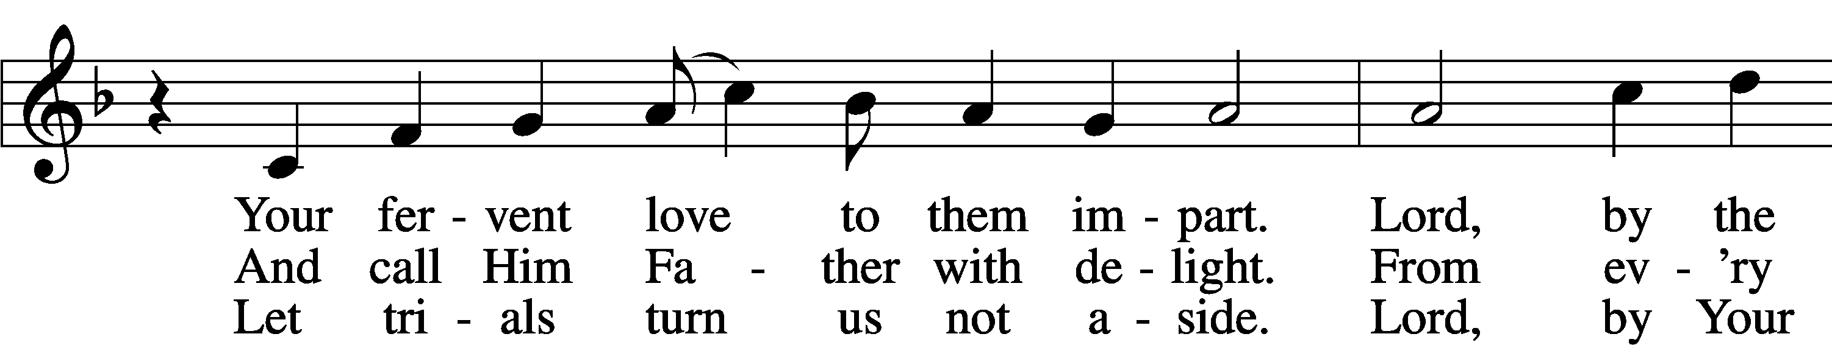

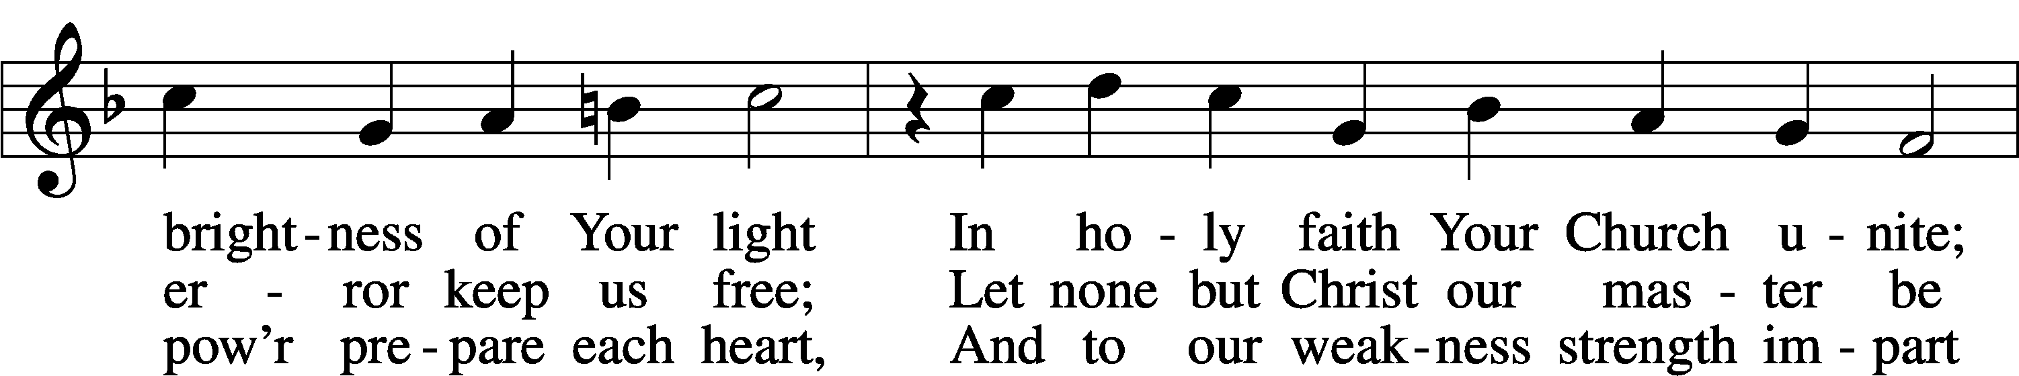

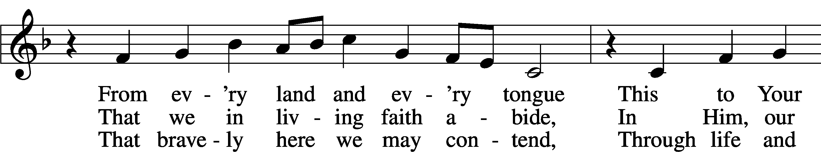

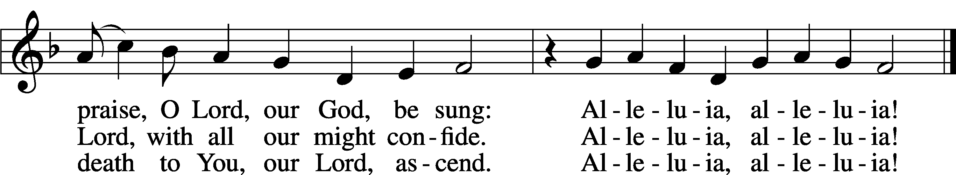

Text: tr. The Lutheran Hymnal, 1941, alt.; (st. 1): German, 15th cent.; (sts. 2–3): Martin Luther, 1483–1546  
Tune: Eyn Enchiridion oder Handbüchlein, 1524, Erfurt  
Text: © 1941 Concordia Publishing House. Used by permission: LSB Hymn License no. 110005504  
Tune: Public domain

Stand

The sign of the cross may be made by all in remembrance of their Baptism.

P In the name of the Father and of the T Son and of the Holy Spirit.

C **Amen.**

P Beloved in the Lord! Let us draw near with a true heart and confess our sins unto God our Father, beseeching Him in the name of our Lord Jesus Christ to grant us forgiveness.

P Our help is in the name of the Lord,

C **who made heaven and earth.**

P I said, I will confess my transgressions unto the Lord,

C **and You forgave the iniquity of my sin.**

Kneel/Stand

Silence for reflection on God’s Word and for self-examination.

P O almighty God, merciful Father,

C **I, a poor, miserable sinner, confess unto You all my sins and iniquities with which I have ever offended You and justly deserved Your temporal and eternal punishment. But I am heartily sorry for them and sincerely repent of them, and I pray You of Your boundless mercy and for the sake of the holy, innocent, bitter sufferings and death of Your beloved Son, Jesus Christ, to be gracious and merciful to me, a poor, sinful being.**

P Upon this your confession, I, by virtue of my office, as a called and ordained servant of the Word, announce the grace of God unto all of you, and in the stead and by the command of my Lord Jesus Christ I forgive you all your sins in the name of the Father and of the T Son and of the Holy Spirit.

C **Amen.**

Stand

# Service of the Word

Introit Psalm 132:13–16; antiphon: Psalm 34:8

Oh, taste and see that the Lord is good!  
 Blessèd is the man who takes refuge in him!  
For the Lord has chosen Zion;  
 he has desired it for his dwelling place:  
“This is my resting place forever;  
 here I will dwell, for I have desired it.  
I will abundantly bless her provisions;  
 I will satisfy her poor with bread.  
Her priests I will clothe with salvation,  
 and her saints will shout for joy.”  
**Glory be to the Father and to the Son**  
 **and to the Holy Spirit;**  
**as it was in the beginning,**  
 **is now, and will be forever. Amen.**  
Oh, taste and see that the Lord is good!  
 Blessèd is the man who takes refuge in him!

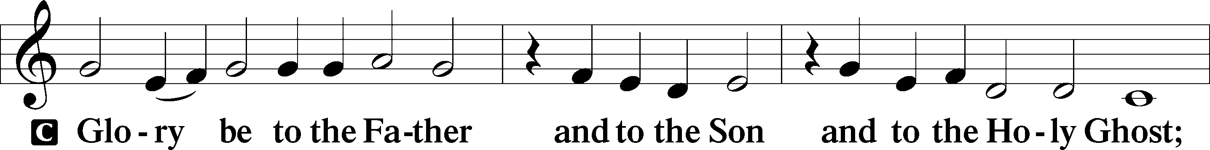

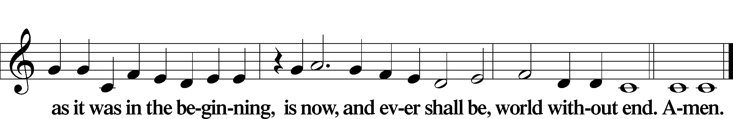

Kyrie LSB 186

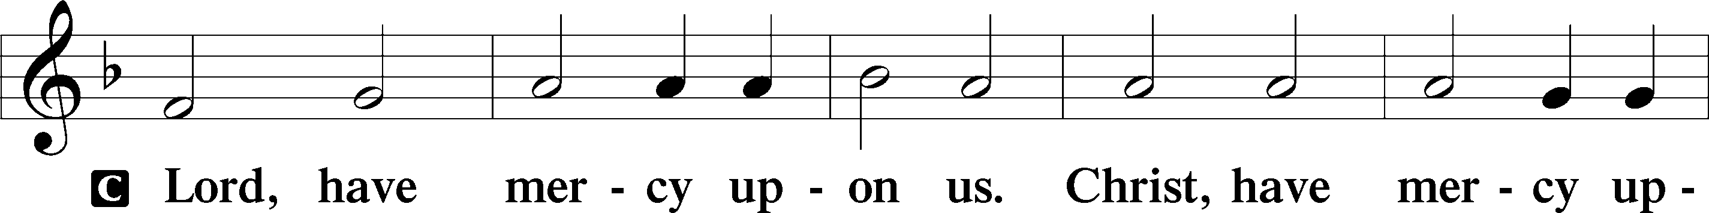

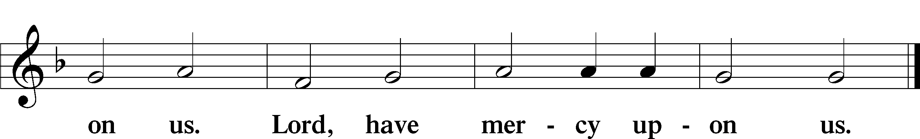

Gloria in Excelsis LSB 187

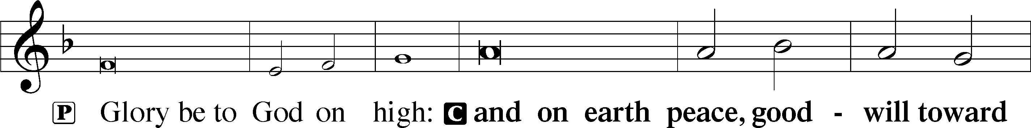

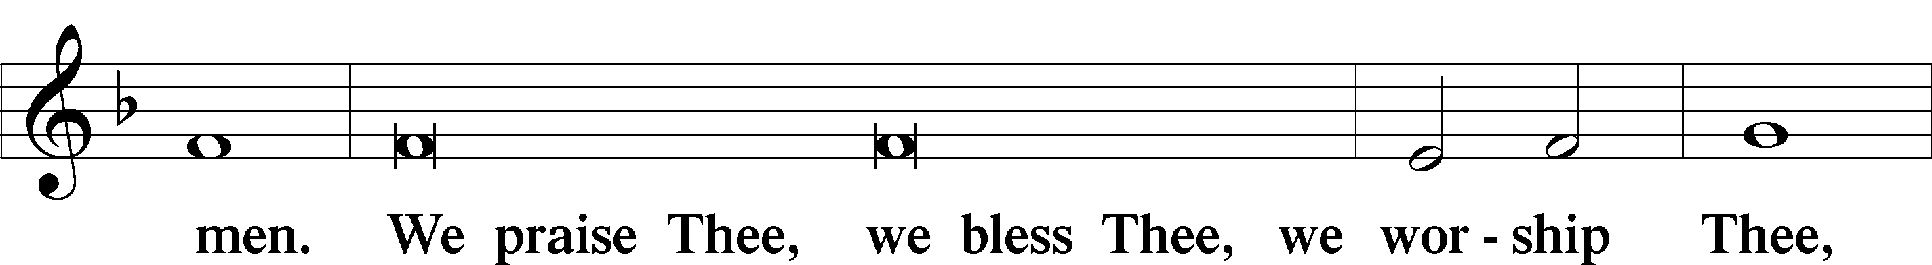

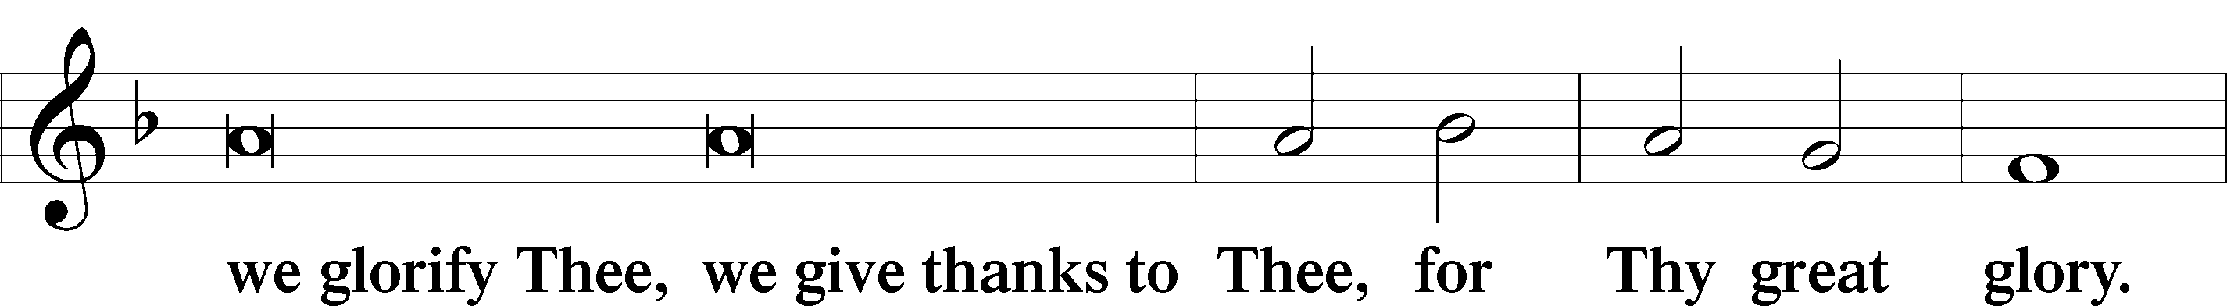

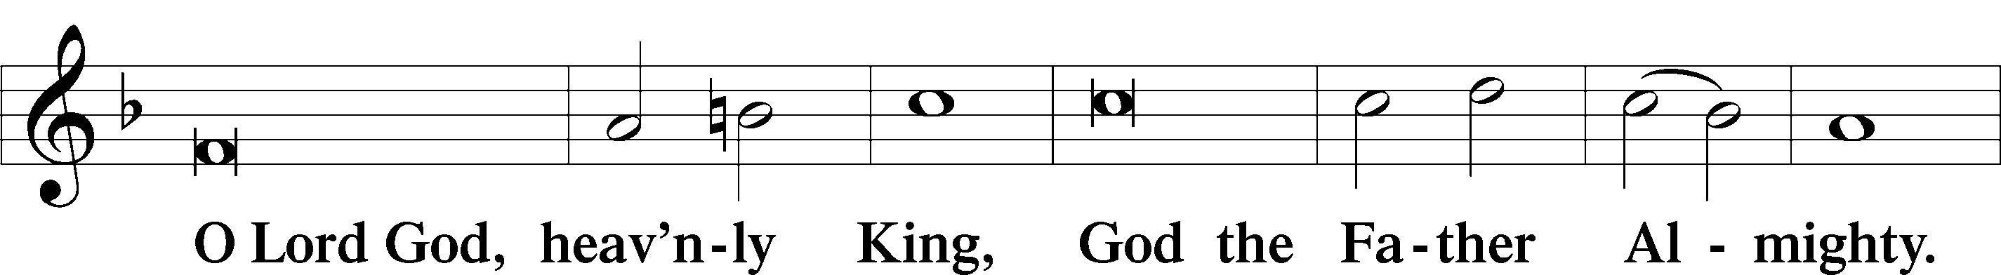

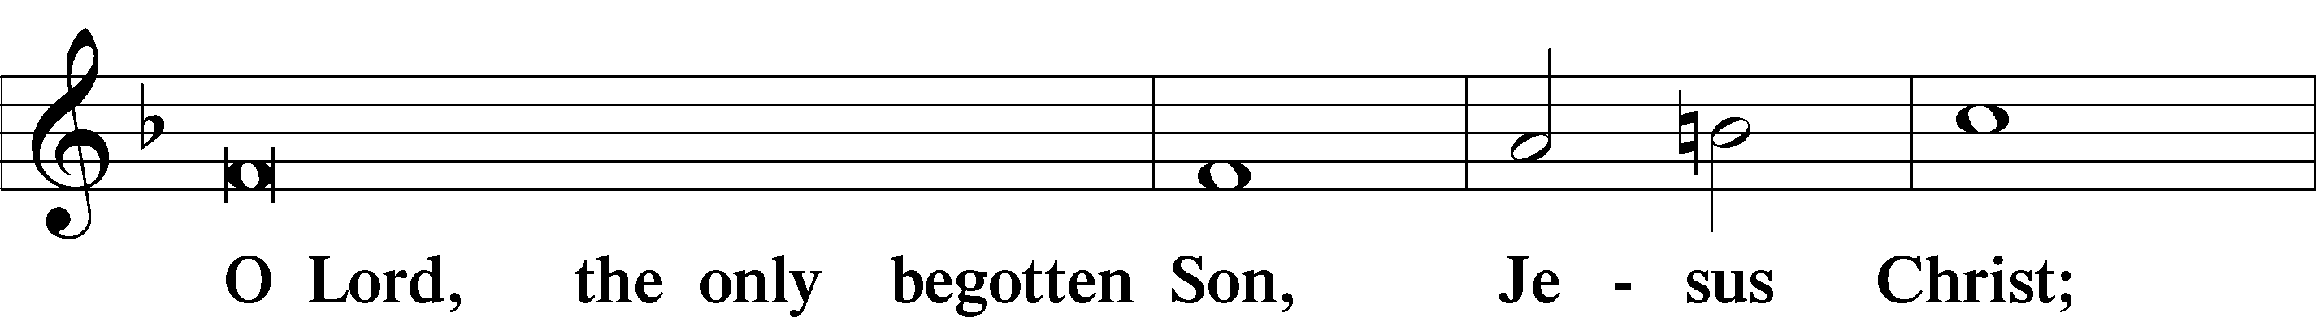

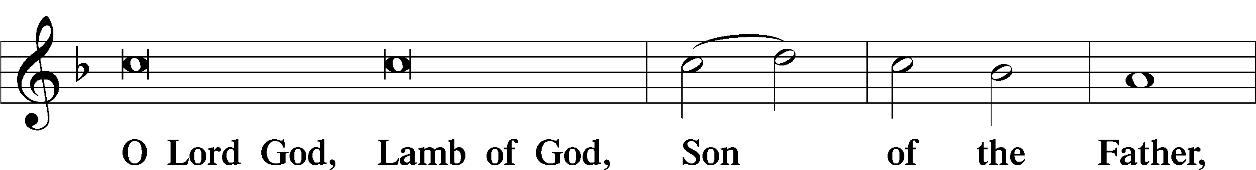

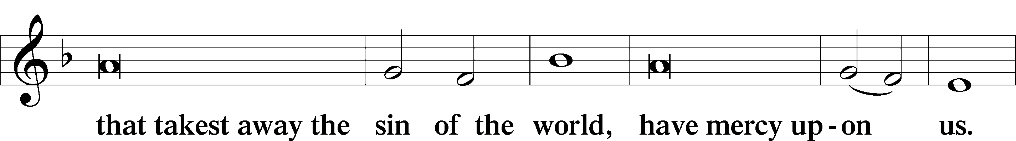

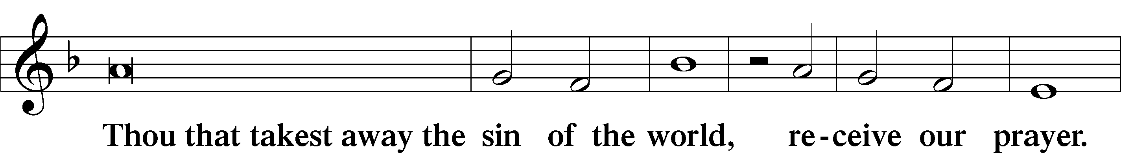

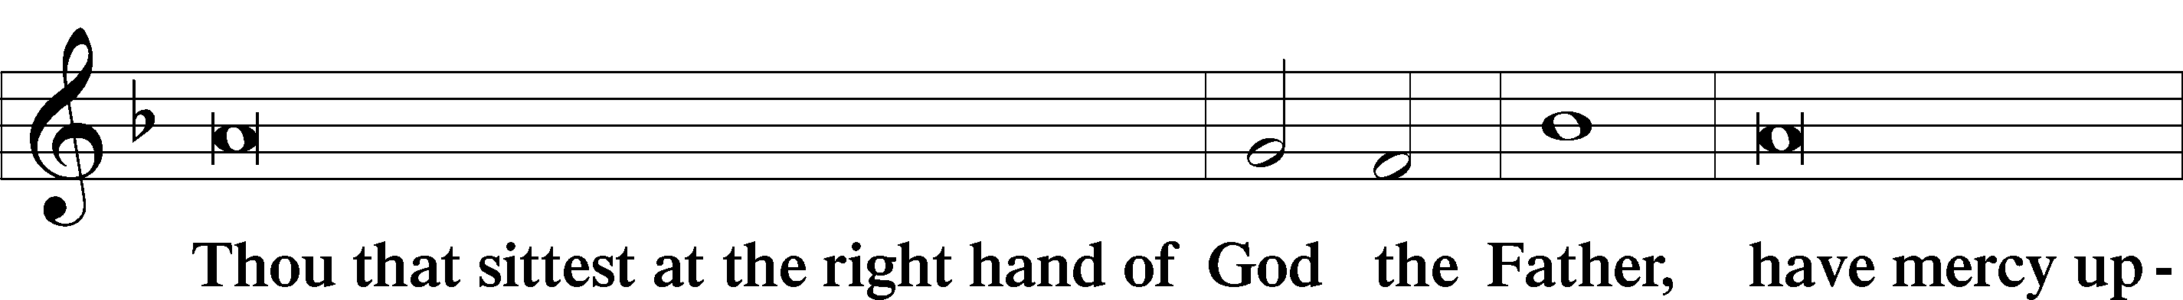

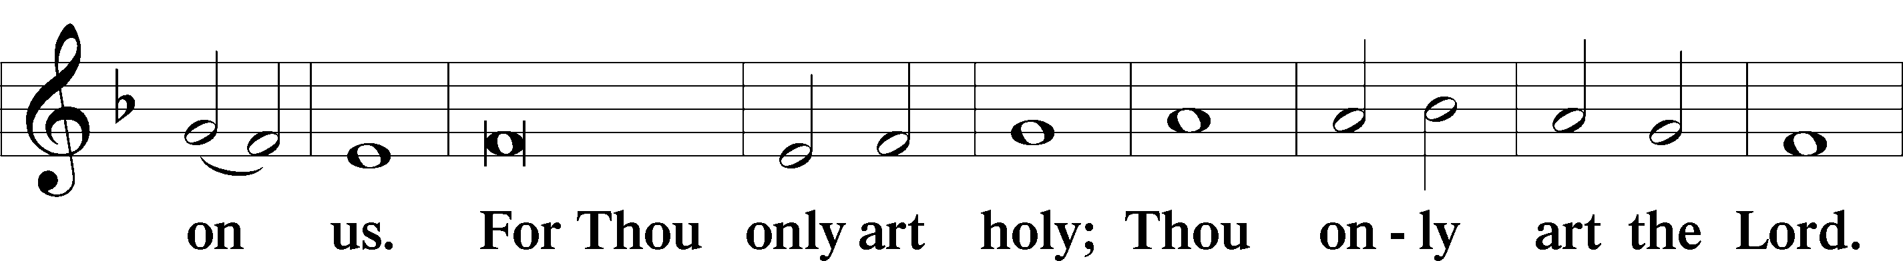

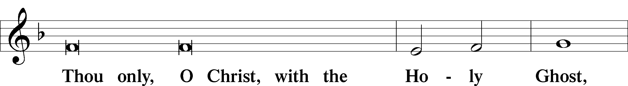

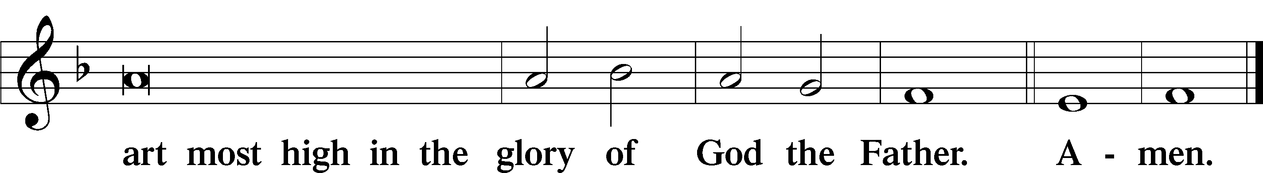

Salutation and Collect of the Day

P The Lord be with you.

C **And with thy spirit.**

P Let us pray.

O God, Your almighty power is made known chiefly in showing mercy. Grant us the fullness of Your grace that we may be called to repentance and made partakers of Your heavenly treasures; through Your Son, Jesus Christ, our Lord, who lives and reigns with You and the Holy Spirit, one God, now and forever.

C **Amen.**

Sit

Old Testament Reading Ezekiel 2:1–5

Ezekiel’s Call

1 He said to me, “Son of man, stand on your feet, and I will speak with you.” 2And as he spoke to me, the Spirit entered into me and set me on my feet, and I heard him speaking to me. 3And he said to me, “Son of man, I send you to the people of Israel, to nations of rebels, who have rebelled against me. They and their fathers have transgressed against me to this very day. 4The descendants also are impudent and stubborn: I send you to them, and you shall say to them, ‘Thus says the Lord God.’ 5And whether they hear or refuse to hear (for they are a rebellious house) they will know that a prophet has been among them.”

A This is the Word of the Lord.

C **Thanks be to God.**

Psalm Psalm 123; antiphon: v. 1

Our Eyes Look to the Lord Our God

1To you I lift up my eyes,  
 O you who are enthroned in the heavens!  
2Behold, as the eyes of servants  
 look to the hand of their master,  
as the eyes of a maidservant  
 to the hand of her mistress,  
so our eyes look to the Lord our God,  
 till he has mercy upon us.  
3Have mercy upon us, O Lord, have mercy upon us,  
 for we have had more than enough of contempt.  
4Our soul has had more than enough  
 of the scorn of those who are at ease,  
 of the contempt of the proud.

Epistle 2 Corinthians 12:1–10

Paul’s Visions and His Thorn

1I must go on boasting. Though there is nothing to be gained by it, I will go on to visions and revelations of the Lord. 2I know a man in Christ who fourteen years ago was caught up to the third heaven—whether in the body or out of the body I do not know, God knows. 3And I know that this man was caught up into paradise—whether in the body or out of the body I do not know, God knows— 4and he heard things that cannot be told, which man may not utter. 5On behalf of this man I will boast, but on my own behalf I will not boast, except of my weaknesses. 6Though if I should wish to boast, I would not be a fool, for I would be speaking the truth. But I refrain from it, so that no one may think more of me than he sees in me or hears from me. 7So to keep me from being too elated by the surpassing greatness of the revelations, a thorn was given me in the flesh, a messenger of Satan to harass me, to keep me from being too elated. 8Three times I pleaded with the Lord about this, that it should leave me. 9But he said to me, “My grace is sufficient for you, for my power is made perfect in weakness.” Therefore I will boast all the more gladly of my weaknesses, so that the power of Christ may rest upon me. 10For the sake of Christ, then, I am content with weaknesses, insults, hardships, persecutions, and calamities. For when I am weak, then I am strong.

A This is the Word of the Lord.

C **Thanks be to God.**

Stand

Alleluia LSB 190

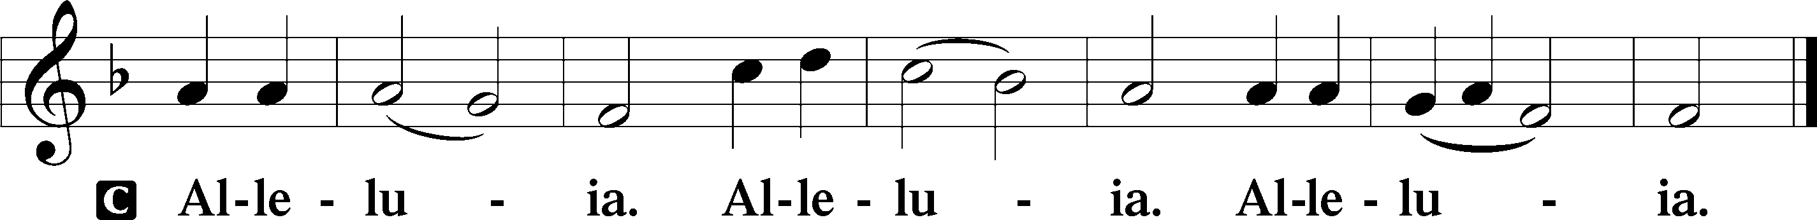

Holy Gospel Mark 6:1–13

P The Holy Gospel according to St. Mark, the sixth chapter.

C **Glory be to Thee, O Lord.**

Jesus Rejected at Nazareth

1[Jesus] went away from there and came to his hometown, and his disciples followed him. 2And on the Sabbath he began to teach in the synagogue, and many who heard him were astonished, saying, “Where did this man get these things? What is the wisdom given to him? How are such mighty works done by his hands? 3Is not this the carpenter, the son of Mary and brother of James and Joses and Judas and Simon? And are not his sisters here with us?” And they took offense at him. 4And Jesus said to them, “A prophet is not without honor, except in his hometown and among his relatives and in his own household.” 5And he could do no mighty work there, except that he laid his hands on a few sick people and healed them. 6And he marveled because of their unbelief.

And he went about among the villages teaching.

Jesus Sends Out the Apostles

7And he called the twelve and began to send them out two by two, and gave them authority over the unclean spirits. 8He charged them to take nothing for their journey except a staff—no bread, no bag, no money in their belts— 9but to wear sandals and not put on two tunics. 10And he said to them, “Whenever you enter a house, stay there until you depart from there. 11And if any place will not receive you and they will not listen to you, when you leave, shake off the dust that is on your feet as a testimony against them.” 12So they went out and proclaimed that people should repent. 13And they cast out many demons and anointed with oil many who were sick and healed them.

P This is the Gospel of the Lord.

C **Praise be to Thee, O Christ.**

Nicene Creed

C **I believe in one God,**

**the Father Almighty,**

**maker of heaven and earth**

**and of all things visible and invisible.**

**And in one Lord Jesus Christ,**

**the only-begotten Son of God,**

**begotten of His Father before all worlds,**

**God of God, Light of Light,**

**very God of very God,**

**begotten, not made,**

**being of one substance with the Father,**

**by whom all things were made;**

**who for us men and for our salvation came down from heaven**

**and was incarnate by the Holy Spirit of the virgin Mary**

**and was made man;**

**and was crucified also for us under Pontius Pilate.**

**He suffered and was buried.**

**And the third day He rose again according to the Scriptures**

**and ascended into heaven**

**and sits at the right hand of the Father.**

**And He will come again with glory to judge both the living and the dead,**

**whose kingdom will have no end.**

**And I believe in the Holy Spirit,**

**the Lord and giver of life,**

**who proceeds from the Father and the Son,**

**who with the Father and the Son together is worshiped and glorified,**

**who spoke by the prophets.**

**And I believe in one holy Christian and apostolic Church,**

**I acknowledge one Baptism for the remission of sins,**

**and I look for the resurrection of the dead**

**and the life** T **of the world to come. Amen.**

Sit

Hymn of the Day: 717 Eternal Father, Strong to Save

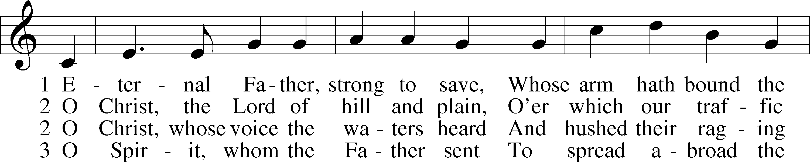

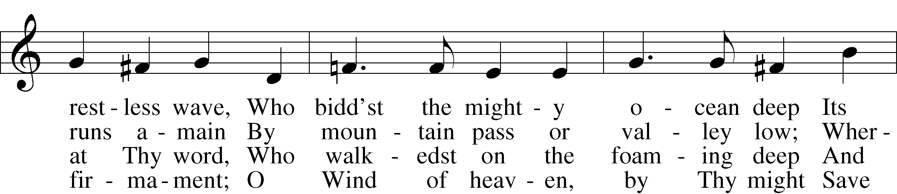

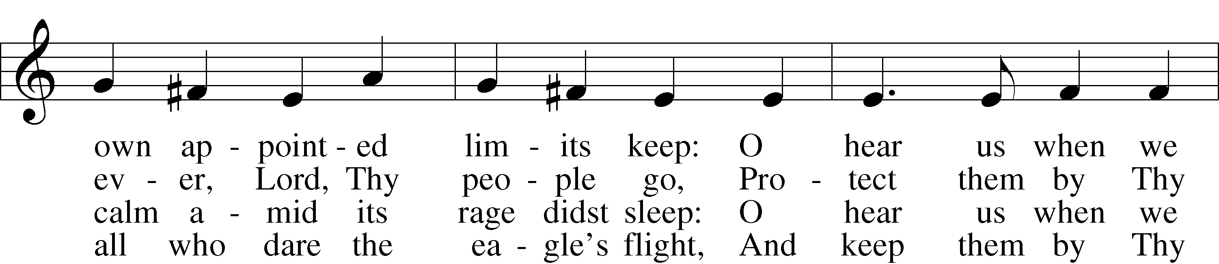

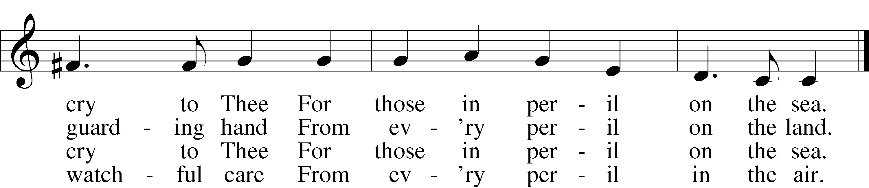

3a Most Holy Spirit, who didst brood  
Upon the chaos dark and rude,  
And bid its angry tumult cease,  
And give, for wild confusion, peace:  
O hear us when we cry to Thee  
For those in peril on the sea.

4 O Trinity of love and pow’r,  
Our people shield in danger’s hour;  
From rock and tempest, fire and foe,  
Protect them wheresoe’er they go;  
Thus evermore shall rise to Thee  
Glad praise from air and land and sea.

Text (sts. 1–4): William Whiting, 1825–78, alt.; (sts. 2a–3a): Robert N. Spencer, 1877–1961, alt.  
Tune: John B. Dykes, 1823–76  
Text (sts. 2–3): © The Church Pension Fund. Used by permission: LSB Hymn License no. 110005504  
Text (sts. 1–4) and tune: Public domain

Sermon

P The peace of God, which passes all understanding, keep your hearts and minds in Christ Jesus.

C **Amen.**

Stand

Offertory LSB 192

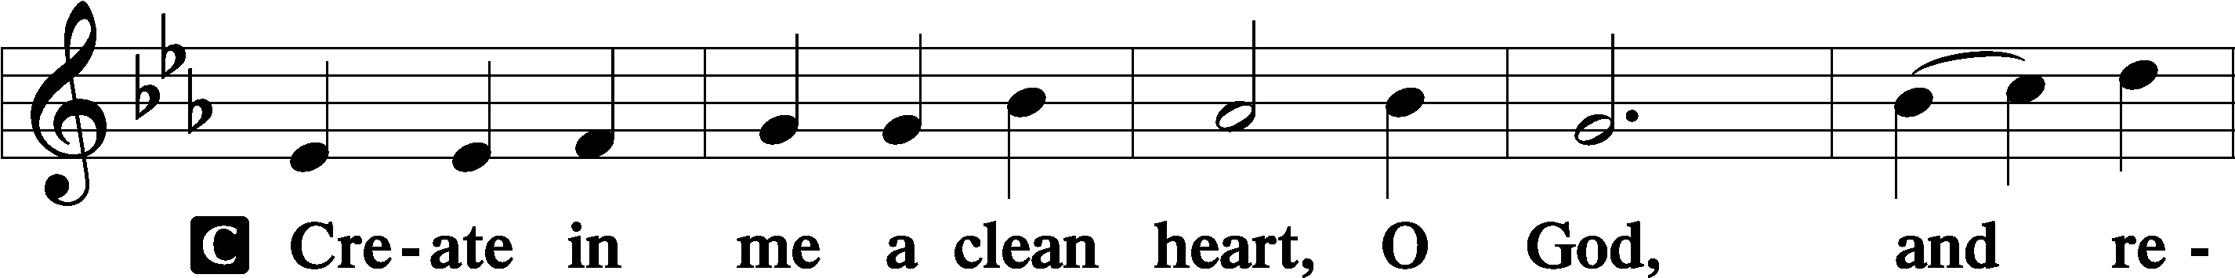

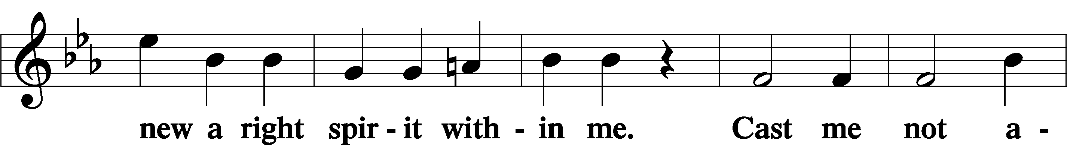

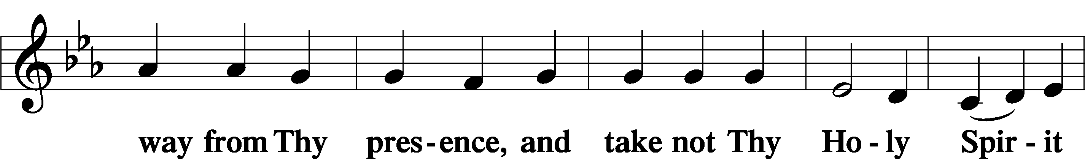

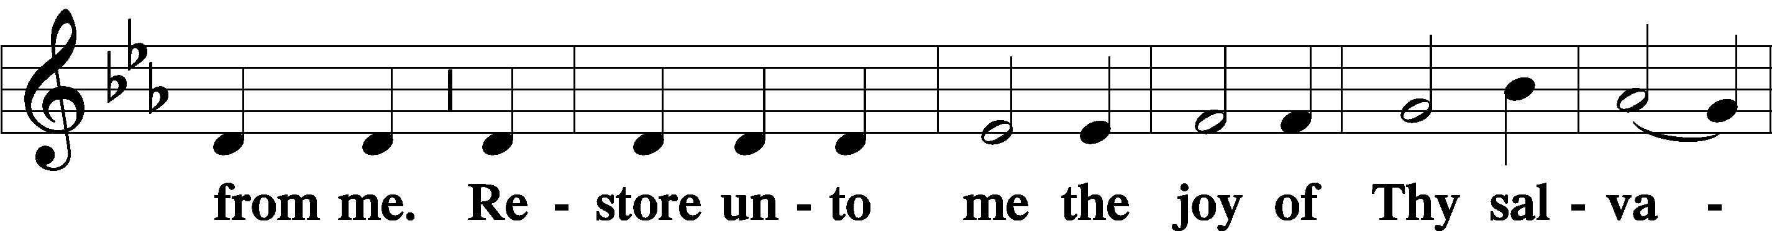

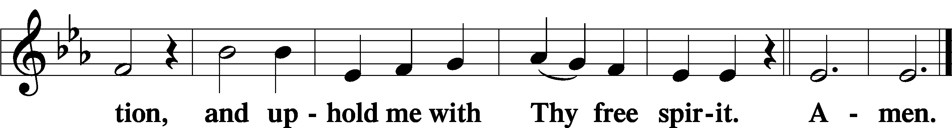

Sit

Offering

Stand

Prayer of the Church

# Service of the Sacrament

Preface LSB 194







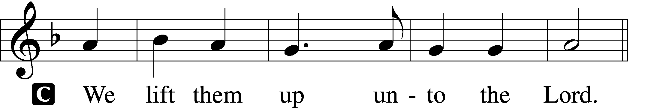

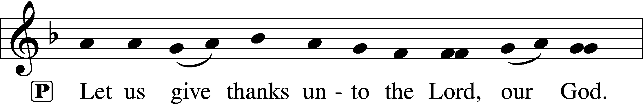

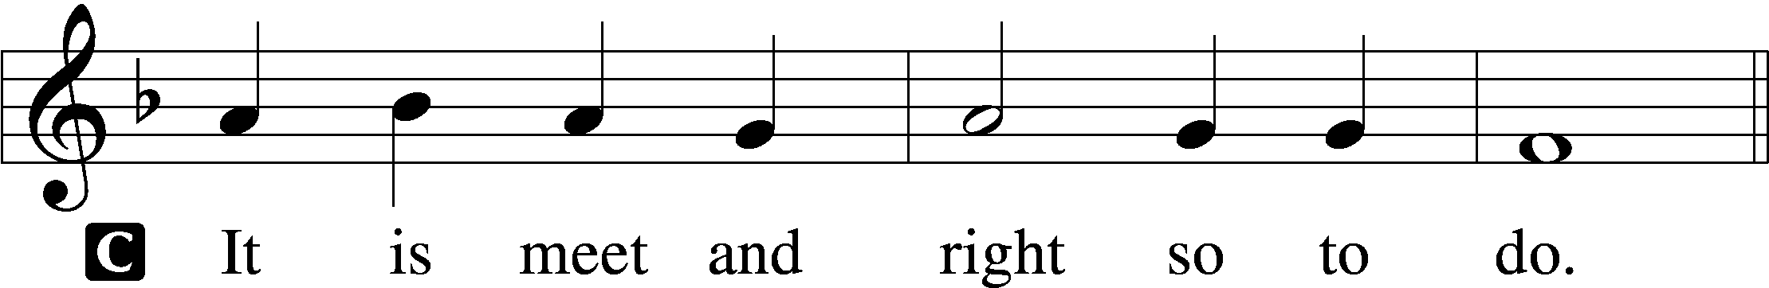

P It is truly meet, right, and salutary that we should at all times and in all places give thanks to You, holy Lord, almighty Father, everlasting God, through Jesus Christ, our Lord, who on this day overcame death and the grave and by His glorious resurrection opened to us the way of everlasting life. Therefore with angels and archangels and with all the company of heaven we laud and magnify Your glorious name, evermore praising You and saying:

Sanctus LSB 195

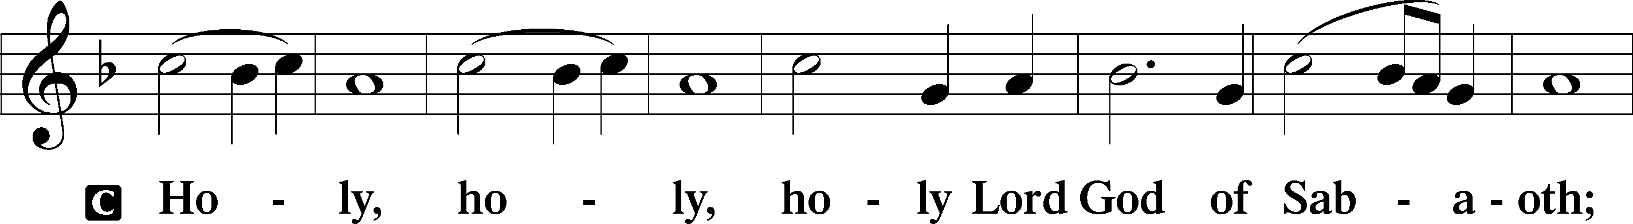

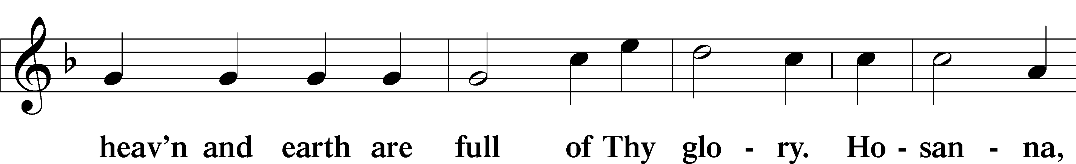

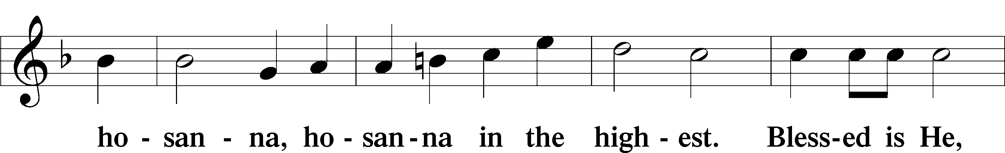

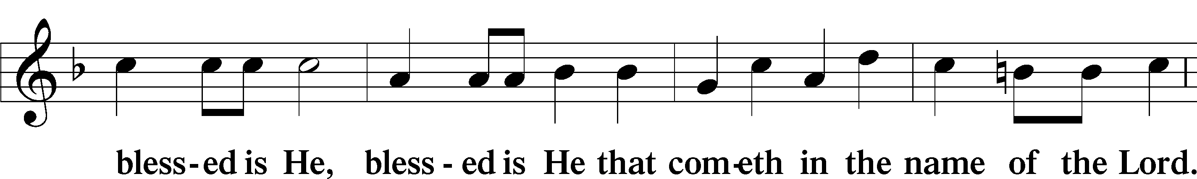

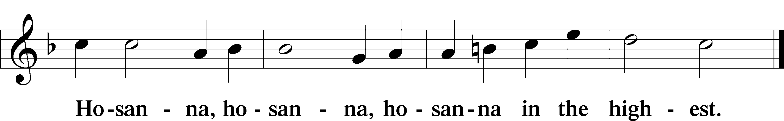

Lord’s Prayer LSB 196

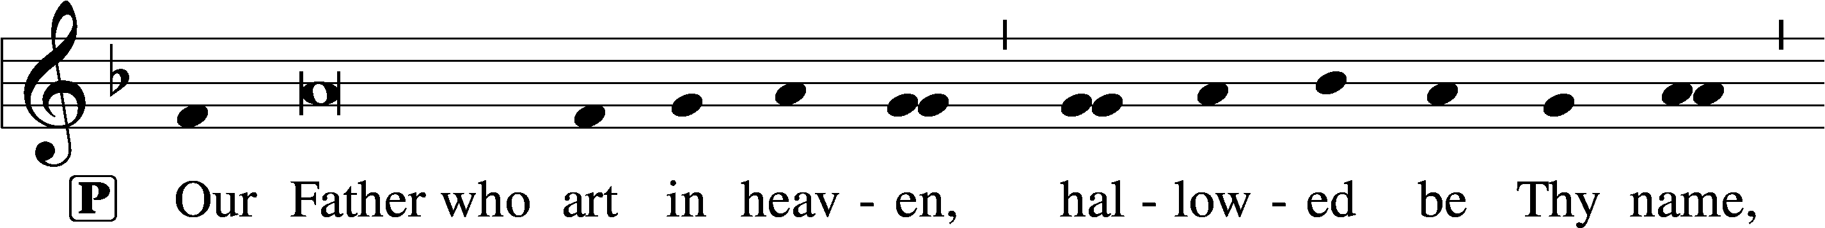

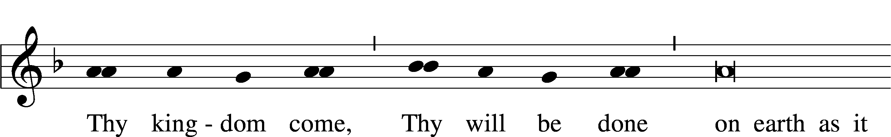

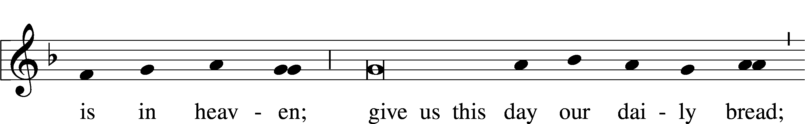

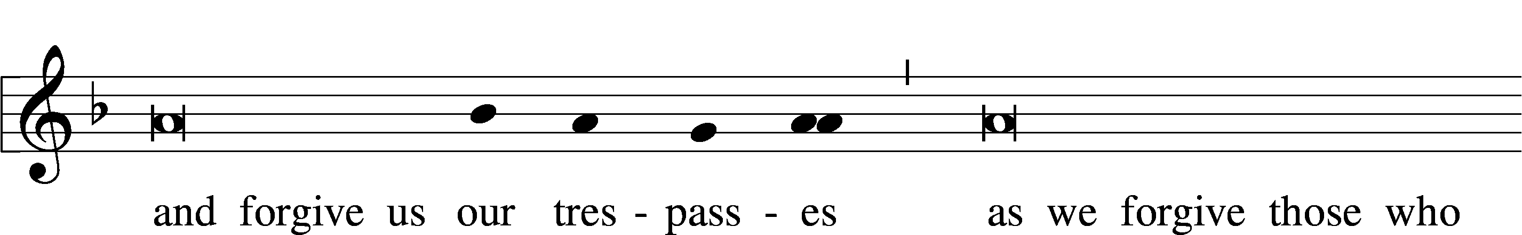

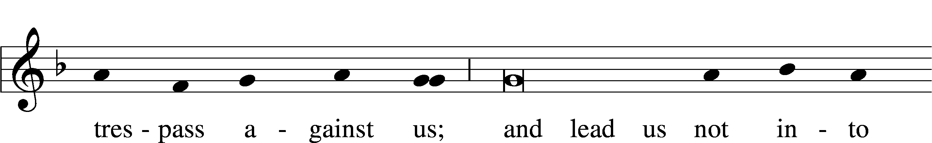

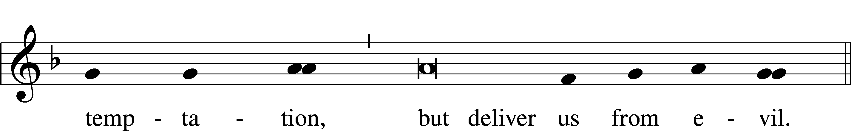

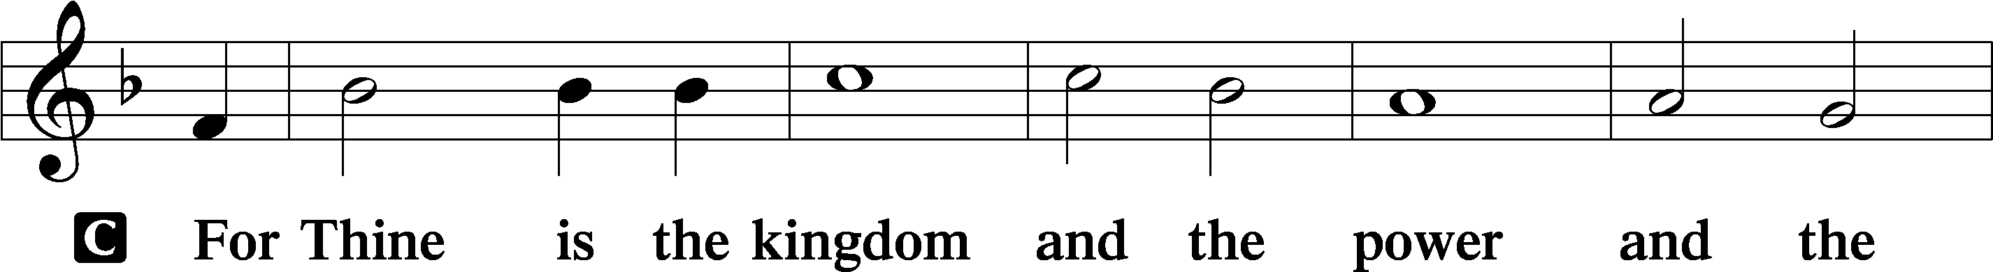

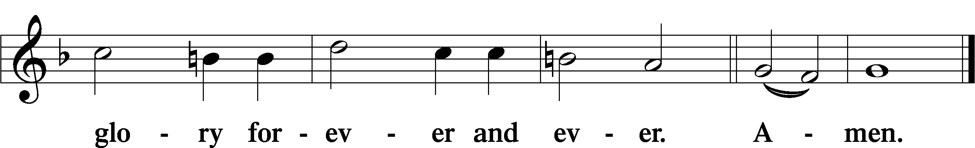

The Words of Our Lord LSB 197

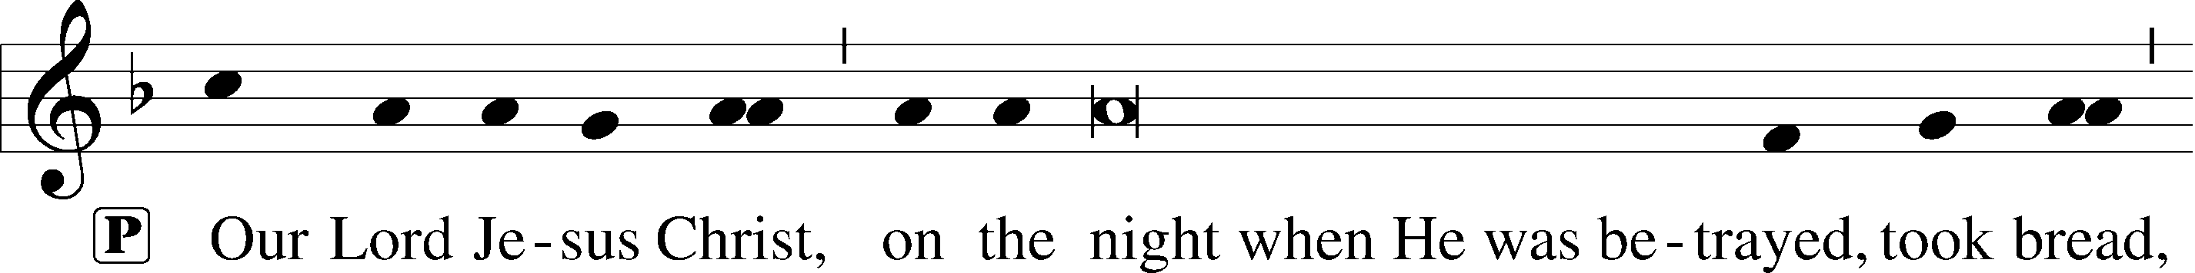

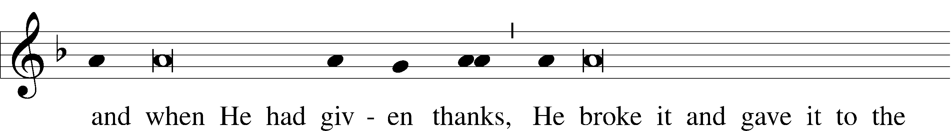

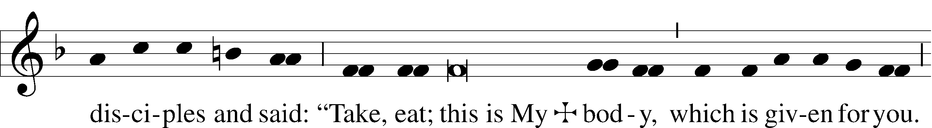

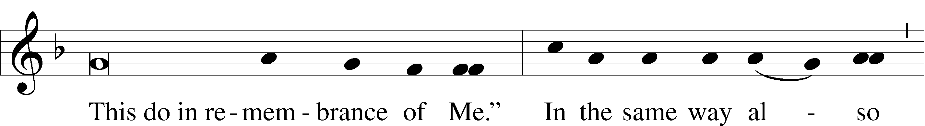

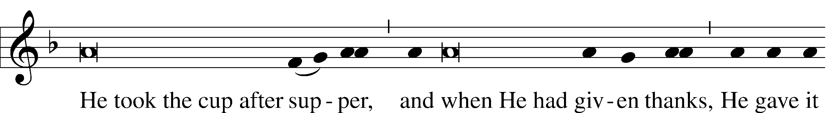

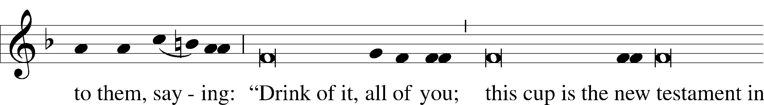

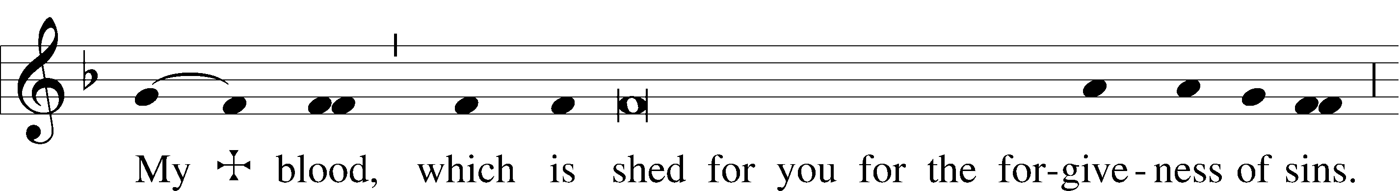

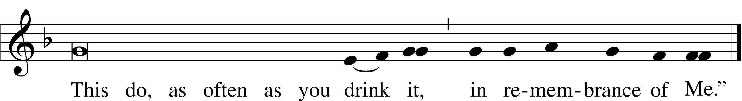

Pax Domini LSB 197

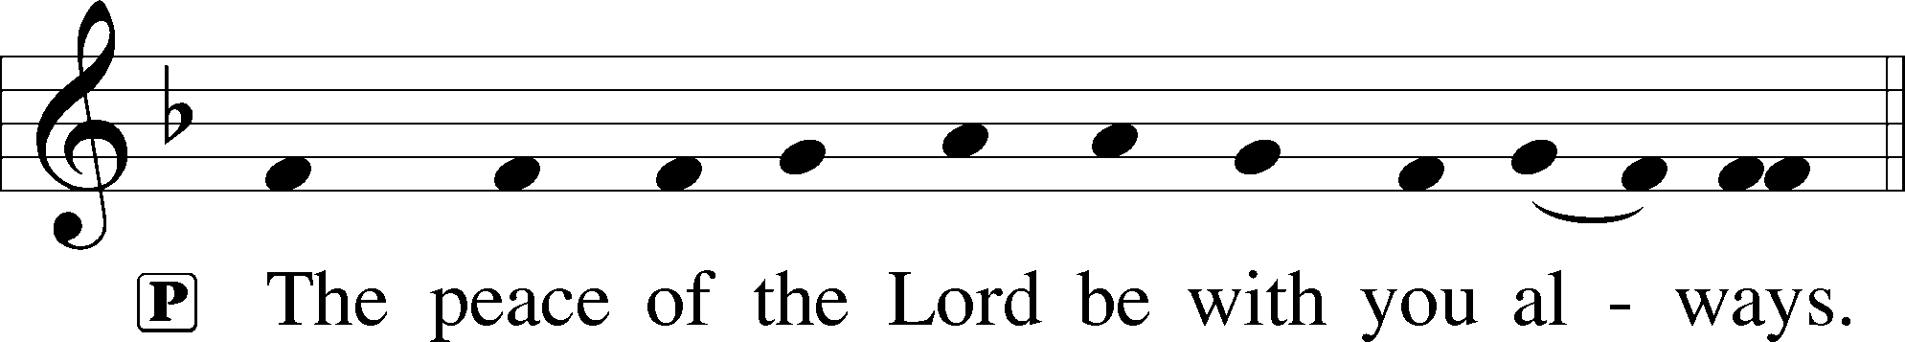

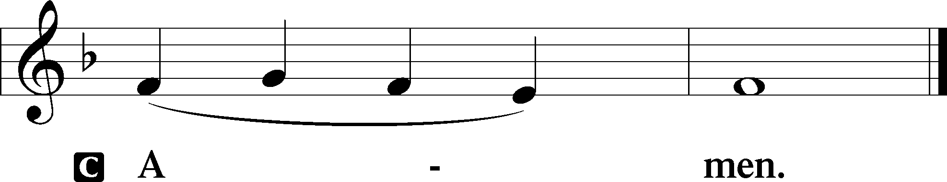

Agnus Dei LSB 198

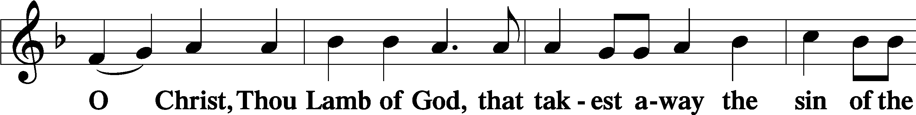

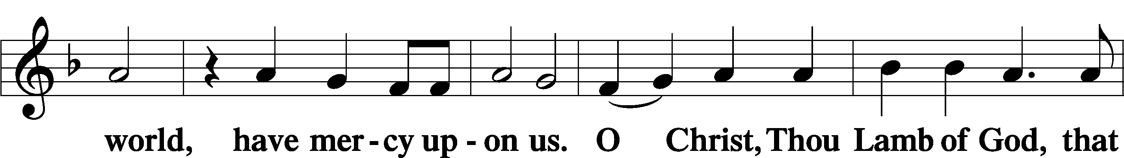

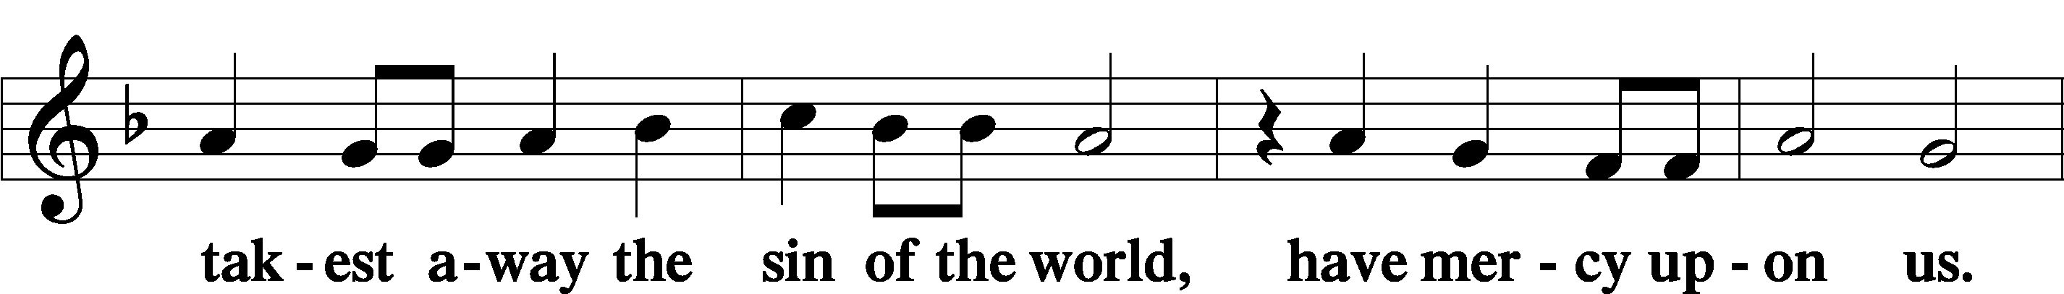

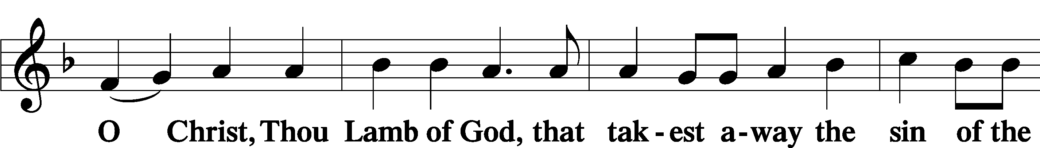



Sit

Distribution

The pastor and those who assist him receive the body and blood of Christ first and then distribute them to those who come to receive, saying:

Take, eat; this is the true body of our Lord and Savior Jesus Christ, given into death for your sins.

**Amen.**

Take, drink; this is the true blood of our Lord and Savior Jesus Christ, shed for the forgiveness of your sins.

**Amen.**

In dismissing the communicants, the following is said:

P The body and blood of our Lord Jesus Christ strengthen and preserve you in body and soul to life everlasting. Depart T in peace.

C **Amen.**

Distribution Hymn: 606 I Lay My Sins on Jesus

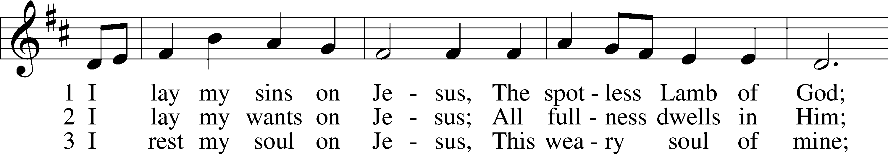

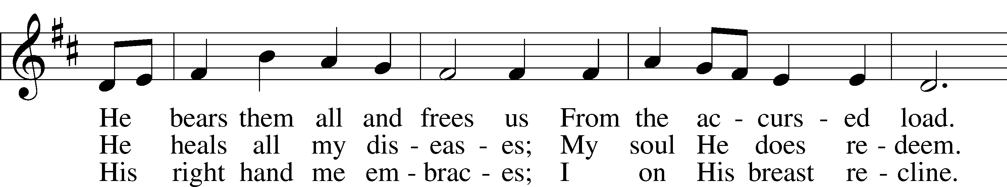

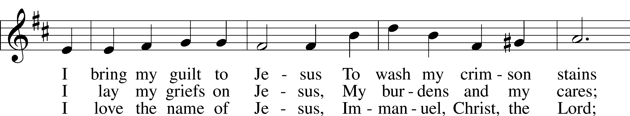

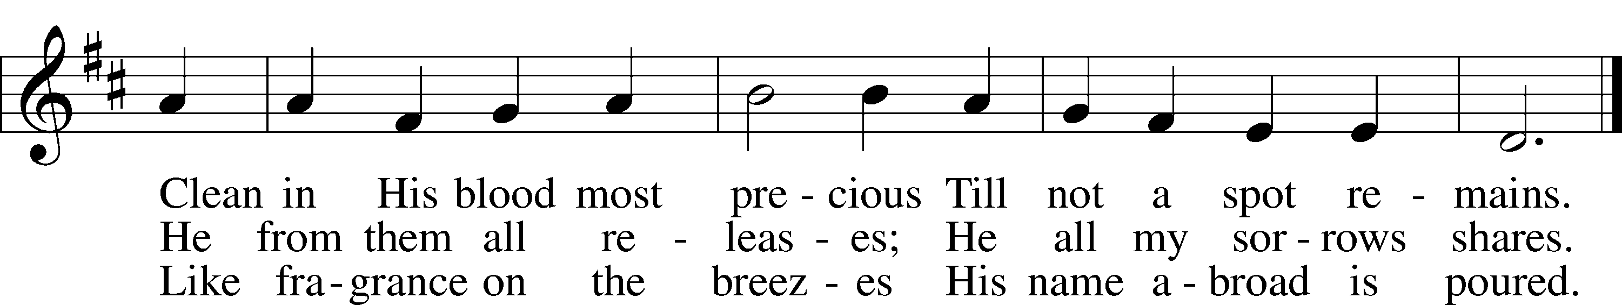

Text: Horatius Bonar, 1808–89  
Tune: Neu-vermehrtes . . . Gesangbuch, 1693, 3rd ed., Meiningen  
Text and tune: Public domain

Distribution Hymn: 563 Jesus, Thy Blood and Righteousness

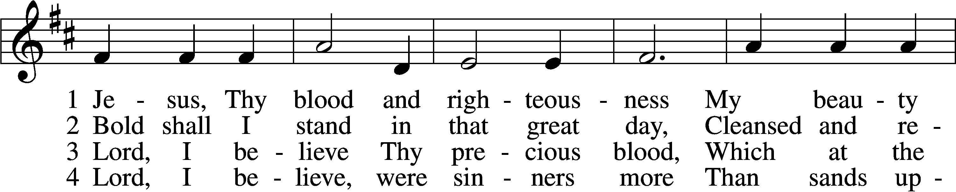

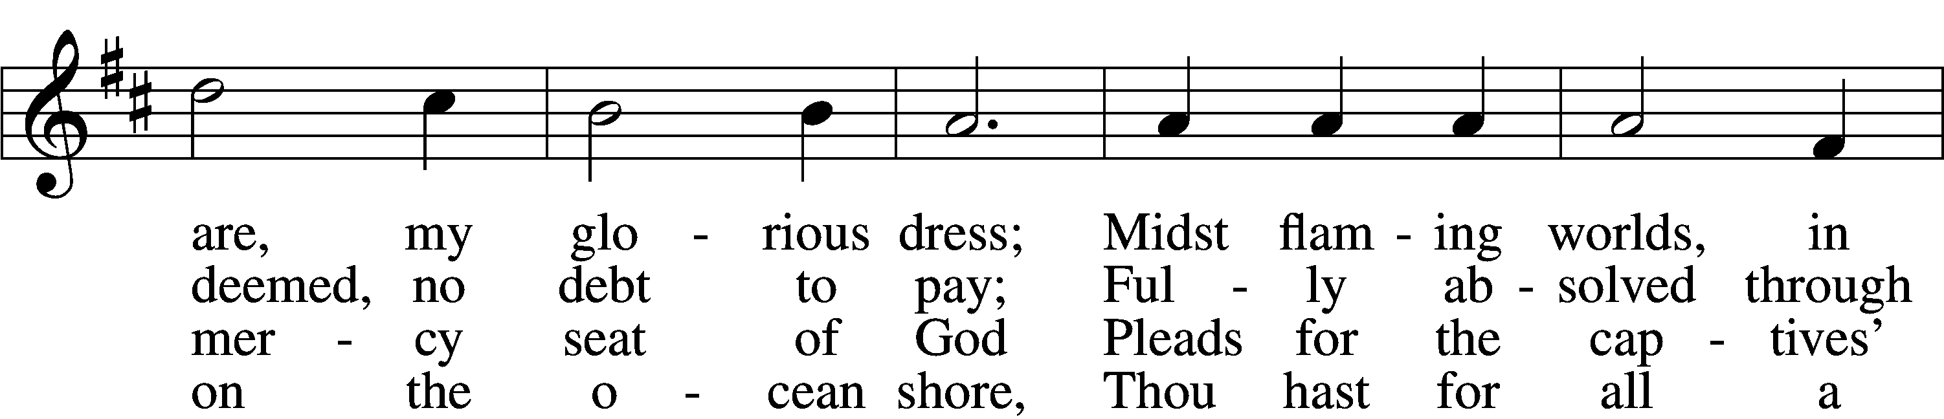

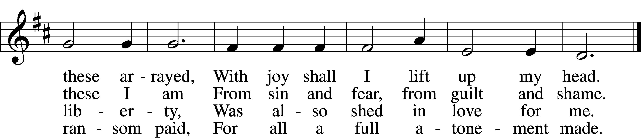

5 When from the dust of death I rise  
To claim my mansion in the skies,  
This then shall be my only plea:  
Jesus hath lived and died for me.

6 Jesus, be endless praise to Thee,  
Whose boundless mercy hath for me,  
For me, and all Thy hands have made,  
An everlasting ransom paid.

Text: Nicolaus Ludwig von Zinzendorf, 1700–60; tr. John B. Wesley, 1703–91, alt.  
Tune: George J. Elvey, 1816–93  
Text and tune: Public domain

Stand

Nunc Dimittis LSB 199

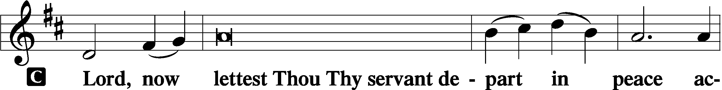

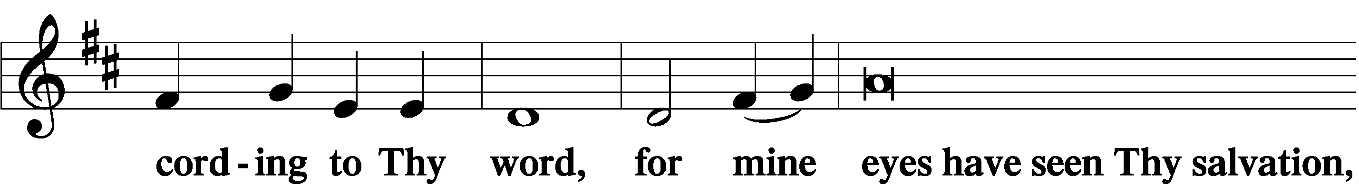

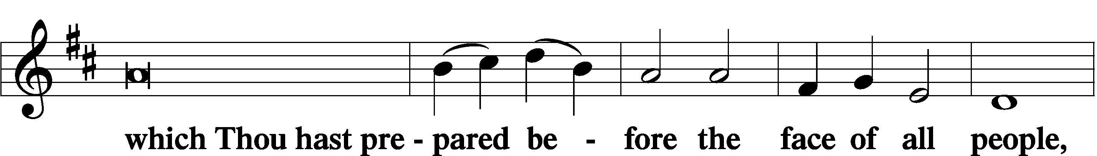

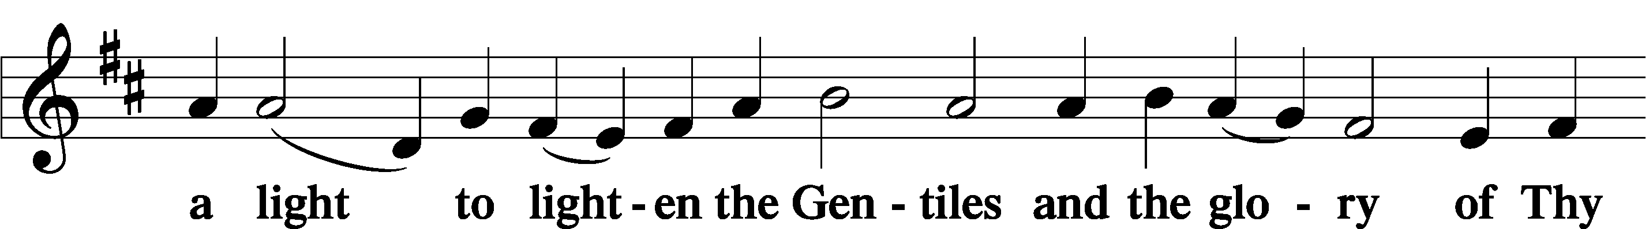

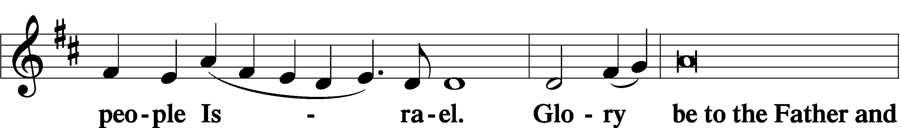

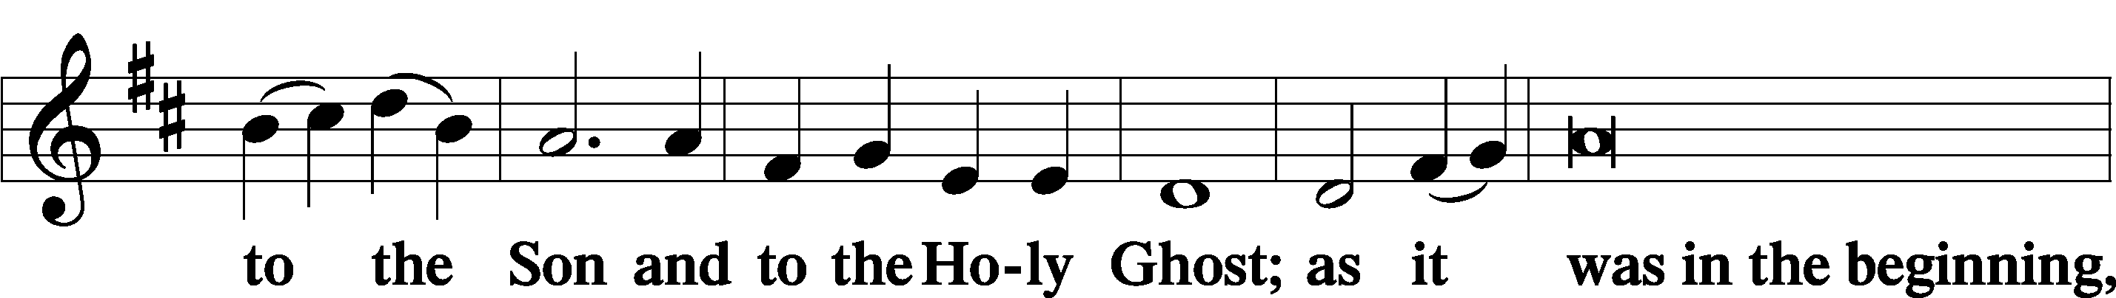

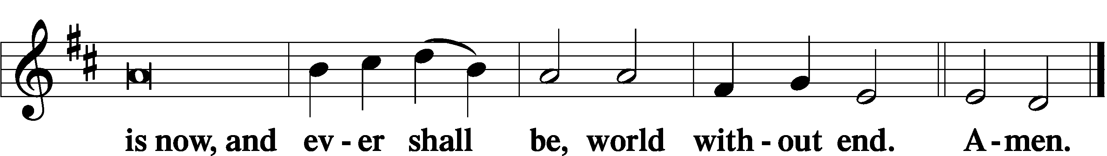

Thanksgiving LSB 200

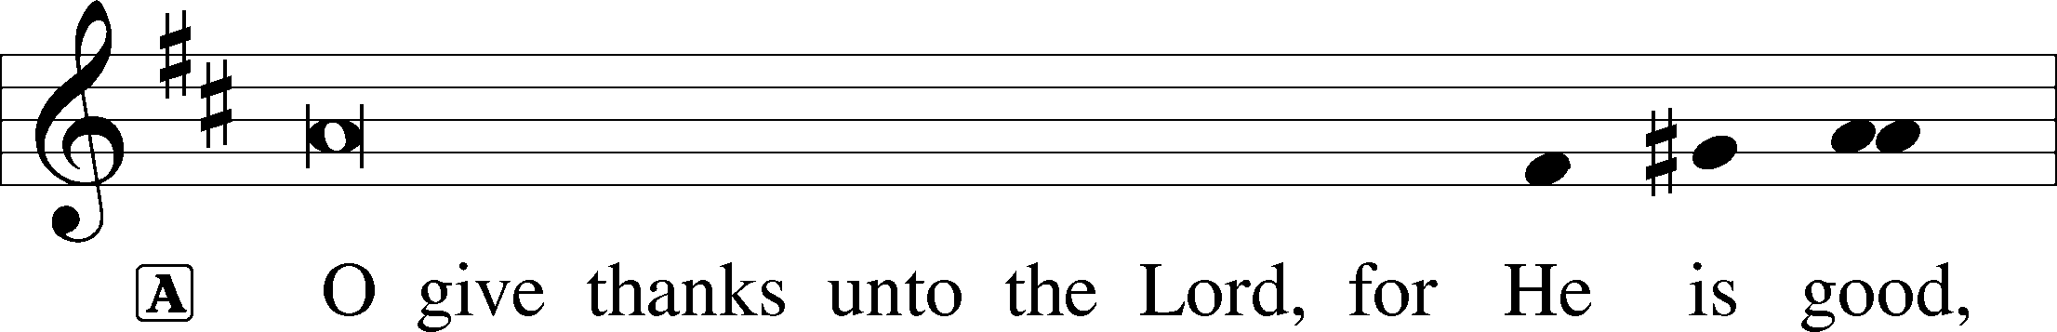

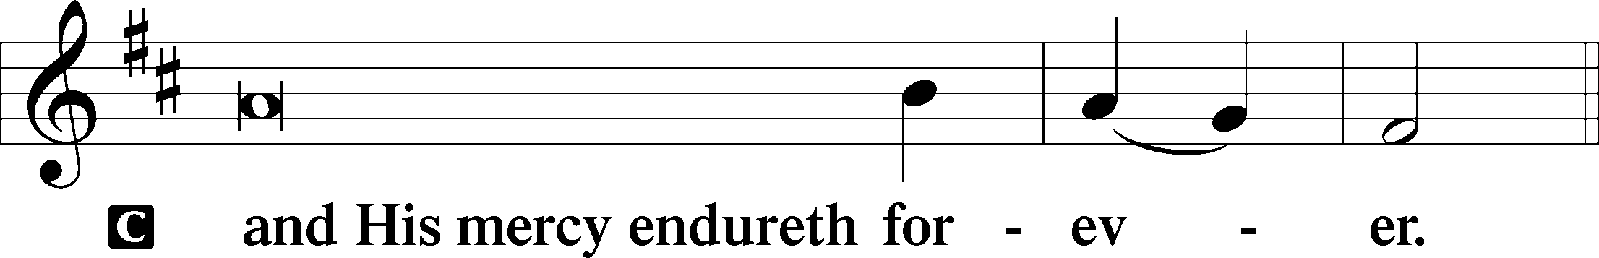

A Let us pray.

We give thanks to You, almighty God, that You have refreshed us through this salutary gift, and we implore You that of Your mercy You would strengthen us through the same in faith toward You and in fervent love toward one another; through Jesus Christ, Your Son, our Lord, who lives and reigns with You and the Holy Spirit, one God, now and forever.



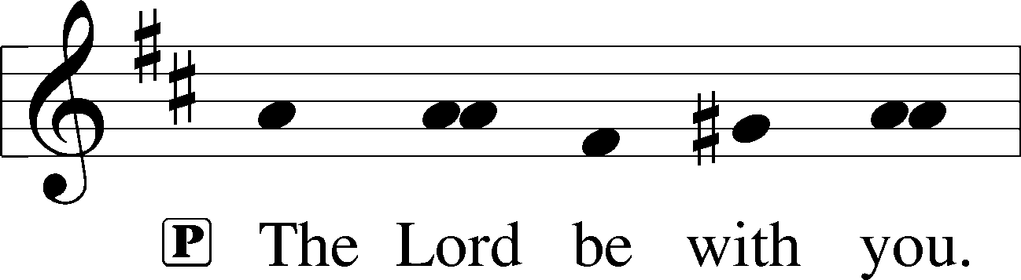

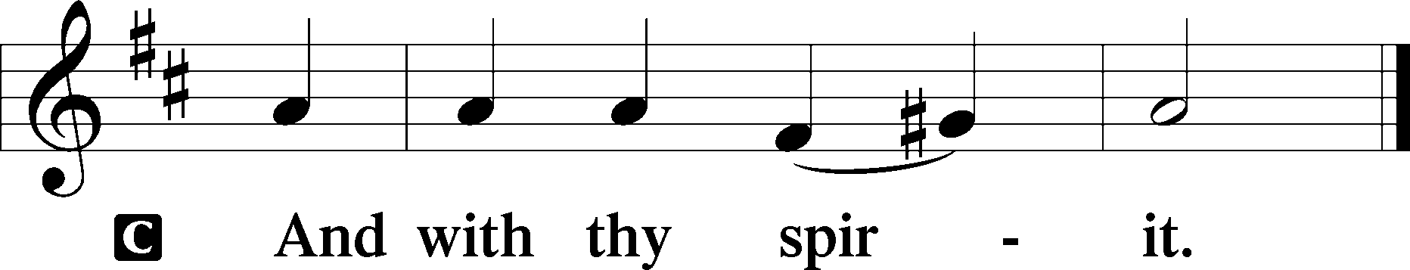

Benedicamus LSB 202

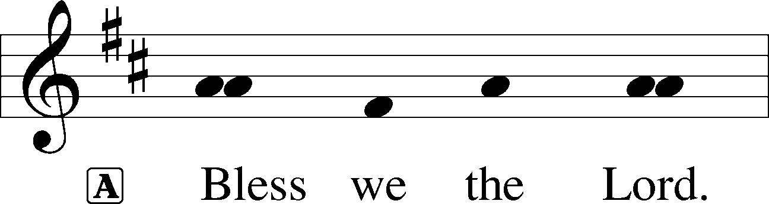

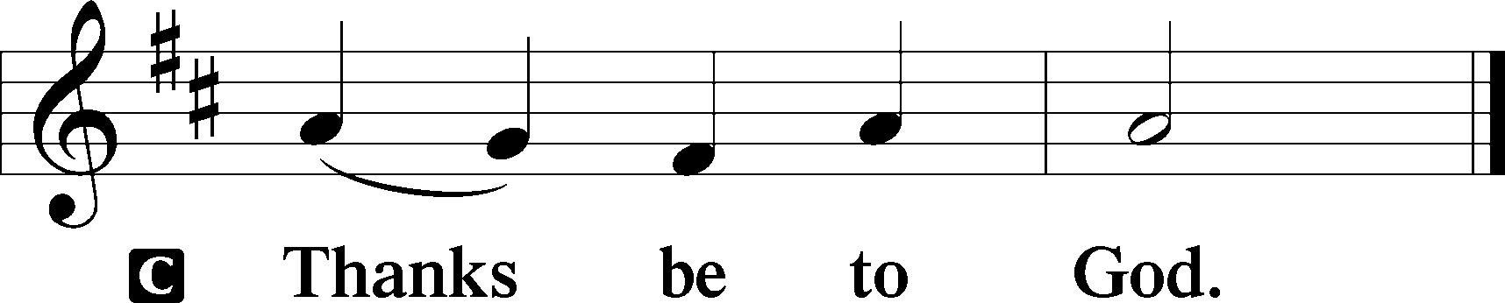

Benediction LSB 202

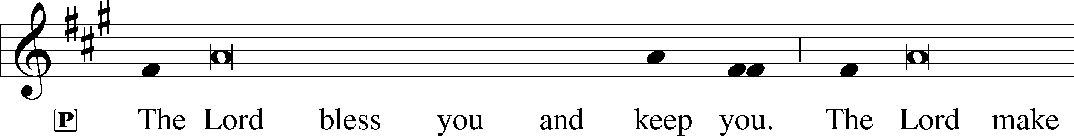

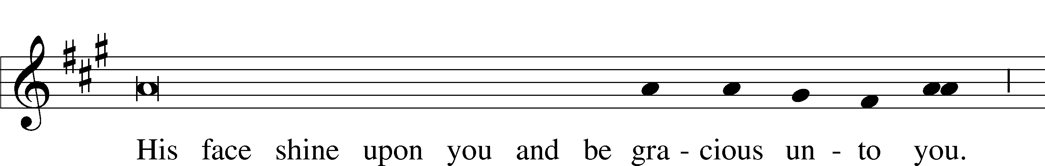

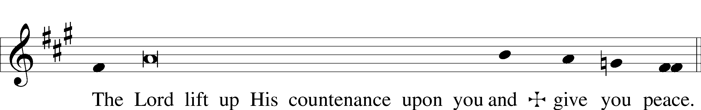

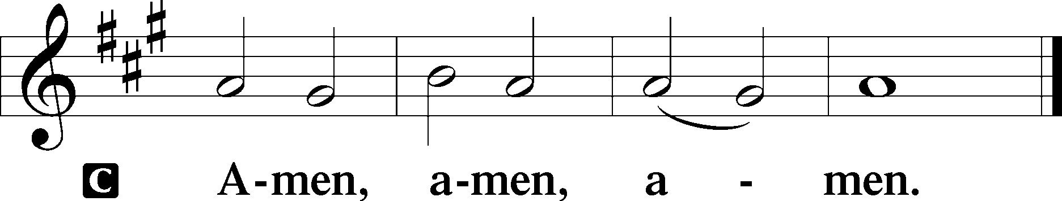

Hymn to Depart: 965 God Bless Our Native Land

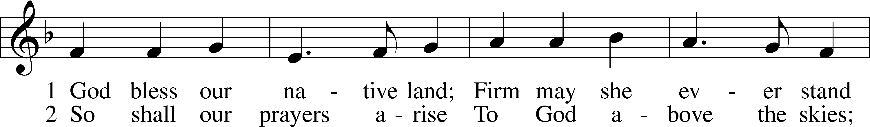

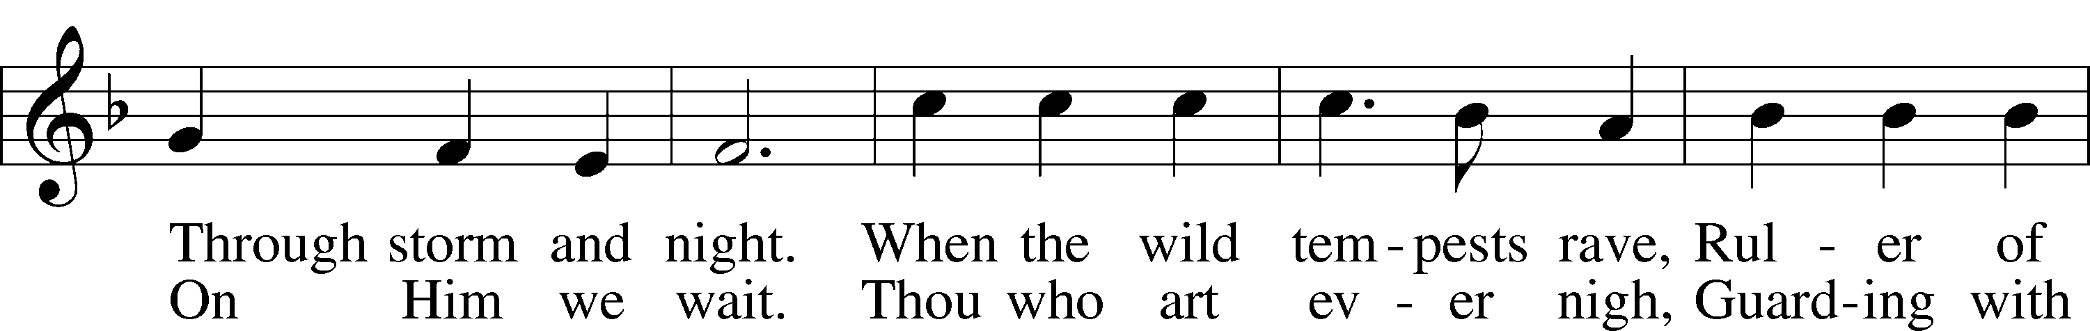

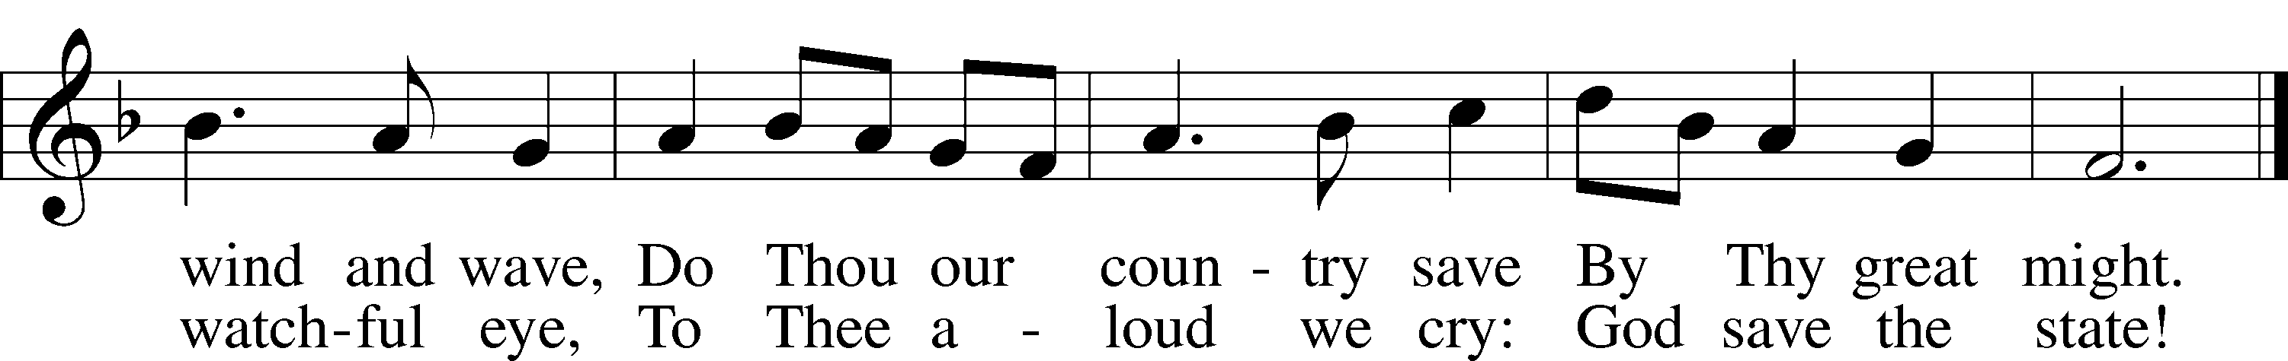

Text (st. 1): Charles T. Brooks, 1813–83, alt.; (st. 2): John S. Dwight, 1813–93, alt.  
Tune: Thesaurus Musicus, c. 1740, London  
Text and tune: Public domain

Acknowledgments

Divine Service, Setting Three from Lutheran Service Book

Unless otherwise indicated, Scripture quotations are from the ESV® Bible (The Holy Bible, English Standard Version®), copyright © 2001 by Crossway, a publishing ministry of Good News Publishers. Used by permission. All rights reserved.

Created by Lutheran Service Builder © 2024 Concordia Publishing House.

**Announcements:**

**Church Service Phone: 715-438-4200**

**(Stay on the line for recorded service to start)**

**Live Stream audio services:** [**http://salem.listentochurch.com**](http://salem.listentochurch.com)

**Salem’s Web Page:** <https://www.salembarron.com/>

**Pastor Fred Buth: Cell phone:715-642-3050 (H)715-353-2540**

**Pastor’s Email: salembarronpastor@gmail.com**

**Office Hours: Monday-Wednesday 9-12**

**Office email: salembarron@gmail.com**

**Attendance:**

**In-person:** 6/30-47

**Coffee and Snacks:** Steele’s

**Elder Today:** Tim Dennis

**Altar Guild:**

**Save the Date:**

July 28 – Root beer Floats August 9th – Annual Church/Childcare Picnic

**SEVENTH SUNDAY AFTER PENTECOST** (Proper 9B)The Ministers of Christ Are Sent with His Authority to Forgive Sins and Give Life

The prophet Ezekiel was raised up by the Spirit of the Lord and sent to speak an unpopular Word to the rebellious house of Israel. As a prophet, he was not to speak his own word, but to preach the Law and the Gospel: “Thus says the Lord GOD,” whether the people “hear or refuse to hear” (Ezek. 2:4–5). So, too, in the footsteps of the prophets before Him, the Lord Jesus “went about among the villages teaching” (Mark 6:6). In His hometown, as elsewhere, “many who heard him were astonished,” marveling at His wisdom and at the “mighty works done by his hands,” and yet “they took offense at him” (Mark 6:2–3). The offense culminates in His cross, which is, ironically, the heart and center of His “authority over the unclean spirits” (Mark 6:7). It is by that authority of His cross that those He sends preach repentance, “cast out many demons” and heal the sick (Mark 6:12–13). Thus, the apostle Paul boasts in the cross of Christ and in his own weaknesses, knowing that God’s grace is sufficient and that the power of Christ “is made perfect in weakness” (2 Cor. 12:8–9).

**Communion Notices:**

Please complete a communion card for our records; they are in the pew in front of you, or request one from an usher. Salem’s communion practice is that of close communion. We invite to our rail those who are members in good standing of sister Missouri Synod parishes. Visitors, please contact the pastor prior to communing. For those who prefer to use the Common Cup, we ask your assistance by holding the cup’s base as you commune.

**Introit** *Psalm 34:8*

Oh, taste and see that the Lord is good!  
 **Blessèd is the man who takes refuge in him!**For the Lord has chosen Zion;  
 **he has desired it for his dwelling place:**  
“This is my resting place forever;  
 **here I will dwell, for I have desired it.**  
I will abundantly bless her provisions;  
 **I will satisfy her poor with bread.**  
Her priests I will clothe with salvation,  
 **and her saints will shout for joy.”**  
Oh, taste and see that the Lord is good!  
 **Blessèd is the man who takes refuge in him!**

**Collect of the Day**

O God, Your almighty power is made known chiefly in showing mercy. Grant us the fullness of Your grace that we may be called to repentance and made partakers of Your heavenly treasures; through Your Son, Jesus Christ, our Lord, who lives and reigns with You and the Holy Spirit, one God, now and forever.

**Prayers Request:**

**Those in the nursing home:** Joann Jaeger **Those Shut-in at home:** Char Herman, Joan Church, Joyce Myers, Joyce Koba **Those with ongoing health issues:** Harrison Fields, Jeanne Perala, Owen Metz, Jeff Bonneville, Daria (Cindy Wright’s friend), Butch L. (Cindy Wright’s Brother-in-law), Melissa Miller. Art Smith (Sue Millerman’s brother), Brenda Sellent (Denise Stabenow’s sister), Sandy Hahn (Cindy Wright’s cousin’s wife)  **Recovering from surgery**: Wyatt Weise, **Those who lead our nation:** Joe Biden, Kamala Harris, Tony Evers, Rod Nordby  **Those who serve in our military and law enforcement:** Ryan Graf, Chaplain Pon Chanthaphon (Our Adopt-a-Chaplain), Rusty Weise **Our Childcare Staff:** Melissa Weinert, Denise Stabenow, Katelyn Hendren, Holly Wilhelmi, Janica Skjerly, Jacie Amundson, Emily Young, Zuri Soto, Cathy Anderson **For Christ Community Lutheran School –** Ask the Lord to provide teachers for the school