Prayer and Preaching

5th Sunday after Pentecost

June 23,2024

Hymn: 790 Praise to the Lord, the Almighty
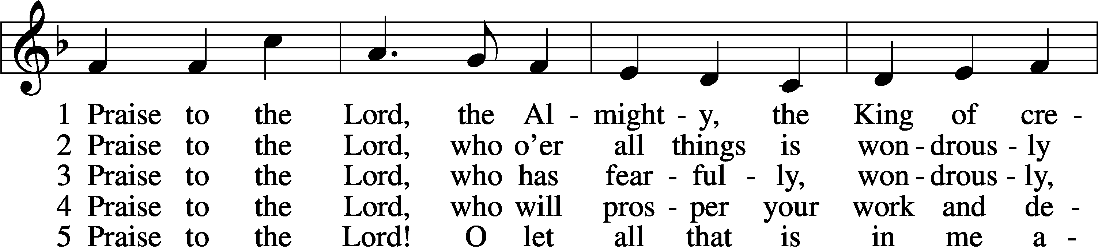
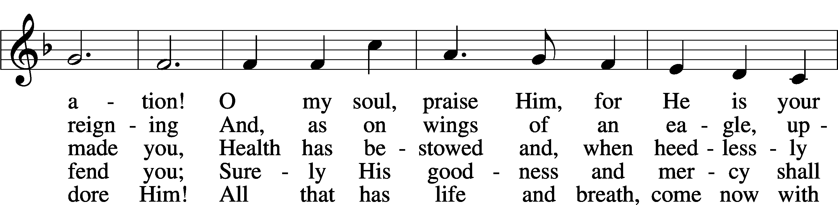
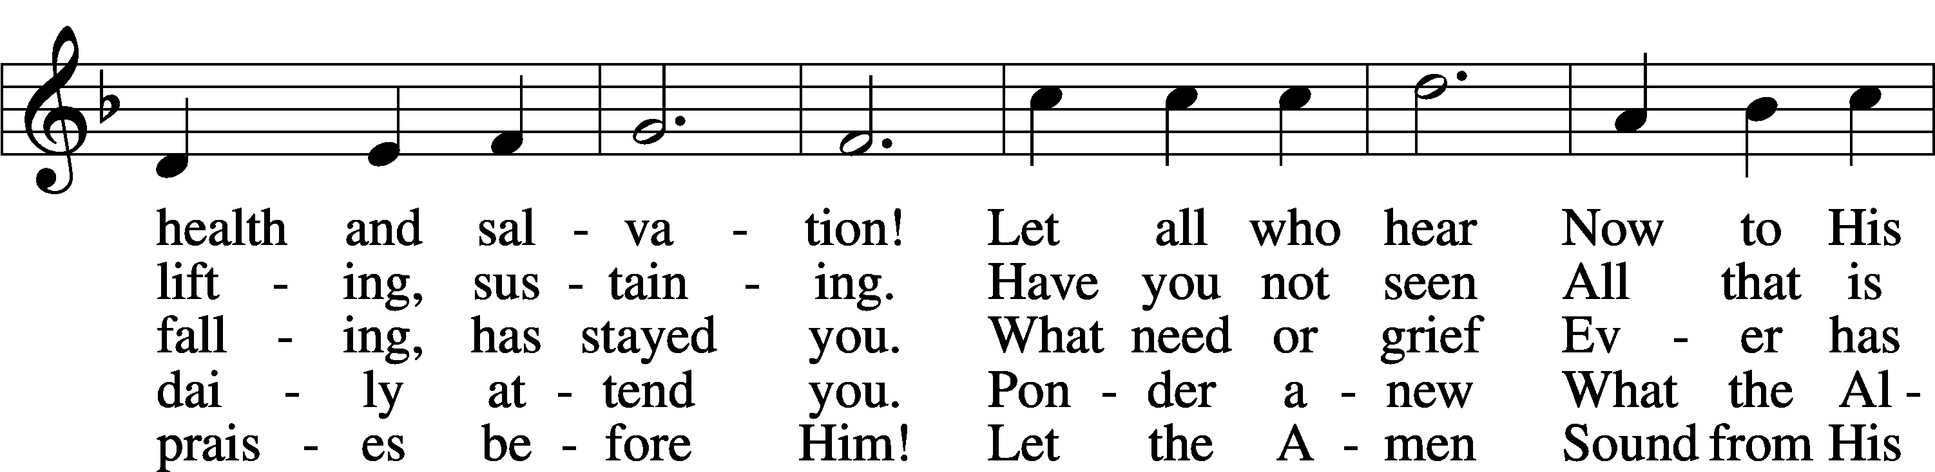
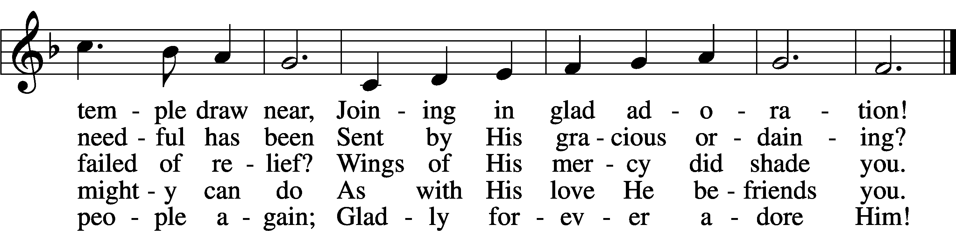
Text: Joachim Neander, 1650–80; tr. Catherine Winkworth, 1827–78, alt.
Tune: Ander Theil Des Erneuerten Gesang-Buchs, 1665, Stralsund
Text and tune: Public domain

Stand

Opening Versicles

L This is the day which the Lord has made;
C let us rejoice and be glad in it.
L From the rising of the sun to its setting,
C the name of the Lord is to be praised.

L Better is one day in Your courts than a thousand elsewhere;
C I would rather be a doorkeeper in the house of my God than dwell in the tents of the wicked.
L Make me to know Your ways, O Lord.
C Teach me Your paths.
L Sanctify us in Your truth.
C Your Word is truth.

L From the rising of the sun to its setting,
C the name of the Lord is to be praised.

C Glory be to the Father and to the Son and to the Holy Spirit;
as it was in the beginning, is now, and will be forever. Amen.

Old Testament Canticle LSB 261
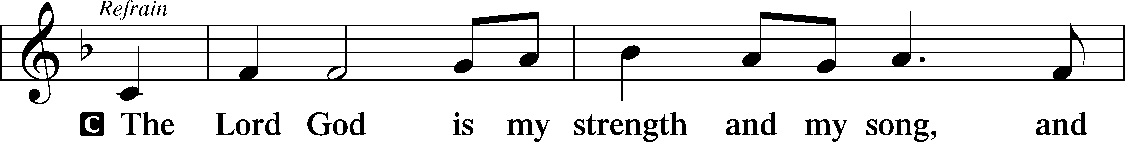
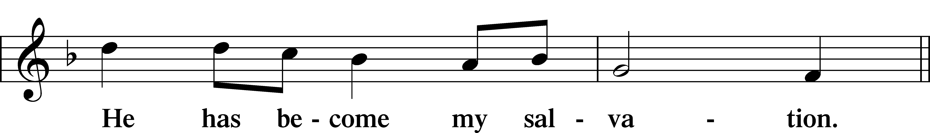
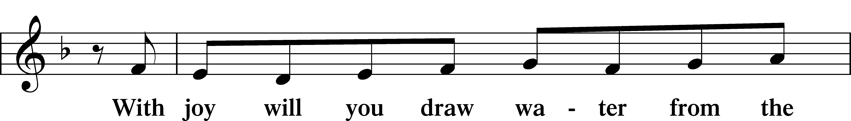
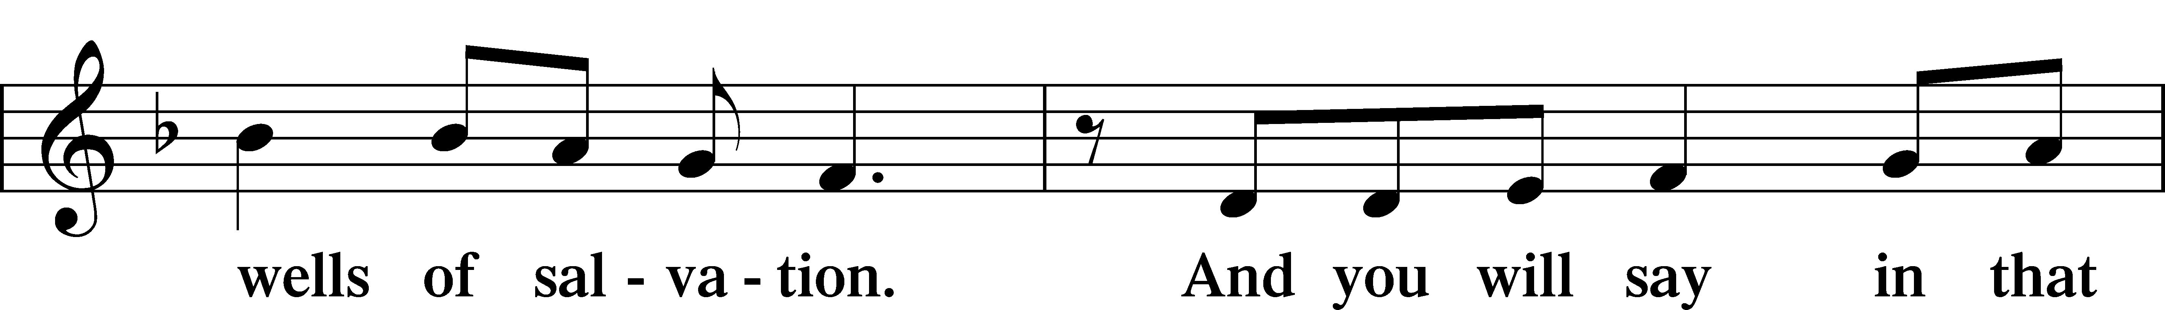
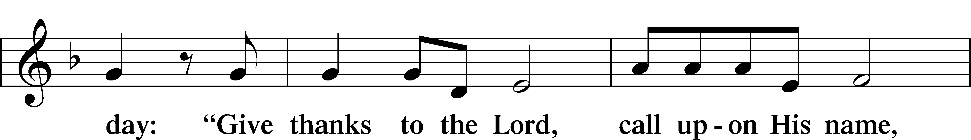
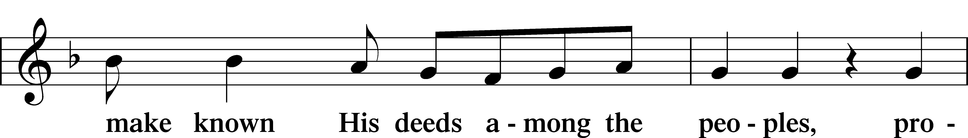
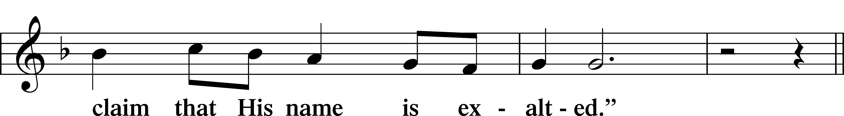
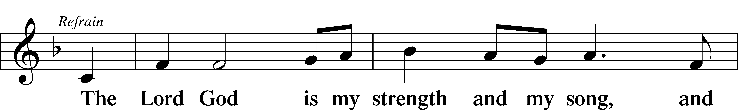
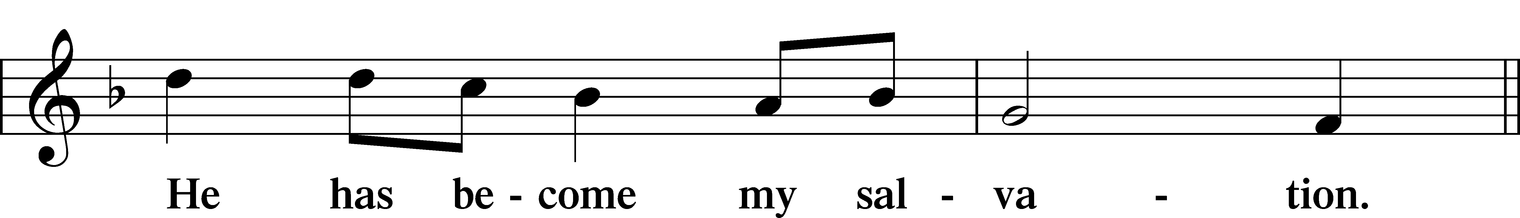
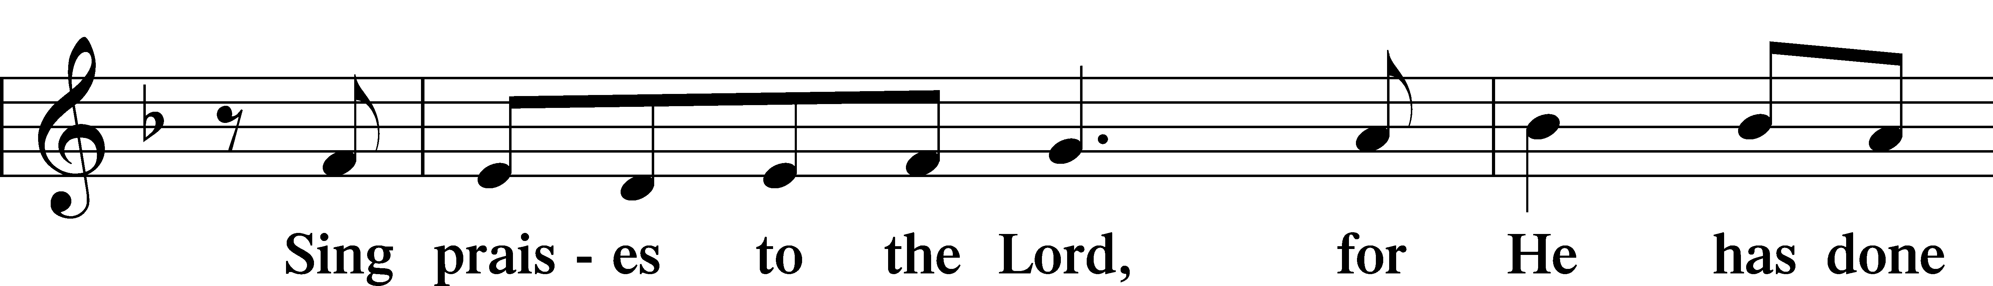
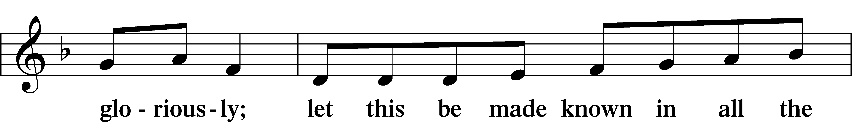
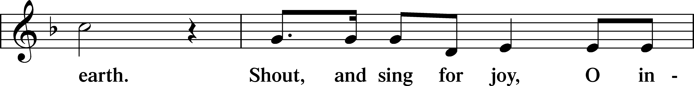
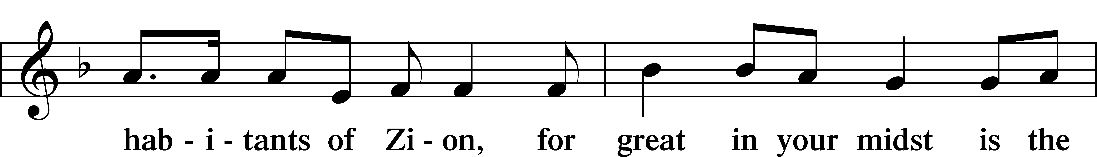
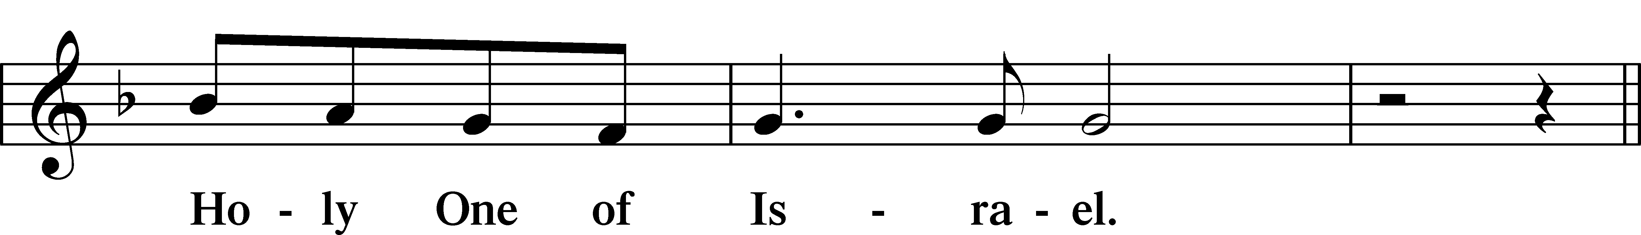
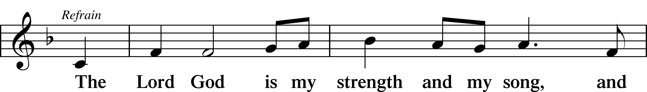
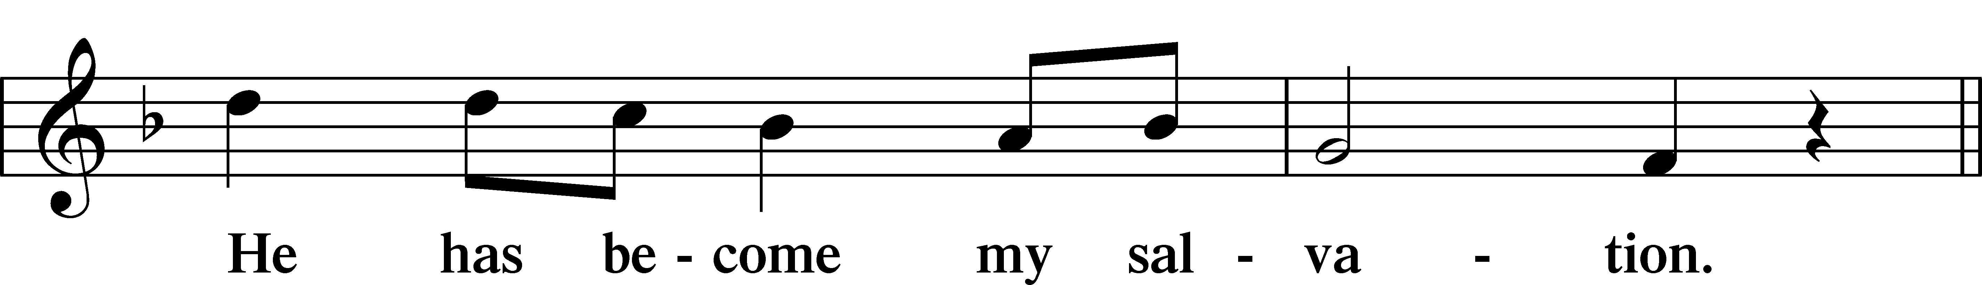
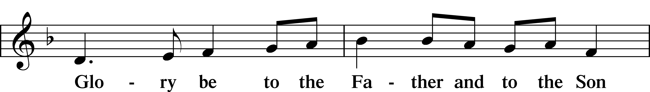
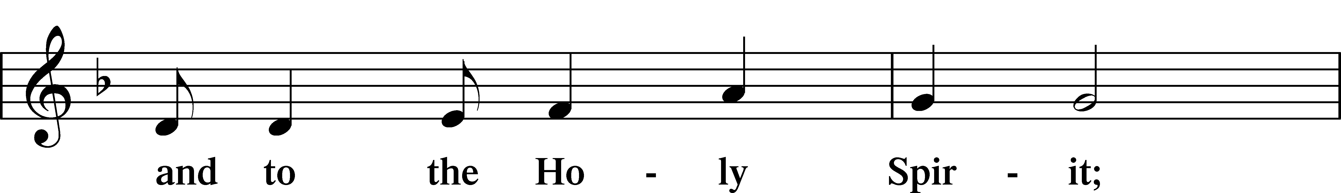
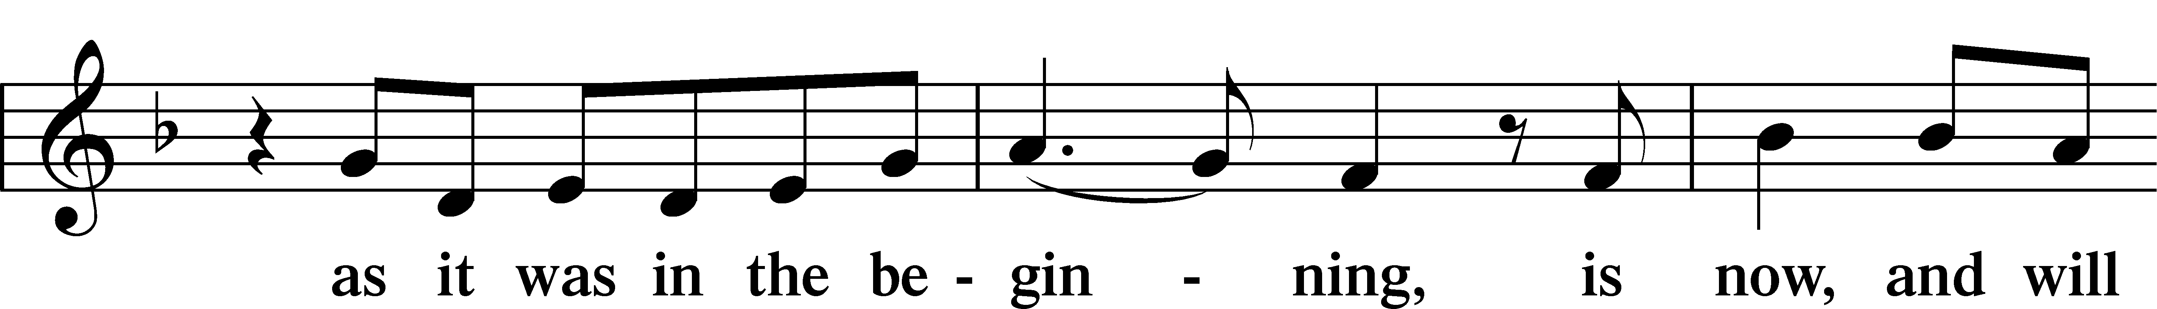
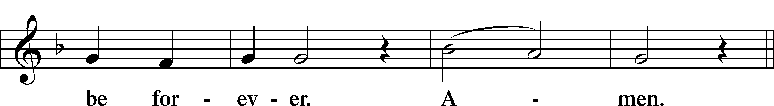
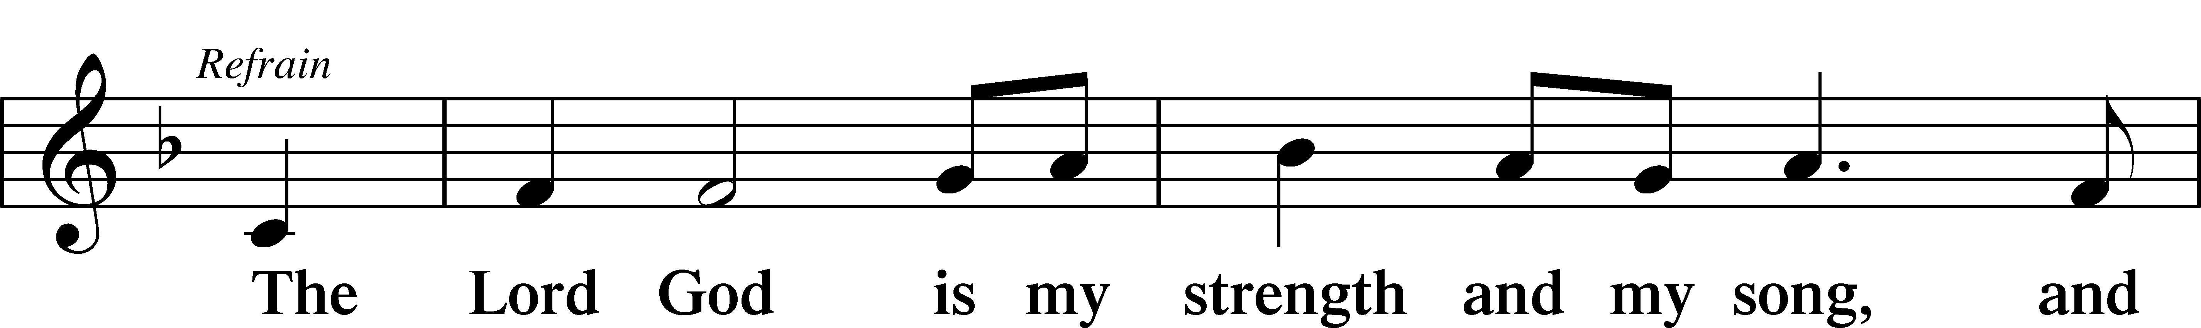
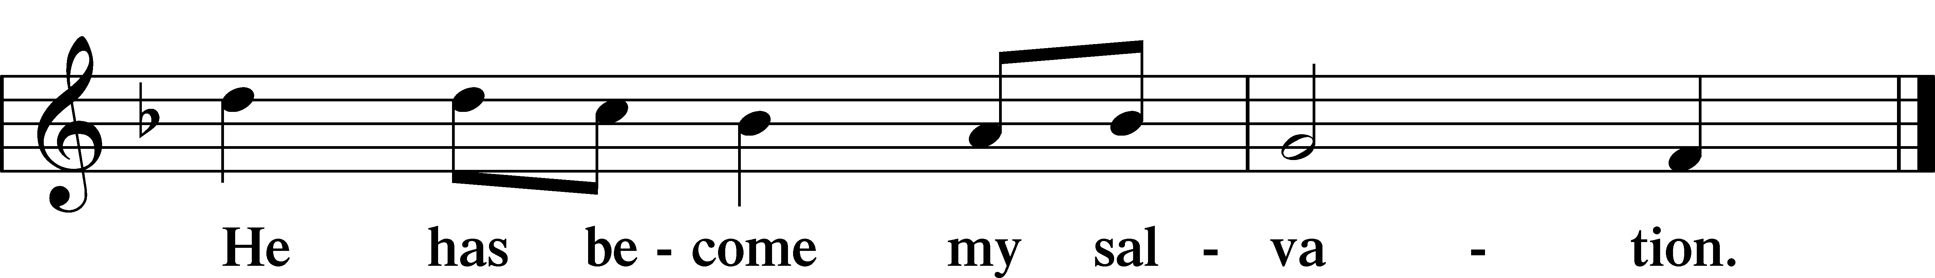

Sit

Readings From Holy Scripture

Reading Job 38:1–11
L A reading from Job, the thirty-eighth chapter.

The Lord Answers Job
1Then the Lord answered Job out of the whirlwind and said:
2“Who is this that darkens counsel by words without knowledge?
3Dress for action like a man;
I will question you, and you make it known to me.
4“Where were you when I laid the foundation of the earth?
Tell me, if you have understanding.
5Who determined its measurements—surely you know!
Or who stretched the line upon it?
6On what were its bases sunk,
or who laid its cornerstone,
7when the morning stars sang together
and all the sons of God shouted for joy?
8“Or who shut in the sea with doors
when it burst out from the womb,
9when I made clouds its garment
and thick darkness its swaddling band,
10and prescribed limits for it
and set bars and doors,
11and said, ‘Thus far shall you come, and no farther,
and here shall your proud waves be stayed’?”

L This is the Word of the Lord.
C Thanks be to God.

Psalms, hymns, or choral music may be sung between the readings.

Reading 2 Corinthians 6:1–13
1Working together with him, then, we appeal to you not to receive the grace of God in vain. 2For he says,
“In a favorable time I listened to you,
and in a day of salvation I have helped you.”
Behold, now is the favorable time; behold, now is the day of salvation. 3We put no obstacle in anyone’s way, so that no fault may be found with our ministry, 4but as servants of God we commend ourselves in every way: by great endurance, in afflictions, hardships, calamities, 5beatings, imprisonments, riots, labors, sleepless nights, hunger; 6by purity, knowledge, patience, kindness, the Holy Spirit, genuine love; 7by truthful speech, and the power of God; with the weapons of righteousness for the right hand and for the left; 8through honor and dishonor, through slander and praise. We are treated as impostors, and yet are true; 9as unknown, and yet well known; as dying, and behold, we live; as punished, and yet not killed; 10as sorrowful, yet always rejoicing; as poor, yet making many rich; as having nothing, yet possessing everything.
11We have spoken freely to you, Corinthians; our heart is wide open. 12You are not restricted by us, but you are restricted in your own affections. 13In return (I speak as to children) widen your hearts also.

Reading Mark 4:35–41
Jesus Calms a Storm
35On that day, when evening had come, [Jesus] said to them, “Let us go across to the other side.” 36And leaving the crowd, they took him with them in the boat, just as he was. And other boats were with him. 37And a great windstorm arose, and the waves were breaking into the boat, so that the boat was already filling. 38But he was in the stern, asleep on the cushion. And they woke him and said to him, “Teacher, do you not care that we are perishing?” 39And he awoke and rebuked the wind and said to the sea, “Peace! Be still!” And the wind ceased, and there was a great calm. 40He said to them, “Why are you so afraid? Have you still no faith?” 41And they were filled with great fear and said to one another, “Who then is this, that even wind and sea obey him?”

Responsory

L Forever, O Lord, Your Word is firmly set in the heavens.
C Lord, I love the habitation of Your house and the place where Your glory dwells.
L Blessed are those who hear the Word of God and keep it.
C Lord, I love the habitation of Your house and the place where Your glory dwells.
L Glory be to the Father and to the Son and to the Holy Spirit.
C Lord, I love the habitation of Your house and the place where Your glory dwells.

Stand

Ten Commandments
C You shall have no other gods.
You shall not misuse the name of the Lord your God.
Remember the Sabbath day by keeping it holy.
Honor your father and your mother.
You shall not murder.
You shall not commit adultery.
You shall not steal.
You shall not give false testimony against your neighbor.
You shall not covet your neighbor’s house.
You shall not covet your neighbor’s wife, or his manservant or maidservant, his ox or donkey, or anything that belongs to your neighbor.

Apostles’ Creed
C I believe in God, the Father Almighty,
maker of heaven and earth.

And in Jesus Christ, His only Son, our Lord,
who was conceived by the Holy Spirit,
born of the virgin Mary,
suffered under Pontius Pilate,
was crucified, died and was buried.
He descended into hell.
The third day He rose again from the dead.
He ascended into heaven
and sits at the right hand of God the Father Almighty.
From thence He will come to judge the living and the dead.

I believe in the Holy Spirit,
the holy Christian Church,
the communion of saints,
the forgiveness of sins,
the resurrection of the body,
and the life T everlasting. Amen.

Lord’s Prayer
C Our Father who art in heaven,
hallowed be Thy name,
Thy kingdom come,
Thy will be done on earth
as it is in heaven;
give us this day our daily bread;
and forgive us our trespasses
as we forgive those
who trespass against us;
and lead us not into temptation,
but deliver us from evil.
For Thine is the kingdom
and the power and the glory
forever and ever. Amen.

Sit

Hymn: 500 Creator Spirit, by Whose Aid
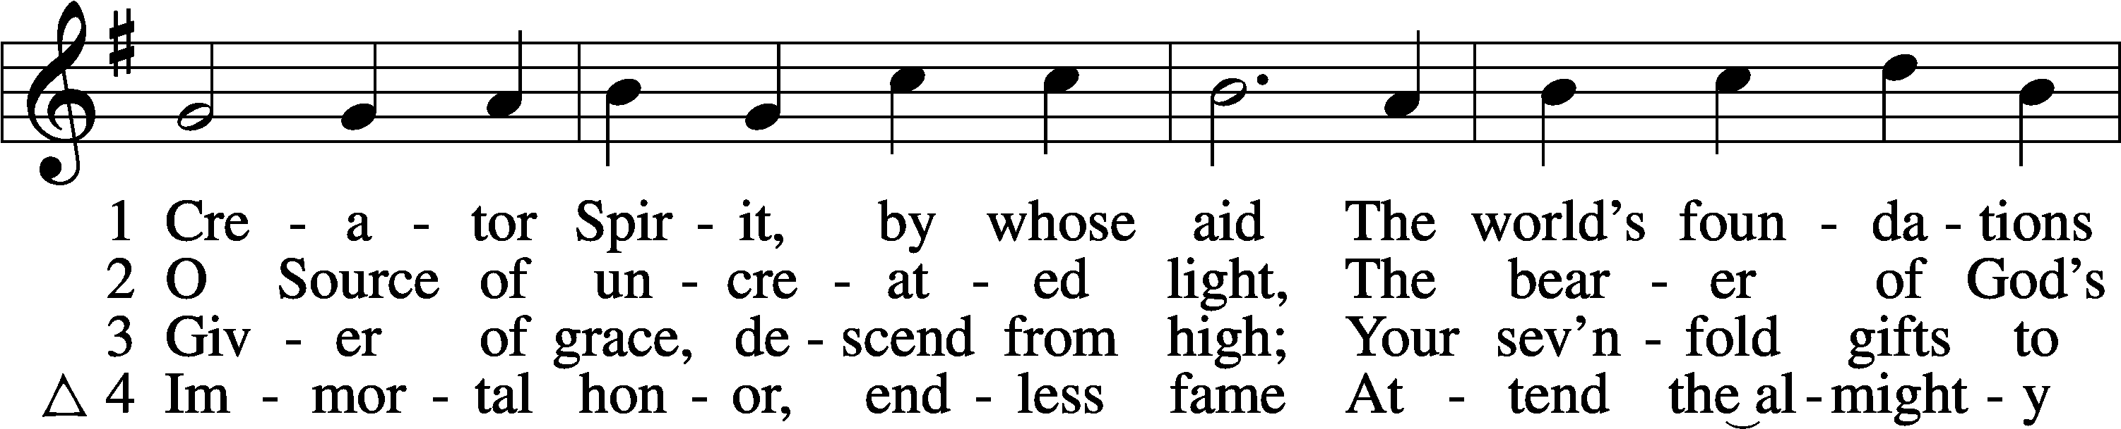
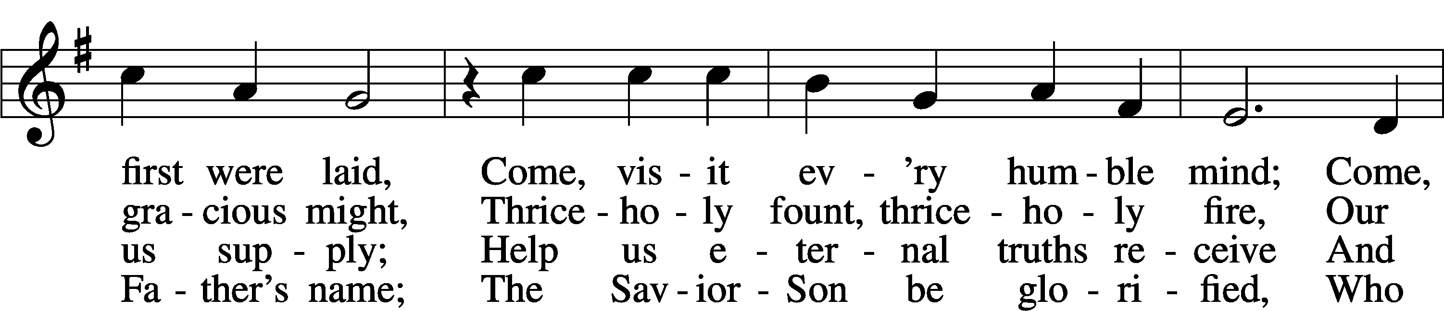
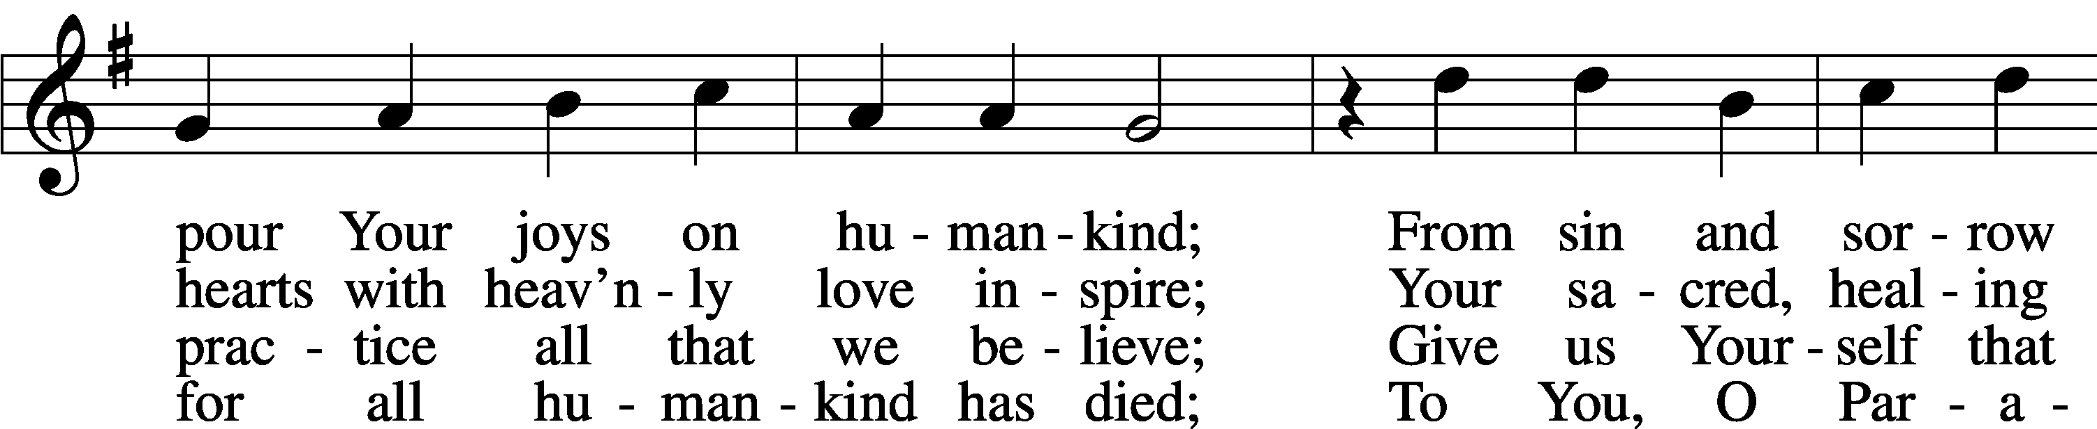
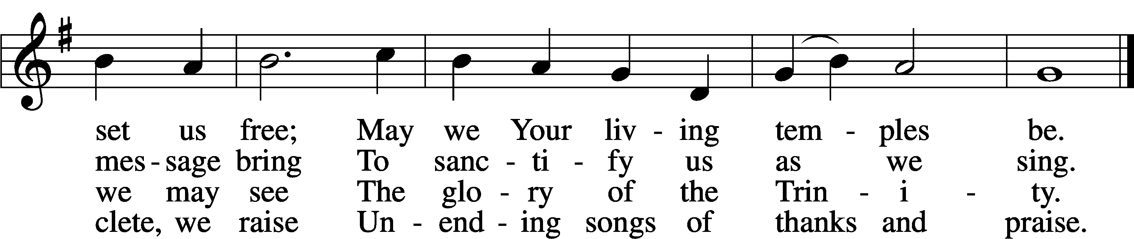
Text: attr. Rabanus Maurus, 776–856; tr. John Dryden, 1631–1700, alt.
Tune: Gesangbuch . . . Psalmen, Geistliche Lieder, 1541, Strassburg, alt.
Text and tune: Public domain

Sermon

Hymn: 506 Glory Be to God the Father
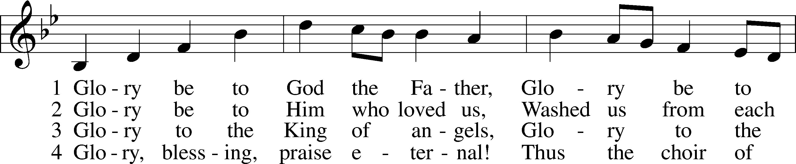
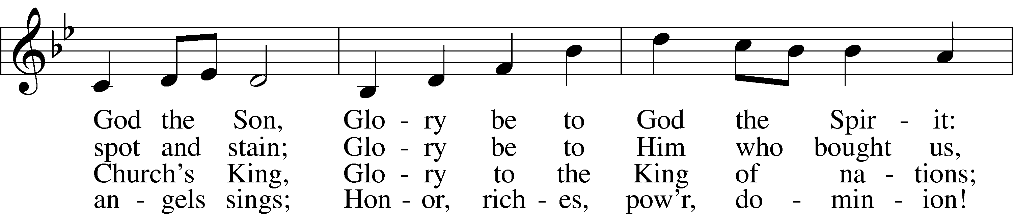
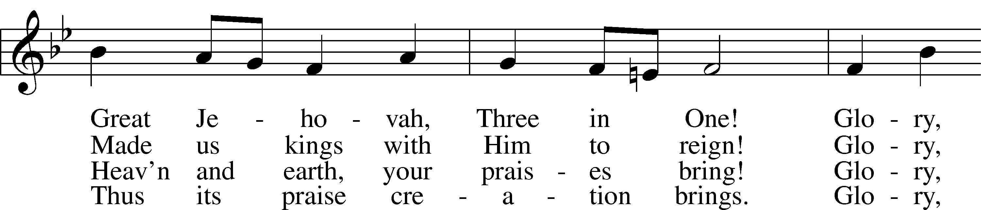
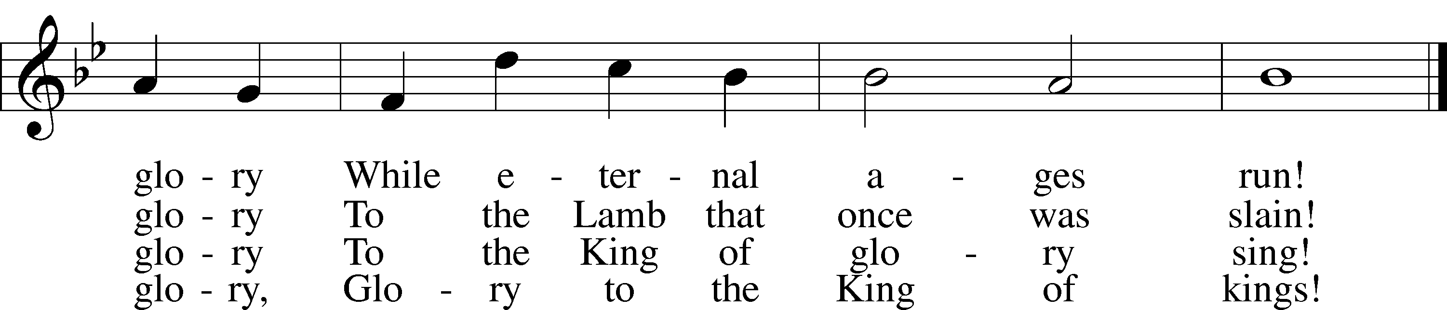
Text: Horatius Bonar, 1808–89
Tune: Walter G. Whinfield, 1865–1919
Text and tune: Public domain

Offering

Stand

Prayer
L In peace let us pray to the Lord:
C Lord, have mercy.
L For the gift of divine peace and of pardon, with all our heart and with all our mind, let us pray to the Lord:
C Lord, have mercy.
L For the holy Christian Church, here and scattered throughout the world, and for the proclamation of the Gospel and the calling of all to faith, let us pray to the Lord:
C Lord, have mercy.
L For this nation, for our cities and communities, and for the common welfare of us all, let us pray to the Lord:
C Lord, have mercy.
L For seasonable weather and for the fruitfulness of the earth, let us pray to the Lord:
C Lord, have mercy.
L For those who labor, for those whose work is difficult or dangerous, and for all who travel, let us pray to the Lord:
C Lord, have mercy.
L For all those in need, for the hungry and homeless, for the widowed and orphaned, and for all those in prison, let us pray to the Lord:
C Lord, have mercy.
L For the sick and dying and for all those who care for them, let us pray to the Lord:
C Lord, have mercy.
L For . . . [additional bids for prayer may be inserted here] . . . let us pray to the Lord:
C Lord, have mercy.
L Finally, for these and for all our needs of body and soul, let us pray to the Lord:
C Lord, have mercy. Christ, have mercy. Lord, have mercy.

Collect of the Day
L Almighty God, in Your mercy guide the course of this world so that Your Church may joyfully serve You in godly peace and quietness; through Jesus Christ, Your Son, our Lord, who lives and reigns with You and the Holy Spirit, one God, now and forever.
C Amen.

Collect for the Word
L Blessed Lord, You have caused all Holy Scriptures to be written for our learning. Grant that we may so hear them, read, mark, learn, and take them to heart that, by the patience and comfort of Your holy Word, we may embrace and ever hold fast the blessed hope of everlasting life; through Jesus Christ, Your Son, our Lord, who lives and reigns with You and the Holy Spirit, one God, now and forever.
C Amen.

Morning Prayer
C I thank You, my heavenly Father, through Jesus Christ, Your dear Son, that You have kept me this night from all harm and danger; and I pray that You would keep me this day also from sin and every evil, that all my doings and life may please You. For into Your hands I commend myself, my body and soul, and all things. Let Your holy angel be with me, that the evil foe may have no power over me.
Amen.

New Testament Canticle LSB 266
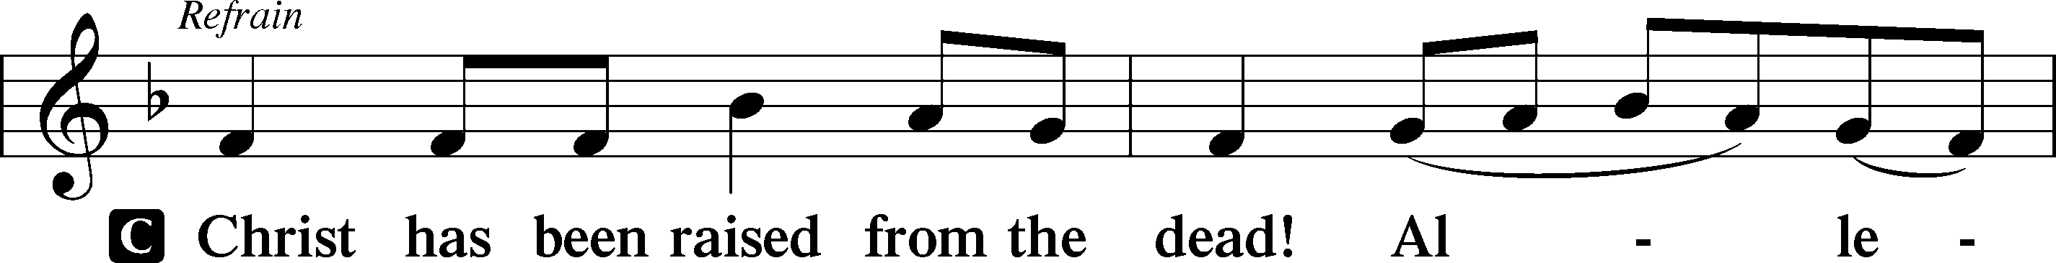
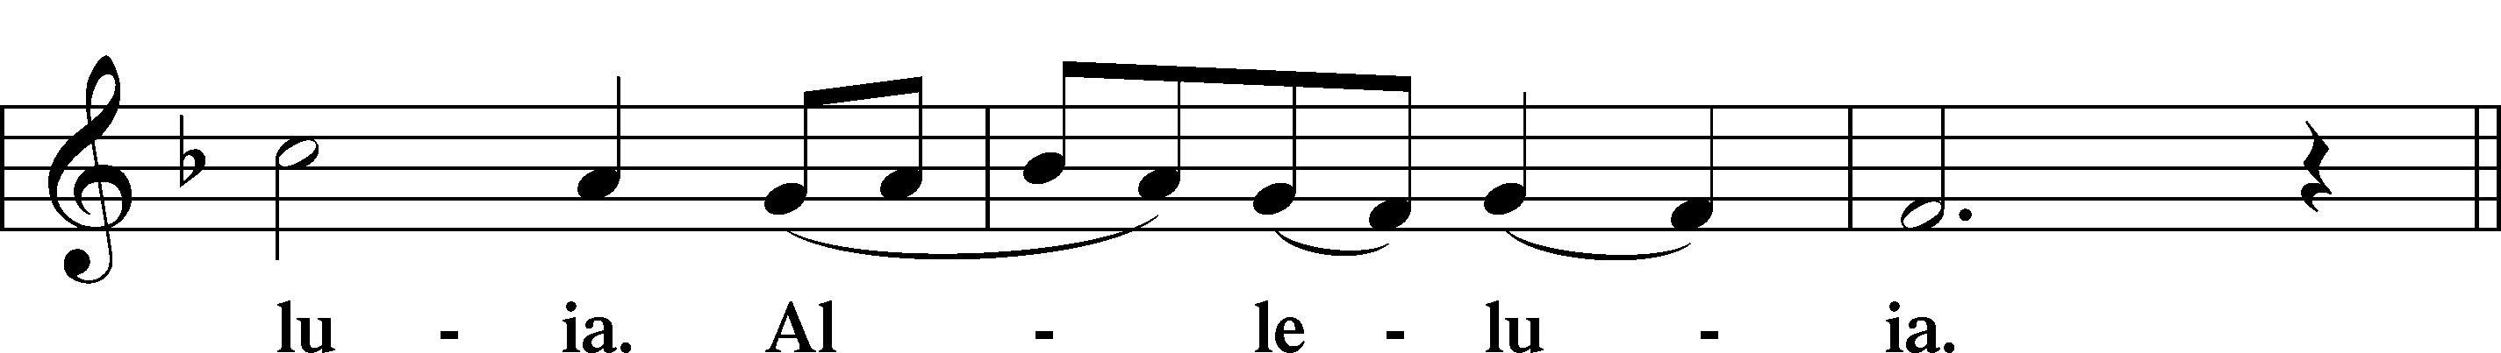
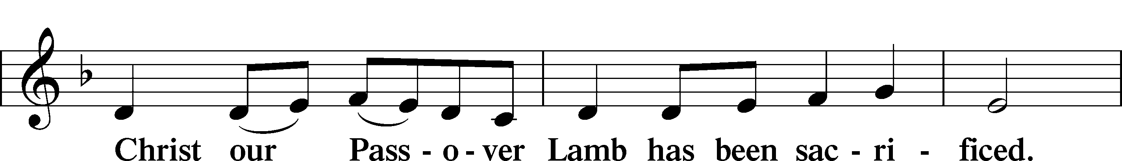
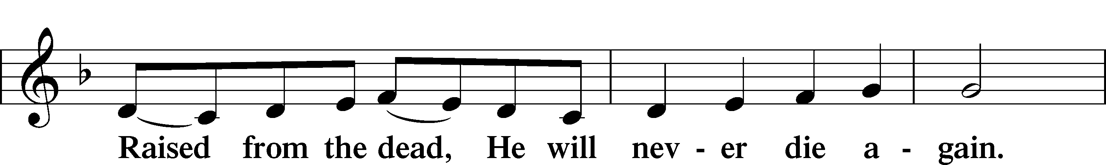
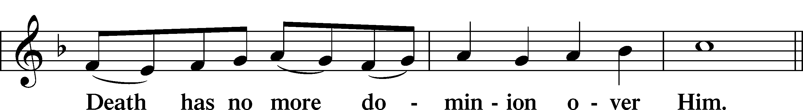
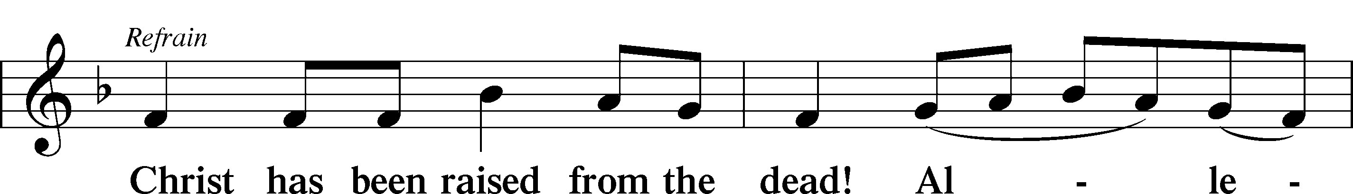
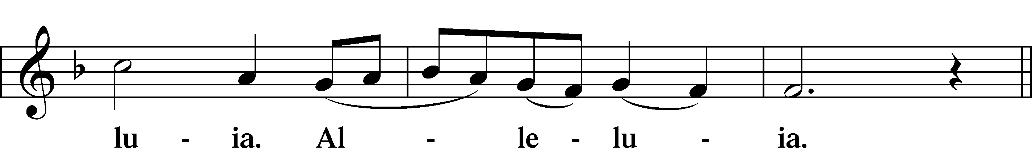
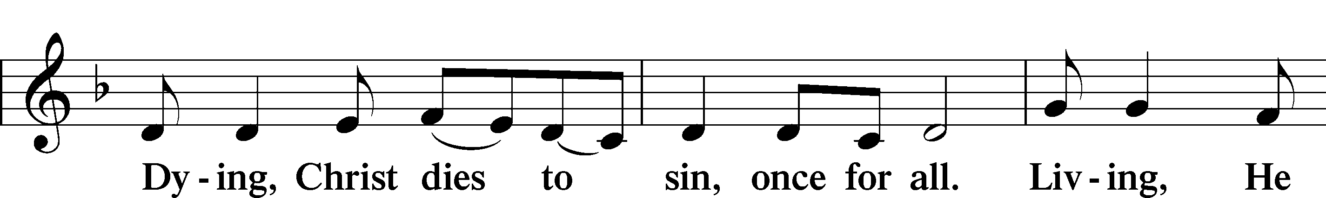
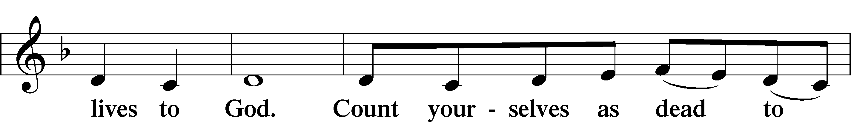
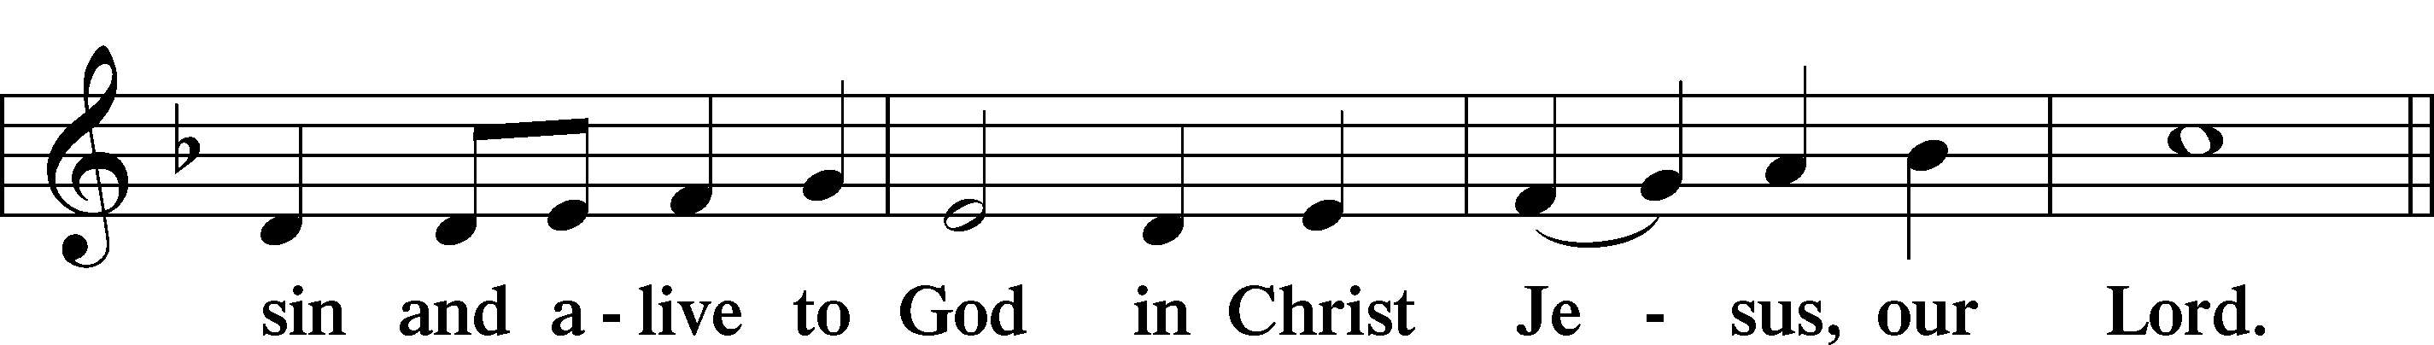
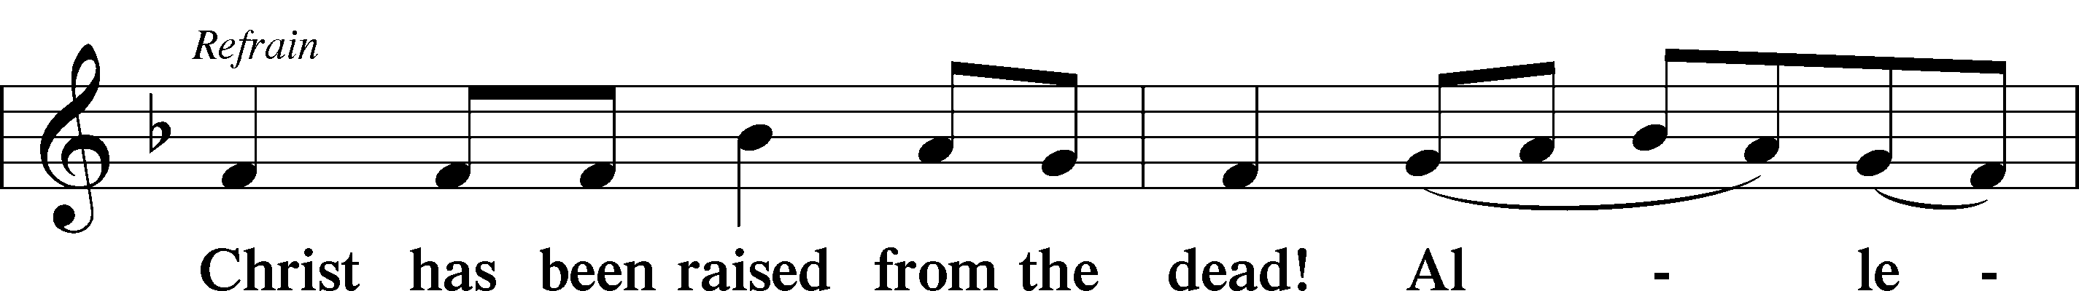
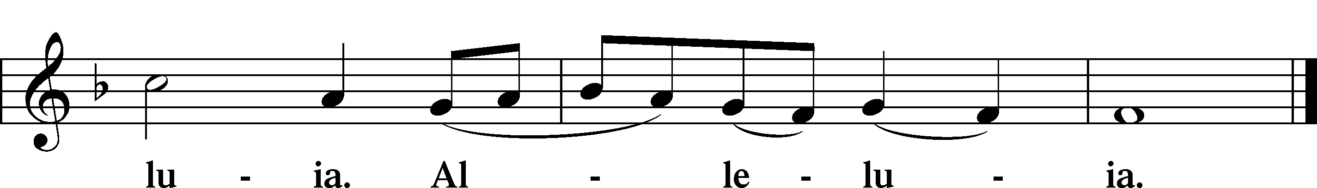

Blessing

L Let us bless the Lord.
C Thanks be to God.

L The almighty and merciful Lord, the Father, the T Son, and the Holy Spirit, bless and preserve us.
C Amen.

Hymn
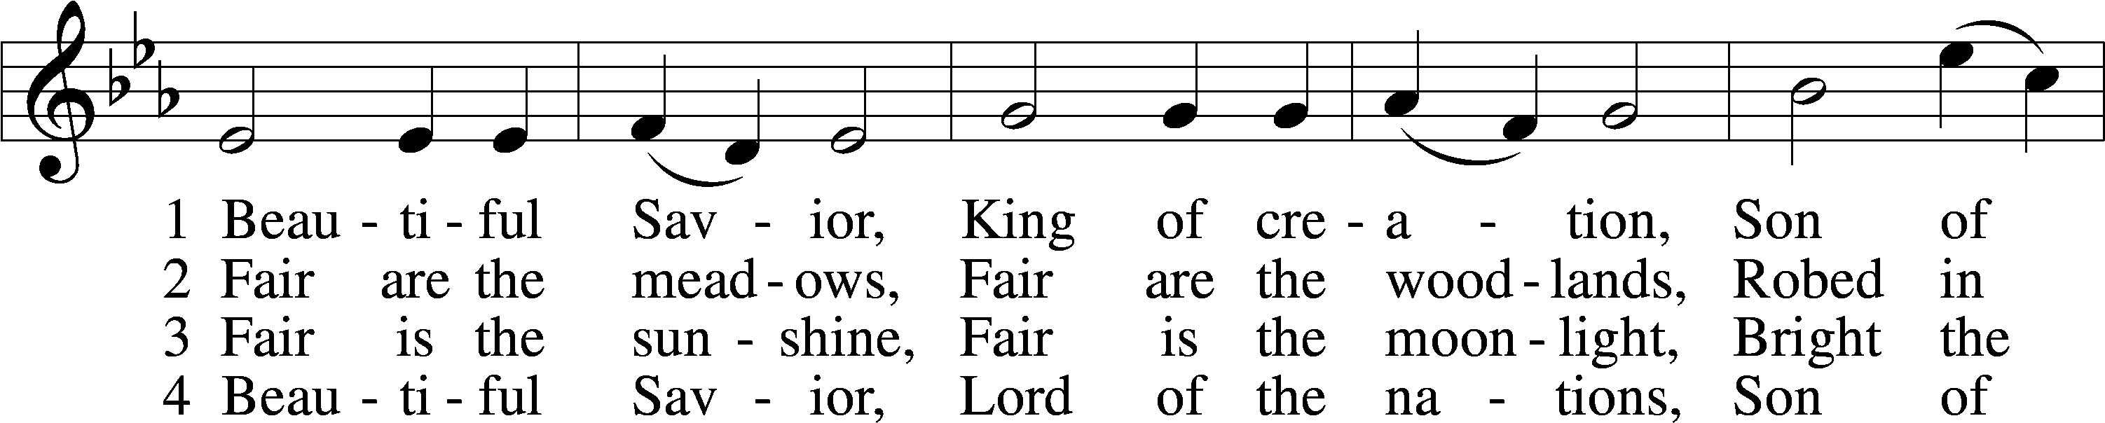
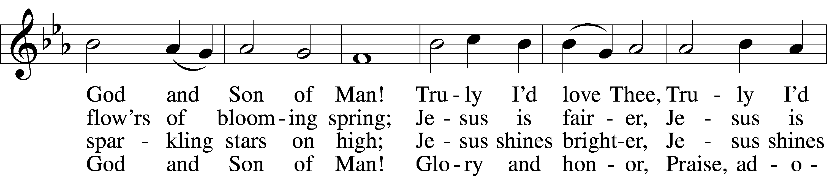
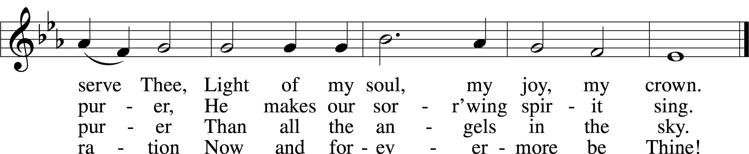
Text: Münsterisch Gesangbuch, 1677, Münster; tr. Joseph A. Seiss, 1823–1904
Tune: Silesian, 19th cent.
Text and tune: Public domain

Acknowledgments
Service of Prayer and Preaching from Lutheran Service Book
Unless otherwise indicated, Scripture quotations are from the ESV® Bible (The Holy Bible, English Standard Version®), copyright © 2001 by Crossway, a publishing ministry of Good News Publishers. Used by permission. All rights reserved.
Created by Lutheran Service Builder © 2024 Concordia Publishing House.
FIFTH SUNDAY AFTER PENTECOST (Proper 7B) The Word of Christ Bestows Peace on His Creation through His Forgiveness of Sins: In his anguish and affliction, Job must be reminded that, as a finite creature, he is in no position to question the Maker of the heavens and the earth. Job’s “words without knowledge” are unable to penetrate the wisdom of the Lord (Job 38:1–2). For the Lord has “prescribed limits” and “set bars and doors,” so that “here shall your proud waves be stayed” (Job 38:9–11). That’s how He humbles us unto repentance. But also by His powerful Word, He calms the “great windstorm” and the waves “breaking into the boat.” He does not permit the chaos of this fallen world to overwhelm us or bring us to despair. By the Word of His Gospel, He speaks “Peace!” to us, which bestows the “great calm” of His new creation (Mark 4:37–39). Therefore, do not be afraid, and do not receive this grace of God in vain. “Now is the favorable time,” and “now is the day of salvation” (2 Cor. 6:1–2)
Church Service Phone715-438-4200 (Stay on the line for recorded service to start) Live Stream audio services: http://salem.listentochurch.com
Salem’s Web Page: https://www.salembarron.com/
Pastor Fred Buth: Cell phone:715-642-3050 (H)715-353-2540
Pastor’s Email: salembarronpastor@gmail.com
Office Hours: Monday-Wednesday 9-12
Office email: salembarron@gmail.com
Attendance: In-person: 6/16-53

Coffee and Snacks: Longmire’s
Elder Today: Don Duncan
Altar Guild: Nancy Koenig/Marcia Elliott

Schedule for the upcoming week:
Monday: 7:00 pm Elders Wednesday June 26th @ 7:00 pm Call Committee Meeting

As of now there will be No VBS as we do not have someone to direct it.
Looking for a volunteer to be Director of Sunday School, also looking for a 7 & 8th grade Sunday school teacher. If you are interested, please contact Sue M.

Save the Date:
July 28th: Root beer float Sunday. (Proceeds will go to Backpack for Kids)
August 9th: Church & Childcare annual picnic, serving 4:30-6:30pm
Prayers Request:
Those in the nursing home: Joann Jaeger Those Shut-in at home: Char Herman, Joan Church, Joyce Myers, Joyce Koba Those with ongoing health issues: Harrison Fields, Jeanne Perala, Owen Metz, Jeff Bonneville, Daria (Cindy Wright’s friend), Butch L. (Cindy Wright’s Brother-in-law), Melissa Miller. Art Smith (Sue Millerman’s brother), Brenda Sellent (Denise Stabenow’s sister), Sandy Hahn (Cindy Wright’s cousin’s wife) Recovering from surgery: Wyatt Weise, Those who lead our nation: Joe Biden, Kamala Harris, Tony Evers, Rod Nordby Those who serve in our military and law enforcement: Ryan Graf, Chaplain Pon Chanthaphon (Our Adopt-a-Chaplain), Rusty Weise Our Childcare Staff: Melissa Weinert, Denise Stabenow, Katelyn Hendren, Holly Wilhelmi, Janica Skjerly, Jacie Amundson, Emily Young, Zuri Soto, Cathy Anderson For Christ Community Lutheran School – Ask the Lord to provide teachers for the school

