Confession and Absolution

Hymn of Invocation: 577 Almighty God, Your Word Is Cast
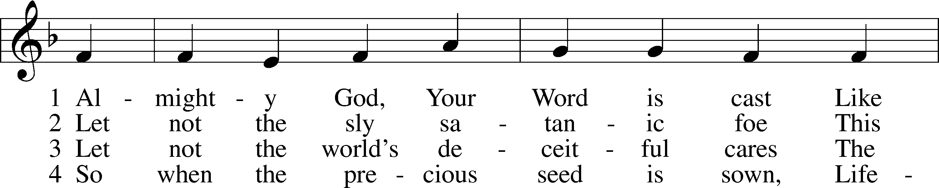
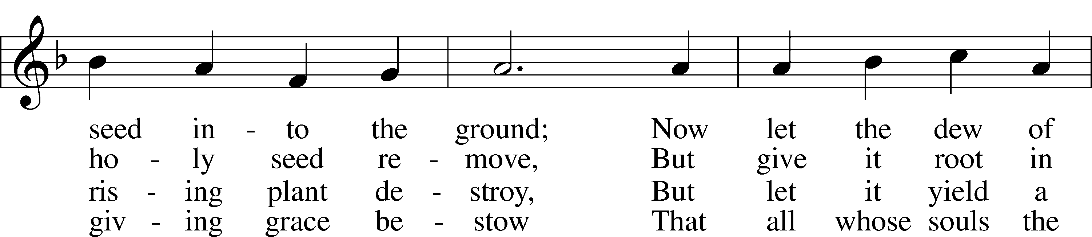
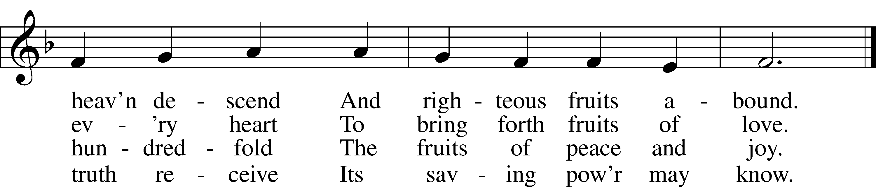
Text: John Cawood, 1775–1852, alt.
Tune: The Whole Booke of Psalmes, 1562, London
Text and tune: Public domain

Stand

The sign of the cross may be made by all in remembrance of their Baptism.

P In the name of the Father and of the T Son and of the Holy Spirit.
C Amen.

P Our help is in the name of the Lord,
C who made heaven and earth.

P If You, O Lord, kept a record of sins, O Lord, who could stand?
C But with You there is forgiveness; therefore You are feared.

P Since we are gathered to hear God’s Word, call upon Him in prayer and praise, and receive the body and blood of our Lord Jesus Christ in the fellowship of this altar, let us first consider our unworthiness and confess before God and one another that we have sinned in thought, word, and deed, and that we cannot free ourselves from our sinful condition. Together as His people let us take refuge in the infinite mercy of God, our heavenly Father, seeking His grace for the sake of Christ, and saying: God, be merciful to me, a sinner.

Kneel/Stand

C Almighty God, have mercy upon us, forgive us our sins, and lead us to everlasting life. Amen.

P Almighty God, merciful Father, in Holy Baptism You declared us to be Your children and gathered us into Your one, holy Church, in which You daily and richly forgive us our sins and grant us new life through Your Spirit. Be in our midst, enliven our faith, and graciously receive our prayer and praise; through Your Son, Jesus Christ, our Lord.
C Amen.

Stand

Service of the Word

Introit Psalm 92:12–15; antiphon: v. 1
It is good to give thanks to the Lord,
to sing praises to your name, O Most High.
The righteous flourish like the palm tree
and grow like a cedar in Lebanon.
They are planted in the house of the Lord;
they flourish in the courts of our God.
They still bear fruit in old age;
they are ever full of sap and green,
to declare that the Lord is upright;
he is my rock, and there is no unrighteousness in him.
Glory be to the Father and to the Son
and to the Holy Spirit;
as it was in the beginning,
is now, and will be forever. Amen.
It is good to give thanks to the Lord,
to sing praises to your name, O Most High.

Kyrie LSB 204
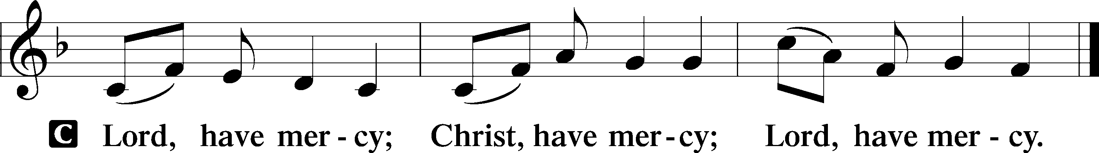

Gloria in Excelsis LSB 204
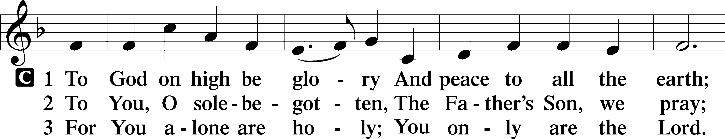
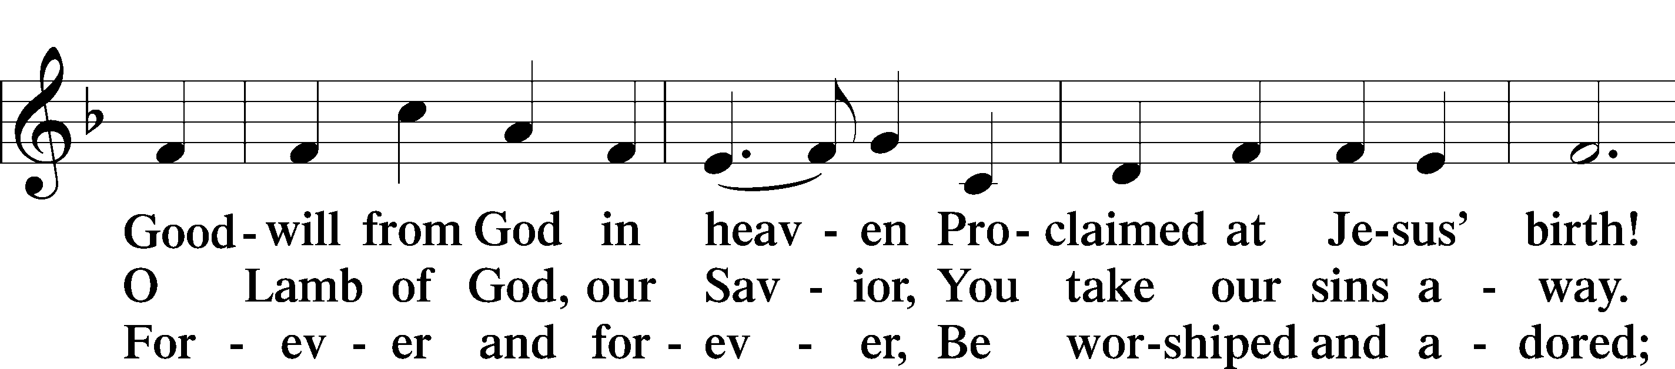
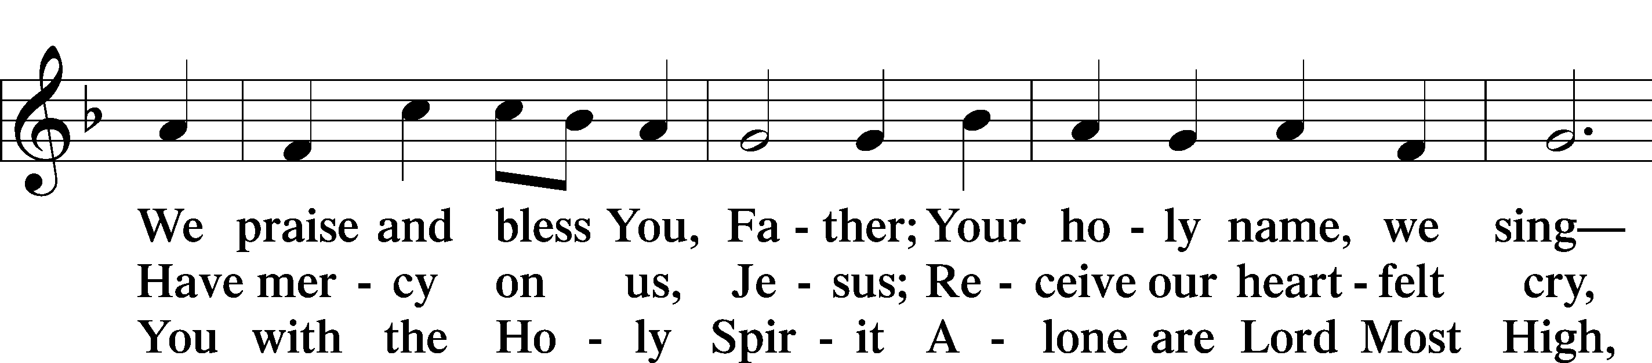
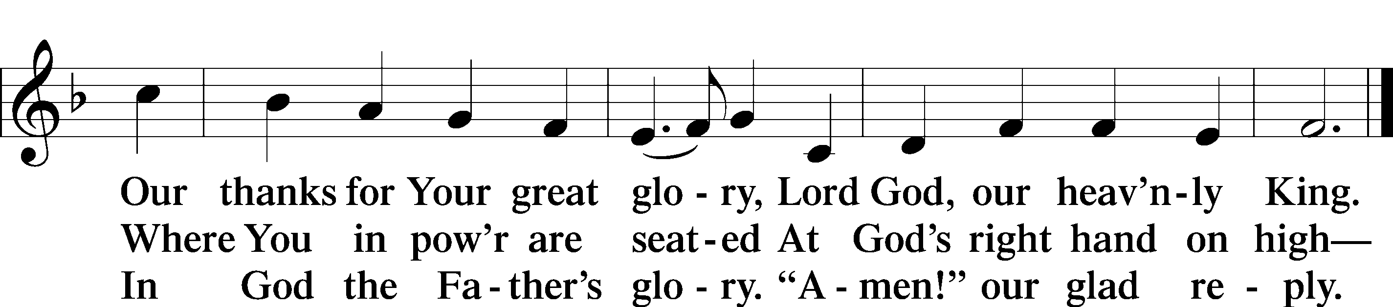
Text: Stephen P. Starke

Salutation and Collect of the Day
P The Lord be with you.
C And also with you.

P Let us pray.
Blessed Lord, since You have caused all Holy Scriptures to be written for our learning, grant that we may so hear them, read, mark, learn, and inwardly digest them that we may embrace and ever hold fast the blessed hope of everlasting life; through Jesus Christ, Your Son, our Lord, who lives and reigns with You and the Holy Spirit, one God, now and forever.

C Amen.

Sit

Old Testament Reading Ezekiel 17:22–24
22Thus says the Lord God: “I myself will take a sprig from the lofty top of the cedar and will set it out. I will break off from the topmost of its young twigs a tender one, and I myself will plant it on a high and lofty mountain. 23On the mountain height of Israel will I plant it, that it may bear branches and produce fruit and become a noble cedar. And under it will dwell every kind of bird; in the shade of its branches birds of every sort will nest. 24And all the trees of the field shall know that I am the Lord; I bring low the high tree, and make high the low tree, dry up the green tree, and make the dry tree flourish. I am the Lord; I have spoken, and I will do it.”

A This is the Word of the Lord.
C Thanks be to God.

Psalm Psalm 1; antiphon: v. 6
The Way of the Righteous and the Wicked
1Blessèd is the man
who walks not in the counsel of the wicked,
nor stands in the way of sinners,
nor sits in the seat of scoffers;
2but his delight is in the law of the Lord,
and on his law he meditates day and night.
3He is like a tree
planted by streams of water
that yields its fruit in its season,
and its leaf does not wither.
In all that he does, he prospers.
4The wicked are not so,
but are like chaff that the wind drives away.
5Therefore the wicked will not stand in the judgment,
nor sinners in the congregation of the righteous;
6for the Lord knows the way of the righteous,
but the way of the wicked will perish.

Epistle 2 Corinthians 5:1–17
Our Heavenly Dwelling
1We know that if the tent, which is our earthly home, is destroyed, we have a building from God, a house not made with hands, eternal in the heavens. 2For in this tent we groan, longing to put on our heavenly dwelling, 3if indeed by putting it on we may not be found naked. 4For while we are still in this tent, we groan, being burdened—not that we would be unclothed, but that we would be further clothed, so that what is mortal may be swallowed up by life. 5He who has prepared us for this very thing is God, who has given us the Spirit as a guarantee.
6So we are always of good courage. We know that while we are at home in the body we are away from the Lord, 7for we walk by faith, not by sight. 8Yes, we are of good courage, and we would rather be away from the body and at home with the Lord. 9So whether we are at home or away, we make it our aim to please him. 10For we must all appear before the judgment seat of Christ, so that each one may receive what is due for what he has done in the body, whether good or evil.
The Ministry of Reconciliation
11Therefore, knowing the fear of the Lord, we persuade others. But what we are is known to God, and I hope it is known also to your conscience. 12We are not commending ourselves to you again but giving you cause to boast about us, so that you may be able to answer those who boast about outward appearance and not about what is in the heart. 13For if we are beside ourselves, it is for God; if we are in our right mind, it is for you. 14For the love of Christ controls us, because we have concluded this: that one has died for all, therefore all have died; 15and he died for all, that those who live might no longer live for themselves but for him who for their sake died and was raised.
16From now on, therefore, we regard no one according to the flesh. Even though we once regarded Christ according to the flesh, we regard him thus no longer. 17Therefore, if anyone is in Christ, he is a new creation. The old has passed away; behold, the new has come.

A This is the Word of the Lord.
C Thanks be to God.

Stand

Alleluia and Verse

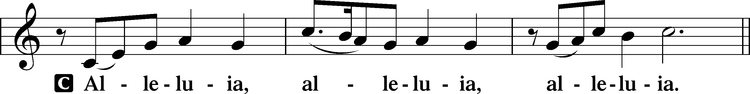

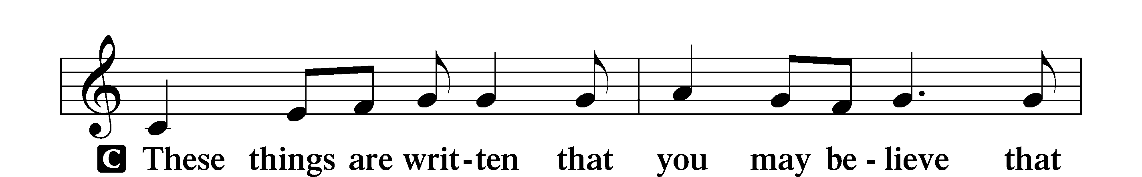
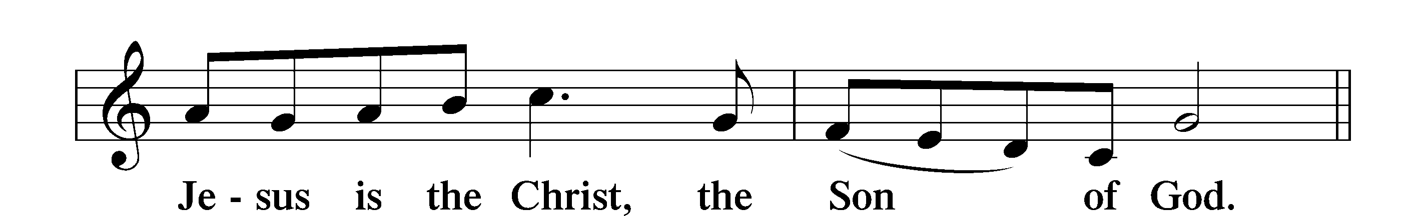

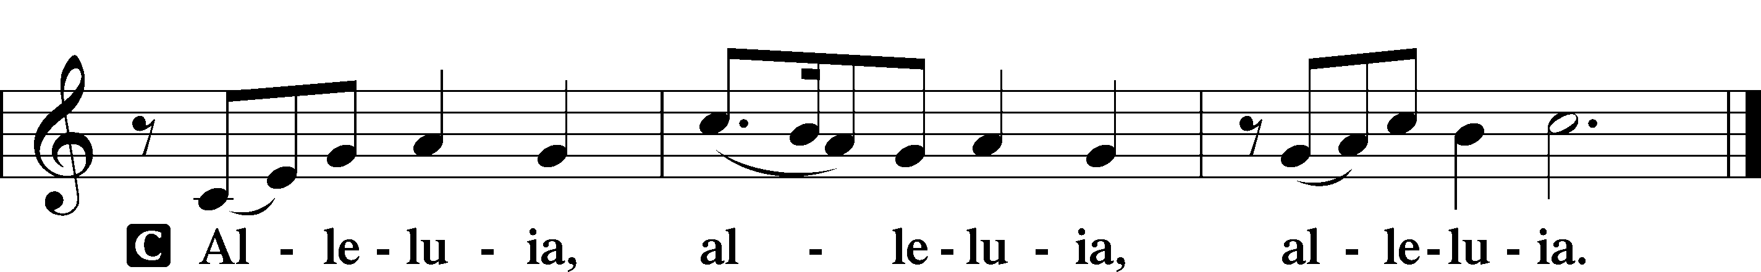

Holy Gospel Mark 4:26–34
P The Holy Gospel according to St. Mark, the fourth chapter.
C Glory to You, O Lord.

The Parable of the Growing Seed
26[Jesus] said, “The kingdom of God is as if a man should scatter seed on the ground. 27He sleeps and rises night and day, and the seed sprouts and grows; he knows not how. 28The earth produces by itself, first the blade, then the ear, then the full grain in the ear. 29But when the grain is ripe, at once he puts in the sickle, because the harvest has come.”
The Parable of the Mustard Seed
30And he said, “With what can we compare the kingdom of God, or what parable shall we use for it? 31It is like a grain of mustard seed, which, when sown on the ground, is the smallest of all the seeds on earth, 32yet when it is sown it grows up and becomes larger than all the garden plants and puts out large branches, so that the birds of the air can make nests in its shade.”
33With many such parables he spoke the word to them, as they were able to hear it. 34He did not speak to them without a parable, but privately to his own disciples he explained everything.

P This is the Gospel of the Lord.
C Praise to You, O Christ.

Nicene Creed
C I believe in one God,
the Father Almighty,
maker of heaven and earth
and of all things visible and invisible.

And in one Lord Jesus Christ,
the only-begotten Son of God,
begotten of His Father before all worlds,
God of God, Light of Light,
very God of very God,
begotten, not made,
being of one substance with the Father,
by whom all things were made;
who for us men and for our salvation came down from heaven
and was incarnate by the Holy Spirit of the virgin Mary
and was made man;
and was crucified also for us under Pontius Pilate.
He suffered and was buried.
And the third day He rose again according to the Scriptures
and ascended into heaven
and sits at the right hand of the Father.
And He will come again with glory to judge both the living and the dead,
whose kingdom will have no end.

And I believe in the Holy Spirit,
the Lord and giver of life,
who proceeds from the Father and the Son,
who with the Father and the Son together is worshiped and glorified,
who spoke by the prophets.
And I believe in one holy Christian and apostolic Church,
I acknowledge one Baptism for the remission of sins,
and I look for the resurrection of the dead
and the life T of the world to come. Amen.

Sit

Hymn of the Day: 704 Renew Me, O Eternal Light
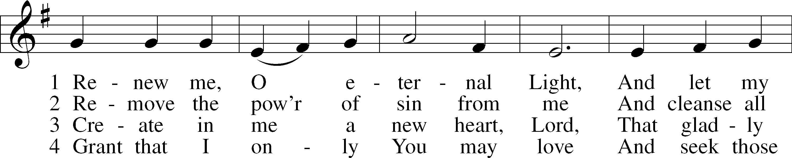
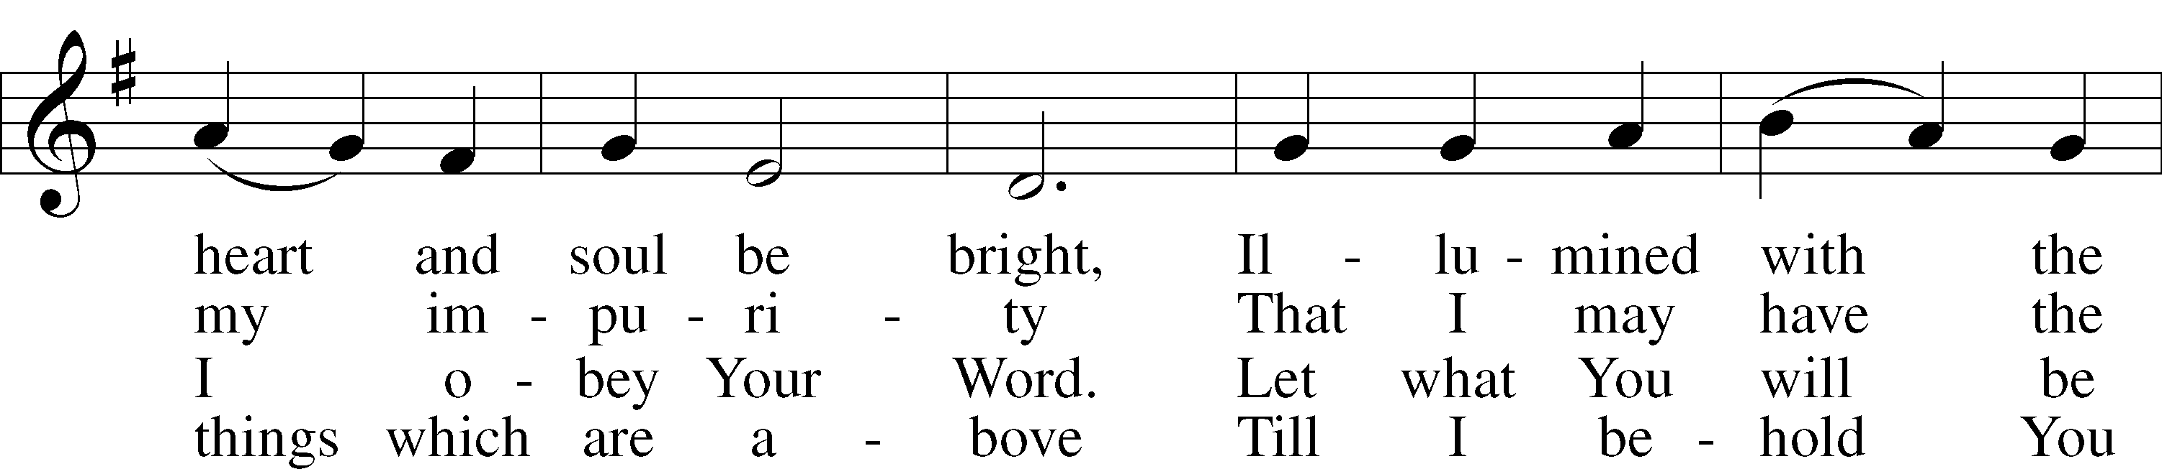
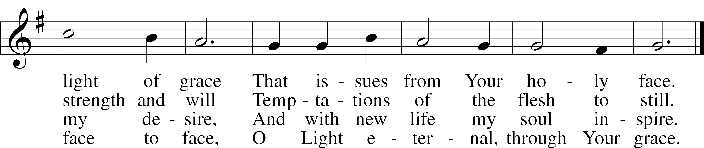
Text: Johann Friedrich Ruopp, 1672–1708; tr. August Crull, 1845–1923, alt.
Tune: As hymnodus sacer, 1625, Leipzig
Text and tune: Public domain

Sermon

Stand

Prayer of the Church

Sit

Offering

Burkart Hymn (insert)

Service of the Sacrament

Stand

Preface LSB 208
P The Lord be with you.
C And also with you.

P Lift up your hearts.
C We lift them to the Lord.

P Let us give thanks to the Lord our God.
C It is right to give Him thanks and praise.

P It is truly good, right, and salutary that we should at all times and in all places give thanks to You, O Lord, holy Father, almighty and everlasting God, for the countless blessings You so freely bestow on us and all creation. Above all, we give thanks for Your boundless love shown to us when You sent Your only-begotten Son, Jesus Christ, into our flesh and laid on Him our sin, giving Him into death that we might not die eternally. Because He is now risen from the dead and lives and reigns to all eternity, all who believe in Him will overcome sin and death and will rise again to new life. Therefore with angels and archangels and with all the company of heaven we laud and magnify Your glorious name, evermore praising You and saying:

Sanctus LSB 208
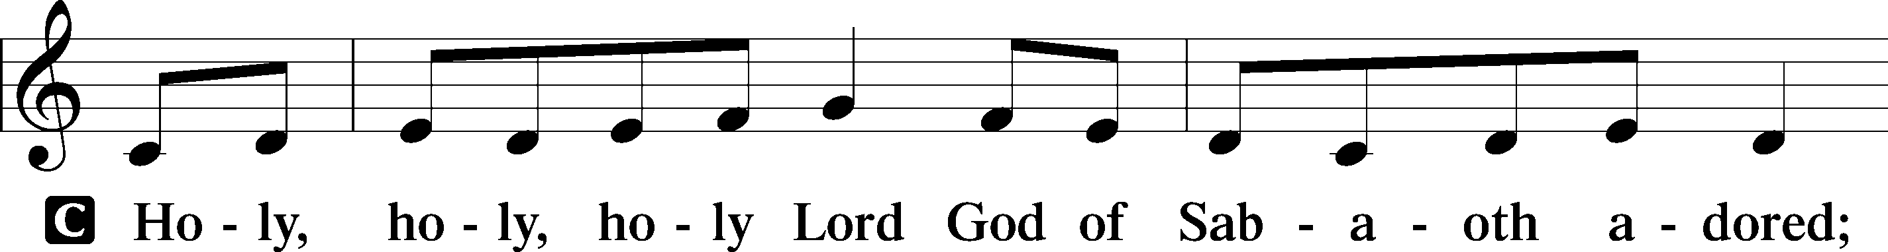
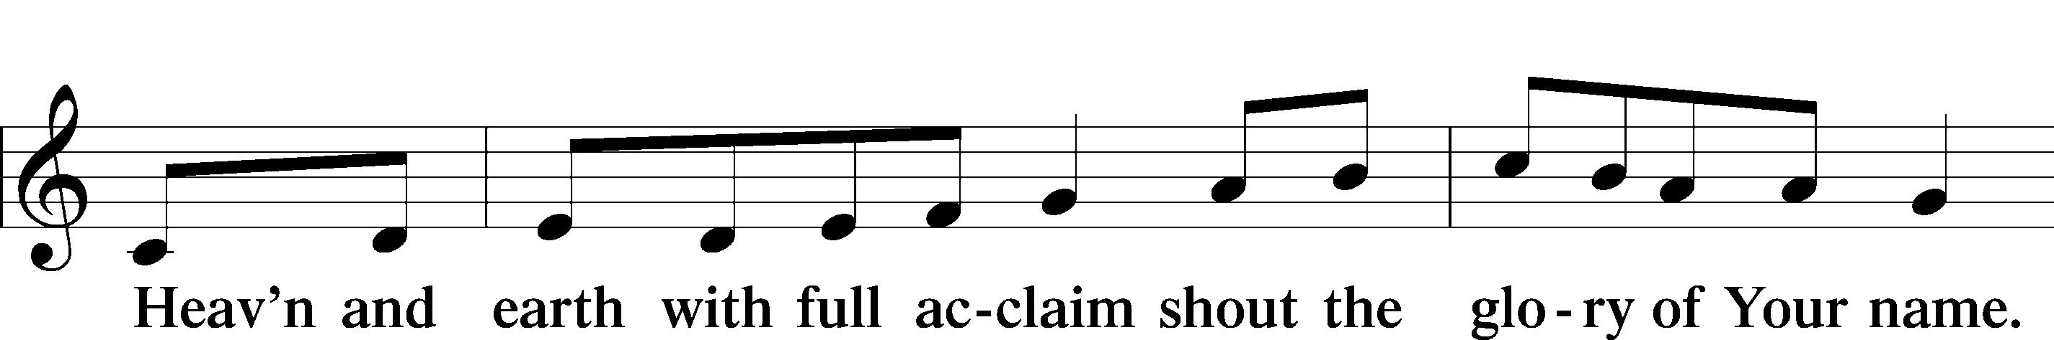
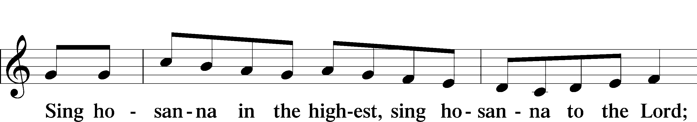
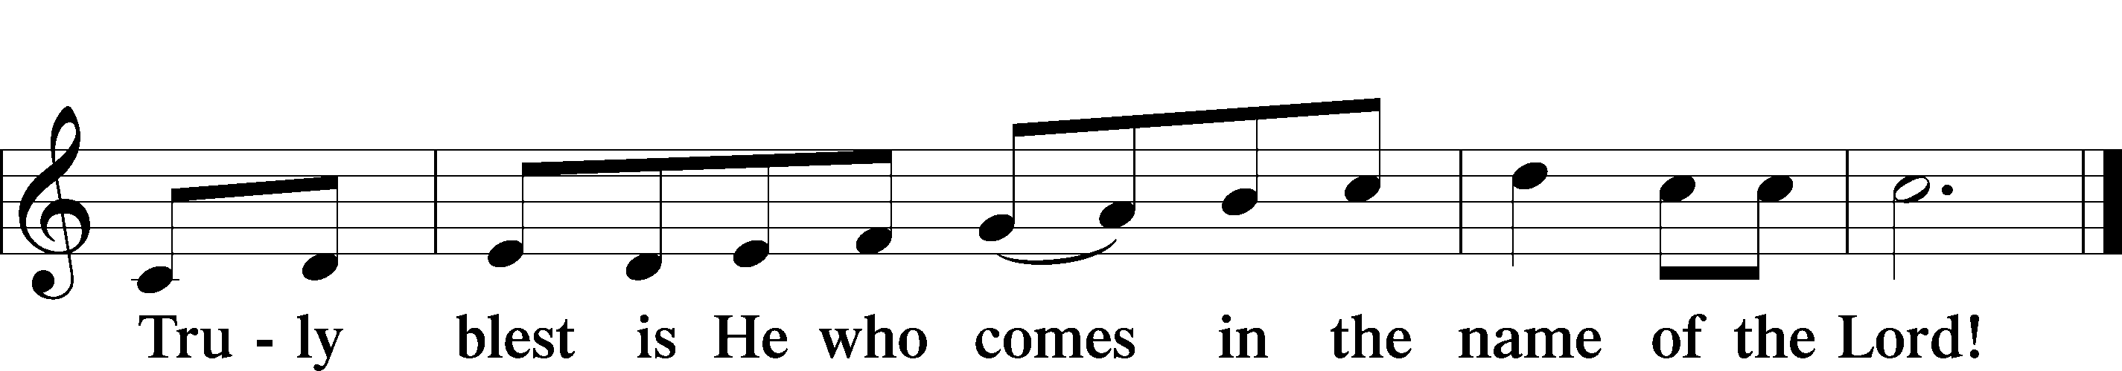
Text: Stephen P. Starke

Prayer of Thanksgiving
P Blessed are You, O Lord our God, king of all creation, for You have had mercy on us and given Your only-begotten Son that whoever believes in Him should not perish but have eternal life.

In Your righteous judgment You condemned the sin of Adam and Eve, who ate the forbidden fruit, and You justly barred them and all their children from the tree of life. Yet, in Your great mercy, You promised salvation by a second Adam, Your Son, Jesus Christ, our Lord, and made His cross a life-giving tree for all who trust in Him.

We give You thanks for the redemption You have prepared for us through Jesus Christ. Grant us Your Holy Spirit that we may faithfully eat and drink of the fruits of His cross and receive the blessings of forgiveness, life, and salvation that come to us in His body and blood.

Hear us as we pray in His name and as He has taught us:

Lord’s Prayer
C Our Father who art in heaven,
hallowed be Thy name,
Thy kingdom come,
Thy will be done on earth
as it is in heaven;
give us this day our daily bread;
and forgive us our trespasses
as we forgive those
who trespass against us;
and lead us not into temptation,
but deliver us from evil.
For Thine is the kingdom
and the power and the glory
forever and ever. Amen.

The Words of Our Lord
P Our Lord Jesus Christ, on the night when He was betrayed, took bread, and when He had given thanks, He broke it and gave it to the disciples and said: “Take, eat; this is My T body, which is given for you. This do in remembrance of Me.”

In the same way also He took the cup after supper, and when He had given thanks, He gave it to them, saying: “Drink of it, all of you; this cup is the new testament in My T blood, which is shed for you for the forgiveness of sins. This do, as often as you drink it, in remembrance of Me.”

Pax Domini
P The peace of the Lord be with you always.
C Amen.

Agnus Dei LSB 210
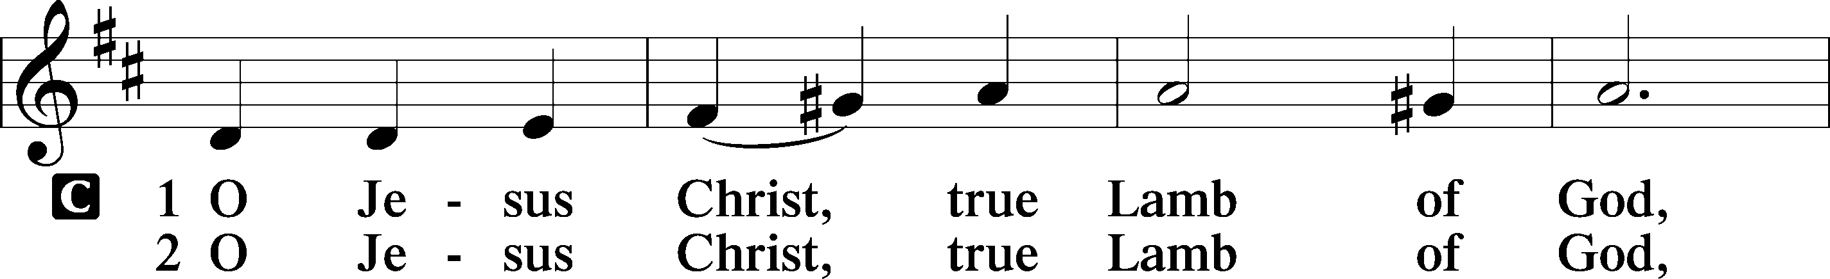
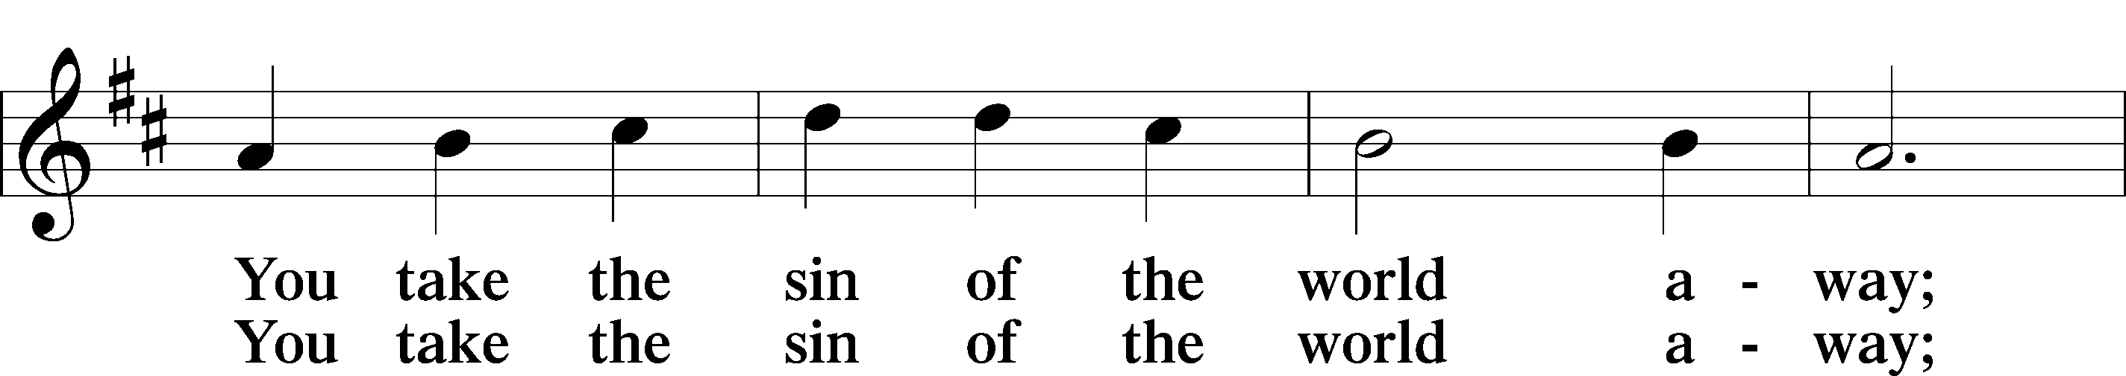
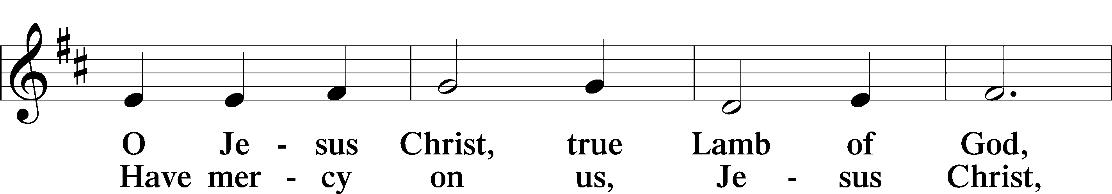
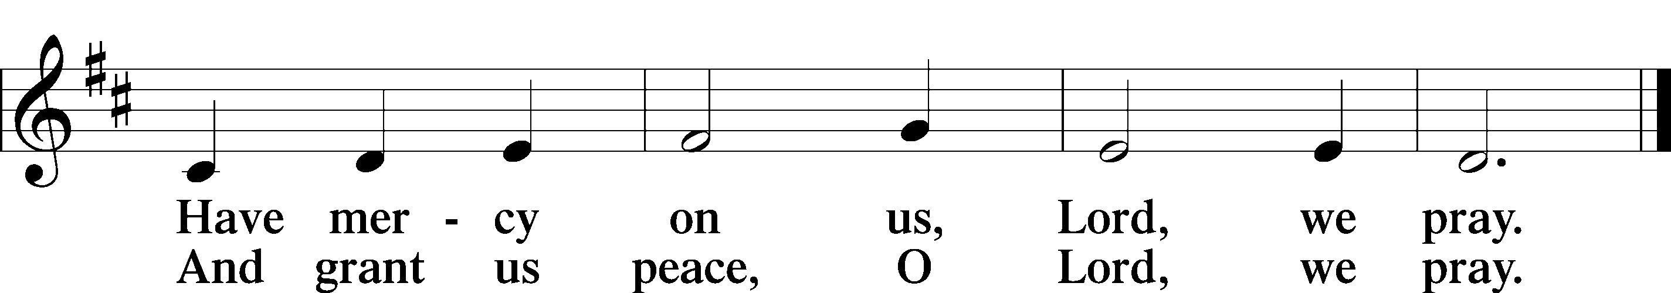
Text: Stephen P. Starke

Sit

Distribution

The pastor and those who assist him receive the body and blood of Christ first and then distribute them to those who come to receive, saying:

Take, eat; this is the true body of our Lord and Savior Jesus Christ, given into death for your sins.
Amen.

Take, drink; this is the true blood of our Lord and Savior Jesus Christ, shed for the forgiveness of your sins.
Amen.

In dismissing the communicants, the following is said:

P The body and blood of our Lord Jesus Christ strengthen and preserve you in body and soul to life everlasting. Depart T in peace.
C Amen.

Distribution Hymn: 623 Lord Jesus Christ, We Humbly Pray
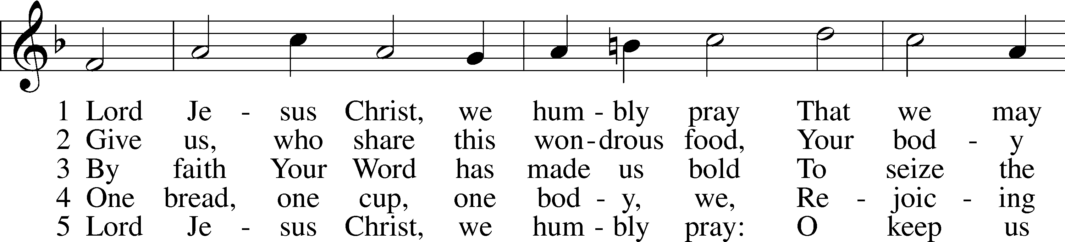
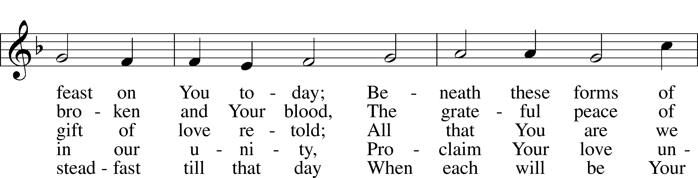
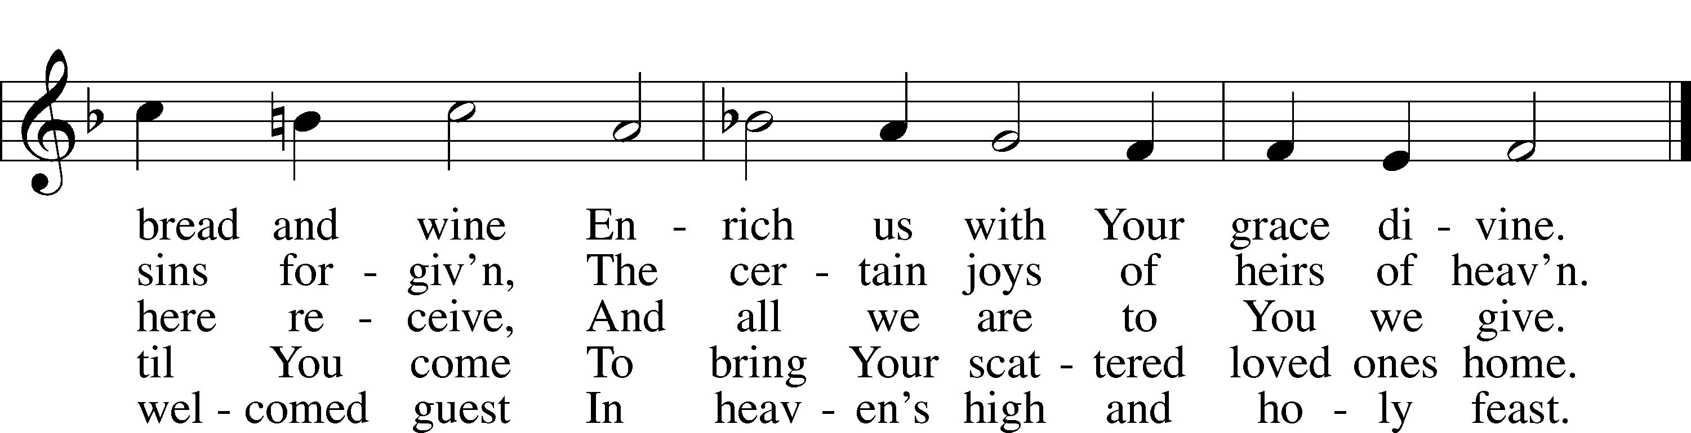
Text: Henry E. Jacobs, 1844–1932, alt.
Tune: Cantionale Germanicum, 1628, Gochsheim
Text and tune: Public domain

Distribution Hymn: 811 Oh, That I Had a Thousand Voices
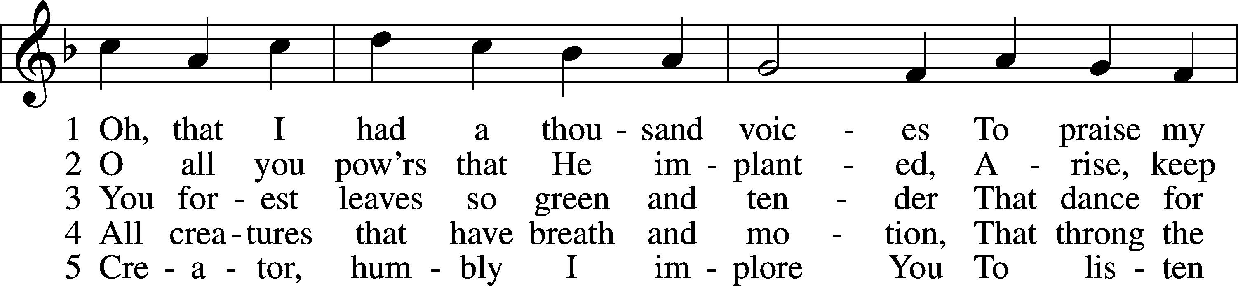
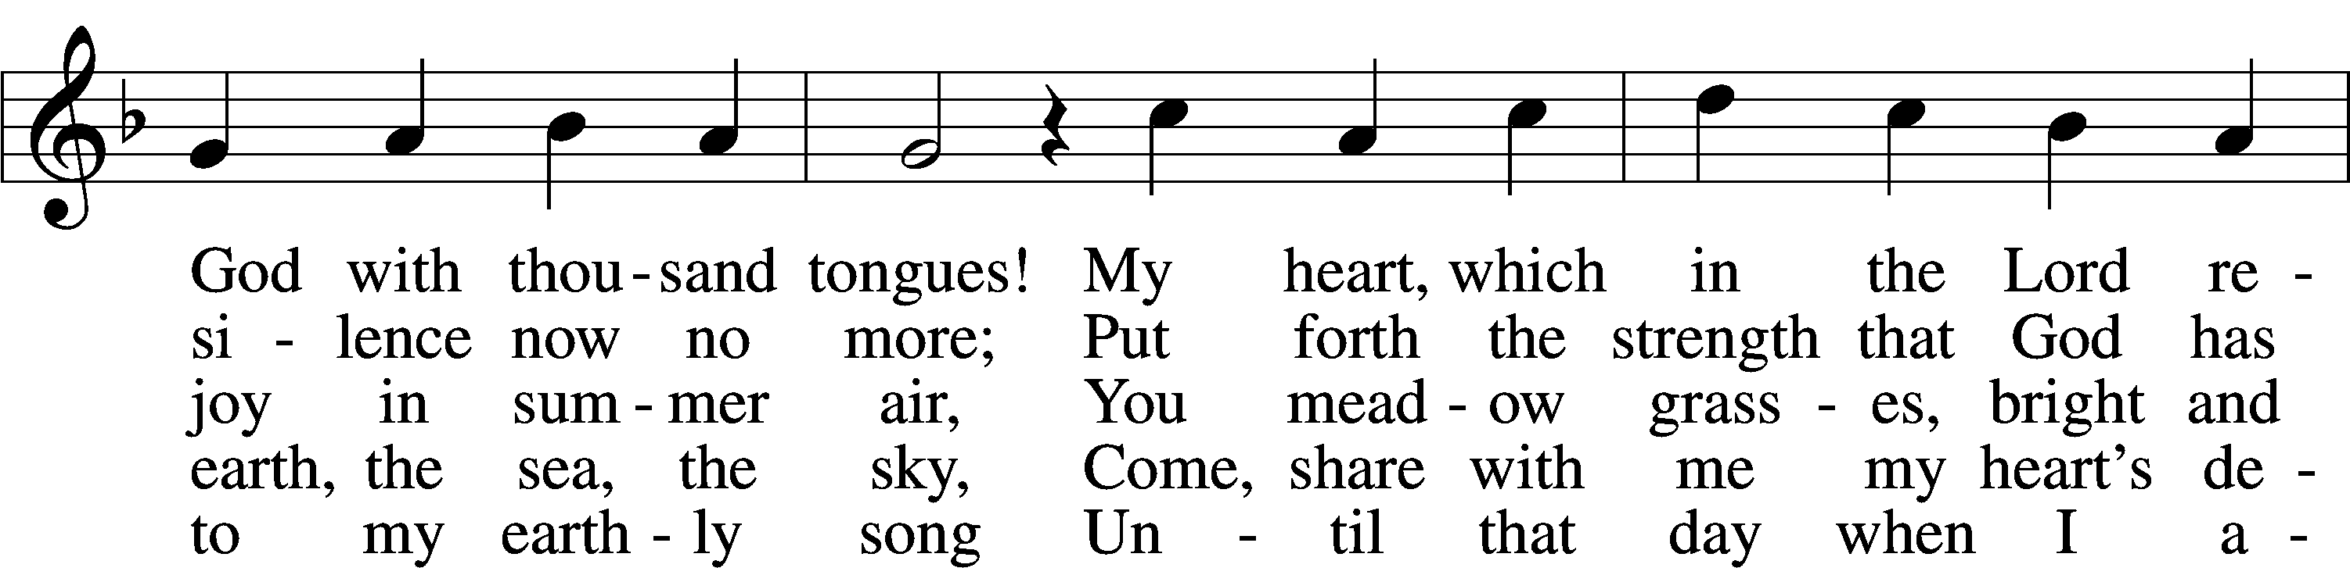
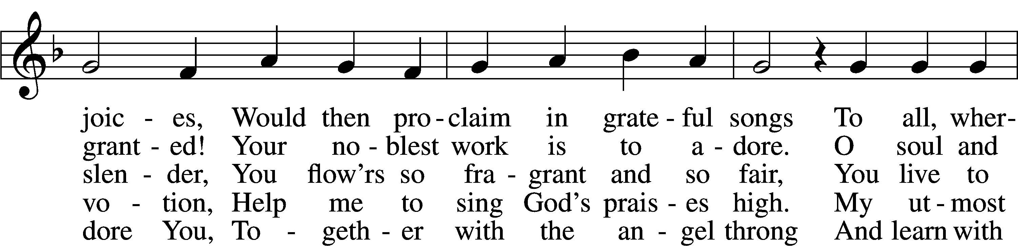
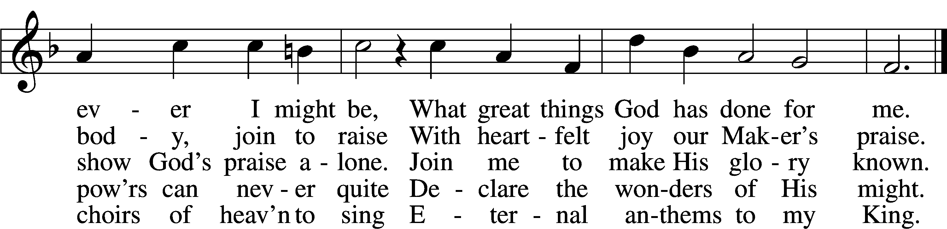
Text: Johann Mentzer, 1658–1734; tr. The Lutheran Hymnal, 1941, alt.
Tune: Johann Balthasar König, 1691–1758
Text: © 1941 Concordia Publishing House. Used by permission: LSB Hymn License no. 110005504
Tune: Public domain

Stand

Nunc Dimittis LSB 211
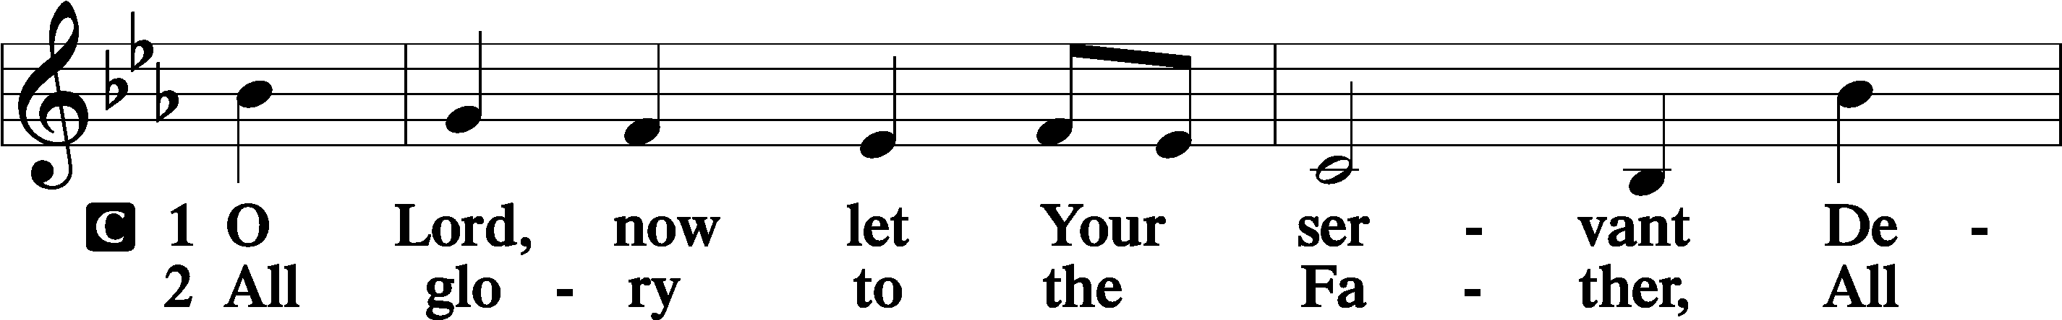
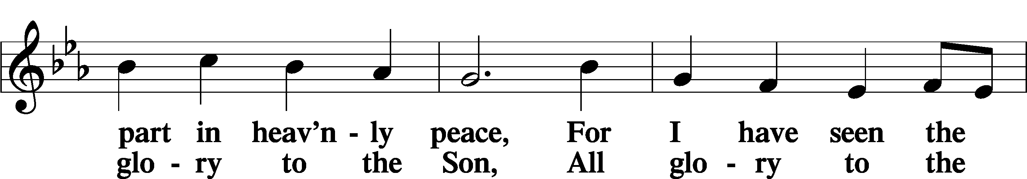
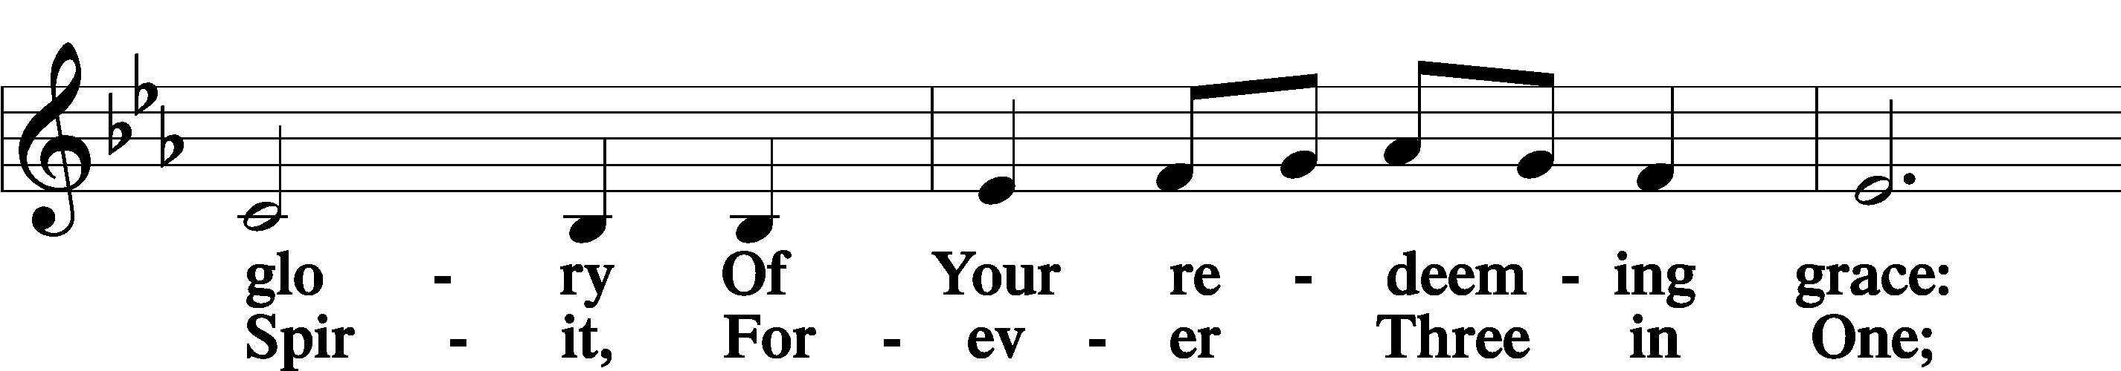
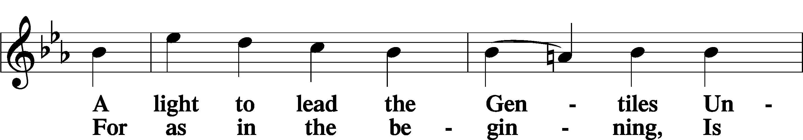
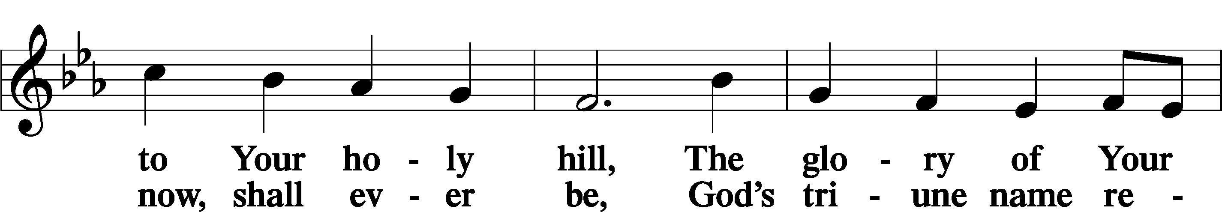
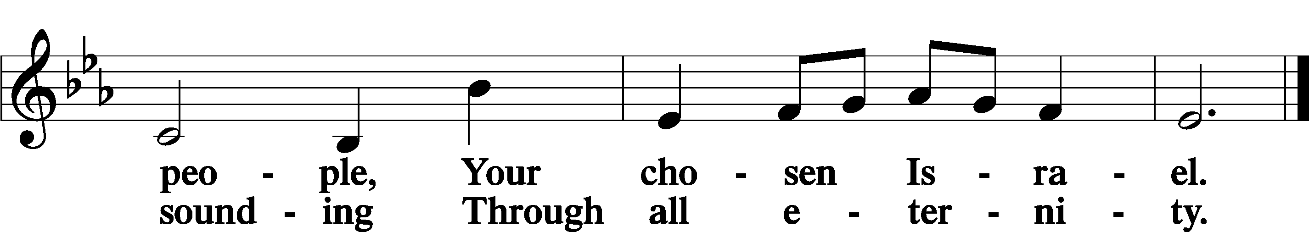

Post-Communion Collect
A Let us pray.
We give thanks to You, almighty God, that You have refreshed us through this salutary gift, and we implore You that of Your mercy You would strengthen us through the same in faith toward You and in fervent love toward one another; through Jesus Christ, Your Son, our Lord, who lives and reigns with You and the Holy Spirit, one God, now and forever.
C Amen.

Benedicamus LSB 212
A Let us bless the Lord.
C Thanks be to God.

Benediction
P The Lord bless you and keep you.
The Lord make His face shine on you and be gracious to you.
The Lord look upon you with favor and T give you peace.
C Amen.

Hymn to Depart: 921 On What Has Now Been Sown
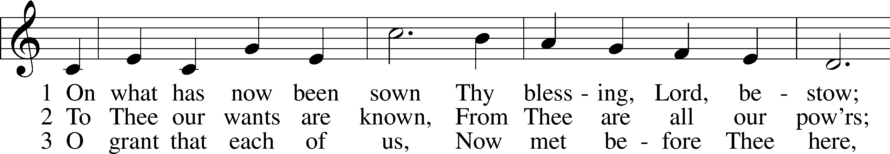
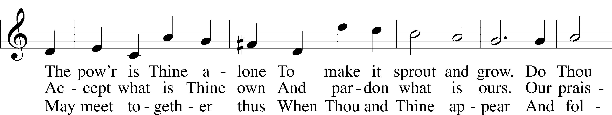
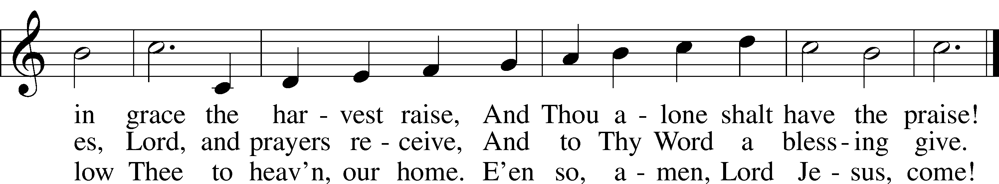
Text: John Newton, 1725–1807, alt.
Tune: John Darwall, 1731–89
Text and tune: Public domain

Acknowledgments
Divine Service, Setting Four from Lutheran Service Book
Unless otherwise indicated, Scripture quotations are from the ESV® Bible (The Holy Bible, English Standard Version®), copyright © 2001 by Crossway, a publishing ministry of Good News Publishers. Used by permission. All rights reserved.
Created by Lutheran Service Builder © 2024 Concordia Publishing House.

Announcements:

Church Service Phone: 715-438-4200
(Stay on the line for recorded service to start)
Live Stream audio services: http://salem.listentochurch.com
Salem’s Web Page: https://www.salembarron.com/
Pastor Fred Buth: Cell phone:715-642-3050 (H)715-353-2540
Pastor’s Email: salembarronpastor@gmail.com
Office Hours: Monday-Wednesday 9-12
Office email: salembarron@gmail.com
Attendance:
Call-in line: 6/9- 0 In-person: 6/9-40
Coffee and Snacks: Thompson/Millerman(Proceeds will go to New Pentecost banner)
Elder Today: Don Duncan
Altar Guild: Nancy Koenig/Marcia Elliott

Schedule for the upcoming week:
Tuesday: 5:30 PM –BOE

As of now there will be No VBS as we do not have someone to direct it.

Save the Date:
July 28th: Root beer float Sunday. (Proceeds will go to Backpack for Kids)
August 9th: Church & Childcare annual picnic, serving 4:30-6:30pm

Happy Father’s Day!!

