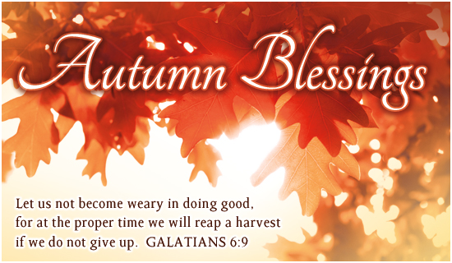

**Salem Lutheran Church**

**Childcare and Preschool**

**October 2024**

Pastor’s Page

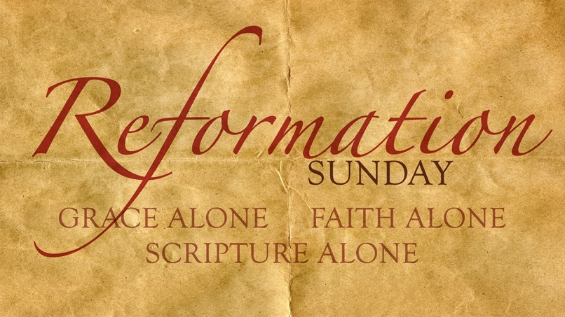

**The Reformation Twelve**

Dr. Martin Luther was the central figure in the Reformation that began October 31:1517, but he never could have accomplished it by himself. Twelve people were essential parts of the rise and success of the Reformation. Interestingly enough, most of them never confessed the faith that Luther discovered: five of them condemned it; one knew nothing of it, and four were indifferent to it. In fact, only two, in addition to Luther could end up being called “Lutherans.” But each of them played a necessary role.

On Sunday – Oct. 27th, during Bible Study hour, we will look at these individuals who played such a big part in the Reformation, even though they did not realize it. Come and join us for this special Bible Study Adventure.

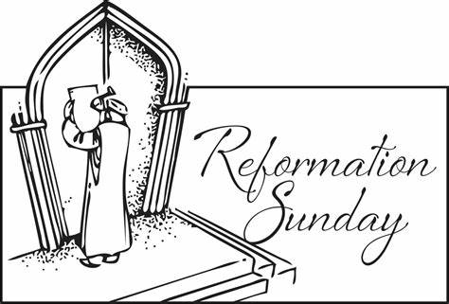

**Reformation Sunday** will be October 27th during which we will have a special service with a visit from Dr. Martin Luther. In this monologue, I will convey the struggles Dr. Luther went through to genuinely understand what it means “to be justified by God.” As he struggled with this meaning, he found it clearly spelled out as he searched the Scriptures themselves. Thereafter, his struggle was for acceptance of these conclusions by the Catholic Church of that day. This did not happen and eventually he and his followers departed from that Church body after they were ex-communicated.

Join us for this special worship as we celebrate and rejoice in the truths of the Gospel, thanking God that He has preserved the church, praying that we will remain faithful to His Word.

**Council Meeting 9/10/2024**

Present: Pastor Buth, President John Steele, Vice President Josh Millerman, Treasurer Mary Ann Thompson, Trustee Tom Lipke, Elder Don Duncan, Board Of Education Chris Severt

Absent: Secretary Emily Steele

President John Steele called the meeting to order

Pastor Buth led the council in a scripture and prayer

**Secretary Report:** Emily provided the minutes from the August 13, 2024 meeting by email. A motion was made to approve the minutes by Don Duncan and seconded by Tom Lipke.

**Treasurer Report:** Mary Ann Thompson provided the financial reports as of 8/31/24. The church income for August is $7,558.89. August expenses were $4,375.95. The net income for August is $3,182.94. The general fund balance is $81,143.32. The current church checking is $68,808.50. The Church Savings is $17,350.30. The building fund account is $34,177.02. The Daycare Checking is $60,317.78 and the Daycare loan balance is $44,759.87. Chris Severt pointed out that on the Daycare account there was a $55.83 Parsonage Maintenance/Repair added to the daycare account. Mary Ann is having that moved to the church account.

A motion was made to approve the Treasurer’s report by Chris Severt and seconded by Josh Millerman

**Elder Report:** No Transfers or Releases. Don gave an update on circuit lay leaders training. We discussed the Health Insurance for the future Pastor and some options we may have if we need. Discussed having laymen do some reading in the future. Stan gave an update on the call. We have talked about the Pastor’s salary and the Elders decided Pastor Buth’s salary would be doubled from $1200.00 to $2400.00 a month starting September 1, 2024. Stan brought up articles from The Lutheran Laymen about teaching teens. He also ordered 6 discovery books for the video that we will be going through during bible study hour starting 9/15/2024.We will be doing the budget next month.The Elder’s also decided to still have 2 advent services on Wednesday’s and the 6:30 service will be lay lead.Closed with the Lord’s PrayerA motion to accept the Elder’s report was made by Chris Severt and seconded by Tom Lipke

**Trustee Report:** The parsonage is just about complete for updates. Bill Balts construction took out the chimney. An electric burning unit was installed. Josh Millerman removed the hot water heater. A motion was made to accept the Trustee’s report by Chris Severt and seconded by Don Duncan

**Board Of Ed Report:** We reviewed the increase projections of $.25, $.50, $.75, $1.00 pay raise for the daycare staff and what that impact would have on our center costs.A motion was made to give all day-care full-time staff employee’s up to $1.00 increase based on their review and at the Director’s discretion. Effective date of August 26, 2024.A motion was made to approve to increase Melissa’s salary from $40,000 to $42,000. It would go back to June.Need to revisit the Concordia email as we should have one set up so that the Director is able to go into Concordia and do updates as employee’s become eligible and terminate employment. Melissa will work with Jen on this.

**Behavior Policy and No Toys from Home Policy**

This policy was sent out thru email to all BOE and we all approved. Behavior Policy has been sent out to all parents.

**State Update**

Melissa received a voice mail from state and State is working with Northwest Connections to get some training for the staff. No citation has been given as of today. Reviewed Handbook and Melissa is going to look at the Grievance Policy and bringing toys from home area and give recommendation. Motion was made to accept the Board Of Ed Report by Mary Ann Thompson and seconded by Tom Lipke

**Pastor Report:** Nothing to report

**Old Business:** None

**New Business:** Tom Lipke called Church Mutual to let them know that the fireplace was removed from the parsonage and that may decrease our insurance. Church Mutual will get back to Tom. Pastor Buth shared that Cindy Wright recently attended the LCMS' 2024 Institute on Liturgy, Preaching & Church Music at Concordia University, Seward, NE.  The theme focused on the Psalms as "Songs of Deliverance - Psalms in the Great Congregation," and all 150 Psalms were sung sometime during the 3-day conference!   Pastor is going to review his songs for services on Sundays and maybe only do a few versus when they are a longer song.

A motion to adjourn was made by Chris Severt and seconded by Tom Lipke.



**Men’s Club meeting 9/3/2024**

* President Tom called the meeting to order
* Secretary’s report was given from 5/7/24 meeting
* We had spent $68.80 for 3 bags of weed and seed for the church yard. The parsonage will have weed and seed put on in the spring.
* Tom has a Thrivent card for the Pancake supper. He will talk to KJ’s and Kwik Trip for donations. Will see if Paul will contact Lot’s of Meat in Bloomer for sausage. Pancake supper will be September 30th 2024 from 4-7pm. Sunday September 29th at 1:00 pm we will set up tables, move ovens out and set up friers, peel potatoes and onions.
* Motion by Jim to adjourn

Closed with the Lord’s Prayer

Don Duncan, Secretary

**October 10:**

**Ava Slayton**

**Bentley Slayton**

**Riley Klimek**

**October 24:**

**Matthew Millerman**





**October 9: scott & becky hammann**

**October 19: Harrison & Shirley fields**

**October 21: Matthew & Maddie Thompson**





**October 1 :** Matthew Millerman

**October 5:** Joyce Myers & Paige Millerman

# October 6: Declan Dennis & Bernie Pedersen

**October 7:** Zachary Dennis

**October 10:** Rachel Hanson

# October 14: Michele Millerman

# October 16: Nancy Koenig

# October 17: Rick Cornelius

# October 20: Marilynn Amundson, Melissa Miller, & Adam Steele

**October 21:** Scott Queiser

**October 25:** Brody Hammann

**October 27:**  Eli Duncan

**October 28:** Darlene Heil

**October 29:** Damen Dennis, Brad Kuchera, & Waylon Steele

**October 31:** Dale Bryan



How to Contact Us

Pastor Buth – Cell: 715-642-3050 Home: 715-353-2540

Pastor: [salembarronpastor@gmail.com](mailto:salembarronpastor@gmail.com)

Office – (715) 537-3011

Preschool – (715) 537-3011 ext.14

Mary Ann Wheeler, Parish Musician – (715) 205-1158

Church Service Phone –715-438-4200

Church Email: [salembarron@gmail.com](mailto:salembarron@gmail.com)

**Salem’s Web Page Is:** <https://www.salembarron.com/>

Click on enter the following link and follow the prompts to support Salem.

<https://smile.amazon.com/ch/39-6137330>

**October Greeters**

6 – Marcia Elliott

13 – Scott Queiser

20 – Stan & Nancy Koenig

27 –

**October Ushers**

**Stan Koenig**

Scott Queiser

Owen Metz

James Dennis

**September/October**

Darlene Heil 715-637-5483

Jim Thalacker 715-859-2228

Jim & Lori Crawford 715-458-6080

Harvey Germanson 715-637-3890

Scot & Becky Hammann 715-637-0586

Dean & Kim Hanson 715-894-7447

Shirley Heil 715-637-3586

Joann Jaeger 715-924-3551

Brad & Carol Kuchera 715-837-1677

Joshua & Jennifer Millerman 715-837-1551

Pastor & Kathy Mueller 715-418-0050

Fred & Linda Riebe 715-637-5243

Herb & Deloris Zabel 715-637-5295



**October Elders**

6 – Tim Dennis

13 – Trevor Duncan

20 – Paul Millerman

27 – Josh Millerman

**Coffee Schedule**

6 – Chris & Jolene Severt Family

13 – David & Cindy Steel Family

20 –

27 – Scot & Becky Hammann Family

**October 2024**

|  |  |  |  |  |  |  |
| --- | --- | --- | --- | --- | --- | --- |
| **Sunday** | **Monday** | **Tuesday** | **Wednesday** | **Thursday** | **Friday** | **Saturday** |

|  |  |  |  |  |  |  |
| --- | --- | --- | --- | --- | --- | --- |
|  |  | 1    8:00 am Bible Class  4:30pm YFMs  7:00 pm Men’s Club | 2  4-5pm Catechism | 3 | 4 | 5 |
| 6 Green  9:00 am Communion Worship  10:00 Coffee/Snacks  10:15 am SS  10:15 am Bible Class | 7  7:00 pm Elders | 8    8:00 am Bible Class  7:00pm Council | 9  4-5pm Catechism | 10 | 11 | 12 |
| 13 Green    9:00 am Worship  10:00 Coffee/Snacks  10:15 am SS  10:15 am Bible Class | 14 | 15    8:00 am Bible Class | 16  4-5pm Catechism | 17 | 18 | 19 |
| 20 Green    9:00 am Communion Worship  10:00 Coffee/Snacks  10:15 am SS  10:15 am Bible Class | 21 | 22    8:00 am Bible Class | 23  4-5pm Catechism | 24 | 25 | 26  10 am to Noon  See the source image 10 am to 3 pm  See the source image |
| 27 Red  9:00 am Worship  10:00 Coffee/Snacks  10:15 am SS  10:15 am Bible Class | 28 | 29  8:00 am Bible Class | 30  4-5pm Catechism | See the source image31 |  |  |

**Christ Community Lutheran School**

Interest Survey

Christ Community Lutheran School is a school of the Lutheran Church - Missouri Synod. As such, CCLS holds to the teachings of the LCMS, namely: Faith Alone, Scripture Alone, Grace Alone. Our eternal salvation comes through faith in Jesus Christ and His atoning sacrifice for us on the cross. The Bible is the inerrant Word of God. God gives His gifts to us by His grace.

A Lutheran school exists to assist parents in the Christian upbringing of their children. CCLS is scheduled to open in Fall of 2025. Please answer the following questions regarding your interest in Christ Community Lutheran School.

1. What is your level of interest in sending a child ( your child, a grandchild, a relative or friend) to CCLS?

_______ Very interested

_______ Would seriously consider

_______ Need more information*

_______ Not interested

*If you would like more information about CCLS, please write your name and preferred contact information here:

___________________________________________________________________________________

2. If you are at all interested, what are the ages of the children you might send?

_____________________________________________________________________________

3. If you have high school students, how interested might you be in virtual classes coordinated through CCLS?

_______ Very interested

_______ Would consider

_______ Not interested

4. What is a reasonable distance to travel from your home to the school? (Currently, the school is set to open at St. Matthew’s in Almena)

_______ up to 10 miles

_______ 10 - 20 miles

_______ 20 - 30 miles 5.

Do you think your congregation would help with the educational cost at CCLS?

_______ Yes

_______ No

_______ Unsure

6. What is the name of your congregation?_________________________

YOU MAY ALSO COMPLETE THE SURVEY ONLINE BY SCANNING THE QR CODE:



