Divine Service 1 Communion pg.151

9th Sunday after Pentecost

July 21,2024

Confession and Absolution

Hymn of Invocation: 711 Savior, like a Shepherd Lead Us
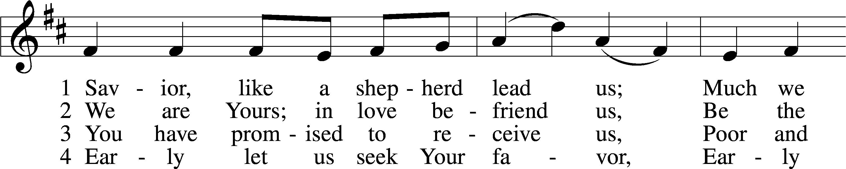
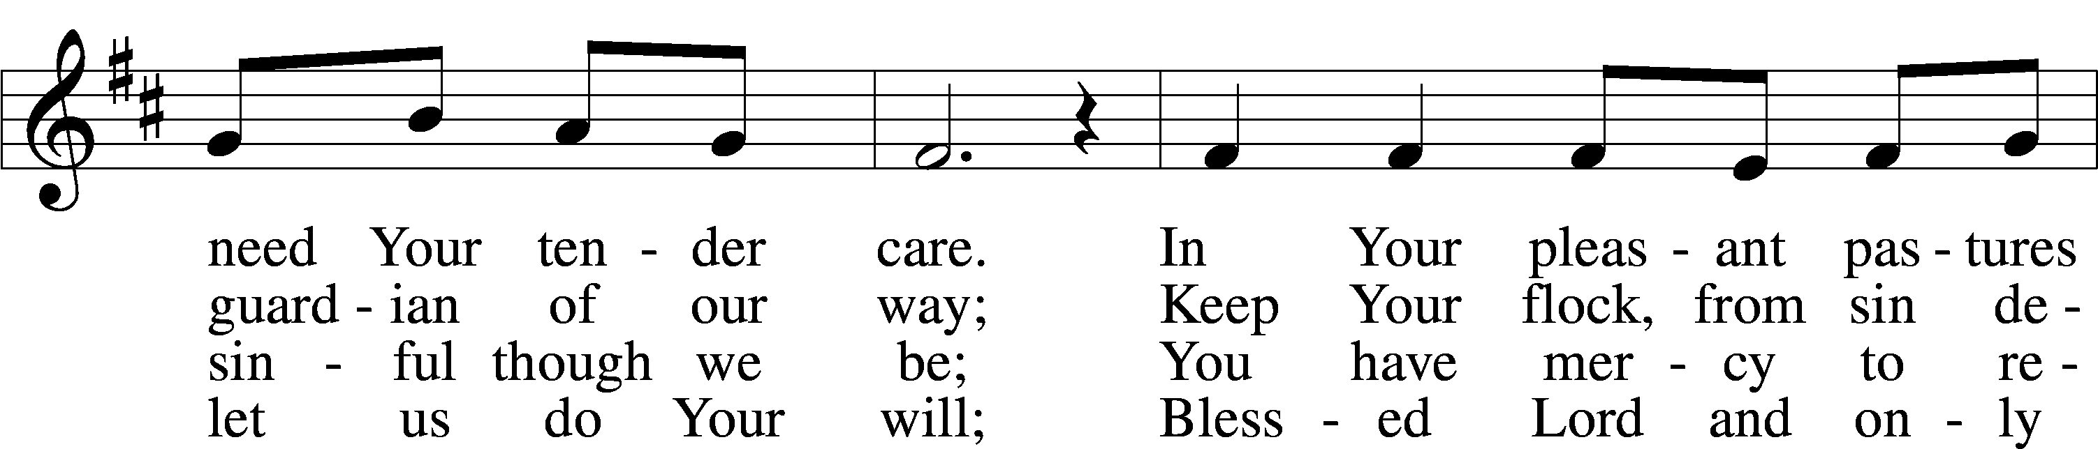
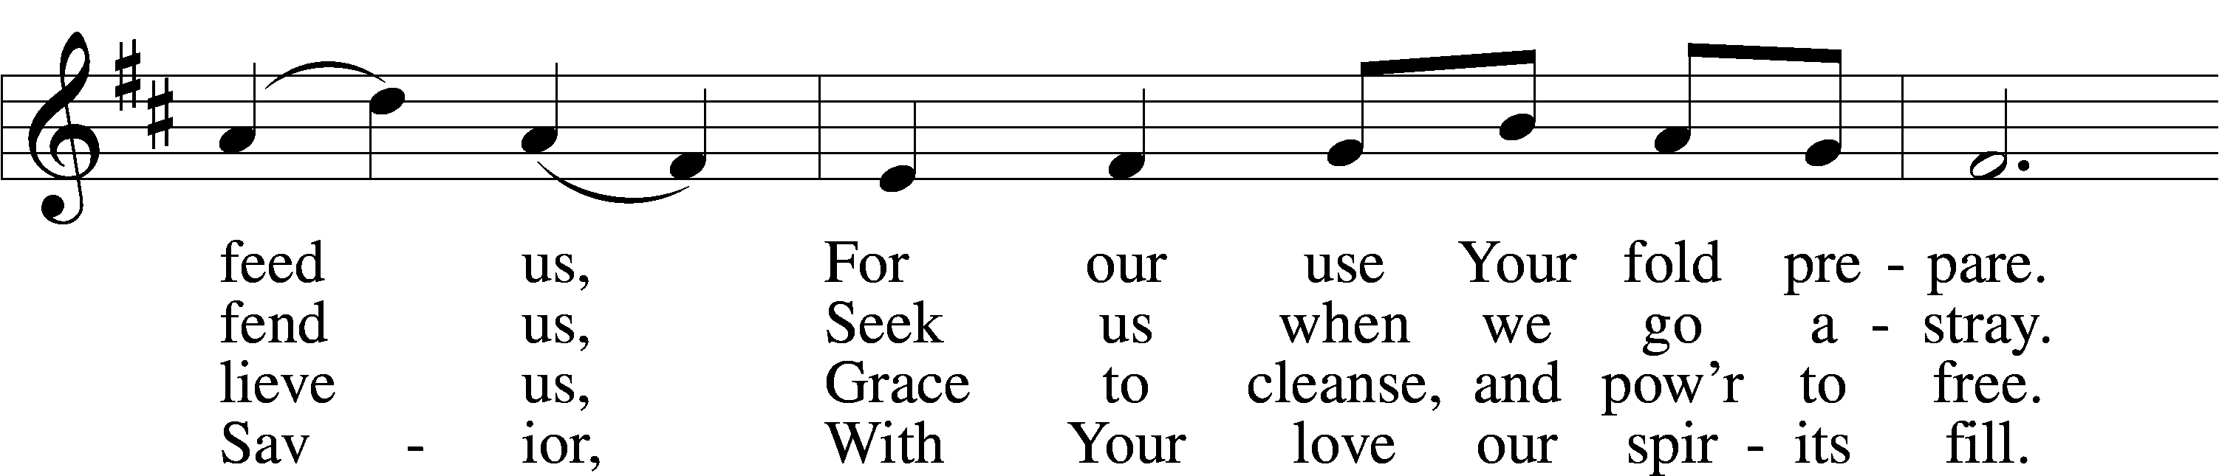
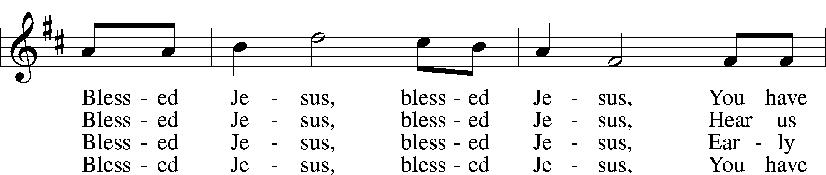
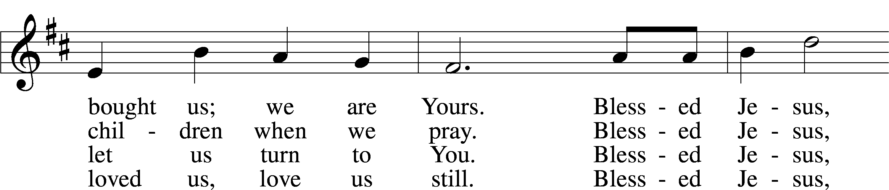
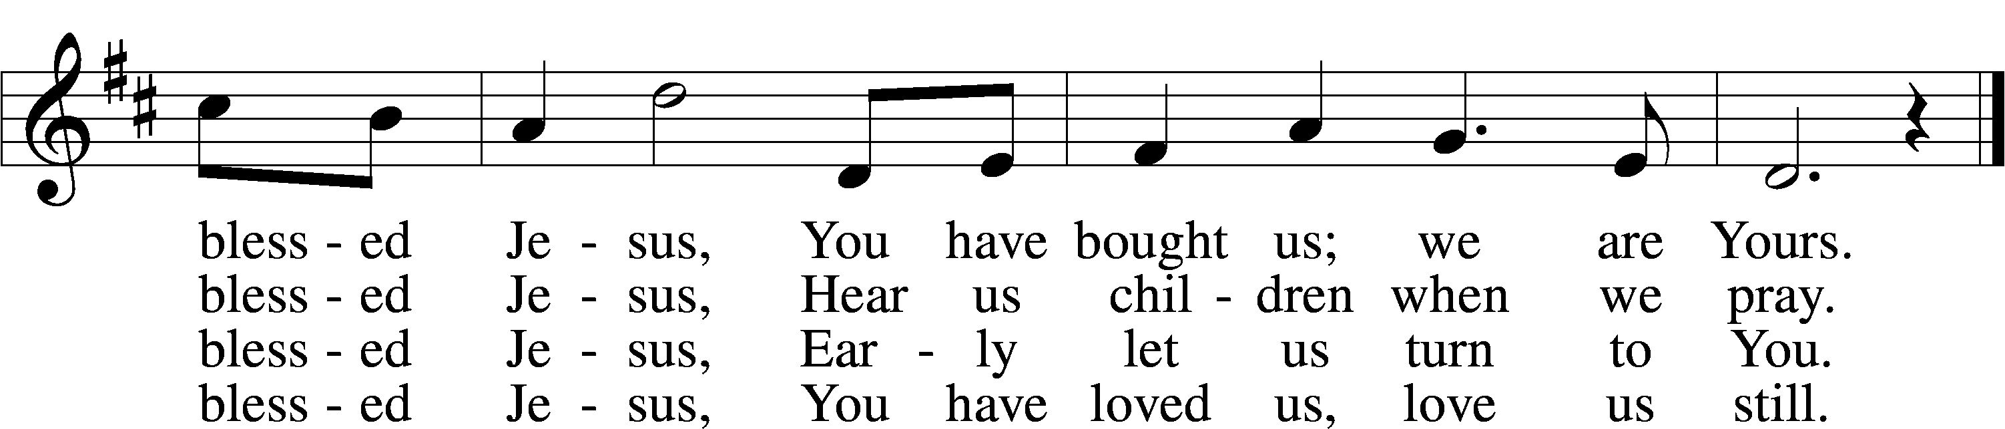
Text: Hymns for the Young, 1836, 4th ed., London, alt.
Tune: William B. Bradbury, 1816–68
Text and tune: Public domain

Stand

The sign of the cross may be made by all in remembrance of their Baptism.

P In the name of the Father and of the T Son and of the Holy Spirit.
C Amen.

P If we say we have no sin, we deceive ourselves, and the truth is not in us.
C But if we confess our sins, God, who is faithful and just, will forgive our sins and cleanse us from all unrighteousness.

Kneel/Stand

Silence for reflection on God’s Word and for self-examination.

P Let us then confess our sins to God our Father.
C Most merciful God, we confess that we are by nature sinful and unclean. We have sinned against You in thought, word, and deed, by what we have done and by what we have left undone. We have not loved You with our whole heart; we have not loved our neighbors as ourselves. We justly deserve Your present and eternal punishment. For the sake of Your Son, Jesus Christ, have mercy on us. Forgive us, renew us, and lead us, so that we may delight in Your will and walk in Your ways to the glory of Your holy name. Amen.

P Almighty God in His mercy has given His Son to die for you and for His sake forgives you all your sins. As a called and ordained servant of Christ, and by His authority, I therefore forgive you all your sins in the name of the Father and of the T Son and of the Holy Spirit.
C Amen.

Stand

Service of the Word

Introit Psalm 147:7–11; antiphon: Psalm 145:16
You open your hand;
you satisfy the desire of every living thing.
Sing to the Lord with thanksgiving;
make melody to our God on the lyre!
He covers the heavens with clouds; he prepares rain for the earth;
he makes grass grow on the hills.
He gives to the beasts their food,
and to the young ravens that cry.
His delight is not in the strength of the horse,
nor his pleasure in the legs of a man,
but the Lord takes pleasure in those who fear him,
in those who hope in his steadfast love.
Glory be to the Father and to the Son
and to the Holy Spirit;
as it was in the beginning,
is now, and will be forever. Amen.
You open your hand;
you satisfy the desire of every living thing.

Kyrie LSB 152

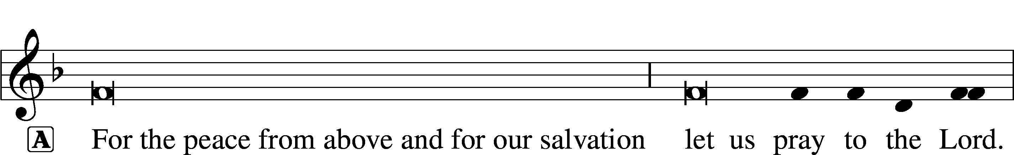

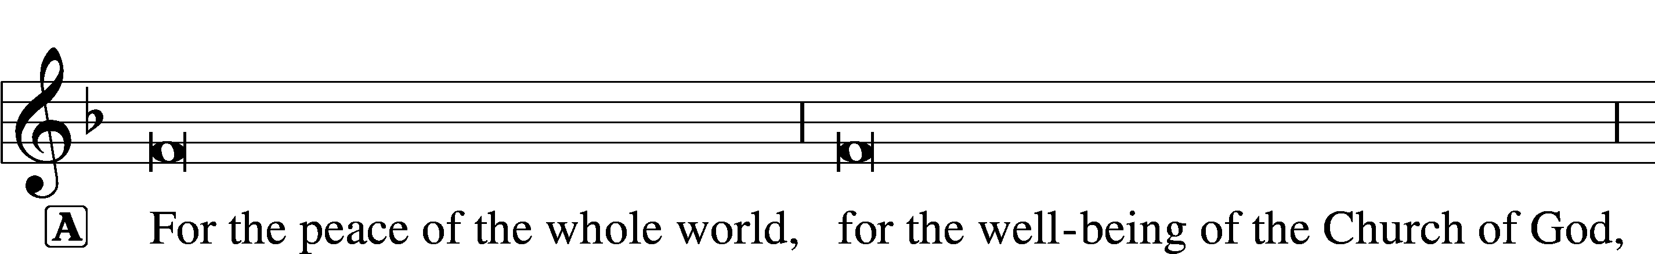

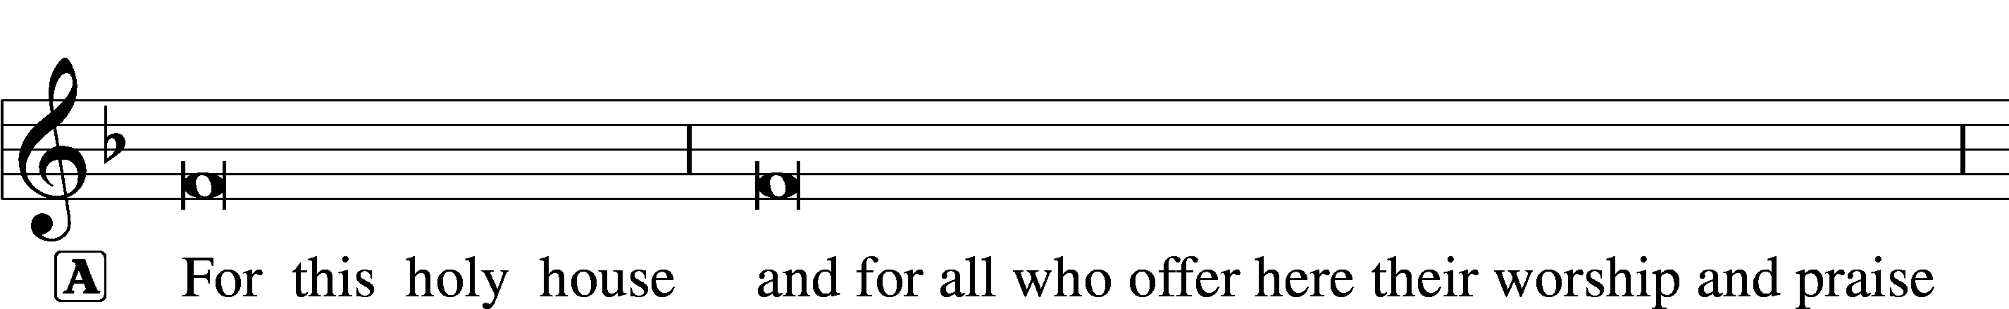

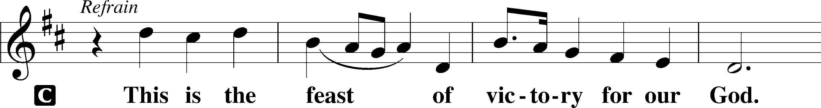
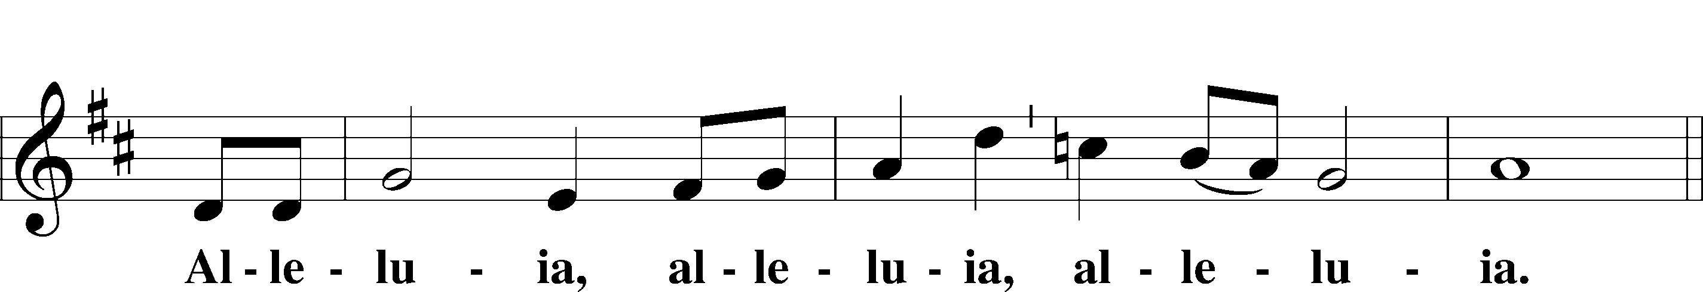
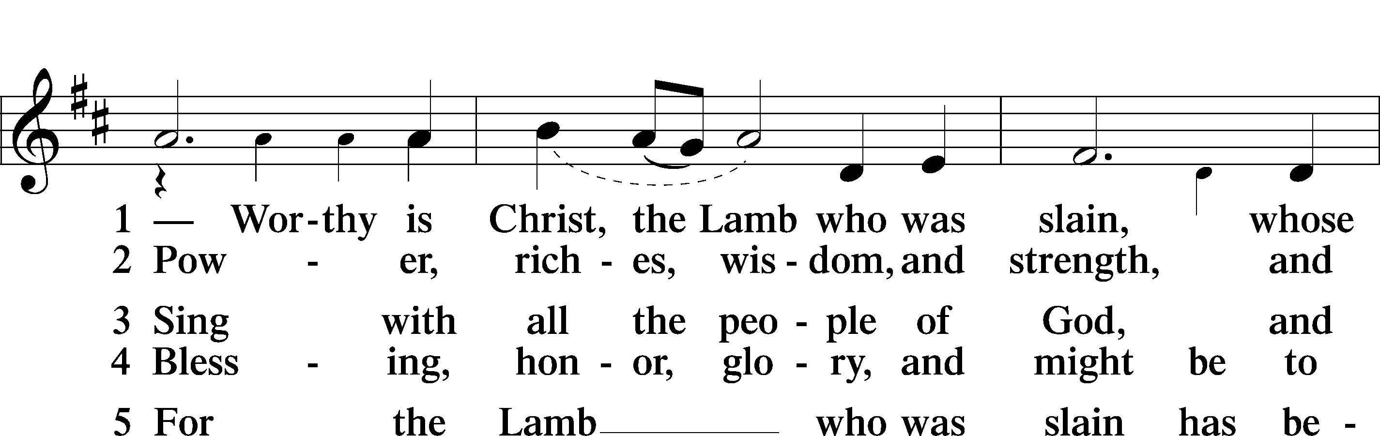
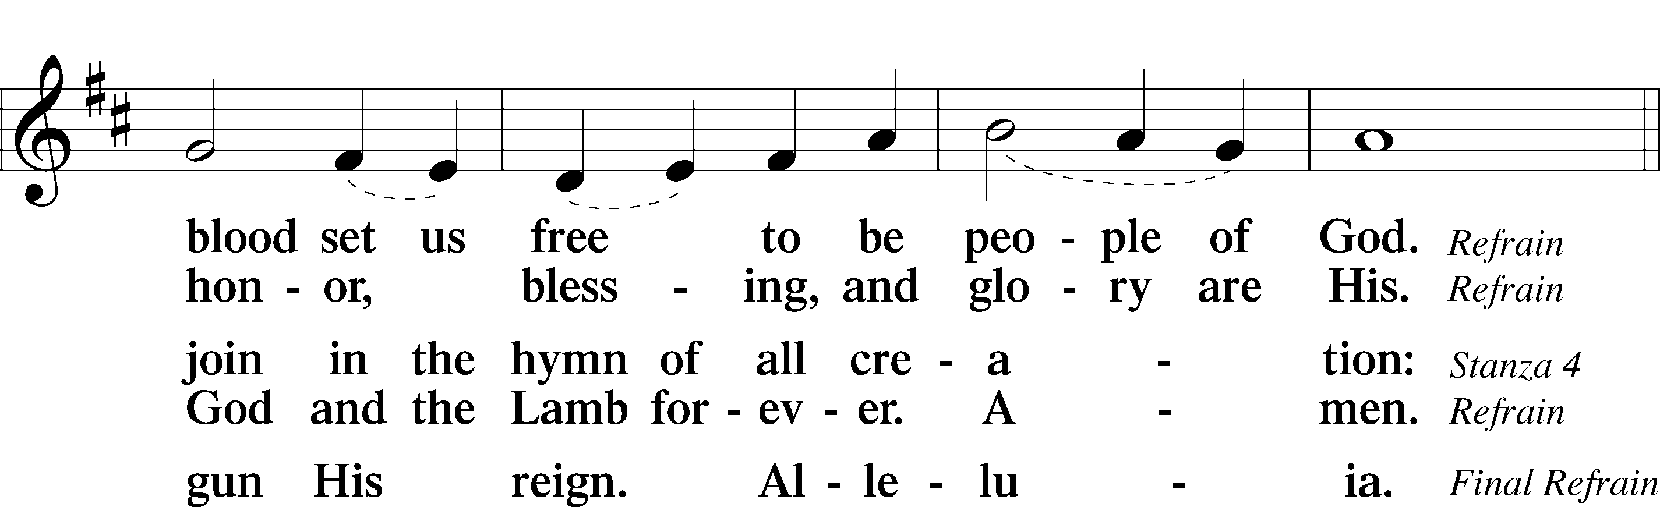
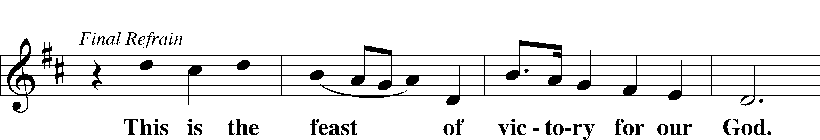
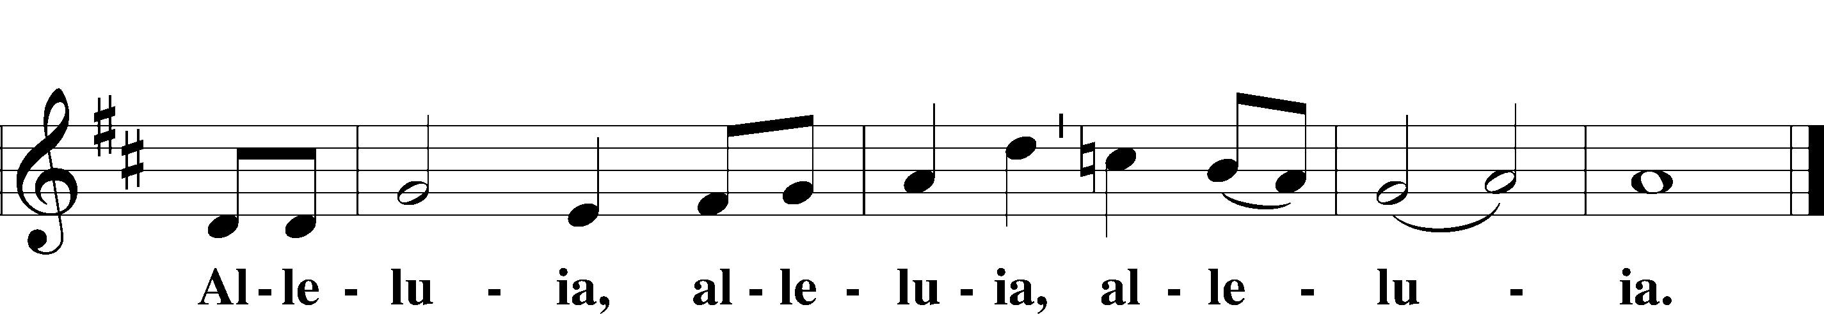

Salutation and Collect of the Day
P The Lord be with you.
C And also with you.

P Let us pray.
Heavenly Father, though we do not deserve Your goodness, still You provide for all our needs of body and soul. Grant us Your Holy Spirit that we may acknowledge Your gifts, give thanks for all Your benefits, and serve You in willing obedience; through Jesus Christ, Your Son, our Lord, who lives and reigns with You and the Holy Spirit, one God, now and forever.

C Amen.

Sit

Old Testament Reading Jeremiah 23:1–6
The Righteous Branch
1“Woe to the shepherds who destroy and scatter the sheep of my pasture!” declares the Lord. 2Therefore thus says the Lord, the God of Israel, concerning the shepherds who care for my people: “You have scattered my flock and have driven them away, and you have not attended to them. Behold, I will attend to you for your evil deeds, declares the Lord. 3Then I will gather the remnant of my flock out of all the countries where I have driven them, and I will bring them back to their fold, and they shall be fruitful and multiply. 4I will set shepherds over them who will care for them, and they shall fear no more, nor be dismayed, neither shall any be missing, declares the Lord.
5“Behold, the days are coming, declares the Lord, when I will raise up for David a righteous Branch, and he shall reign as king and deal wisely, and shall execute justice and righteousness in the land. 6In his days Judah will be saved, and Israel will dwell securely. And this is the name by which he will be called: ‘The Lord is our righteousness.’”

A This is the Word of the Lord.
C Thanks be to God.

Psalm Psalm 23; antiphon: v. 6
The Lord Is My Shepherd
1The Lord is my shepherd;
I shall not want.
2He makes me lie down in green pastures.
He leads me beside still waters.
3He restores my soul.
He leads me in paths of righteousness for his name’s sake.
4Even though I walk through the valley of the shadow of death,
I will fear no evil, for you are with me;
your rod and your staff, they comfort me.
5You prepare a table before me
in the presence of my enemies;
you anoint my head with oil;
my cup overflows.
6Surely goodness and mercy shall follow me
all the days of my life,
and I shall dwell in the house of the Lord forever.

Epistle Ephesians 2:11–22
One in Christ
11Remember that at one time you Gentiles in the flesh, called “the uncircumcision” by what is called the circumcision, which is made in the flesh by hands— 12remember that you were at that time separated from Christ, alienated from the commonwealth of Israel and strangers to the covenants of promise, having no hope and without God in the world. 13But now in Christ Jesus you who once were far off have been brought near by the blood of Christ. 14For he himself is our peace, who has made us both one and has broken down in his flesh the dividing wall of hostility 15by abolishing the law of commandments and ordinances, that he might create in himself one new man in place of the two, so making peace, 16and might reconcile us both to God in one body through the cross, thereby killing the hostility. 17And he came and preached peace to you who were far off and peace to those who were near. 18For through him we both have access in one Spirit to the Father. 19So then you are no longer strangers and aliens, but you are fellow citizens with the saints and members of the household of God, 20built on the foundation of the apostles and prophets, Christ Jesus himself being the cornerstone, 21in whom the whole structure, being joined together, grows into a holy temple in the Lord. 22In him you also are being built together into a dwelling place for God by the Spirit.

A This is the Word of the Lord.
C Thanks be to God.

Stand

Alleluia and Verse LSB 156
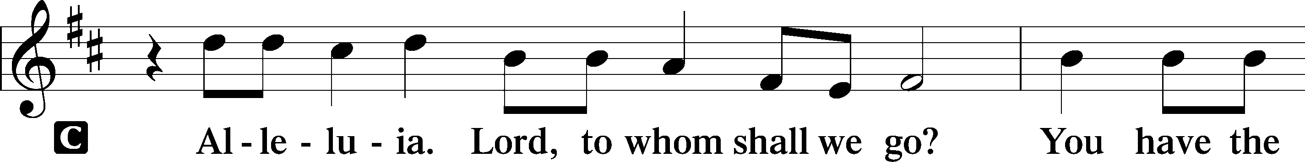
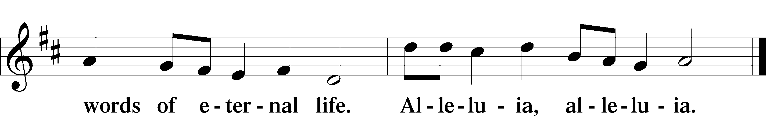

Holy Gospel Mark 6:30–44
P The Holy Gospel according to St. Mark, the sixth chapter.
C Glory to You, O Lord.

Jesus Feeds the Five Thousand
30The apostles returned to Jesus and told him all that they had done and taught. 31And he said to them, “Come away by yourselves to a desolate place and rest a while.” For many were coming and going, and they had no leisure even to eat. 32And they went away in the boat to a desolate place by themselves. 33Now many saw them going and recognized them, and they ran there on foot from all the towns and got there ahead of them. 34When he went ashore he saw a great crowd, and he had compassion on them, because they were like sheep without a shepherd. And he began to teach them many things. 35And when it grew late, his disciples came to him and said, “This is a desolate place, and the hour is now late. 36Send them away to go into the surrounding countryside and villages and buy themselves something to eat.” 37But he answered them, “You give them something to eat.” And they said to him, “Shall we go and buy two hundred denarii worth of bread and give it to them to eat?” 38And he said to them, “How many loaves do you have? Go and see.” And when they had found out, they said, “Five, and two fish.” 39Then he commanded them all to sit down in groups on the green grass. 40So they sat down in groups, by hundreds and by fifties. 41And taking the five loaves and the two fish he looked up to heaven and said a blessing and broke the loaves and gave them to the disciples to set before the people. And he divided the two fish among them all. 42And they all ate and were satisfied. 43And they took up twelve baskets full of broken pieces and of the fish. 44And those who ate the loaves were five thousand men.

P This is the Gospel of the Lord.
C Praise to You, O Christ.

Sit

Hymn of the Day: 645 Built on the Rock
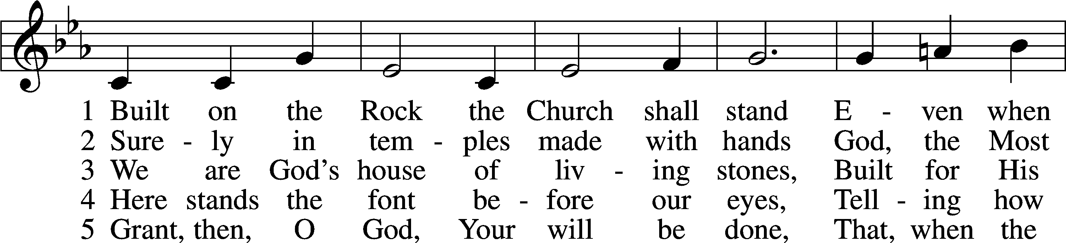
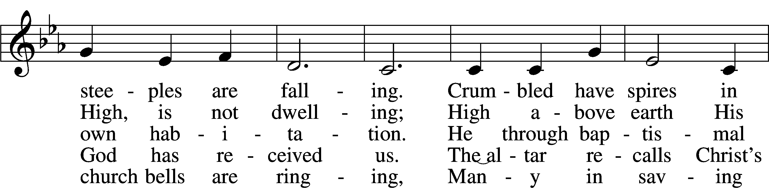
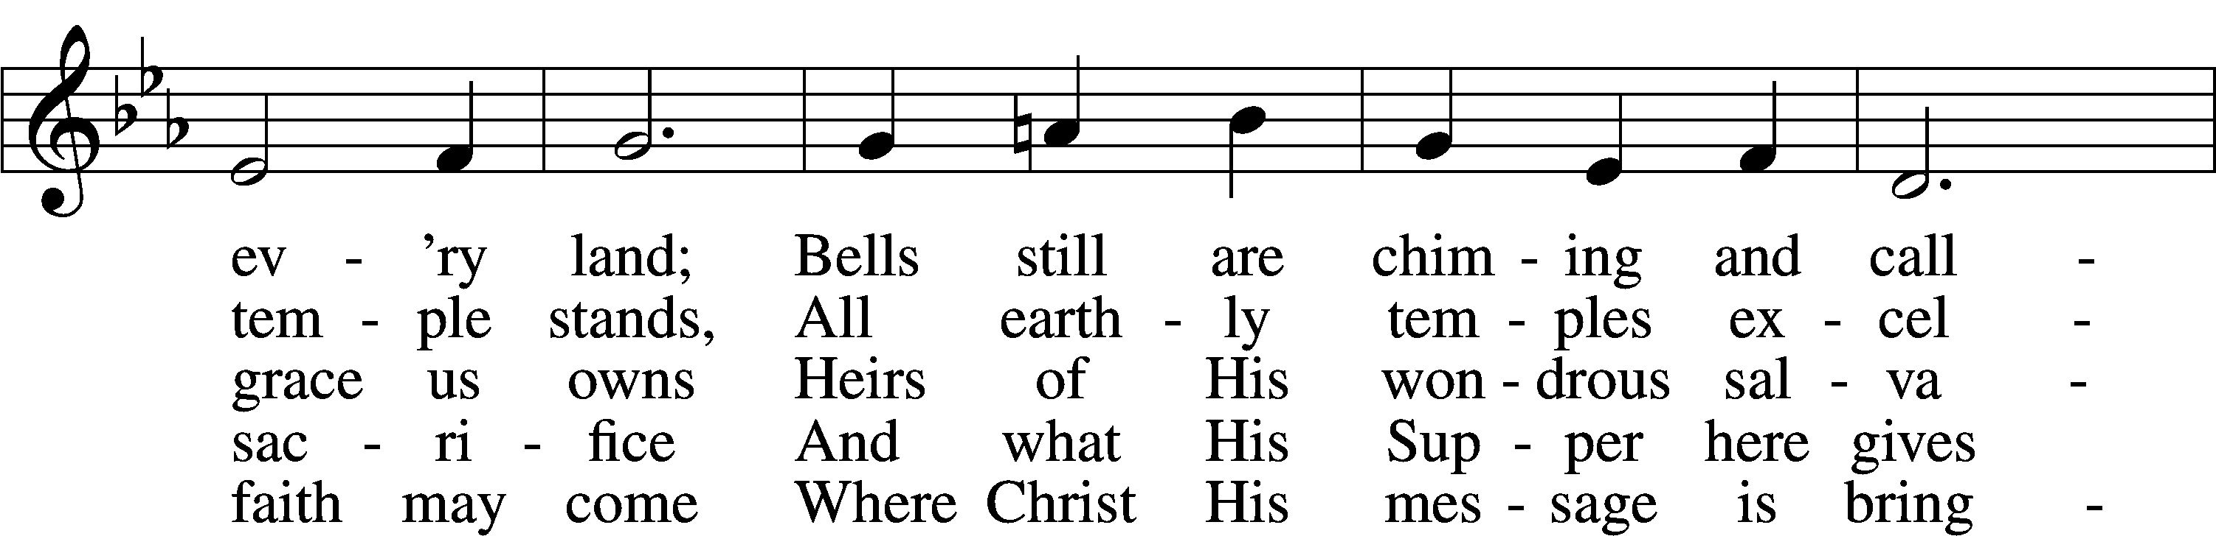
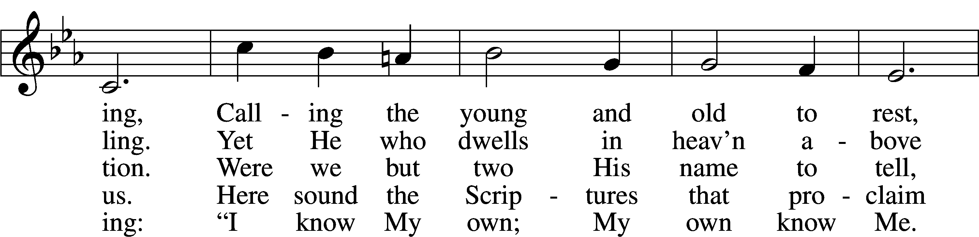
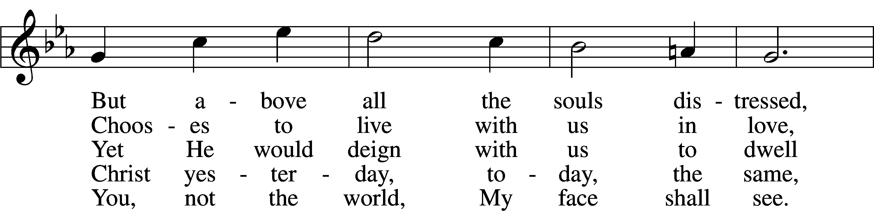
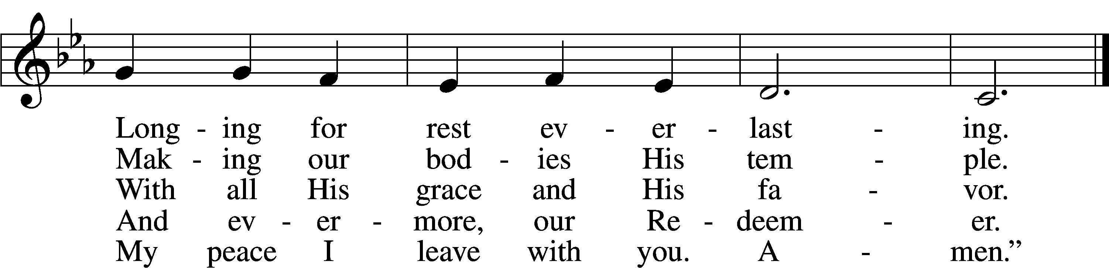
Text: Nikolai Fredrik Severin Grundtvig, 1783–1872, abr.; tr. Carl Döving, 1867–1937, alt.
Tune: Ludvig M. Lindeman, 1812–87
Text and tune: Public domain

Sermon

Stand

Nicene Creed
C I believe in one God,
the Father Almighty,
maker of heaven and earth
and of all things visible and invisible.

And in one Lord Jesus Christ,
the only-begotten Son of God,
begotten of His Father before all worlds,
God of God, Light of Light,
very God of very God,
begotten, not made,
being of one substance with the Father,
by whom all things were made;
who for us men and for our salvation came down from heaven
and was incarnate by the Holy Spirit of the virgin Mary
and was made man;
and was crucified also for us under Pontius Pilate.
He suffered and was buried.
And the third day He rose again according to the Scriptures
and ascended into heaven
and sits at the right hand of the Father.
And He will come again with glory to judge both the living and the dead,
whose kingdom will have no end.

And I believe in the Holy Spirit,
the Lord and giver of life,
who proceeds from the Father and the Son,
who with the Father and the Son together is worshiped and glorified,
who spoke by the prophets.
And I believe in one holy Christian and apostolic Church,
I acknowledge one Baptism for the remission of sins,
and I look for the resurrection of the dead
and the life T of the world to come. Amen.

Prayer of the Church

Following the prayers, the people may greet one another in the name of the Lord, saying, “Peace be with you,” as a sign of reconciliation and of the unity of the Spirit in the bond of peace (Matt. 5:22–24; Eph. 4:1–3).

Sit

Offering

Stand

Offertory LSB 159
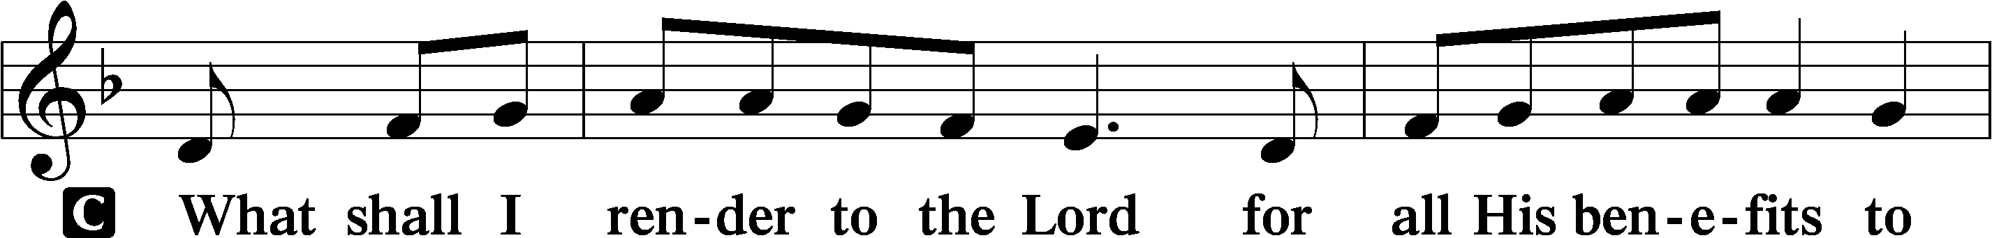
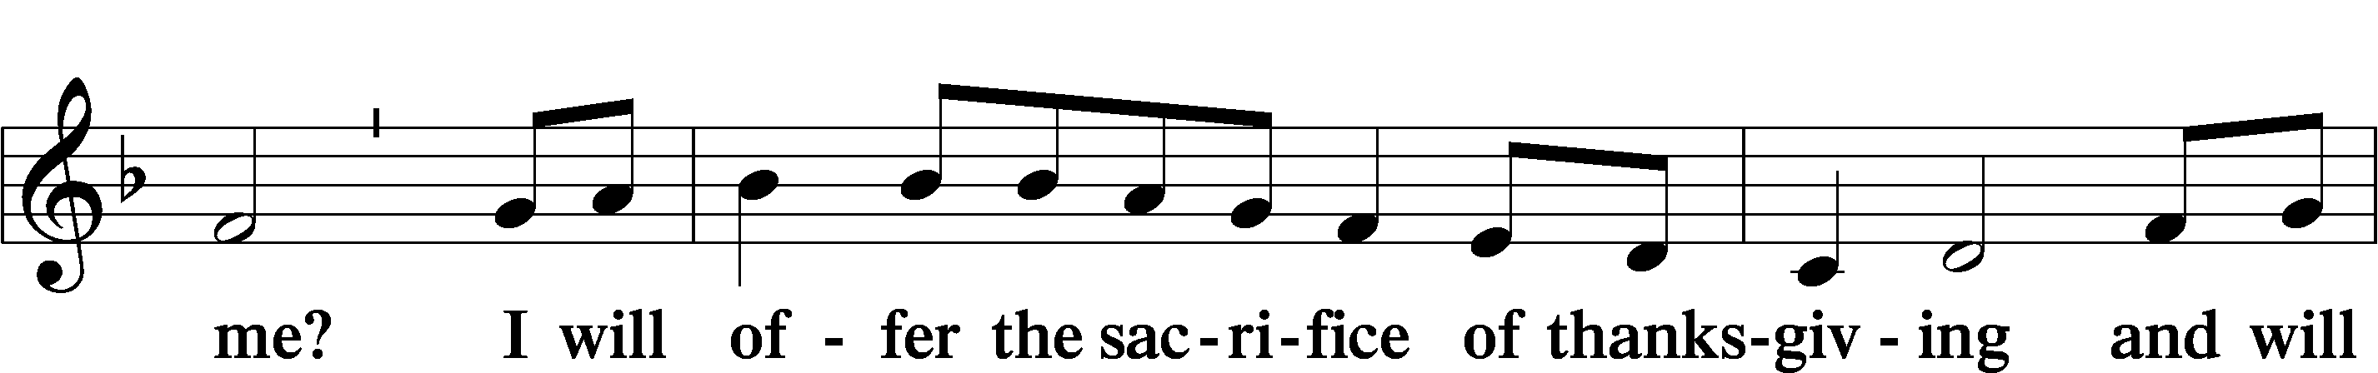
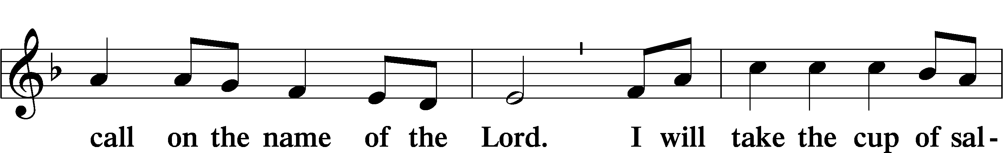
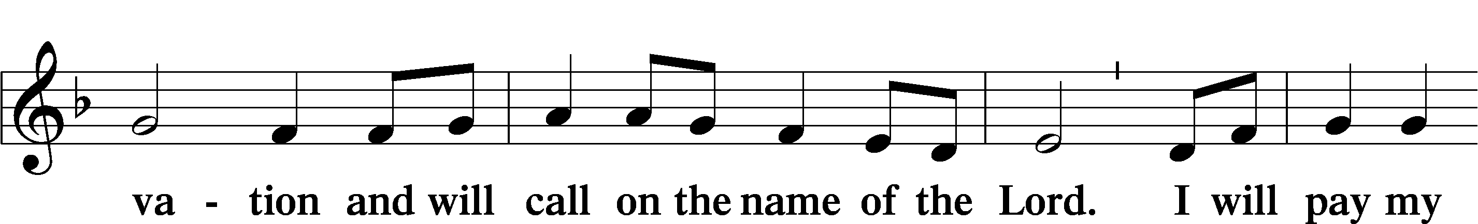
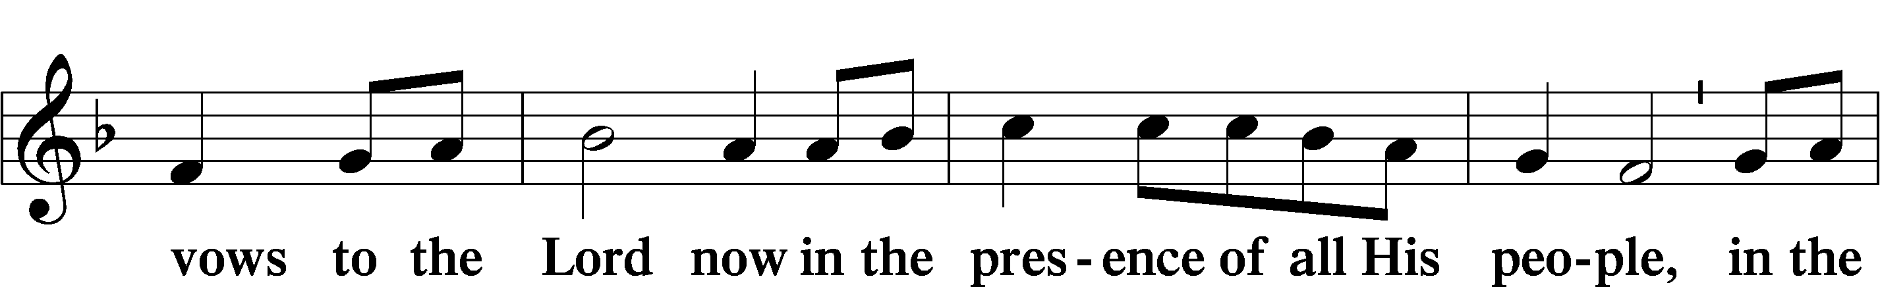
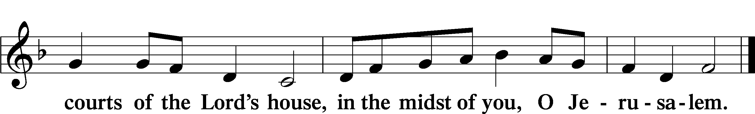

Service of the Sacrament

Preface LSB 160
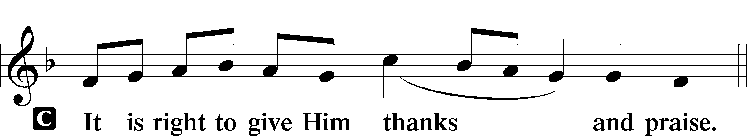

P It is truly good, right, and salutary that we should at all times and in all places give thanks to You, holy Lord, almighty Father, everlasting God, through Jesus Christ, our Lord, who, having created all things, took on human flesh and was born of the virgin Mary. For our sake He died on the cross and rose from the dead to put an end to death, thus fulfilling Your will and gaining for You a holy people. Therefore with angels and archangels and with all the company of heaven we laud and magnify Your glorious name, evermore praising You and saying:

Sanctus LSB 161
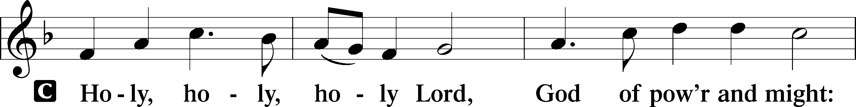
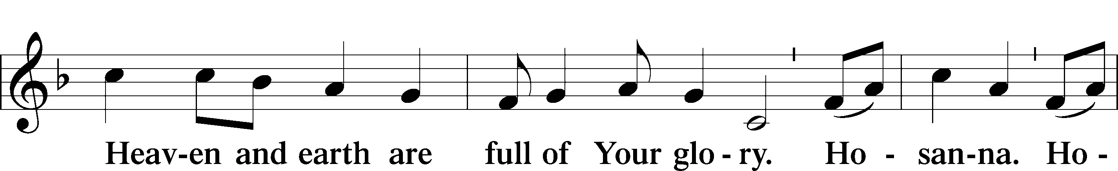
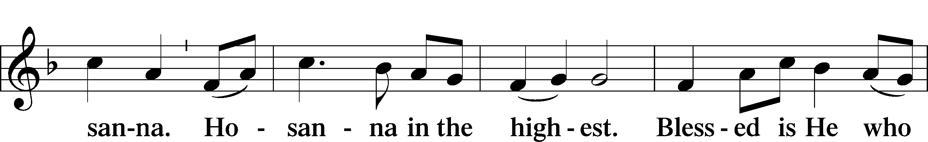
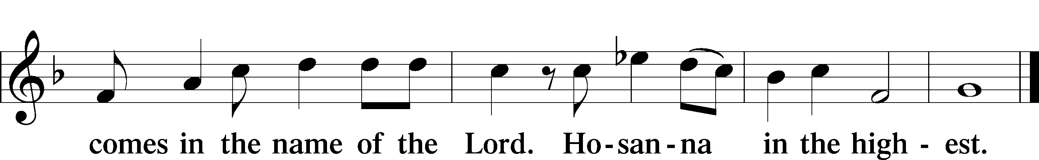

Prayer of Thanksgiving LSB 161
P Blessed are You, Lord of heaven and earth, for You have had mercy on those whom You created and sent Your only-begotten Son into our flesh to bear our sin and be our Savior. With repentant joy we receive the salvation accomplished for us by the all-availing sacrifice of His body and His blood on the cross.

Gathered in the name and the remembrance of Jesus, we beg You, O Lord, to forgive, renew, and strengthen us with Your Word and Spirit. Grant us faithfully to eat His body and drink His blood as He bids us do in His own testament. Gather us together, we pray, from the ends of the earth to celebrate with all the faithful the marriage feast of the Lamb in His kingdom, which has no end. Graciously receive our prayers; deliver and preserve us. To You alone, O Father, be all glory, honor, and worship, with the Son and the Holy Spirit, one God, now and forever.
C Amen.

The Words of Our Lord
P Our Lord Jesus Christ, on the night when He was betrayed, took bread, and when He had given thanks, He broke it and gave it to the disciples and said: “Take, eat; this is My T body, which is given for you. This do in remembrance of Me.”

In the same way also He took the cup after supper, and when He had given thanks, He gave it to them, saying: “Drink of it, all of you; this cup is the new testament in My T blood, which is shed for you for the forgiveness of sins. This do, as often as you drink it, in remembrance of Me.”

P As often as we eat this bread and drink this cup, we proclaim the Lord’s death until He comes.
C Amen. Come, Lord Jesus.

P O Lord Jesus Christ, only Son of the Father, in giving us Your body and blood to eat and to drink, You lead us to remember and confess Your holy cross and passion, Your blessed death, Your rest in the tomb, Your resurrection from the dead, Your ascension into heaven, and Your coming for the final judgment. So remember us in Your kingdom and teach us to pray:

Lord’s Prayer
C Our Father who art in heaven,
hallowed be Thy name,
Thy kingdom come,
Thy will be done on earth
as it is in heaven;
give us this day our daily bread;
and forgive us our trespasses
as we forgive those
who trespass against us;
and lead us not into temptation,
but deliver us from evil.
For Thine is the kingdom
and the power and the glory
forever and ever. Amen.

Pax Domini LSB 163
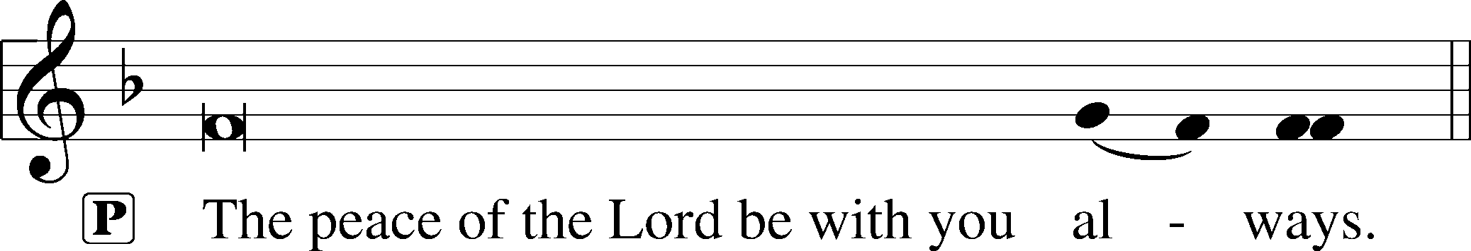

Agnus Dei LSB 163
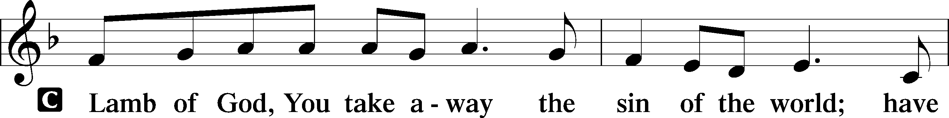
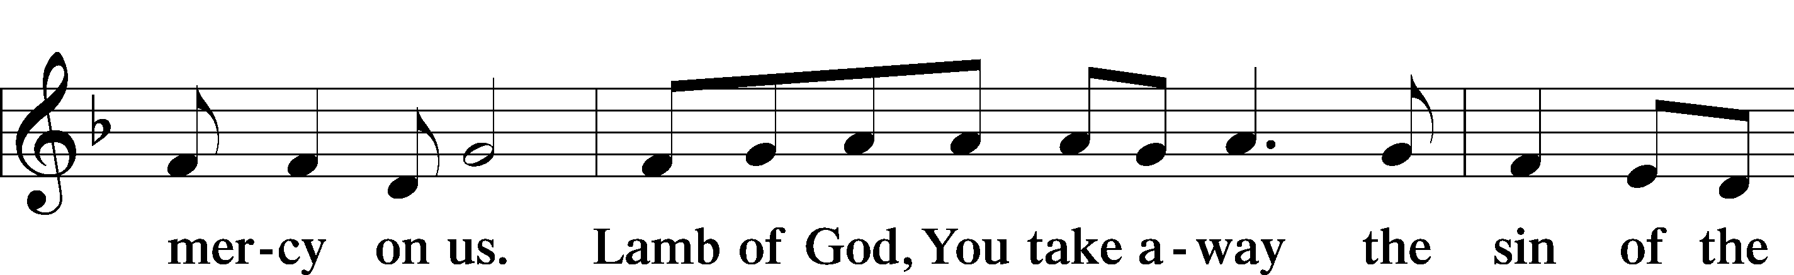
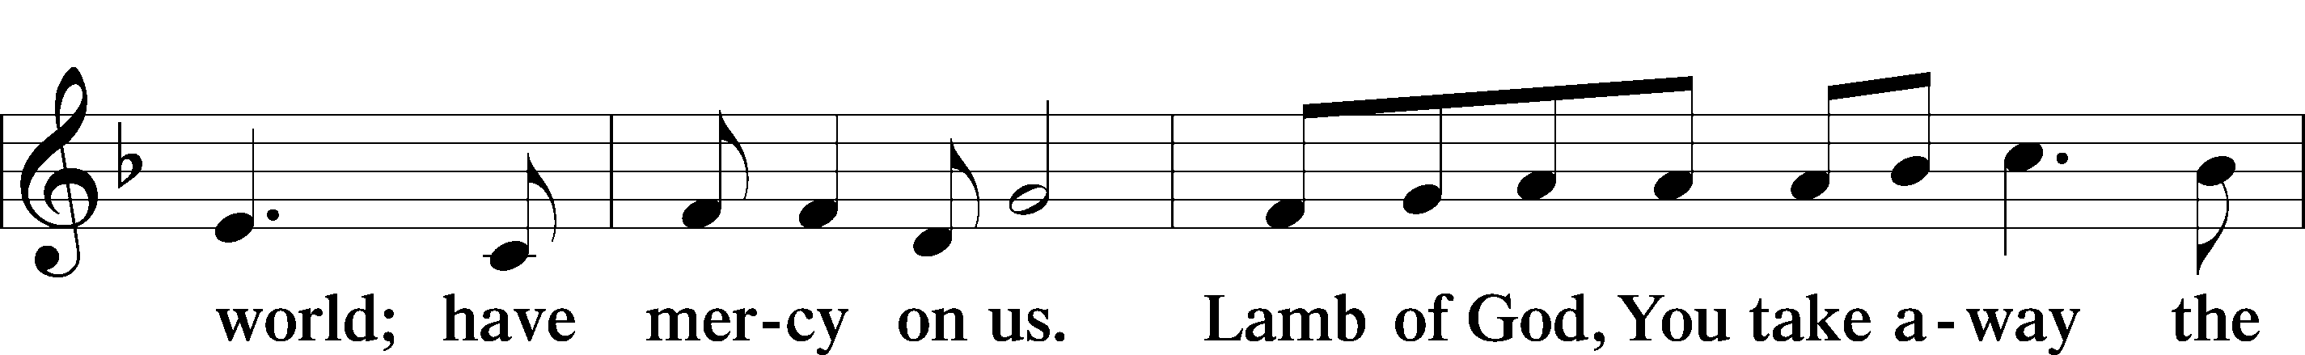
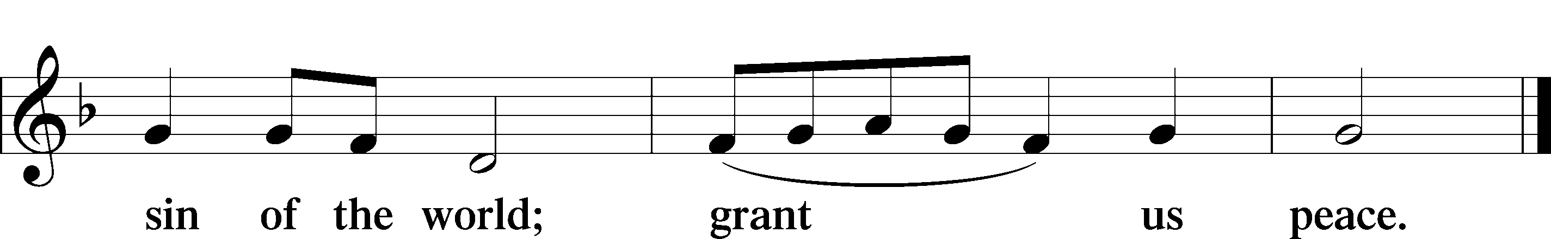

Sit

Distribution

The pastor and those who assist him receive the body and blood of Christ first and then distribute them to those who come to receive, saying:

Take, eat; this is the true body of our Lord and Savior Jesus Christ, given into death for your sins.
Amen.

Take, drink; this is the true blood of our Lord and Savior Jesus Christ, shed for the forgiveness of your sins.
Amen.

In dismissing the communicants, the following is said:

P The body and blood of our Lord Jesus Christ strengthen and preserve you in body and soul to life everlasting. Depart T in peace.
C Amen.

Distribution Hymn: 642 O Living Bread from Heaven
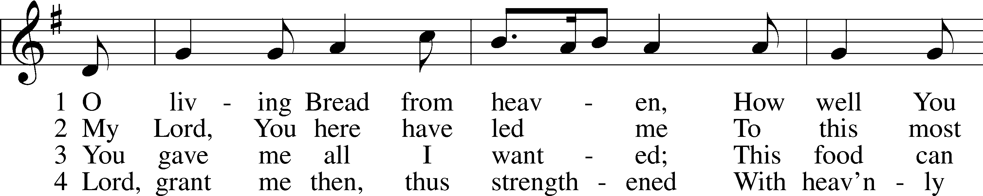
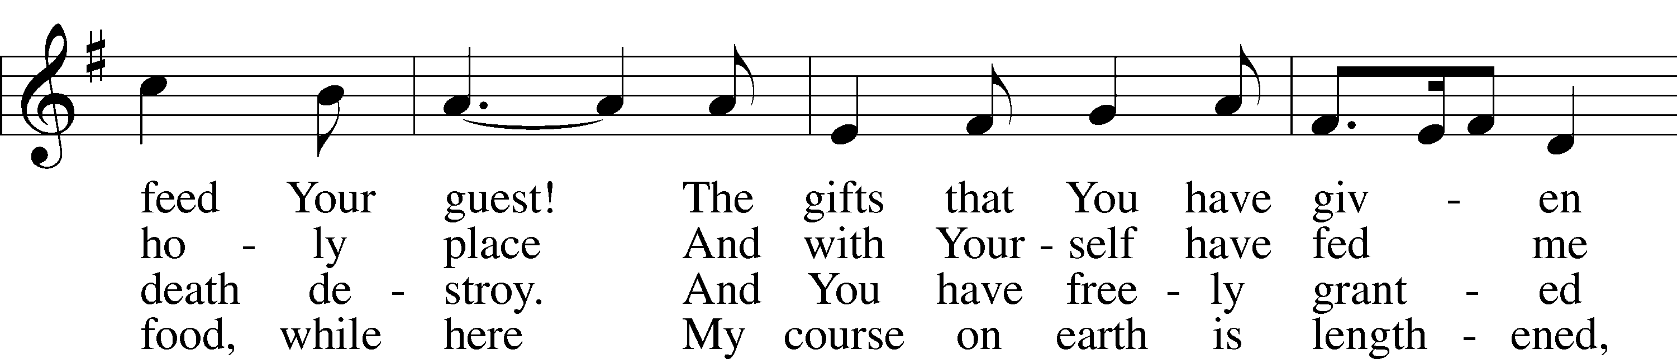
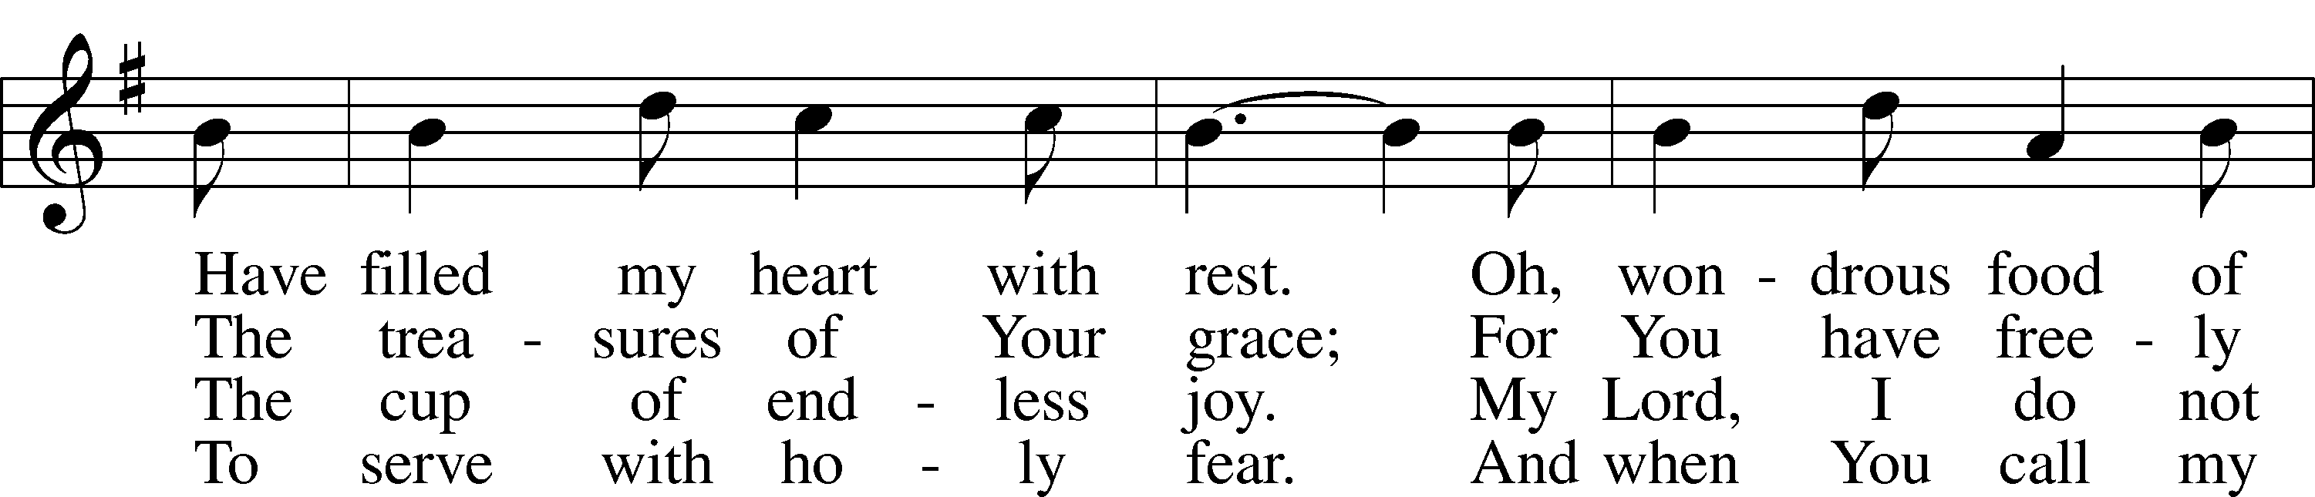
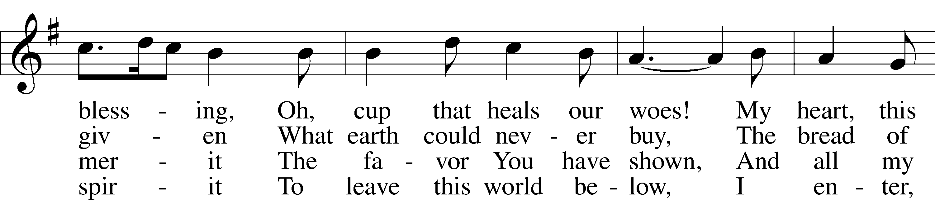
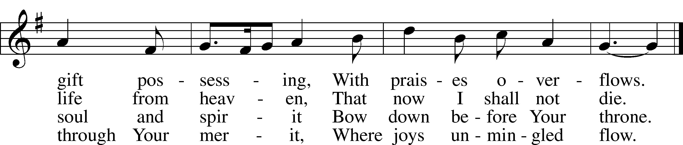
Text: Johann Rist, 1607–67; tr. Catherine Winkworth, 1827–78, alt.
Tune: Musae Sioniae, 1609, vol. 7, Wolfenbüttel, ed. Michael Praetorius
Text and tune: Public domain

Distribution Hymn: 748 I’m But a Stranger Here
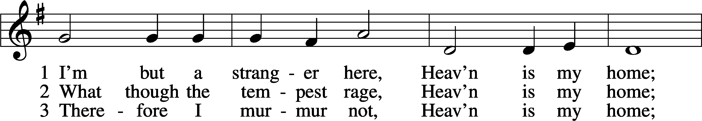
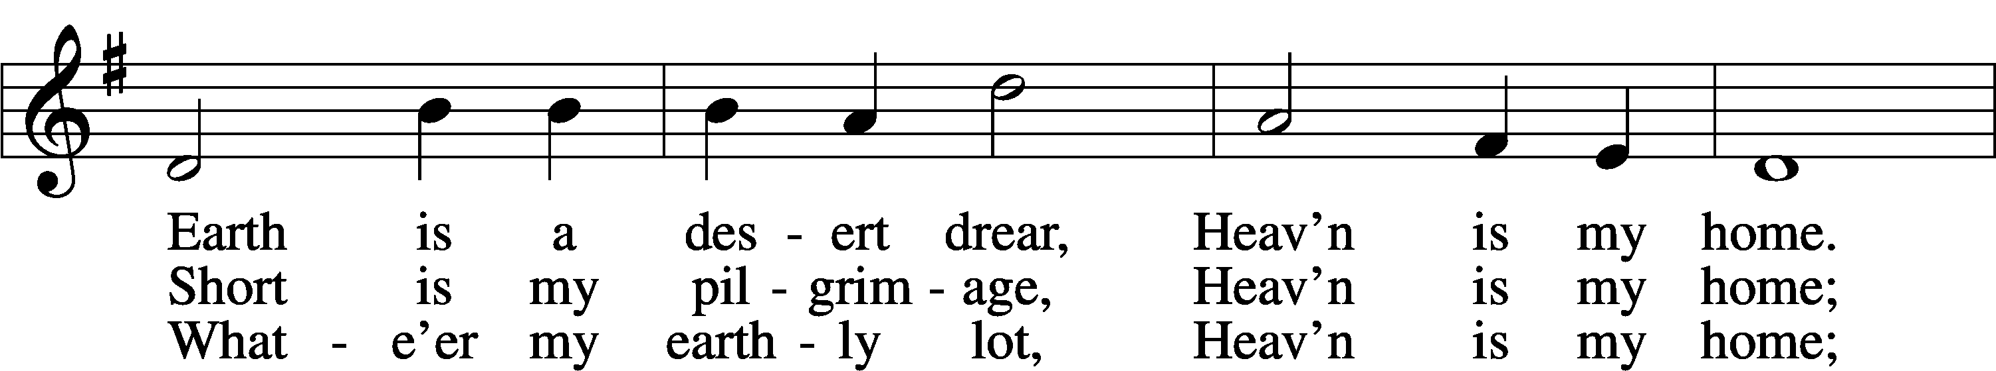
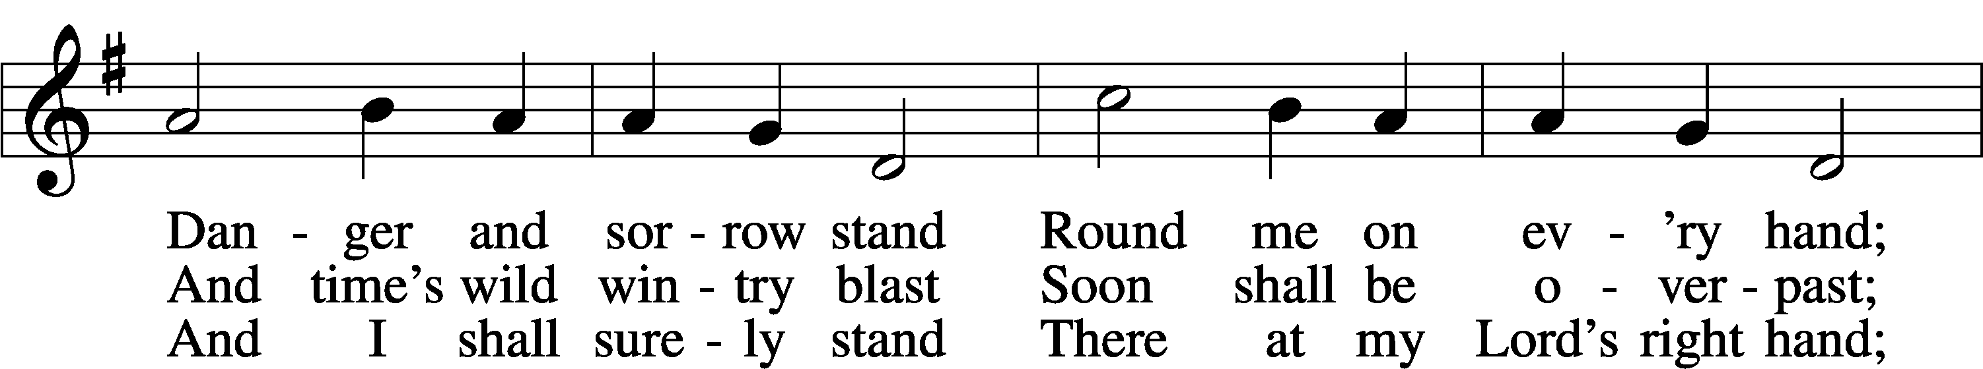
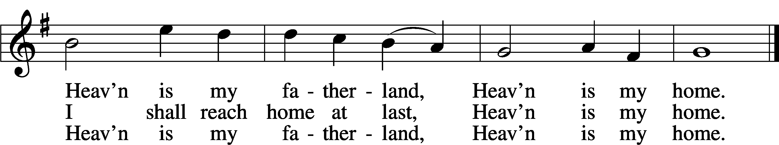
Text: Thomas R. Taylor, 1807–35
Tune: Arthur S. Sullivan, 1842–1900
Text and tune: Public domain

Stand

Thank the Lord LSB 164
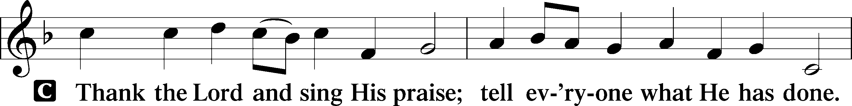
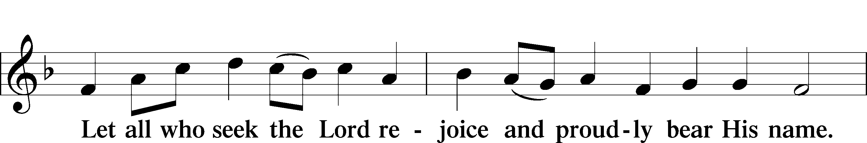
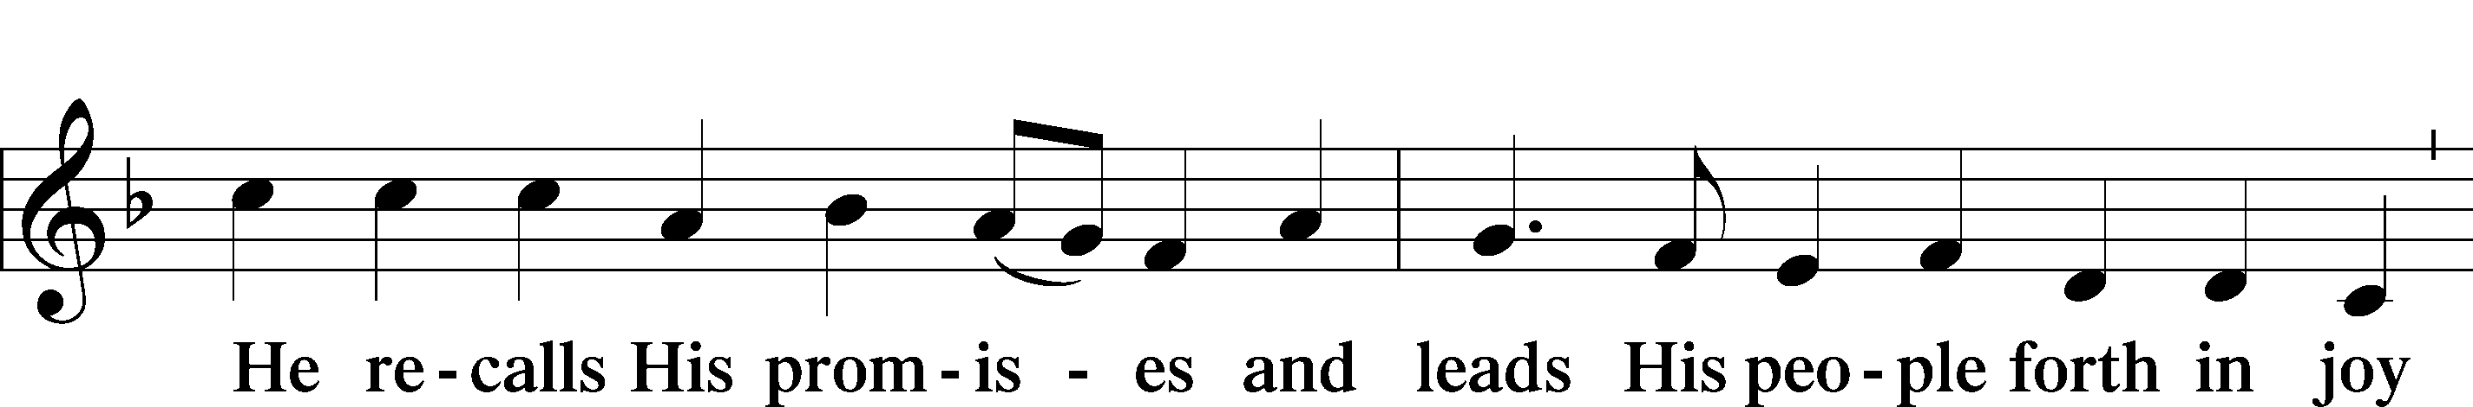
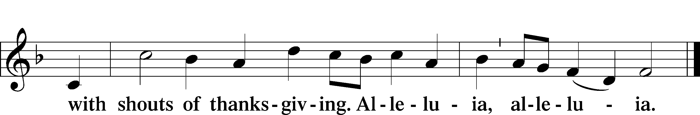

Post-Communion Collect
A Let us pray.
We give thanks to You, almighty God, that You have refreshed us through this salutary gift, and we implore You that of Your mercy You would strengthen us through the same in faith toward You and in fervent love toward one another; through Jesus Christ, Your Son, our Lord, who lives and reigns with You and the Holy Spirit, one God, now and forever.
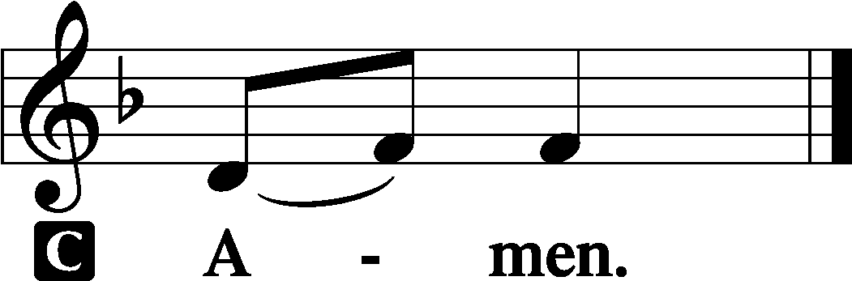

Benediction LSB 166
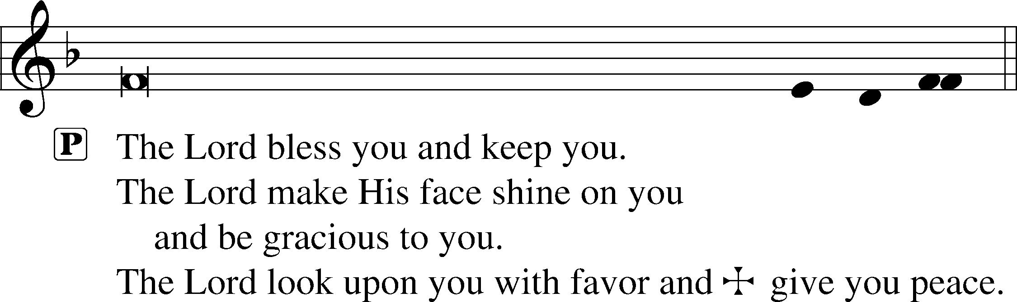

Hymn to Depart: 861 Christ Be My Leader
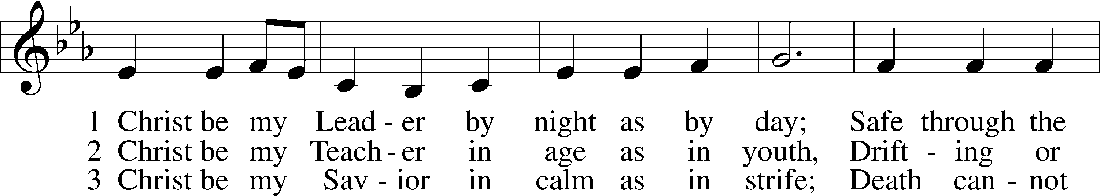
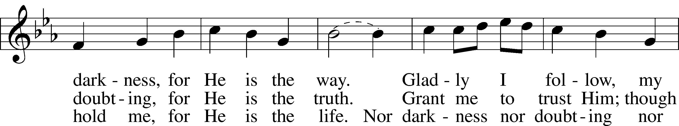
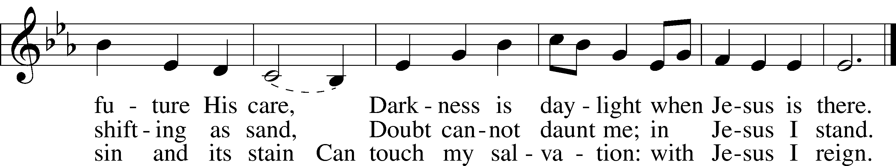
Text: Timothy Dudley-Smith, 1926
Tune: Irish
Text: © 1964, renewed 1992 Hope Publishing Co. Used by permission: LSB Hymn License no. 110005504
Tune: Public domain

Acknowledgments
Divine Service, Setting One from Lutheran Service Book
Unless otherwise indicated, Scripture quotations are from the ESV® Bible (The Holy Bible, English Standard Version®), copyright © 2001 by Crossway, a publishing ministry of Good News Publishers. Used by permission. All rights reserved.
Created by Lutheran Service Builder © 2024 Concordia Publishing House.

Announcements:
Church Service Phone: 715-438-4200
(Stay on the line for recorded service to start)
Live Stream audio services: http://salem.listentochurch.com
Salem’s Web Page: https://www.salembarron.com/
Pastor Fred Buth: Cell phone:715-642-3050 (H)715-353-2540
Email: salembarronpastor@gmail.com
Pastor’s Office Hours: Monday-Wednesday 9-12
Attendance: In-person: 7/14 - 50
Coffee and Snacks: Koenig/Elliott
Elder Today: Paul Millerman
Altar Guild: Kathy Schuettpelz
Schedule for the week:
Today: 7:00 pm Call Committee Meeting
Tuesday: 5:30 PM – BOE Meeting

We are looking for a volunteer to be Director of Sunday School, also looking for a 7 & 8th grade Sunday school teacher. If you are interested, please contact Sue M.

Save the Date:
July 28th – Root Beer Floats- Men’s Club/YFM
August 9th – Annual Church Picnic, serving 4:30-6:30 pm
Christ Community Lutheran School is hiring a headmaster. We are open to all levels of experience. Please email a resume’ or questions to administrator@christcommunityls.org
NINTH SUNDAY AFTER PENTECOST The Lord Jesus Shepherds His Church on Earth by the Ministry of the Gospel The Lord rebukes and removes “the shepherds who destroy and scatter the sheep” (Jer. 23:1). He gathers the flock, brings them back to the fold, and sets “shepherds over them who will care for them” (Jer. 23:3–4). He raises up the Son of David, the great Good Shepherd, to “reign as king and deal wisely” (Jer. 23:5). He is “our righteousness,” in whom we “dwell securely” (Jer. 23:6). He has compassion on all of us, who were “like sheep without a shepherd” (Mark 6:34). Not only does He teach us many things, but taking the bread, He blesses and breaks and gives it to the disciples “to set before the people” (Mark 6:41). He abundantly provides for His Church on earth, so that everyone is fed and fully satisfied in body and soul. He preaches peace “to you who were far off,” and “by the blood of Christ,” He brings you near (Eph. 2:13, 17). Though you were “separated from Christ” by your sin, “having no hope and without God in the world” (Eph. 2:12), now “you are fellow citizens with the saints and members of the household of God” (Eph. 2:19). Communion Notices Please complete a communion card for our records; they are in the pew in front of you, or request one from an usher. Salem’s communion practice is that of close communion. We invite to our rail those who are members in good standing of sister Missouri Synod parishes. Visitors, please contact the pastor prior to communing. For those who prefer to use the Common Cup, we ask your assistance by holding the cup’s base as you commune.
Introit Psalm 147:7–11; antiphon: Psalm 145:16
You open your hand;
you satisfy the desire of every living thing.
Sing to the Lord with thanksgiving;
make melody to our God on the lyre!
He covers the heavens with clouds; he prepares rain for the earth;
he makes grass grow on the hills.
He gives to the beasts their food,
and to the young ravens that cry.
His delight is not in the strength of the horse,
nor his pleasure in the legs of a man,
but the Lord takes pleasure in those who fear him,
in those who hope in his steadfast love.
Glory be to the Father and to the Son
and to the Holy Spirit;
as it was in the beginning,
is now, and will be forever. Amen.
You open your hand;
you satisfy the desire of every living thing.

Collect of the Day

Heavenly Father, though we do not deserve Your goodness, still You provide for all our needs of body and soul. Grant us Your Holy Spirit that we may acknowledge Your gifts, give thanks for all Your benefits, and serve You in willing obedience; through Jesus Christ, Your Son, our Lord, who lives and reigns with You and the Holy Spirit, one God, now and forever.

Prayers Request:
Those in the nursing home: Joann Jaeger Those Shut-in at home: Char Herman, Joan Church, Joyce Myers, Joyce Koba Those with ongoing health issues: Harrison Fields, Jeanne Perala, Owen Metz, Jeff Bonneville, Daria (Cindy Wright’s friend), Butch L. (Cindy Wright’s Brother-in-law), Melissa Miller. Art Smith (Sue Millerman’s brother), Brenda Sellent (Denise Stabenow’s sister), Sandy Hahn (Cindy Wright’s cousin’s wife) , Brenda Gustum (Missy Wiese’s mom) Recovering from surgery: Wyatt Weise, Those who lead our nation: Joe Biden, Kamala Harris, Tony Evers, Rod Nordby Those who serve in our military and law enforcement: Ryan Graf, Chaplain Pon Chanthaphon (Our Adopt-a-Chaplain), Rusty Weise Our Childcare Staff: Melissa Weinert, Denise Stabenow, Katelyn Hendren, Holly Wilhelmi, Janica Skjerly, Jacie Amundson, Cathy Anderson For Christ Community Lutheran School – Ask the Lord to provide teachers for the school

